Yep !!!

Here is, as promised, a summary of my lesson called “spinning and geometry”…in English please!

To begin, it presents a few basic geometry principles that we can see on rotating instruments (different symmetries on different configurations of rotation). (p. 3)
As an illustration, I will present the big circle and different ways to do it in the main configuration of rotation of the arms and poï. This example, on two famous figures, will lead us to shed light on the symmetry point and axes. (p. 4-5)

After that, I will generalize and propose a method to work on all (uh… nobody’s perfect!) the conceivable geometric forms which have symmetry point or axes. (p.6)

Then, I’ll show different geometric forms that I imagined. From segments to complex assemblies, I will present at the same time the symmetry effects which are on the forms. These will enable us to know how to draw forms with the two hands (with poï) and with the corresponding configurations of rotation. (p. 7-9)

About the most basic forms, I will introduce you to some figures that I found (principally with sticks or with two balls). (p. 10-12)

By doing the method in reverse, that is to say by applying symmetric effects to basic forms, I will show the result of different figures implying the symmetric point or axes. (p. 13-16)

Without talking about symmetry or other boring things, but still on geometric forms, I will talk about some other ways I’ve found until now to do these forms (on ¼, 1/3… time, by using point to point, with hybrid…). (p. 17-18)

To finish, I will try to open the reflection on the representation I use. I will talk about some other “remarkable points” on the instruments, which will lead me to propose another use for the drawings. (p. 19)

The aim of this article is to open your juggling mind to a geometric point of view on spinning practices, but also to let you imagine some other figures by using the proposed method.

I’m sharing here with you some understandings and experiences I had. I hope this document will be of any use for you.

Cyrille

MAIN SYMMETRY EFFECTS
« DOUBLE » EFFECT
CENTRAL SYMMETRY

HORIZONTAL SYMMETRY
DIAGONAL SYMMETRY

VERTICAL SYMMETRY

ARMS
POÏS
4 TIMES ROSETTE

«Double » effect
Central symmetry
Vert. symmetry
Horiz. symmetry

BRAS
POÏS
4 PETALS FLOWER (keywords reluctant to translation !)
Symétrie centrale
Symétrie vert.
Symétrie horiz.
Effet « double »

METHOD
On all the conceivable geometric forms, the symmetry effects can be exploited with the corresponding rotation configurations.

- If the form (or the assembly) has a « double » effect, then, we can do it with the two hands drawing the same thing (stacked or not), with poï rotating in the same direction at the same time.
- Here is an example on a triangle and an assembly of triangles:

- With a central symmetry point, the hands draw the form by beginning on two opposite points from the central symmetry point, and poï rotate in the same direction in split time.
- Example on a square and an assembly of squares:

- With a vertical symmetry axis, the hands draw the form by making use of the vertical axis and poï rotate in opposite direction at the same time.
- Example on a triangle and an assembly of triangles:

- With a horizontal symmetry axis, the hands draw the form by making use of the horizontal axis and poï rotate in opposite direction in split time.
- Example on a triangle and an assembly of triangles:

I let you imagine for the other axes…

……
A FEW EXAMPLES OF FORMS AND CORRESPONDING AXES
THE CIRCLE :
(All the axes…)

SEGMENTS :
(2 axes and a central symmetry point)

TRIANGLES :
(1 to 3 symmetry axes)

SQUARES :
(4 axes and a central symmetry point)

A FEW EXAMPLES OF ASSEMBLIES AND OTHER COMPLEX FORMS

FIGURES ON A SEGMENT
Staffs Balls manipulation Poïs (when it’s possible…)

SPIN ANTISPIN

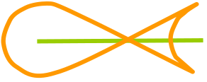

.…

.…

SPIN AND ANTISPIN :

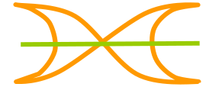
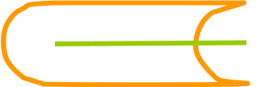
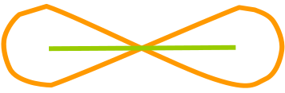
.…

- By visualizing, on the figures above, the symmetry point or axes, it becomes possible to know how to realize them with the two hands.
FIGURES ON A TRIANGLE
SPIN ANTISPIN

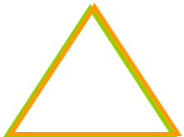

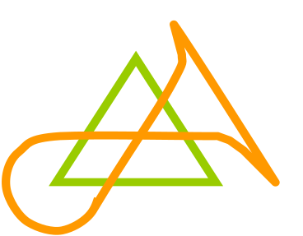

…

Two triangles :

…

SPIN + ANTISPIN :

…

FIGURES ON A SQUARE :
SPIN :
ANTI-SPIN :

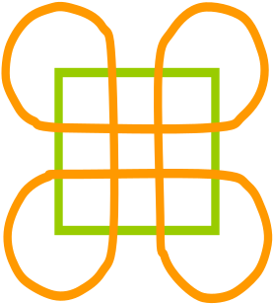

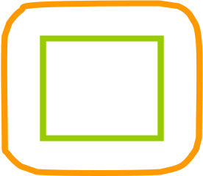


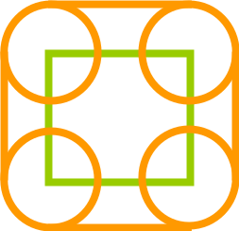

Two squares :
…

SPIN + ANTI-SPIN :

…

FIGURES IN ANTI SPIN ON ASSEMBLIES WITH
« DOUBLE » EFFECT

Two segments :

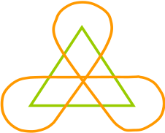
…

Two triangles :

Two squares :

…

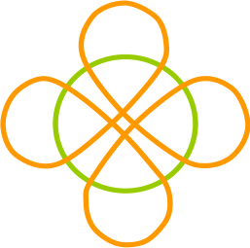

Two small circles :

…

FIGURES IN ANTI SPIN ON ASSEMBLIES WITH
CENTRAL SYMMETRY

Two segments :
Two squares :

Two triangles :

…

…

Two small circles :

FIGURES IN ANTI SPIN ON ASSEMBLIES WITH
VERTICAL SYMMETRY AXIS

Two segments :

Two triangles :

Two squares :
Two small circles :

Deux carrés :
Deux petits cercles :

…

…

Two segments :
Two squares :
Two small circles :

FIGURES IN ANTI SPIN ON ASSEMBLIES WITH
HORIZONTAL SYMMETRY AXIS

Two triangles :

OTHER WAYS TO DRAW FORMS
By using the axes of each form

On the assemblies, it’s also interesting to use the symmetry effects on each form composing the assembly. A square, for example, can be seen like an assembly of four segments. By using that, the rotation configuration of poï will change from a segment to another.
- Example on a square (hands joined, poïs rotating in opposite direction) :

As we’re here on joined hand moves, it’s possible to use this way of drawing on all the conceivable forms!
- Here’s another example I particularly appreciate, on an assembly of triangles :

- Here’s another example on an assembly of squares. This time, the move will be done according to the axes on each square.

With the 1/x time

Poï can be disposed on all the conceivable angles. The angle can change depending on the form and its angles. We have to begin here on a form on two different points.
- Examples on two forms:

With the « point to point »

Point to point consists in moving hands on a form independently and randomly. On each form, we can imagine an infinity of patterns. This method is applicable on all the rotation configurations, of hands and poï.
Here is the simplest example on two aligned segments:
2
2

1
1

With linear hybrid

The use of hybrid move, hand joined, also enables the hands to move on a line. During the time one poï head is isolated, you can move your hand wherever you want around the poï. So the hand could move during this time on a line. The other hand, with poi rotating in one of the two ways, follows the first hand. By doing this, we could do for example the horizontal segment with poï rotating in opposite direction at the same time (which we could already do with poï rotating in opposite split time, by making use of the horizontal axis).

Hybrid :

Here is a pattern of Andy in which one of the segments of the triangle is done with a linear hybrid.

- In this article, I’ve only considered two remarkable points on the instruments. Thus, I’ve voluntarily talked more about poï and possible hand moves. But there are other remarkable points, physically present or not. We can also take in consideration the trajectory of the centre of the instrument. By considering the blue trajectory on geometric forms, we can imagine a lot of other patterns. Here is, to illustrate what I’ve just said, Gé’s work showing some flowers that we can do on a trajectory of the centre of the instrument around a circle.
http://www.firesouls.de/wbb2/thread.php?threadid=965&threadview=0&hilight=&hilightuser=0&page=4

- The representation that I’m proposing remains exploitable with the other remarkable points. With poï for example, if we replace on the drawings the green by the blue, representing the centre of the poï, the form will be executed with semi isolation.
- Example:

By following it, the figures that Gé proposes in his document are conceivable with poï.

- If now we replace the green by the orange, this will have no incidence on the figure with balls or staff. But with poï, there will be, this time, moves including total isolation.

Possible ???

I wanted to regroup the 3 practices mentioned (poï, balls manipulation and staffs) with the aim of creating a single representation. The problem remains the gravity… but even though f***ing gravity doesn’t allow us to realize all the figures proposed (p10-12) with poï, I think it’s worth trying!

For remarks or questions: cyrille_humen@hotmail.com

