Here is a theoretical approach of the definitions and illustrations about the anti-spin. I lost my mind when I think about the anti-spin movements since I understood what it was about, and actually , I was really confused... ^^ surely because of the efforts of coordination that that implies or the work of cerebral hemispheres and so on. Moreover, I love isolations, symmetrical figures and movements.

STARS AND FLOWERS
Theoretical bases of the anti-spin.

Recall on isolations:
The spinning, is based on the movements of the body on the one hand and those of the objects which it handles on the other hand. During these movements, it is possible to carry out what is called a "isolations" : it is question to fridge the object (or part of the object: medium of a poi, end of a staff etc), in the space, following a movement, or the body itself (or part of the body: arm, head, basin etc). According to Pich (http://www.maniballe.net/) "the isolation is a point fixed by an object in relation / opposition with a point moving by an object". The goal is to create a visual effect which will give a depth to the movements:

- a hypnotic effect which is due to the circular motions around a central point, fixed in space.
- a more mechanical effect which is remarkable following displacements in the space of this point of isolation, with stops and well marked trajectories.
- an effect of levitation, by which the isolated point loses its gravity, especially when it has just moved right front. (there are surely many other aspects to dig and discover).

This approach can combine with many juggled practices (balls, clubs, diabolo etc.) or body (the art of mime calls upon the isolations as for the breakdance or the smurf, loves the 80' s!). I discovered the isolations through the acrylic balls (thank you Pich and Vincent Sama!!)

Here an example of insulation body and ball contact by Durbs:
>> Nearly Durbs : http://www.hugbubble.co.uk/Nearly.wmv

The practice of the isolations knows in this moment a beautiful expansion with ideas and very rich combinations, one saw Firefox in particular making an isolation of fire breathing!
>> Trailer BCC : http://therob.free.fr/bcc/TrailerBCC.wmv (1’54)

Spinning uses the isolations more and more and ended up developing many techniques and derived.

Anti-Spin

Linked to isolations, the anti-spin it is mostly a question of direction of rotations and geometrical figures. To create anti-spin, one needs (at least) two distinct rotations. This concept can be carried out with various objects, especially : poi, staff and acrylic balls for what I really know about but that can be extended to all that contains at least a rotation, diabolo and devil stick for example. Let’s see what it is about : in poi for example, the central point of rotation is the hand which holds the poi, I would say that it is the center of the small circle. However if one has fun to make large circles with the tended arm, one then creates a second rotation whose central point is the shoulder, it is the center of the large circle. Instinctively we all tend to make turn the poi in the same direction as that of the arm. But if you concentrates a little to make turn the poi in one direction while making circles with the arm in the other direction, then you enter the gates of anti-spin. The figures of anti-spin are created according to the relationship between the radius of the small circle (length of the poi) and that of the large circle (length of the arm).

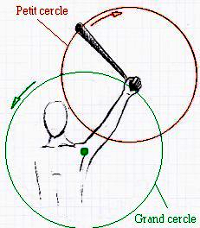

this draw has been made without compass : P

These two circles thus added form a third circle whose radius is equal to that of the small circle plus that of the large circle. It is the final circle. The figure which comes naturally with these proportions is drawn in four points of isolations which, connected to each other, form a square tilted and centered in the final circle:

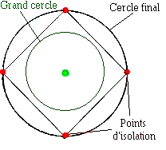

This square is instinctively tilted because the bench marks which are opposite oneself vertically and the two others which trace a horizontal line, are a quite simple base to memorize and visualize in space. These horizontal and vertical axes are very familiar to us.

Foot-note: Movements, explanations and the figures which follow, are theorized according to only one poi or staff. I do not have enough experiment especially in poi, to approach the superposed layouts of the two hands. The same figures with pair petals can be theoretically carried out in symmetry by the two hands and it must also be possible to carry out the odd figures with impair petals with one time shifted (or more) between each poi.

Equidistant figures:
To make it easier, the points of isolation are equidistant (it all are separated by the same distance) but one could make it very well so that they are not (see developments : why equidistant ?). There are as many possible points of isolation than there are points on the perimeter of the large circle, remain to choose how much and at which places to place them. The equidistant geometrical figures are easier to do and imagine because once again, they constitute reference marks which are familiar for us.

Stars and flowers:
It is possible to draw geometrical figures in space, it’s only a question of light: you can use fire or glows in a dark environment. For a good visual made, you might need to work the points of insulation (respect the precise site of each point for each new rotation). A photo catch in front of you with a quite long exposure time makes it possible to visualize the flowers and stars ; you can also carry out the figure very quickly so that, thanks to retinal persistence, the drawing is perceptible directly by the eye.

The tilted square is a good reference mark to start, it is the basic figure of the anti-spin:

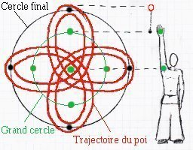
>> Poi : 4 petals Flower

Foot-note: to redraw on paper the trajectory of the figures helped me well to include/understand the movements the rates/rhythms and the layouts, it is a good drive to refine the reference marks;)

You can also do it with staff, it’s the same principle but not the same draw, looks like a star rather than a flower. On the frontal plane, you might be able to control the fingers technique of infinite rotation. It is thus preferable to use a very short staff, quite thin and light. Staff has two luminous points in the center of which, there is the hand which remains the central point of the small circle. The length of staff determines the diameter of the small circle, whereas that of the arm corresponds, as for the poi to the radius of the large circle. The whole forms a star with four branches centered in the final circle.
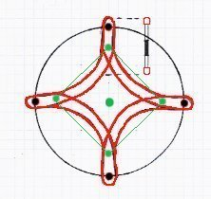
>> Staff : 4 branches Star / extended points

Change the proportions:
For the same figure, one can carry out different drawings according to the size of staff / poi. With a very short poi, petals are simply smaller. I drew the trajectories of anti-spin with staff according to two categories of stars:

- isolated points: Rather long staff (double length of the arm)
- extended points: Rather short staff (less than 1 meter)

Star with 4 branches realized with a longer staff, looks like a ''+''. With different colors for each end, we realize that the horizontal axis and the vertical axis are respectively traced by the same end.

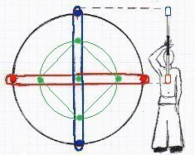

>> Staff : 4 branches Star / isolated points

Variations:
The number of petals or branches depends on the number of points of isolation carried out. The figure with two points for example is carried out on an axis (which should then be determined : vertical, horizontal, oblique...) it thus moves on only one dimension : a go and return along a segment of right-hand side. This report which relates to a rotation and an axis, is thus not yet a total anti-spin movement, what do you think ? I think anti-spin implies at least two rotations, but on a movement like this, when the isolated point is going in a direction and the instrument is spinning the opposite direction, I guess one can already call it anti-spin. I think it is only half anti-spin for poi when you take the whole trick, go and return, for example : go is ‘‘spin’’ and return is ‘‘anti-spin’’.

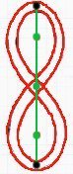

>> Poi : 2 petals Flower

All really begin from three points of isolation thus distributed on two dimensions. The more one increases the number of points of isolation on the large circle, the more the poi or the staff will have to be short (at least according to the size of the arm which holds it). It is also necessary to increase proportionally the speed of execution in order to be able to identify and recognize the figures ; thus if you want to create a quite visible 8 petals flower, you will have to be carried out twice more quickly than that with 4 petals.

Foot-note: all illustrated figures have the same reference mark expressed by the point of isolation of '' the top '' which rises all the ratios from proportions. This bench mark can be moved (see the final paragraph : developments / Stiff neck).

Three equidistant points of isolation : the equilateral triangle

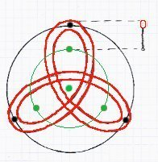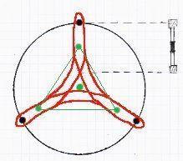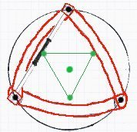
>> Poi : 3 petals Flower >> Staff : 3 branches Star / extended and isolated points

Five equidistant points of isolation : the pentagon

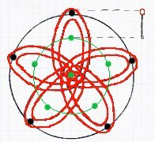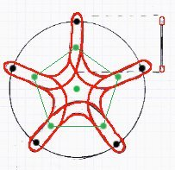
>> Poi : 5 petals Flower >> Staff : 5 branches Star / extended points

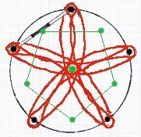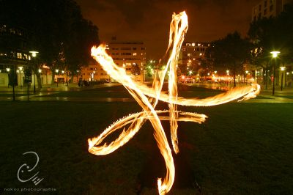
>> Staff : 5 branches Star / isolated points Imakokode photo by Nokos

It is the last figure represented with staff in prolonged points that I illustrate because it requires already a very short staff; the figures at 6 points of insulation and more, would require a staff of less than one meter or a very long arm very very and stilts for example.

Six equidistant points of insulation: the hexagon

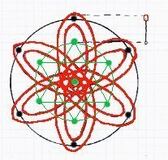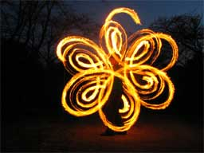
>> Poi : 6 petals Flower Yuta

It is the most common figure with poi, but there are several manners of approaching it : Either poi redraws petals one by one (as it is the case above on Yuta photo up there) or it acts oneself in fact of two flowers with three petals carried out in symmetry by the two arms and thus both poi simultaneously. These are thus two triangles (a hand by triangle) which are traced, one downwards and the other upwards, as for the Jewish star.

Video illustration by Nick Woosley:
>>Dervishly yers : http://www.playpoi.com/global/videos/dervishly_yers.wmv (2’38)

Video illustration by Yuta :
>> Yuta’s Poi 2005 : http://poicommunity.poke1.jp/net/video/yuta.wmv (4’50)

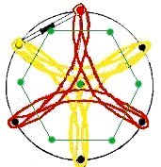

> > Staff: 6 branches Star / isolated points

Foot-note: the layouts of the two ends are independent as for the ''+'' of 4 branches star. That means for each new rotation of the large circle (I think we can speak about cycle of revolution, as for stars, I mean... the real ones ; ) ) the two ends respectively find the same points of isolation and redraw the same layouts. One can then have fun to differentiate the colors from the flames (yellow/green) or with glows to make beautiful pictures. This distinction of colors is not possible for the figures with impair isolations. We notice thus a shift with each new cycle which makes superimpose the points of isolation and thus the colors.

Seven equidistant points of insulation: the heptagon

Things are becoming quite complicated in practice!! One needs a poi or a very short stick from now. Moreover speed must increase considerably.
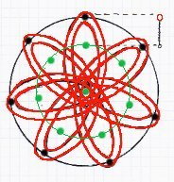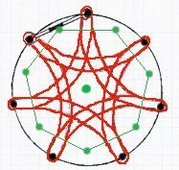
>> Poi : 7 petals Flower >> Staff : 5 branches Star / isolated points

equidistant points of insulation: the octagone

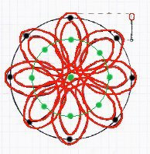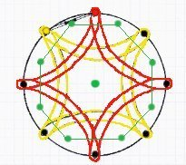
>> Poi : 8 petals Flower >> Staff : 8 branches Star / isolated points

Figures with 9 and 12 points of isolation are very interesting I think but they need you to be very precise ; it is to difficult so that we adventures there in this text. Therefore here is a beautiful 12 branches isolated star just to see what we’ll never do... unless working double staff anti-spin 2 separated stars with 6 branches shifted out ^^

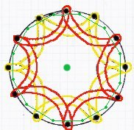

>> Staff: 12 branches Star / isolated points

Rhythm: The points of isolation are sensitive to the weight of the poi and staff, which makes accelerate the movement in downward phase. One can use this weight to mark a rhythm (the number of beat is proportional to the number of isolated points) or to try '' to erase '' this effect for one made more fluid. Music is excellent to work with these figures, you’ll have to find a binary track with well marked beats and tempo adapted to our level for figures with 2, 4 and 8 branches / petals, and respectively for the odd figures with 3, 5 and 7 beats. For these ones, rarer to find in music, the metronome can be very useful. ; )

Developments:

>> Stiff neck. One can voluntarily incline the geometrical figures, preserving their equidistant ratios. For example the tilted square becomes a traditional square, the triangle or the star with five branches points downwards either than upwards etc. That creates new figures to be worked and new reference marks.

>> Why equidistant? Nothing prevents us from working of the figures whose isolations are placed on the final circle according to unequal distances.

>> Horizontal Anti-spin. Completely possible while making turn staff horizontally to the top of the head, between the legs or around oneself. With the poi, it is possible by shortening the length of the it so that they can pass horizontally under the arms. But it is especially with the acrylic balls that it is most interesting, I think. Imagine that two balls which turn in a hand correspond at the two ends of a staff... then you got it ; )

>> Anti-spin double staff. The possibilities of combinations multiply, it is necessary to work the two hands. ''the translations'' (parallel movements slipped and insulated) are compatible, which brings quite beautiful variations.

>> Stars with poi. With a short poi one can go to further seek the point of isolation, without rotation but by pointing the poi with a deceleration and change of direction, or ''rebound'' (as for the small staff and these points of prolonged stars). The rotation of the anti-spin is preserved but the loops which formed the petals are replaced by points. The only true constraint it is the ground, it is thus enough to go up on a podium or something which makes it possible to plunge the poi below the level of the feet.

>> More than two rotations. For most flexible, one can work with a third rotation whose central point would be the elbow. While making independent the circle of the shoulder and that of the elbow, and with the rotation of the poi, one works thus on three circles. I know it’s a mess ; ) .One can more simply turn on oneself, and follow the trajectory of a large circle on the ground, or several as Nick Woosley (www.playpoi.com) explains it in his interviews. Only to preserve the same plan, one needs spinner or rather '' anti-spinner '' horizontally ; )
For the vertical plan, one can help oneself for example of a large wheel machine... what for? Sensations my friends, sensations! and then, imagine a large wheel (not too large either and rather rapid) with in each cabin an ‘‘antispinnor’’ with fire, the whole synchronized on the same rhythm... isn’t the picture beautiful ?!!

>> the para-spin "Or anti-spin 3D" i.e. '' beyond the anti-spin '' : this is with much difficulty possible for the poi which in addition to their flexibility, have an inertia within their own rotation which does not make it possible to change plan easily ; however for staff it is quite easy to do. Take again the principle of the anti-spin no longer on two dimensions but on three dimensions. The plans thus are alternated : vertical, horizontal and depth (x, y and z) and this, with each new isolation, while preserving the concept of the anti-spin. Appear take shape then fully in space ; the model of the triangle is replaced by that of the tetrahedron (pyramid with four faces) the square by that of cube etc. It is noticed that the figures are not entirely traced in strict “para-spin”: if the alternation of the plan and the directions of rotation are correctly applied, one obtains a cycle of revolution which does not take into account the totality of the edges of the figure 3d for example:

for a cube: 6 beats for a tetrahedron: 4 beats
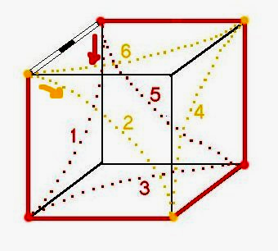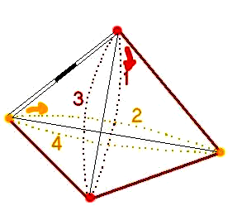

I leave it to you to seek the cycles of revolution on the dodecahedron (the figure 3D with a 5 edges base) which has a cycle of 12 beats revolution, like for all the other conceivable equidistant figures. While leaving the strict para-spin (which respects the alternation of the plans and the isolated points) one can move around all the edges of a figure like a cube or '' to leave out '' this figure and create a new one starting from a common point of isolation and to thus evolve in space, of figures in figures, points in points, by the means of multiple isolations.

Enough for the theory, now PRACTICE ! ☺

