# Yet Another BSA Organizer v0.1.0

This tool helps with editing BSA files for Xenoverse 2, which contains many important properties and attributes for projectiles in the game.

This is not a guide on what each entry means. This is just a tool to make editing them easier. For a more comprehensive guide to that, please refer to the [Skill/Moveset Editing Manual](https://docs.google.com/document/d/18gaAbNCeJyTgizz5IvvXzjWcH9K5Q1wvUHTeWnp8M-E/edit#heading=h.v77lp7pp65pd)

Features include:

* Copying/Pasting/Adding/Deleting entries
* Find/Replace entries by value
* Shared clipboard between different instances of the BSA organizer

## Getting Started

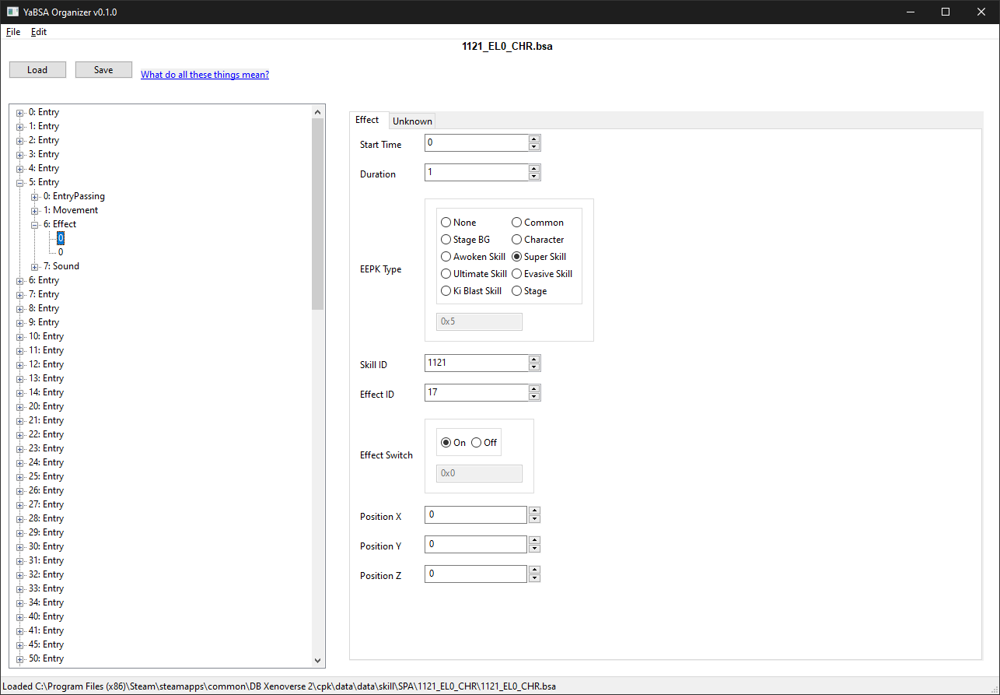

To load a BSA, just click on the **Load** button or drag a file onto the window

To save a BSA, just click on the **Save** button

### BSA Tree

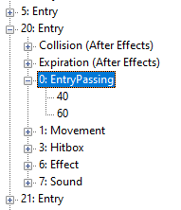

The left side is the tree view of the BSA. It consists of many entries, each with groupings of similar type sub-entries such as Animation ands and Hitboxes.

**20**: **Entry**

* **Index** - Used in BCM’s to refer to an entry.

**Collision (After Effects)  
Expiration (After Effects)**

* These don’t actually have any BSA Type

**0**: **EntryPassing**

**40**

**60**

* **BSA Type**
* **Sub-Entry Start Time** - When this particular sub-entry starts. Always ordered.

### Entry Panel

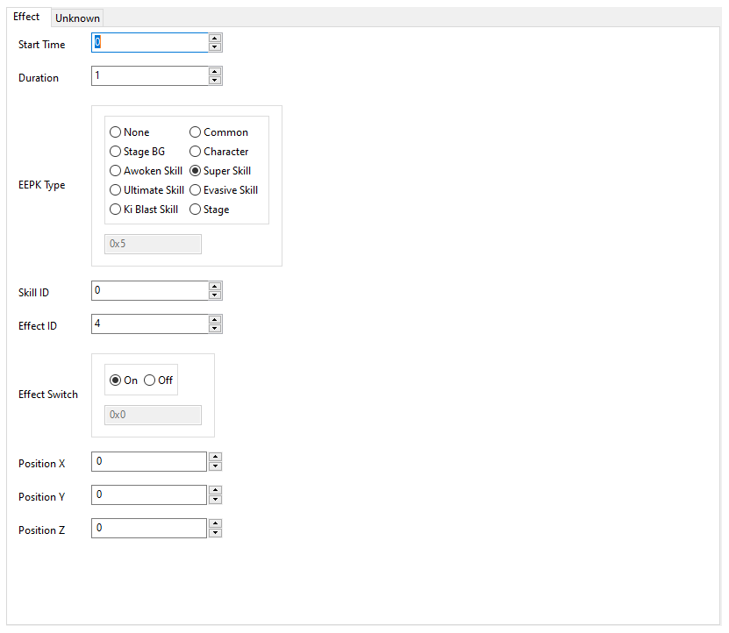

Each different sub-entry has its own panel with multiple pages of info. Please refer to the [Skill/Moveset Editing Manual](https://docs.google.com/document/d/18gaAbNCeJyTgizz5IvvXzjWcH9K5Q1wvUHTeWnp8M-E/edit#heading=h.v77lp7pp65pd) for an explanation of these. Changing these values is straightforward. The Radioboxes/Checkboxes have a hex entry below thats useful for cross referencing XML entries from other tools.

## Adding

Can only do this from a parent BSA Entry

### Adding/Inserting Entry

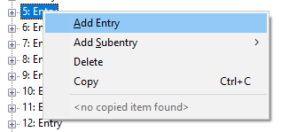

Adding will create an empty BSA Entry after the selected Entry

### Adding Subentry

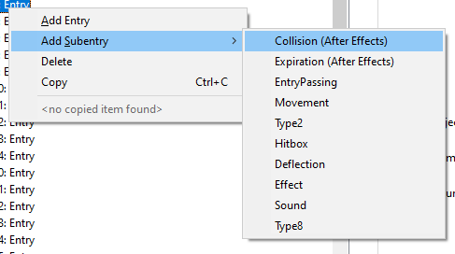

Adds an empty sub-entry of the specified type to the selected BSA

## Deleting

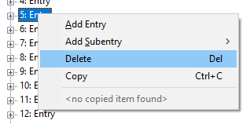

These deletes any selected items.

## Copying Items

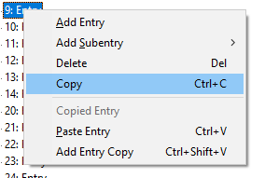

Any BSA Tree item can be copied. When pasting, it must be pasted over the same class of item, ex: Entry over Entry, Animation group over Animation Group, Effect sub-entry over Effect sub-entry.

Copied items can also be added as a copy as well. Entries can be added to or before the current entry, while subentries can be added alongside existing ones.

## Find/Replace

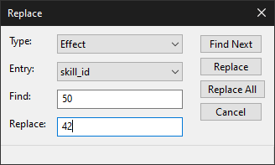

Open either in the **Edit Menu** or **Ctrl+F** for find and **Ctrl+H** for replace. Replace is shown here (Find is identical except no option to replace)

**Type**: BSA Type

**Entry**: BSA Entry

Example of usage: Replacing Skill Ids Indexes in Effects that are 50 with 42

## Credits

* LazyBones – Source code for the XML serializer helped with a few nitty gritty details of BSA files
* DeadlyGommba, TheNero - For the BSA section of the Skill/Moveset guide

## Changelog

0.1.0 - Initial Release