# Yet Another EAN Organizer v0.3.9

This tool to help edit ean and esk files for Xenoverse, among the features are:

* Copying animations (and associated bones) and Insert/Append/Paste them
* Change the duration of animations
* Add an offset, rotation, and scale to animations and skeletons
* Filter on what bones are allowed to be edited.
* Changing camera target focus point for cam.ean files
* Copy/delete/rename bones from EAN and ESK skeletons
* Remove keyframes from animations filtered on bones

## Getting Started

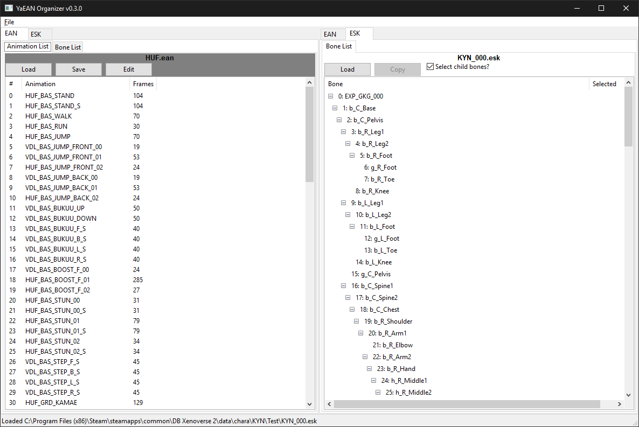

The organizer is split into two panels:

1. The left panel contains the EAN and ESK that are being worked on
2. The right panel contains the EAN and ESK where animations and bones can be copied

You can switch between EAN and ESK files using the tabs above, and animation and bone list tabs underneath as well.

Furthermore to reduce confusion, EAN files are highlighted gray while ESK files are highlighted white as seen above

To load an ean, just click on the **Load** button or drag a file in each respective panel

To save an ean, just click on the **Save** button (only available on the left pane)

## Editing Animations

### Selecting Animations

To start editing, select the animations you want to edit. You can use **Shift-Lclick** and **Ctrl-Lclick** to select more than one.

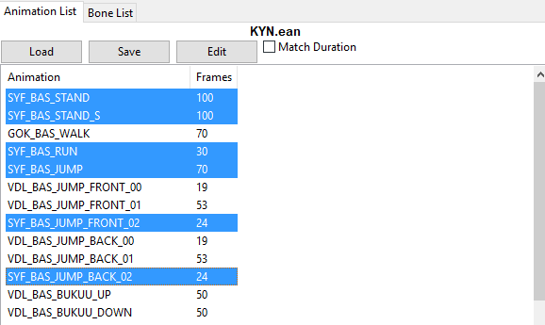

### Edit Menu

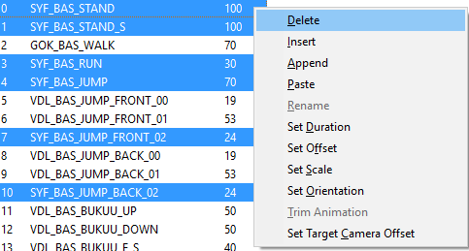

**Delete:** Deletes the selected animation  
**Insert:** Inserts copied animations before the first selection  
**Append**: Appends copied animations after the last selection  
**Paste:** Pastes copied animations over current selection (*see Copying/Pasting section)*

**Rename:** Renames selected animations

**Set Duration:** Sets the duration of the selected animations in frames (1s = 60 frames)

**Set Offset:** Adds offset to animation (*see Offset section*)

**Set Scale:** Scales the animation up or down (*see Scale section*)

**Set Orientation:** Changes the orientation of the animation (*see Orientation section*)

**Set Camera Offset:** Changes the offset of the camera in cam.ean files

### Copying/Pasting Animations

The right panel is used to copy animations from other sources. They are loaded the same way as the left panel. To copy animations, select the desired animations and click on **Copy** or press **Ctrl+c**. The copied column will show a checkmark for each animation that is currently copied.

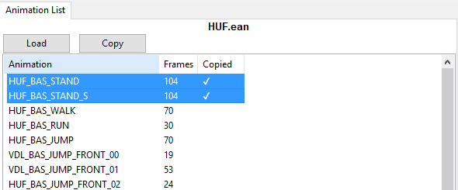

Once copied, it can be **inserted/appended/pasted** into the current working ean in the left panel. For this section, we’ll only focus on **Pasting** using the SYF and HUF stances as an example.

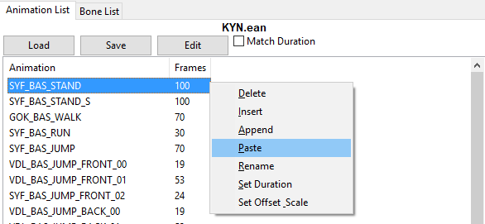

Here we want to paste the two animations from HUF to SYF. When pasting, the tool will try to use the first two selections, and use the next available if not enough were given.

When pasting multiple animations, the tool will pop up a warning asking if you’re sure and listing what animations will be replaced.

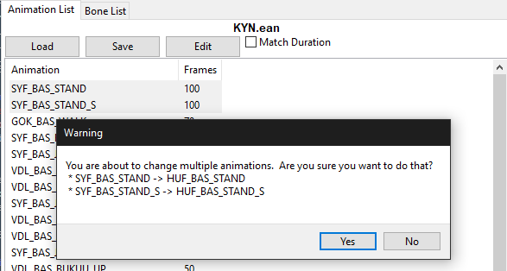

When pasting, if the current EAN is missing bones that the pasted animations have, it’ll ask if the user wants to add them or not

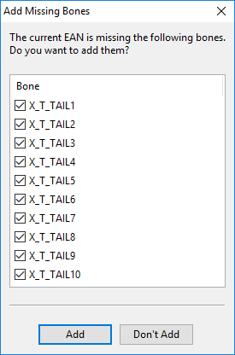

Afterwards, if there were any bones not found, or filtered out by the tools’ bone filter, they would be displayed after pasting.

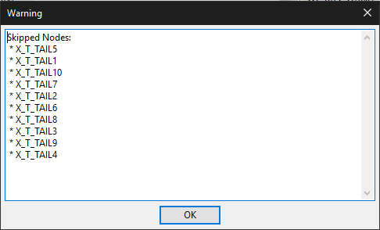

If the animations pasted go past the end, it’ll just add the remaining to the end. If there are any duplicate names encountered while adding new animations, the tool will rename it by appending ‘.xxx’ to the end of the name

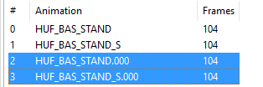

#### Pasting with a bone filter

If there is a bone filter present, for example you want to copy and paste just the tail animation, when pasting, the copied animation will have its duration adjusted to match the final animation.

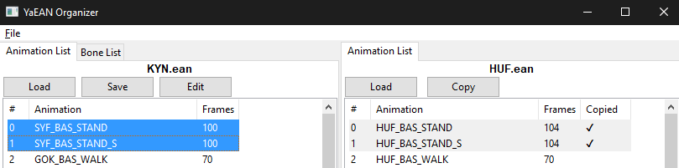

For example here, if with a bone filter present, copying HUF_BAS_STAND over will not change the duration of SYF_BAS_STAND and will instead match its duration before pasting.

### Rename Animation

For a single animation, just enter the new name for the animation

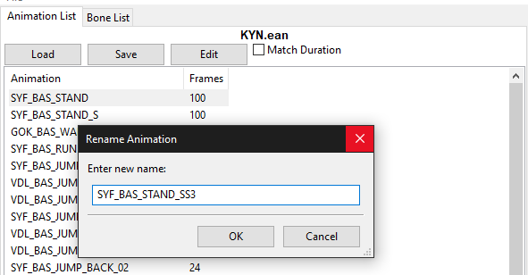

For multiple animations, you can do a search and replace, add a prefix/suffix, or use a regex expression to rename them. If there are any conflicts with existing names, it won’t be changed.  
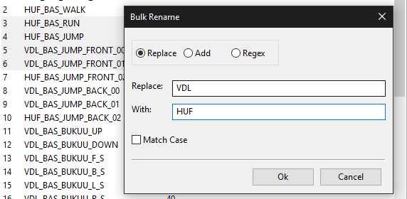

Before they are renamed, a confirmation box will pop up to give you a chance to see what will change.

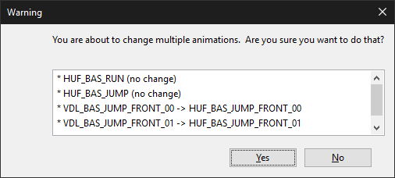

### 

### Set Duration

Enter the desired number of frames for the animation

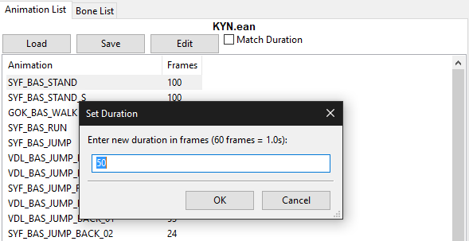

### Transformation options (Offset/Scale/Orientation)

This will perform the requested transformation on the selected bone. The bone that is chosen by this will also in turn have its children affected, e.g. scaling the left shoulder up will also make the arm, hand, and fingers scale up.

Note: If you use this multiple times, the values always reset after each use and are based off the current animation.

#### Axes

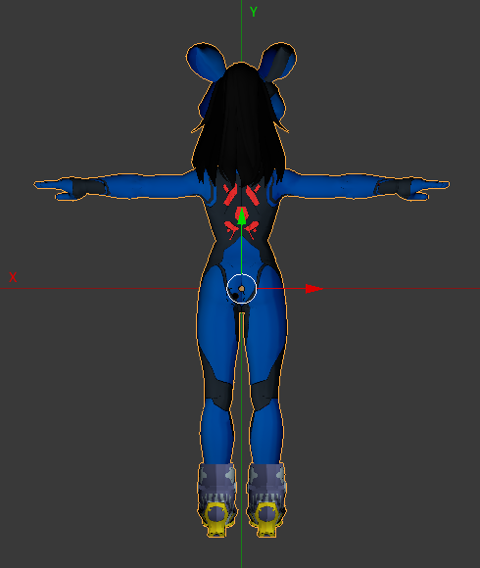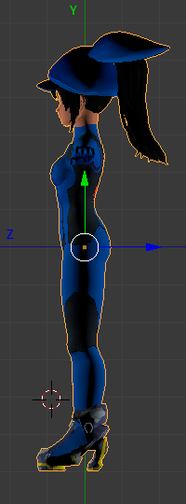

#### Offset

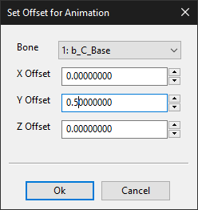

X Offset - Negative values shift to the left, Positive values shift to the right.

Y Offset - Negative values shift down, Positive values shift up

Z Offset - Negative values shift forwards, Positive values shift back

#### Scale

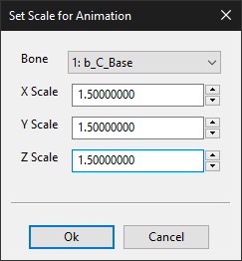

X Scale - Width

Y Scale - Height

Z Scale - Depth

For scaling, a value of 1.0 means it stays the same. 0.5 means it is halved. 2.0 means its doubled.

#### Orientation

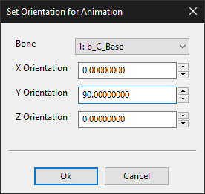

Assuming this is looking over the shoulder behind a character

X Orientation - Negative values leans forward, Positive values leans back

Y Orientation - Negative values turns left, Positive values turns right

Z Orientation - Negative values leans left, Positive values leans right

### Trim Animation

Enter desired Start Frame and End Frame. Any frame before Start Frame and after End Frame will be erased from the selected animation

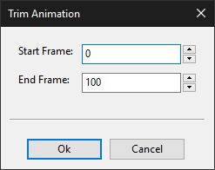

### Remove Keyframes

Removes keyframe from selected animations and bones as specified by the bone filter. You can select to remove position, orientation, scale, or any combination of the three. Useful if you want to get rid of say facial animations.

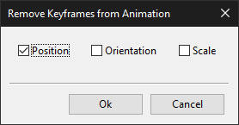

### Set Camera Offset

Note: Only for cam.ean files. Does nothing to normal ean files.

Enter desired offsets for where the camera will point at. Offsets will move the point at where the camera is targeted at on the xyz axis.

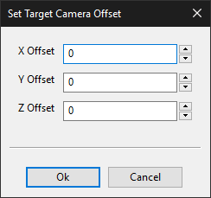

X (Width) - Negative values shift to the left, Positive values shift to the right.

Y (Height) - Negative values shift down, Positive values shift up

Z (Depth) - Negative values shift towards, Positive values shift away

Note: If you use this multiple times, the values always reset after each use and are based off the current animation.

## Editing Bones

#### EAN

You can edit EAN bones by accessing the **Bone LIst** by clicking on the tab on the left panel. When the **EAN** tab is selected

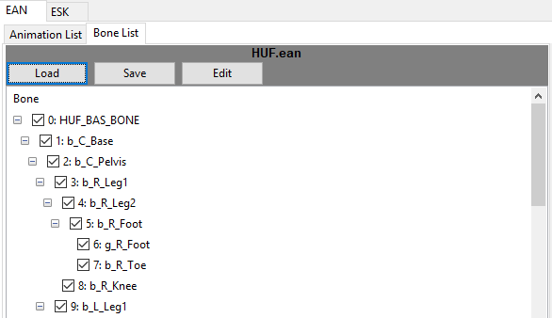

#### ESK

To edit ESK bones, select the **ESK** tab

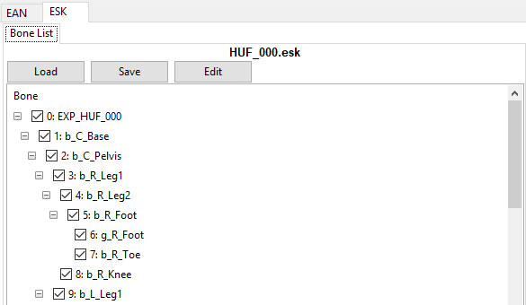

### Edit Menu

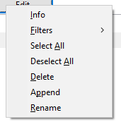

**Info:** See and change position, orientation, and scale for a selected bone

**Filters:** See filters section for more details

**Select All/Deselect All:** Select/Deselect all the bones for bone filters (See next section)

**Delete:** Deletes the current bone and its children

**Append:** Appends any copied bones as the children of the currently selected bone

**Rename:** Renames the current bone

### Info

This window allows you to look at position, orientation, and scale for an individual bone on both panels. The main panel will allow you to edit it. See the Transformation section on under **Editing Animations** for more information on what each parameter does.

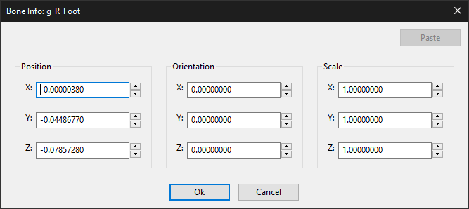

#### Copying Bone Information

For bone information on the right panel, you can copy the **position, orientation,** and **scale** information for use on the left panel. Just click on **copy** to copy the information.

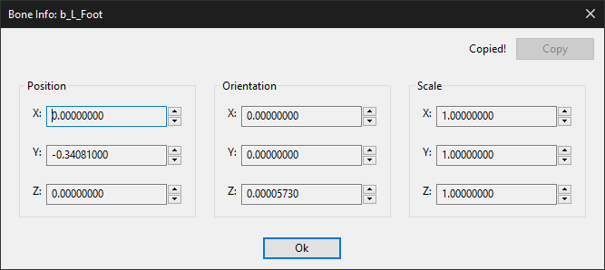

Back on the left side, once you have that copied information, you can **paste** it by going to the **bone info** and clicking on **paste.** The information of whats copied will be displayed to the left of the **paste** button

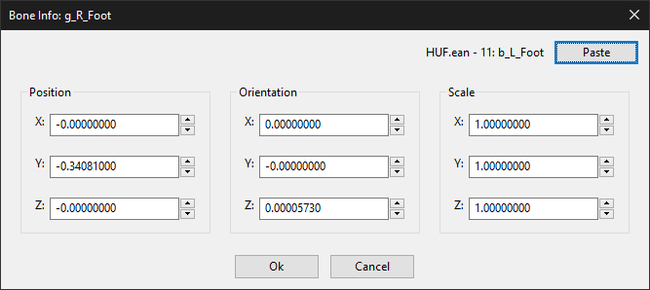

### 

### Filters

By using bone filters, you can select the bones you want to edit the animation for. Any unchecked bones will not have its animation changed. To manually choose bones to filter on, you can just check the box next to each bone.

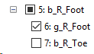

* A check or box means the bone is included in the filter. Empty means the bone is not.
* A filled in box indicates that this bone and only some of its children has been selected.

To filter multiple bones, you can use **Shift-Lclick** and **Ctrl-Lclick** to select more than one and either click on the checkbox, or use **Space** to toggle the filter on and off.

#### 

You can additionally access preset filters from the filter menu or right-clicking on the desired bones:

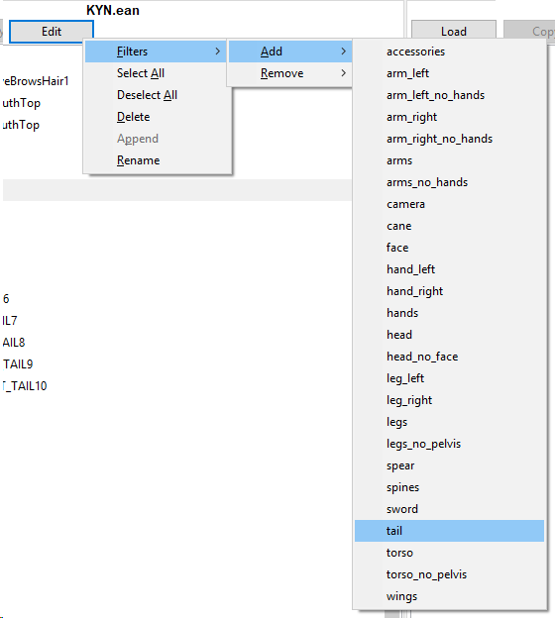

For example, if you wanted to edit only the tail animations:

1. **Edit > Deselect All**  
   This will deselect everything, meaning no bones will be overwritten. Alternatively, you can use **Ctrl+A** to select and unselect all while focused on the bone list.
2. **Edit > Filters > Add > tail**This will select only the tail bones, meaning those bones will be overwritten

#### 

#### 

#### 

#### Custom Bone Filters

The Bone filters are all defined in **/config/bone_filters.** You can add your own **.json** file to define any additional bone filters to load. The template is as follows:

{

"<filter_name_1>": [

"<bone_1>",

"<bone_2>",

...

],

"<filter_name_2>": [

...

}

### Copying/Pasting Bones

The right panel is used to copy bones from other sources. They are loaded the same way as the left panel. To copy bones, first you need to be on the bone list view and then select a bone to copy, then clicking **Copy** or press **Ctrl+c**. By default, children of that bone are copied as well, but that can be turned off by unchecking **Select child bones?**

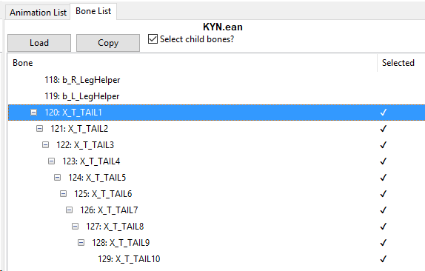

Once copied, it can be **pasted** to the skeleton of the current working ean in the left panel. The copied bones. To do so, **Right-click** on the bone you want as the parent and click on **paste**. It will then add the bones to the end of the list. In this example, you will see that the tail bones were pasted to the **b_C_Pelvis** bone as its child.

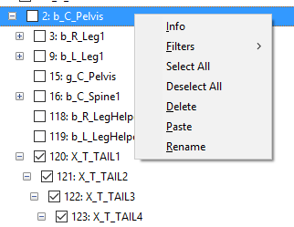

The tool will also attempt to search for any existing bones under the selected bone and will ask the user if its ok to overwrite before doing so.

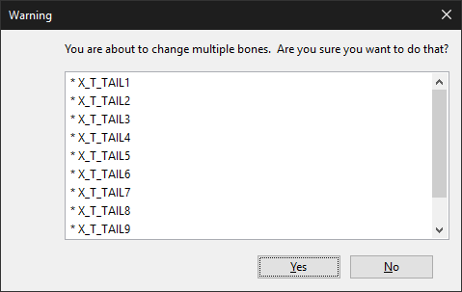

If the bones of the same name exist elsewhere on the skeleton, but not where its being pasted, it will append “.xxx” to it to avoid conflicting names. You can then rename them.

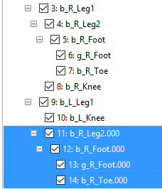

### Renaming Bones

This behaves just like renaming animations

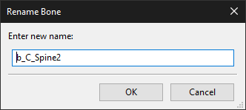

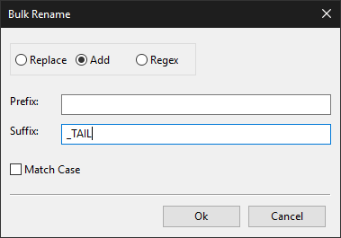

#### Note

One thing to remember is that the organizer will not keep the ESK and EAN bones in sync.

## Credits

Olganix and Dario for LibXenoverse of which parts were ported to Python for this

## Changelog

0.1 - Initial release

0.1.1 - Small bug fixes, Added new bone filters (thanks @Komodo), and updated section on user-defined custom bone filters

0.1.2 - Fixed duration bug when shortening duration

0.1.3 - Allow users to drag files in to open them (thanks @Seiki for the suggestion)

0.1.4 - Add EanIndex to the list for easy lookup for BAC editing

0.1.5 - Fixed loading EAN’s on the left panel using the button

0.1.6 - Add BoneIndex to the ESK list, redid SetDuration so it no longer duplicates frames

0.1.7 - Removed match duration toggle. From now on, when pasting with a bone filter, the copied animation will have its duration adjusted to match the target animation.

0.1.8 - Added trim animation, made pasting smarter when matching durations, bug fixes with paste and set duration. Added error dialog popup for easier debugging.

0.1.9 - Added set target camera offset to change where the camera is pointed at in cam.ean files

0.2.0 - Added the ability to copy bones from one ean to another, as well as deleting/renaming bones

0.2.1 - Added orientation to rotate animations, redid transformation options (offset, scale, & orientation)

0.3.0 - Added ESK file support, added ESK Bone Info window to edit individual bone position, rotation, and scale

0.3.1 - Numerous life improvements. Appending bones renamed to Pasting bones. It’ll try to find existing bones to replace their data with before creating new ones. Bone info can be copy/pasted. Better support of bulk renaming that now allows you to do a search/replace, add prefix/suffix, or use a regex expression.

0.3.2 - Fixed trim animation not working properly, fixed animations that would have the wrong frames removed, optimized so that interpolated frames are removed before saving to reduce resulting file size

0.3.3 - Added “remove position keyframes option” to help with animation exports from certain applications that like to add position frames.

0.3.4 - Expanded “remove position keyframes” option to “remove keyframes” and allowing the user to choose what type of keyframes to remove.

0.3.5 - EAN Bones can be added while pasting animations now. (ESK’s still have to be edited separately)

0.3.6 - Fixed bug where pasting animations with filters can sometimes cause crashes. Fixed bug when trying to load a second time.

0.3.7 - Optimized EAN operations so saving is faster

0.3.8 - Fixed a bug that happens when an animations has exactly 256 frames

0.3.9 - Fixed adding prefix/suffix to animation/bone names as part of renaming them