# Yet Another Moveset Organizer v0.2.4

This is a simple tool that allows copying/pasting moves from other movesets to create a new one. The tool shows BAC entries and when pasting BAC entries, it will automatically create/overwrite EAN Animations and BDM entries.

## Getting Started

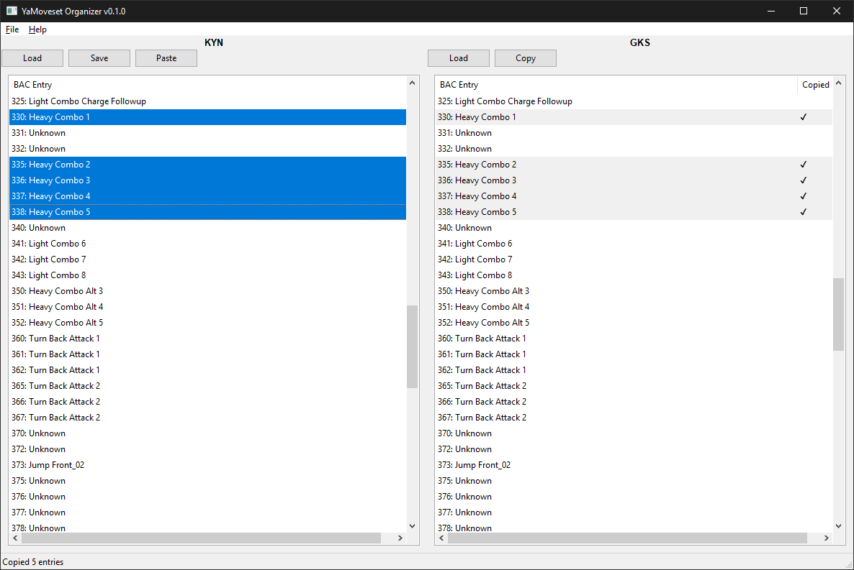

The organizer is split into two panels:

1. The left panel contains the moveset that is being worked on
2. The right panel contains the moveset can be copied

Each panel contains a list of entries corresponding to the BAC Entry and is labeled with any known moveset info. For combos, **Help** contains a window that shows Combo information along with the BAC Entries it uses for easier usage.

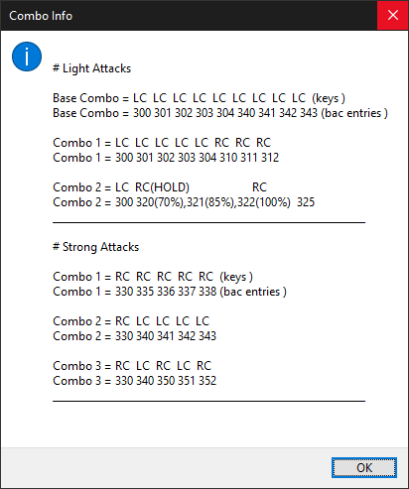

To load a moveset, just click on the **Load** button or drag a file/folder in each respective panel

* Note: When dragging, any file with the 3-letter character code can be dropped onto it
* Folder must contain the following files:
  + XXX_PLAYER.bac
  + XXX.ean
* The following files are optional, but if any BAC Entry needs them it will fail.
  + XXX.cam.ean
  + XXX_PLAYER.bdm

If there are multiple movesets in the folder, it’ll ask which one to open

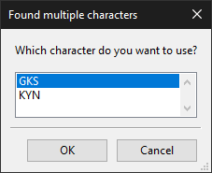

To save a moveset, just click on the **Save** button (only available on the left pane). After selecting the folder, it will give you the option of changing the character code.

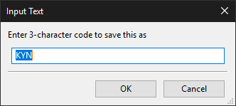

## Copying

The right panel is used to copy movesets from other sources. To copy movesets, select the desired BAC Entries (Use **Ctrl/Shift** to select multiple) and click on **Copy** or press **Ctrl+c** to copy them. The copied column will show a checkmark for each BAC Entry that is currently copied.

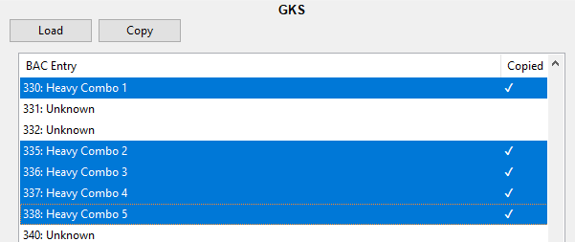

## Pasting

The left panel is used to paste movesets from other sources. To paste movesets, select the desired BAC Entries (Use **Ctrl/Shift** to select multiple) and click on **Paste** or press **Ctrl+v** to paste over them. If multiple entries are being pasted, the tool will select/deselect until the number of entries matches the number of copied entries, then it will pop up a confirmation asking if the paste it wants to do is correct.

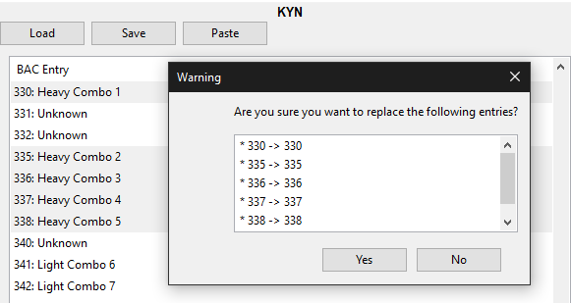

When it pastes, it will also add/replace any EAN animations, Camera animations, or BDM entries as needed. The changes it made will be displayed in a window after it is pasted.

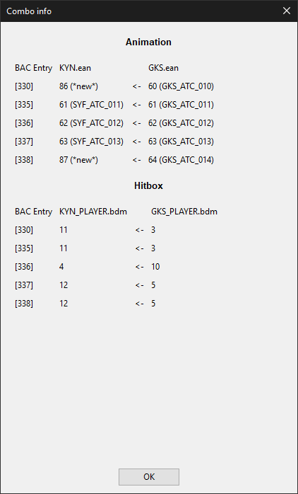

For example, it copied Entry 60 in GKS.ean here and added it as a new entry in KYN.ean as Entry 86.

(new in 0.2.0) When pasting entries that uses animations such as boost/step or similar BAS/GRD entries, such as SYF’s Light combo ender that has her boost before attacking, it will not change those animations and reuse them since they are commonly used in many other BAC Entries.

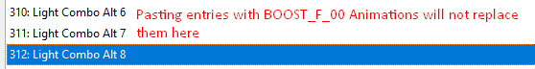

Exceptions are for the BAC Entries that actually are them, indicated   
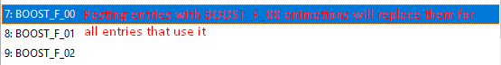

Another feature is if the old BAC entry had bones with animations that did not exist in the source (i.e. Tail bones), it will also copy/keep those animations so no need to re-add those animations again.

## 

## Credits

* SK for the BAC Moveset Info file

## Changelog

0.1.0 - Initial Release

0.1.1 - Bug fixes made CAM.EAN and BDM files optional to open (but fail if they are required by a BAC Entry), added more context into errors finding certain indexes if EAN/BDM files don’t match up with the BAC file.

0.1.2 - Fixed another bug with BDM copying

0.1.3 - Fixed an issue when copying to an Entry that doesn't have the same number of EAN/BDM Entries

0.1.4 - Fixed an issue that was caused by the last fix

0.1.5 - Added some missing BAC Entry names for the Stamina Breaks.

0.1.6 - Optimized EAN operations so saving is faster

0.1.7 - Updated some more BAC Entry names, added EAN Animation names showing what was replaced after pasting

0.2.0 - Improved pasting to cut down on duplicate animations, follow up paste dialog made to be more informative, Updated more BAC Entry names.

0.2.1 - Fixed bug with certain animations

0.2.2 - Another minor bug fix

0.2.3 - More bug fixes with BAC Entries that contain many animations

0.2.4 - More bug fixes