QML Research
Cross-dataset report for the combined experiment outputs
This report synthesizes the logs, metrics, plots, and metadata stored under `combined_outputs` for Iris, Wine, Heart Disease, and Breast Cancer.

Executive Summary
- Classical SVM matched or outperformed QSVM on all four datasets.
- Iris was the only tie; Wine, Heart Disease, and Breast Cancer all favored the classical model.
- QSVM search and confirmation phases dominated runtime by a wide margin in every run.
- Operational logs showed one early parameter-grid setup error and repeated QSVM Optuna trial failures, but all final runs completed successfully.

Cross-Dataset Results Summary
This comparison uses the final test metrics and phase-level runtime summaries stored inside each dataset output folder.
Dataset | Rows | Features | SVM Acc. | QSVM Acc. | Gap | QSVM Build Time
Iris | 150 | 4 | 93.3% | 93.3% | Tie | 11.9 min
Wine | 178 | 13 | 97.2% | 91.7% | 5.6 pts | 23.7 min
Heart Disease | 303 | 13 | 82.0% | 80.3% | 1.6 pts | 1.79 h
Breast Cancer | 569 | 30 | 98.2% | 95.6% | 2.6 pts | 2.49 h
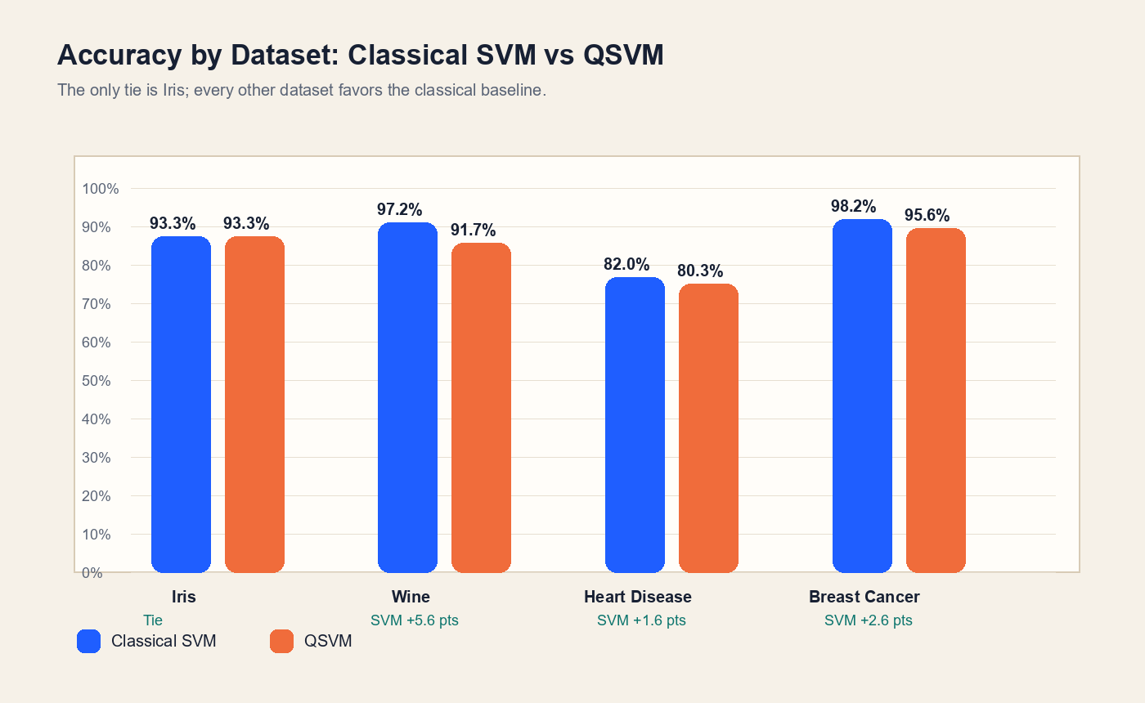

Compute and Runtime Findings
Across every dataset, the heaviest phase was the QSVM Optuna search. Classical model selection stayed under three seconds, while QSVM build time ranged from about 12 minutes on Iris to more than 2.4 hours on Breast Cancer.
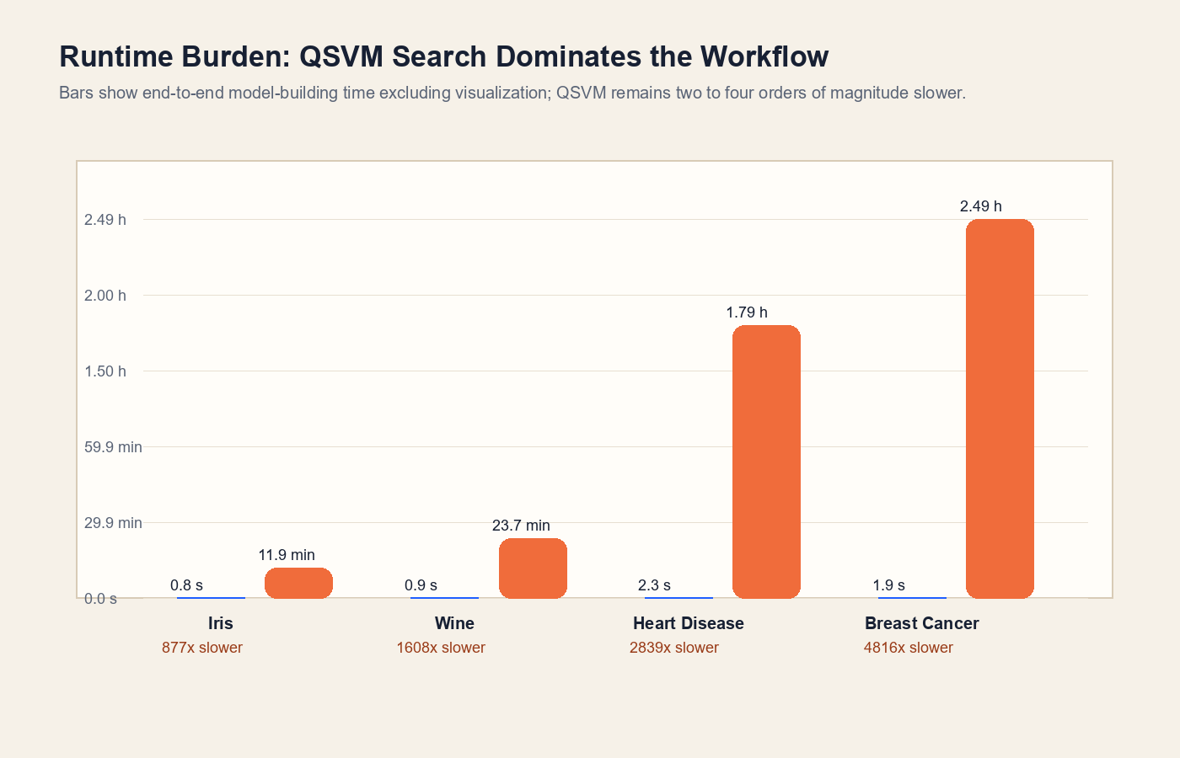
- QSVM search plus confirmation dominated total runtime in all four experiments.
- CPU saturation warnings appeared in every dataset, suggesting the pipeline was compute-bound rather than I/O-bound.
- The Heart Disease run had GPU visibility, but the resource summary still flagged the GPU as mostly idle in several phases.
- No dataset reported sustained memory pressure, so runtime inefficiency appears tied to search cost rather than RAM exhaustion.

Dataset-Specific Findings

Iris
Classical SVM reached 93.3% accuracy versus 93.3% for QSVM. This was the only dataset where both models tied.
- Dataset shape: 150 rows, 4 features, 3 classes; source=builtin.
- Best classical settings: C=0.1, kernel=linear.
- Best confirmed QSVM settings: PauliFeatureMap, reps=2, entanglement=linear, paulis=Y,Z.
- Most frequent confusion: versicolor predicted as virginica (1 case(s)).

Wine
Classical SVM reached 97.2% accuracy versus 91.7% for QSVM. The classical model led by 5.6 percentage points.
- Dataset shape: 178 rows, 13 features, 3 classes; source=builtin.
- Best classical settings: C=1, gamma=scale, kernel=rbf.
- Best confirmed QSVM settings: PauliFeatureMap, reps=3, entanglement=circular, paulis=X,Y,Z.
- Most frequent confusion: class_2 predicted as class_1 (1 case(s)).

Heart Disease
Classical SVM reached 82.0% accuracy versus 80.3% for QSVM. The classical model led by 1.6 percentage points.
- Dataset shape: 303 rows, 13 features, 2 classes; source=openml.
- Best classical settings: C=1, gamma=0.01, kernel=rbf.
- Best confirmed QSVM settings: PauliFeatureMap, reps=1, entanglement=linear, paulis=Y,Z.
- Type I errors: 10, Type II errors: 1 for positive class 1.0.

Breast Cancer
Classical SVM reached 98.2% accuracy versus 95.6% for QSVM. The classical model led by 2.6 percentage points.
- Dataset shape: 569 rows, 30 features, 2 classes; source=builtin.
- Best classical settings: C=10, gamma=0.01, kernel=rbf.
- Best confirmed QSVM settings: PauliFeatureMap, reps=1, entanglement=linear, paulis=Z.
- Type I errors: 0, Type II errors: 2 for positive class malignant.

Log Review
The logs add useful operational context beyond the final metrics. One configuration bug surfaced early, and the QSVM search repeatedly recorded failed Optuna trials before the runs still completed successfully.
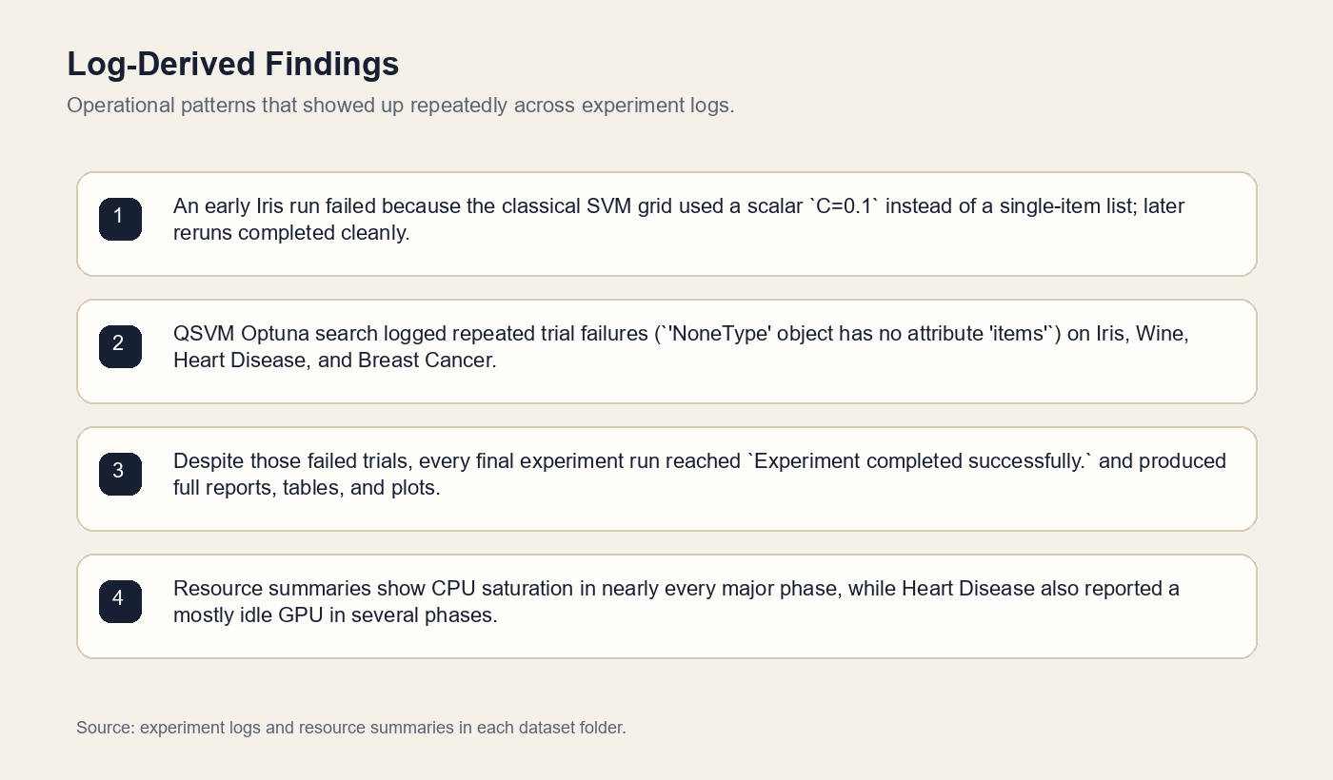

Iris log notes
- 2026-05-16 09:39:32,056 | ERROR | Phase failed: classical_svm_grid_search
- 2026-05-16 09:56:50,959 | WARNING | QSVM Optuna trial 1 failed: 'NoneType' object has no attribute 'items'
- 2026-05-16 09:57:25,587 | WARNING | QSVM Optuna trial 4 failed: 'NoneType' object has no attribute 'items'
- 2026-05-16 09:59:36,383 | WARNING | QSVM Optuna trial 14 failed: 'NoneType' object has no attribute 'items'

Wine log notes
- 2026-05-16 10:17:48,338 | WARNING | QSVM Optuna trial 1 failed: 'NoneType' object has no attribute 'items'
- 2026-05-16 10:18:36,830 | WARNING | QSVM Optuna trial 4 failed: 'NoneType' object has no attribute 'items'
- 2026-05-16 10:24:02,520 | WARNING | QSVM Optuna trial 18 failed: 'NoneType' object has no attribute 'items'
- 2026-05-16 10:27:29,572 | WARNING | QSVM Optuna trial 25 failed: 'NoneType' object has no attribute 'items'

Heart Disease log notes
- 2026-05-16 18:27:26,230 | WARNING | QSVM Optuna trial 1 failed: 'NoneType' object has no attribute 'items'
- 2026-05-16 18:32:35,584 | WARNING | QSVM Optuna trial 4 failed: 'NoneType' object has no attribute 'items'
- 2026-05-16 18:52:09,240 | WARNING | QSVM Optuna trial 14 failed: 'NoneType' object has no attribute 'items'
- 2026-05-16 19:00:37,885 | WARNING | QSVM Optuna trial 19 failed: 'NoneType' object has no attribute 'items'

Breast Cancer log notes
- 2026-05-16 11:00:48,147 | WARNING | QSVM Optuna trial 1 failed: 'NoneType' object has no attribute 'items'
- 2026-05-16 11:09:19,328 | WARNING | QSVM Optuna trial 4 failed: 'NoneType' object has no attribute 'items'
- 2026-05-16 11:59:15,141 | WARNING | QSVM Optuna trial 18 failed: 'NoneType' object has no attribute 'items'
- 2026-05-16 12:13:27,263 | WARNING | QSVM Optuna trial 25 failed: 'NoneType' object has no attribute 'items'

Recommendations
- Keep the classical SVM as the primary baseline and likely production default for this workflow.
- Treat QSVM as an exploratory model class unless there is a clear quantum-specific objective beyond accuracy, because the current runtime cost is disproportionate to the observed gains.
- Fix or investigate the repeated Optuna trial failures (`'NoneType' object has no attribute 'items'`) before running larger studies.
- Standardize the experiment environment, because Heart Disease was executed on a materially stronger machine than the other runs, which complicates direct runtime comparisons.
- If QSVM work continues, prioritize reducing search space and profiling the feature-map evaluation path before scaling to larger datasets.

