Open Positron

Select third option from the slide on the left

Clinck on Clone repository to clone in from Github

Select a folder where to save the cloned repository

Positron will ask me if we can trust it.

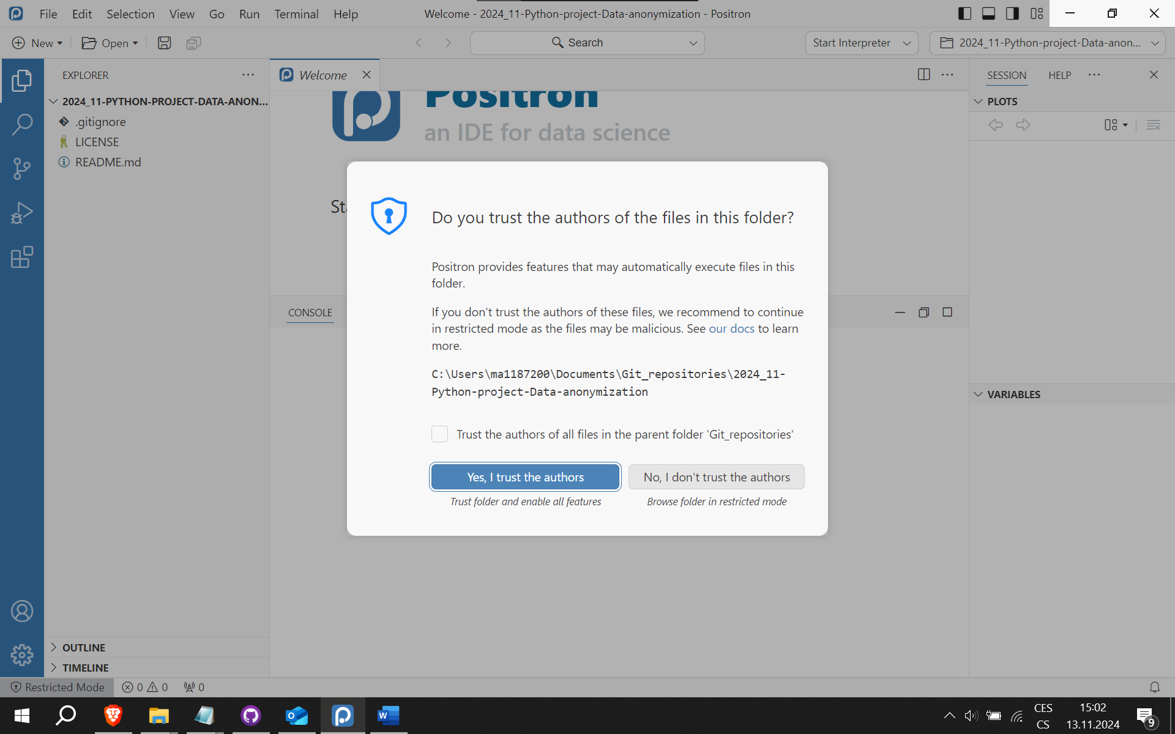

Use git:

