**Electric Vehicle Market Segmentation**

[Satyam Rai](mailto:satyamrai3362@gmail.com)

[**https://github.com/Kyouma45/Eletronic-Vehicle-Market-Segmentation**](https://github.com/Kyouma45/Eletronic-Vehicle-Market-Segmentation)

Datasets used:

1. “EV_India.csv” :

Contains count of number of electric and non-elctric cars for each state.

1. “RS_Session_256_AU_2673_2.i.csv” :

Contains number of charges present in each state.

1. “RS_Session_256_AU_2673_2.i.csv” :

Contains data of different countries about EV shares, EV stocks, oil displacement, electricity demand for both hybrid cars and battery operated cars from 2011 to 2022.

1. “Cars.csv” :

Contains info about different EV cars like MPG, cylinders, displacement, horsepower, weight, acceleration, model, origin.

1. “Electric Car.csv” :

Contains price and specs of different EVs like acceleration, top speed, range, efficiency, fast charge, rapid charge, powertrain, plug type, body style, segment, seats.

EDA:

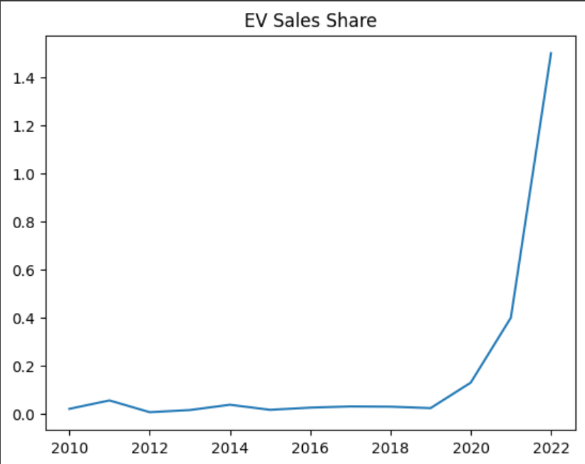

From this graph, it is clearly visible that EV shares had a boom in 2019 and has been in high demand since then.

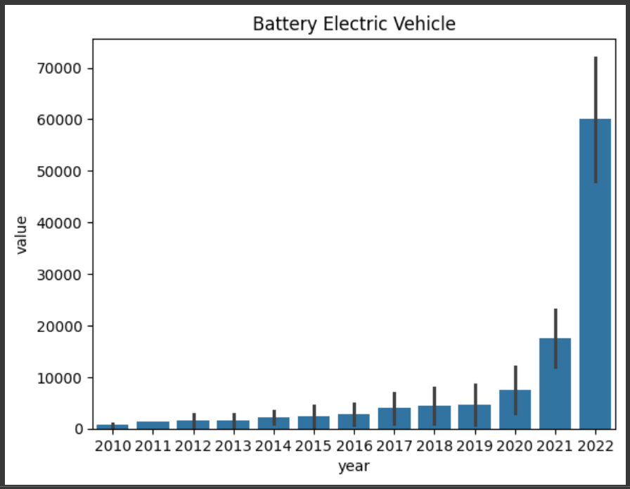

From this graph, it is clear that the demand for battery operated electric vehicles has increased exponentially over the past years making them very popular.

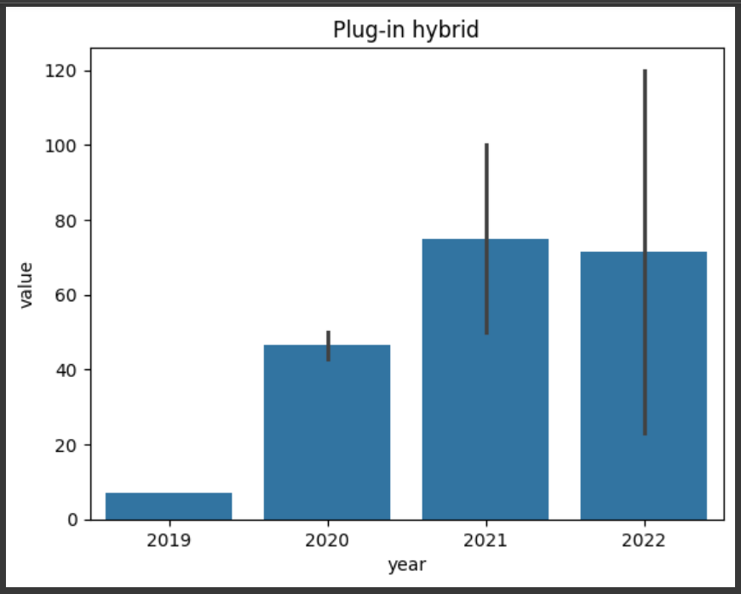

Whereas demand for plug-in hybrid is decreasing recently..

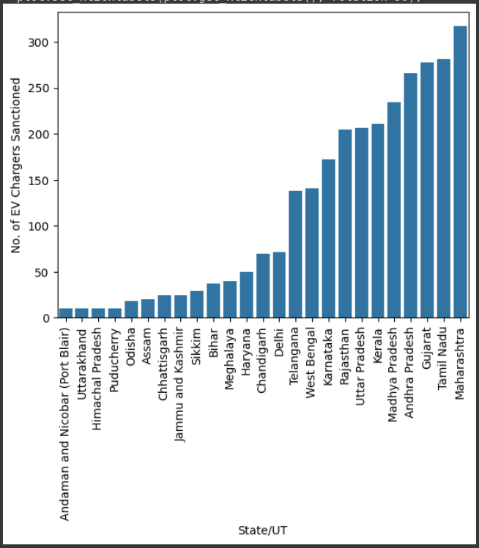

This bar plot shows number of charging stations sorted in the statewise order

More chargers the state has, more likely people will buy EV in those regions.

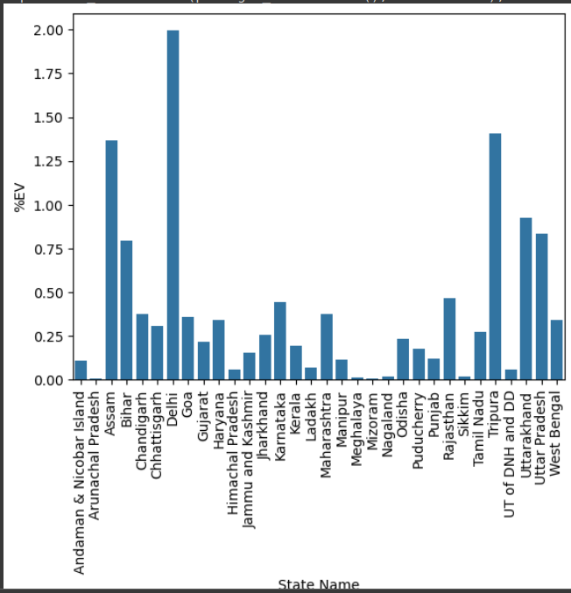

Total EV market share for each state.

PCA:

Variables:

* parameters( EV sales share, EV stock, EV sales, Oil displacement Mbd)
* powertrain( EV, BEV)
* Year
* Unit
* Value

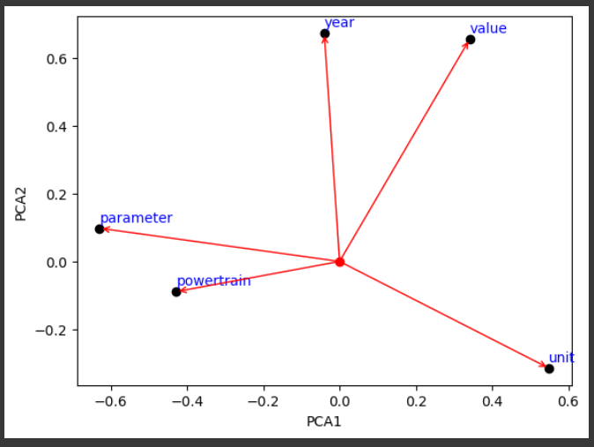

From the PCA analysis, we can see that parameter and powertrain are positively related to each other and negatively related to the value.

Year and Value are positively correlated to each other but are negatively related to unit, parameter and powertrain.

PCA2:

Variables:

* Model
* HorsePower
* MPG
* Origin
* Displacement
* Weight
* Cylinders

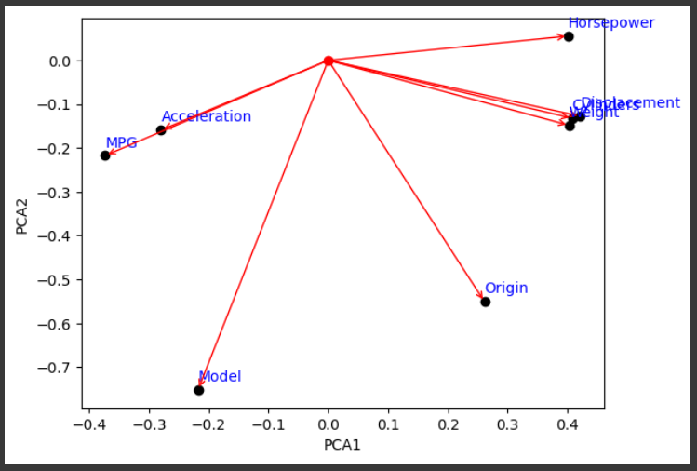

For this PCA analysis, we can say that horsepower, displacement, weight and origin are positively related to each other and acceleration and model are negatively correlated to each other.

Conclusion:

* Market share for both, hybrid cars and battery cars have grown exponentially other the recent years while battery operated electric vehicles show even more promising growth. This is because the battery prices are made more affordable. Also with the advancements made in AI/ML, with new algorithms in reinforcement models, etc the new battery operated EVs are packed with many new features with a very reliable support at low cost.
* From PCA analysis we can conclude that variables such as acceleration, horsepower, displacement, origin heavily influence the value of EV, whereas acceleration, MPG, model does not directly affect the value.