Stego Challenge 2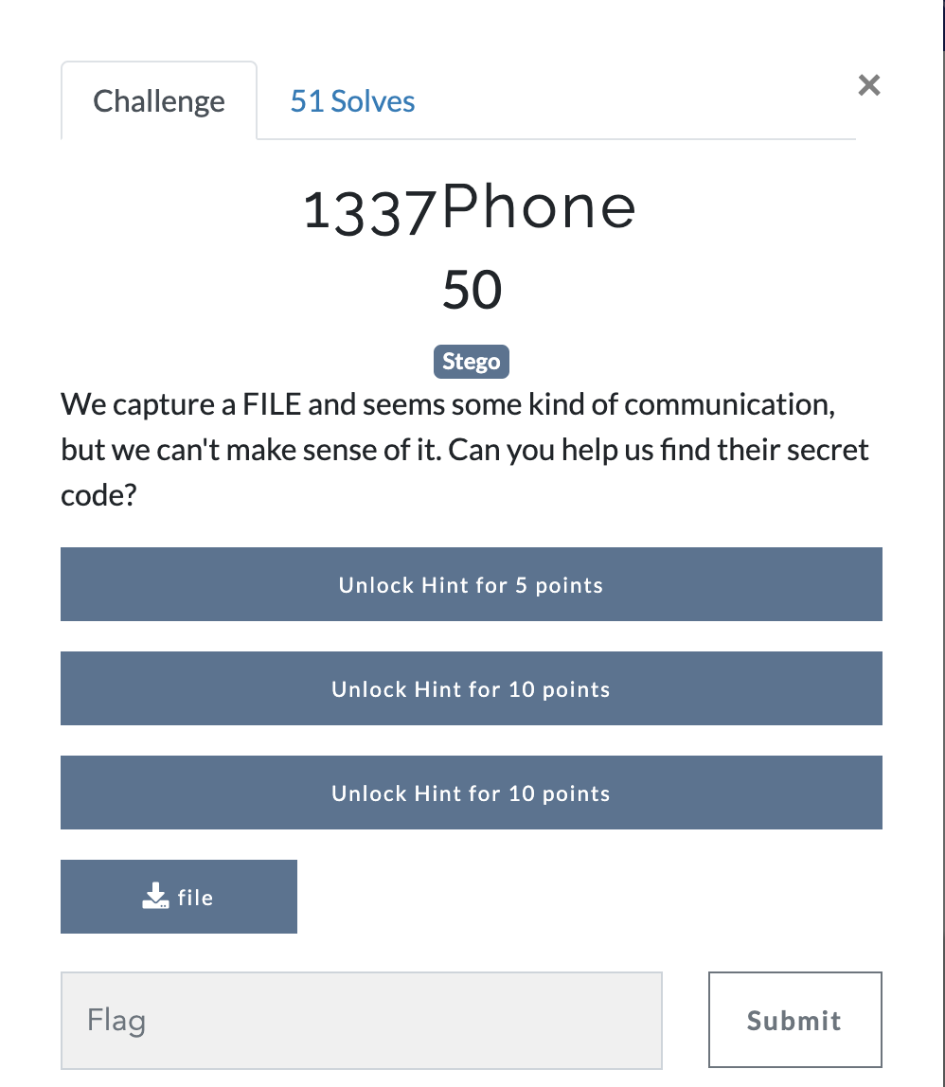
Answer: We have a file called file and nothing else.
Using the file command we can see that this is a wav file. Command: file file
Listening to the file it sounds like DTMF (dual tone multi frequency) or dial tones when you press keys on your phone.
What we need to do is convert the audio to the numbers that were pressed. To do this I’m going to use and old software call DTMF checker http://dl.djsoft.net/DTMFChecker.zip we select the wav file as input and receive our output.
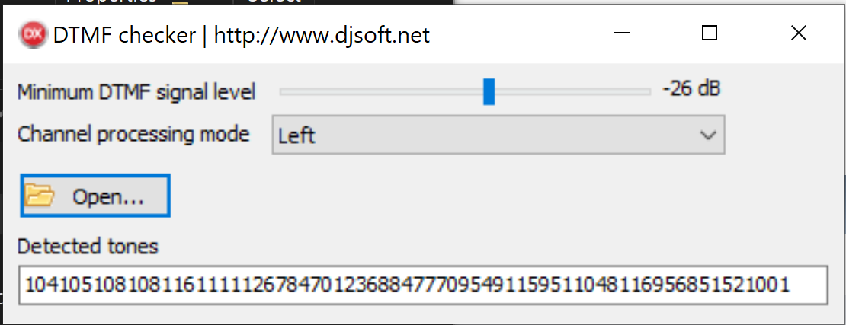
Now that we have number let’s see what we’re looking at. It seems to be a decimal string as it doesn’t match output for a t9 message. Let’s separate are values and decode using cyberchef https://gchq.github.io/CyberChef/
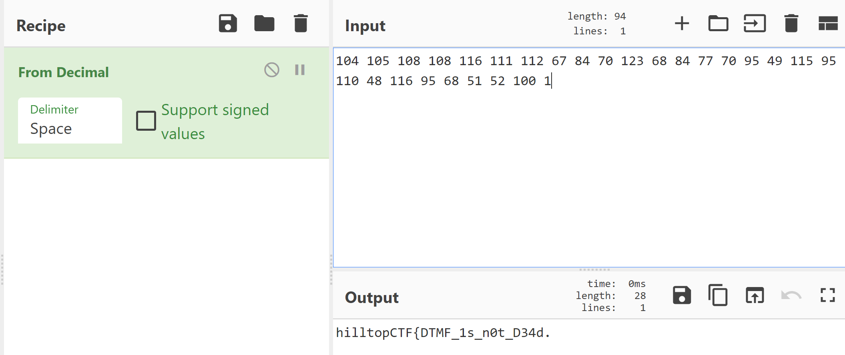
Looks good except that last character. Using an online tool http://dialabc.com/sound/detect/index.html we can see that we are missing the last two values
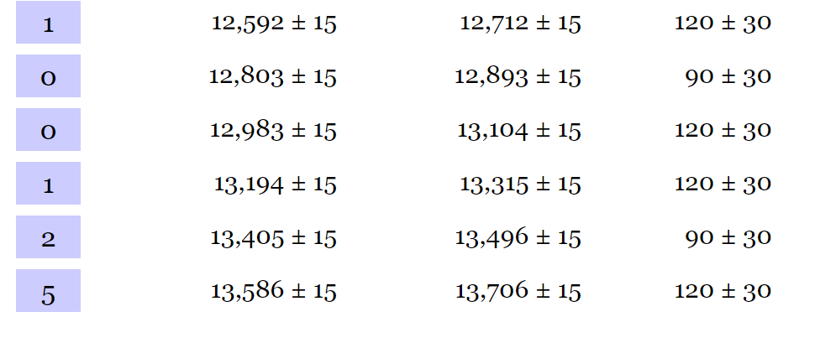
Adding those gives us the flag
FLAG: hilltopCTF{DTMF_1s_n0t_D34d}
This can also be done in kali using multimon-ng and sox.
First make sure you install multimon-ng and sox if not already installed
apt-get install sox
apt-get install multimon-ng
next let multimon-ng decode the file using the below command
multimon-ng -a DTMF -t wav "/home/kali/Pictures/file.wav"
