

|  |
| --- |
| DAT601 Milestone 3 |
| Physical Database Design |
| Name: Rhylei Tremlett  ID: 13513865  Date: 15/06/2023 |

Table of Contents

# Translate Logical Model to Physical Model

I decided to try to use a different naming convention. I chose to use a convention similar to the Microsoft AdventureWorks database. Most notably, I have changed my column names from snake case to pascal case.

No other changes have been made other than the automatic conversion of datatype to MSSQL done by Visual Paradigm.

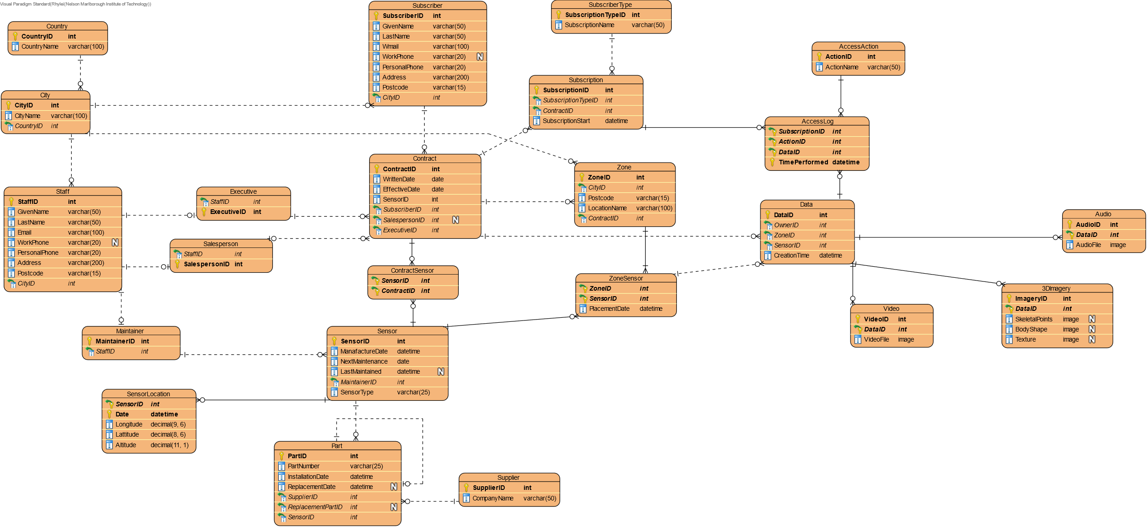



# Database Implementation

While generating test data and creating the procedures to execute, I ran into an issue where data was converted to an integer on a column that takes varchar. The data that I’ve generated is not numeric, and it includes symbols and text. SQL Server then would throw an error as it fails the conversion.

Another problem I had was with Mocakroo, I realised when testing the insert script that I had a lot of foreign key constraint errors. This turned out to be because of one statement failing, which caused the rest to fail because the rows were missing. The problem that occurred was that I had improperly generated data for one of my very simple tables (executive, two columns). I had the data in the wrong columns, and this meant that the row referenced later in the script didn’t exist.

# Analyse Transactions

# Identify Potential Secondary Indexes

# Estimate Required Disk Space

# Design User Views

# Design Database Roles

# SQL Queries