|  |
| --- |
| DAT602 Assessment 1 |
| Stage One |
| Rhylei Tremlett  ID: 13513865 |

|  |
| --- |
| Rhylei Tremlett  March 2, 2023 |

Table of Contents

Interface Designs 1

Login & Registration 1

User Stories 1

Functional Descriptions 1

Settings 2

User Stories 2

Functional Descriptions 2

Admin Settings 3

User Stories 3

Functional Descriptions 3

Gameplay 4

User Stories 4

Functional Descriptions 4

Inventory & Chests 5

User Stories 5

Functional Descriptions 5

Win & Lose 6

User Stories 6

Functional Descriptions 6

Logical Entity Relationship Diagram 7

CRUD Analysis 7

SQL Implementation 7

Application Prototype 7

References 8

Appendix 1

# RE:Battlespire

## Summary

In RE:Battlespire, players are locked inside an “inescapable dungeon” called the Battlespire; the Battlespire has multiple exits; however, it is not so easy to escape!

The Battlespire is full of monsters and chests that players may come across to aid or hinder their escape.

## Core Gameplay

### Setting

Players begin the game after being thrown into the centre of the Battlespire; they have absolutely nothing to their name except the tattered rags they wear. Players must begin exploring the Battlespire in search of armour, weapons, amulets, and shields to strengthen themselves. Players will encounter monsters scattered throughout the Battlespire; these monsters grow stronger further from the centre. Monsters can drop items that are stronger than the ones you would find lying around in a dungeon; this incentivises players to hunt monsters for stronger equipment.

### Objective

Players are to attempt to venture as far as possible outwards from the centre in search of an exit. Leaderboard rankings are based on how far the exit used is from the centre.

The objective of RE:Battlespire is to escape the dungeon using an exit as far away from the centre as possible to increase your chances of starting a new life and not being thrown back into the dungeon.

Players are ranked based on far from the centre they were able to escape the Battlespire. Rankings are tied to the player’s accounts, and players can attempt to escape multiple times to improve their scores.

### Combat

Players can attack any monster or player by being on a neighbouring tile and clicking their target. Players will have an attack speed stat which determines how many effective attacks they can make per second; any other clicks will not register an attack.

### Equipment

Weapons and armour are core to the game’s progression. Due to the game’s difficulty scaling, players must regularly replace their armour and weapons. Items can be found throughout the map inside chests; monsters will spawn a chest that contains twice as many items as a regular chest when they die. Items dropped by monsters tend to be more potent than those found in chests; this rewards players for engaging in combat.

## Features

### Difficulty Scaling

RE: Battlespire has a non-linear difficulty modifier based on the distance travelled from the centre; this makes it progressively harder to progress as the player gets further. Monsters and the equipment the player may find will become stronger.

### Map Generation

The Battlespire is multi-levelled, and no level is the same; the game uses a simple form of map generation to create infinitely expanding maps. Maps are generated outside the player’s vision and are generated ad hoc; if only one player is online and travels in one direction, only the areas around them will be generated.

### Player vs Player

The game allows full-loot player versus-player combat; however, it is unlikely that it will ever be an even fight, as one player is likely to be substantially stronger. Although PvP is allowed, it is unlikely to occur away from the home tile as players will tend to spread out. PvP may be removed at a future date if it risks high-level players slaying other new players near the home tile, which doesn’t invite a pleasant experience for new players.

# Interface Designs

## Login & Registration

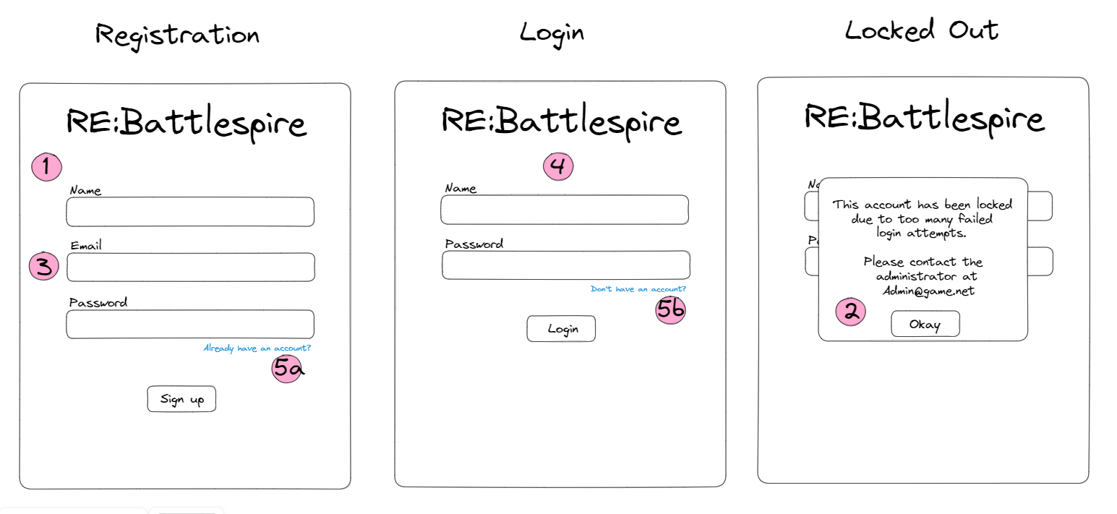

### User Stories

1. As a player, I want to be able to register an account so that I can save my progress and log in from other machines.
2. As a player, if I forget my password and get locked out of my account, I want to be able to contact an Administrator for help.
3. As a player, I want my account to be secured by registering using my email address.
4. As a player, I want to be directed to the login page when opening the game.
5. As a player, I want to switch between the login and registration pages if necessary.

### Functional Descriptions

1. Players can register an account in RE:Battlespire and log into their account from anywhere.
2. When a player is locked out of their account due to forgetting their password, they are given the contact information of a game administrator.
3. Account registration includes email addresses so that accounts are more secure, this will be accompanied by email verification, and a forgot password method.
4. When opening RE:Battlespire, players are directed to the login page, where they can either log in or switch to the registration page.
5. Players can switch between registration and login forms as needed.

## Settings

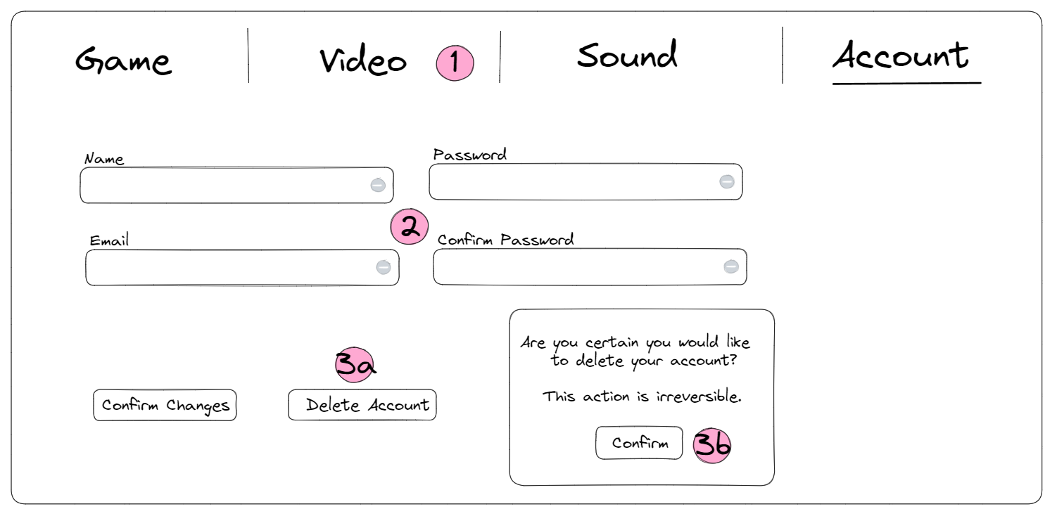

### User Stories

1. As a player, I want to be able to configure in-game settings such as; volume, resolution, fullscreen, etc.
2. As a player, I want to be able to change my password and email if necessary.
3. As a player, I want to have control over my data and be able to delete my account at my behest.

### Functional Descriptions

1. Players can customise game settings such as; volume, screen resolution, toggle fullscreen, and more.
2. Players can change their account information from the account settings.
3. Players can delete their account and any associated data and receive a confirmation message.

## Admin Settings

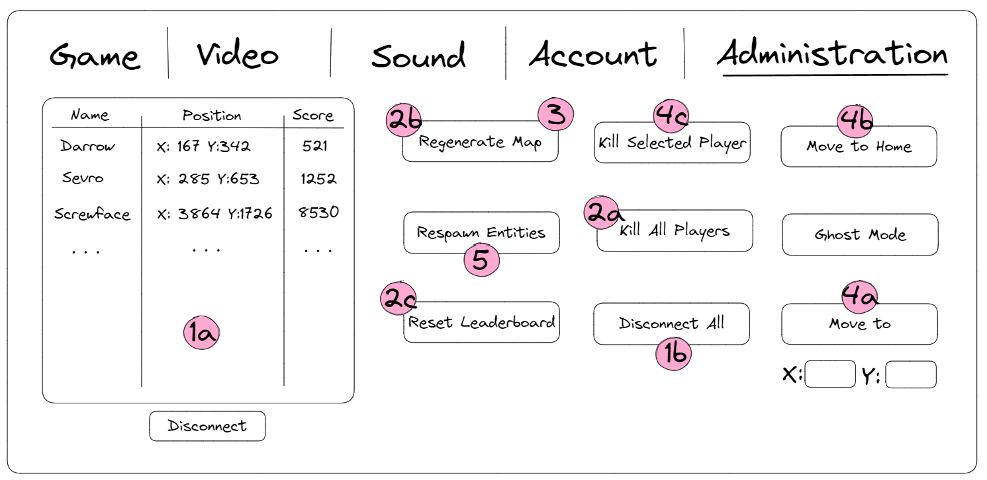

### User Stories

1. As an admin, I need to be able to remove individual players from the game or all players at once.
2. As an admin, I need to be able to reset the game.
3. As an admin, I want to be able to generate a new map while keeping the leaderboard scores.
4. As an admin, I need to be able to update player information in ways such as; moving the player back home, resetting player progress, killing a player, etc.
5. As an admin, I might need to wipe all monsters and items from the map and regenerate them.

### Functional Descriptions

1. Admins can disconnect/log out selected or all players simultaneously.
2. Admins can effectively reset the game by killing all player characters, regenerating the map and resetting the leaderboard. (disconnect player is a requirement)
3. Admins can regenerate the map when needed in case of poor map generation.
4. Admins can affect the player’s position if they get stuck.
5. Admins can respawn all non-player entities. This will delete all chests and monsters and spawn new ones.

## Gameplay

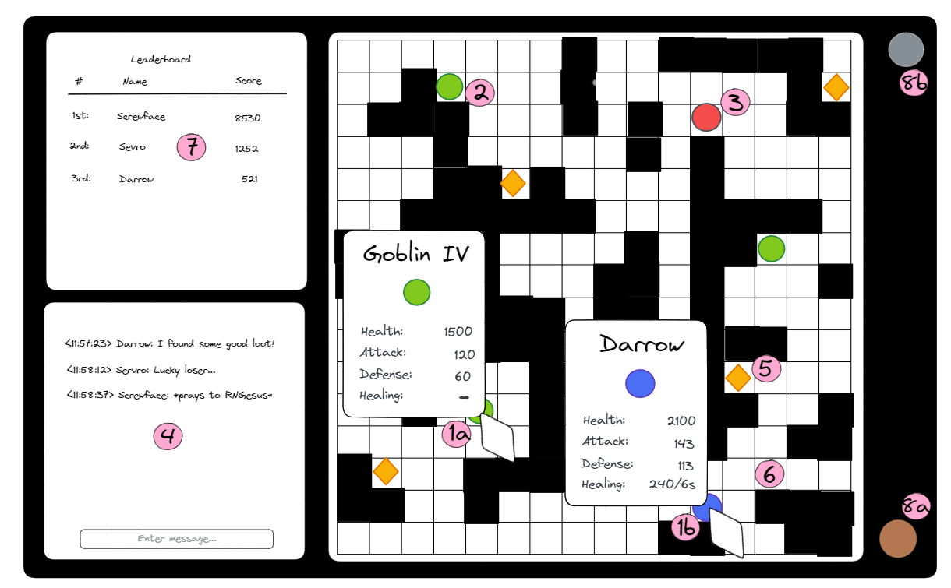

### User Stories

1. As a player, I want to see the stats of monsters and Players when I hover my cursor over them.
2. As a player, I want the game to have roaming monsters to make the game more interactive.
3. As a player, I want to be able to engage in combat with monsters and other players.
4. As a player, I want to be able to interact with other players through a chat system.
5. As a player, I want to move around the map and collect various items to power up my character.
6. As a player, I want to be able to move around the map by clicking on tiles next to my character.
7. As a player, I always want to see a live leaderboard of the top players.
8. As a player, I want to open my settings and Inventory via buttons or keystrokes.

### Functional Descriptions

1. Players can hover their cursor over other players or monsters to see their name, tier, and stats.
2. RE:Battlespire has various monsters that wander around the map offering Player versus Environment (PvE) combat.
3. Players can choose to engage in Player versus Player (PvP) combat; this is by design, not a fair system.
4. Players can communicate with each other through an inbuilt chat system.
5. Collecting equipment is done via locating chests (yellow diamonds); more is shown on the next page about inventory and chests.
6. Players can move their characters by clicking neighbouring tiles or using keystrokes.
7. Players can always see a live leaderboard of top players.
8. Players can access their inventory or settings via the buttons on the right.

## Inventory & Chests

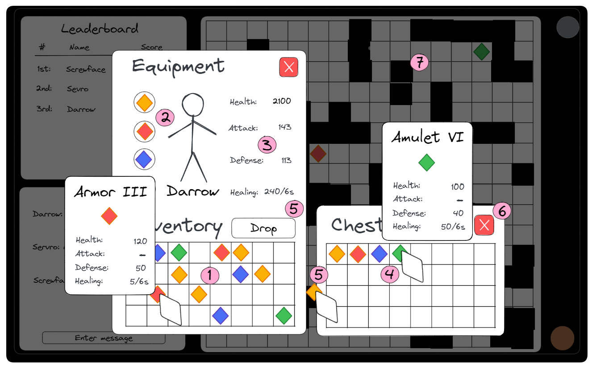

### User Stories

1. As a player, I want to be able to rearrange and organise my character's inventory.
2. As a player, I want to see what equipment my character has equipped and be able to equip new stronger items.
3. As a player, I want to see my character stats to show my strength.
4. As a player, I want to see an item and its stats before I put it in my inventory.
5. As a player, I want to be able to drop items out of my inventory to reduce clutter.
6. As a player, after opening a chest and taking items, I need to be able to close the chest to continue moving around.
7. As a player, I would like the game to darken when I open my inventory so it is less distracting.

### Functional Descriptions

1. Player inventory saves items’ locations so players can organise their items.
2. Player inventories have equipment slots to show which items are currently equipped; items are dragged to these slots to be equipped.
3. Players can see their character’s stats, which update equipped items change.
4. Players can hover the cursor over items in chests or inventory to see the item’s stats.
5. Players can drag items between inventories to take or get rid of items.
6. The player inventory is also closed when the chest window is closed.
7. The background behind the inventory windows is darkened to be less distracting.

## Win & Lose

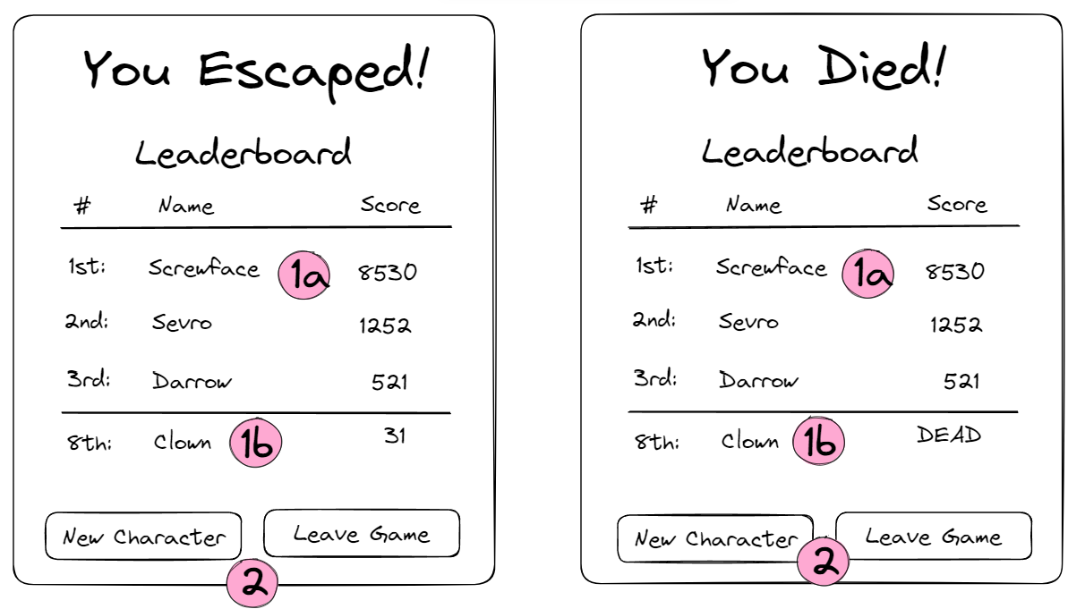

### User Stories

1. As a player, if my character escapes, I want to see the current leaderboard and my place.
2. As a player, when I'm finished with a character, I want to start a new character or leave the game.

### Functional Descriptions

1. When the player’s character dies or escapes, the current leaderboard and the player’s current ranking are shown.
2. Once the ‘Game Over’ window appears, the player can start a new character or leave the game.

# Logical Entity Relationship Diagram

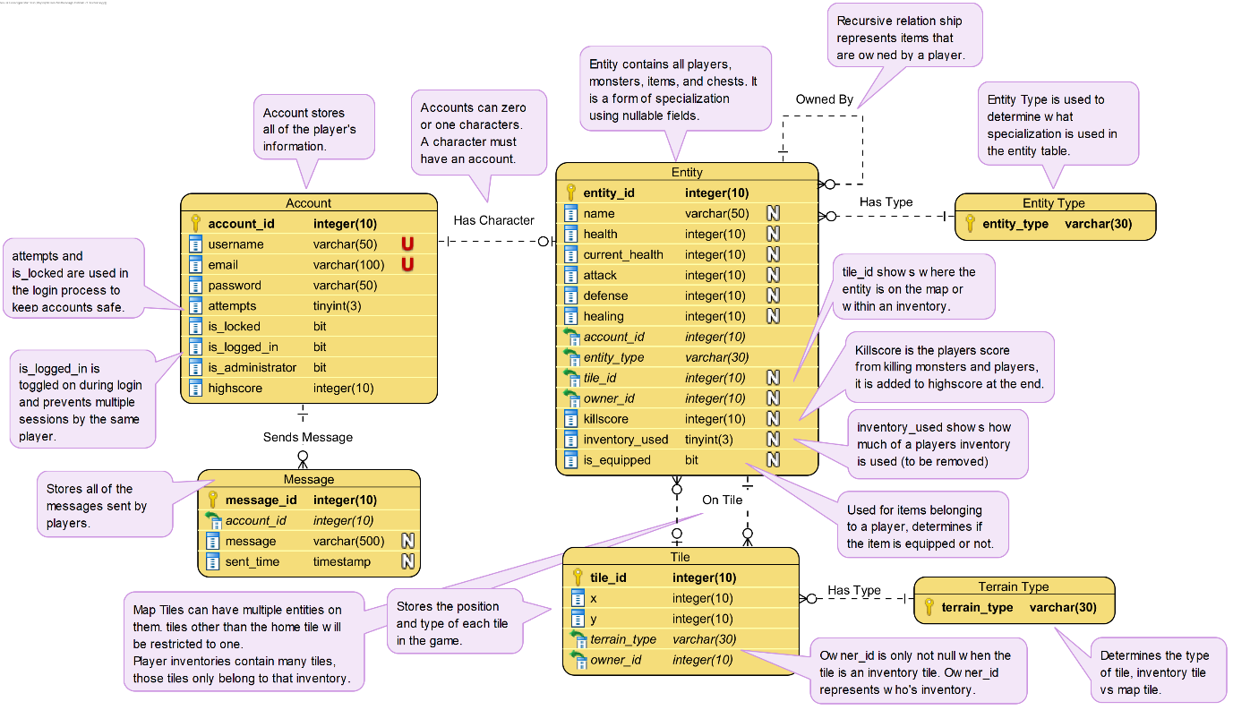

Export quality was set to maximum; if it’s not readable enough, the Visual Paradigm project is within the repository, inside the diagrams folder.

# CRUD Analysis



# SQL Implementation

I have provided four scripts within the repository in the scripts folder.

The ‘DAT602-project-script’ is the main script to be run. The other four are what I used during development and share the same data as the main script but split into more files.

## Stored Procedures

### CreateDatabase

This is the main creation procedure; it has all the create table statements and defines the database structure.

### InsertData

This makes calls to various other procedures and uses them to fill the database with valid test data. Procedures are called multiple times and must be contacted in the correct order.

### GenerateMap

This generates the initial tileset where players will spawn.

### CreateItem

This generates a new item based on the distance from the centre of the chest the item will be placed into.

### CreatePlayer

This creates a new player character that is associated with the account that is provided to it.

### GenerateInventory

This generates the tiles required for the entity’s inventory, taking width and height as parameters so inventory can be different sizes.

### MoveInventoryItem

This updates the tile_id of an entity with the id that is provided to it, used when a player is dragging items between and around inventories.

### SendMessage

Creates a new message record.

### SpawnChest

Creates a chest entity at the location provided, calls create item 1-2 times.

### SpawnMonster

Creates a monster entity at the location provided

### SpawnMonsterChest

Creates a chest entity where a monster has died, calls create item 4-5 times.

### UpdateEntityInventory

Updates the inventory used on the provided entity and checks what other entities have it as their owner. This is a redundant procedure and attribute and will be removed in a later iteration.

## Functions

### CalculateTier

Takes in the distance from the centre and returns what the tier of an entity should be.

### GetChestIDFromItem

Takes in an item entity id and returns the chest that possesses that item.

### GetChestIDFromTile

Takes in a tile id and returns the chest that occupies that tile.

### GetEntityIDFromInventoryTile

Takes in an inventory tile id and returns the id of the item occupying that tile.

### GetPlayerID

Takes an account id and returns the character tied to that account.

# Application Prototype

There is a testing admin account for you to use.

Username: Todd

Password: 1234

Much functionality that hasn’t been implemented well within my capabilities, such as lockout, blocking log-in if already logged in (is_logged_in attribute), log out on application close, but I ran out of time.