

|  |
| --- |
| SDV602 Assessment 2 |
| Project Two |
| Name: Rhylei Tremlett  ID: 13513865  Date: 22/09/2023 |

Table of Contents

Introduction 1

Purpose 1

Scope 1

Project Plan 1

Intended Audience 1

Intended Usage 2

Software Requirements 2

Functional 2

Non-functional 2

System 3

Design 3

Initial sketch 3

Login 3

Homepage 3

Data Explorer Screen 4

Storyboards 5

Login 5

Interaction Table 5

Homepage 6

Interaction Table 6

Interaction Table 7

References 8

Appendix 1

# Introduction

This is a supporting document for Rhylei’s SDV602 Project Two, which contains documentation for the phases of the project which have been undertaken.

## Purpose

This project is to develop an application that allows multiple users to view and analyse various data sources through interactive graphs and charts.

## Scope

This project is an educational project with significant time constraints. As such, the scope of the project will be more limited.

The project will aim to create a fully functioning application that is cross-platform, visually appealing and easy to use. The application will allow users to log in with accounts made on request. Users will then have access to the home page.

From the homepage, users will be able to perform the following actions:

* Create a new data explorer screen (DES) instance.
* Load a previously created DES.
* Join another user’s DES via a join code.

Each screen has a chat system and data source.

The project will also include a cloud database to store users and DES information.

## Project Plan

This project will follow a mostly iterative approach with some caveats. The design phase will completed in two parts.

The first iteration of the design phase is a preliminary design that covers the visual aspects of the application. The deliverables for this phase will be a complete set of wireframes that are annotated with user stories and user interactions.

After the first design phase, an explorative implementation phase will begin. In this phase, the intent is to learn and practice implementing advanced object-orientated design patterns and principles.

Following the explorative implementation, a second design phase will be performed if time constraints allow. In this re-iterated phase, the application will be redesigned with proper object-orientated design using UML diagrams such as class diagrams. Any design flaws identified during the explorative implementation will be removed at this point.

## Intended Audience

This application is made primarily for data analysts and scientists who want a simple way to visualise data and communicate with one another.

## Intended Usage

Typical usage of this application would involve the following:

* A user logging into their account.
* Creating/loading/joining a DES.
* Loading a data source into a DES.
* Selecting a graph/chart type for the data source.
* Manipulating the graph/chart settings.
* Communicating with other users on the same DES.

## Software Requirements

### Functional

* The application must allow users to log in.
* The application must be able to create many DES instances.
* Users must be able to open other user’s DES via join codes.
* When users log in, they must be shown the homepage.
* The homepage must show a list of the user’s DESs.
* Users must be able to open many DES at the same time.
* A DES must take a data source and display it in a graphical format.
* Users must be able to configure chart settings per DES.
* Users must be able to retrieve a join code from the DES.
* Each DES must have its own local chat system.
* Users must be able to send and see chat messages.
* The application should give clear and intuitive success and error messages when necessary.
* Users should be able to manipulate the charts, such as panning and zooming, without changing chart settings.
* Users should have admin privileges over their created DES, such as clearing chat and deleting the DES.

### Non-functional

* The application should be easy to navigate and use, with a clear and intuitive user interface.
* The application should be designed in a modular and extensible way to allow for easy updates and maintenance.
* The interface should have a clean, minimal design that reduces user distractions.
* The application shouldn’t crash or produce incorrect results when invalid input is provided.
* The application and DESs should open almost instantaneously.
* Loading of data sources and retrieval of data from the online database should be as fast as the network will allow (no fluff once it is loaded).

### System

* The application should run on all target platforms (Windows, Linux, MacOS, IOS and Android).
* The application should be written in Python using Kivy and Matplotlib as the main libraries.
* The application should have a maintainable code base following accepted style guides and PEPs.

# Design

## Initial sketch

### Login

### Homepage

### Data Explorer Screen

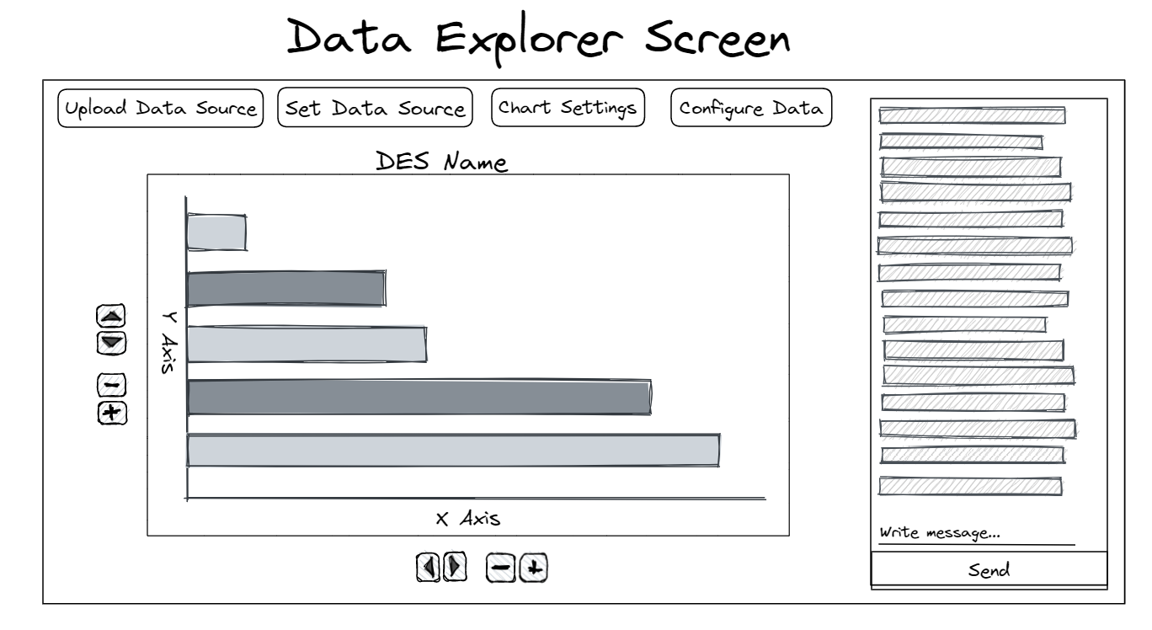

## Storyboards

### Login

#### Interaction Table

|  |  |
| --- | --- |
| # | Interaction |
| 1 | Users can enter their username |
| 2 | Users can enter their password |
| 3 | Users can request their password be reset by an admin |
| 4 | Users can submit the form to attempt a login |

### Homepage

#### Interaction Table

|  |  |
| --- | --- |
| # | Interaction |
| 1 | Users can see a static image preview of the DES/Graph |
| 2 | Users can select a DES from a list, which will open in a new window |
| 3 | Users can create a new DES |
| 4 | Users can delete DES that they own |
| 5 | Users can join other user’s DES via a join code |

Data Explorer Screen

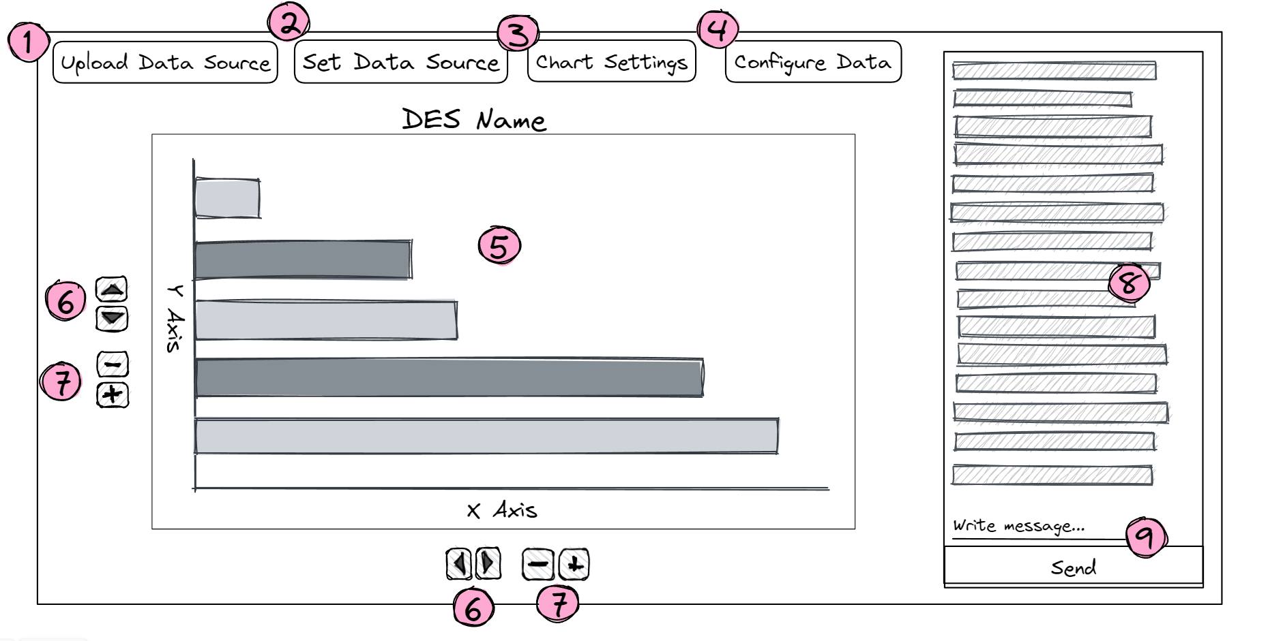

#### Interaction Table

|  |  |
| --- | --- |
| # | Interaction |
| 1 | Users can upload a data source for the DES, this will be stored server side |
| 2 | Users can set the data source as a url. |
| 3 | Users can configure the settings of the graph/chart |
| 4 | Users can configure the data, such as renaming columns, limiting the set. |
| 5 | Users can see an interactive graph displaying the datasource |
| 6 | Users can pan along an axis if they have zoomed in |
| 7 | Users can zoom into a dataset |
| 8 | Users can interact with other users on the same DES via a chat |
| 9 | Users can send their own messages into the DES chat |