NASM 32-bit ASSEMBLY

STUDENT EXERCISE SET

Module 1: Getting Started with NASM 32-bit
5 Programming Exercises | Test Cases | Guide Ǫuestions | Coding Space

Student Name | Kyre Francis Torregoza
Section | TN25
Date | 9/13/26
Instructor | M

Module Focus
NASM program structure, .text and .data sections, global _start, sys_write, sys_exit, multiple output calls, exit status, and basic debugging.

Workbook Goal
Solve five new problems that use the same core concepts as the module but use different scenarios and data. Build each program with NASM 32-bit and Linux int 0x80 system calls.

Standard Build Commands
nasm -f elf32 exercise.asm -o exercise.o ld -m elf_i386 -o exercise exercise.o
./exercise

Problem Statement. Create a NASM 32-bit program that prints a three-line welcome board for an assembly laboratory. Use separate string labels and one sys_write call for each line, then exit cleanly with status 0.

Required Input | No keyboard input. Three initialized strings in .data.
Required Output | Three lines: "Assembly Laboratory", "Mode: NASM 32-bit", and "Status: Ready".

Test Cases

Test Case | Sample Input / Change | Expected Result / Output
1 | Use the default strings. | Assembly Laboratory Mode: NASM 32-bit Status: Ready
2 | Change the second line to "Mode: Linux ELF32". | Only the second output line changes; the other lines remain the same.
3 | Add an exclamation mark to the third line. | The full edited third line prints because its length is computed from the label.

Test Case 1

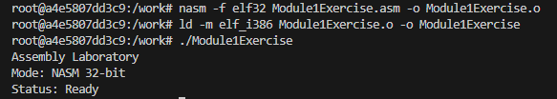

Test Case 2

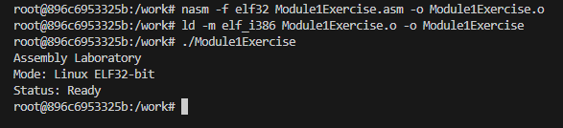

Test Case 3

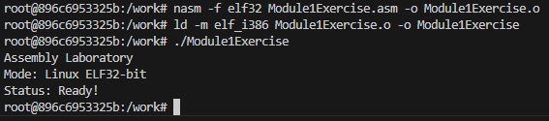

Ǫuestions
- What is the purpose of global _start?
- Which four registers are prepared before each sys_write call?
- Why must EAX be loaded again with SYS_WRITE before every separate write?
Answers:
1. global _start makes _start visible to the linker as the program’s entry point.
2. Before every sys_write, prepare EAX, EBX, ECX, and EDX.
3. EAX must be loaded again because after a system call, it contains the return value instead of sys call number 4.

NASM Code / Work Area
Write your complete NASM program below. Use the test cases to verify your result.

Problem Statement. Print three independent build-status messages: Assembler ready, Linker ready, and Program ready. Each message must be stored separately and printed with its own sys_write call.

Required Input | No keyboard input.
Required Output | Assembler ready Linker ready Program ready

Test Cases

Test Case | Sample Input / Change | Expected Result / Output
1 | Default source. | Assembler ready Linker ready Program ready
2 | Remove 0xa from the first message. | The first and second messages run together on one line.
3 | Temporarily skip the second sys_write block. | Only the first and third messages appear.

Test Case 1
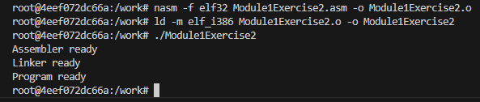
Test Case 2
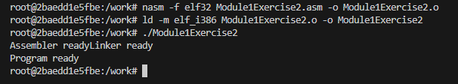
Test Case 3
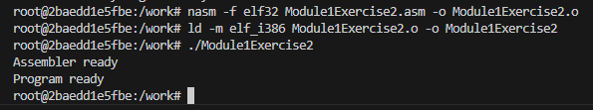

Ǫuestions
- What does 0xa represent in the data section?
- What does EDX control during sys_write?
- What will happen if ECX points to the wrong string label?
Answers;
4. 0xA is the newline or line-feed character.
5. EDX contains the number of bytes that sys_write will print.
6. If ECX points to the wrong label, the program prints data from the wrong memory location or may crash.

NASM Code / Work Area
Write your complete NASM program below. Use the test cases to verify your result.
section .data

Problem Statement. Write a program that prints "Task complete." and then returns exit status 25 to the shell. After running the program, use echo $? to verify the status.

Required Input | No keyboard input. The shell command echo $? is used after execution.
Required Output | Task complete. followed by shell exit status 25.

Test Cases

Test Case | Sample Input / Change | Expected Result / Output
1 | Run the default program, then echo $?. | Task complete. 25
2 | Change the exit value from 25 to 7. | The message is unchanged; echo $? displays 7.
3 | Change the exit value to 0. | The message is unchanged; echo $? displays 0.

Test Case 1
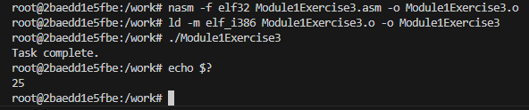

Test Case 2
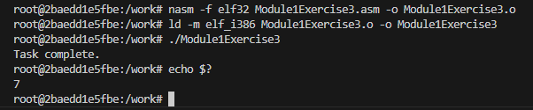
Test Case 3
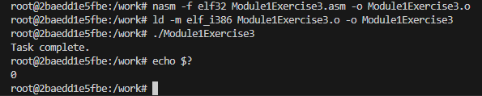

Ǫuestions
- Which register carries the exit status for sys_exit?
- Why can a program print correct output but still return a nonzero exit status?
G. What shell variable is displayed by echo $?
Answers:
7. EBX carries the exit status for sys_exit.
8. A program can print correct output but return a nonzero status because output and exit status are separate operations.
9. $? is a shell variable containing the exit status of the most recently executed command.

NASM Code / Work Area
Write your complete NASM program below. Use the test cases to verify your result.

Problem Statement. Store three workflow lines inside one contiguous buffer and print the whole block with a single sys_write call. The lines are Step 1: Edit, Step 2: Assemble, and Step 3: Run.

Required Input | No keyboard input. One multi-line buffer in .data.
Required Output | Step 1: Edit  Step 2: Assemble  Step 3: Run

Test Cases

Test Case | Sample Input / Change | Expected Result / Output
1 | Default buffer. | Step 1: Edit  Step 2: Assemble  Step 3: Run
2 | Add "Step 4: Debug" to the same buffer. | The fourth line appears without adding another sys_write call.
3 | Set EDX temporarily to 12. | Only the first 12 bytes of the block are printed.

Test Case 1
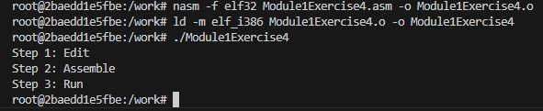

Test Case 2
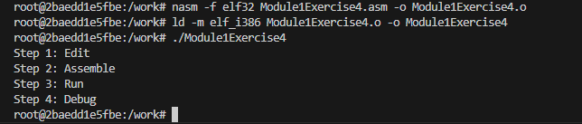

Test Case 3

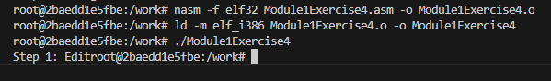

Ǫuestions
- How can one label represent several printed lines?
- Why does one sys_write work for the entire block?
- What determines the exact number of bytes printed?

Answers:
10. One label can represent several lines when all the text and newline characters are stored consecutively in one buffer.
11. One sys_write works because ECX points to the beginning of the complete buffer and EDX contains its total length
12. EDX determines how many bytes from the buffer are printed.

NASM Code / Work Area
Write your complete NASM program below. Use the test cases to verify your result.

Problem Statement. Create the corrected version of a broken notice program. The faulty version omits global _start, places the message address in EBX instead of ECX, uses SYS_READ instead of SYS_WRITE, and exits without loading SYS_EXIT. Repair all four problems so the notice prints correctly and the program exits with status 0.

Required Input | No keyboard input. Repair the four stated logical errors.
Required Output | System notice: READY

Test Cases

Test Case | Sample Input / Change | Expected Result / Output
1 | Correct all four errors. | System notice: READY
2 | Put the message address in EBX again. | The sys_write arguments are wrong and the expected notice is not printed correctly.
3 | Use the correct code but change the message text. | The edited notice prints when the length constant is also computed from the label.

Test Case 1
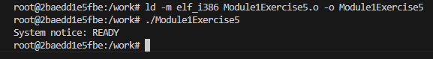

Test Case 2

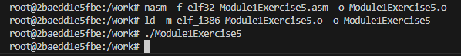

Test Case 3
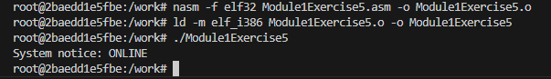

Ǫuestions
- Why must the buffer address be placed in ECX for sys_write?
- What is the role of global _start during linking?
- Why are logical register mistakes not always detected by the assembler?
Answers:
13. The buffer address must be in ECX because Linux sys_write expects the address of the data in that register.
14. global _start exports the _start label so that the linker can use it as the program entry point.
15. The assembler may detect invalid register use, undefined labels, or invalid instructions and stop with an error. Some logical register mistakes are still valid syntax, so they may only cause incorrect behavior while running.

NASM Code / Work Area
Write your complete NASM program below. Use the test cases to verify your result.

