Kyriakos Fournarakis
Matriculation Number : S2028690
I confirm that the code contained in this file (other than that provided or authorised) is all my own work and has not been submitted elsewhere in fulfilment of this or any other award.

Contents:
- Main.cpp
- Main Game.cpp – Main game.h
- Mesh.cpp – Mesh.h
- Camera.h
- Shader.cpp
- Texture.cpp – Texture.h
- SDLAudio.h – SDLAudio.cpp
- Monkey3.obj

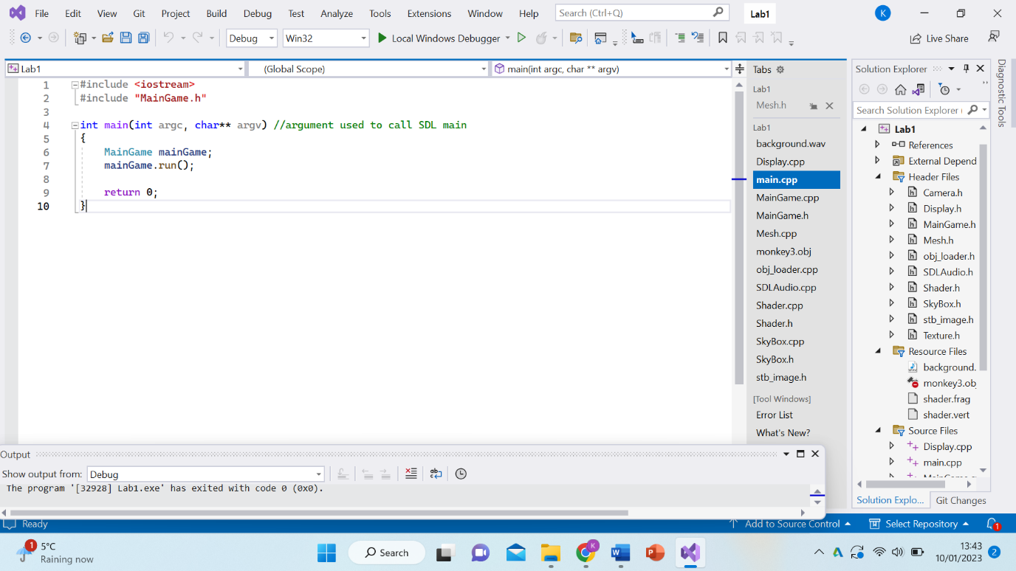
Figure 1

Firstly, and most importantly is the main.cpp script and this is because it allows the application to run with just those 3 simple lines of code. As this script includes the MainGame.h, it has the ability to also include every other script in the project hence as it starts to run the project it makes sure that all the scripts have no errors, otherwise it wouldn’t work, and so if and when the whole project has no errors, it will start to run correctly. Another reason this is the most important script is because the line “mainGame.run();” is the whole the reason that the game will start to run as it should.

1

The next most important scripts are the MainGame because one includes all the scripts together so that then they are able to be placed in the main.cpp all together instead of one by one. Then the other explains each part of the application separately and how they align together in the end in order to make game work.
The script MainGame.cpp shows each component of the game individually away from their own script by having less code but still working in the same way so it correctly goes into MainGame.h and then into Main.cpp in order to play the application. At first it creates the display so that the background is created and adjusts it to a reasonable size so its easy to see. Then the meshes are created so that the application isn’t just a 2D image and with is it allows the model to be in 3D and in any shape or form decided by the code. Then the audio is added so that the application isn’t silent and any audio can be placed to make the game more enjoyable. After that, the exact model needs to be added which is the monkey and the meshes need to be exact with the shape of the added model. Then the camera needs to be included which is very important because without it, we wouldn’t be able to see anything when the application is running. Then the shader is added so we can see what the colour of the model is going to be and that adds attraction towards the application because if it is more colourful, its more likely to have people see it. Furthermore, textures are added in order to show that the monkey isn’t so bland, it has more detail to it. Then a collider is added so it detects nearby monkeys and avoid when possible. And finally, a way to quit is included so that you can leave the application. After that, when the monkey is mostly done, the script includes the position, rotation and scale of the monkey so it has exact measurements when it is playing. The camera stays the same even with these adjustments in order to see the whole monkey. Finally, with all these attributes are now together the application can be played.
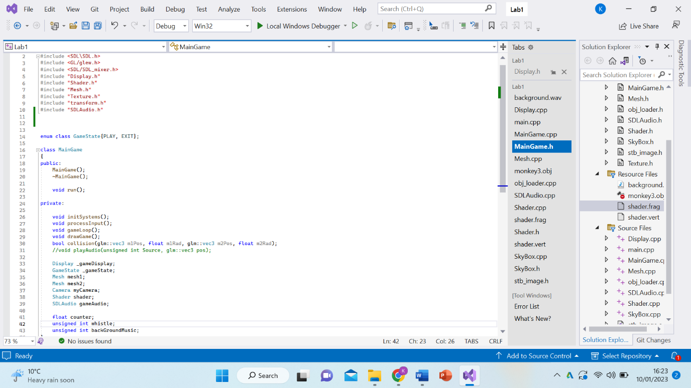
Figure 2
The MainGame.h is where all the scripts are added together in order to be in the same place so they can be added all together to Main.cpp which starts the application. As you can see in the code, the game starts to run first and then it goes by priority which is the display then mesh then camera then the shader and finally the audio. This is because obviously the game has to start, then you have to able to see the background, then the actual model and you to see it immediately with the shader instead of it being bland, and finally, the audio is added as it is the least important for an application.

2

Next are the mesh.h and mesh.cpp which are both really useful because they create the actual model with all of its vertices and buffers which hold all the data before the application is run. Firstly, the mesh.h has to include the vertices which contain a position, normal, and texture coordinate vector each. Then we add the position and set the radius of the model so we know how large the model is going to be. Then you would start to draw the model, if you are starting from the beginning, using the vertices, the indices, the radius and using the starting position to load the model. The mesh.h is loading in the model which is the main part whereas every other aspect of the application are the mechanics and extras.

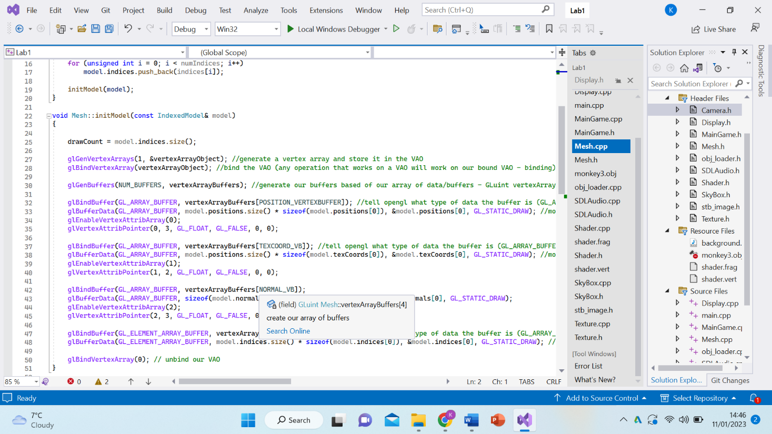
Figure 3
Furthermore, the mesh.cpp also contains the vertices which contain a position, normal, and texture coordinate vector each and it pushes them into the model along with the vertex arrays. The mesh.cpp also includes all the buffers for the model which are crucial toward the application because it speeds up the process and there are no issues while the application is running due to the fact that the new data is processed before the data that is being played at the time before, which is very efficient and also reduces the difference between and input and output speed. For this application, it has a buffer for the vertex array object and then it has buffers for the models’ position, normal, indices and the size of the model which are all very important as the application is running because it is already making the next position as the current position is happening. And so it loads the model and draws the elements for it and finally it keeps updating the position but keeps the same radius as the model is moving.

3

Additionally, camera.h is a vital part of the application because without it we wouldn’t be able to see anything while the game is running. The camera is a critical part for any game because no matter what is playing, you can’t see it.
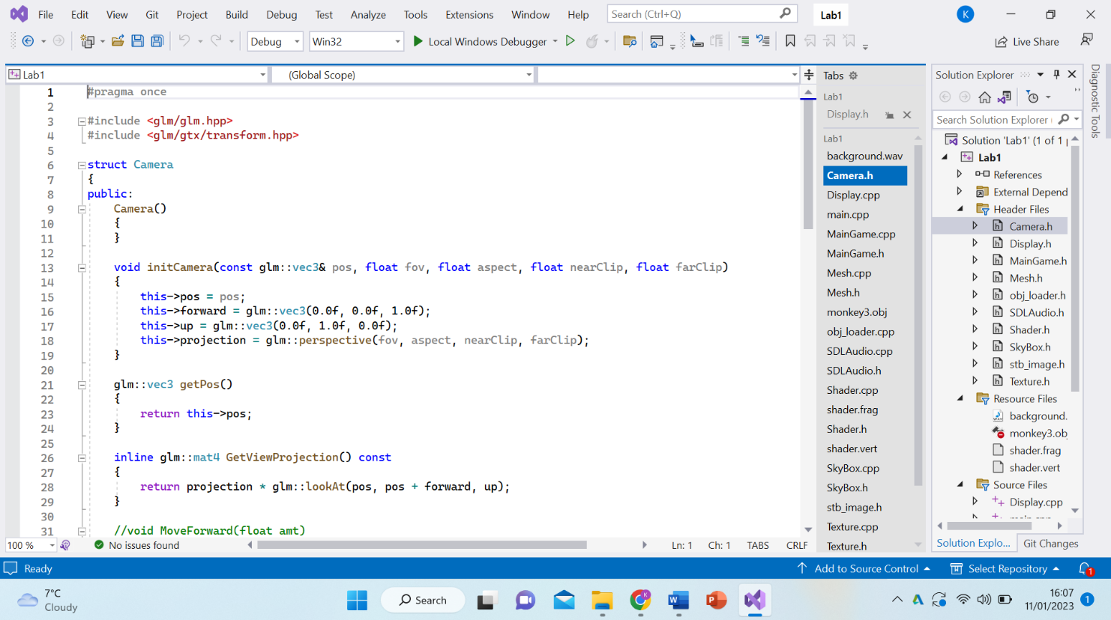
Figure 4

This camera script allows the viewer to see things that are happening in the foreground and in the background by having the “nearClip” and “farClip” included in the code. This code also allows the camera to get the perspective of things that are happening everywhere not just in the middle. It also allows to have the projection and the position of what is playing and can see forward and up.

4

Then, the shader can be added, and this is used using the shader.cpp script which makes sure that the model has the correct colours on it or if it doesn’t have any colours on it at all. For example, the model that is in this application has no colour, but a shader is included nonetheless. A shader makes sure that the model has the right coloured pixels using the lighting input and material configuration.
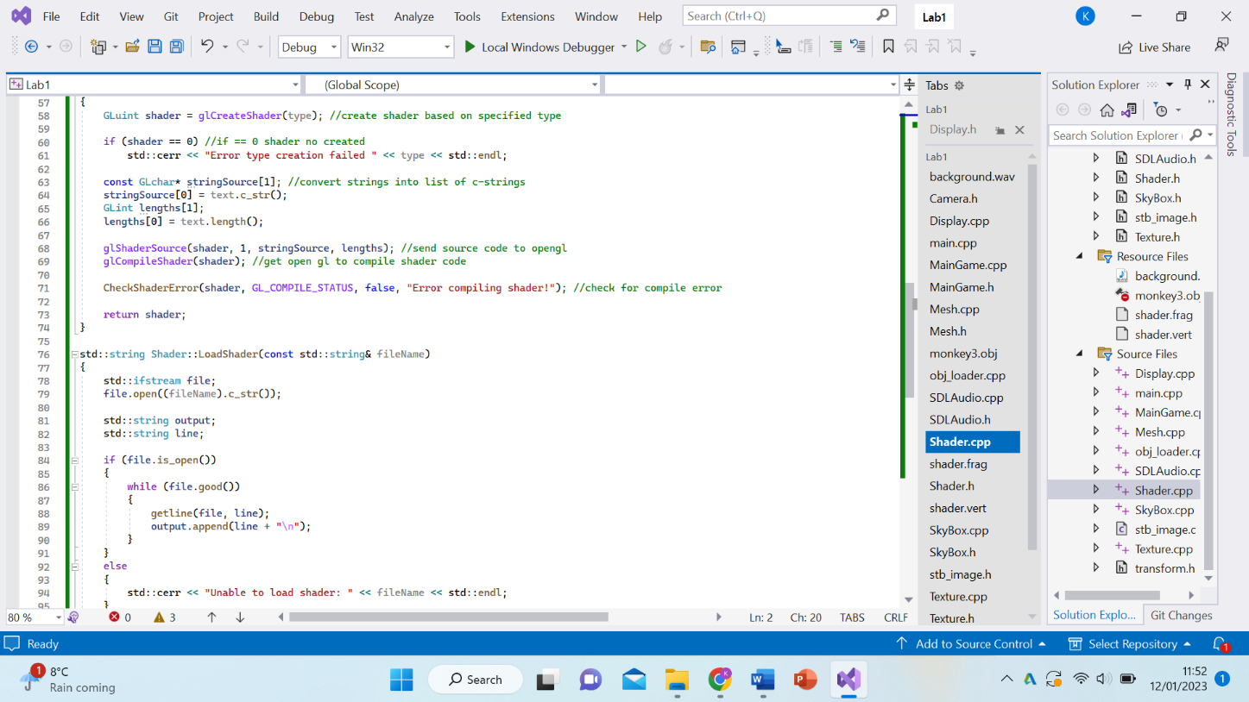
Figure 5
Firstly, the shader has to be introduced and created into the project by finding the source of the shader inside the files. Then the shader is compiled into the project so the lighting and the coloured pixels can start to be configured. However, there could be an error as the shader could be unavailable or just not found or created yet. Next, if the shader is found inside the files, then it is loaded into the project because it is compatible with the object that is already inside the project. The shader also includes the camera and the transform because the coloured pixels need to be to able to be seen and also while the application is moving as well. Finally, we would get an error if it isn’t compatible and use a different shader that is in order for the object to have a shader connected to it.

5

Next is the texture for the project and this is really important because it places the image onto to the object that is seen on the application. And so to include this we need to add the texture.cpp and texture.h. The texture is crucial to any project because it makes sure that the object isn’t just blank, it has an image to it for example, a brick object with no image would just be brown but a texture added to it, which is an image, it will have the white lines and the different shades of brown because of its slow decay. And so for this object, a texture needs to be added because without it, it will just be a grey 3D object. This is where the texture.cpp is added in order to make the object have a texture to it including the image.
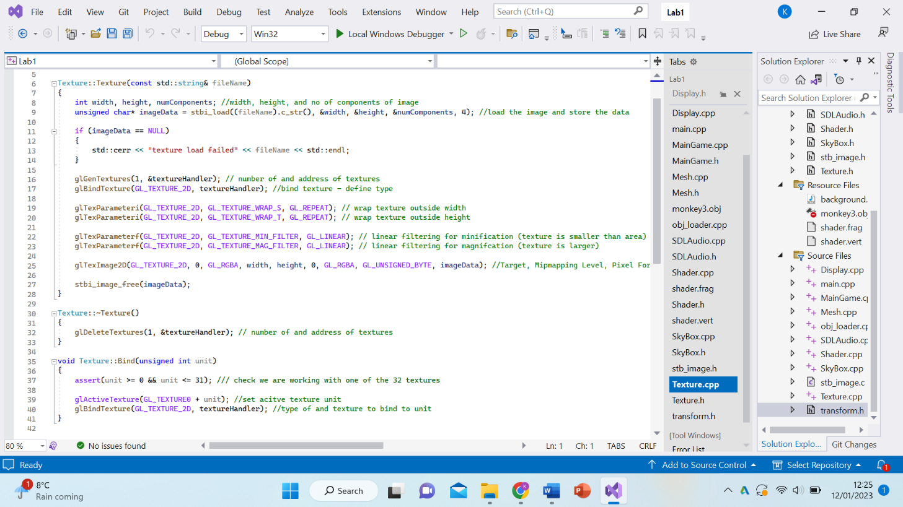
Figure 6
This code firstly finds the texture inside the files and makes sure it is compatible with the object already inside the project and having the correct measurements. It then loads and generates the texture onto the object to now having the object an actual image. Having the correct parameters is also important so that the texture isn’t outside the object. Finally, the code activates the texture and the monkey image is created onto the object.
Secondly, the texture.h just finds the texture from the files and binds it onto the object and isn’t included onto any other code because the texture itself is its own image. However, it is included onto the maingame.h because without it, it would just be an empty object.

6

Finally the audio is added onto the project to make it a little bit more interesting to keep you engaged because otherwise silence makes it more boring. This is included by using the SDLAudio.h and SDLAudio.cpp into the project. The first one makes sure that there is a reference into the other so that it allows the second to connect to the first. The SDLAudio.h is the more important because it has the definition for the other and because that is the one included inside the maingame.h. 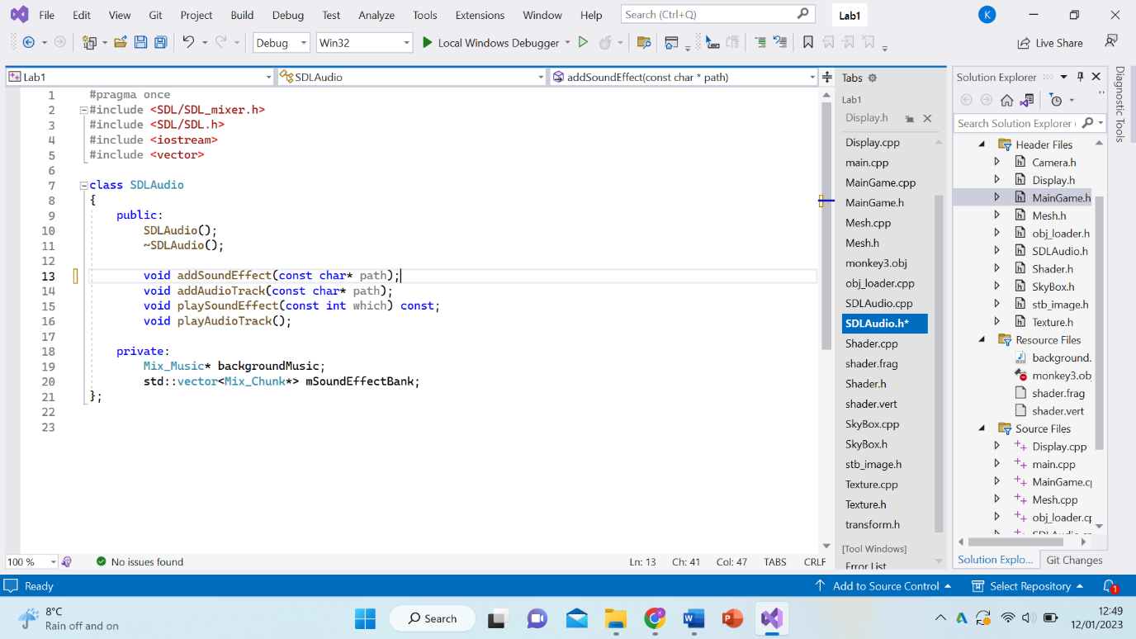
Figure 7
These definitions create the addition of the audio whilst the application is being played. And so the first one adds the sound effect used from the background.wav script. Then the audio track is the actual music. Next the sound effect starts to happen and the audio starts to play throughout the application. Finally, the code makes it the background music so it doesn’t take over what the application is actually doing.
Secondly, the SDLAudio.cpp actually creates the sounds and audio by creating more in depth code. For example, the sound effect used “Mix_Chunk * tmpChunk” in order to create the sound and also created an error if the sound wasn’t found. The adding of the track was created by making it the background music and also had an error if it didn’t work. The playing of the sound used “std:: cout” in order to play it and to play the audio “Mix_PlayMusic”.

7

The addition of the actual monkey had to be added so that the end product could be shown after all the coding was combined and played in the application.
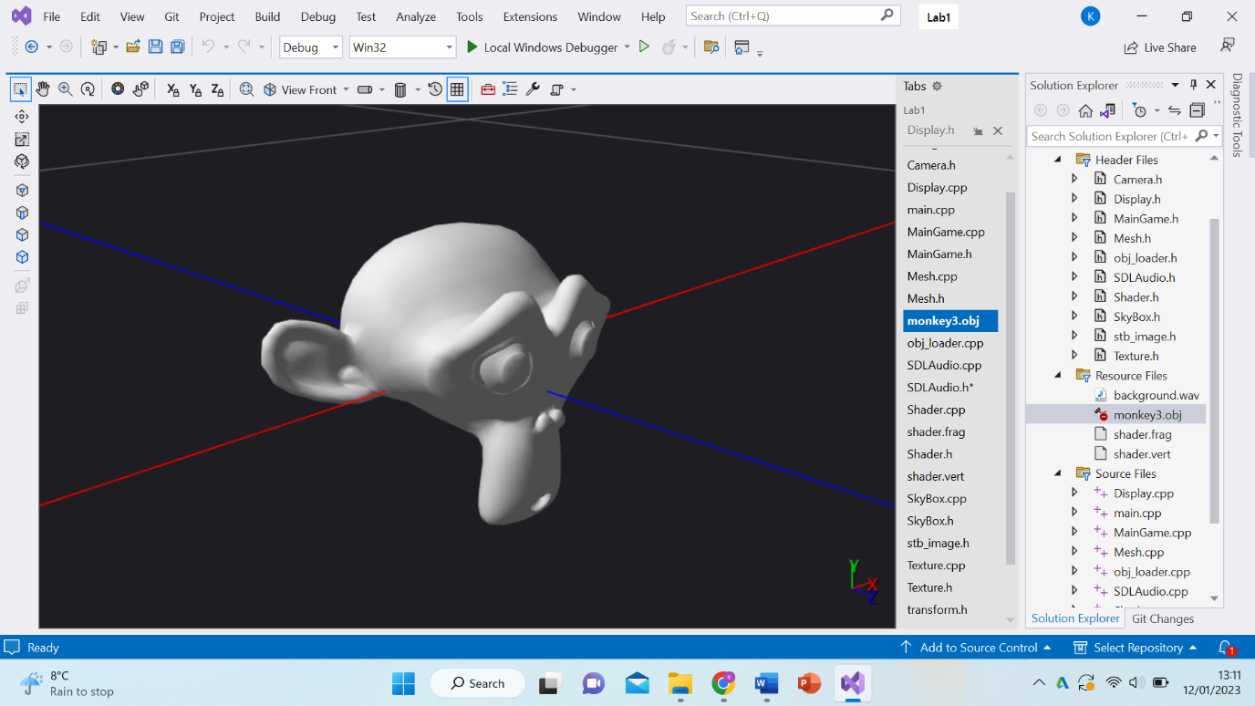
This monkey was created using the mesh to make all the vertices for the object and hold all the buffers. Then the camera was added in so we could actually see what was going on while the application was running. Next the shader was included so the object could have an actual colour to it and with that the texture was created to have the actual image of the monkey. And finally the audio was included so the application wouldn’t be silent.
All this created the final product which will be the video on github.

