题目一:
Score表:
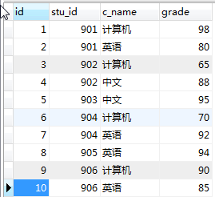
Student表:
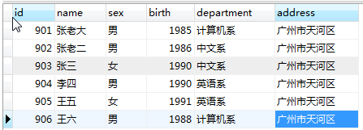

- 从student表中查询每个院系有多少人.
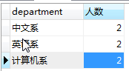
select department,count(id) 人数 from student GROUP BY department
- 从score表中查询每个课程的最高分.
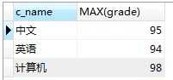
SELECT c_name,MAX(grade) FROM score GROUP BY c_name;

- 计算学生的考试平均分
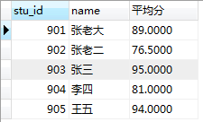
SELECT stu_id,student.name,AVG(grade) 平均分 FROM score left join student on(score.stu_id=student.id) GROUP BY stu_id;

4.查询出每门课程最高分的学生如下图:
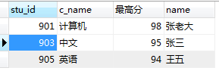
select stu_id,c_name,grade 最高分 ,stu.name from score s
left join student stu on (stu.id=s.stu_id)
where (s.grade,s.c_name) in
(select max(grade) grade,c_name from score GROUP BY c_name )

5.获取计算机课程和英语课程分数都大于80分的学生姓名.
select stu_id,name,com,en from student,
(select stu_id,max(IF(c_name='计算机',grade,0)) com,max(IF(c_name='英语',grade,0)) en from score group by stu_id having en>80 and com>80) a
where student.id= a.stu_id

- 根据记录,获取到如下的统计信息.

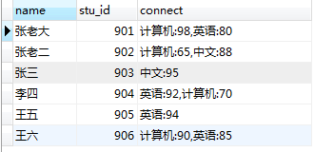
select name,stu_id,a.connect from student d,
(select stu_id,GROUP_CONCAT(c_name,":",grade) connect from score GROUP BY stu_id) a where a.stu_id= d.id

- 查询计算机成绩低于95的学生信息
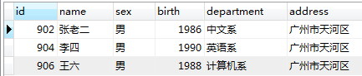
SELECT * FROM student
WHERE id IN
(SELECT stu_id FROM score
WHERE c_name="计算机" and grade<95);

- 查询同时参加计算机和英语考试的学生的信息
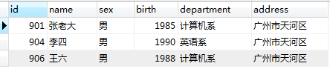
SELECT * FROM student
WHERE id =ANY
( SELECT stu_id FROM score
WHERE stu_id IN (
SELECT stu_id FROM
score WHERE c_name= '计算机')
AND c_name= '英语' );

题目二:
表名tmp,
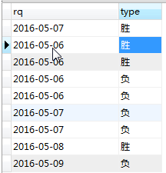
根据上面的记录,查询出下列结果出来:
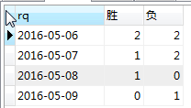

select t.rq,IFNULL(a.type,0) 胜,IFNULL(B.type,0) 负 from (select DISTINCT rq from tmp) t left join
(select rq,count(type) type from tmp where type='胜' GROUP BY rq) a on a.rq = t.rq
left join
(select rq,count(type) type from tmp where type='负' GROUP BY rq) b on b.rq = t.rq
order by t.rq

