GitHub link :

# Topic Brief:

A programming language is a Collection of commands, instructions, and other syntax use to create a software program. We use this Languages to write codes are called "high-level languages." This code can be compiled into a "low-level language," this codes is a language by that the computer understand us. As we can contact with the computer by using this language.

High-level languages As are designed to be easy to read and understand Symbols like <, >, ==, and != are common operators. Many high-level languages are similar enough to enable programmers to understand easily.

There are many languages include C, C++, Java, and PHP.

# Source Code:

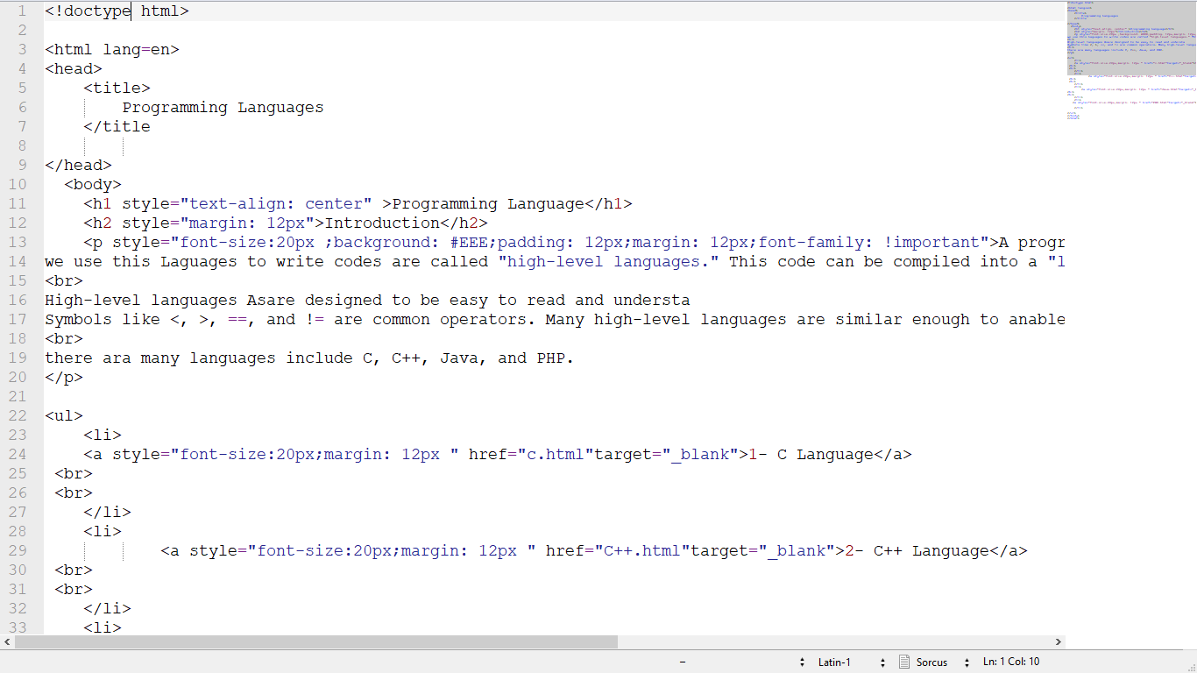

Home Page

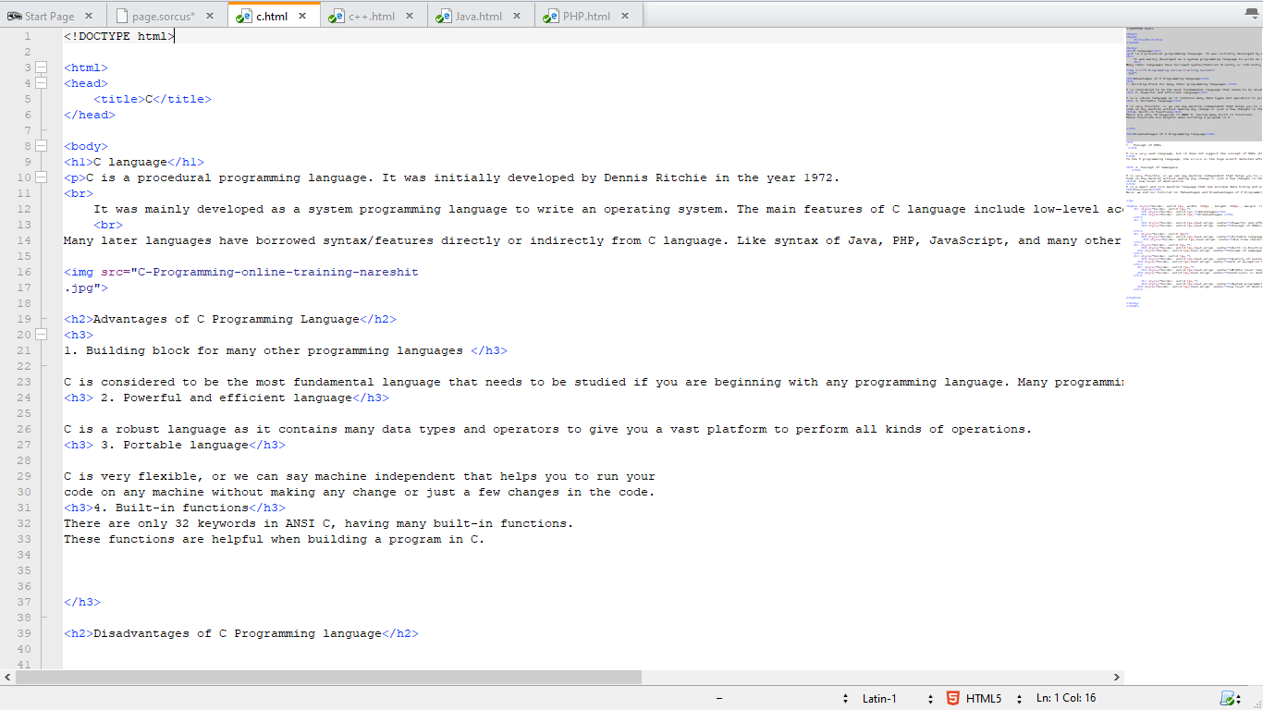

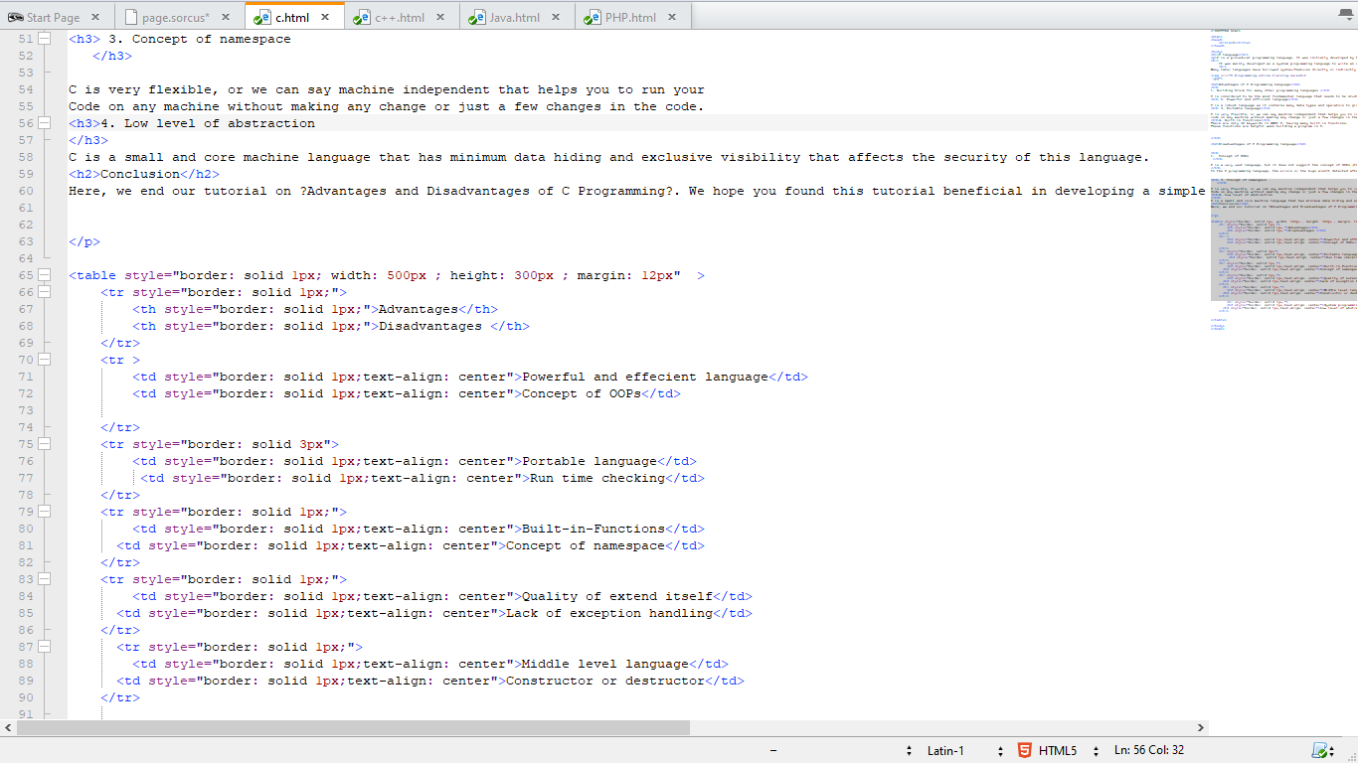

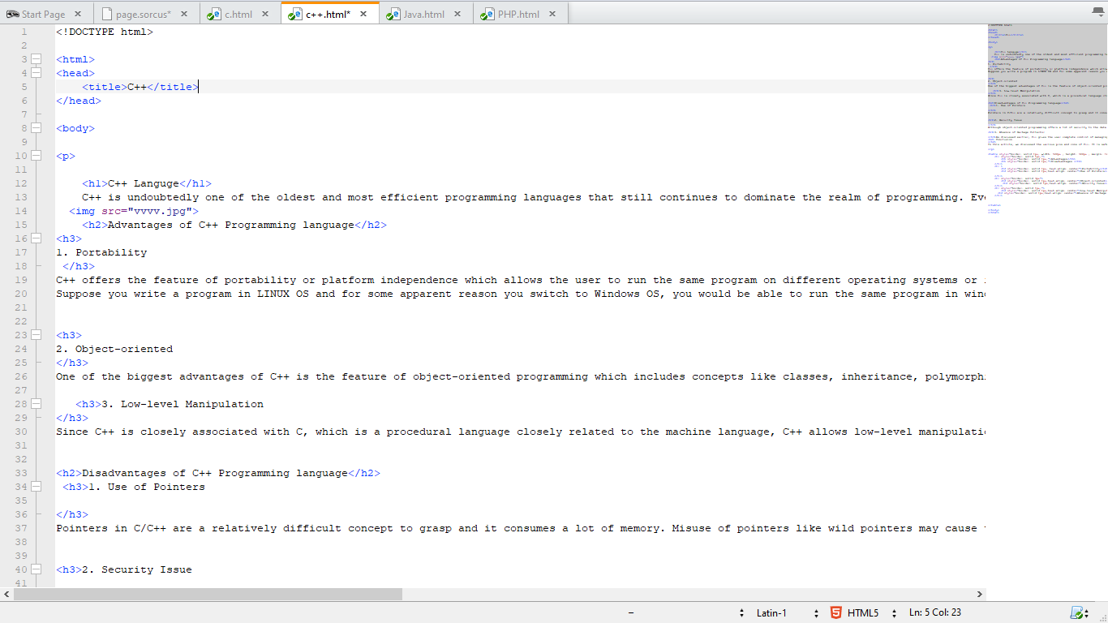

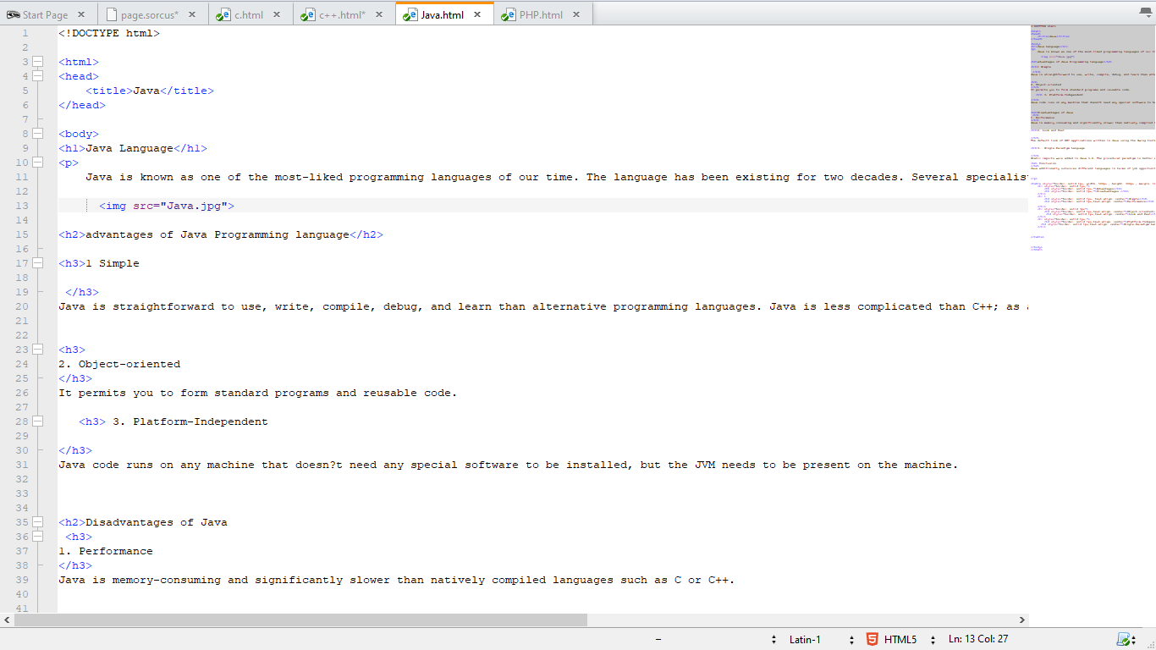

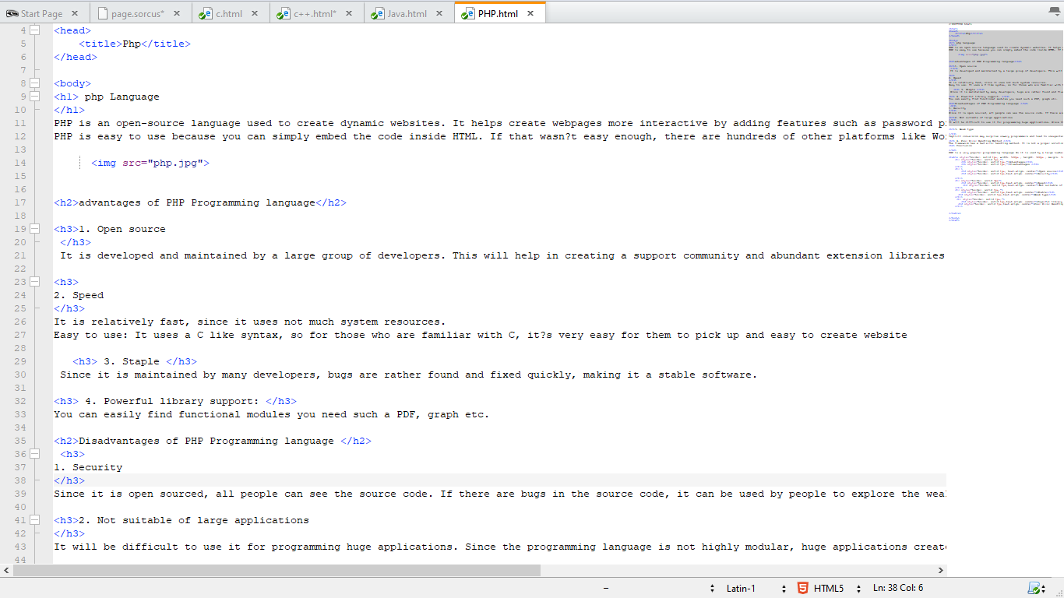

# Web Site Screenshots:

