

turtle Flower Power

Thomas J. Short



August 26, 2019

Sc4

CIS-260-01

Due

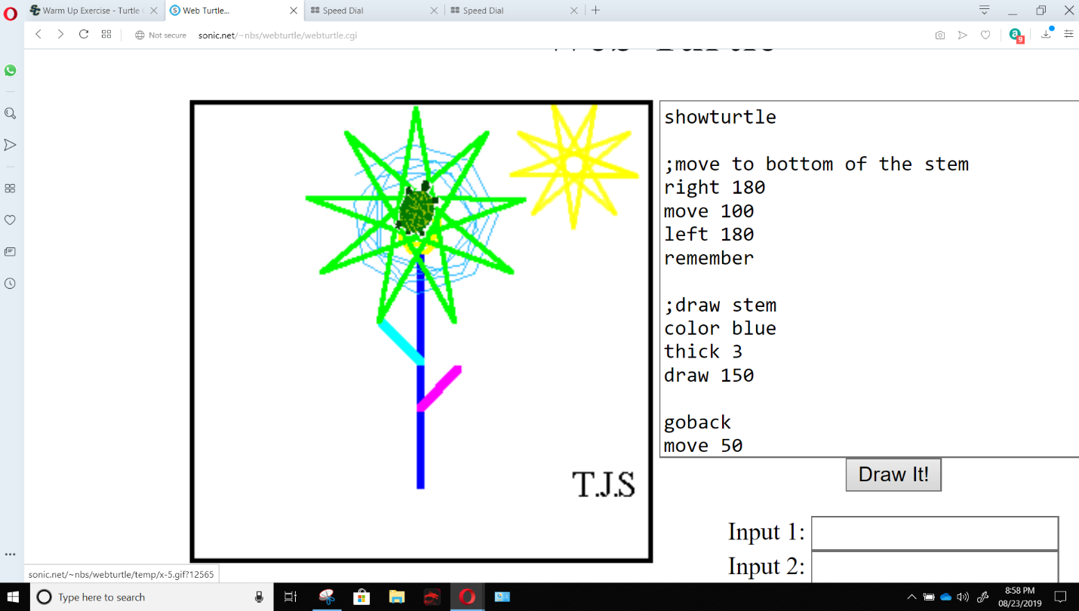

**Turtle Flower Power**

First, I had to show my turtle to help me understand my basic movement. I used some basic draw functions to draw my stem using the remember feature. Once I reached the top of my stem, I knew that I needed to move, turn and repeat. With some help from the examples, I was able to assign a variable and increment that variable resulting in a round circle spiral shape, similar to a sun flower.

I wanted to experiment with the transparency so I wrote the code again in a different color which would have been a great spot for some sort of loop maybe with the color incrementing by one. I Knew that might not impress so I want to draw a star pattern around the outer circle. This is where I spent Some time trying to only go around the circle, that did not happen. What resulted was the sun-like shape you see, which I had to move to the upper right corner of the page.

I feel I should have broken my code into smaller sequences and added more comments to help refer to and break up my code. I don’t really have any subroutines broken up in the right way, which I may have been able to do, and my looping could use some help. I hope to develop my understanding of looping, assigning variables, using functions. Fun exercise even though I am not too keen on drawing.