

Pirates Trading Post

Make Change



September 23, 2019

Thomas J. Short

Cis 260-01

Pirates Trading Post

**Requirements-**

Create a program for the Pirates Trading Post. The program must only accept Doubloons as currency, and it must return change to the user using the least amount of coins possible. It must clearly prompt the user to enter how much their item costed and how many Doubloons they will be paying with then calculate their change.

**Analysis-**

What is the problem?

The problem that we are trying to solve is how much change the pirates will receive after their purchase.

We need convert their doubloons into bits and then subtract the cost of their item to calculate a total and give least change as possible back.

How ill we know if the problem is solved.

We will know if the problem is solved if we get the correct amount of change while using the least amount of coins.

Test Set

|  |  |  |  |  |
| --- | --- | --- | --- | --- |
| **Pirate Trading Post Test Set** | **Cost of the item in Specified in (bits)** | **Number of (Doubloons) paid** | **Expected output from: (Bit, PeicesOfEight, Pistole, doubloon)** | **Rationale:** |
| **Test #1** | 127 | 1 | 1 bit  0 PoE  0 Pistole  0 Doubloon | 128 bits == 1 Doubloon so;  128 bits – 127 bits == 1 bit |
| **Test #2** | 120 | 1 | 0 bit  1 PoE  0 Pistole  0 Doubloon | 8 bits == 1 PoE so,  128 bits - 120 bits == 8 bits or  1 PoE |
| **Test #3** | 96 | 1 | 0 bit  0 PoE  1 Pistole  0 Doubloon | 1 Pistole == 32 bits so,  128 bits -96 bits == 32 bits  Or 1 Pistole |
| **Test #4** | 128 | 2 | 0 bit  0 PoE  0 Pistole  1 Doubloon | 2 Doubloons == 256 bits so,  256 bits – 128 bits == 128 bits or 1 Doubloon |
| **Test #5** | 128 | 1 | 0 bit  0 PoE  0 Pistole  0 Doubloon | 128 bits == 1 Doubloon so;  128 bits -128 bits == 0 bits or 0 Doubloons |
| **Test #6** | 128 | 0 | -1 bit  0 PoE  0 Pistole  0 Doubloon | 128 bits == 1 Doubloon so,  0 bits – 128 bits == -128 bits or  -1 Doubloon |

**Pirate Trading Post Results**

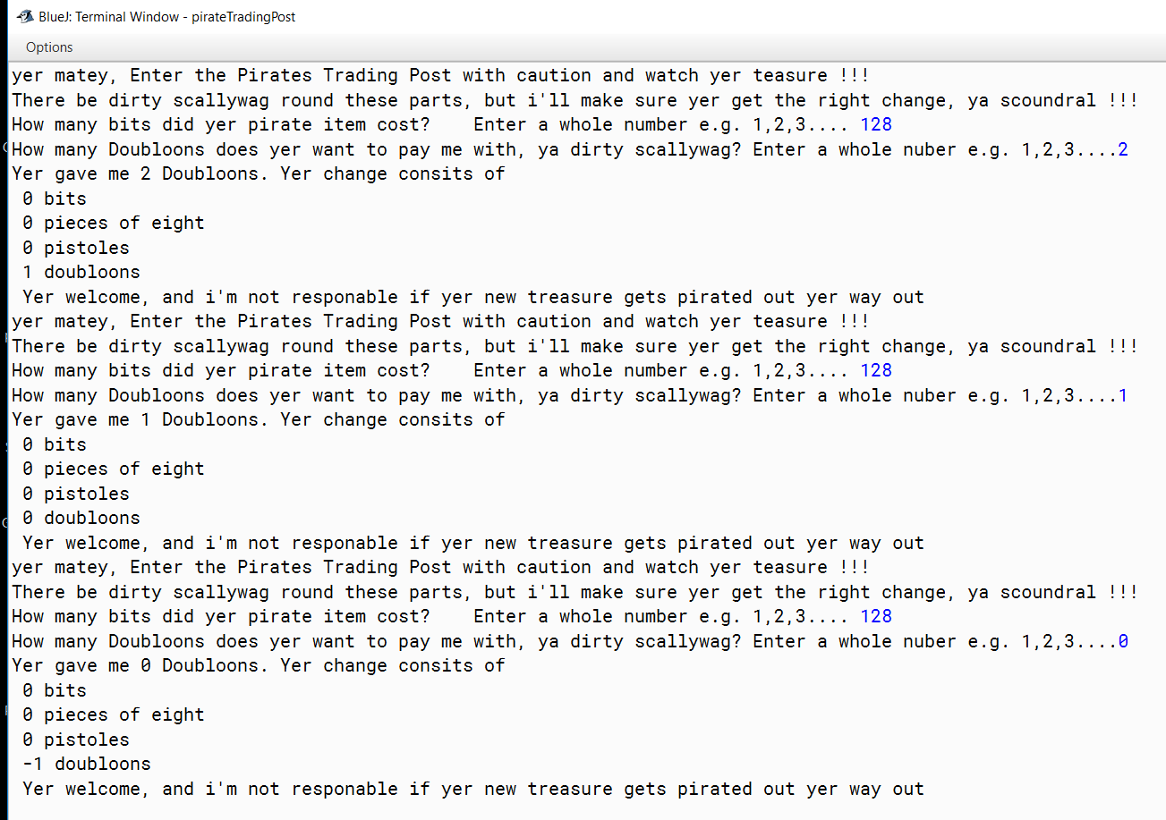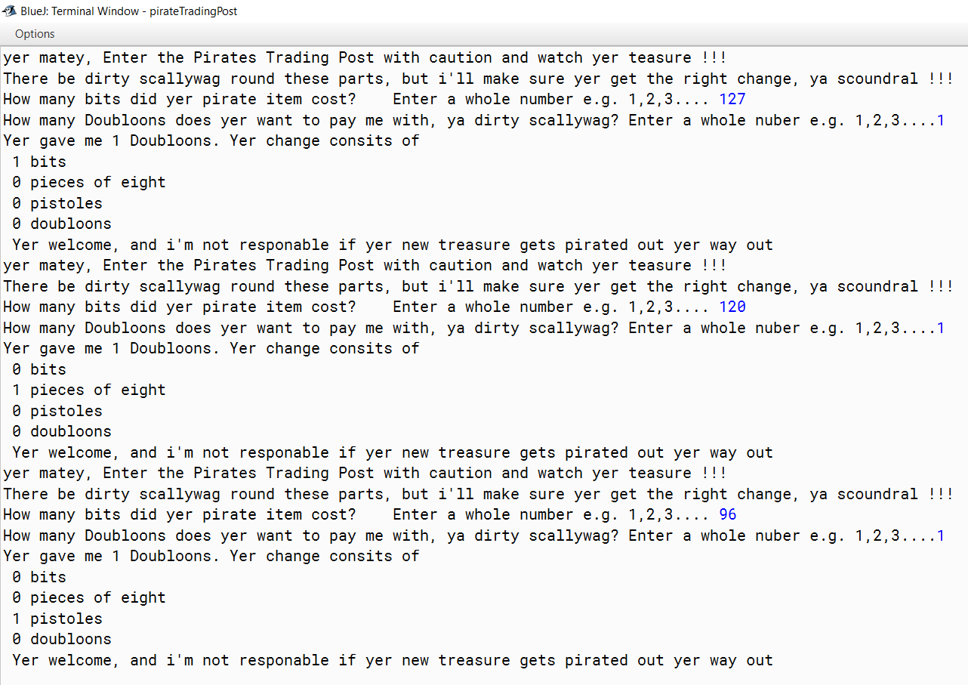

Pirate Algorithm

1. Import a scanner from java library == java.util.scanner
2. Make a public class for the pirates trading post == public class PirateTradingPost
3. Open a main method == public class void main (String[] args)
4. Create a new scanner object == Scanner input = new scanner(System.in)
5. Display greeting message for pirate trading post == system.out.println()
6. Prompt user for cost of their item in bits using integer #’s only (1,2,3...) and assign the user value = Item Cost
7. Prompt user for an integer number (1,2,3...) of doubloons he will be paying with and assign that value amount Paid
8. Convert the amount paid into bits.. Formula = ((amount paid) * 128) assign that value to the remaining amount.
9. Divide the remaining Amount by 128 and assign that value to doubloons
10. Obtain the remaining bits using the remainder %. (doubloons % 128) and assign that value to remaining amount
11. Find the amount of pistole by dividing the remaining amount by 32 and assign that value to the integer pistole.
12. Obtain the remaining bits using the remainder %. (pistole % 32) and assign that value to remaining amount
13. Find the amount of pieces of eight by dividing the remaining amount by 8 and assign that value to the integer pieces of eight.
14. Obtain the remaining bits using the remainder %. (pieces of eight % 8) and that value is the remaining bits
15. Display the result, your change is ...then display each piece of currency below that on separate line starting with the smallest currency first then work down to the biggest currency
16. Display a farewell message of your choosing (remember they are pirates. Yar, matey)