Laboratory Work 1 Caesar Cipher

1 Objective
The objective is to implement encryption and decryption for the 31-letter Romanian alphabet using the Caesar cipher and a keyword-based permutation. The program demonstrates reversible letter substitution, validates user input, and shows how changing the alphabet changes the ciphertext.

2 Short theory

2 1 Caesar cipher
The Caesar cipher replaces each plaintext letter with a letter a fixed number of positions further along the alphabet. Letters are encoded by their positions, starting from zero, rather than by ASCII or Unicode values. For the Romanian alphabet, n = 31 and the numeric key k is an integer from 1 to 30.
Encryption: c = (x + k) mod 31
Decryption: x = (c - k + 31) mod 31
Here x is the plaintext letter index and c is the ciphertext letter index. Modulo wraps the result around the alphabet. Adding 31 during decryption prevents a negative intermediate value for the allowed keys. There are only 30 possible nonzero keys, so trying every shift is practical.

2 2 Caesar cipher with a permutation
The second version uses a numeric shift and a keyword of at least seven letters. The unique keyword letters are written first in their original order, followed by the unused Romanian letters in their normal order. The same encryption and decryption formulas are then applied to positions in this permuted alphabet.
If every alphabet permutation is considered, the nominal number of permutation-and-shift pairs is 31! × 30, approximately 2.47 × 10³⁵. Different pairs can give the same substitution, so this is not the number of distinct encryption mappings. Practical keyword choices also reduce the effective search space.
Both versions are monoalphabetic substitutions: each occurrence of a letter produces the same ciphertext letter. Letter frequencies and repeated patterns remain visible. The keyword version makes a simple shift search harder when the keyword is unknown, but it is still vulnerable to frequency analysis and is unsuitable for modern confidential communication.

3 Implementation
The solution is a Java console application in the org.example package. The user selects the version, selects encryption or decryption, enters the numeric key, optionally enters a keyword, and then provides the text. StringBuilder is used to construct the alphabet and the result.

3 1 Romanian letter encoding
static final String ALPHABET =
"AĂÂBCDEFGHIÎJKLMNOPQRSȘTȚUVWXYZ";
int position = alphabet.indexOf(letter);
The string contains all 31 Romanian letters in the required order. For example, A has index 0, Ă has index 1, Â has index 2, and Z has index 30. In the keyword version, alphabet contains the permuted order, so indexOf returns the position in that order.

3 2 Numeric input validation
int number = Integer.parseInt(input.nextLine().trim());
if (number >= min && number <= max) return number;
// Otherwise, repeat the prompt and display:
System.out.println("Enter an integer from "
+ min + " to " + max + ".");
readNumber repeats until an integer in the required range is entered. The version and operation accept 1 or 2, while the shift accepts 1 through 30. NumberFormatException handles input that cannot be parsed as an integer; the supplied implementation also prints the exception stack trace before the range message.

3 3 Text normalization and validation
if (letter == ' ' && !keyword) continue;
String upper = String.valueOf(letter).toUpperCase(Locale.ROOT)
.replace('Ş', 'Ș').replace('Ţ', 'Ț');
if (upper.length() != 1 || !ALPHABET.contains(upper)) {
// Report the rejected character and ask for the text again.
valid = false;
break;
}
cleaned.append(upper);
Message spaces are removed, lowercase letters are converted to uppercase, and cedilla variants are normalized to Ș and Ț. Characters outside the alphabet are rejected. Spaces are not accepted in the keyword. An empty message is rejected, and the normalized keyword must contain at least seven letters before duplicate removal.

3 Implementation continued

3 4 Building the permuted alphabet
StringBuilder reordered = new StringBuilder();
for (char letter : (keyword + ALPHABET).toCharArray()) {
if (reordered.indexOf(String.valueOf(letter)) == -1) {
reordered.append(letter);
}
}
alphabet = reordered.toString();
The loop visits the keyword first and then the complete alphabet. A letter is appended only when it is not already present, preserving its first occurrence. Every Romanian letter therefore appears exactly once. The program prints the resulting alphabet so it can be checked manually.
For keyword WHATSUP, the resulting alphabet is:
WHATSUPĂÂBCDEFGIÎJKLMNOQRȘȚVXYZ

3 5 Encryption and decryption
int shift = operation == 1 ? key : -key;
StringBuilder result = new StringBuilder();
for (char letter : text.toCharArray()) {
int position = alphabet.indexOf(letter);
int newPosition = (position + shift + 31) % 31;
result.append(alphabet.charAt(newPosition));
}
Encryption uses a positive shift, while decryption uses its negative. The newPosition expression keeps the index between 0 and 30. The same loop works for both versions because only the alphabet order changes. Decryption requires the same numeric key and, for version 2, the same permuted alphabet.

4 Results overview
The four runs shown on the following pages demonstrate encryption and decryption for both versions. In the standard version, FACE encrypts to IBFH with key 3 and decrypts back to FACE. With keyword WHATSUP and key 3, JAVA encrypts to MUZU and decrypts back to JAVA. Uppercase output reflects the normalization step.

5 Conclusions
The examples demonstrate that both implementations recover the normalized plaintext when the same keys are used. The laboratory work illustrates alphabet indexing, modular arithmetic, keyword deduplication, and input validation. The standard cipher has only 30 keys. A permuted alphabet increases the search space, but the fixed letter substitution still reveals frequency patterns.

6 Source code
GitHub repository: [insert repository URL]

4 1 Standard Caesar cipher results
Numeric key 3 shifts each letter three positions in the Romanian alphabet. The screenshots show the complete encryption and decryption cycle.
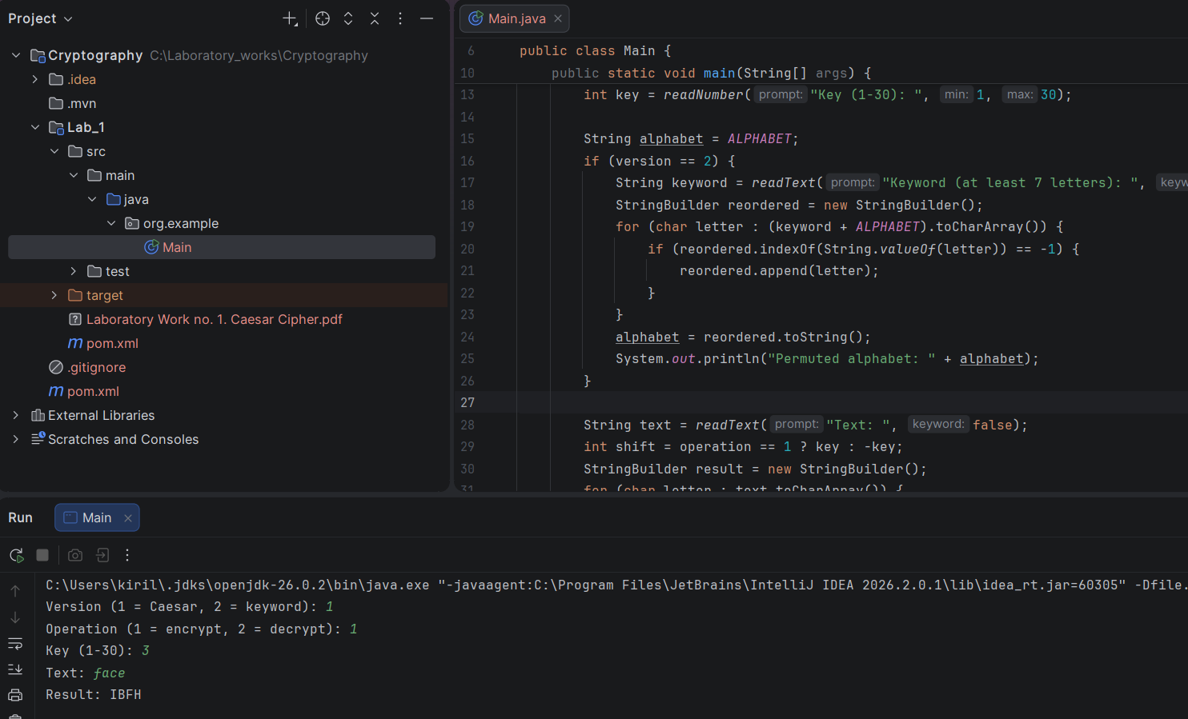
Figure 1. Version 1 encryption with key 3: face → IBFH.
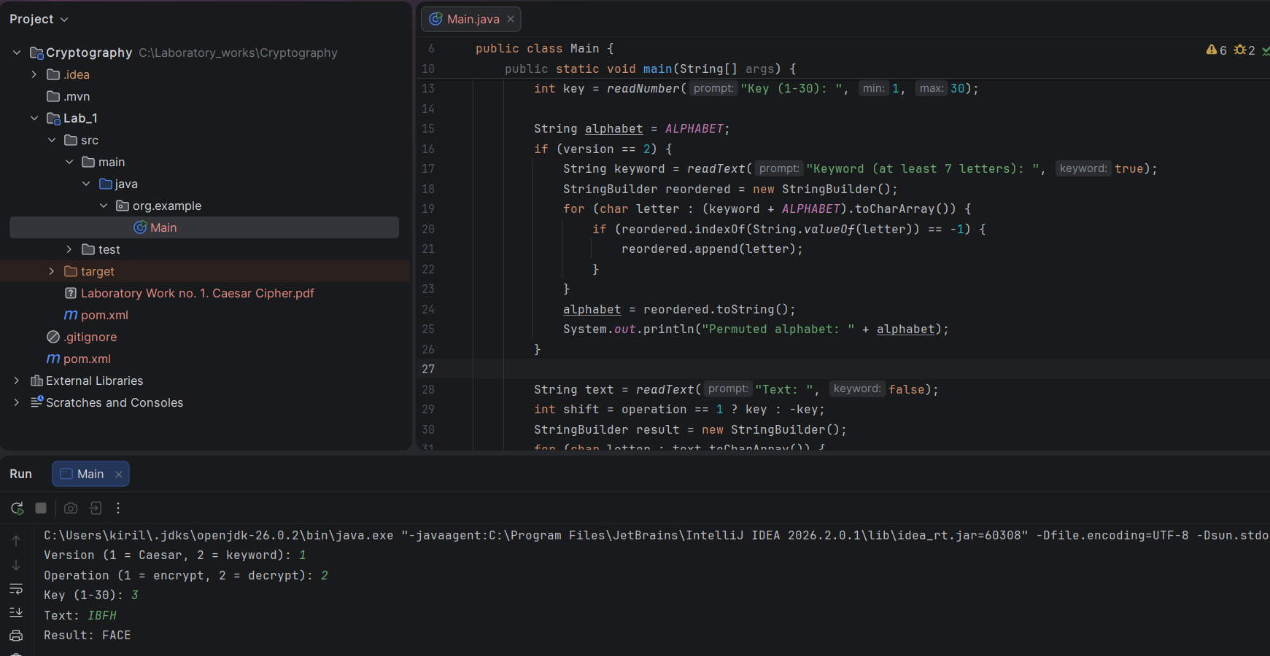
Figure 2. Version 1 decryption with key 3: IBFH → FACE.
Manual check: F → I, A → B, C → F, and E → H. The reverse shift restores FACE.

4 2 Keyword Caesar cipher results
The keyword whatsup is normalized to WHATSUP. Both operations use numeric key 3 and the same displayed permuted alphabet.
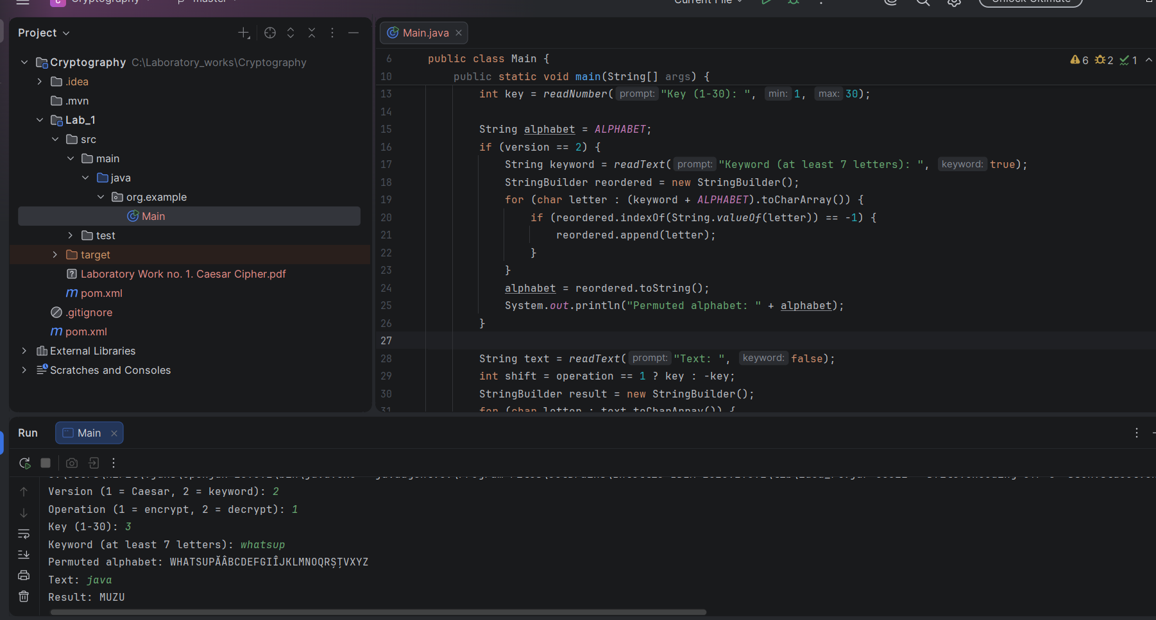
Figure 3. Version 2 encryption with keyword WHATSUP: java → MUZU.
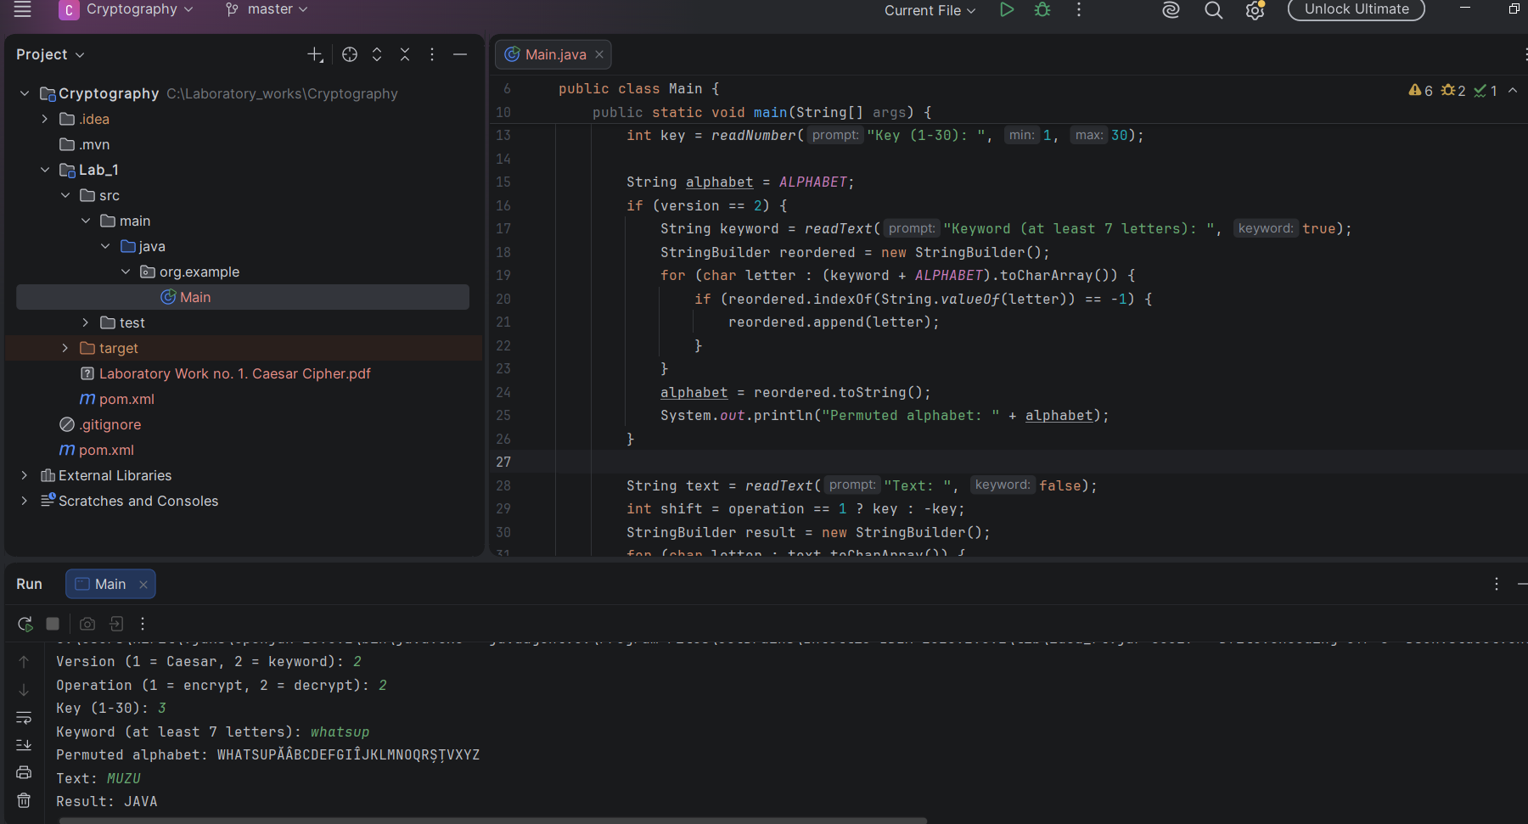
Figure 4. Version 2 decryption with keyword WHATSUP: MUZU → JAVA.
Manual check in the permuted alphabet: J → M, A → U, and V → Z. Applying the reverse shift restores JAVA.

