MINISTRY OF EDUCATION, CULTURE AND RESEARCH
OF THE REPUBLIC OF MOLDOVA
Technical University of Moldova
Faculty of Computers, Informatics and Microelectronics
Department of Software Engineering and Automation

Report
Laboratory work n.3
of Operating Systems

Kiril Boboc FAF-242
Verified by:
Reițman Patricia

Chisinau – 2026

Purpose of the work
To practice Bash command-line navigation, command discovery, shell expansions, redirection, command chaining, job control, pipelines and text filters; to write reusable scripts and schedule a script using cron.

Preparation
The provided course dataset was generated in ~/os-lab3/access.log. The first entries are 2026-10-05 10:01 user1 OK /page1, 10:02 user2 OK /page2 and 10:03 user3 OK /page3. Verification showed 500 lines and 100 FAIL records. The existing lab environment was used.

Part 1. Move fast, find help
Tab completion displayed matching paths for /usr/share and /etc. Bash history was tested with previously entered date, whoami and pwd commands. The type command identified cd and echo as shell built-ins; ls was aliased to ls --color=auto, with the external executable at /usr/bin/ls. The PATH output contained 10 entries (including /snap/bin twice). A nonexistent command returned 127. The man ls, ls --help, man -k and help cd commands were consulted; ls -t sorts by modification time.
Observe: cd must be built-in because changing directories in a child process would not change the current shell directory. PATH is searched for external executables. A command not found returns status 127.
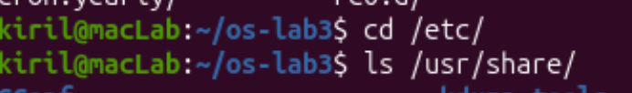
Figure 1.1 – Tab completion and path suggestions
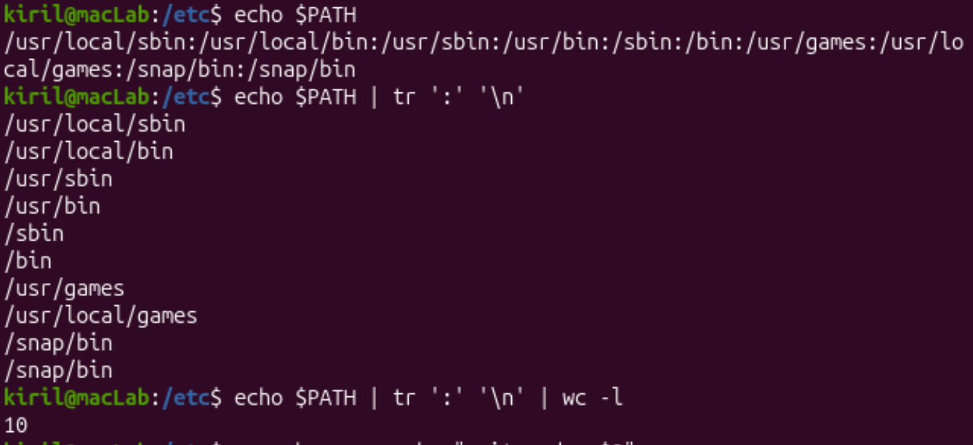
Figure 1.2 – Built-ins, alias and executable location

Figure 1.3 – Command-line completion exercise
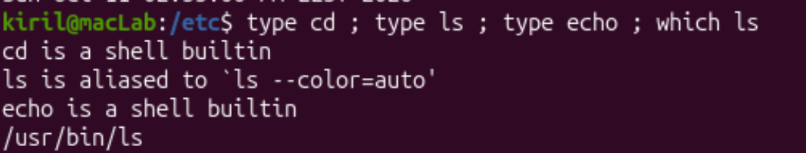
Figure 1.4 – Shell exploration
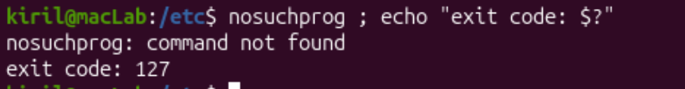
Figure 1.5 – Missing command returns exit code 127
Figure 1.6 – PATH entries and directory count
Observe 1. Which of cd, ls, echo are built-ins, and why MUST cd be one?
Answer: cd and echo are shell built-ins; ls resolves to an alias for the external /usr/bin/ls. cd must execute in the current shell to change its working directory.
Observe 2. How many directories are in your PATH, and in which one is ls?
Answer: The terminal counted 10 PATH entries (including a repeated /snap/bin). ls is located at /usr/bin/ls.
Observe 3. What exit code does a command that is not found return?
Answer: 127, as observed for nosuchprog.
Observe 4. Which option of ls sorts by modification time?
Answer: -t (newest modification time first).

Part 2. What the shell does to a command line
Test files were created in ~/os-lab3/play. The predictions below are the predictions recorded in the supplied lab notes; the observed results were compared against them.
Command | Prediction | Observed result
echo *.c | a.c b.c | a.c b.c
echo file?.txt | file1.txt file2.txt | file1.txt file2.txt
echo [a-b]* | a.c alfa beta.txt b.c | a.c alfa beta.txt b.c
echo *.xyz | *.xyz | *.xyz
ls alfa beta.txt | Two missing-file errors | Two missing-file errors
ls "alfa beta.txt" | One filename | File shown as quoted name
echo '$HOME' "$HOME" \$HOME | $HOME /home/kiril $HOME | $HOME /home/kiril $HOME
echo {1..5}; echo $((7 * 6)) | 1 2 3 4 5; 42 | 1 2 3 4 5; 42
echo "today is $(date +%A), I am $(whoami)" | Weekday and kiril | today is Sunday, I am kiril
touch log{1..3}.txt && ls log* | log1.txt log2.txt log3.txt | Not shown in submitted evidence
Observe: Filename patterns are expanded by Bash before echo receives arguments. The unquoted space in alfa beta.txt creates two arguments; quoting the entire name or escaping the space fixes the error. Single quotes prevent expansion; double quotes allow variable and command substitution. The quotes displayed by ls are output formatting, not part of the filename.
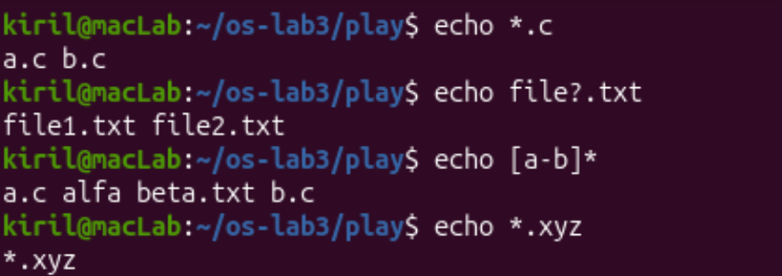
Figure 2.1 – Files in the play directory
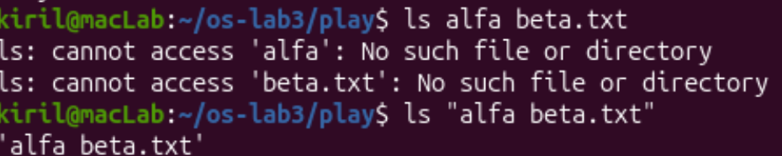
Figure 2.2 – Globbing expansion results
Figure 2.3 – Filename with a space: error and correction
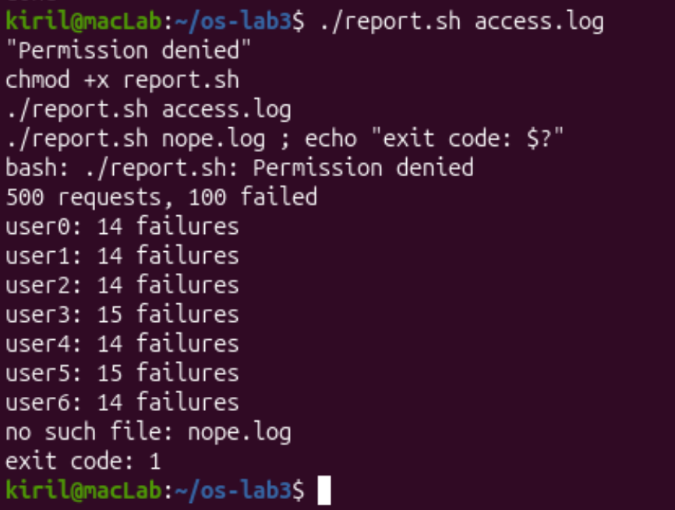
Figure 2.4 – Quoting and HOME expansion
Observe 1. For each of the ten PREDICT lines, what were your prediction and real output?
Answer: The prediction-versus-result table above records all ten commands. The final log{1..3} command is a reference expectation because its terminal output was not supplied.
Observe 2. echo knows nothing about files, yet echo *.c printed file names. Who produced them?
Answer: Bash expands the *.c wildcard into matching filenames before echo is executed.
Observe 3. Why did ls alfa beta.txt fail? Give two different ways to fix it.
Answer: The unquoted space splits the name into two arguments. Use ls "alfa beta.txt" or ls alfa\ beta.txt.
Observe 4. What is the difference between single and double quotes?
Answer: Single quotes preserve literal text; double quotes allow variable and command substitution while preventing ordinary word splitting. ls may quote a filename containing spaces to show its boundaries unambiguously; the quote marks are not part of the name.

Part 3. Redirection, chaining and jobs
Running ls /etc /nope > out.txt 2> err.txt produced 238 listing lines in out.txt and a missing-file error in err.txt. The test of redirection order showed that > all.txt 2>&1 captures the error in the file (grep count 1), while 2>&1 > all.txt leaves stderr on the terminal (grep count 0). The input redirection wc -l < access.log printed 500 without the filename.
Observe: Redirections are evaluated from left to right. The semicolon runs the following command regardless of status; && runs it on success; || runs it on failure. A nonexistent /nope returned code 2. The sleep 100 & process was started as a background job, listed with jobs, and terminated with kill %1.
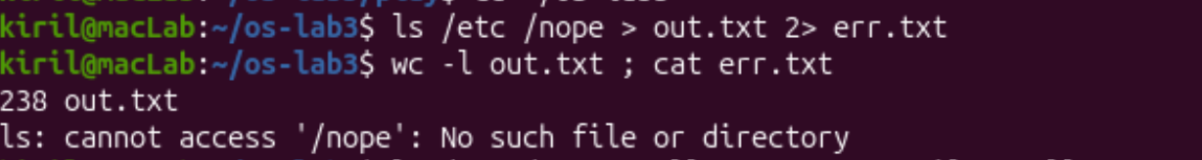
Figure 3.1 – stdout and stderr separated
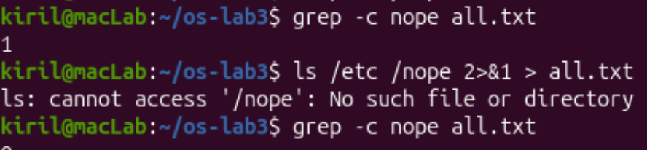
Figure 3.2 – Effect of redirection order
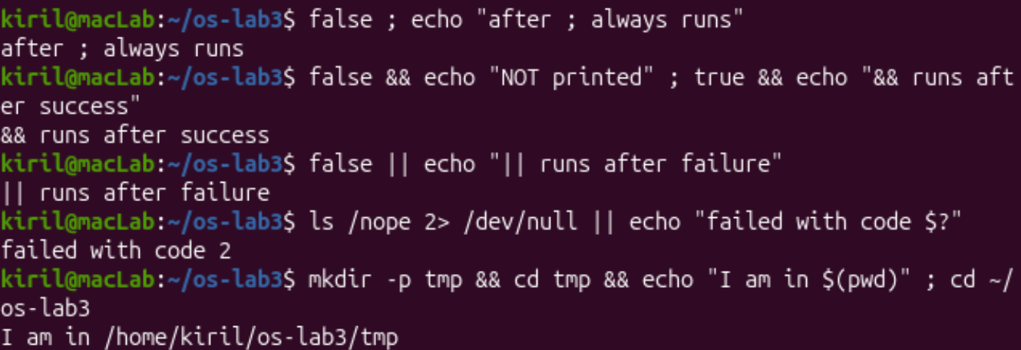
Figure 3.3 – Semicolon, AND and OR operators
Background job evidence is recorded in the terminal notes: [1] 8830; jobs reported Running, then Terminated after kill %1.
Observe 1. Which file got the error message, and which got the listing?
Answer: err.txt received the missing-/nope error; out.txt received the /etc listing (238 lines in the screenshot).
Observe 2. What is the difference between > all.txt 2>&1 and 2>&1 > all.txt? Why?
Answer: In the first order both streams go to all.txt. In the second order stderr stays connected to the terminal while stdout goes to all.txt. Bash processes redirections left to right.
Observe 3. Why does wc -l < access.log print only a number, while wc -l access.log also prints the file name?
Answer: With < the file is connected to standard input, so wc receives no filename argument; with access.log as an argument, wc prints the name too.
Observe 4. Explain each operator in one sentence: ; && ||.
Answer: ; runs the next command regardless of success; && runs it only if the previous command succeeds; || runs it only if the previous command fails.

Part 4. Questions answered using one-liners
Question | Result / explanation
Q1 | 100 failed requests
Q2 | 4 pages: /page0, /page1, /page2, /page3
Q3 | 125 requests for each page (total 500)
Q4 | user3 and user5 tie with 15 failures each
Q5 | user3 made 72 requests; 15 failed
Q6 | 10:10 user0; 10:15 user5; 10:20 user3
Q7 | Command: cut -d: -f7 /etc/passwd | sort | uniq -c | sort -rn. Actual machine-specific counts were not supplied.
Q8 | ls -l /etc includes an additional total line, so its line count is one higher.
Bonus | The minute-ends-in-zero AND FAIL filter matches 50 lines in the specified generated dataset.
The submitted oneliners.sh uses grep, cut, sort, uniq, wc, tail, paste and awk. Q4 correctly filters the maximum tied counts. Q3 sums to 500; the seven per-user failure counts sum to 100. A partial execution screenshot/transcript confirms Q1–Q3 and the file creation, but the complete Q1–Q8 terminal run was not supplied.
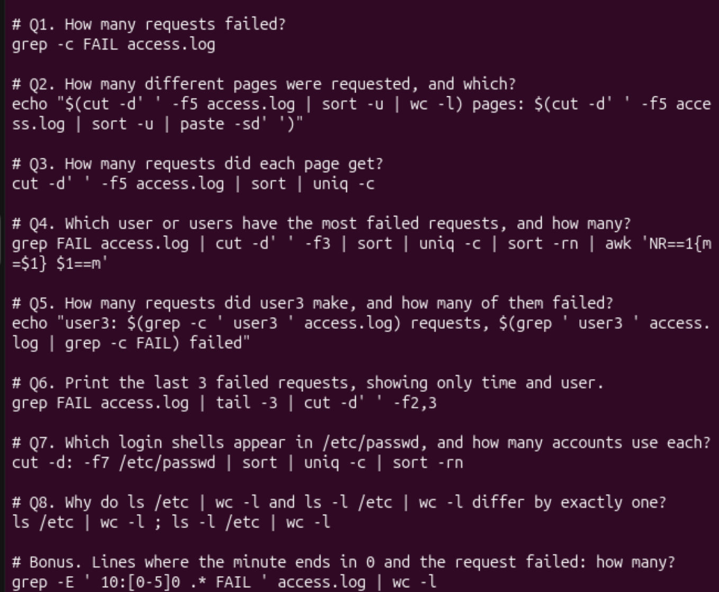
Figure 4.1 – Contents of oneliners.sh
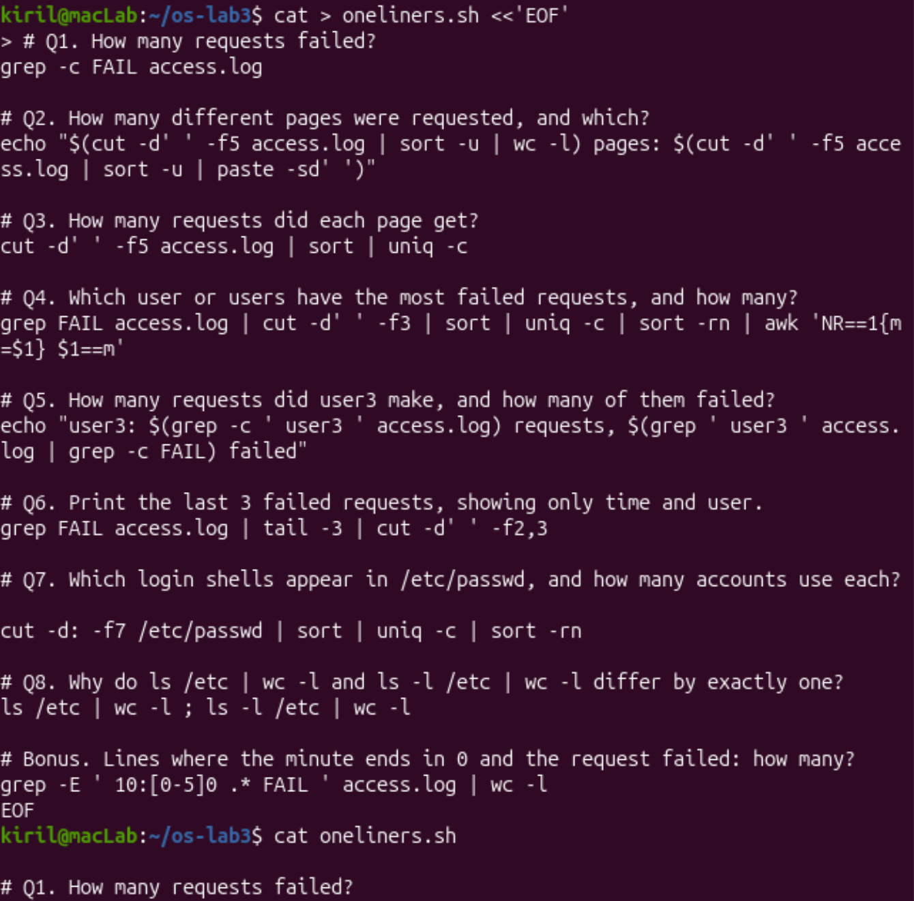
Figure 4.2 – Creating oneliners.sh
Q1. How many requests failed?
Answer: 100 (grep -c FAIL access.log).
Q2. How many different pages were requested, and which?
Answer: Four: /page0, /page1, /page2, /page3.
Q3. How many requests did each page get?
Answer: 125 per page, totaling 500.
Q4. Which user or users have the most failed requests, and how many?
Answer: user3 and user5 tied at 15 failures each.
Q5. How many requests did user3 make, and how many of them failed?
Answer: 72 requests; 15 failed.
Q6. Print the last 3 failed requests, showing only time and user.
Answer: 10:10 user0; 10:15 user5; 10:20 user3 (computed from the specified 500-line generator; compare with the local run).
Q7. Which login shells appear in /etc/passwd, and how many accounts use each?
Answer: Use cut -d: -f7 /etc/passwd | sort | uniq -c | sort -rn. The actual shell counts were not visible in the submitted screenshots, so no system-specific numbers are asserted.
Q8. PREDICT, then explain: why do ls /etc | wc -l and ls -l /etc | wc -l differ by exactly one?
Answer: Prediction: the long listing has one additional line. Explanation: ls -l prints a leading total line containing the total allocated blocks; plain ls does not.
Bonus (+1). With grep -E, print failed lines where the minute ends in 0. How many?
Answer: 50 matching requests in the generated dataset. Command: grep -E "10:[0-5]0 .* FAIL " access.log | wc -l.

Part 5. First Bash script
report.sh checks for a valid log argument, calculates total and failed requests, and iterates through user0–user6 to report failure counts. Before chmod +x, direct execution failed with Permission denied. After chmod +x, the script reported 500 requests and 100 failed, followed by counts 14, 14, 14, 15, 14, 15, 14. A missing file printed no such file: nope.log and exited with code 1.
Observe: #!/bin/bash selects Bash as interpreter. ./ explicitly executes a file in the current directory because . is normally not in PATH. >&2 directs errors to stderr and exit 1 signals failure.
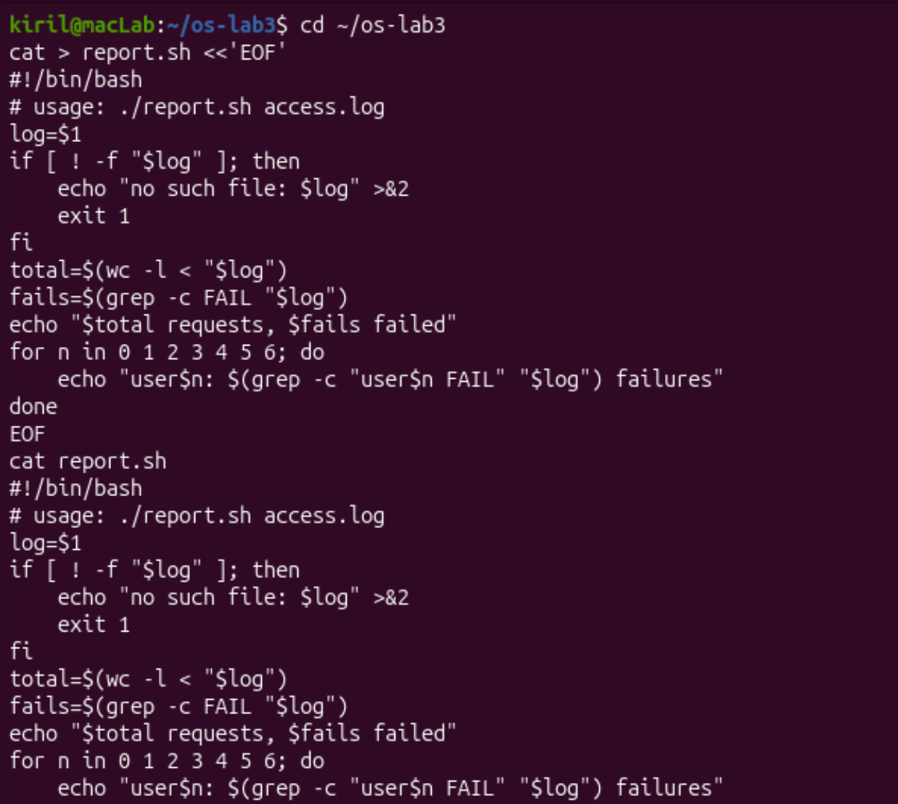
Figure 5.1 – Source code of report.sh
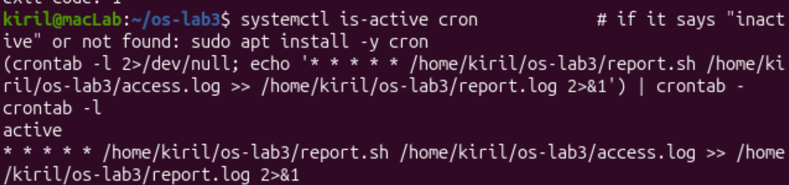
Figure 5.2 – Successful script and missing-file handling
Observe 1. What does #!/bin/bash do, and what happens before chmod +x?
Answer: The shebang chooses Bash as the interpreter. Direct execution before chmod +x produces Permission denied, as shown.
Observe 2. Why type ./report.sh instead of just report.sh?
Answer: ./ specifies the current directory; the current directory is normally not searched via PATH.
Observe 3. Why use >&2 and exit 1?
Answer: >&2 sends an error to standard error, while exit 1 returns a nonzero status to signal failure.

Bonus: cron scheduling
The cron service was active. A once-per-minute crontab entry invoked /home/kiril/os-lab3/report.sh with the absolute access.log path and appended both output streams to report.log. The provided log shows four repeated successful report blocks. The crontab was subsequently removed, with no crontab for kiril reported.
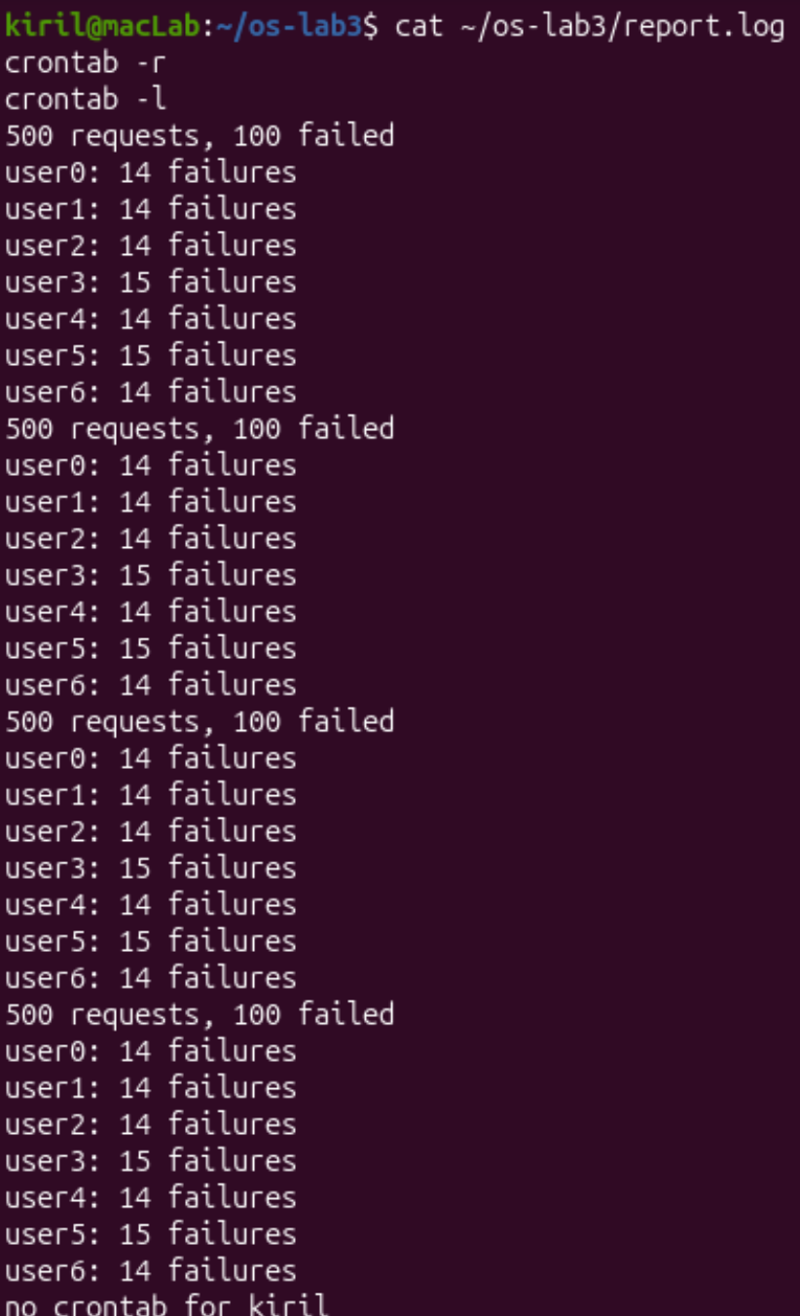
Figure 5.3 – Cron entry and active service
Figure 5.4 – Command operators (additional evidence)
Bonus (+1). Run report.sh every minute with cron, append to report.log, show the log, then remove the cron entry.
Answer: The screenshot shows an active cron service and an every-minute entry: * * * * * /home/kiril/os-lab3/report.sh /home/kiril/os-lab3/access.log >> /home/kiril/os-lab3/report.log 2>&1. The log shows multiple successful 500/100 reports; the final “no crontab for kiril” confirms removal.

Conclusions
The lab demonstrated how Bash parses and expands commands before execution, how input and output streams are routed, and how pipes combine small utilities into useful data analyses. The scripted log analysis correctly counted 500 requests and 100 failures and handled missing input files. The cron bonus demonstrated scheduled execution and output logging. Results requiring machine-specific output should be taken from the actual machine rather than inferred.

