
MINISTRY OF EDUCATION, CULTURE AND RESEARCH
OF THE REPUBLIC OF MOLDOVA
Technical University of Moldova
Faculty of Computers, Informatics and Microelectronics
Department of Software Engineering and Automation
Kiril Boboc FAF-242
Report
Laboratory work n.8
of Operating Systems
The Same Calls, Inside Your Own OS (xv6)
Verified by:
Reițman Patricia
Chisinau – 2026

Contents
Part 1. run, inside xv6 3
Part 2. pingpong 5
Conclusion 6

Lab 8 Report: The Same Calls, Inside Your Own OS
Setup: the work was done in the ~/xv6-riscv tree (xv6 for RISC-V, built with riscv64-linux-gnu-gcc and run in QEMU) in the Ubuntu terminal of the host macLab, user kiril. Every new program is a file user/NAME.c plus one line $U/_NAME\ in the UPROGS list of the Makefile. xv6 is left with Ctrl-A, then X.
Command | What it does
cd ~/xv6-riscv | Enters the xv6 source tree.
make qemu | Builds the kernel and all user programs, creates the disk image fs.img and starts xv6 in QEMU; the xv6 shell prompt is $.
sed -i 's|^\t\$U/_zombie\\$|\t$U/_zombie\\\n\t$U/_run\\\n\t$U/_pingpong\\|' Makefile | Adds the lines for run and pingpong to UPROGS, right after $U/_zombie (each starts with a TAB).
grep -n -P '^\t\$U/_(zombie|run|pingpong)\\$' Makefile | Checks that the three lines are in the Makefile.

Interesting output:
152: $U/_zombie\
153: $U/_run\
154: $U/_pingpong\

Observed: the Makefile now builds run and pingpong; in the mkfs line of make qemu they appear as user/_run and user/_pingpong, which means they are put into the xv6 disk image.

Part 1. run, inside xv6
user/run.c is the same program as run.c in Lab 7, written for xv6: there is no glibc here, only the system calls of the kernel I compiled. The parent forks, the child becomes echo, and the parent waits. Because the next steps change only two lines, I edited the file with sed and restored the echo version at the end.
Command | What it does
cat > user/run.c <<'EOF' ... EOF | Creates user/run.c with the code of the lab (fork, exec("echo", args), wait).
make qemu then run | Rebuilds and starts xv6, then runs the program run at the xv6 prompt.
sed -i 's|char \*args\[\] = { "echo", ... };|char *args[] = { "ls", 0 };|; s|exec("echo", args);|exec("ls", args);|' user/run.c | Changes the two lines so that the child becomes ls.
sed -i 's|exec("ls", args);|exec("nosuchprog", args);|' user/run.c | Asks exec for a program that does not exist.
grep -n -E 'args|exec' user/run.c | Shows the changed lines to prove the edit.

Step 1. The child becomes echo
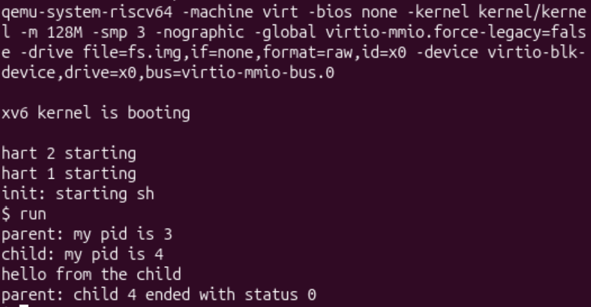
Figure 1.1. xv6 boots and run executes echo in the child
Interesting output:
$ run
parent: my pid is 3
child: my pid is 4
hello from the child
parent: child 4 ended with status 0

Step 2. The child becomes ls
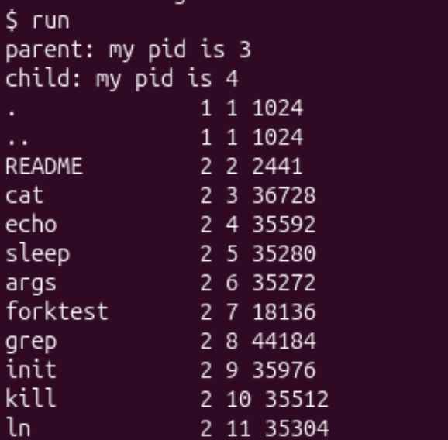
Figure 1.2. run with exec("ls", args): the listing of the xv6 disk
Interesting output:
$ run
parent: my pid is 3
child: my pid is 4
. 1 1 1024
...
run 2 23 35888
pingpong 2 24 34888
...
parent: child 4 ended with status 0

Step 3. A program that does not exist
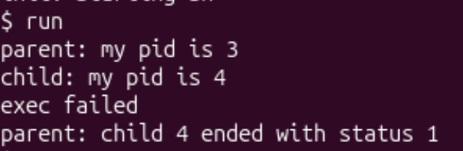
Figure 1.3. run with exec("nosuchprog", args)
Interesting output:
$ run
parent: my pid is 3
child: my pid is 4
exec failed
parent: child 4 ended with status 1

Observed: the lines "parent", "child" and the output of the program always come in this order, and the new programs run and pingpong are in the ls listing (inode numbers 23 and 24). After the experiments I restored exec("echo", args), and the last run again printed "hello from the child".
Observe: Part 1
1. Write the three calls that run.c uses in xv6 and the three calls run.c used on Linux in Lab 7. What is the same?
xv6: fork(), exec("echo", args), wait(&status). Linux: fork(), execlp("ls", "ls", "-l", NULL), waitpid(pid, &status, 0). What is the same is the idea and the order: fork makes a copy and returns 0 in the child and the child PID in the parent; exec replaces the child with another program and does not return on success; wait makes the parent wait until the child ends and gives its exit status. Only the details differ: on Linux execlp is a library function that searches the program in PATH and waitpid can choose a child and needs WEXITSTATUS, while xv6 has the simple system calls directly, with the argument array ending in 0.
2. Who prints "hello from the child": the code of run, or echo?
`echo` does. The code of run prints only the two "pid" lines and calls exec. After a successful exec the child is no longer run: its memory holds the program echo, which prints its arguments ("hello from the child") and ends.
3. Why is the status 1 here and 127 on Linux? (Look at the exit line after exec in both programs.)
Because the two programs end differently after the failed exec: in xv6 the line is exit(1) (after printing "exec failed"), in the Linux program it was exit(127) (after perror). The parent just prints the number that the child gave to exit. The value 127 on Linux is the shell's convention for "command not found"; the lab code for xv6 chooses 1.

Part 2. pingpong
user/pingpong.c makes two processes talk through two pipes: the parent sends one byte to the child through p2c, the child prints "received ping" with its own pid and sends the byte back through c2p, and the parent prints "received pong" and waits for the child. I completed the TODO lines with read(fd, &b, 1) and write(fd, &b, 1), and the parent first sets b = 'x' because the variable is not initialised.
Command | What it does
cat > user/pingpong.c <<'EOF' ... EOF | Creates pingpong.c with the two pipes and the read/write calls (it replaces an empty placeholder with exit(0) that I used to make the first build work).
make qemu then pingpong | Rebuilds and starts xv6, then runs the program at the xv6 prompt.

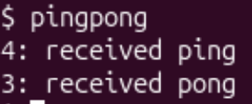
Figure 2.1. pingpong in xv6
Interesting output:
$ pingpong
4: received ping
3: received pong

Observed: "ping" comes first and from the child (pid 4), and "pong" second from the parent (pid 3), as required.
Observe: Part 2
1. Why do you need TWO pipes, and not one for both directions?
A pipe is one-directional: bytes written into one end are read from the other end, in order. If both processes used the same pipe, each could read the byte that it wrote itself: after its write, the parent could immediately read its own byte back before the child has seen it, and the child would then wait forever. With two pipes every direction has its own channel (p2c for parent to child, c2p for child to parent), so each byte goes only to the other process.
2. Nothing in your code says "wait until the child has replied". Which call makes the parent wait?
The `read(c2p[0], &b, 1)` in the parent. When the pipe is empty, read blocks (the process sleeps) until some data arrives, i.e. until the child has done write(c2p[1], &b, 1); only then does the parent print "received pong". The later wait(0) only collects the finished child.

Conclusion
In this lab I ran inside xv6, the small OS I build, the same programs as on Linux. run showed that the three calls are the same: fork copies the process, exec turns the child into another program (echo, then ls) and wait collects it. A program that does not exist makes exec return, so the child prints "exec failed" and ends with the status 1 chosen in the code (127 in the Linux version); the numbers 3 and 4 are simply the pids that xv6 gave to the parent and the child.
With pingpong two processes talked through pipes. Each pipe works in only one direction, so the exchange needs two of them, and the blocking read is what makes the parent wait for the answer without any other synchronisation. Together with Lab 7 this shows that the system calls of a real OS and of my own small OS have the same meaning: the difference is only in how much the library hides.

