
MINISTRY OF EDUCATION, CULTURE AND RESEARCH
OF THE REPUBLIC OF MOLDOVA
Technical University of Moldova
Faculty of Computers, Informatics and Microelectronics
Department of Software Engineering and Automation

Report
Laboratory work n.10
of Operating Systems

Kiril Boboc FAF-242
Verified by:
Reițman Patricia

Chisinau – 2026

Purpose of the work
To add a new system call, trace, to xv6. A process sets a mask with trace(mask); after that, the kernel prints every system call whose number is switched on in the mask, together with the process id and the return value. The work follows the number 23 from a user program down to a function in the kernel.

Part 1. The number and the user side
The call received the number 23 (22 is already used by sync). Five edits were made: the number, the declaration, the stub, the user program and the Makefile entry.
File | Change
kernel/syscall.h | #define SYS_trace 23
user/user.h | int trace(int);
user/usys.pl | entry("trace"); (generates the stub: li a7, SYS_trace; ecall; ret)
user/trace.c | Sets the mask with trace(atoi(argv[1])), then runs the command with exec; the mask is kept because exec keeps the process
Makefile | $U/_trace\ added to UPROGS

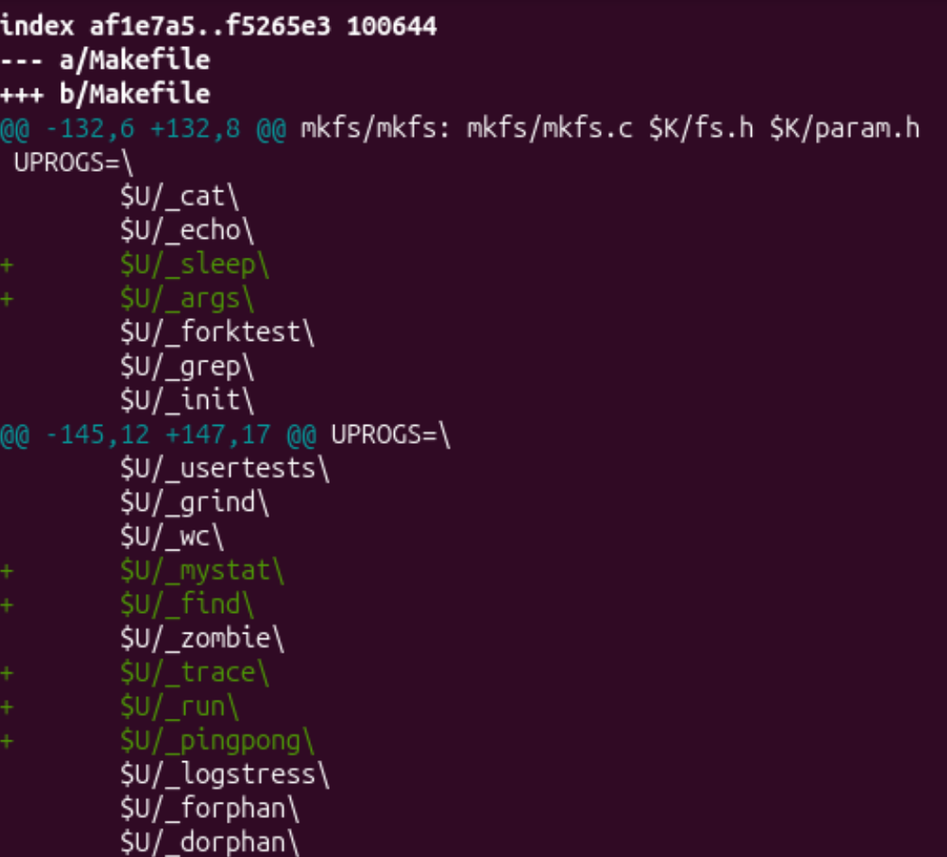
Figure 1.1 – git diff of the Makefile: $U/_trace added to UPROGS

Part 2. The kernel side
File | Change
kernel/proc.h | int trace_mask; added to struct proc
kernel/sysproc.c | sys_trace() reads argument 0 with argint and stores it in myproc()->trace_mask
kernel/syscall.c | extern declaration and table entry [SYS_trace] = sys_trace; table syscallnames[] placed above syscall(); two lines in syscall() that print after the call
kernel/proc.c | np->trace_mask = p->trace_mask; in the fork function (kfork in this tree)

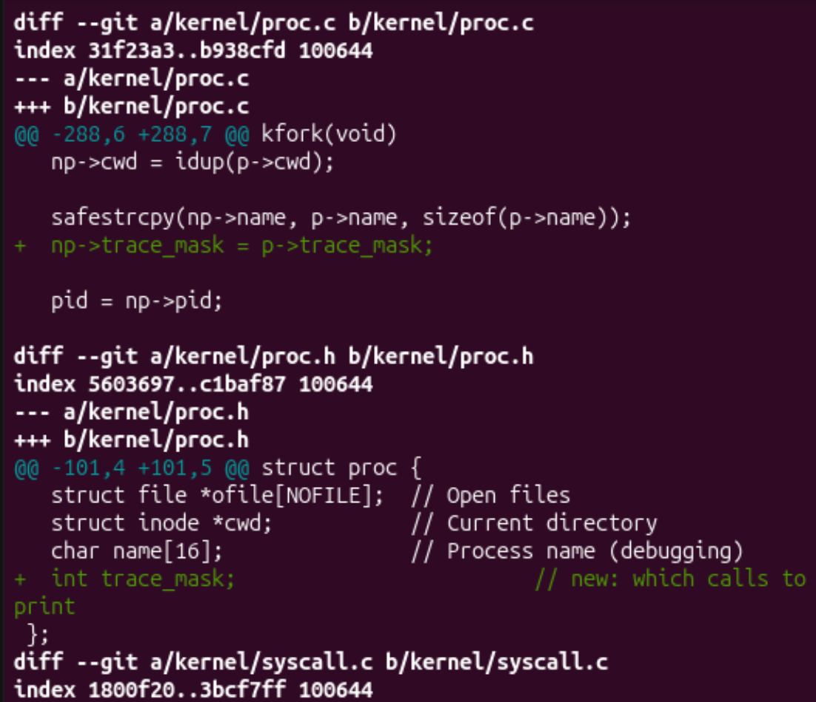
Figure 2.1 – git diff of kernel/proc.c and kernel/proc.h: trace_mask added and inherited in fork
p->trapframe->a0 = syscalls[num]();
+ if ((p->trace_mask >> num) & 1)
+ printk("%d: syscall %s -> %ld\n",
+ p->pid, syscallnames[num], p->trapframe->a0);

Figure 2.2 – Print added in syscall() (git diff, kernel/syscall.c)
uint64
sys_trace(void)
{
int mask;
argint(0, &mask);
myproc()->trace_mask = mask;
return 0;
}

Figure 2.3 – sys_trace() (kernel/sysproc.c)
The print is placed after the call, so the return value is already in a0. The kernel in this tree uses printk, not printf. After rebuilding with make qemu, the required test was run:
$ trace 32 grep hello README
3: syscall read -> 1023
3: syscall read -> 965
3: syscall read -> 453
3: syscall read -> 0

Figure 2.4 – trace 32 grep hello README
The numbers are 1023 + 965 + 453 = 2441, the size of README, read in three pieces, followed by 0 for the end of the file.

Part 3. Playing with the mask
The mask is read in binary: bit N on means "print system call number N".
Command | Mask bits | Result
trace 2147483647 grep hello README | all bits on | trace, exec, open, read x4, close
trace 2 usertests forkforkfork | bit 1 (fork) | Only fork lines, from several processes; the last two return -1; ALL TESTS PASSED
trace 65536 echo hi | bit 16 (write) | Two write lines: -> 2 and -> 1

4: syscall trace -> 0
4: syscall exec -> 3
4: syscall open -> 3
4: syscall read -> 1023
4: syscall read -> 965
4: syscall read -> 453
4: syscall read -> 0
4: syscall close -> 0

Figure 3.1 – trace 2147483647 grep hello README
usertests starting
test forkforkfork: 5: syscall fork -> 6
6: syscall fork -> 7
7: syscall fork -> 8
7: syscall fork -> 9
...
8: syscall fork -> 66
8: syscall fork -> -1
7: syscall fork -> -1
OK
ALL TESTS PASSED

Figure 3.2 – trace 2 usertests forkforkfork (beginning and end)
hi68: syscall write -> 2

68: syscall write -> 1

Figure 3.3 – trace 65536 echo hi
Observation answers
1. Why only read? Mask 32 is 2^5, so only bit 5 is on, and 5 is SYS_read. open (15) and close (21) have different bits, which are off, so they are not printed. With all bits on (Figure 3.1) open and close do appear.
2. Why do several pids print in forkforkfork? The line np->trace_mask = p->trace_mask; in the fork function of kernel/proc.c. Every child copies the mask of its parent, so the children and grandchildren created by forkforkfork also print their fork calls. In the run, the pids 5 to 9 printed lines.
3. Why is the trace line printed between "hi" and the new line? echo calls write twice: once for the text "hi" and once for the newline. The kernel prints the trace line right after the first write returns (2 bytes), so it appears between "hi" and the newline. The second write (1 byte) then prints the newline and its own trace line.
4. Which mask traces only open and close? Open is 15 and close is 21, so the mask is (1 << 15) | (1 << 21) = 32768 + 2097152 = 2129920. This value was calculated and was not run in xv6.

Conclusion
The new system call trace was added to xv6 by following the number 23 through the user stub (ecall with a7 = 23), the system call table in the kernel, the handler sys_trace that stores the mask in struct proc, and the print in syscall(). The mask is inherited by child processes through fork and kept across exec, which is why trace 32 grep hello README works. The tests in Part 3 showed how the mask selects calls: all calls, only fork, and only write.

