
MINISTRY OF EDUCATION, CULTURE AND RESEARCH
OF THE REPUBLIC OF MOLDOVA
Technical University of Moldova
Faculty of Computers, Informatics and Microelectronics
Department of Software Engineering and Automation
Kiril Boboc FAF-242
Report
Laboratory work n.5 & 6
of Operating Systems
Lab 5: The File System with Your Own Hands (Linux)
Lab 6: Inside the xv6 File System
Verified by:
Reițman Patricia
Chisinau – 2026

Contents
Lab 5 Report: The File System with Your Own Hands 3
Part 1. The tree and the file types 3
Part 2. Inodes and links 4
Part 3. Permissions 7
Part 4. Disks and the kernel as files 9
Stretch 10
Conclusion 11
Lab 6 Report: Inside the xv6 File System 12
Part 1. Read what xv6 shows you 12
Part 2. Write mystat 14
Part 3. Measure the limits 16
Part 4. Write find 18
Conclusion 21

Lab 5 Report: The File System with Your Own Hands
Setup: working as a normal user (not root), because root ignores most permission checks and the experiments would give misleading results.
Command | What it does
whoami | Prints the name of the user I am logged in as; it must not print root.
mkdir -p ~/os-lab5 && cd ~/os-lab5 | Creates the working folder (-p: no error if it exists) and enters it, but only if mkdir succeeded (&&).

Interesting output:
kiril@macLab:~$ whoami
kiril

Observed: I am the normal user kiril, so the permission experiments below are valid. The VM is Ubuntu on VirtualBox (host name macLab).

Part 1. The tree and the file types
Command | What it does
ls / | Lists the top level of the directory tree.
ls -ld /etc /etc/passwd /bin /dev/null /tmp | Long listing of the paths themselves (-d: do not enter directories); the first letter is the file type.
ls -l /dev | head | Shows the first device files in /dev.
file /usr/bin/ls /etc/passwd /bin | Detects the real type of each path from its content, not from its name.
du -sh /var/log ; du -sh /usr | Prints the total disk usage of each tree in human-readable units.

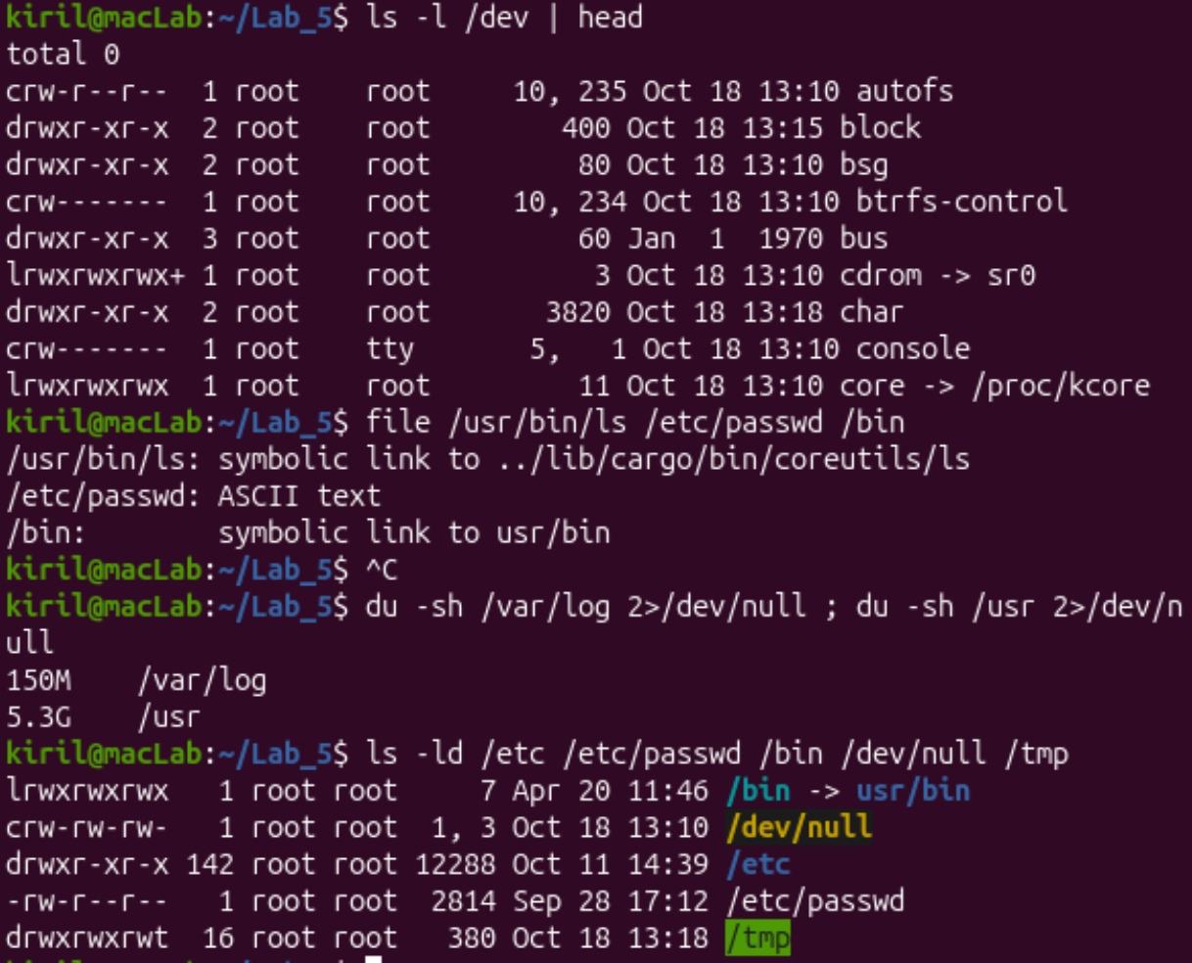
Figure 1.1. ls -l /dev | head, file, du -sh and ls -ld
Interesting output:
lrwxrwxrwx 1 root root 7 Apr 20 11:46 /bin -> usr/bin
crw-rw-rw- 1 root root 1, 3 Oct 18 13:10 /dev/null
drwxr-xr-x 142 root root 12288 Oct 11 14:39 /etc
-rw-r--r-- 1 root root 2814 Sep 28 17:12 /etc/passwd
drwxrwxrwt 16 root root 380 Oct 18 13:18 /tmp

/usr/bin/ls: symbolic link to ../lib/cargo/bin/coreutils/ls
/etc/passwd: ASCII text
/bin: symbolic link to usr/bin

150M /var/log
5.3G /usr

Observe: Part 1
1. For each path in the second line, write its type from the first letter of ls -l.
/etc is d (directory). /etc/passwd is - (regular file). /bin is l (symbolic link). /dev/null is c (character device). /tmp is d (directory; the last permission letter is t, the sticky bit).
2. What is /bin on your system: a directory or a link, and to where?
It is a symbolic link to usr/bin (/bin -> usr/bin; file agrees: "symbolic link to usr/bin"). On this Ubuntu the old /bin and /usr/bin were merged, so the two paths lead to the same directory. In the same way /usr/bin/ls is itself a link, to ../lib/cargo/bin/coreutils/ls.
3. Find one character device and one block device in /dev.
Character device: /dev/null (c, major/minor 1, 3), also /dev/console (c, 5, 1) in the ls -l /dev | head output. These transfer a stream of bytes. Block device: /dev/sda, the virtual 25 GB disk (lsblk lists it with TYPE disk and MAJ:MIN 8:0, see Figure 4.1). Block devices are accessed in fixed-size blocks and can be mounted.
4. Which is bigger on your laptop, /var/log or /usr, and by roughly how much?
/usr is bigger: 5.3 GB against 150 MB for /var/log, so roughly 35 times bigger. /usr holds the installed programs and libraries, while /var/log only holds log files that grow slowly.

Part 2. Inodes and links
Command | What it does
echo hello > notes.txt | Creates a file containing "hello" (6 bytes with the newline).
stat notes.txt | Prints the inode metadata: size, blocks, inode number, link count, permissions, owner and timestamps.
ls -li notes.txt | Long listing with the inode number (-i) in the first column; the number after the permissions is the link count.
ln notes.txt hard.txt | Creates a hard link: a second name for the same inode.
ln -s hard.txt soft.txt | Creates a symbolic link: a small file that stores the path "hard.txt".
rm notes.txt / rm hard.txt | Removes one name (directory entry) of the file.
mkdir d ; ls -ld d | Creates a directory and shows its link count.
du -h / ls -lh | du shows the disk space really used (blocks), ls shows the apparent size.
truncate -s 1G big.img | Sets a file to 1 GiB without writing any data (creates a sparse file).

Step 1. An inode, and a name that is not part of it
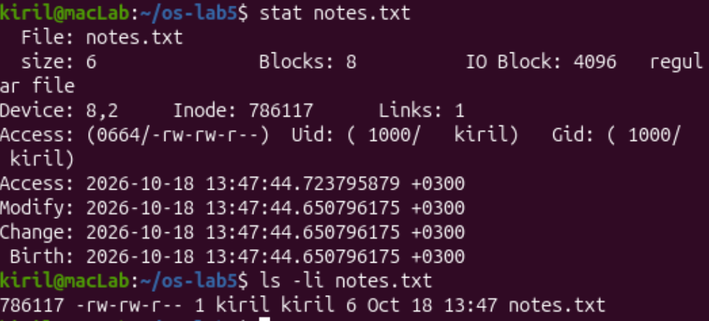
Figure 2.1. stat and ls -li on notes.txt
Step 2. Hard link, then remove the "original"
Interesting output:
$ ln notes.txt hard.txt
$ ls -li notes.txt hard.txt
786117 -rw-rw-r-- 2 kiril kiril 6 Oct 18 13:47 hard.txt
786117 -rw-rw-r-- 2 kiril kiril 6 Oct 18 13:47 notes.txt
$ rm notes.txt
$ cat hard.txt ; ls -li hard.txt
hello
786117 -rw-rw-r-- 1 kiril kiril 6 Oct 18 13:47 hard.txt

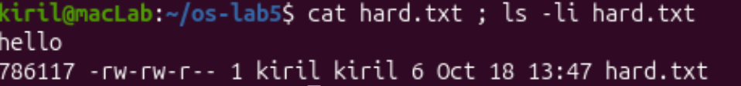
Figure 2.2. hard.txt is still readable after rm notes.txt (same inode 786117, link count back to 1)
Step 3. Symbolic link, then remove its target
Interesting output:
$ ln -s hard.txt soft.txt
$ ls -li hard.txt soft.txt
786076 -rw-rw-r-- 1 kiril kiril 6 Oct 18 13:55 hard.txt
786117 lrwxrwxrwx 1 kiril kiril 8 Oct 18 13:56 soft.txt -> hard.txt
$ cat soft.txt
hello
$ rm hard.txt
$ cat soft.txt ; ls -l soft.txt
cat: soft.txt: No such file or directory
lrwxrwxrwx 1 kiril kiril 8 Oct 18 13:56 soft.txt -> hard.txt

Note: I had re-created hard.txt before this step (it was made again at 13:55), so its inode number (786076) is different from Step 2. The important point is the same: the symlink has its own inode, different from the one of its target.
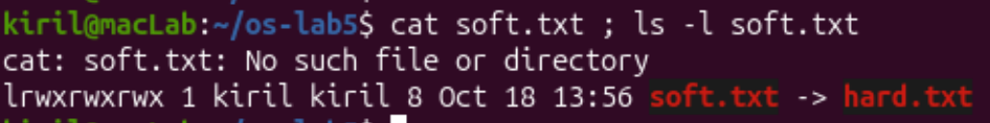
Figure 2.3. cat soft.txt fails once its target is gone; the link is 8 bytes (shown in red as dangling)
Step 4. Directories have links too
Prediction before running: a new directory has 2 links, and 4 after two subdirectories are created.
Step 5. Size is not space
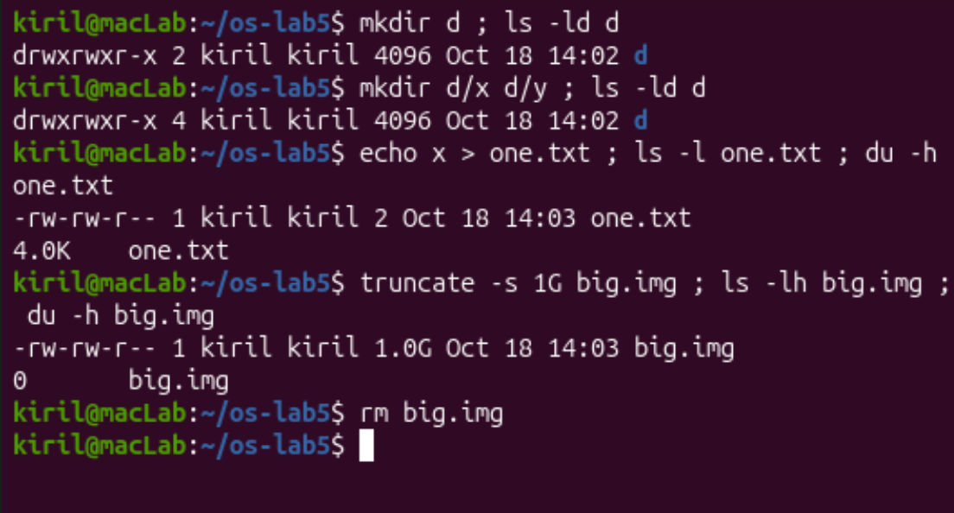
Figure 2.4. Directory link count (2, then 4) and size vs. disk usage of one.txt and big.img
Observe: Part 2
1. Which number in stat is the inode, and which tells how many names the file has?
Inode: 786117 is the inode number, and Links: 1 is the number of names (hard links) the file has. ls -li shows the same two values: the first column (786117) and the number after the permission string (1).
2. After rm notes.txt, why could you still read hard.txt? What does rm really remove?
A file is its inode (data and metadata); a name is only a directory entry that points to the inode. ln added a second entry, so the link count went to 2 and both names showed inode 786117. rm notes.txt removed just one directory entry and decreased the count to 1, so the inode and the data stayed and cat hard.txt still printed "hello". The data is freed only when the link count reaches 0 and no process has the file open.
3. Why did cat soft.txt fail at the end, although soft.txt still exists? How big is soft.txt and why exactly that size?
A symbolic link is a separate small file with its own inode that stores a path, not a reference to the target inode. After rm hard.txt that path points to nothing (a dangling link), so opening it fails with "No such file or directory", although the link file itself still exists. Its size is 8 bytes because it stores the 8 characters of the path hard.txt (h-a-r-d-.-t-x-t), with no terminator.
4. A new directory has 2 links, and 4 after you create two subdirectories. Explain where each link comes from.
A new directory gets 2 links: one is its name in the parent directory (d entry in ~/os-lab5), the other is its own . entry that points to itself. Each subdirectory contains a .. entry that points back to its parent, so every new subdirectory adds one more link to d. With d/x and d/y the count is 2 + 2 = 4. (Regular files in the directory do not add links.)
5. Why does a 2-byte file use 4.0K, and a 1 GB file use 0?
The file system allocates disk space in whole blocks (4096 bytes here, "IO Block: 4096"), so even a 2-byte file occupies one 4 KiB block and du reports 4.0K. truncate -s 1G only sets the file size in the inode; no data blocks are allocated for the holes, so it is a sparse file with apparent size 1.0 GB but about 0 blocks used (du shows 0).

Part 3. Permissions
Command | What it does
chmod 600 s.txt | Sets rw------- (owner read and write, nobody else anything).
chmod 000 s.txt | Removes all permissions for everybody.
chmod u+r s.txt | Adds read permission for the owner (u = user/owner).
umask | Prints the mask of permission bits that are removed from newly created files and directories.
touch new.txt ; mkdir newdir | Create a new empty file and directory, to see the default permissions.
chmod u=r,go= box | Gives the owner read only and the group and others nothing; u=x does the same with execute only.
ls -l /usr/bin/passwd ; ls -ld /tmp | Shows a program with the setuid bit and a directory with the sticky bit.
cat /etc/shadow ; ls -l /etc/shadow | Tries to read the password hash file, which belongs to root.

Step 6. Files
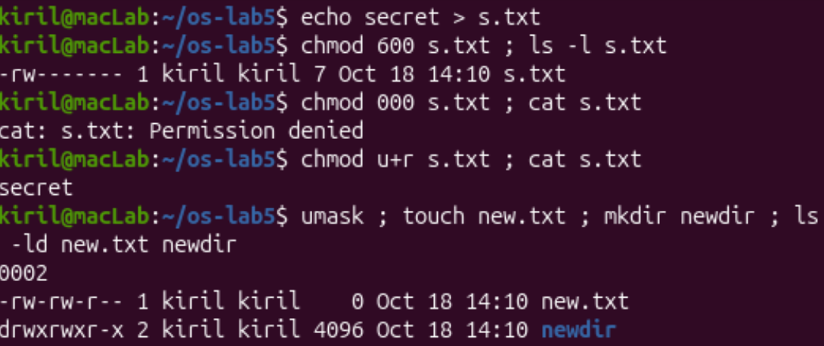
Figure 3.1. chmod 600 / 000 / u+r on s.txt, and the umask with new.txt and newdir
Step 7. Directories
Predictions before running: with read only, ls box works but cat box/f fails; with execute only, ls box fails but cat box/f works.
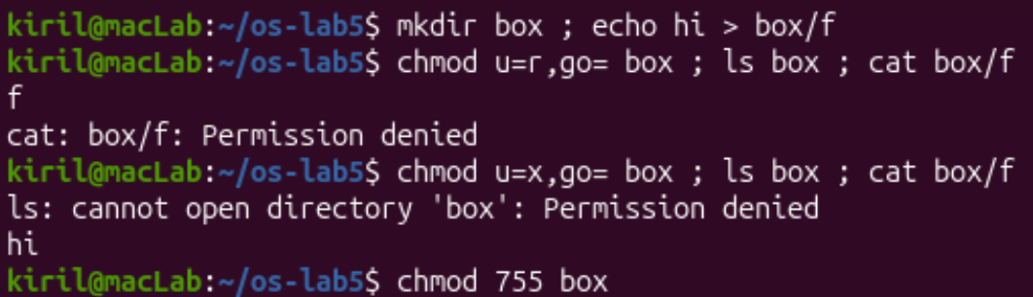
Figure 3.2. The box experiment: read-only directory, then execute-only directory
Step 8. Special bits and other people's files
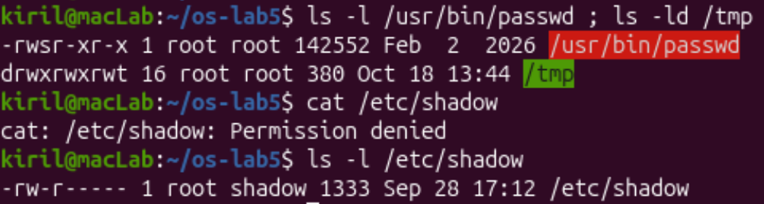
Figure 3.3. /usr/bin/passwd (setuid), /tmp (sticky) and /etc/shadow
Interesting output:
-rw------- 1 kiril kiril 7 Oct 18 14:10 s.txt (chmod 600)
cat: s.txt: Permission denied (chmod 000)
0002
-rw-rw-r-- 1 kiril kiril 0 Oct 18 14:10 new.txt
drwxrwxr-x 2 kiril kiril 4096 Oct 18 14:10 newdir
-rwsr-xr-x 1 root root 142552 Feb 2 2026 /usr/bin/passwd
drwxrwxrwt 16 root root 380 Oct 18 13:44 /tmp
-rw-r----- 1 root shadow 1333 Sep 28 17:12 /etc/shadow

Observe: Part 3
1. Write 600, 644, 755 and 700 as rwx strings, and give one real use for each.
600 = rw-------: private file, e.g. an SSH private key (~/.ssh/id_ed25519) or a file with secrets.
644 = rw-r--r--: ordinary data file that everybody may read but only the owner may change, e.g. /etc/passwd or a web page.
755 = rwxr-xr-x: program or directory that everybody may run or enter, but only the owner may change, e.g. /usr/bin programs and public directories.
700 = rwx------: private directory or script, e.g. ~/.ssh or a personal bin directory.
2. With chmod 000 you own the file but cannot read it. Why does ownership not help?
The kernel picks one class of permission bits: if you are the owner, only the owner bits are used (they do not fall back to group or others). With 000 the owner bits are empty, so cat is denied. Ownership does not grant access by itself; it only gives the right to change the mode. That is why chmod u+r s.txt worked: I could give myself the read permission back, and then cat printed "secret".
3. What is your umask, and how does it explain the permissions of new.txt and newdir?
My umask is 0002. Programs ask for 666 (rw-rw-rw-) for new files and 777 (rwxrwxrwx) for directories, and the umask bits are removed: 666 - 002 = 664 gives -rw-rw-r-- for new.txt, and 777 - 002 = 775 gives drwxrwxr-x for newdir, exactly as listed. (Only the "write for others" bit is taken away; Ubuntu can use this relaxed value because every user has a private group.)
4. Explain the box experiment: what does r allow on a directory, and what does x allow?
r (read) allows listing the names inside the directory: with u=r, ls box printed f. But without x, cat box/f failed with "Permission denied", because reaching an entry (reading its inode) needs the x bit on the directory.
x (execute / search) allows entering the directory and using a name inside it: with u=x, cat box/f printed "hi" because I knew the name, but ls box failed ("cannot open directory"), because listing the names needs r.
5. What do the s in /usr/bin/passwd and the t in /tmp mean, and why does passwd need the s?
The s in -rwsr-xr-x is the setuid bit: whoever runs the program gets the privileges of the file's owner (root) while it runs. passwd must write the user's new password hash into /etc/shadow, which is -rw-r----- root:shadow, so a normal user cannot even read it (my cat /etc/shadow was denied). With setuid, passwd runs as root and can update only my entry in the safe, controlled way the program implements.
The t in drwxrwxrwt is the sticky bit on a directory. Everybody can create files in /tmp (rwx for all), but a file there can be deleted or renamed only by its owner (or by the directory owner or root), so users cannot delete each other's temporary files.

Part 4. Disks and the kernel as files
Command | What it does
lsblk | Lists the block devices (disks, partitions, loop devices, CD drive) as a tree with their mount points.
df -h | Shows each mounted file system with its size, used and free space.
mount | grep " / " | Shows what is mounted on the root directory and which file system type it is.
grep -c processor /proc/cpuinfo | Counts the processor entries, i.e. the CPU cores seen by the kernel.
head -3 /proc/meminfo | Shows the first memory counters of the kernel (MemTotal, MemFree, MemAvailable).
head -5 /proc/self/status | Shows the status of "myself": /proc/self is the process that reads the file.
ls -l /proc/self/fd | Lists the open file descriptors of that process.

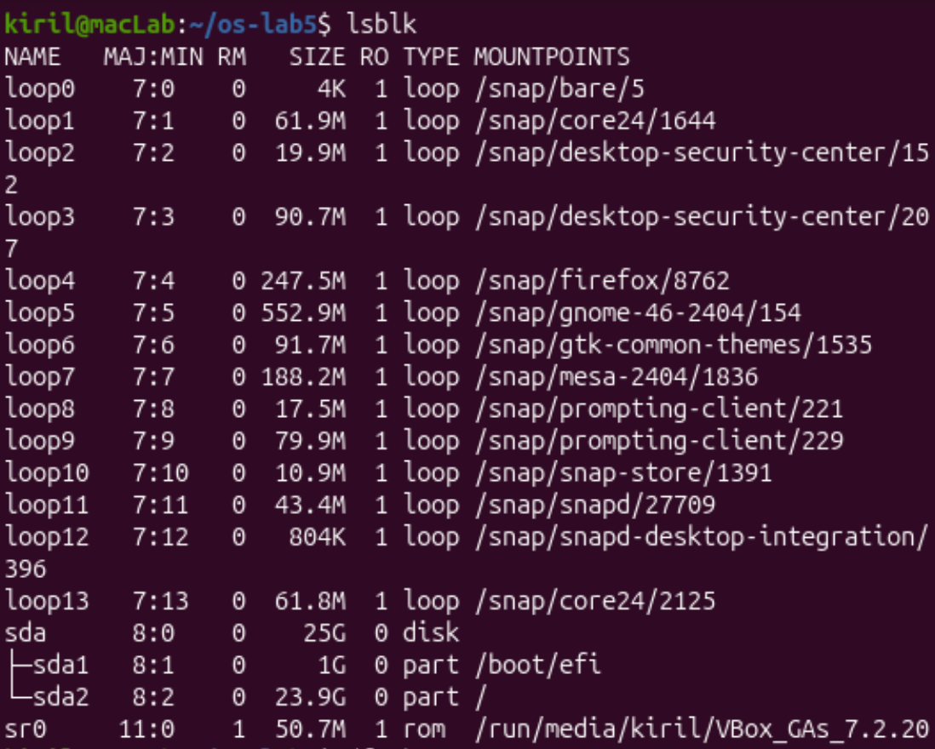
Figure 4.1. lsblk: disk sda with partitions sda1 (/boot/efi) and sda2 (/)
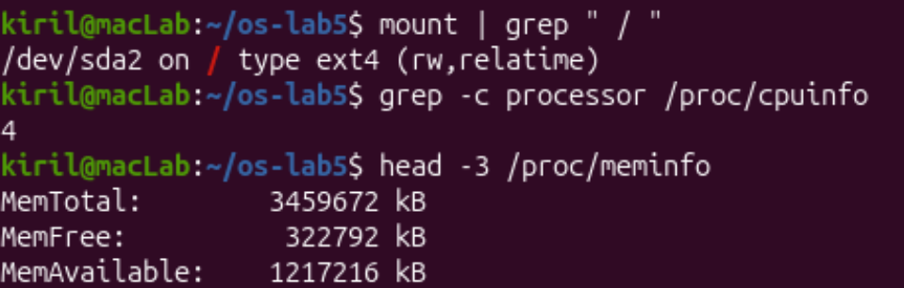
Figure 4.2. Root file system type, CPU count and memory
Interesting output:
$ df -h
Filesystem Size Used Avail Use% Mounted on
/dev/sda2 24G 12G 11G 52% /
/dev/sda1 1.1G 6.6M 1.1G 1% /boot/efi
/dev/sr0 51M 51M 0 100% /run/media/kiril/VBox_GAs_7.2.20

$ head -5 /proc/self/status
Name: head
Umask: 0002
State: R (running)

$ ls -l /proc/self/fd
lrwx------ 1 kiril kiril 64 Oct 18 14:20 0 -> /dev/pts/0
lrwx------ 1 kiril kiril 64 Oct 18 14:20 1 -> /dev/pts/0
lrwx------ 1 kiril kiril 64 Oct 18 14:20 2 -> /dev/pts/0
lr-x------ 1 kiril kiril 64 Oct 18 14:20 3 -> /proc/13543/fd

Observe: Part 4
1. Draw your disk: disk name, partitions, which one is mounted at / and with what file system type.
sda (25 GB virtual disk)
|-- sda1 1 GB /boot/efi (EFI boot partition)
`-- sda2 23.9 GB / ext4 (rw,relatime) <- root file system
sr0 (50.7 MB virtual CD, VirtualBox Guest Additions) /run/media/kiril/...

The disk is sda; the root file system is on the partition /dev/sda2, type ext4. The many loop devices are read-only images of snap packages mounted under /snap.
2. How full is your root file system?
/dev/sda2 is 24 GB in size, 12 GB used, 11 GB free: 52 % full.
3. How many CPU cores and how much RAM does your laptop have, according to /proc?
4 CPU cores (grep -c processor printed 4) and MemTotal 3 459 672 kB, about 3.3 GiB of RAM. These are the values of the virtual machine, not of the physical host.
4. /proc/self/status showed the name of a program. Which one, and why that one?
It showed Name: head. /proc/self is a link to the directory of the process that opens it, and the process that read the file was the head command itself (the shell only started it). The same is visible in /proc/self/fd: fd 0, 1 and 2 are my terminal /dev/pts/0, and fd 3 is the directory handle the ls process was using (/proc/13543/fd, i.e. its own PID).

Stretch
(a) Magic numbers
Command | What it does
gzip -c /etc/passwd > notes.txt | Compresses /etc/passwd into a file called notes.txt (the name says nothing about the content).
file notes.txt | Detects the real type from the first bytes of the content.
xxd notes.txt | head -1 | Prints the first line of the file as hexadecimal bytes plus ASCII.

Interesting output:
$ gzip -c /etc/passwd > notes.txt ; file notes.txt ; xxd notes.txt | head -1
notes.txt: gzip compressed data, was "passwd", last modified: Mon Sep 28 14:12:37 2026, from Unix, original size modulo 2^32 2814
00000000: 1f8b 0808 d575 ba6a 0003 7061 7373 7764 .....u.j..passwd

Answer: the first two bytes 1f 8b are the gzip magic number. file ignores the name .txt and identifies the format from them (the next byte 08 is the "deflate" method, and the name "passwd" is stored in the header). A file extension is only a hint; the content decides the type.
(b) Hunt for setuid programs
Command | What it does
find / -xdev -perm -4000 -type f 2>/dev/null | Finds regular files (-type f) on the root file system only (-xdev) that have the setuid bit (-perm -4000); error messages are discarded.

Interesting output:
/usr/lib/dbus-1.0/dbus-daemon-launch-helper
/usr/lib/openssh/ssh-keysign
/usr/lib/cargo/bin/sudo
/usr/lib/cargo/bin/su
/usr/bin/passwd
/usr/bin/fusermount3
/usr/bin/mount
/usr/bin/ntfs-3g
/usr/bin/chsh
/usr/bin/pkexec
/usr/bin/sudo.ws
/usr/bin/chfn
/usr/bin/gpasswd
/usr/bin/su
/usr/bin/umount
/usr/sbin/pppd
/opt/VBoxGuestAdditions-7.2.20/bin/VBoxDRMClient

Answer: 17 files. The classic ones are there (passwd, su, sudo, mount, umount, chsh, chfn, gpasswd). Others, specific to this machine: pkexec (PolicyKit), fusermount3 and ntfs-3g (mounting file systems as a normal user), pppd, ssh-keysign, the D-Bus launch helper, and VBoxDRMClient from the VirtualBox Guest Additions, which exists only because this is a VirtualBox VM. Also interesting: sudo and su appear under /usr/lib/cargo/bin/ (Rust re-implementations on this Ubuntu), next to the original sudo.ws. Every setuid program is a possible target, so the list should stay short.

Conclusion
In this lab I checked on a real Linux system how the file system works. A file is an inode; names are only directory entries that point to it, so a hard link is a second name for the same inode (the data lives until the last name is removed), while a symbolic link is a separate file that stores a path and breaks when its target disappears. A directory's link count comes from its name, its . entry and the .. entries of its subdirectories. File size and disk usage are different things: a 2-byte file takes a 4 KiB block and a sparse 1 GB file takes none.
For permissions I saw that the owner class is checked alone (chmod 000 locks out even the owner), that the umask (0002) explains the default 664 and 775, that on a directory r lists names and x lets you enter, and that the special bits setuid (passwd) and sticky (/tmp) solve real problems. Finally, lsblk, df and /proc showed the disk layout (sda with sda2 as ext4 root, 52 % full) and that the kernel exposes its own state as files: /dev/null, /proc/cpuinfo, /proc/meminfo and /proc/self all behave like ordinary files, which is the Unix idea that "everything is a file".

Lab 6 Report: Inside the xv6 File System
Setup: the xv6 tree is in ~/xv6-riscv. Every new program is a file user/NAME.c plus a line $U/_NAME\ in UPROGS of the Makefile. QEMU is left with Ctrl-A, then X.
Command | What it does
bash os2026-setup.sh --check | Checks the toolchain, QEMU and the xv6 tree (this script is not present on my VM, so I checked the pieces by hand).
which qemu-system-riscv64 | Shows where the RISC-V QEMU emulator is installed.
riscv64-linux-gnu-gcc --version | head -1 | Shows the version of the RISC-V cross compiler used to build xv6.
cd ~/xv6-riscv | Enters the xv6 source tree (kernel/, user/, mkfs/, Makefile).

Interesting output:
kiril@macLab:~/xv6-riscv$ bash os2026-setup.sh --check
bash: os2026-setup.sh: No such file or directory
kiril@macLab:~/xv6-riscv$ which qemu-system-riscv64
/usr/bin/qemu-system-riscv64
kiril@macLab:~/xv6-riscv$ riscv64-linux-gnu-gcc --version | head -1
riscv64-linux-gnu-gcc (Ubuntu 15.2.0-16ubuntu1) 15.2.0

Observed: The setup script is not installed on this VM, but everything it checks is there: QEMU (/usr/bin/qemu-system-riscv64), the RISC-V compiler (gcc 15.2.0) and the ~/xv6-riscv tree. make qemu boots xv6 ("xv6 kernel is booting", then the $ prompt).

Part 1. Read what xv6 shows you
Command | What it does
make qemu | Builds xv6 and the disk image fs.img and starts xv6 inside QEMU.
ls | Lists the current directory in xv6; each line is: name, type, inode number, size in bytes.
mkdir a ; ls a | Creates an empty directory and lists it.
cat kernel/stat.h (on the host) | Shows the definitions of the type numbers T_DIR, T_FILE and T_DEVICE.

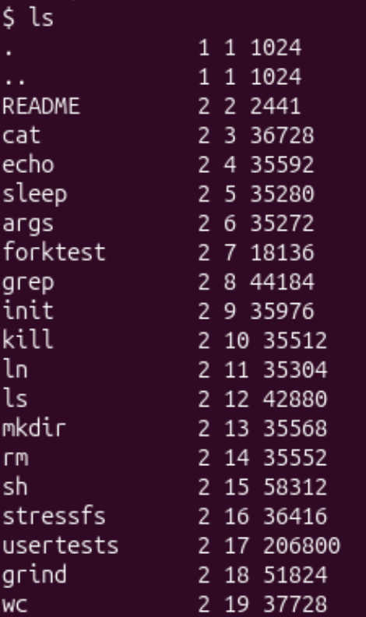
Figure 6.1. ls in xv6: name, type, inode number and size of every entry
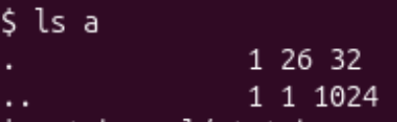
Figure 6.2. ls a: the empty directory a has size 32 and two entries
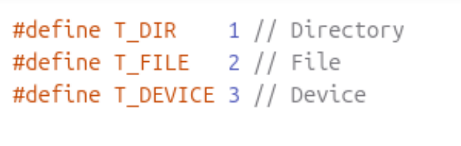
Figure 6.3. kernel/stat.h: the three file types
Interesting output:
$ ls
. 1 1 1024
.. 1 1 1024
README 2 2 2441
cat 2 3 36728
...
console 3 25 0
$ mkdir a
$ ls a
. 1 26 32
.. 1 1 1024

Observe: Part 1
1. What do types 1, 2 and 3 mean (kernel/stat.h)?
1 = T_DIR (directory, e.g. . and a), 2 = T_FILE (regular file, e.g. README, cat), 3 = T_DEVICE (device file, e.g. console).
2. Which inode number does the root directory have, and why are . and .. the same there?
The root directory is inode 1 (. 1 1 1024; it is the constant ROOTINO in kernel/fs.h). .. means "the parent directory", but the root has no parent, so .. points to the root itself and shows the same inode 1 and the same size 1024.
3. An empty directory a has size 32. A directory entry has a fixed size. How big is one entry, and which two entries does a contain?
A directory is a file that holds a table of fixed-size entries (struct dirent: a 2-byte inode number plus a name of DIRSIZ = 14 bytes). So one entry is 16 bytes, and 32 / 16 = 2 entries: . (inode 26, the directory itself) and .. (inode 1, its parent, the root).

Part 2. Write mystat
Command | What it does
cat > user/mystat.c <<'EOF' ... | Creates the source file from a here-document (on the host, not inside xv6).
grep -n "_wc\|_mystat\|_find" Makefile | Checks that my programs are in the UPROGS list of the Makefile.
mystat README . console | Prints name, type, inode, link count and size of each argument using the stat() system call.
ln README r2 | Creates a hard link r2 to the same inode as README.
rm README | Removes the name README (unlink).
cat r2 | wc | Reads the file through the remaining name and counts lines, words and bytes.

mystat calls stat() for every argument, fills a struct stat (dev, ino, type, nlink, size), and prints the line NAME: TYPE, inode N, links N, size N bytes. On error it prints to fd 2 and continues with the next argument. The function typename() turns T_DIR, T_FILE and T_DEVICE into "directory", "file" and "device". The Makefile got the lines $U/_mystat\ and $U/_find\ after $U/_wc\.
user/mystat.c
#include "kernel/types.h"
#include "kernel/stat.h"
#include "user/user.h"

char *
typename(int t)
{
if(t == T_DIR) return "directory";
if(t == T_FILE) return "file";
if(t == T_DEVICE) return "device";
return "?";
}

int
main(int argc, char *argv[])
{
struct stat st;

for(int i = 1; i < argc; i++){
if(stat(argv[i], &st) < 0){
fprintf(2, "mystat: cannot stat %s\n", argv[i]);
continue;
}
printf("%s: %s, inode %d, links %d, size %d bytes\n",
argv[i], typename(st.type), st.ino, st.nlink, (int)st.size);
}
exit(0);
}

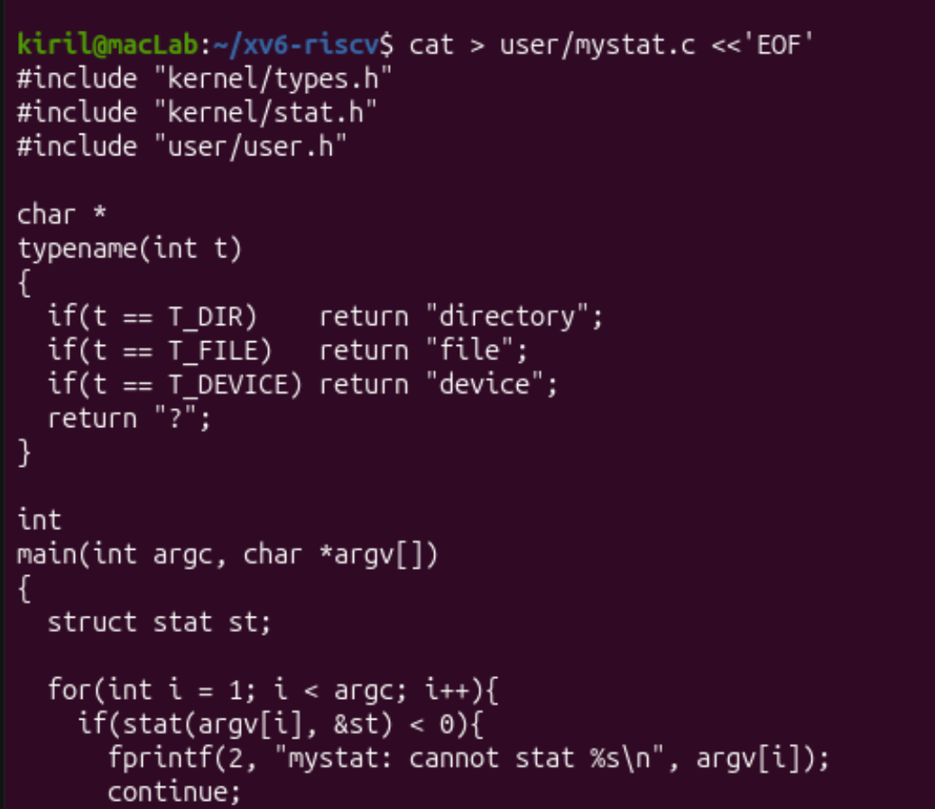
Figure 6.4. Creating user/mystat.c on the host
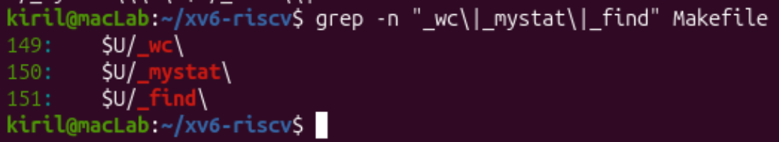
Figure 6.5. The new programs in UPROGS (Makefile lines 149-151)
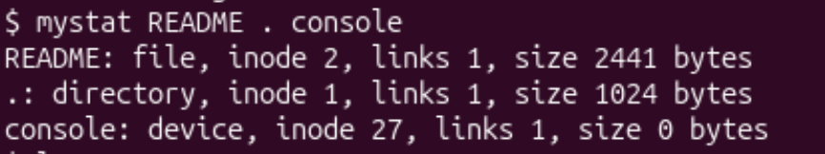
Figure 6.6. mystat README . console
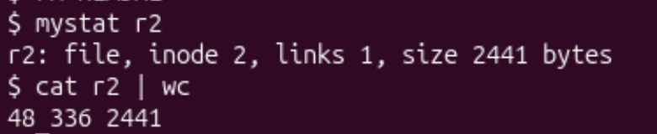
Figure 6.7. mystat r2 and cat r2 | wc after rm README
Interesting output:
$ mystat README . console
README: file, inode 2, links 1, size 2441 bytes
.: directory, inode 1, links 1, size 1024 bytes
console: device, inode 27, links 1, size 0 bytes
$ ln README r2
$ mystat README r2
README: file, inode 2, links 2, size 2441 bytes
r2: file, inode 2, links 2, size 2441 bytes
$ rm README
$ mystat r2
r2: file, inode 2, links 1, size 2441 bytes
$ cat r2 | wc
48 336 2441

kernel/sysfile.c:244: ip->nlink--; (inside sys_unlink, which starts at line 202)

Note: console has inode 27 here, not 25 as in my first ls: adding two programs (mystat and find) to UPROGS puts two more files on the disk image before the console device node, so the inode numbers after them shift by two.
Observe: Part 2
1. Paste the outputs after ln and after rm. What changed and what did not?
After ln README r2: both names show the same inode 2, and links changed from 1 to 2; type and size (2441) are the same, because they are two names of one file. After rm README: r2 still shows inode 2 and size 2441, and links went back to 1. What changed is only the link count (and which names exist); the inode, the size and the data did not change: cat r2 | wc still printed 48 lines, 336 words and 2441 bytes, the full README.
2. Find the line in kernel/sysfile.c (sys_unlink) that decrements the link count. When are the data blocks freed?
The line is ip->nlink--; at line 244 of kernel/sysfile.c, inside sys_unlink (starting at line 202). Nearby, line 239 dp->nlink--; removes the .. link of a deleted subdirectory from its parent, and the other ip->nlink-- at line 178 belongs to the error path of sys_link. sys_unlink only erases the directory entry and decrements the count. The data blocks are freed later, when iput() (kernel/fs.c) sees that the link count is 0 and no process has the file open; then itrunc() frees the blocks and the inode is released. In my experiment the count only went from 2 to 1, so nothing was freed.
3. xv6 has no symbolic links and no permissions. Look at struct dinode in kernel/fs.h: which fields does an xv6 inode have?
struct dinode has: type (short; file, directory or device; there is no symlink type), major and minor (short; device numbers for T_DEVICE only), nlink (short; number of links), size (uint; bytes) and addrs[NDIRECT + 1] (uint; the block addresses: 12 direct plus 1 indirect). There is no owner, group or mode field, so permissions cannot exist, and no timestamps.
struct dinode {
short type; // File type
short major; // Major device number (T_DEVICE only)
short minor; // Minor device number (T_DEVICE only)
short nlink; // Number of links to inode in file system
uint size; // Size of file (bytes)
uint addrs[NDIRECT + 1]; // Data block addresses
};

Part 3. Measure the limits
Command | What it does
grep -n "define BSIZE\|define NDIRECT\|define NINDIRECT\|define DIRSIZ" kernel/fs.h | Prints the constants that define the file system limits.
make clean ; make fs.img 2>&1 | grep nmeta | Rebuilds the disk image; mkfs prints the disk layout in the line that starts with nmeta.
mkdir averyveryverylongname ; ls | Creates a directory with a name longer than DIRSIZ and lists it.

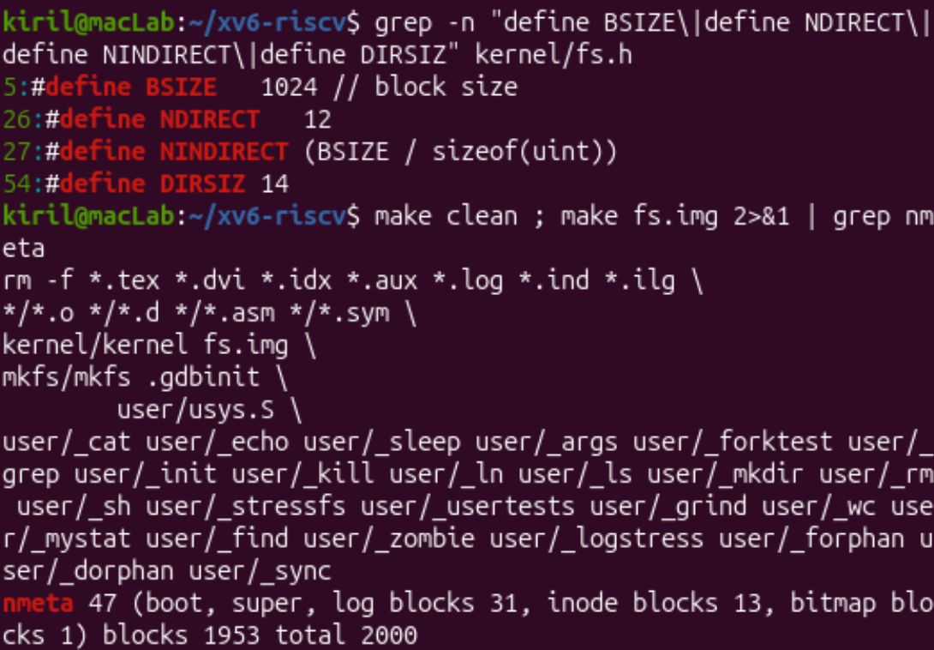
Figure 6.8. Constants from kernel/fs.h and the nmeta line printed while building fs.img
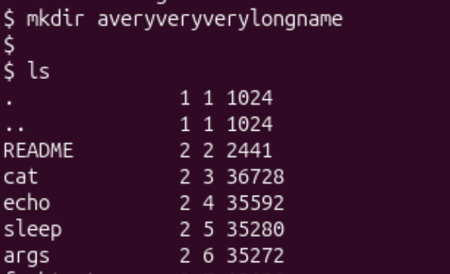
Figure 6.9. mkdir averyveryverylongname and ls
Interesting output:
5:#define BSIZE 1024 // block size
26:#define NDIRECT 12
27:#define NINDIRECT (BSIZE / sizeof(uint))
54:#define DIRSIZ 14

nmeta 47 (boot, super, log blocks 31, inode blocks 13, bitmap blocks 1) blocks 1953 total 2000

averyveryveryl 1 28 32

Observe: Part 3
1. What does ls show for averyveryverylongname, and which constant explains it?
ls shows averyveryveryl, only the first 14 characters of the name (type 1 = directory, inode 28, size 32). The constant is DIRSIZ = 14 (kernel/fs.h): a directory entry has a fixed 14-byte name field, so longer names are cut when the entry is stored.
2. Compute the largest file xv6 can hold: 12 direct blocks plus one indirect block that holds block numbers of 4 bytes each, blocks of BSIZE bytes. Show the calculation.
BSIZE = 1024 bytes
NDIRECT = 12 direct blocks
NINDIRECT = BSIZE / sizeof(uint) = 1024 / 4 = 256 blocks (via the indirect block)

max blocks = NDIRECT + NINDIRECT = 12 + 256 = 268 blocks
max size = 268 * 1024 = 274 432 bytes (about 268 KB)

The 12 direct blocks hold 12 KB, and the single indirect block points to 256 more blocks (256 KB). So the largest file is 274 432 bytes, about 268 KB.
3. From the nmeta line: how many blocks does the whole disk have, and how many are for the log, the inodes, and the data?
boot 1
superblock 1
log 31
inode 13
bitmap 1
-----------------
metadata 47 (nmeta)
data 1953
total 2000

The whole disk has 2000 blocks (2000 KiB). 31 blocks are for the log, 13 for the inodes (with 16 inodes of 64 bytes per 1024-byte block, that is room for 208 inodes), 1 for the free-block bitmap, plus the boot block and the superblock. Together the metadata is 47 blocks (1 + 1 + 31 + 13 + 1), and the remaining 1953 blocks are data blocks.

Part 4. Write find
Command | What it does
cat > user/find.c <<'EOF' ... | Creates the source file (on the host).
make clean ; make qemu | Starts from a fresh disk image, so the test files are the only extra ones.
mkdir a ; mkdir a/b | Create a small directory tree.
echo x > a/b/r2 ; echo y > a/r2 | Create two different files named r2 in different directories.
ln cat r2 | Makes a hard link r2 to the program cat in the root directory.
find . r2 ; find a b | Runs my program: prints every path under the directory whose last component is the given name.

find <dir> <name> works like ls.c, but recursively. The function find(path, name, showino) first calls stat() on the path and prints it if its last component (found by basename()) equals the name; this is why directories can match as well (find a b prints a/b). If the path is a directory, it opens it, copies the path into a buffer plus /, and reads struct dirent entries one by one. It skips free slots (inum == 0) and never recurses into . and .., builds the full child path, and calls itself on it. Every directory is closed with close(fd), because a process may have only 16 open files. The buffer is 256 bytes because the user stack in xv6 is only one page and the function is recursive. The optional third argument -n prints the inode number next to each path.
user/find.c
#include "kernel/types.h"
#include "kernel/stat.h"
#include "kernel/fs.h"
#include "user/user.h"

char *
basename(char *path)
{
char *p;
for(p = path + strlen(path); p >= path && *p != '/'; p--)
;
return p + 1;
}

void
find(char *path, char *name, int showino)
{
char buf[256], *p;
int fd;
struct dirent de;
struct stat st;

if(stat(path, &st) < 0){
fprintf(2, "find: cannot stat %s\n", path);
return;
}

if(strcmp(basename(path), name) == 0){
if(showino)
printf("%s %d\n", path, st.ino);
else
printf("%s\n", path);
}

if(st.type != T_DIR)
return;

if((fd = open(path, 0)) < 0){
fprintf(2, "find: cannot open %s\n", path);
return;
}
if(strlen(path) + 1 + DIRSIZ + 1 > sizeof(buf)){
fprintf(2, "find: path too long\n");
close(fd);
return;
}
strcpy(buf, path);
p = buf + strlen(buf);
*p++ = '/';
while(read(fd, &de, sizeof(de)) == sizeof(de)){
if(de.inum == 0)
continue;
if(strcmp(de.name, ".") == 0 || strcmp(de.name, "..") == 0)
continue;
memmove(p, de.name, DIRSIZ);
p[DIRSIZ] = 0;
find(buf, name, showino);
}
close(fd);
}

int
main(int argc, char *argv[])
{
if(argc < 3){
fprintf(2, "usage: find <dir> <name> [-n]\n");
exit(1);
}
int showino = (argc >= 4 && strcmp(argv[3], "-n") == 0);
find(argv[1], argv[2], showino);
exit(0);
}

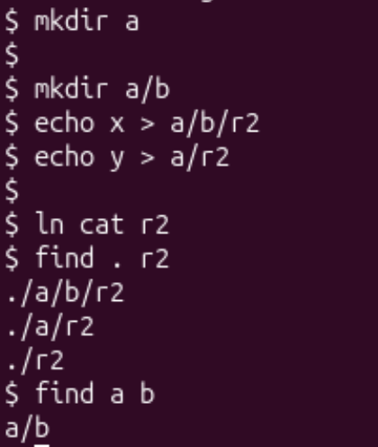
Figure 6.10. The find test on a fresh disk: find . r2 and find a b
Interesting output:
$ find . r2
./a/b/r2
./a/r2
./r2
$ find a b
a/b

Observed: find . r2 found all three files named r2 (the one in a/b, the one in a and the hard link in the root), and find a b printed a/b, the directory itself, exactly as the task expects. Both programs compiled without errors.
Stretch: find . r2 -n
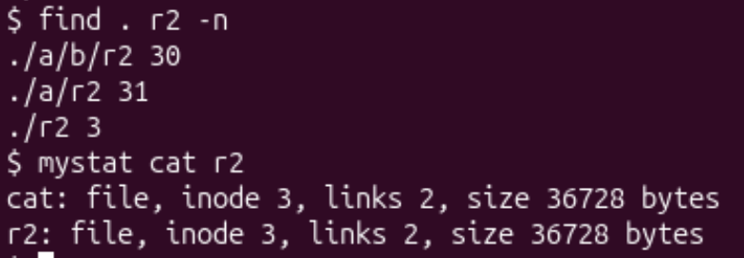
Figure 6.11. find . r2 -n and mystat cat r2
Interesting output:
$ find . r2 -n
./a/b/r2 30
./a/r2 31
./r2 3
$ mystat cat r2
cat: file, inode 3, links 2, size 36728 bytes
r2: file, inode 3, links 2, size 36728 bytes

Answer: only ./r2 (inode 3) is the same file as cat: mystat shows inode 3, links 2 and size 36728 bytes for both names, because ln cat r2 added a second name to the same inode. ./a/b/r2 (inode 30, contains "x") and ./a/r2 (inode 31, contains "y") are different files that only share the name r2: a name is just a directory entry, and the inode number tells which file it really is.

Conclusion
In this lab I looked inside the xv6 file system, which has the same ideas as ext4 in a few hundred lines. ls showed that types 1, 2 and 3 are directory, file and device, that the root is inode 1 with .. pointing to itself, and that a directory is a table of 16-byte entries (a 2-byte inode number and a 14-byte name), so an empty directory with . and .. has size 32. With my own mystat I watched hard links: ln raised the link count of inode 2 to 2, and rm only decremented it, so the data stayed readable; the decrement is the line ip->nlink-- in sys_unlink, and blocks are freed only when the count reaches 0. The xv6 inode has no owner, mode or symlink information.
I also measured the limits from kernel/fs.h: names are cut at DIRSIZ = 14 characters (averyveryveryl), the largest file is (12 + 256) x 1024 = 274 432 bytes, and the 2000-block disk has 47 metadata blocks (31 log, 13 inode, 1 bitmap, boot and super) and 1953 data blocks. Finally, I wrote find, which walks the tree recursively using stat, open and read on struct dirent, and with the -n option I confirmed that ./r2 is the same inode as cat.

