MINISTRY OF EDUCATION AND RESEARCH OF THE REPUBLIC OF MOLDOVA
TECHNICAL UNIVERSITY OF MOLDOVA
Faculty of Computers, Informatics and Microelectronics
Department of Software Engineering and Automation

REPORT
Laboratory Work No. 4
Operating Systems
The xv6 Shell from the Outside

Performed by: Kiril Boboc, FAF-242
Verified by: Reițman Patricia

Chișinău – 2026

Purpose of the laboratory
To compare the behavior of the Linux Bash shell and the xv6 shell, update the sleep utility for the available system-call interface, inspect argument processing using test programs, and identify how the xv6 shell parses and executes commands.

Part 1. Updating the sleep utility
The declaration in user/user.h is int pause(int); therefore, user/sleep.c calls pause(atoi(argv[1])). It validates that exactly one argument is supplied and prints usage: sleep <ticks> otherwise. The executable was added to Makefile UPROGS as $U/_sleep.
Command | Result / purpose
grep -n "pause\|sleep" user/user.h | Confirmed pause(int) declaration
cat user/sleep.c | Verified argument checking and pause call
grep -n "_sleep" Makefile | Confirmed UPROGS entry
make qemu; sleep 20; sleep | Booted xv6; sleep 20 completed; sleep without argument displayed usage
Figure 1.1 – pause system-call declaration
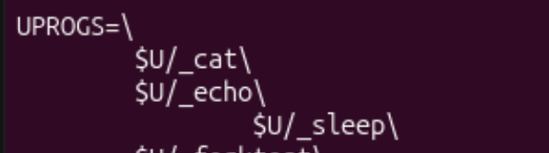
Figure 1.2 – sleep.c implementation and Makefile entry
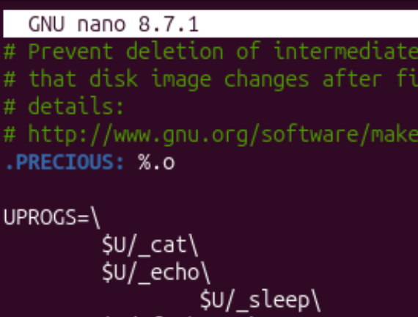
Figure 1.3 – xv6 boot and sleep utility tests

Part 2. Bash versus xv6 shell
The same commands were executed in Bash (~/shtest) and the xv6 shell. The comparison below records the observed outputs and their interpretation.
Test | Bash | xv6 / explanation
echo hello > f ; cat < f | hello | hello; both support redirection and command lists
ls | grep READ | README | README file listing; both support pipes
(echo a; echo b) | wc | 2 2 4 | 2 2 4; both support grouped commands and pipes
echo one ; echo two | one, two | one, two; command sequencing works
echo bg & | bg, with job notification | bg; background execution works but job control differs
ls * | README f | ls: cannot open *; no glob expansion in xv6
echo $HOME | /home/kiril | $HOME literally; no variable expansion
echo "a b" | a b | "a b" literally; quotes not interpreted as Bash does
mkdir d ; cd d ; ls .. | Lists parent directory | exec cd failed in list; xv6 cd must be a top-level shell command
Arrow / Tab / Ctrl+R | History, completion, reverse search | Not provided by basic xv6 shell
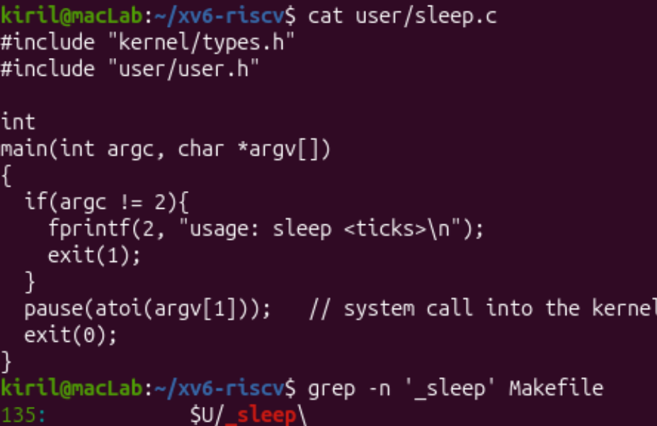
Figure 2.1 – Bash command tests
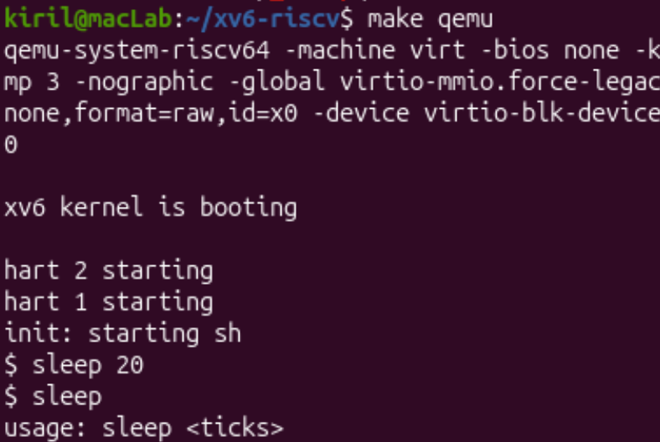
Figure 2.2 – xv6 shell command tests
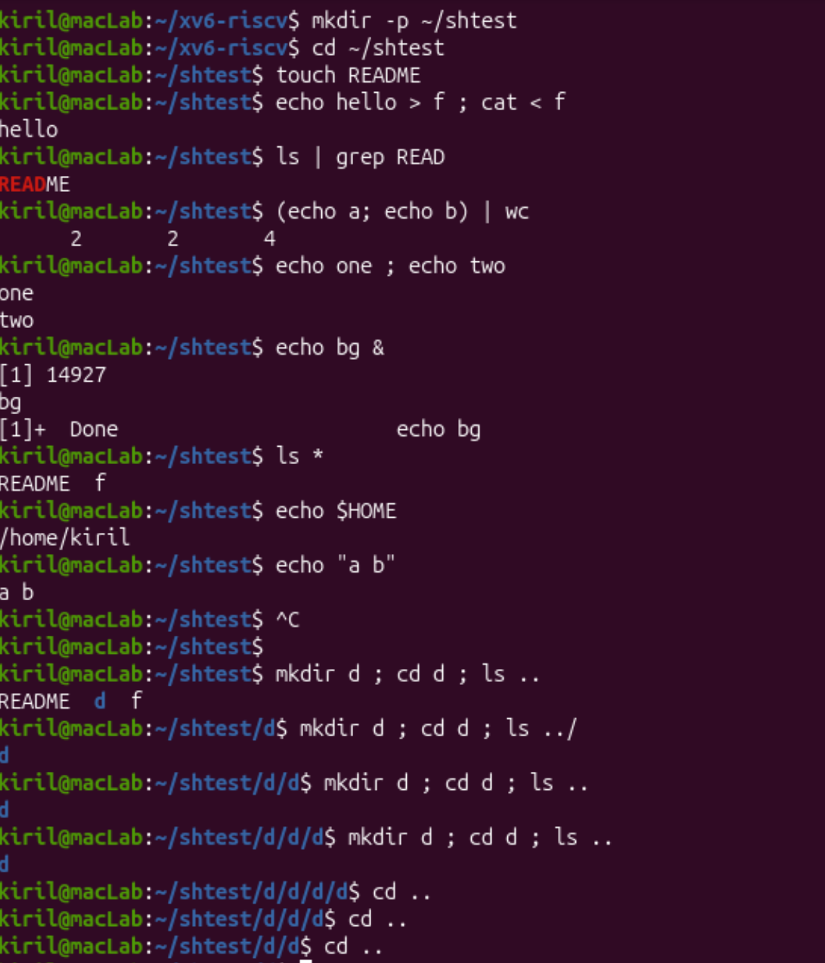
Figure 2.3 – xv6 command and directory behavior
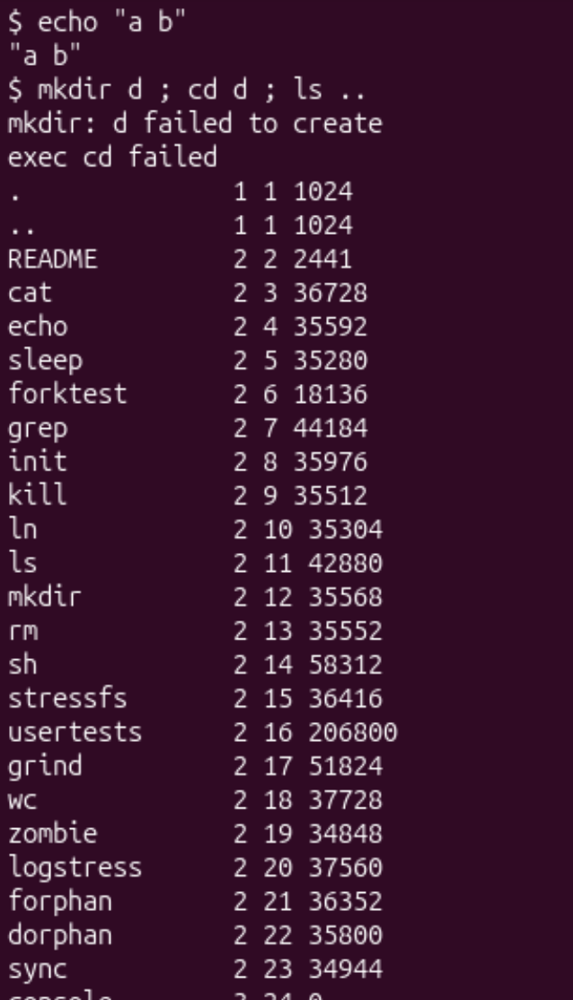
Figure 2.4 – Executing ../ls after changing directory
Observation answers: Both shells support ordinary commands, pipes, redirection, lists and background execution. Bash additionally provides wildcard expansion, environment-variable expansion, shell quoting, command history, completion and job control. After cd d in xv6, ls is not found because xv6 does not search a PATH: executables are resolved relative to the current directory. Running ../ls from d works when the executable is in the parent directory. History is the feature I would miss most; basic command history would be a reasonable small extension.

Part 3. Argument processing
Two equivalent test programs print argc and each argv entry: user/args.c for xv6 and args_linux.c compiled using gcc for Linux. These experiments demonstrate which transformations happen in the shell before a program receives its arguments.
Input | Bash | xv6
one two three | argc=4; three arguments | argc=4; three arguments
*.c "x y" | argc=5; three .c matches and one x y argument | exec args failed in observed run; no argc available
$HOME | argc=2; /home/kiril | argc=2; literal $HOME
'single quoted' | argc=2; one argument single quoted | argc=3; split into 'single and quoted' with quotes retained
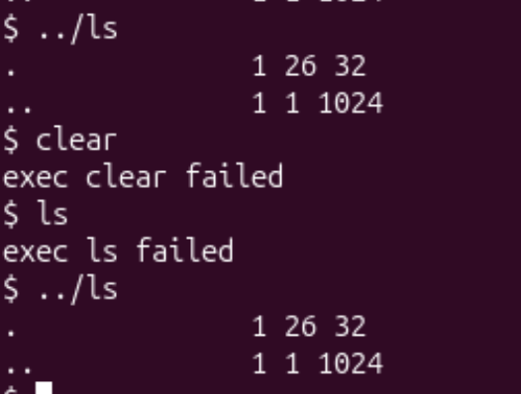
Figure 3.1 – xv6 args.c and Makefile registration
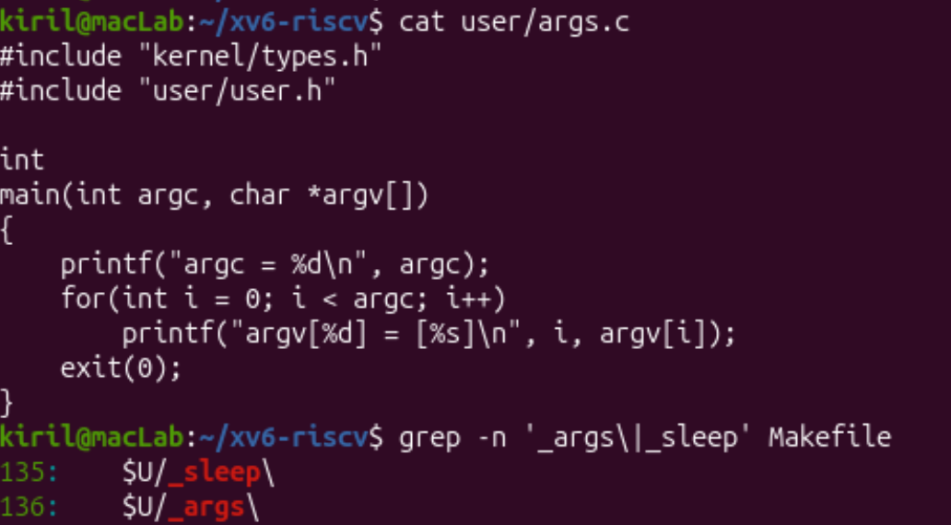
Figure 3.2 – Bash argument parsing results
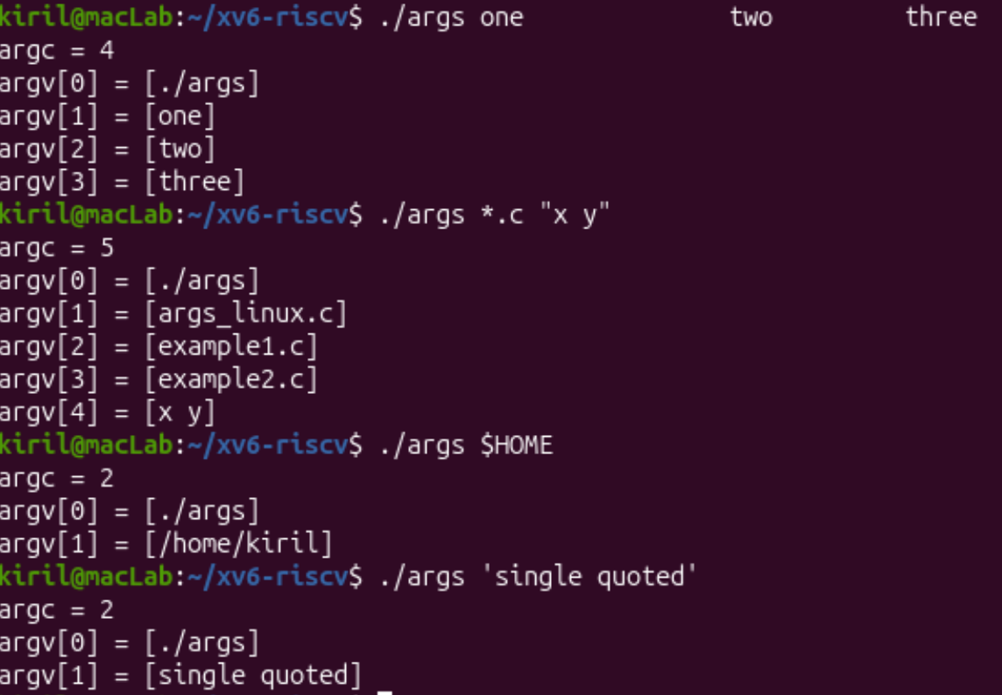
Figure 3.3 – Bash argument output
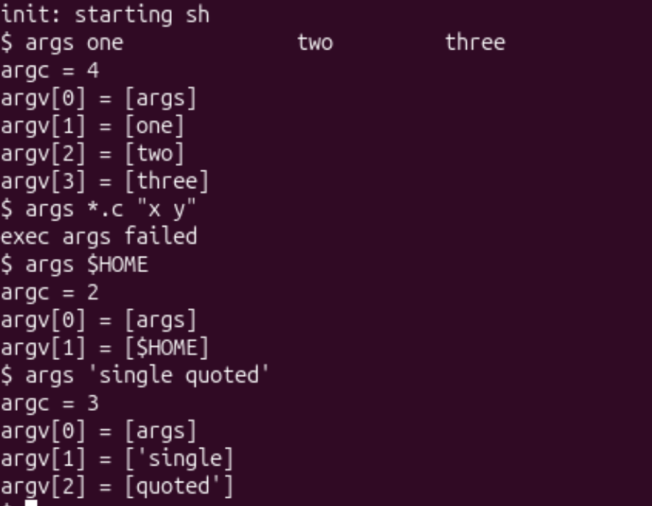
Figure 3.4 – xv6 argument output
Observation answers: In Bash, the shell expands *.c to matching filenames, expands $HOME to the home directory, and removes syntactic quote characters while preserving grouped words. Repeated spaces separate words and do not become arguments. xv6 does not perform those expansions or interpret quoting. The observed xv6 command with *.c and "x y" returned exec args failed, so no argument count can be reported for that particular invocation; the result should not be presented as a successful args run.

Part 4. Reading user/sh.c
The inspected user/sh.c contains 499 lines. The five command node types are EXEC, REDIR, PIPE, LIST and BACK. The parser recognizes tokens including |, ;, &, <, >, parentheses, and >>.
Type | Meaning
EXEC | Run a command
REDIR | Redirect standard input or output
PIPE | Connect processes with a pipe
LIST | Execute a command sequence
BACK | Run a command in the background
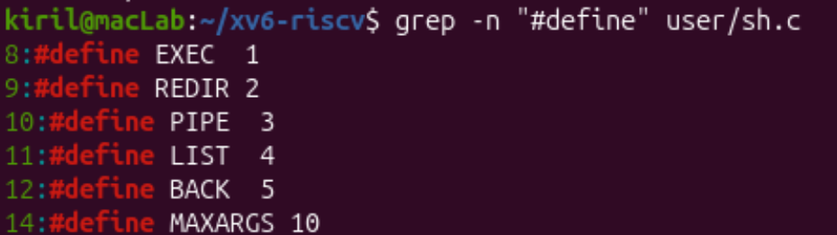
Figure 4.1 – Defined shell command types
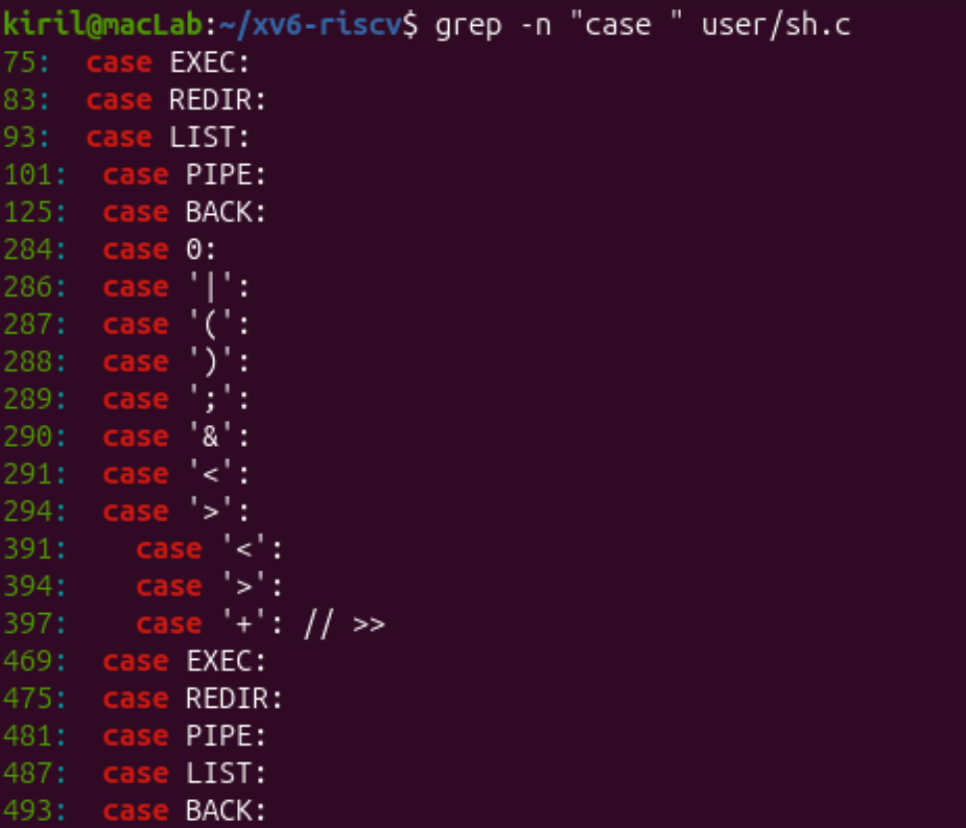
Figure 4.2 – Switch cases in user/sh.c
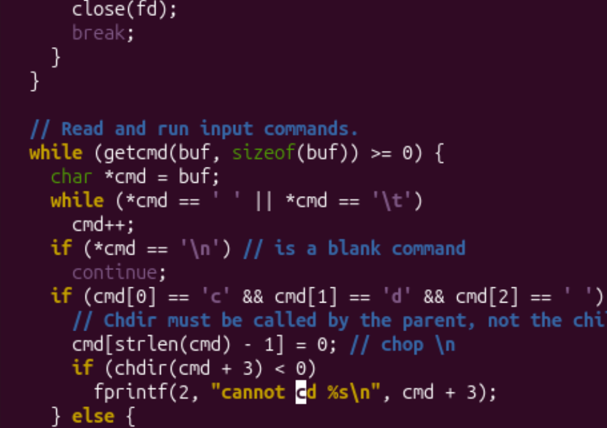
Figure 4.3 – cd handled by the shell process
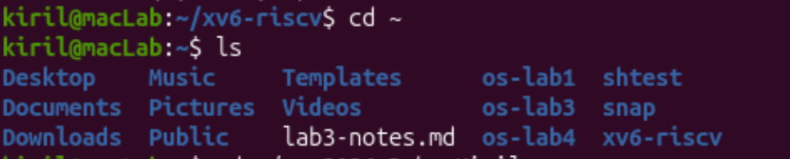
Figure 4.4 – Additional source inspection
Observation answers: The cd command is implemented directly in the shell main loop because changing directory in a child process would not change the parent shell’s working directory. The inspected shell does not implement Bash-style * wildcard expansion or $ variable expansion; the experiment outputs confirm these limitations.

Conclusion
The lab verified the working xv6 sleep utility and compared shell behavior in Linux and xv6. Both shells support basic process execution, pipes, redirection and sequencing. Bash performs additional parsing and expansions before launching a program, while xv6 intentionally provides a minimal shell. Inspecting sh.c connected the observed behavior to the shell’s command structures and cd implementation.

Files submitted
Lab4_Boboc_FAF-242.docx, sleep.c, args.c, args_linux.c, and the modified Makefile.

