
MINISTRY OF EDUCATION, CULTURE AND RESEARCH
OF THE REPUBLIC OF MOLDOVA
Technical University of Moldova
Faculty of Computers, Informatics and Microelectronics
Department of Software Engineering and Automation
Kiril Boboc FAF-242
Report
Laboratory work n.7
of Operating Systems
Three Small Programs: Processes, Redirection, a Pipe (Linux)
Verified by:
Reițman Patricia
Chisinau – 2026

Contents
Part 1. fork + exec + wait 3
Part 2. A zombie, on purpose 5
Part 3. Redirection: ls -l > out.txt 6
Part 4. A pipe: ls /etc | wc -l 7
Conclusion 9

Lab 7 Report: Three Small Programs: Processes, Redirection, a Pipe

Purpose of work: Understand process creation, execution, zombies, redirection, and communication through pipes.

Setup: all programs were written in C and compiled with gcc -Wall -Wextra in the Ubuntu terminal (host name macLab, user kiril). The working folder is ~/Operstion-Systems/Lab_7. Each part starts from a short program that does what the shell does for one command, and then changes one line to see what happens.
Command | What it does
cd ~/Operstion-Systems/Lab_7 | Enters the working folder; all source files and binaries of this lab are here.
gcc -Wall -Wextra -o NAME NAME.c | Compiles NAME.c with all the common warnings turned on (none appeared) and writes the program NAME.

Part 1. fork + exec + wait
run.c does the three steps the shell does for ls -l: fork copies the process, execlp turns the copy into ls, and waitpid makes the parent wait. The variants for date and nosuchprog were made as copies with sed, so run.c stays the ls version.
Command | What it does
cat > run.c <<'EOF' ... EOF | Creates run.c with the code of the lab (fork, execlp("ls","ls","-l"), waitpid).
gcc -Wall -Wextra -o run run.c && ./run | Compiles and runs it; ./run is started only if gcc succeeded (&&).
sed 's/execlp("ls", "ls", "-l"/execlp("date", "date"/' run.c > run_date.c | Copies run.c to run_date.c, replacing the program to execute with date.
sed 's/execlp("ls", "ls", "-l"/execlp("nosuchprog", "nosuchprog"/' run.c > run_nosuch.c | Same, with a program name that does not exist.
grep -n execlp run_nosuch.c | Shows the changed line (with its line number) to prove the edit.

Step 1. The child becomes ls
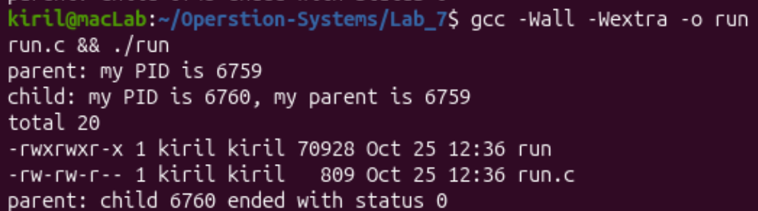
Figure 1.1. run.c: the child becomes ls
Interesting output:
parent: my PID is 6759
child: my PID is 6760, my parent is 6759
total 20
-rwxrwxr-x 1 kiril kiril 70928 Oct 25 12:36 run
-rw-rw-r-- 1 kiril kiril 809 Oct 25 12:36 run.c
parent: child 6760 ended with status 0

Step 2. The child becomes date
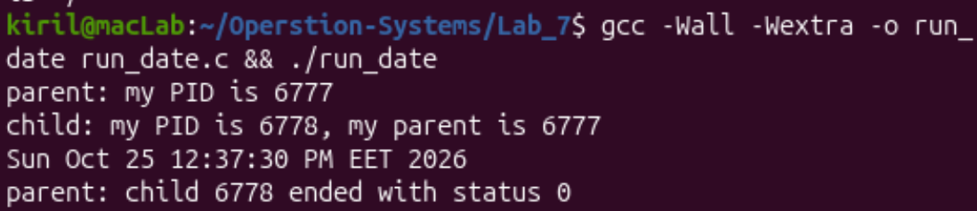
Figure 1.2. The same program with execlp("date", ...)
Interesting output:
parent: my PID is 6777
child: my PID is 6778, my parent is 6777
Sun Oct 25 12:37:30 PM EET 2026
parent: child 6778 ended with status 0

Step 3. A program that does not exist
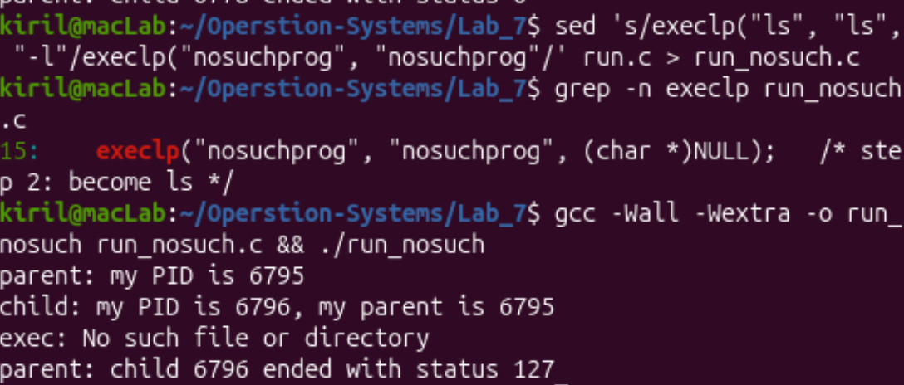
Figure 1.3. sed, grep and the run with nosuchprog
Interesting output:
15: execlp("nosuchprog", "nosuchprog", (char *)NULL); /* step 2: become ls */
parent: my PID is 6795
child: my PID is 6796, my parent is 6795
exec: No such file or directory
parent: child 6796 ended with status 127

Observed: the order of the lines is parent, child, the program's own output, parent. Only the child's code changes between the three runs; the parent code is the same.
Observe: Part 1
1. The line perror("exec") is in the child, right after execlp. Why is it printed only with nosuchprog?
When execlp succeeds, it never returns: the process image of the child is replaced by ls (or date), so the old code, including the perror line, no longer exists in that process. execlp returns (with -1) only when it fails, as with nosuchprog, which is not found in any folder of PATH. Then the child continues with perror("exec"), which prints "No such file or directory", and exit(127).
2. Which number does the child print as "my parent", and whose PID is it?
It prints 6759 (Figure 1.1), the PID of the parent process, i.e. of the running ./run program itself, which printed "parent: my PID is 6759" just before. The child got the next PID, 6760. The same relation holds in the other runs (6777/6778 and 6795/6796).
3. What status does the parent see with ls, and what status with nosuchprog?
With ls (and with date) the status is 0: the program ended normally. With nosuchprog the status is 127, the value the child gave to exit(127) after the failed exec. The parent reads it with WEXITSTATUS(status).

Part 2. A zombie, on purpose
zombie.c is run.c with one new line, sleep(20);, before waitpid. For 20 seconds the child (ls) has already ended but the parent has not waited for it yet.
Command | What it does
sed 's|^ int status;| int status;\n sleep(20); /* the new line */|' run.c > zombie.c | Creates zombie.c from run.c by adding the sleep(20) line just before waitpid.
grep -n -B1 -A1 "sleep(20)" zombie.c | Shows the new line with the lines around it (line 20 is sleep, line 21 is waitpid).
./zombie > /dev/null & | Starts the program in the background; its output is thrown away so it does not mix with ps.
sleep 2; ps -o pid,ppid,stat,cmd | After 2 seconds prints the process table with the columns PID, parent PID, state and command.
sleep 20; ps -o pid,ppid,stat,cmd | Waits for the parent to finish its sleep and prints the table again.

Step 1. While the parent sleeps
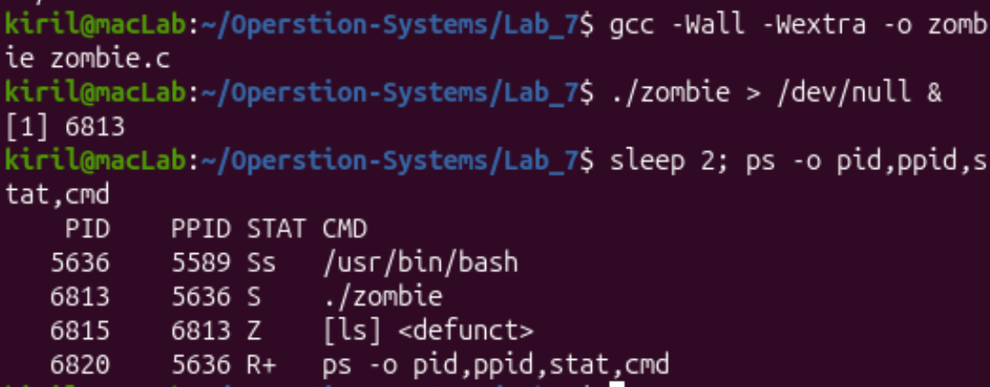
Figure 2.1. ps while ./zombie sleeps: the child [ls] is defunct
Interesting output:
PID PPID STAT CMD
5636 5589 Ss /usr/bin/bash
6813 5636 S ./zombie
6815 6813 Z [ls] <defunct>
6820 5636 R+ ps -o pid,ppid,stat,cmd

Step 2. After 20 seconds
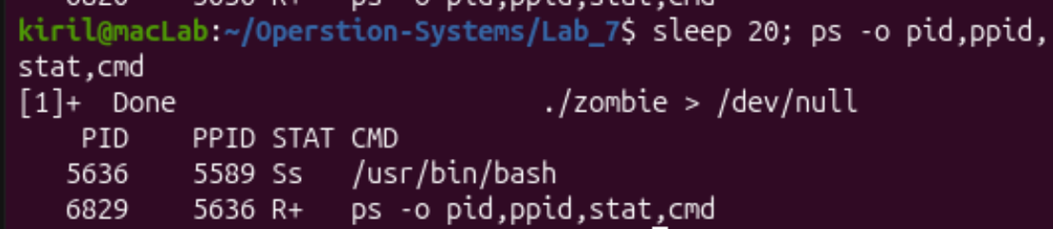
Figure 2.2. ps after the parent finished: the zombie is gone
Interesting output:
[1]+ Done ./zombie > /dev/null
PID PPID STAT CMD
5636 5589 Ss /usr/bin/bash
6829 5636 R+ ps -o pid,ppid,stat,cmd

Observed: PID 6815 (ls) has parent 6813 (./zombie) and the state Z; after the parent ended, the shell reported "Done" and only bash and ps remained.
Observe: Part 2
1. Which letter does ls have in the STAT column, and what does it mean?
The letter is Z: zombie (shown as [ls] <defunct>). The child has already ended, but its parent has not called wait yet, so the kernel keeps a small entry in the process table (the PID and the exit status) until the parent collects it. The parent ./zombie is in state S (sleeping, inside sleep(20)).
2. After 20 seconds, is the [ls] <defunct> line still there? Which line of zombie.c made it disappear?
No, the line is gone (Figure 2.2). It was removed by the line `waitpid(pid, &status, 0);`, which runs after the 20 seconds of sleep(20): it reads the exit status of the child and lets the kernel free its entry. The parent then finished too, which is why the shell printed "Done".

Part 3. Redirection: ls -l > out.txt
redirect.c does what the shell does for ls -l > out.txt: in the child it closes descriptor 1, opens out.txt (which gets the smallest free number) and then runs ls, which is not changed at all.
Command | What it does
cat > redirect.c <<'EOF' ... EOF | Creates redirect.c (fork, close(1), open("out.txt"), execlp ls).
gcc -Wall -Wextra -o redirect redirect.c && ./redirect | Compiles and runs it. The message "open gave descriptor" goes to stderr (descriptor 2), "done" to the screen.
head -3 out.txt | Shows the first 3 lines of the file that now holds the listing.
ls ; cat out.txt | head -3 | Lists the folder, then shows the start of out.txt again.

Step 1. Run the program and look into the file
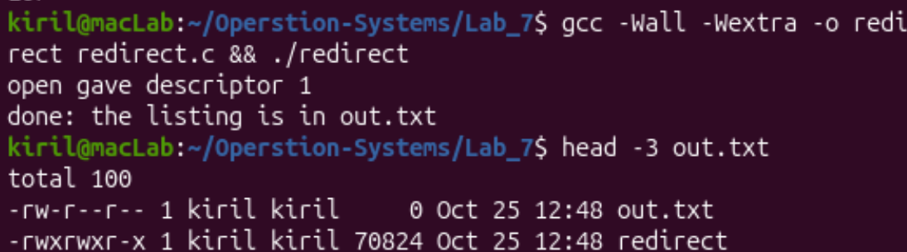
Figure 3.1. ./redirect and head -3 out.txt
Interesting output:
open gave descriptor 1
done: the listing is in out.txt
total 100
-rw-r--r-- 1 kiril kiril 0 Oct 25 12:48 out.txt
-rwxrwxr-x 1 kiril kiril 70824 Oct 25 12:48 redirect

Step 2. The folder at the end of the lab
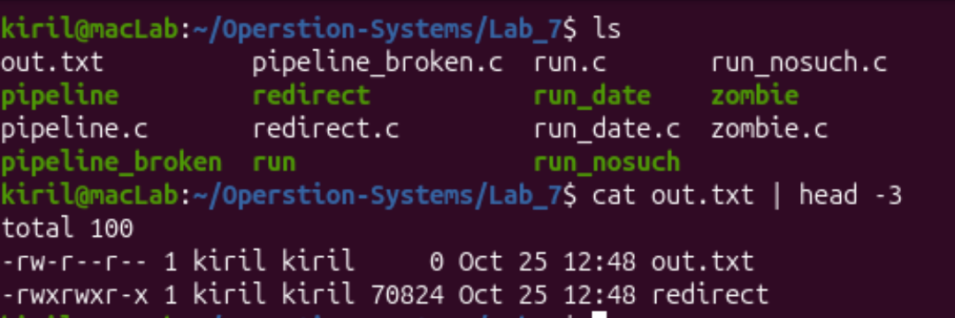
Figure 3.2. ls of the working folder and cat out.txt | head -3
Observed: the listing really is inside out.txt: the screen shows only the two messages of the program. The file lists itself with size 0, because ls read the size of out.txt (just created and still empty) before it wrote its output into it.
Observe: Part 3
1. Which number did open give, and why exactly that one?
1 ("open gave descriptor 1"). open always returns the smallest free descriptor number. In the child, 0 (input) and 2 (errors) are still open and close(1) has just freed 1, so the new file gets exactly 1.
2. ls was not changed at all. Why does its listing not appear on the screen?
ls always writes to descriptor 1. After close(1) and open, descriptor 1 points to out.txt instead of the terminal, and open descriptors are kept by execlp, so ls starts with its standard output already redirected and writes into the file without knowing it. This is exactly what the shell does for >.
3. To redirect the errors instead (like 2> err.txt), which descriptor would you close before open?
Descriptor 2 (standard error). Then open("err.txt", ...) would get number 2 as the smallest free one, and everything ls writes to its error output would go to the file.

Part 4. A pipe: ls /etc | wc -l
pipeline.c builds the shell pipeline by hand: one pipe, two fork. In the child for ls, descriptor 1 becomes the writing end p[1]; in the child for wc, descriptor 0 becomes the reading end p[0]. dup copies a descriptor into the smallest free number, like open.
Command | What it does
cat > pipeline.c <<'EOF' ... EOF | Creates pipeline.c with the code of the lab.
gcc -Wall -Wextra -o pipeline pipeline.c && ./pipeline | Compiles and runs the hand-made pipeline.
ls /etc | wc -l | The same pipeline made by the shell, for comparison.
sed '/the parent uses neither end/{n;s|close(p\[1\]);|/* close(p[1]); */|}' pipeline.c > pipeline_broken.c | Copies pipeline.c and turns the parent's close(p[1]) (the line after the comment) into a comment.
grep -n -A1 "parent uses neither" pipeline_broken.c | Shows that the line is now commented out.
./pipeline_broken & | Starts the broken program in the background (it will not end).
sleep 2; ps -o pid,ppid,stat,cmd | Shows which processes are still alive.
kill %1; pkill wc | Stops the hanging program and the waiting wc.

Step 1. Compare with the shell
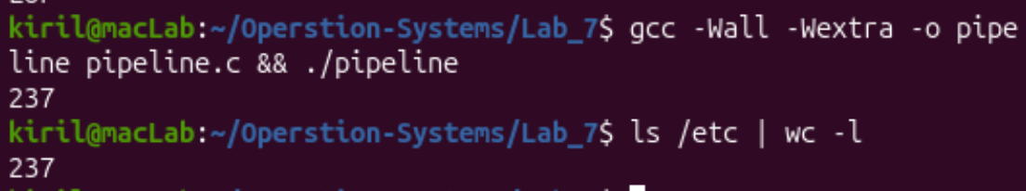
Figure 4.1. ./pipeline and ls /etc | wc -l
Interesting output:
237
237

Step 2. Break it on purpose
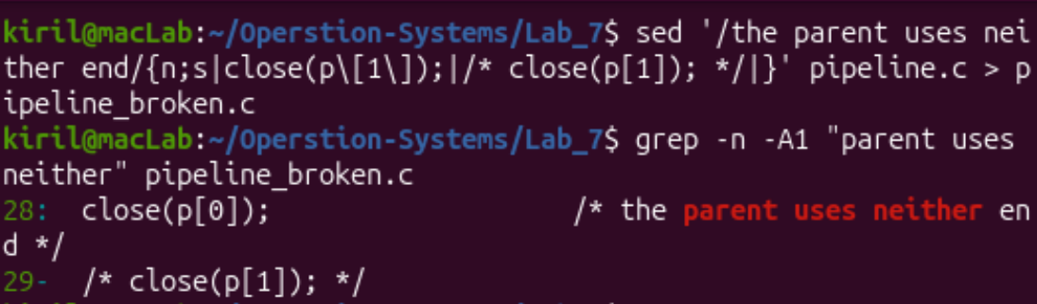
Figure 4.2. pipeline_broken.c: close(p[1]) is commented out
Interesting output:
28: close(p[0]); /* the parent uses neither end */
29- /* close(p[1]); */

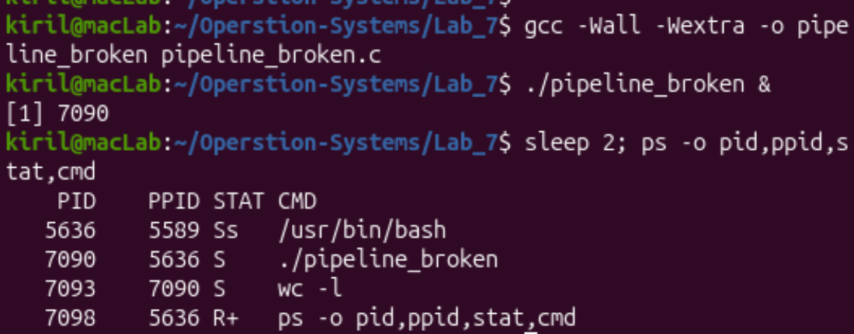
Figure 4.3. ps while ./pipeline_broken is running: wc -l is still alive
Interesting output:
PID PPID STAT CMD
5636 5589 Ss /usr/bin/bash
7090 5636 S ./pipeline_broken
7093 7090 S wc -l
7098 5636 R+ ps -o pid,ppid,stat,cmd

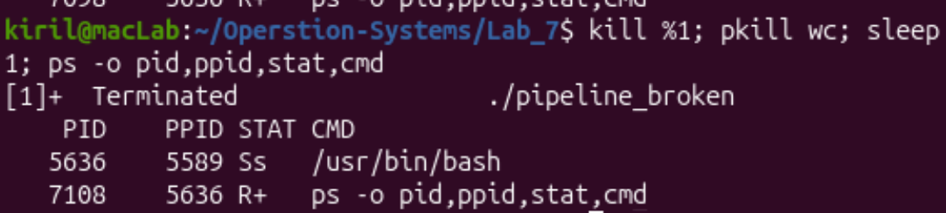
Figure 4.4. kill %1; pkill wc ends the hanging processes
Observed: after two seconds ./pipeline_broken (7090) and its child wc -l (7093) are both in state S (sleeping), and there is no ls in the list: it has already finished.
Observe: Part 4
1. Did ./pipeline and ls /etc | wc -l give the same number?
Yes, both print 237 (Figure 4.1). The hand-made pipeline connects ls and wc in the same way as the shell does.
2. After the change, which of the two children never ends, ls or wc?
wc never ends. ls writes its list, finishes and is collected by the first wait; only wc -l (PID 7093) remains, and the parent waits for it in the second wait.
3. Why, in one sentence: what is wc waiting for?
wc waits for end-of-file on its input, which the pipe reports only when all copies of the writing end p[1] are closed; the parent still holds one open (the close(p[1]) was commented out), so wc keeps waiting for more data that never comes.

Conclusion
In this lab I ran on Linux the answers to three questions from the lecture. A new process is created by fork (a copy of the parent), the copy becomes another program with exec, and the parent waits with wait. This is what the shell does for every command: ls and date ended with status 0, and a missing program made exec fail, so the child ended with the status 127 that my code chose. The PIDs showed the relation: the child's "parent" is the PID of run itself. With sleep(20) before waitpid I saw a zombie: a child that has ended but has not been waited for stays in the process table in state Z until the parent calls wait.
Redirection and pipes work because descriptors are numbers and open, dup and pipe take the smallest free number. After close(1) the file out.txt became descriptor 1, so the unchanged ls wrote its listing into the file, and the same idea with dup connected ls to wc through a pipe (237 lines in both my program and the shell). Finally, the broken pipeline showed that a reader gets end-of-file only when every writing end is closed: one forgotten close(p[1]) in the parent made wc wait forever.

