
MINISTRY OF EDUCATION, CULTURE AND RESEARCH
OF THE REPUBLIC OF MOLDOVA
Technical University of Moldova
Faculty of Computers, Informatics and Microelectronics
Department of Software Engineering and Automation

Kiril Boboc FAF-242
Report
Laboratory work n.1 & 2
of Operating Systems

Verified by:
Reițman Patricia

Chisinau – 2026
Part 1. Files and directories (file management) 3
Part 2. Processes (process management) 5
Part 3. Memory (memory management) 7
Part 4. Devices and storage (I/O management) 8
Bonus: system calls with strace 9
Conclusion 9
Part 1. Build it and boot it 10
Part 2. Use xv6 as the Unix it is 11
Part 3. Read the source 12
Part 4. Write your first xv6 program 14
Conclusion 15

Lab 1 Report: The OS as a Resource Manager
Setup: who and what is managing this machine
Command | What it does
mkdir -p ~/os-lab1 && cd ~/os-lab1 | Creates the working folder (-p: no error if it exists) and enters it, but only if mkdir succeeded (&&).
whoami | Prints the name of the user I am logged in as.
uname -a | Prints kernel name, version, build date and CPU architecture.
uptime | Shows the current time, how long the system has been up, logged-in users and load average.

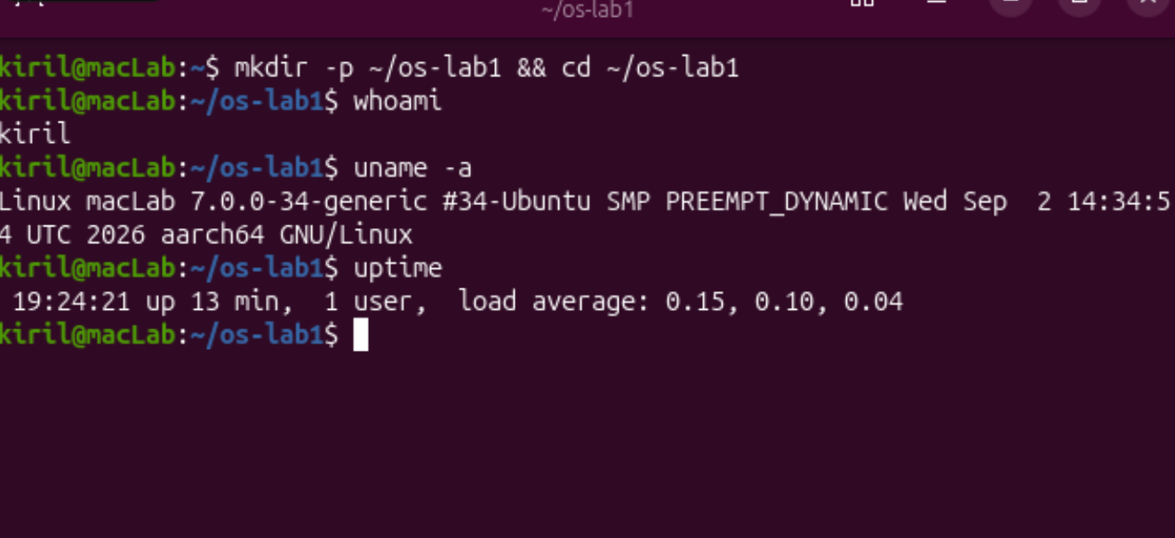
Figure 1. whoami, uname -a, uptime
Observed: I am user kiril; the kernel is Linux 7.0.0-34-generic on aarch64 (ARM); the machine had been up only a few minutes and the load average (0.15, 0.10, 0.04) shows it was almost idle.

Part 1. Files and directories (file management)
Command | What it does
pwd | Prints the current working directory.
ls -la / | Lists the root of the tree in long format, including hidden entries (-a).
ls -la ~ | Same for my home directory (~).
cd /etc && ls | head | Enters /etc and shows the first 10 entries (head).
mkdir demo | Creates a directory.
echo "..." > note.txt | Writes text into note.txt (creating it); > redirects output into a file.
cp / mv / rm | Copy a file, rename (move) a file, and delete a file.
ls -l note.txt | Shows permissions, owner, group, size and date of the file.
chmod 600 / 644 | Changes permissions: 600 = owner read+write only; 644 = owner read+write, everyone else read-only.

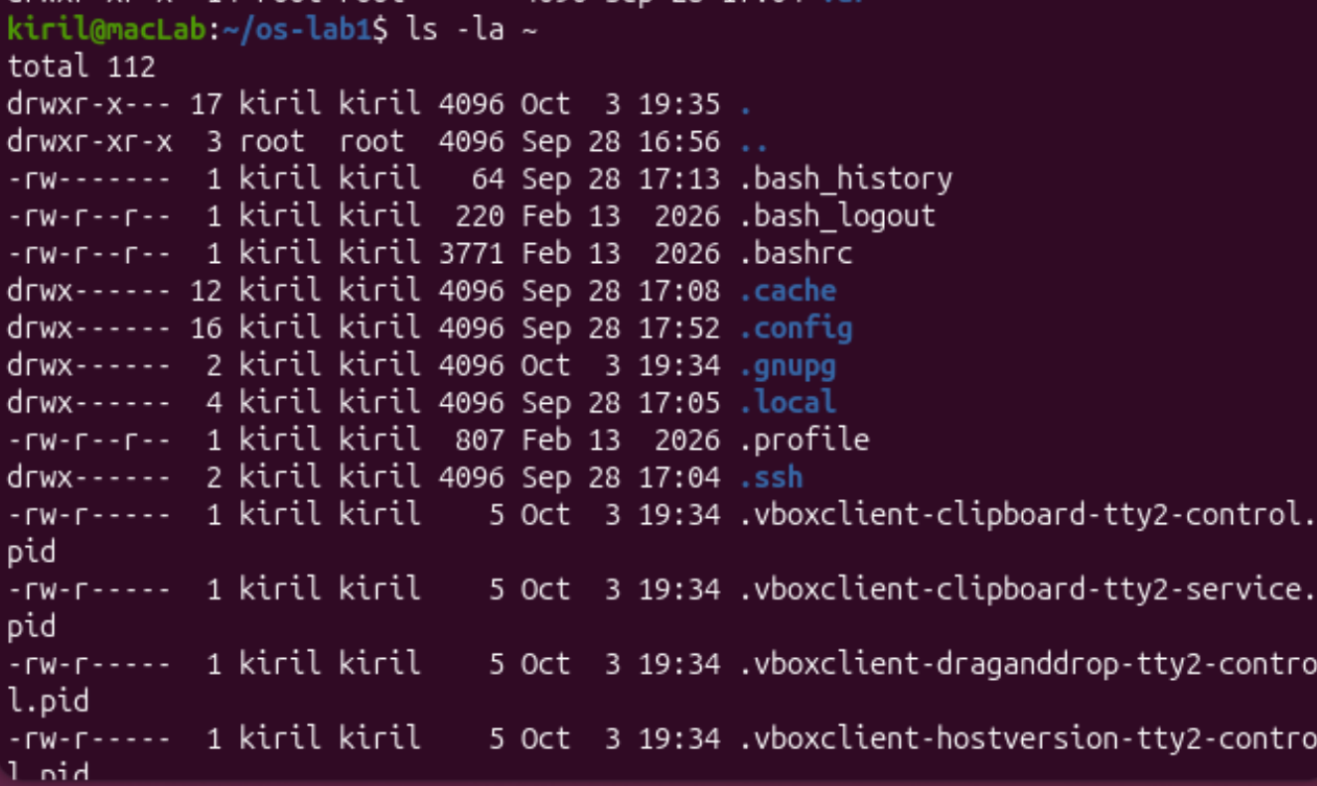
Figure 1.1. ls -la ~ (my home directory with owners and permissions)
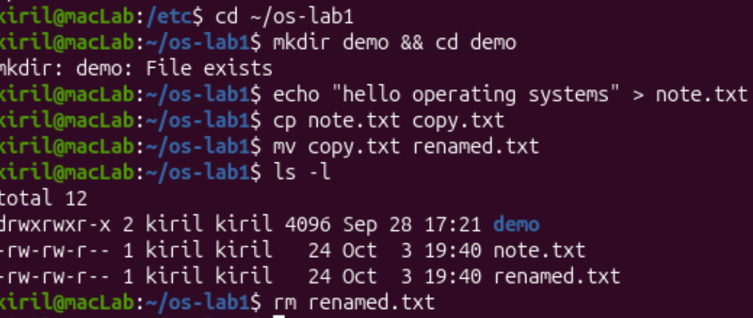
Figure 1.2. mkdir, echo, cp, mv, ls -l, rm
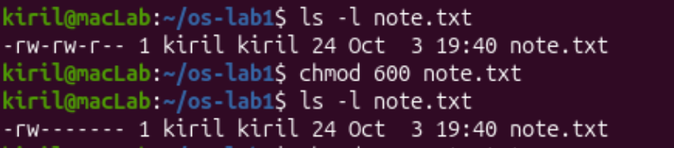
Figure 1.3. note.txt before and after chmod 600
Interesting output:
-rw-rw-r-- 1 kiril kiril 24 Oct 3 19:40 note.txt (default)
-rw------- 1 kiril kiril 24 Oct 3 19:40 note.txt (after chmod 600)
-rw-r--r-- 1 kiril kiril 24 Oct 3 19:40 note.txt (after chmod 644)
Observe: Part 1
1. Who owns the files you just created, and which group?
The owner is the user kiril and the group is also kiril. When a process creates a file, the OS assigns it the owner and primary group of the user running that process. On Ubuntu every user gets a private group with the same name.
2. What do the ten characters at the start of ls -l mean for note.txt after chmod 600?
They read -rw-------: the 1st character - is the file type (a regular file; a directory would be d). The next three, rw-, are the owner's permissions: read and write, no execute. The next three, ---, are the group's permissions: none. The last three, ---, are everyone else's permissions: none. So only kiril can read or modify this file.
3. Name two directories directly under / and say what they hold.
/etc holds system-wide configuration files. /home holds the home directories of the normal users (here /home/kiril). (Also seen: /dev holds device files, /proc is the kernel's view of running processes.)

Part 2. Processes (process management)
Command | What it does
ps aux | head | Lists all processes of all users; head keeps the first 10 lines.
ps aux | wc -l | Counts the lines of that list (number of processes + 1 header line).
top | Live, refreshing view of processes, CPU and memory (q quits).
ps -p 1 -o pid,comm | Shows the PID and name of process number 1.
sleep 300 & | Starts a process that just waits 300 s; & puts it in the background and the shell prints its PID.
jobs | Lists background jobs of the current shell.
ps -ef | grep sleep | Finds the sleep process among all processes (grep filters lines).
kill <PID> | Asks the OS to terminate the process with that PID (sends SIGTERM).
PID=$! | $! is the PID of the last background process; it is stored in a variable.
ls /proc/$PID/ | Lists what the kernel exposes about that process in the /proc pseudo-filesystem.
cat /proc/$PID/status | head -20 | Prints the process state, IDs and memory info.

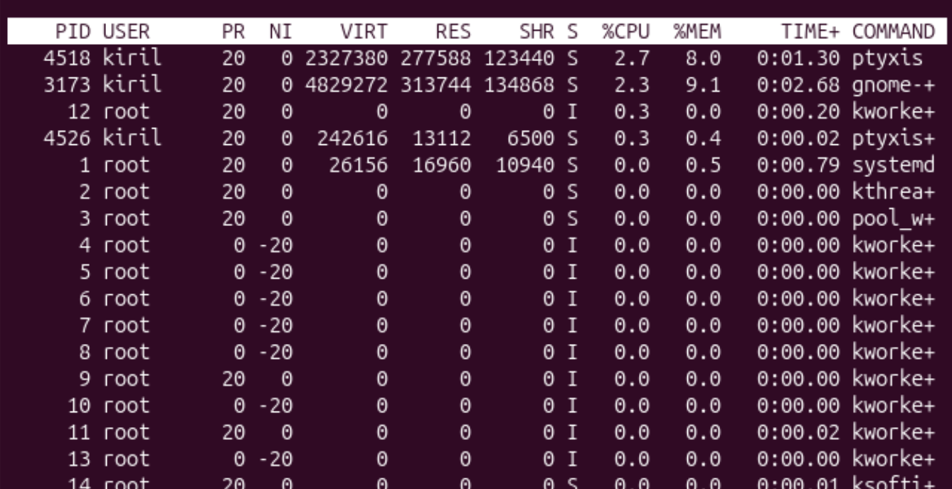
Figure 2.1. top: systemd is PID 1; the machine is almost idle
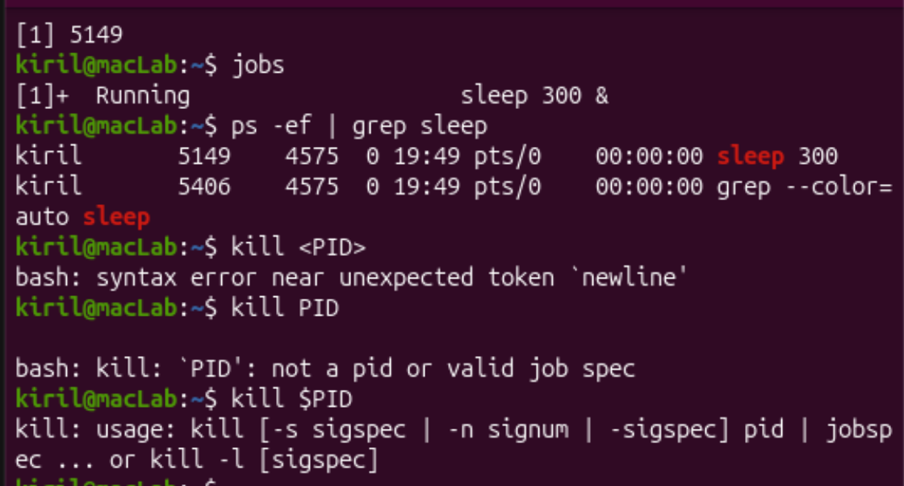
Figure 2.2. Background sleep (PID 5149), jobs and ps -ef | grep sleep

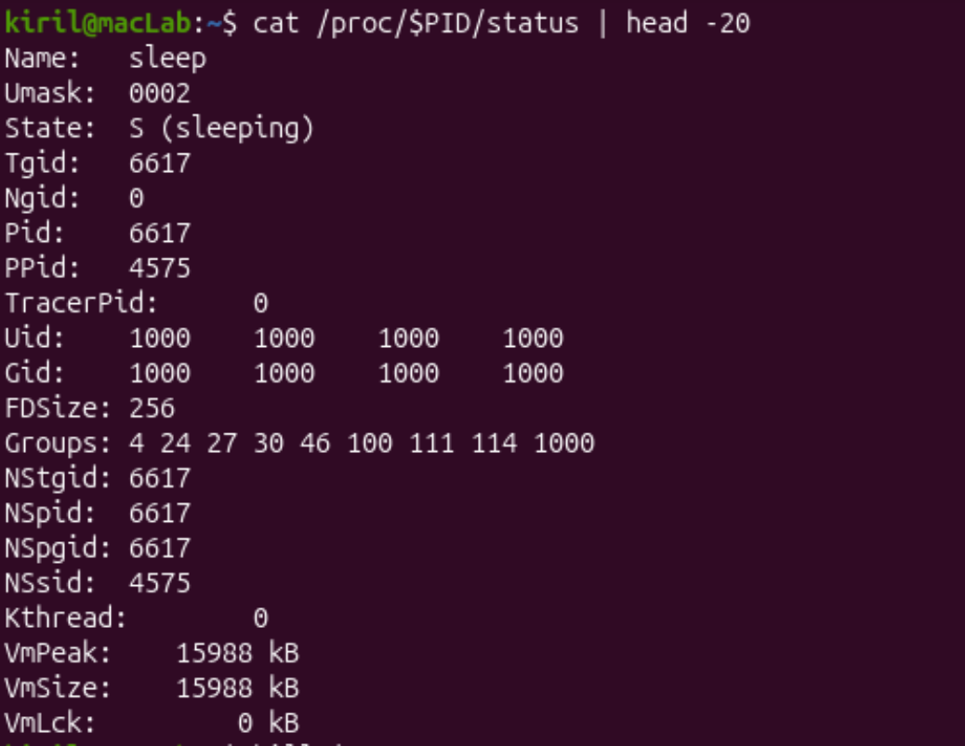
Figure 2.3. /proc/<pid>/status of the sleeping process
Interesting output:
kiril@macLab:~$ ps aux | wc -l
215
Tasks: 213 total, 1 running, 212 sleeping, 0 stopped, 0 zombie
kiril@macLab:~$ ps -p 1 -o pid,comm
PID COMMAND
1 systemd
Observe: Part 2
1. What is the PID of process number 1, and what is it?
PID 1 is systemd (run as root). It is the init process: the first user-space process the kernel starts at boot, and it starts and supervises the other services. Every other process descends from it.
2. Roughly how many processes were running on your idle VM?
About 213 (top: "Tasks: 213 total"; ps aux | wc -l printed 215 lines, which includes the header line and the ps/wc commands themselves). Of these, 212 were sleeping and only 1 was actually running, so on an idle machine almost all processes are just waiting for something to happen.
3. What does the "State:" line say for your sleeping process?
It says State: S (sleeping). The process is waiting (here for the timer of sleep to expire) and is not using the CPU; the OS scheduler will wake it up when the 300 seconds are over.

Part 3. Memory (memory management)
Command | What it does
free -h | Shows total, used, free, shared, cache and available RAM, plus swap, in human-readable units.
cat /proc/meminfo | head -6 | Shows the kernel's own memory counters (in kB); the first 6 lines.
grep VmRSS /proc/$PID/status | Prints the resident set size: how much real RAM that process occupies.

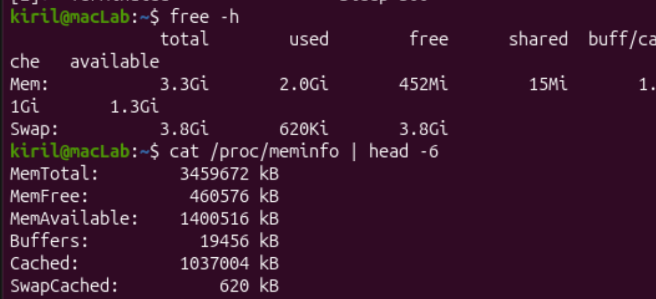
Figure 3. free -h and /proc/meminfo
Interesting output:
Mem: 3.3Gi total 2.0Gi used 452Mi free 1.1Gi buff/cache 1.3Gi available
Swap: 3.8Gi total 620Ki used 3.8Gi free
VmRSS: 8360 kB (a bare "sleep" process)
Observe: Part 3
1. How much total RAM does the VM have, and how much is free?
Total RAM is about 3.3 GiB (MemTotal = 3 459 672 kB). Only 452 MiB is completely free, but 1.3 GiB is "available", because about 1.1 GiB is used by the page cache (cached file data), which the OS can give back to programs at any moment. Free RAM being small is therefore normal: the OS uses spare RAM for caching.
2. What is swap, and how much is configured?
Swap is disk space the OS uses as an overflow for RAM: when memory is short, rarely used pages are moved from RAM to disk so RAM can be reused. Here 3.8 GiB of swap is configured (it is the file /swap.img of about 4 GB in the root directory, seen in ls -la /), and only 620 KiB of it is used, so the VM is not under memory pressure.
3. How much resident memory does a bare sleep process use, and does that surprise you?
VmRSS was 8360 kB (about 8 MB). Yes, it is a bit surprising that a program that does nothing needs 8 MB. The reason is that it has the C library and the program itself mapped into memory; most of those pages are shared with other processes, so the real extra cost of one more sleep is much smaller. Its virtual size (VmSize, 15 988 kB) is about twice its resident size, because the OS gives each process a larger virtual address space than the RAM it actually uses.

Part 4. Devices and storage (I/O management)
Command | What it does
df -h | Shows each mounted filesystem with its size, used and free space.
lsblk | Lists the block devices (disks, partitions, loop devices, CD drive) as a tree.
du -sh ~/os-lab1 | Shows the total disk usage of my work folder.
ls -l /dev | head | Lists the first device files; the first character c = character device, b = block device, l = symlink.
mount | head | Shows what is mounted where, with filesystem type and options.

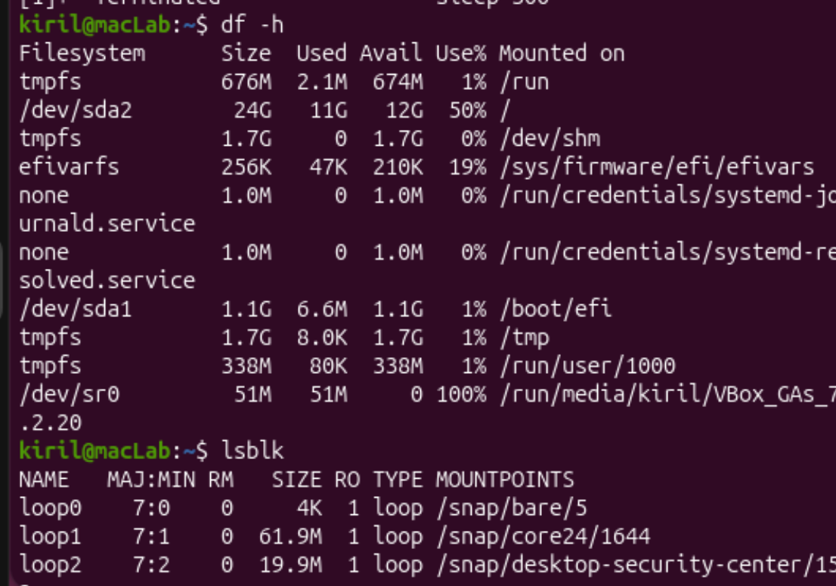
Figure 4. df -h and lsblk
Interesting output:
/dev/sda2 24G 11G 12G 50% /
/dev/sda1 1.1G 6.6M 1.1G 1% /boot/efi
/dev/sda2 on / type ext4 (rw,relatime)
du -sh ~/os-lab1 -> 16K
lrwxrwxrwx 1 root root 3 Oct 3 19:47 cdrom -> sr0
Observe: Part 4
1. Which device is your root filesystem "/" mounted on?
On the partition /dev/sda2 (24 GB, ext4, 50% used). It is the second partition of the disk sda; the first one, /dev/sda1, is the EFI boot partition mounted on /boot/efi.
2. Give one entry from /dev and say what real thing it stands for.
/dev/sda stands for the (virtual) 25 GB hard disk of this VM. Another example is /dev/sr0 (also reachable as /dev/cdrom, which is a symlink to it), the virtual CD/DVD drive with the VirtualBox Guest Additions disc.
3. In one sentence: what does "everything is a file" mean?
It means that the OS gives disks, terminals, CD drives and even process information (/proc) a name in the same file tree, so they can be listed with ls, read and written with the same simple file operations as normal files.

Bonus: system calls with strace
The command strace -c ls runs ls and counts the system calls it made to the kernel.
% time seconds usecs/call calls errors syscall
18.37 0.000495 22 22 mmap
11.99 0.000323 24 13 mprotect
10.06 0.000271 20 13 read
9.47 0.000255 23 11 1 openat
9.02 0.000243 243 1 execve
...
1.60 0.000043 21 2 getdents64
0.89 0.000024 24 1 write
100.00 0.002694 19 139 5 total
Just listing one directory took 139 system calls. Most of them (mmap, mprotect, openat, read) are the program being loaded and its libraries mapped into memory; getdents64 is the call that actually reads the directory entries from the filesystem, and write prints the result to the terminal. A "simple" command is therefore a long conversation with the OS.

Conclusion
The OS manages four kinds of resources: files, processes, memory and devices. I saw files with ls -l (owners and permissions) and processes with ps aux or top, where PID 1 is systemd and almost all of the 213 processes were sleeping. I saw memory with free -h (3.3 GiB of RAM and 3.8 GiB of swap) and devices with df -h or lsblk, which showed that the root filesystem lives on /dev/sda2.

Lab 2 Report: Meet the OS You Will Build
Track B: build your own small OS (xv6)
Setup: getting the sources and the toolchain
Command | What it does
git clone https://github.com/mit-pdos/xv6-riscv ~/xv6-riscv | Downloads the xv6 source code from GitHub into my home directory.
ls | Lists the top-level folders: kernel/, user/, mkfs/, Makefile, README.
sudo apt install -y git build-essential gdb-multiarch qemu-system-misc gcc-riscv64-linux-gnu binutils-riscv64-linux-gnu | Installs the tools: a cross-compiler that produces RISC-V code on my ARM VM, the linker/binutils, a debugger and the emulator.
sudo apt install -y qemu-system-riscv | Installs the RISC-V emulator qemu-system-riscv64 (it was a separate package on this Ubuntu).

Figure 0. The xv6-riscv source tree (kernel/, user/, mkfs/, Makefile, README)
The VM image did not have the RISC-V toolchain, so the first builds failed. The problems and fixes were:
Error message | Cause | Fix
Couldn't find a riscv64 version of GCC; unknown value 'rv64gc' for -march | make fell back to the normal ARM gcc, which cannot compile RISC-V code | Installed gcc-riscv64-linux-gnu and binutils-riscv64-linux-gnu
qemu-system-riscv64: not found | The emulator was not installed | Installed qemu-system-misc and qemu-system-riscv

Part 1. Build it and boot it
Command | What it does
make qemu | Compiles the kernel and all user programs with the RISC-V cross-compiler, builds the disk image fs.img (mkfs), and starts the emulated RISC-V computer in QEMU, which boots xv6.
Ctrl-A, then X | QEMU's own exit sequence: it stops the emulator and returns me to the Linux shell.

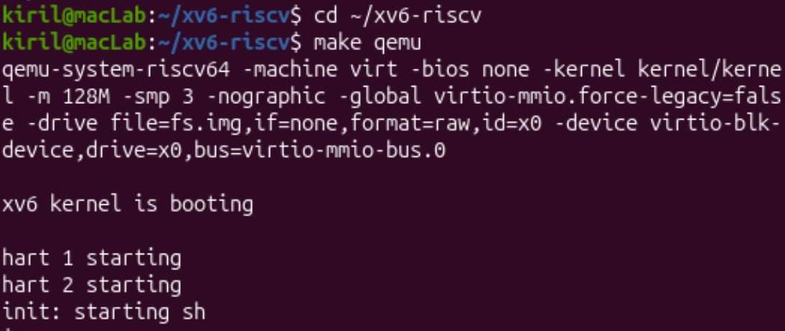
Figure 1. xv6 booting: "xv6 kernel is booting", the other CPUs (harts) starting, "init: starting sh" and the $ prompt
Observed: xv6 booted in a few seconds on 3 virtual CPUs (the boot CPU plus "hart 1" and "hart 2"). The kernel started the first process, init, which started the shell sh and gave me the $ prompt.

Part 2. Use xv6 as the Unix it is
Command | What it does
ls | Lists the files in the current directory of the xv6 disk (name, type, inode number, size). The programs xv6 ships with are listed here.
cat README | Prints the contents of the file README.
echo hello xv6 | Prints its arguments.
ls | grep c | A pipe: the output of ls is fed into grep, which keeps only lines containing the letter c.
wc README | Counts lines, words and bytes in README.

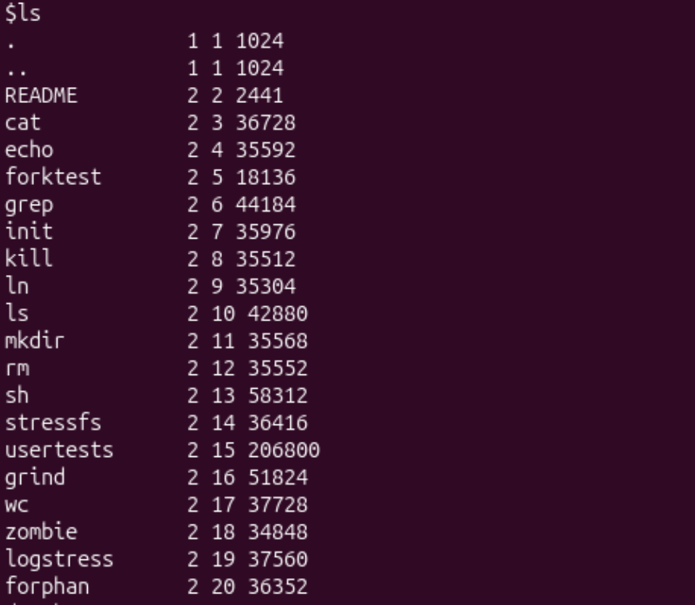
Figure 2.1. ls in xv6
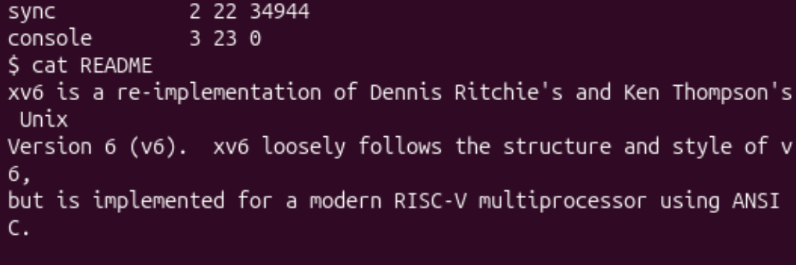
Figure 2.2. cat README
Interesting output:
$ echo hello xv6
hello xv6
$ ls | grep c
cat 2 3 36728
echo 2 4 35592
wc 2 17 37728
sync 2 22 34944
console 3 23 0
$ wc README
48 336 2441 README
Note: I accidentally typed x as a command first, and the shell printed "exec x failed", which is the normal reaction to a program that does not exist. I skipped the optional usertests.
Observe: Part 2
1. List three programs xv6 ships with.
ls, cat and grep (also echo, wc, sh, kill, ln, mkdir, rm, and others, as seen in the ls output).
2. Which two OS features must exist for a pipe to work?
Processes and inter-process communication. The shell has to create two processes (fork and exec: one runs ls, the other runs grep), and the kernel has to provide a pipe, a buffer in kernel memory with a write end and a read end (the pipe system call). The output of ls is connected to one end and the input of grep to the other, using file descriptors. Without separate processes there would be nothing to connect, and without a communication mechanism the two processes could not exchange data.
3. In one sentence: how does the xv6 shell compare to the Linux shell from Lab 1?
The xv6 shell works on the same idea (read a command, fork, exec the program, wait) and also supports pipes and redirection, but it is much smaller and plainer, with none of the comfort features of the Linux bash such as command history, tab completion, variables or scripting.

Part 3. Read the source
Command | What it does
sed -n "1,40p" user/ls.c | Prints lines 1 to 40 of the source of the ls program.
sed -n "1,30p" user/cat.c | Prints lines 1 to 30 of the source of cat.
cat user/user.h | Shows the header with the list of system calls available to user programs.
grep -n "sys_read\|sys_write" kernel/sysfile.c | head | Searches the kernel file for the two handlers and prints them with their line numbers (-n); \| means "or".

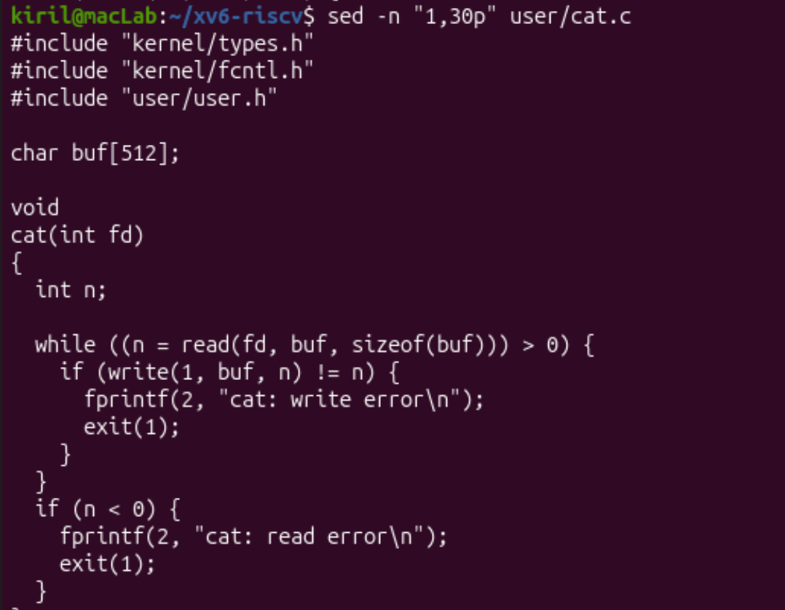
Figure 3.1. The start of user/cat.c: read() and write() are called in the loop
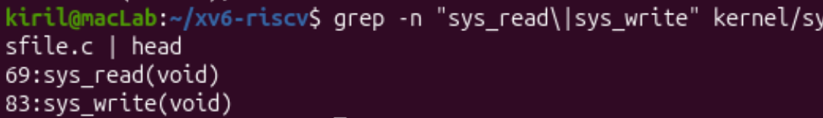
Figure 3.2. sys_read is on line 69 and sys_write on line 83 of kernel/sysfile.c
Interesting output: the list of system calls in user/user.h (shortened)
// system calls
int fork(void);
int exit(int) __attribute__((noreturn));
int wait(int *);
int pipe(int *);
int write(int, const void *, int);
int read(int, void *, int);
int close(int);
int open(const char *, int);
int pause(int);
int uptime(void);
Observe: Part 3
1. Which system calls does user/cat.c use, and what does each one ask the kernel to do?
read(fd, buf, n) asks the kernel to read up to n bytes from the open file fd into the buffer buf. write(1, buf, n) asks the kernel to write n bytes from buf to file descriptor 1 (standard output, the console). In main it also uses open (open a file by name and get a file descriptor), close (release the descriptor) and exit (end the process). fprintf is not a system call itself but a library function (user/printf.c) that ends up calling write.
2. In which kernel file, and on which line, is sys_read implemented?
In kernel/sysfile.c, where the function sys_read starts on line 69 (its return type uint64 is on the line above). It fetches the arguments with argaddr, argint and argfd and then calls fileread. sys_write follows on line 83.
3. In one sentence: what is the difference between the code in kernel/ and the code in user/?
The code in kernel/ is the operating system itself, which runs in privileged mode with full access to the hardware (scheduler, memory, file system, system-call handlers), while the code in user/ is ordinary programs that run unprivileged on top of it and can only get services by asking the kernel through system calls.

Part 4. Write your first xv6 program
Command | What it does
cat > user/sleep.c <<'EOF' ... EOF | Writes the lines up to EOF into the new file user/sleep.c without needing an editor.
grep -n -B2 -A2 "_sleep" Makefile | Checks my Makefile edit by showing the matching line with 2 lines of context before and after.
make qemu | Rebuilds everything (now including sleep) and boots xv6 again.

The final program, user/sleep.c:
#include "kernel/types.h"
#include "kernel/syscall.h"
#include "user/user.h"

int
main(int argc, char *argv[])
{
if(argc != 2){
fprintf(2, "usage: sleep <ticks>\n");
exit(1);
}
#ifdef SYS_pause
pause(atoi(argv[1]));
#else
sleep(atoi(argv[1]));
#endif
exit(0);
}
The program checks that exactly one argument was given and otherwise prints the usage message to standard error (file descriptor 2) and exits with code 1. Otherwise it converts the argument to a number with atoi and calls the sleep system call, which makes the kernel put the process to sleep for that many clock ticks, then exits with code 0. In this xv6 version, pause() worked successfully.
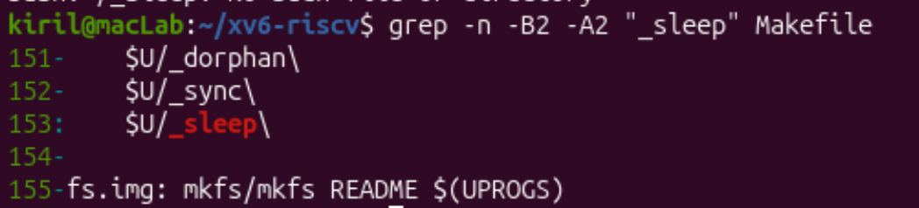
Figure 4.1. The new entry $U/_sleep\ in the UPROGS list of the Makefile (a tab at the start, backslash at the end)
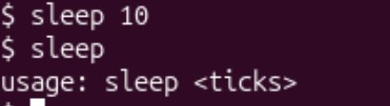
Figure 4.2. Test in xv6: sleep 10 pauses and returns to the prompt; sleep without argument prints the usage message

Conclusion
I built xv6 from source, booted it on an emulated RISC-V computer and used it as a small Unix with the same kind of commands and pipes as Linux in Lab 1. Reading the source showed the split between user/ (programs that ask) and kernel/ (code that answers): cat calls read and write, and the kernel handles them in sys_read (line 69) and sys_write (line 83) of kernel/sysfile.c. Finally I wrote my own program, sleep, added it to the Makefile and ran it inside xv6, where it calls the sleep system call of a kernel I compiled myself.

