HOCHIMINH CITY UNIVERSITY OF TECHNOLOGY | SOCIALIST REPUBLIC OF VIETNAM
INSTITUTE OF INTERNATIONAL EDUCATION | Independence - Freedom – Happiness

REPORT

Week 01 : Development Environment & UI
Course: Basic Project

Lecturer : Dr. Le Thi Ngoc Tho

Student 1 : Trần Duy Thành ID : 2380602052
Student 2 : Nguyễn Đình Quốc ID : 2380601854
Student 3 : Lê Nguyễn Bảo Khang ID : 2380600979

I. Introduction
This project presents a Vietnamese Traffic Law Consultation Chatbot, developed using Artificial Intelligence and the Google Gemini API.
The system aims to assist users in retrieving legal information related to traffic regulations in Vietnam, including traffic laws, penalties, road signs, and driving license requirements.
The chatbot is designed to handle natural language queries and provide accurate legal references in various real-world situations.II Infomation

2.1 Information of the website :
Name : VietNamese Traffic Law Consulation Chatbot
Website : updating
Platform :

2.2 Basic Data preprocessing :
The collected data is preprocessed before being used in the chatbot system:
- Removing HTML tags and unnecessary symbols
- Standardizing text format
- Splitting legal documents into smaller chunks
- Mapping legal references (article, clause)
- Converting data into JSON format
This step ensures that the data is clean, structured, and suitable for AI processing.
Arrcording to Thư viện pháp luật ( https://thuvienphapluat.vn ),National Databases about Law (https://vbpl.vn/pages/portal.aspx) and VietNamese Minstry of Transport(http://www.mt.gov.vn), dataset for this project include :
2.2.1 Thư viện pháp luật Dataset :
Structure:
- chapter
- article
- content
Purpose:
Used to answer general legal questions and provide official law references.
2.2.2 National Databases about Law Dataset :
Collected from:
- Decree 100/2019/NĐ-CP
- Decree 123/2021/NĐ-CP

Structure:
- article
- clause
- violation
- vehicle_type
- penalty
Purpose:
Used for answering questions related to fines and violations.
2.2.3 Traffic Sign Dataset
Based on QCVN 41:2019/BGTVT.
Structure:
- sign_code
- sign_name
- sign_type
- description
Example:
- P.124: No Left Turn
- R.407: One-way road
Purpose:
Supports recognition and explanation of traffic signs.

2.2.4 Driving Liences Dataset :
Structure:
- license_type
- age_requirement
- conditions
Example:
- A1, A2, B1, B2
Purpose:
Provides information about licensing requirements.
2.2.5 Administrative Violation Law Dataset :
Based on the Law on Handling Administrative Violations 2012.
Structure:
- penalty_procedure
- authority
- deadline
Purpose:
Explains legal procedures and enforcement authority.

III Diagram – Flowchart

3.1 UseCase
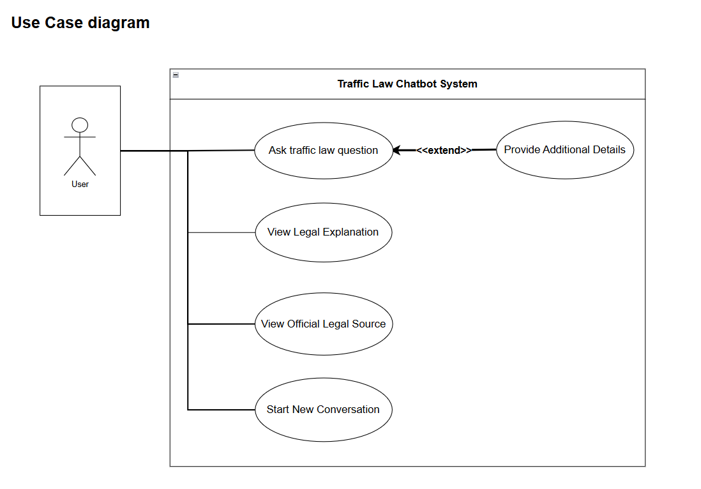

3.2 . Activity of Chatbot System
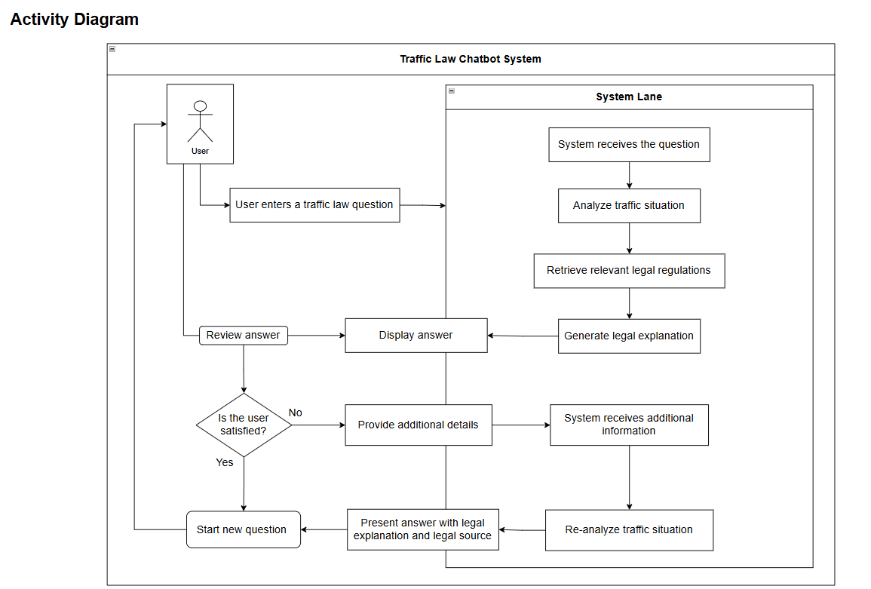

3.3 Architechure
