**LGU 1:BARANGAY TANOD PATROL MANAGEMENT SYSTEM: (PATROL SCHEDULING AND ASSIGNMENT, PATROL ROUTE MAPPING, INCIDENT REPORTING AND RESPONSE, PERFORMANCE TRACKING, RESOURCE**

**MANAGEMENT)**

A Capstone

Presented to the Faculty of

The College of Computer Studies

Bestlink College of the Philippines

In Partial Fulfillment

of the Requirements for the Degree of

Bachelor of Science in Information Technology

Abbatuan, Mc. Angelo A.

Garcia, Kim Rovil S.

Mallari, Tristan Cyrus S.

Medica, Reymond M.

Omnes, Noeven M.

October 2024

**APPROVAL SHEET**

This capstone entitled **LGU1 : BARANGRAY TANOD PATROL MANAGEMENT SYSTEM ( PATROL SCHEDULING AND ASSIGNMENT, PATROL ROUTE MAPPING, INCIDENT REPORT AND RESPONSE, PERFORMANCE TRACKING, RESOURCE MANAGEMENT )** prepared and submitted by **Reymond M. Medica, Mc. Angelo A. Abbatuan, Kim Rovil S. Garcia, Noeven M. Omnes, Tristan Cyrus S. Mallari,** in partial fulfilment of the requirements for the degree of Bachelor of Science in Information Technology, has been examined and is recommended for acceptance and approval Pre - Oral Defense.

**RICHELYN VILLASOR**

Adviser

**CAPSTONE REVIEW PANEL**

Approved by the Committee on Pre - Oral Examination with a grade of **Passed**

**VINCENT CARLO T. GARADOS**   **GLENOX O. LUZONG**

Member Member

**ROMMEL J. CONSTANTINO, MSIT**

Chairperson

Accepted and approved in partial fulfillment of the requirements for the degree of Bachelor of Science in Information Technology.

**ROSICAR E. ESCOBER, Ph. D**

Dean, College of Computer Studies

Date of Pre-Oral Defense: December 1, `2024

**ACKNOWLEDGMENT**

The researchers would like to express their heartfelt thanks and gratitude to the following persons who, in one way or another, has contributed much, and extended willingness and support needed to make this research possible:

**Dr. Maria M. Vicente,** President/CEO, Bestlink College of the Philippines, for her generosity and kind heart in establishing this institution and giving opportunities to those less fortunate students to continue their studies and pursue their dreams;

**Ms. Edith M. Vicente**, Executive Vice President, for providing the needed information to complete this research;

**Dr. Charlie I. Cariño**, Vice President for Academic Affairs, for his support and encouragement to make this thesis writing possible;

**Engr. Diosdado T. Lleno,** Vice President for Administration and Finance, for his words of encouragement and motivation;

**Dr. Joy Evelyn A. Ignacio,** Director,Center for Research and Development, for her good heart to extend her help needed by the researchers.

**Dr. Rosicar E. Escober**, Dean, College of Computer Studies of Bestlink College of the Philippines, for providing a guideline documentation in capstone project.

**Mr. Rommel J. Constantino**, Program Head, Bachelor of Science in Information Technology, for the constant supervision as well as providing necessary information regarding the project and also for his support in completing this project

**Mr. Ronald G. Roldan Jr.,** Research Coordinator, for helping us in improving our research and guiding us in completing this project.

**Ms. Richelyn Villasor**, Capstone Adviser, for giving us suggestions and ideas to improve our research and guiding us in completing this project.

Panelists, **Mr.Vincent Carlo T. Garados, Engr. Reynante B. Ponay**, and **Mr. Rommel J. Constantino**, who extended their effort and time to be able to constructively criticize this thesis and share their knowledge with the researcher to deepen and widen their needed information.

**Families and Friends**, for all the financial and moral support that have enabled the researchers to triumph all the challenges, especially during the lowest time that served as their inspiration to complete this study; and

Above all, to the **Almighty God**, for the strength and knowledge that were used for the accomplishment of this research journey.

**THE RESEARCHERS**

**DEDICATION**

This business research study is wholeheartedly dedicated first and foremost to the researchers, for executing dedication, time, effort, motivation, sacrifice, and courage to make this conducting study a fruitful and successful piece of work.

To our beloved parents who have been our inspiration and gave us strength when we thought of giving up, which continually provide their moral, spiritual, emotional and financial support.

To each sibling and circle of friends who shared their words of advice and encouragement to finish this study.

To the research advisers and professors, for extending help by giving guidance, supervision, time and wisdom to the researchers in conducting this business research study.

And lastly, above all, to our Almighty God, for giving guidance, strength, power of mind, protection, skills and for giving us a healthy life. All of these we offer to you.

**THE RESEARCHERS**

**ABSTRACT**

Title: **BARANGRAY TANOD PATROL MANAGEMENT SYSTEM ( PATROL SCHEDULING AND ASSIGNMENT, PATROL ROUTE MAPPING, INCIDENT REPORT AND RESPONSE, PERFORMANCE TRACKING, RESOURCE MANAGEMENT )**

Authors: **REYMOND M. MEDICA**

**MC. ANGELO A. ABBATUAN**

**KIM ROVIL S. GARCIA**

**NOEVEN M. OMNES**

**TRISTAN CYRUS S. MALLARI**

Degree: **Bachelor of Science of Information Technology**

Major: **Information Management, Information Security, Network Administrative**

Date of Completion:

The Barangay Tanod Patrol Management System was developed to improve the efficiency, coordination, and responsiveness of community safety operations at the barangay level. This capstone project aims to digitize and streamline core functions such as patrol scheduling and assignment, patrol route mapping, incident reporting and response, performance tracking, and resource management. Traditionally managed through manual logbooks and fragmented communication, the barangay's patrol operations were prone to delays, human error, and lack of accountability.

The system was developed using MongoDB for flexible data storage and Visual Studio as the primary development environment, leveraging web-based technologies for accessibility and ease of use. Through a user-friendly interface, administrators can create and manage patrol schedules, assign personnel, and monitor task performance. Barangay tanods can view their patrol duties and submit incident reports in real-time, improving transparency and response times. Integration with emergency response and logistics modules ensures that resources such as radios, flashlights, and first-aid kits are tracked and properly allocated.

The development process included requirements gathering from local stakeholders, use case identification, system prototyping, and iterative testing. Integration and interoperability were addressed through a modular system design, ensuring that different components—such as scheduling, mapping, and reporting—work cohesively. Testing strategies included unit testing, integration testing, and debugging to ensure system reliability and functionality.

The result is a centralized system that promotes organized scheduling, effective resource distribution, and quicker incident response. This contributes to a safer and more accountable community. The project lays the groundwork for future enhancements such as automated notifications and analytics dashboards. Overall, the Barangay Tanod Patrol Management System demonstrates how technology can modernize local governance and empower community-level security initiatives.

**TABLE OF CONTENTS**

**Page**

**TITLE PAGE i**

**APPROVAL SHEET ii**

**ACKNOWLEDGMENT iii**

**DEDICATION v**

**ABSTRACT vi**

**TABLE OF CONTENTS viii**

**LIST OF TABLES x**

**LIST OF FIGURES xi**

**CHAPTER I**

1. **Introduction**
   1. Background of the Capstone Project 1
   2. Context and Scope 3
   3. Problem Statement 6
   4. Objectives and Goals 7
   5. Significance and Relevance 8
   6. Structure of Document 11

**CHAPTER 2**

1. **Related Studies and Literature Review 14**
   1. Agile Scrum Methodology Overview 14
   2. Enterprise Architecture Concept 16
   3. Microservices Architecture 17
   4. DevOps and CI/CD 18
   5. Relevant Studies and Research
   6. Integration of Information System in Enterprise 20 Environment

**CHAPTER 3**

1. **Methodology 32**
   1. Scrum Agile Methodology in the Project 32
   2. Roles and Responsibilities 32
   3. Scrum Board 33
   4. Sprint Cycles 35
   5. Scrum Artifacts 39

Product Backlog 39

Sprint Backlog 42

* 1. Microservices Architecture 47

Microservices Diagram 47

Communication pattern 48

Data Flow Diagram 49

Patrol Scheduling and Mapping 50

Patrol Route Mapping 51

Incident Report and Response 52

Performance Tracking 53

Resource Management 54

* 1. DevOps Implementation 55

CI/CD Pipelines 55

Infrastructure as Code (IaC) 56

* 1. Inovation Integration 57

Integration Digram 57

BPA Level 1 58

BPA level 2 59

Data Flow Diagram 60

API Gateway 61

* 1. Additional Consideration 62

Usecase digram 62

Sequence diagram 63

Admin 63

Tanod 64

User 64

Activity Diagram 65

**Chapter 4**

1. **Requirements Analysis 56**

Stakeholder Indentification 56

Requirement Gathering Techniques 58

Interviews 58

Survey and Questionnaires 58

Focus Group 59

Obeservations 59

Workshops and Brainstorming 59

* 1. **User Stories and User Cases 60**

User Stories 60

User Cases 61

* 1. **Function Requirements for Integration 61**

Data Exchange Protocols 61

Synchronization Mechanisms 62

Error Handling 62

User Access Control 63

Module - Specific Integrations 63

Dependencies and Constraints 64

* 1. **Bussiness Process Architecture 65**

Identification of Bussiness Proces 65

Patrol Scheduling and Assignment 65

Patrol Route Mapping 66

Incident Response and

Response 66

Performance Tracking 67

Resource Manegement 68

Bussiness Process Diagram 68

Alignment of Integrated System

With Bussiness Process 72

Business Process Improvement 73

* 1. Application Architecture 75

Components of application

Architecture 75

Application Architecture

Diagram 76

**List of Tables**

**Table Page**

1. Roles and Responsibility 43
2. Scrum Board 44
3. Sprint Cycle 46
4. Product Backlog 50
5. Sprint Product 52

**List of Figures**

**Table Pages**

1. Microsevices Diagram 47
2. Communication Pattern 49
3. Data Flow Diagram ( Patrol Scheduling and

Assignment ) 50

1. Data Flow Diagram ( Patrol Route Mapping ) 51
2. Data Flow Diagram ( Incident Report And Response ) 52
3. Data Flow Diagram ( Performance Tracking ) 53
4. Data Flow Diagram ( Resource Management ) 54
5. DevOps Implementation 55
6. CI/CD Pipelines 55
7. Infrastracture as Code ( IaC) 56
8. BPA level 0 57
9. BPA level 1 58
10. BPA level 2 59
11. Data Flow Diagram level 2 60
12. API Gateway 61
13. Use Case Diagram 62
14. Sequence Diagram ( ADMIN ) 63
15. Sequence Diagram ( TANOD ) 64
16. Sequence diagram ( USER) 64
17. Activity Diagram 65

Chapter 1

INTRODUCTION

* 1. **Background of the Capstone Project**

In the Philippines, barangay tanods are the front-line community security officials entrusted with upholding safety and public order in their communities. They carry out crucial tasks including responding to crises, patrolling the community, and helping to enforce local laws. Even though the work they provide is vital, many barangays still manage Tanod operations using antiquated manual procedures. Operational inefficiencies brought about by these antiquated techniques include inefficient resource management, irregular workload distribution, delayed incident responses, and scheduling conflicts. The community's general safety is frequently jeopardized as a result.

The scheduling and deployment of patrols, where barangay officials still manually manage patrol schedules, is one major difficulty. This results in problems like uneven workloads, conflicting schedules, and lapses in patrol coverage, which exposes vulnerable locations. The security of the neighborhood is further jeopardized when Tanods are not always deployed strategically due to the lack of an established patrol route mapping system.

The lack of digital tools also affects the process of reporting incidents and responding to them. Typically, incidents are reported using primitive communication devices like cell phones or radios, which can cause reaction times to be delayed and inconsistent documentation to be produced. It becomes challenging for barangay authorities to keep track of response times, observe trends in incidents, or effectively handle persistent issues in the absence of a centralized reporting system.

Furthermore, there is little performance monitoring of Tanods, which makes it difficult for barangay leaders to evaluate the efficacy of patrols or pinpoint areas in need of development. Accountability and transparency within Tanod operations are further restricted by the absence of accurate statistics on patrol completion, reaction times, and incident resolution rates. Last but not least, resource management is a problem as barangays frequently find it difficult to track and distribute vital resources like cars and patrol gear, which results in shortages and inefficiencies.

This capstone project suggests creating a Barangay Tanod Patrol Management System in order to deal with these problems. Through the automation of crucial processes like patrol scheduling, route mapping, incident reporting, performance tracking, and resource management, the system seeks to modernize and optimize Tanod operations management. Barangays may drastically increase operational effectiveness, accountability, and community safety management by implementing digital tools.

* 1. **Context and Scope**

**Context**

In the Philippines, the Barangay Tanod Patrol Management System is essential to preserving law and order in local communities. They frequently respond to crises, disturbances, and other situations within the barrio as volunteer security personnel. But many barangays continue to assign jobs, report issues, and oversee Tanod patrols using antiquated manual procedures. These techniques may result in inefficiencies, making it challenging to keep track of patrol plans, keep an eye on employee performance, and guarantee that resources are used wisely.

The "Barangay Tanod Patrol Management System" introduces a digital platform designed specifically for local government units (LGUs) in an effort to modernize and streamline existing procedures. This technology will make important tasks like:

* Patrol Scheduling and Assignment: Efficiently assigning patrols to ensure that no area is ignored or overlapped.
* Patrol Route Mapping: Developing route optimizations that improve patrol coverage and guarantee tanod visibility in key locations.
* Incident Reporting and Response: Enabling instant incident reporting, guaranteeing prompt reactions and precise monitoring of Tanod operations.
* Performance Tracking: Giving barangay official the ability to keep an eye on and evaluate tanod’s performance using vital statistics like patrol coverage and reaction times.
* Resource Management: Overseeing the supply of vital resources, such as patrol gear and other required insturments.

The patrol activities of barangays can be greatly enhanced by implementing this technique. Task automation and real-time data provision can improve collaboration, cut down on delays, and enable more strategic use of people and resources. With all operations being monitored and documented, it also encourages accountability and transparency and enables officials to make data-driven judgments and assessments.

Long-term, this strategy can increase local government-resident confidence while also enhancing community safety and event response times. The Barangay Tanod Patrol Management System has the ability to change how barangays handle their patrols and respond to occurrences by offering a more structured and effective framework, creating a community that is safer and more secure.

**Scope**

The development and implementation of a Barangay Tanod Patrol Management System for Local Government Unit (LGU) 1 is the main subject of this study. Barangay Tanods currently uses manual processes for patrol scheduling, patrol route planning, incident reporting and response, performance tracking, and resource management. The system is intended to eliminate these inefficiencies.

The study will cover the following areas:

* **Patrol Scheduling and Assignment**: to ensure an efficient distribution of work, the system will automate the scheduling of patrol shifts for Barangay Tanod. This automation’s ability to lessen schedule conflicts and enhance coverage will be invegastigated in the study.
* **Patrol Route Mapping**: Barangay officials would be able to designated, allocated, and modify patrol routes with the help of a route mapping tool built into the system. The study will look at how these routes enhance neigborhood visibility and coverage
* **Incident Reporting and Response**: Tanod will be able to instantly notify the appropriate authorities about occurrences and report them instanly in real-time thanks to the system. The impact of this feature on incident data accuracy and reaction times wil be examined in the research
* **Performance Tracking**: This feature will monitor each Tanod’s performance and actions based on criteria including incident resolution rates, patrol completion rates, and reaction times. Accountability and operation efficiency will be assessed as a result of this tracking.
* **Resource performance**: The system will have capabilities for controlling the distrubution and utilization of resources ( vehicle, patrol gear, etc). The influence of this on the efficient use of resources in daily operations will be evaluated by the reseach.
  1. **Problem statement**

The Barangay Tanod's existing manual system for organizing patrols is ineffective and error-prone, making it impossible to schedule, assign patrols, and manage patrol routes. Due to this lack of automation, patrol officers have less accountability, slower reaction times, and delayed event reporting. In addition, the lack of an organized system for monitoring performance and allocating resources makes it more difficult for the Barangay to maintain community safety, maximize patrol coverage, and allocate resources efficiently. To overcome these operational difficulties, a simplified patrol management system is desperately needed.

* 1. **Objectives and Goals**

**Objectives**

* **Patrol Scheduling and Assignment**: Create a module that allows for automatic patrol scheduling and effective tanod assignment, guaranteeing the best possible coverage depending on available manpower and community requirements
* **Patrol Route Mapping**: Put in place a route mapping system to plan and maximize patrol routes, guaranteeing coverage of the important areas, cutting downs on reaction times, and improving visibility in susceptible locations.
* **Incident Reporting and Response** : Develop a feature that enables Tanod’s to use the system to report incident in real-time, giving the Barangay Office instant information and enabling prompt issue resolution.
* **Performance Tracking** : To ensure accountability and pinpoint areas for improvement, create a performance tracking module to track and analyze Tanod patrol actions, including attendance, route coverage, incident response times, and the quality of incident handled.
* **Resource Management** : is to efficiently allocate, track, and maintain resources to ensure optimal usage, minimize downtime, and support seamless patrol and emergency operations.

**Goal**

The "Barangay Tanod Patrol Management System" aims to improve the effectiveness and efficiency of the neighborhood's patrol operations by automating and streamlining crucial procedures such resource management, incident reporting, route mapping, patrol scheduling, and performance tracking.

* 1. **Significance and Relevance**

For the purpose of improving community security, upholding law and order, and assisting the capture of criminals, a barangay patrol management system is essential. It makes sure that law enforcement officers are deployed effectively based on crime trends and community needs by using patrol scheduling and assignment, which enhances coverage and speeds up response times.

The guard used to rely on pen and paper to verify if they had passed a checkpoint or even take a photo each time they did. This data is only accessible for review after the conclusion of a security officer's shift.

By enabling Barangay Tanods to use their smartphones, the cloud-based solution automates the entire patrol procedure. Paper and pens are not needed. The owner or manager can visit the software platform at any time to view any information that the doorman uploads automatically. The purpose of barangay patrol activities is to deter crime and boost public trust in urban security. To handle operational and resource restrictions, they entail route design, resource allocation, and jurisdiction planning (Weihong, 2017). Conventional patrol tactics, which rely on specialized expertise and two-dimensional spatial units, have shown to be unworkable and ineffective. As a result, sophisticated patrol methods that take into account the layout of the city, patrol officers' cooperation, and task distribution are required. For efficient coverage of crime hotspots and quicker reaction times during emergencies, patrol route optimization is essential (Alincastre & Dalugdog, 2022). Law enforcement organizations can improve their patrolling techniques and uphold community safety and security by employing spatial crime data and taking into account the structure of the street network. Nonetheless, there exist obstacles with the precision of law enforcement officials' assessments of high-crime areas and the distribution of pertinent data and insights (Gannapathy et al., 2023).

The system's capability for Barangay patrol route mapping allows for strategic planning and real-time adjustments, increasing visibility in high-risk areas and ensuring timely responses to incidents. Streamlined incident reporting and response processes enhance documentation and coordination, facilitating effective communication among officers and command centers (Alincastre & Dalugdog, 2022). Another benefit of using a software system to assist with security management is that patrols, logs and reports are the same no matter who filled it out. This ensures that every report contains important facts and details. If a report is required as evidence, rest assured that the report will be detailed enough to provide authorities with information they can use (Weihong, 2017).

If old reports need to be reviewed, management can go into the system and pull them out in seconds. They don’t have to be on site or go through thick documents.

Performance tracking promotes accountability and enables data-driven decisions, identifying trends and areas for improvement. Lastly, efficient resource management ensures optimal allocation of personnel and equipment, contributing to cost-effectiveness and better budget planning. Patrol Management System fosters a proactive approach to law enforcement, enhancing community trust, deterring crime, and ultimately creating a safer environment for all (Gannapathy et al., 2023).

* 1. **Structure of the Document**

"Barangay Tanod Patrol Management System" will be organized to give a thorough overview of the system. It will start with a Title Page that contains the research title, author(s), institution, and date. Then, an Abstract will follow, outlining the goals, methods, and anticipated results of the study. If there is an Acknowledgments section, it will acknowledge people or organizations that provided support for the research. For simplicity, a List of Figures and Tables will be included with a Table of Contents that includes a list of all the sections and subsections. The study's past, the problem statement and its general and particular aims will all be covered in the introduction. Additionally, it will outline the study's boundaries and significance for community members, LGUs, and barangay tanods, among other stakeholders. Existing systems, best practices, and relevant studies on patrol management, scheduling, and incident reporting will all be examined in the Review of Related Literature.

The Barangay Tanod Patrol Management System is structured to ensure clarity and coherence across all key sections, from the review of relevant literature to the detailed methodologies used in the project. Chapter 2: Related Studies and Literature Review covers essential topics that provide foundational knowledge for the system's development. This chapter begins with an overview of the Agile Scrum Methodology, which is used to manage and organize the project's development cycles. It also explores Enterprise Architecture Concepts, helping frame how the system fits within larger organizational frameworks, followed by a deep dive into Microservices Architecture, highlighting its principles, benefits, and challenges. The chapter further discusses DevOps and CI/CD, focusing on how these practices enhance software development efficiency. Additionally, the review covers Relevant Studies and Research that have informed the project, along with insights into the Integration of Information Systems in Enterprise Environments, establishing how complex systems work in harmony.

Chapter 3: Methodology focuses on the specific approaches and tools applied to build and implement the patrol management system. It begins with an explanation of how the Agile Scrum Methodology is used throughout the project to ensure iterative and flexible development. The chapter also defines the various Roles and Responsibilities assigned to team members and stakeholders to manage different project areas efficiently. It details the Sprint Cycles, specifying how the development work is divided into smaller, manageable phases, and outlines the various Scrum Artifacts used to track progress. A detailed explanation of the Adopted Microservices Architecture is provided, describing how the system is modularized for scalability and maintainability. The chapter also elaborates on the DevOps Implementation, highlighting the use of CI/CD pipelines and automation tools to streamline deployment processes. Finally, it discusses the Integration of Innovations, showcasing how modern technologies such as AI, IoT, and mobile applications enhance the system's capabilities and improve patrol operations.

**Chapter 2**

**LITERATURE REVIEW**

1. **Related Studies and Literature Review**
   1. **Overview of the Agile Scrum Methodology**

Agile Scrum methodology utilizes the principles of Agile philosophy with the Scrum framework, emphasizing project development. Agile promotes the delivery of projects in small increments, while Scrum structures this process through defined time frames known as "sprints,". A sprint represents a concise, time restricted phase during which a Scrum team aims to accomplish a specific amount of work. Central to both Scrum and Agile methodologies, effective management of sprints is crucial for enhancing software delivery and minimizing complications (Drumond, 2024). In Scrum, each sprint encompasses a defined duration during which all designated tasks must be completed (Joubert, 2024). A Scrum consists of members that will work on a specific task on a scrum. In this group, different people can do various jobs, and they work together to create a part of a product. They aim to finish and deliver something valuable in a short period, which they call a “Sprint.” It consists of:

**Product Owner:** Manages the product backlog and ensures the team provides value to stakeholders by prioritizing features.

**Scrum Master**: Serves as a facilitator, ensuring adherence to Scrum practices, addressing obstacles, and coaching the team.

**Development Team**: A diverse group of professionals collaborating to produce potentially shippable increments of the product by the end of each sprint.

Before initiating a sprint, careful preparation is very important, including the establishment of the duration of the time box, defining the sprint goal, and determining the starting point. The sprint planning session serves as the meeting that establishes the goals for the sprint (Joubert, 2024). When executed effectively, this session fosters an environment that motivates and challenges team members, facilitating their success. However, poorly constructed sprint plans can hinder the team's progress by setting unattainable expectations. The primary objective of each sprint is to prioritize and develop essential features, resulting in a potentially deliverable product after each iteration. Subsequent sprints build upon previous work, incorporating stakeholder and customer feedback to refine the product further (Peek, 2024).

Adding to the traditional project management approaches that aim to complete a project in one comprehensive effort, Agile Scrum focuses on delivering multiple iterations, thus maximizing business value in the shortest time frame. This methodology enhances the pace of product development, as each sprint mandates the completion of specific goals within its time constraints (Drumond, 2024). The frequent planning and goal-setting processes inherent in Scrum foster a concentrated effort from the team on the current sprint's objectives, ultimately leading to increased productivity (Joubert, 2024).

* 1. **Enterprise Architecture Concept**

Enterprise architecture is very similar to urban design and involves analyzing, designing, planning, and implementing strategies for organizations (Hajela, 2013). EA helps to minimize redundancy, complexity, and information database, as well as the risks tied to IT investments. It also serves as a guide for creating an effective IT strategy and supports the gradual development of IT in a way that benefits the business while keeping costs low (White, 2022).

Experts in this domain examine the structure and procedures of the organization. They make use of the data they collect to support the major objectives of Enterprise Architecture (EA), which include enhancing the efficacy, efficiency, agility, and continuity of complex business processes (Hajela, 2013). A high-level framework for corporate software development is provided by the Open Group Architecture Framework (TOGAF), an enterprise architecture approach. By using a methodical approach, TOGAF assists in organizing the development process and helps to reduce errors, manage timetables, remain within budget, and integrate IT with business divisions to generate high-quality products (White, 2022).

* 1. **Microservices Architecture**

Microservices are a software architecture style that structures an application as a collection of loosely coupled services designed to implement a specific business function or process. This approach allows an application to be developed, deployed, and scaled as a suite of small, independent services (Velepucha & Flores, 2023). It also develops software systems divided into small, independent services, each running its process and communicating through lightweight mechanisms (Bushong, 2021). This approach enables the rapid, reliable, and frequent deployment of large, complex applications. Microservices architecture is a design approach in which an application is developed as a collection of small, autonomous services, each performing a unique function and communicating over a network (Microservice Architecture Pattern, n.d.).

Microservice architecture centers around independent services, each designed for specific tasks, promoting loose coupling to minimize the impact of changes. Each service manages its own database, ensuring data autonomy and fault tolerance, while an API Gateway acts as the main entry point for client requests, handling routing and cross-cutting concerns like authentication (Bushong, 2021). Service discovery allows dynamic communication between services, essential in a cloud environment where their locations may change frequently. Communication can be synchronous or asynchronous, depending on needs, and configuration management tools help maintain consistency across various environments (Velepucha & Flores, 2023). Containerization technologies like Docker and Kubernetes streamline deployment and management, while CI/CD practices support frequent updates and quicker release cycles. Finally, robust monitoring and logging are vital for diagnosing issues and understanding application performance in this distributed setup (Velepucha & Flores, 2023).

* 1. **DevOps and CI/CD**

Continuous Integration (CI) and Continuous Deployment (CD) involve automating the process of integrating code changes from multiple developers into a unified codebase (Bigelow, 2024). This practice requires developers to frequently commit their work to a central repository. Automated tools then build the newly committed code and perform necessary actions, like code reviews, during integration (What Is CI/CD?, 2023). The main objectives of Continuous Integration are to quickly identify and fix bugs, streamline the integration process for development teams, enhance software quality, and shorten the time needed to release new features. CI/CD pipelines represent structured workflows and tools aimed at facilitating the building, testing, and delivery of contemporary software (Ashtari, 2022). In modern software development, speed is crucial. The traditional Waterfall model has been supplanted by rapid, iterative methodologies, such as Agile and DevOps, alongside practices like continuous integration, delivery, and deployment (Ashtari, 2022).

While each of these methodologies presents nuanced differences, they share a unified focus on continuous iteration, fundamentally transforming software development's scope and efficiency (Bigelow, 2024). This approach enables businesses to expedite software market entry, experiment with innovative features while minimizing risk and costs, and iteratively enhance products over time.

Each stage within a CI/CD pipeline works on different software iterations simultaneously; for instance, as a stable build is prepared for production deployment, an earlier version is undergoing testing, and an even earlier iteration is being developed, all while future builds are planned to sustain the software development lifecycle (Bigelow, 2024).

* 1. **Integration of Information Systems in Enterprise Environment**

There are advantages and problems associated with integrating information systems into the business environment. The intricacy of coordinating many systems and data sources is a big obstacle that might cause compatibility problems and demand a large amount of implementation resources. Progress might also be hampered by staff opposition to change and possible disruptions during integration. But there are significant advantages. Organizations can function more smoothly through the simplification of procedures and the elimination of unnecessary work that comes with effective integration. Because interconnected systems share a single source of truth, there are fewer mistakes and conflicts, improving data consistency. Better decision-making results from this dependability since it gives stakeholders access to fast and accurate information.

For example, a study conducted in Malaysia proved that their Mobile and Web-Based Security Guard Patrolling, Monitoring and Reporting System to Maintain Safe and Secure Environment at Premises System which helps companies and organizations to monitor their security activities such as protecting people, buildings, assets, or equipment. It enhanced the protection of the property and assets and assisted their host organization in providing an effective execution of Standard Operating Procedure (SOP) modules (Gannapathy et al., 2023). However, in another study conducted in Lipa, Batangas, which is Philippine National Police Electronic Project Systems, that aims to automate and digitalize their old and by-the-book method of keeping police records in their area, it proved that only minimal problems are encountered in the course of the study. They only encountered manpower training and familiarization of the personnel (Alincastre & Dalugdog, 2022).

**Chapter 3**

**METHODOLOGY**

1. **Agile Scrum Methodology in the project**
   1. **Scrum Methodology**

The Barangay Tanod Patrol Management System adheres to Agile Scrum methodology that allows for fast user feedback and iterative development. The project is divided into multiple sprints each of 1-2 weeks focusing on individual features like patrol scheduling, route mapping, incident reporting and resource management. The Scrum team, comprised of developers, testers, and a Product Owner, meet often including times for sprint planning, daily stand-ups, and sprint reviews. The aim is to have a potentially shippable product increment at the end of each sprint so that feedback and improvements can happen on an ongoing basis. This method is designed for flexibility, adaptability and deliver the system in a time frame so that it meets user need.

* 1. **Roles and Responsibilities**

The key duties of each participant in the capstone are indicated in the table below.

|  |  |  |
| --- | --- | --- |
| **Name** | **Role** | **Responsibilities** |
| Reymond Medica | Project Manager/ Scrum Master | The project manager oversees the project's progress, ensures deadlines are met, assigns team members, collaborates, and communicates with stakeholders, planning, tracking progress, and aligning objectives. |
| Kim Rovil Garcia | Lead Programmer | Leads development, writes and reviews code, and ensures technical quality. |
| Tristan Cyrus Mallari and Noeven Omnes | Document Specialist | Manages and maintains project documentation, ensuring clarity and accuracy. |
| Mc. Angelo Abbatuan | System Analyst | Analyzes user requirements, translates them into technical specifications, and designs effective solutions. |

Table no:1 Roles and Responsibilities

* 1. **Scum Board**

|  |  |  |  |
| --- | --- | --- | --- |
| **Task / Story** | **To do** | **In Progress** | **Done** |
| Set up server and database infrastructure |  | ✔ |  |
| Create patrol scheduling module |  | ✔ |  |
| Design patrol route mapping interface | ✔ |  |  |
| Implement patrol assignment feature | ✔ |  |  |
| Develop incident reporting and response API | ✔ |  |  |
| Integrate incident alert notification system | ✔ |  |  |
| Conduct testing on patrol route mapping | ✔ |  |  |
| Test role-based access and user authentication |  |  | ✔ |
| Prepare partial documentation (drafts/manuals) | ✔ |  |  |
| Gather feedback for ongoing documentation revisions | ✔ |  |  |
| Finalize deployment checklist | ✔ |  |  |
| Conduct user training for patrol personnel | ✔ |  |  |

Table no. 2 : Scrumboard

* 1. **Sprint Cycles**

Sprint cycle 1: System Planning and Initial Setup

|  |  |  |  |  |
| --- | --- | --- | --- | --- |
| **Sprint Cycle** | **User stories no:** | **User stories / Task** | **Timeline** | **Responsible Team Members** |
| Sprint planning | 1 | Identify core system requirements for the patrol management system | Start of sprint 1 |  |
| Daily Stand-ups | 2 | Discuss progress on defining project scope and resolving blockers | Daily throughout sprint 1 |  |
| Print review | 3 | Validate the project plan requirements with stakeholders | End of sprint 1 |  |

Table No 3 Sprint Cycle 1: System Planning and Initial Setup

Sprint cycle 2: Patrol Scheduling and assignment Module

|  |  |  |  |  |
| --- | --- | --- | --- | --- |
| **Sprint Cycle** | **User stories no:** | **User stories / Task** | **Timeline** | **Responsible Team Members** |
| Sprint planning | 4 | Create patrol scheduling and assignment framework | Start of sprint 2 |  |
| Daily Stand-ups | 5 | Monitor task completion and address issues with schedule generation | Daily throughout sprint 2 |  |
| Print review | 6 | Review the scheduling interface and assignment logic | End of sprint 2 |  |

Table No 4 Sprint Cycle 2: Patrol Scheduling and assignment Module

Sprint cycles 3: Patrol Route Mapping Module

|  |  |  |  |  |
| --- | --- | --- | --- | --- |
| **Sprint Cycle** | **User stories no:** | **User stories / Task** | **Timeline** | **Responsible Team Members** |
| Sprint planning | 7 | Set up map-based route planning for patrols | Start of sprint 3 |  |
| Daily Stand-ups | 8 | Track development of routing algorithm and integration with patrol data | Daily throughout sprint 3 |  |
| Print review | 9 | Validate patrol routes and test route visualization | End of sprint 3 |  |

Table No 5 Sprint Cycle 3: Patrol Route Mapping Module

Sprint cycle 4 : Incident Report and Response Module

|  |  |  |  |  |
| --- | --- | --- | --- | --- |
| **Sprint Cycle** | **User stories no:** | **User stories / Task** | **Timeline** | **Responsible Team Members** |
| Sprint planning | 10 | Develop incident reporting and alert mechanisms | Start of sprint 4 |  |
| Daily Stand-ups | 11 | Monitor progress in building incident forms and backend logic | Daily throughout sprint 4 |  |
| Print review | 12 | Test and review the incident reporting functionality | End of sprint 4 |  |

Table No 6 Sprint Cycle 4: Incident Report and Response Module

Sprint Cycle 5 : Performance Tracking and Resource Management Module

|  |  |  |  |  |
| --- | --- | --- | --- | --- |
| **Sprint Cycle** | **User stories no:** | **User stories / Task** | **Timeline** | **Responsible Team Members** |
| Sprint planning | 13 | Define metrics and tracking tools for performance management | Start of sprint 5 |  |
| Daily Stand-ups | 14 | Ensure smooth integration of tracking and resource data | Daily throughout sprint 5 |  |
| Print review | 15 | Validate performance tracking and resource management modules | End of sprint 5 |  |

Table No 7 Sprint Cycle 5: Performance Tracking and Resource Management Module

Sprint cycle 6: Integration, Testing, and Final Review

|  |  |  |  |  |
| --- | --- | --- | --- | --- |
| **Sprint Cycle** | **User stories no:** | **User stories / Task** | **Timeline** | **Responsible Team Members** |
| Sprint planning | 16 | Prepare for system integration and testing | Start of sprint 4 |  |
| Daily Stand-ups | 17 | Coordinate testing efforts and integration across all modules | Daily throughout sprint 4 |  |
| Print review | 18 | Review and finalize the integrated system for deployment | End of sprint 4 |  |

Table No 8Sprint cycle 6: Integration, Testing, and Final Review

* 1. **Scrum Artifacts**

**Product Backlog**

The Barangay Tanod Patrol Management System consists of five sub-modules: Patrol Scheduling and Assignment, Route Mapping, Incident Reporting, Performance Tracking, and Resource Management, each with prioritized user stories for project alignment.

|  |  |  |  |  |
| --- | --- | --- | --- | --- |
| **User story no#** | **User stories** | **User story priority** | **Revised priority** | **status** |
| Patrol Scheduling and Assignment | | | | |
| 1 | Set up patrol scheduling interface | 5 | 5 | Ongoing |
| 2 | Develop patrol assignment logic | 5 | 5 | Ongoing |
| 3 | Add calendar integration for schedules | 3 | 5 | Ongoing |
| 4 | Implement shift notification for patrols | 3 | 3 | Ongoing |
| 5 | Create admin dashboard for shift management | 3 | 5 | Ongoing |
| 6 | Test patrol schedule and assignment module | 3 | 5 | Ongoing |
| Patrol Route Mapping | | | | |
| 7 | Integrate google maps API for route mapping | 5 | 5 | Ongoing |
| 8 | Develop route optimization feature | 3 | 3 | Ongoing |
| 9 | Add real-time route tracking | 5 | 5 | Ongoing |
| 10 | Create route adjusment options | 3 | 3 | Ongoing |
| 11 | Implement route visualization dashboard | 5 | 5 | Ongoing |
| 12 | Perform testing for route mapping functionality | 3 | 3 | Ongoing |
| Incident Reporting and Response | | | | |
| 13 | Build incident reporting form | 5 | 5 | Ongoing |
| 14 | Add media attachment feature | 3 | 3 | Ongoing |
| 15 | Implement notification alerts for incidents | 5 | 5 | Ongoing |
| 16 | Create incident tracking dashboard | 5 | 5 | Ongoing |
| 17 | Develop incident history module | 3 | 3 | Ongoing |
| 18 | Test the incident reporting and response module | 3 | 3 | Ongoing |
| Performance Tracking | | | | |
| 19 | Build performance tracking dashboard | 5 | 5 | Ongoing |
| 20 | Develop weekly and monthly performance report | 3 | 3 | Ongoing |
| 21 | Implement report export (pdf,csv) feature | 3 | 3 | Ongoing |
| 22 | Add alerts for patrol performance | 5 | 5 | Ongoing |
| 23 | Create performance summary feature | 3 | 3 | Ongoing |
| 24 | Conduct testing on performance tracking | 3 | 3 | Ongoing |
| Resource Management | | | | |
| 25 | Develop resource manage dashboard | 5 | 5 | Ongoing |
| 26 | Implement resource allocations system | 3 | 3 | Ongoing |
| 27 | Add inventory tracking for patrol equipment | 5 | 5 | Ongoing |
| 28 | Create low-resource alerts | 3 | 3 | Ongoing |
| 29 | Monitor resource usage trends | 3 | 3 | Ongoing |
| 30 | Perform testing for resource management module | 3 | 3 | Ongoing |

Table no. 9 Product Backlog

**Sprint Backlog**

The Sprint Backlog is the dynamic planning that determines the specific tasks, features, and user stories to be completed in a sprint cycle in the Barangay Tanod Patrol Management System. It delineates prioritized items in the product backlog to work out actionable items to ensure the development team stays focused on delivering incremental progress. This backlog is continually refined and updated throughout the sprint, thereby providing the transparency, collaboration, and flexibility needed to meet the project needs and deliver relevant, high-priority features on time.

|  |  |  |  |  |
| --- | --- | --- | --- | --- |
| **Sprint no#** | **User story** | **task** | **Responsible member** | **Timeline**  **(hours)** |
| Patrol Schedule and Assignment | | | | |
| 1 | As an admin, I want to create patrol schedules | Develop scheduling interface | Kim Rovil | 8 |
| 2 | Assign patrols automatically based on shifts | Implement assignment logic | Reymond | 8 |
| 3 | Notify patrols about their shifts | Set up shift notification | Tristan Cyrus | 8 |
| 4 | View patrol schedules in a calendar format | Integrate calendar view | Noeven | 8 |
| 5 | Manage patrol shifts via admin dashboard | Develop admin dashboard | Mc. Angelo | 8 |
| 6 | Test the scheduling and assignment module | Perform unit testing | Kim Rovil | 8 |
| Patrol Route Mapping | | | | |
| 7 | Map patrol routes using google maps | Integrate Google maps API | Kim Rovil | 8 |
| 8 | Optimize patrol routes for efficiency | Develop route optimization logic | Mc. Angelo | 8 |
| 9 | Track patrols in real-time | Implement real-time tracking | Reymond | 8 |
| 10 | Modify routes when necessary | Add route adjustment option | Noeven | 8 |
| 11 | View patrol route on the admin dashboard | Create route visualization dashboard | Tristan Cyrus | 8 |
| 12 | Test patrol route mapping modules | Perform module testing | Kim Rovil | 8 |
| Incident Reporting and Response | | | | |
| 13 | Report incidents with details | Develop incident reporting form | Tristan Cyrus | 8 |
| 14 | Attach photos/videos to incident report | Add media upload featuire | Noeven | 8 |
| 15 | Send notification to responders | Implement notification system | Mc. Angelo | 8 |
| 16 | Track incident on the admin dashboard | Build incident trackin dashboard | Reymond | 8 |
| 17 | View response history for incidents | Develop incident historu module | Kim Rovil | 8 |
| 18 | Test incidents reporting and response module | Perform module testing | Kim Rovil | 8 |
| Performance Tracking | | | | |
| 19 | Monitor patrol performace | Develop performance tracking dashboard | Kim Rovil | 8 |
| 20 | View patrol performance reports | Implement reporting functionality | Reymond | 8 |
| 21 | Export pergformance report | Add export feature (PDF, CSV) | MC.Angelo | 8 |
| 22 | Generate weekly and monthly performance summaries | Create summary report logic | Tristan cyrus | 8 |
| 23 | Notify patrols on theirs performance | Set up performance | Noeven | 8 |
| 24 | Test performance tracking module | Perform testing | Kim Rovil | 8 |
| Resource Management | | | | |
| 25 | Manage patrol resources | Develop resource management dashboard | Kim Rovil | 8 |
| 26 | Track patrol equipment inventory | Implement inventory tracking | Noeven | 8 |
| 27 | Notify admin for low resource levels | Set up low-resource alerts | Tristan Cyrus | 8 |
| 28 | Allocate resources to patrols | Implement resource allocation logic | Reymond | 8 |
| 29 | Monitors resource usage trends | Add usage trend analytics | Mc.Angelo | 8 |
| 30 | Test resource module | Performance test | Kim Rovil | 8 |

Table no. 10 Sprint Backlog

* 1. **Microservices Architecture**

**Microservices Diagram**

Microservices architecture diagram provides a visual model for modularity in the Barangay Tanod Patrol Management System. Each individual service is going to serve as an independent unit with a focus on specific functionalities such as patrol scheduling, incident reporting, resource management, and performance tracking. This architecture promotes more scalable, flexible, and easier maintenance since individual services can be developed, deployed, and updated independently while remaining cohesive and communicating well with other modules through well-defined APIs.

**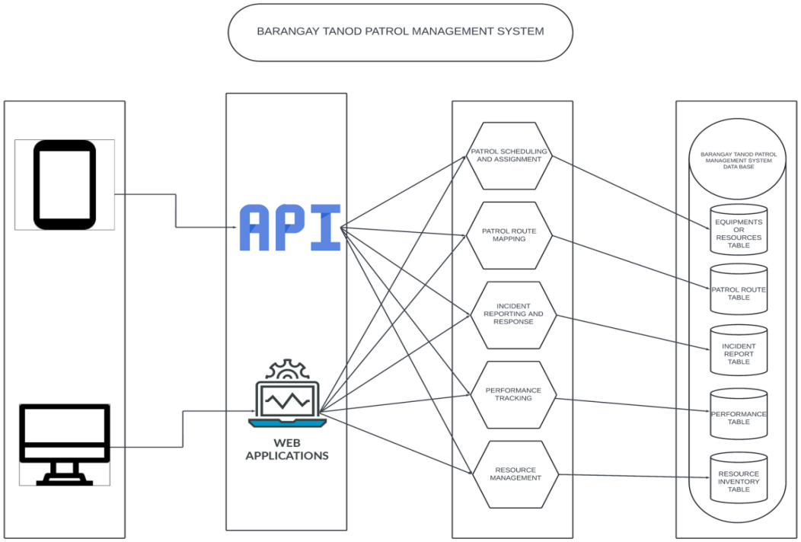**Figure no 1: Microservices diaram

**Communication Patterns**

The communication pattern describes the modes and manners in which different elements and users of the Barangay Tanod Patrol Management System interact and exchange information. It will aid microservices, admin dashboards, mobile apps, and external systems to communicate with each other through defined protocols, such as REST APIs or message queues, for smooth communication and exchange of information. This enables real-time data flows that may occur while scheduling patrols, reporting incidents, and updating resources so that appropriate responses can be made within the shortest possible time frame by managing coordination among barangay officials, tanods, and residents.

**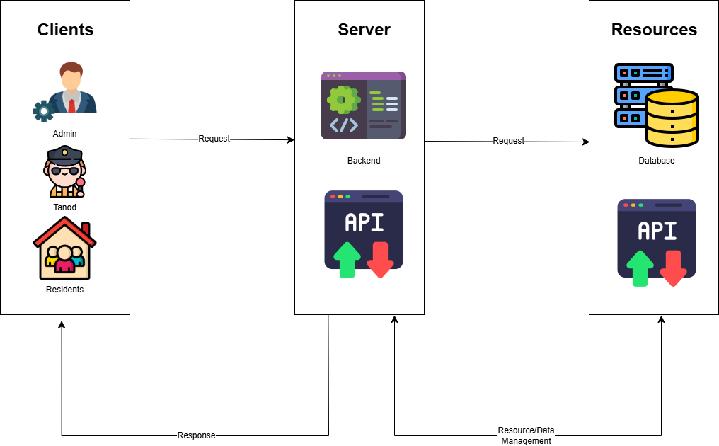**

Figure no. 2: Communication Pattern

**Data Flow Diagram**

In the DFD of the Barangay Tanod Patrol Management System, it shows off flows of data within the system-the means whereby information flows between key components of the system like patrol scheduling, incident reporting, resource management, and user interfaces. It gives a presentable way on how the system and its modules interact with inputs thereof, say user reports, patrol logs, and outputs thereof, or through notifications, report, analytics, and how the data further processed each of the modules. The diagram clearly provides information about data pathways; hence, the system can efficiently handle data and co-ordinate all other functions of the system smoothly.

**Patrol Scheduling and Assignment**

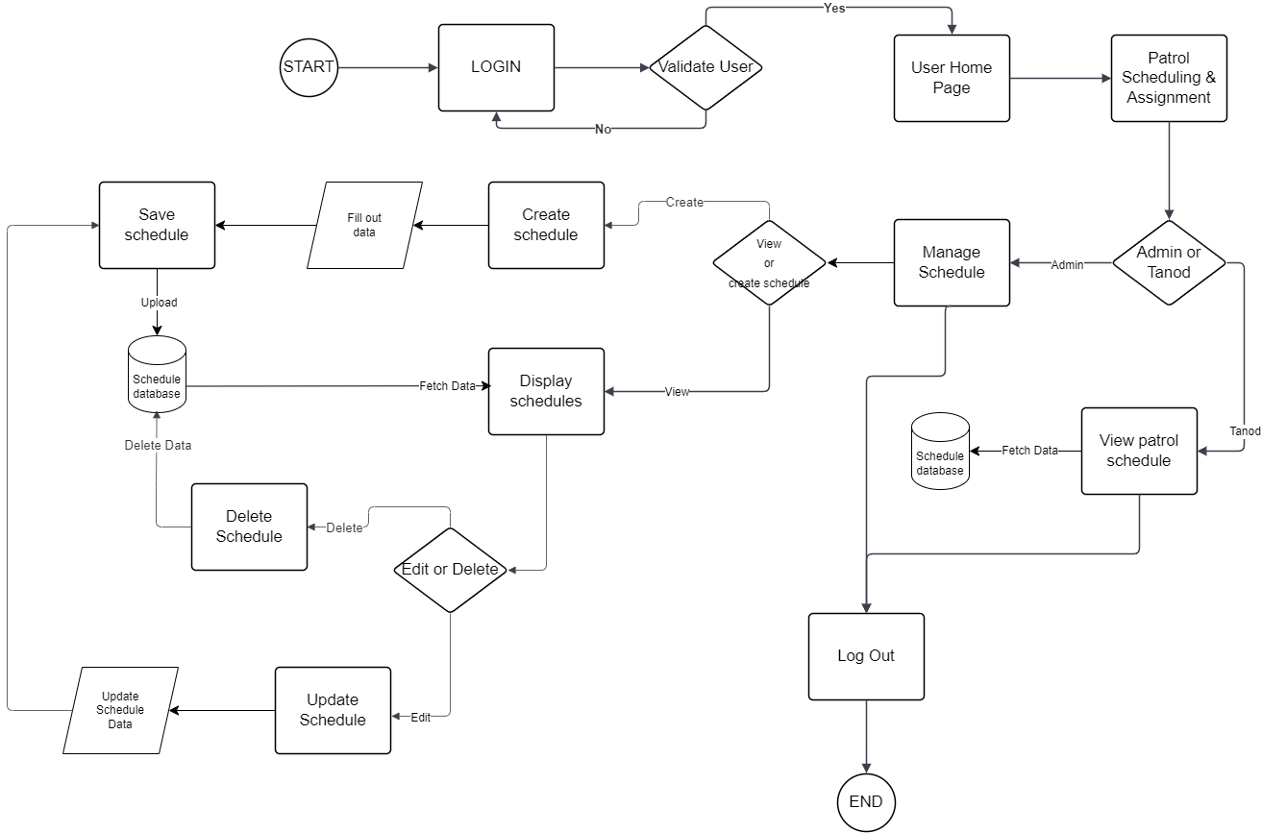The Data Flow Diagram (DFD) for the Patrol Scheduling and Assignment Module provides a visual representation of how data flows within the system to manage patrol schedules and assign tasks to barangay tanods. It outlines the key processes involved, such as creating patrol schedules, assigning personnel, and updating patrol logs, along with interactions between the admin, tanods, and system database. The DFD also shows how external inputs, like shift availability and patrol routes, are processed to generate optimized schedules. This diagram ensures a clear understanding of the data pathways, supporting efficient coordination and seamless patrol management.

Figure no. 3: Patrol Schedule and Assignment (DFD)

**Patrol Route Mapping**

The Data Flow Diagram (DFD) for the Patrol Route Mapping Module illustrates the flow of information involved in planning, managing, and optimizing patrol routes. It highlights key processes, such as route creation, updates based on patrol coverage or incidents, and access to mapped routes by patrol officers. The DFD showcases interactions between the admin, patrol officers, and the system database, as well as external inputs like geographic data or past incident locations. This diagram provides a clear understanding of how data moves through the system, ensuring effective route planning and improved patrol efficiency.

**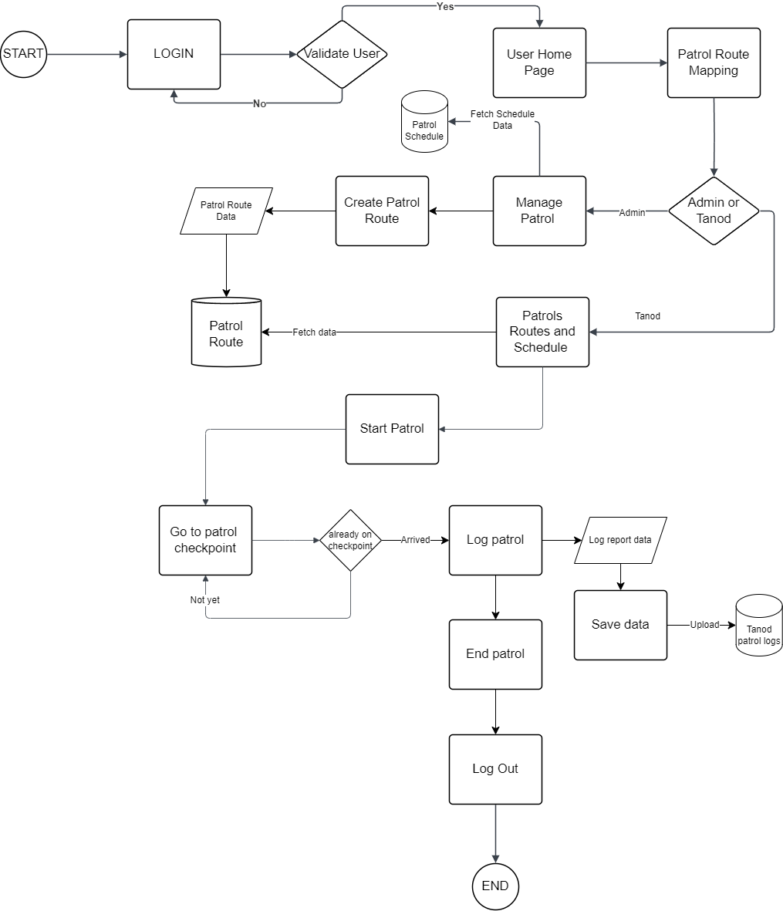**Figure no. 4 Patrol Route Mapping (DFD)

**Incident Report And Response**

The Data Flow Diagram (DFD) for the Incident Reporting and Response Module visualizes the flow of information involved in reporting incidents and coordinating responses. It outlines key processes, such as the submission of incident reports by residents, validation and prioritization by the admin, and assignment of patrol officers for response. The DFD highlights interactions between users, admins, patrol officers, and the system database, as well as notifications and status updates. This diagram provides a clear view of how data flows through the system, ensuring timely incident reporting, efficient response coordination, and seamless communication among stakeholders.

**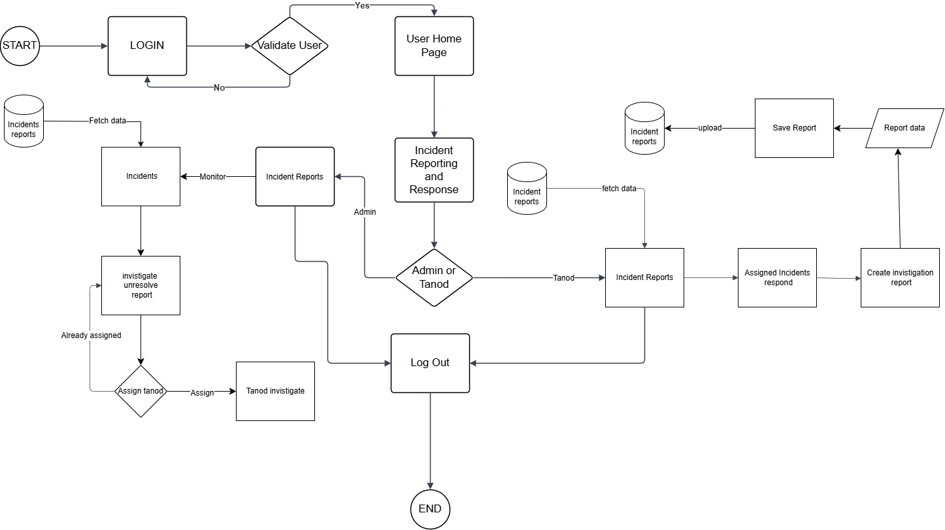**

Figure no. 5: Incident Report and Response

**Performance Tracking**

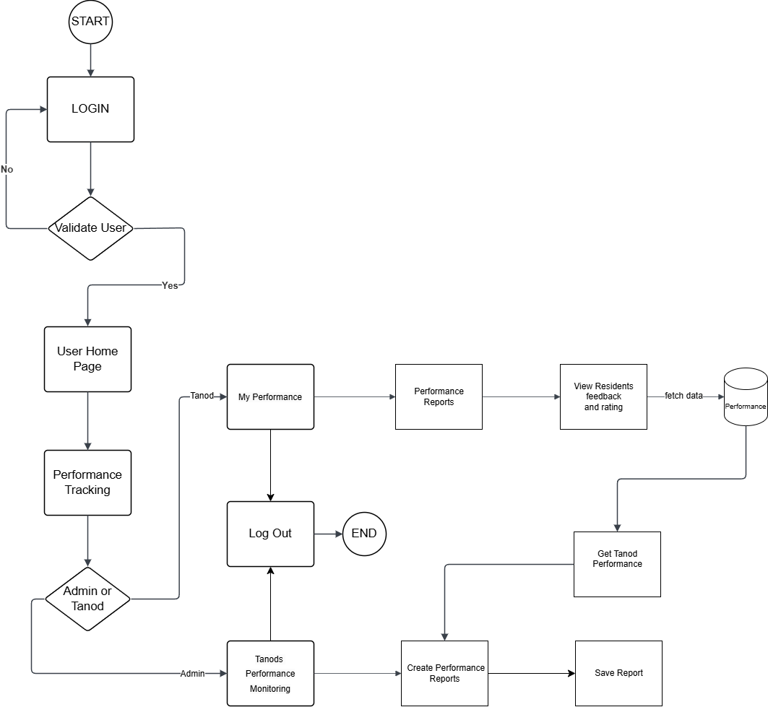The Data Flow Diagram (DFD) for the Performance Tracking Module illustrates the flow of data involved in monitoring and evaluating the performance of patrol officers and overall system operations. It outlines key processes such as data collection from patrol logs, incident reports, and resource usage, which are analyzed to generate performance metrics and reports. The DFD shows interactions between the admin, patrol officers, and the database, as well as feedback loops through performance reports. This diagram ensures a clear understanding of how data is processed to track performance, enabling informed decisions, continuous improvement, and accountability.

Figure no. 6 : Performance Tracking (DFD)

**Resource management**

The Data Flow Diagram (DFD) for the Resource Management Module outlines the flow of information involved in managing resources such as personnel, equipment, and supplies. It highlights key processes, including resource allocation, inventory updates, and tracking resource availability and usage. The DFD depicts interactions between the admin, patrol officers, and the system database, ensuring that resources are efficiently assigned and maintained. This diagram provides a clear view of how data moves within the module, supporting optimal resource utilization and ensuring that essential tools are available for effective patrol operations and incident response.

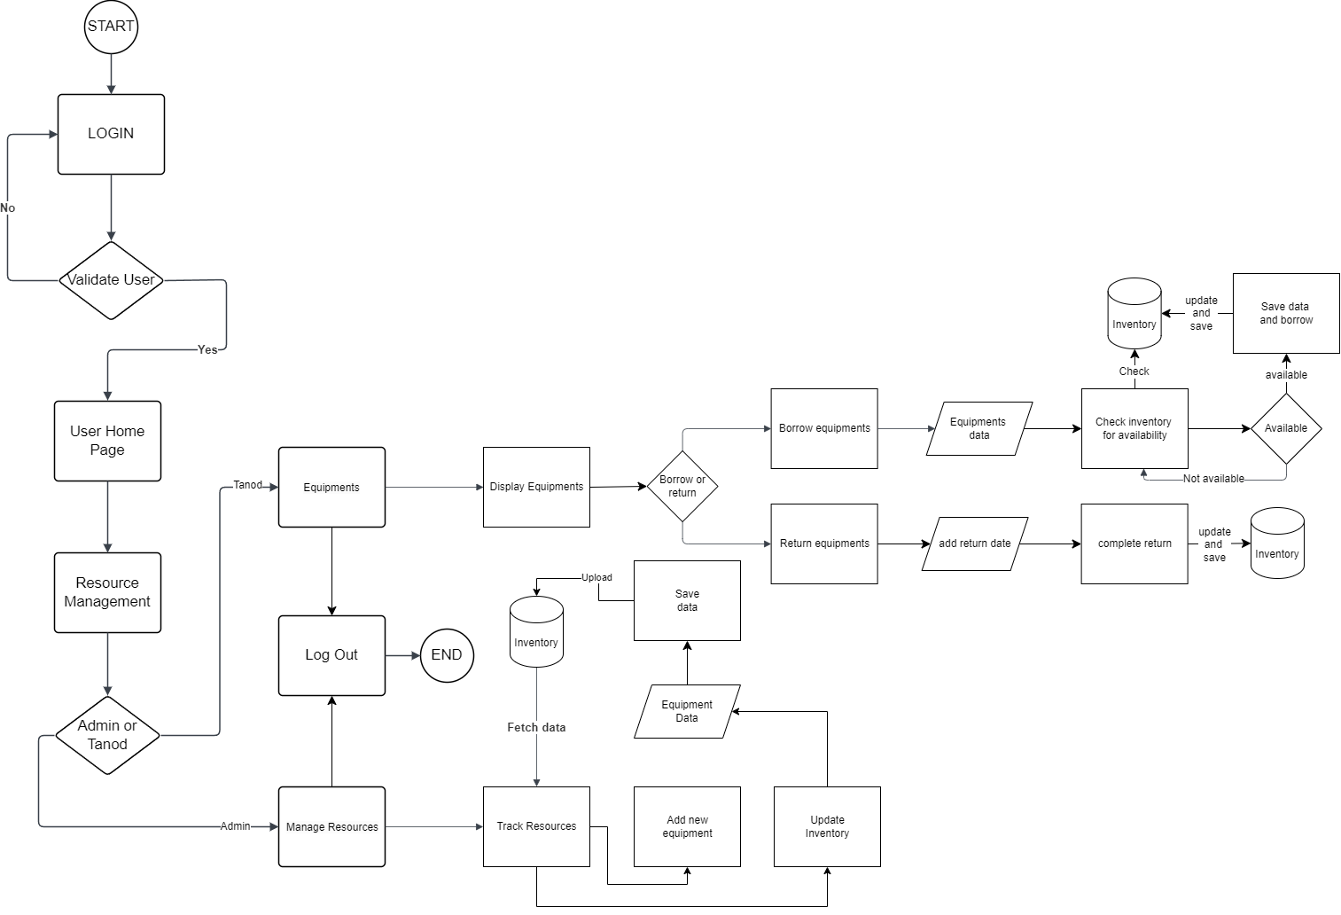

Figure no. 7 : Resource Management (DFD)

* 1. **DevOps Implementation**

DevOps are steps that combine software development and IT operations to provide an effective and faster service for our project.

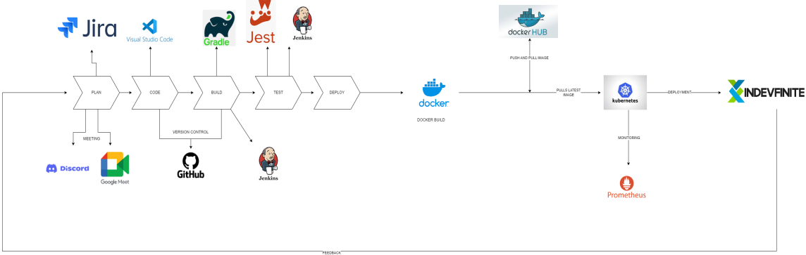

Figrure no. 8 DevOps Implementation

**CI/CD Pipelines**

The Barangay Tanod Patrol Management System's CI/CD Pipeline makes sure that software development, testing, and deployment are efficient and dependable. Code changes from several developers can be automatically merged into a single source using the Continuous Integration method, which also runs tests early to identify any problems. With CD, verified code is distributed to staging or production environments with the least amount of human involvement possible. It increases development efficiency, decreases downtime, and allows for rapid iterations of new features, bug fixes, and enhancements without causing any inconvenience or disturbance to users.

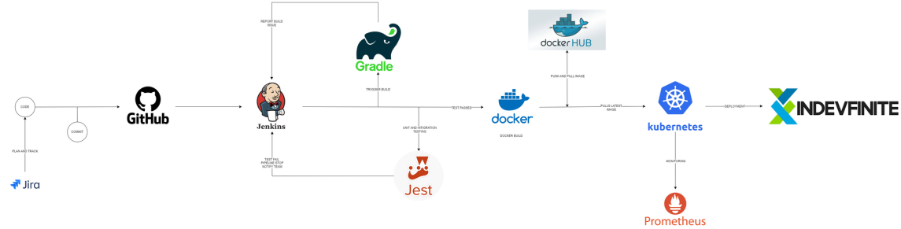Figure no. 9 CI/CD Pipelines

**Infastracture as code (IaC)**

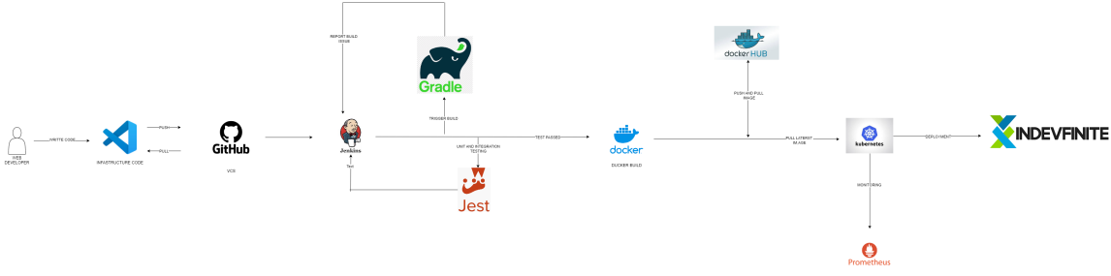The Barangay Tanod Patrol Management System uses the Infrastructure as Code (IaC) paradigm, which uses code to provision, manage, and deploy infrastructure. This ensures that any development is scalable, repeatable, and consistent whether it is in a development, test, or production environment. Because configuration files define resources like servers, networks, and databases, consistency and scalability are made possible. Because fewer errors are made by hand while using IaC, setup setups are made simpler. Additionally, it permits version control over infrastructure modifications, guaranteeing a seamless infrastructure deployment that remains in line with system requirements.

Figure no. 10 Infrastructure as code (IaC)

* 1. **Integration**

**Integration Diagram**

The collaboration of LGU 1, 2, 3, and 4 aims to improve public service delivery and cater to the needs of residents in these areas. Through the harmonization of processes and systems, this initiative seeks to offer more effective, efficient, and accessible services to the local community. It encourages better coordination and sharing of resources among the LGUs, leading to a more responsive governance approach that prioritizes the well-being and convenience of citizens, while also promoting transparency and accountability.

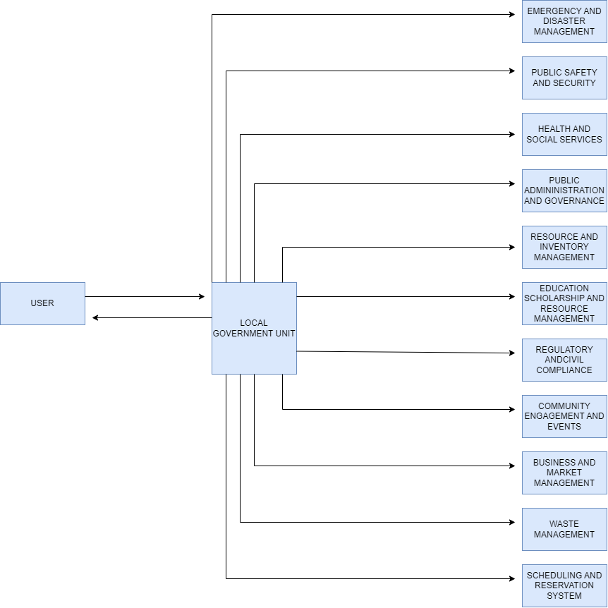Figure no. 11 Integration diagram (BPA Level 0)

**BPA Level 1**

This diagram shows how the Barangay Tanod Patrol Management System (BTPMS) connects with key systems to improve safety and coordination. It receives incident reports from the Public Safety Incident Reporting System and sends updates or responses. For emergencies, it requests backup from the Emergency Response and Disaster Management System. It also manages resources through the Resource Control and Inventory System, and verifies resident data via the Barangay Census and Demographic Management System. The system can also connect with nearby LGU systems for broader support and coordination.

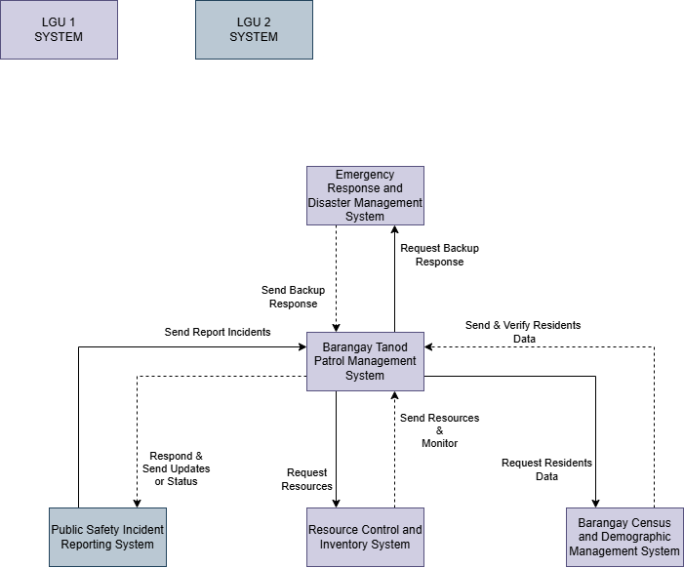

Figure no. 12 Integration diagram (BPA Level 1)

**Bpa level 2**

The Barangay Tanod Patrol Management System integrates multiple modules to streamline patrol operations, incident response, and resource coordination. It connects with systems like the Barangay Census, Public Safety Reporting, and Emergency Response to enable real-time data sharing and informed decision-making. Core functions include patrol scheduling, incident reporting, performance tracking, and resource management, all centered on improving public safety. The system ensures efficient coordination between tanods, barangay officials, and other LGU units, enhancing community protection and response capabilities.

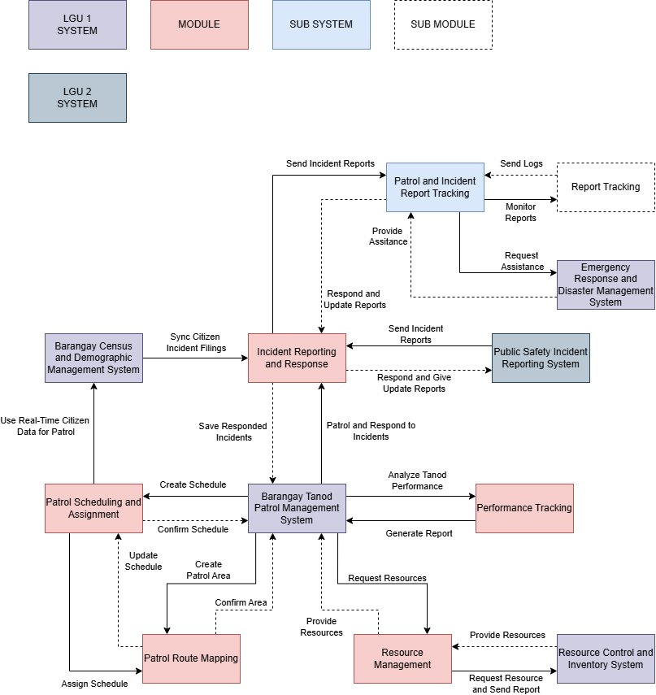Figure no. 13 Integration diagram (BPA Level 2)

**Data Flow Diagram (DFD)**

The Barangay Tanod Patrol Management System's Data Flow Diagram (DFD) with Integrations shows how information flows throughout the system and connects to other platforms. Along with links to external systems like government records or public safety services, it shows the information flow across modules like patrol scheduling, incident reporting, resource management, and performance tracking. In order to offer real-time information, streamline operations, and improve collaboration among stakeholders, the DFD identifies important data inputs (such as incident reports and patrol logs) and outputs (such as notifications and reports).

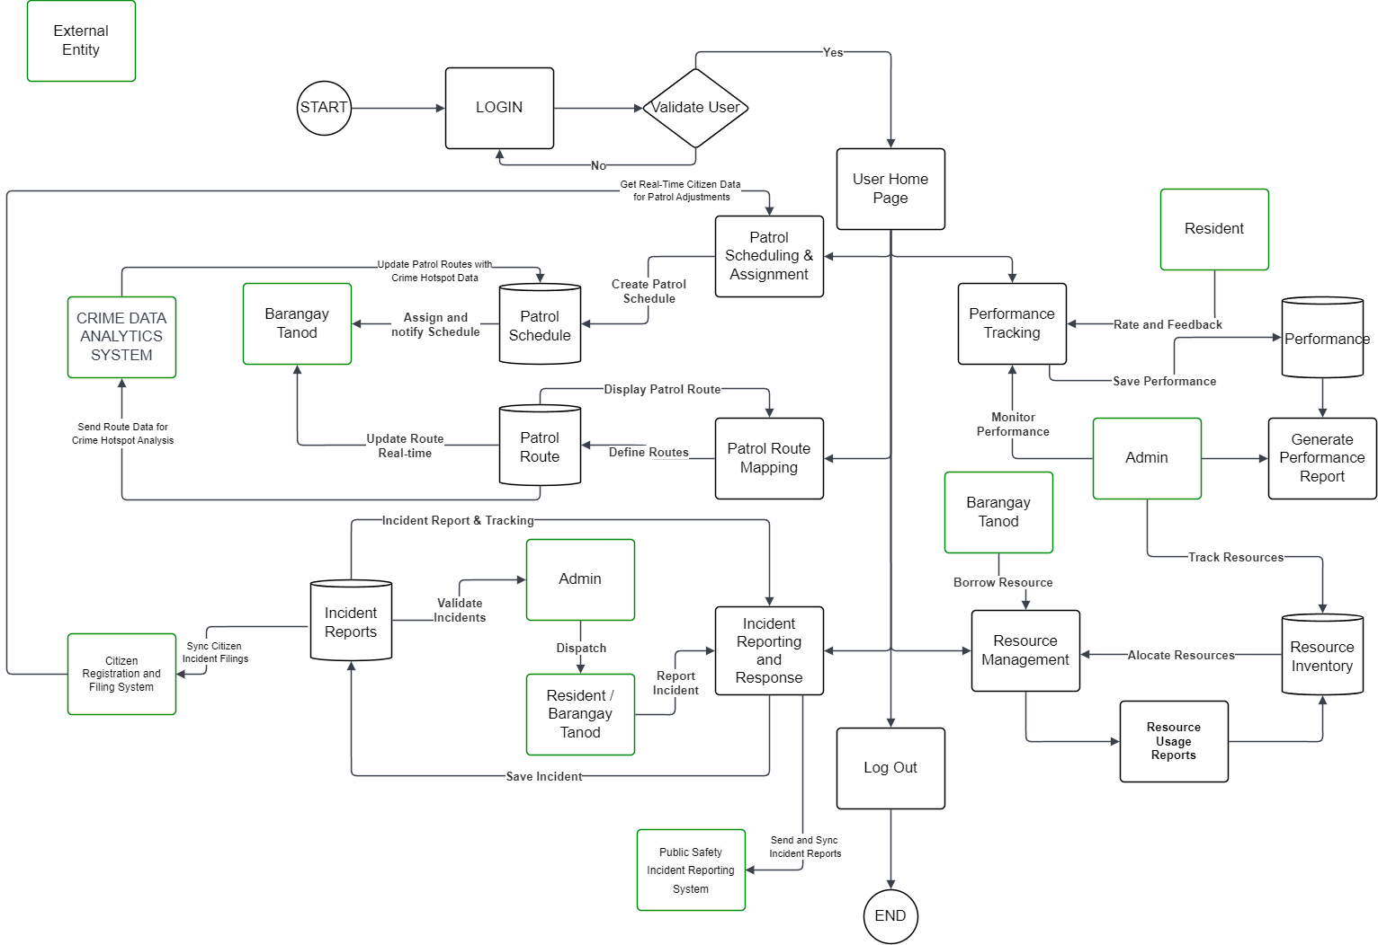Figure no. 14 Data Flow Diagram level 2

**API Gateway**

The Barangay Tanod Patrol Management System's API Gateway acts as a central hub for managing and directing requests between different microservices and clients. Serving as a middleman, it responds to user requests—from patrol officers to residents—and routes them to the relevant backend services, including data analytics, resource management, or incident reporting. The API Gateway facilitates the administration of service contacts, boosts security, and increases performance by offering capabilities like authentication, rate limitation, and load balancing. In addition to permitting simple connectivity with external services, this centralized architecture guarantees effective communication within the system.

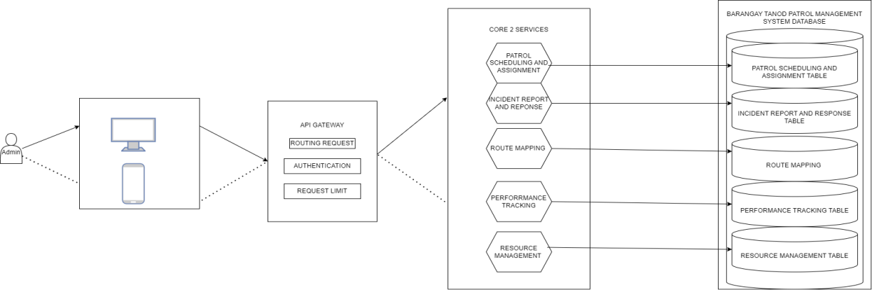Figure no. 15 API Gateway

* 1. **Adittional Considiration**

**Use case diagram**

The Use Case Diagram for the Barangay Tanod Patrol Management System visually represents the interactions between users (such as patrol officers, administrators, and residents) and the system’s functionalities. It outlines key use cases, including patrol scheduling, incident reporting, resource management, and performance tracking, illustrating how different actors engage with these processes. By mapping these interactions, the diagram provides a clear understanding of user requirements, system behavior, and the relationships between various components, serving as a foundational tool for system design and development.

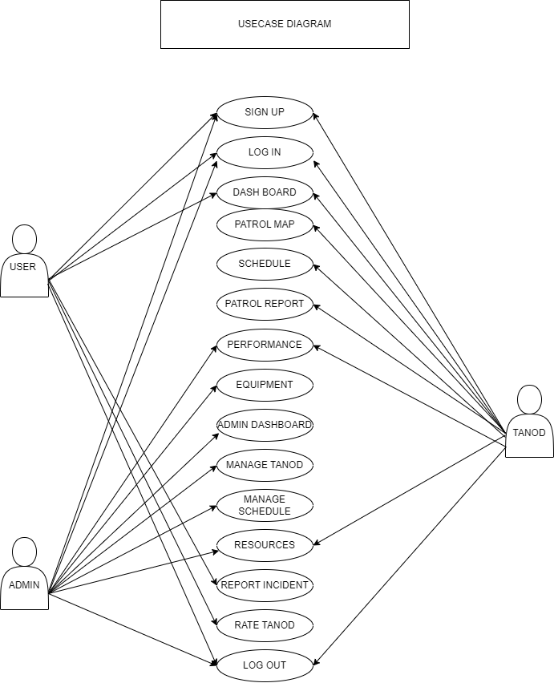Figure no. 16 Usecase Diagram

**Sequence diagram**

The Sequence Diagram for the Barangay Tanod Patrol Management System illustrates the dynamic interactions between the admin, tanod (community safety officer), and user (resident) during various system operations. It details the sequence of messages exchanged as these actors perform tasks such as incident reporting, patrol assignment, and resource management. By mapping out the flow of information over time, the sequence diagram highlights the order of interactions and the dependencies between different components, providing a clear visualization of the system's functionality and enhancing understanding of how each role contributes to effective public safety management.

**Sequence diagram : ADMIN**

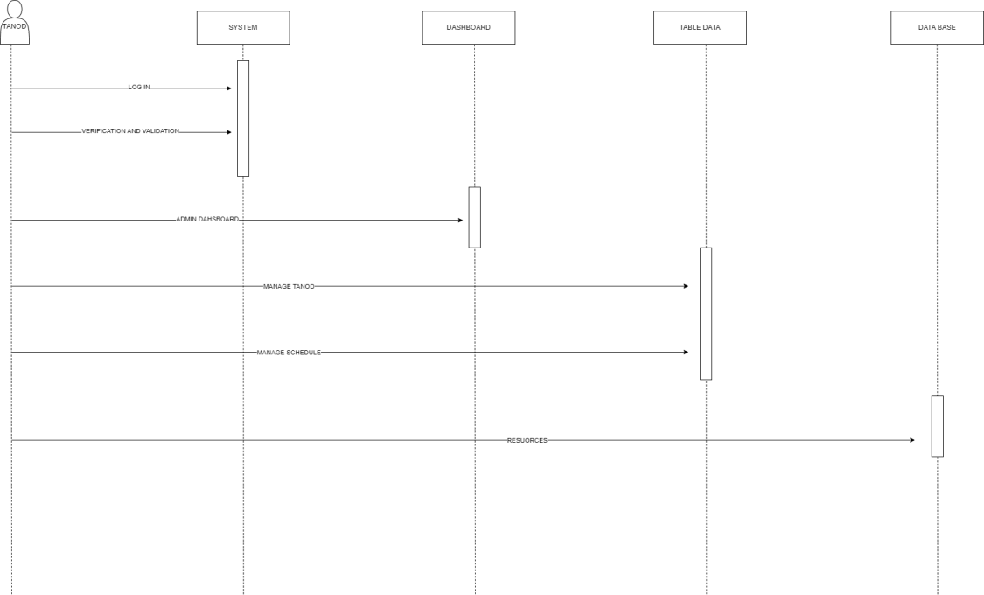Figure no. 17 Sequence Diagram (ADMIN)

**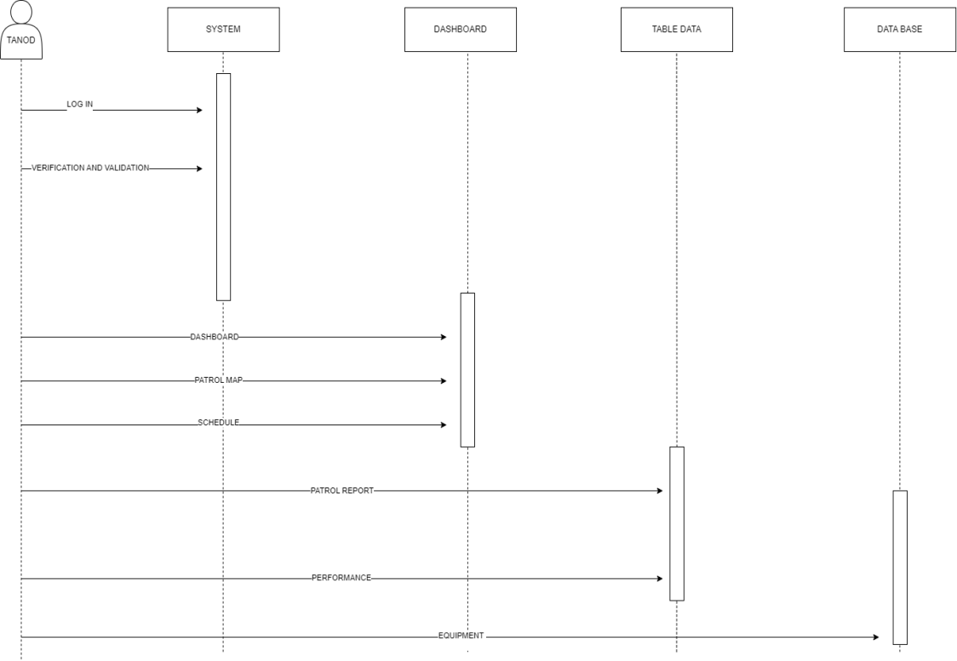 Sequence diagram : TANOD**

Figure no. 18 Sequence Diagram (TANOD)

**Sequence Diagram : User**

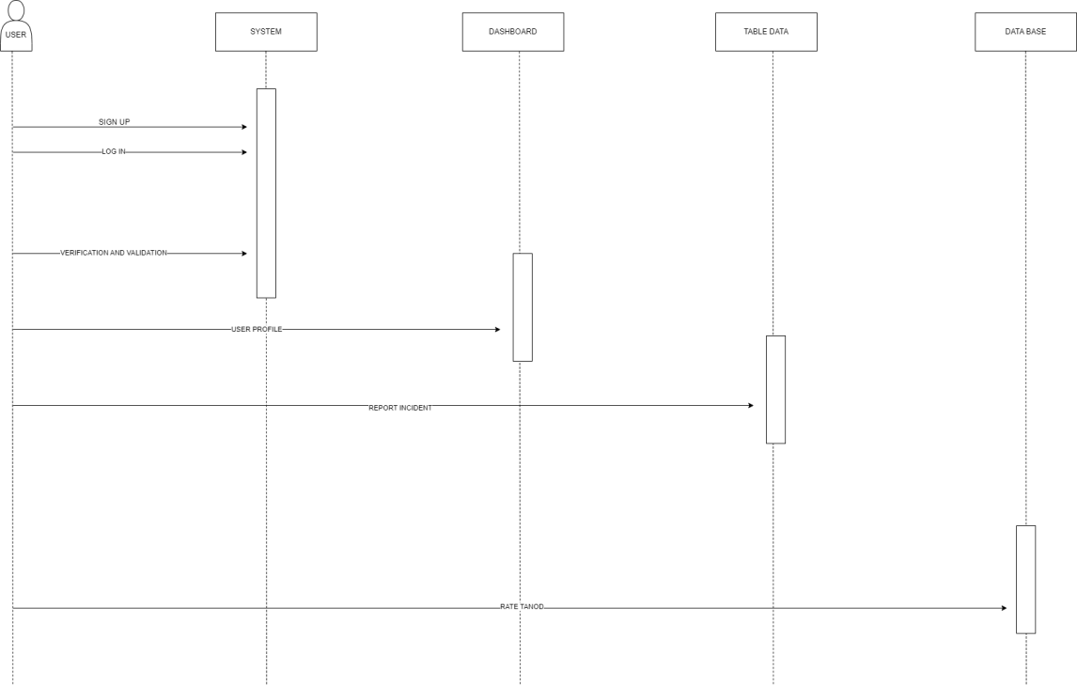Figure no. 19 Sequence diagram ( User )

**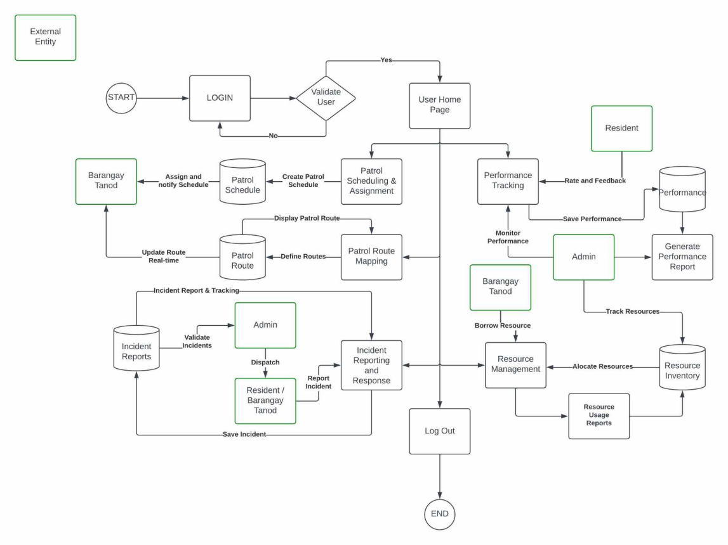 Activity diagram**

Figure no. 20 Activity Diagram

Chapter 4

**REQUIREMENTS ANALYSIS**

1. **Requirements Analysis**

Requirements analysis is crucial in ensuring that a system meets the needs of its users and stakeholders. It helps identify necessary features, functionalities, and constraints before development begins, reducing the risk of project failure. By gathering clear and well-defined requirements, developers can create a system that is user-friendly, efficient, and aligned with stakeholder expectations. Additionally, it minimizes costly revisions, enhances project planning, and ensures smooth implementation, ultimately leading to a more effective and reliable solution.

* 1. **Stakeholder Identification**

Stakeholder identification is essential for the successful development of the Barangay Tanod Patrol Management System, which focuses on improving patrol scheduling, route mapping, incident reporting, and resource management. Key stakeholders include Barangay Officials, Barangay Tanods, Community Residents, IT Department, Local Government Units (LGUs), and Emergency Response Teams. Understanding their power and interest helps address their needs, ensure smooth collaboration, and support the system’s effective implementation.

|  |  |  |  |
| --- | --- | --- | --- |
| Key | Project Stakeholder | Power Rate  (1 - 5) | Interest Rate  ( 1 - 5 ) |
| A | Baranngay Officials | 5 | 5 |
| B | Baranggay Tanods | 4 | 5 |
| C | Community Residents | 2 | 5 |
| D | IT Department | 4 | 4 |
| E | Local Government units | 5 | 4 |
| F | Emergency Response | 3 | 4 |

Table no: 11. Stakeholder Identification

Figure no. 21 Stakeholder

* 1. **Requirements Gathering Techniques**

To ensure the successful development of the Barangay Tanod Patrol Management System, various requirements gathering techniques were employed to collect relevant information from stakeholders. Below are the key methods used:

**Interviews** – One-on-one discussions were conducted with barangay captains, tanod leaders, and community safety officers to understand their current processes, challenges, and expectations. These interviews provided insights into common patrol issues, incident reporting workflows, and the need for real-time updates.

**Surveys and Questionnaires** – Structured surveys were distributed to barangay tanods, officials, and residents to gather quantitative data on patrol frequency, effectiveness of current security measures, and suggestions for system improvements. This method helped capture a broader perspective from multiple stakeholders.

**Focus Groups** – Group discussions with barangay officials, tanods, and IT experts were conducted to validate system requirements. These sessions facilitated brainstorming on system usability, necessary features, and integration with existing local government safety measures.

**Observations** – To gain firsthand insights into patrol operations, project researchers and developers observed barangay tanods during their shifts. This technique helped identify real-time challenges in communication, documentation, and coordination during patrols and incident responses.

**Workshops and Brainstorming Sessions** – Interactive sessions with developers, barangay officials, and IT consultants were conducted to define system functionalities, refine user interface preferences, and address potential implementation challenges. This collaborative approach ensured that all concerns and expectations were considered in system development.

* 1. **User Stories and User Cases**

**User Stories**

|  |  |
| --- | --- |
| User Stories No: | User Stories |
| 1 | As a Barangay Official, I want to assign patrol schedules to tanods. |
| 2 | As a Barangay Tanod, I want to view my assigned patrol route on a map. |
| 3 | As a Community Resident, I want to report incidents quickly and easily. |
| 4 | As a Barangay Official, I want to track and monitor the performance of tanods. |
| 5 | As a Tanod, I want to submit incident reports directly through the system. |
| 6 | As a Barangay Official, I want to manage resources and equipment for patrols. |
| 7 | As an Emergency Response Team, I want real-time access to incident reports. |

Table no: 12 Stories and User Cases

**User cases**

Figure no: 22. User Cases

* 1. **Functional Requirements for Integration**

The integration of the Barangay Tanod Patrol Management System focuses on ensuring seamless communication between different system modules—Patrol Scheduling and Assignment, Patrol Route Mapping, Incident Reporting and Response, Performance Tracking, and Resource Management. The following outlines the specific functional requirements essential for successful system integration, ensuring smooth data flow, error handling, and user access across all system components:

**Data Exchange Protocols**

* The system must allow real-time data exchange between the patrol scheduling, incident reporting, and performance tracking modules.
* Ensure the system uses RESTful APIs for secure data communication between the modules and external systems (e.g., LGU databases).
* Support data synchronization through automated updates to ensure incident reports and patrol schedules remain current.

**Synchronization Mechanisms**

* Implement automatic synchronization of patrol schedules with tanod dashboards after new assignments or updates.
* Ensure incident reports submitted by tanods are immediately reflected on the barangay official’s system for rapid response.
* Enable resource inventory updates across all user interfaces to prevent duplicate requests and maintain accurate records.

**Error Handling**

* Provide real-time error logging for failed data exchanges between system modules to identify and resolve integration issues.
* Implement input validation on all data entries (e.g., patrol schedules, incident reports) to prevent incorrect or incomplete submissions.
* Display error notifications to users in case of failed synchronization or system malfunctions.

**User Access Controls**

* Enforce role-based access where barangay officials can manage patrol schedules, monitor incidents, and review reports while tanods can only view assignments, report incidents, and track their performance.
* Restrict sensitive information (e.g., performance evaluations, resource requests) to authorized personnel only.
* Ensure audit logging of all user activities to maintain accountability and track changes.

**Module-Specific Integration**

* Patrol Scheduling & Assignment: Automatically push patrol schedules to tanod dashboards after assignment.
* Patrol Route Mapping: Sync updated patrol routes with both barangay officials' and tanods' systems in real time.
* Incident Reporting & Response: Notify barangay officials of new incident reports via system alerts and log incident status changes.
* Performance Tracking: Integrate patrol logs with performance metrics to allow tracking of tanod activities.
* Resource Management: Synchronize resource availability and usage requests across all user roles to avoid redundancy.

**Dependencies and Constraints**

* Requires internet connectivity for real-time synchronization across different system components.
* The system depends on LGU databases for cross-referencing and archiving incident reports.
* Must comply with data privacy regulations for secure handling of sensitive information.

These functional requirements ensure that the Barangay Tanod Patrol Management System delivers an integrated platform that enhances efficiency, facilitates accurate reporting, and supports decision-making while maintaining security and data integrity.

* 1. **Bussiness Process Architecture**

**Identification of Business Process**

The Barangay Tanod Patrol Management System focuses on enhancing the efficiency and coordination of barangay tanods through the integration of key business processes. Identifying and defining these processes is essential to ensure the system meets the operational needs of barangay officials, tanods, and the community. Below are the primary business processes involved:

**Patrol Scheduling and Assignment**

This process involves creating and managing patrol schedules to ensure that barangay tanods are assigned to specific areas and time slots. Barangay officials are responsible for setting schedules, assigning personnel, and ensuring fair distribution of tasks.

Significance:

Accurate scheduling ensures comprehensive community coverage, prevents overlapping duties, and allows for organized patrol rotations. This process improves operational efficiency by ensuring every area receives attention and helps identify gaps in coverage.

**Patrol Route Mapping**

This process focuses on designing and maintaining clear patrol routes for barangay tanods. It involves mapping high-risk areas, updating routes based on community needs, and providing accessible route information to patrollers.

Significance:

Well-defined patrol routes help optimize patrol coverage, ensuring that critical areas are regularly monitored. This process enhances community safety by directing patrols to vulnerable zones and minimizing the risk of crime and emergencies going unnoticed.

**Incident Report and Response**

This process allows barangay tanods to report incidents, such as disturbances, emergencies, or crimes, in real time. It also involves notifying barangay officials and tracking the status of each report from initiation to resolution.

Significance:

Effective incident reporting improves response times and ensures timely intervention in emergencies. This process increases transparency, supports data-driven decision-making, and enables better coordination between barangay tanods and other emergency services.

**Performance Tracking**

This process monitors and evaluates the activities of barangay tanods. It includes logging patrol hours, tracking completed patrols, and assessing individual and team performance.

Significance:

Tracking performance provides insights into operational efficiency and identifies areas for improvement. This process ensures accountability, promotes fair recognition, and enables barangay officials to make informed decisions about training and resource allocation.

**Resource Management**

This process manages barangay resources, including equipment allocation (e.g., radios, flashlights) and tracking resource usage. It also handles requests for new supplies and monitors inventory levels.

Significance:

Efficient resource management ensures that barangay tanods are equipped to perform their duties effectively. This process reduces waste, prevents shortages, and enables smooth patrol operations by ensuring the availability of necessary tools.

**Business Process Diagrams**

The Business Process Diagram for the Barangay Tanod Patrol Management System illustrates the key workflows and operational activities involved in managing patrol schedules, incident reporting, response coordination, and resource tracking within the barangay. This diagram serves as a visual representation of how data and tasks flow between tanods, barangay officials, and other stakeholders. By mapping out these processes, the system ensures clear responsibilities, efficient communication, and structured handling of security operations. Understanding and documenting these processes are essential for identifying areas of improvement, aligning system features with actual needs, and ensuring effective implementation of the patrol management solution.

****Figure no. 23 Patrol Scheduling and Assignment

****

Figure no. 24 Patrol Route Mapping

****

Figure no. 24 Incident Reporting and Response

****

Figure no. 25 Performance Tracking

****

Figure no. 26 Resource Management

**Alignment of Integrated System with Business Process**

The Barangay Tanod Patrol Management System integrates seamlessly with emergency response and logistics to enhance the efficiency and coordination of community safety operations. The system allows for real-time incident reporting, enabling tanods to quickly log emergencies and automatically notify emergency response teams, ensuring faster and more accurate intervention. This integration supports immediate data sharing, allowing emergency personnel to access critical information, such as incident location and severity, which helps streamline their response efforts.

In terms of logistics, the system facilitates resource tracking and management by monitoring patrol equipment and supplies, ensuring that tanods have the necessary tools for their duties. It also enables barangay officials to allocate resources efficiently based on real-time data, optimizing the deployment of personnel and equipment during emergencies. Additionally, the system supports route optimization by providing updated patrol maps and suggesting the fastest routes for emergency responders, reducing response times. This integrated approach improves coordination between barangay tanods, emergency teams, and logistics operations, ensuring a more effective, organized, and timely response to incidents while enhancing overall community safety.

**Business Process Improvement**

The Barangay Tanod Patrol Management System significantly enhances business processes by improving efficiency, accuracy, and coordination. One major improvement is the automation of patrol scheduling and assignment, which reduces manual errors and ensures fair and efficient deployment of tanods across designated areas. Incident reporting and response are also streamlined through real-time logging and automatic notifications, allowing for quicker emergency handling and better coordination with emergency response teams. This reduces response times and enhances public safety.

In performance tracking, the system provides detailed logs and analytics, enabling barangay officials to monitor and evaluate tanod activities, identify areas for improvement, and recognize outstanding performance. Resource management is improved by offering real-time tracking of patrol equipment and supplies, ensuring that resources are properly allocated and maintained. The integration with logistics optimizes the deployment of personnel and resources, reducing operational inefficiencies.

Additionally, the system enhances data accuracy and reporting through automated data collection and analysis, allowing decision-makers to generate timely and accurate reports. This supports better planning and resource allocation. Overall, the system improves workflow efficiency, accountability, and communication, leading to better service delivery and a safer community.

* 1. **Application Architecture**

**Componets of Application Architecture**

The application architecture of the Barangay Tanod Patrol Management System is composed of several key components that ensure efficient patrol operations, streamlined incident reporting, and effective resource management. The User Interface (UI) Layer provides a user-friendly platform accessible via web and mobile devices, allowing barangay tanods, officials, and emergency responders to monitor real-time patrol activities and generate reports. The Application Layer contains core functionalities such as patrol scheduling and assignment, incident reporting and response, performance tracking, and resource management, ensuring smooth coordination among stakeholders.

The Data Management Layer includes a Database Management System (DBMS) for securely storing patrol schedules, incident reports, and performance records, along with data analytics and reporting tools for generating insights on crime trends and operational efficiency. The Integration Layer facilitates seamless communication and coordination through emergency response integration, Geographical Information System (GIS) mapping, and communication APIs for real-time notifications. To enhance security, the Security and Access Control component implements user authentication, role-based access control, and data encryption, ensuring that only authorized personnel can access critical information.

Lastly, the Deployment and Infrastructure Layer supports cloud-based or on-premise hosting, ensuring system scalability and availability across multiple devices. By integrating these components, the system enhances the efficiency of barangay patrol operations, improves response times, and strengthens community safety, ultimately providing a robust and reliable patrol management solution.

**Application Architecture Diagram**

The Application Architecture Diagram for the Barangay Tanod Patrol Management System provides a visual representation of the system’s structure, showcasing how different components interact to ensure efficient patrol management, incident response, and resource allocation. It outlines key layers, including the User Interface, Business Logic, Data Management, Integration, Security, and Deployment, demonstrating how data flows between users, databases, and external services. This structured approach ensures seamless coordination, real-time updates, and secure access, ultimately enhancing barangay security operations and public safety.

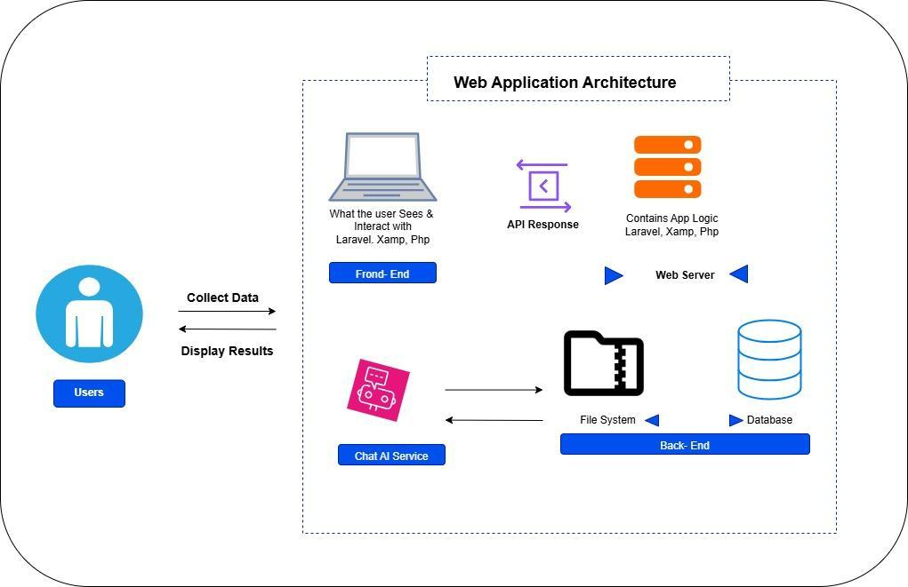

**Integration of Software Modules**

The integration of system software modules in logistics and emergency response plays a crucial role in enhancing the efficiency and coordination of the Barangay Tanod Patrol Management System. The logistics module ensures proper tracking and management of essential resources such as patrol equipment, communication devices, and emergency supplies, preventing shortages and optimizing resource allocation. Meanwhile, the emergency response module enables real-time incident reporting, automated alerts, and seamless coordination with law enforcement, medical responders, and fire services. By integrating these modules, the system ensures faster response times, improved situational awareness, and better decision-making, ultimately enhancing the overall effectiveness of barangay patrol operations and ensuring the safety of the community.

**Communication and Interaction Patterns**

The Barangay Tanod Patrol Management System relies on well-defined communication and interaction patterns to ensure efficient coordination among barangay officials, tanods, emergency responders, and the community. The system integrates multiple communication channels, including real-time notifications, automated alerts, and direct messaging, to facilitate seamless interaction.

**System-to-User Communication** – The system provides real-time alerts to tanods and officials through mobile and web applications, updating them on patrol schedules, incident reports, and emergency responses. Notifications via SMS, emails, or push alerts ensure timely dissemination of critical information.

**User-to-System Interaction** – Barangay tanods and officials can input patrol logs, incident reports, and resource requests through the system. The user-friendly interface enables them to update statuses, document incidents, and manage resources efficiently.

**User-to-User Communication** – The system enables direct communication between barangay officials, tanods, and emergency responders through in-app messaging or emergency call features. This interaction pattern ensures immediate response coordination and enhances teamwork during critical situations.

**System-to-System Integration** – The system interacts with external platforms, such as emergency response services, GIS mapping, and law enforcement databases, to streamline incident reporting and resource management. This integration enhances collaboration and ensures faster, data-driven decision-making.

By implementing these communication and interaction patterns, the system enhances situational awareness, improves response times, and strengthens coordination, ultimately leading to a safer and more efficient barangay patrol operation.

* 1. **Data Architecture**

**Data Source and Type**

The LGU1 System collects and manages data to support its core features: Patrol Scheduling, Route Mapping, Incident Reporting, Performance Tracking, and Resource Management.

It uses a central database to store patrol schedules, tanod profiles, incident reports, and resource inventories. For route mapping, the system integrates Google Maps API to create and display patrol routes and checkpoints.

The system also gathers incident data directly from tanods and residents, including location, incident type, and photos. This combination of internal records and mapping services helps barangay officials manage patrols and respond to incidents effectively.

**Data Flow Diagram**

The Barangay Tanod Patrol Management System's Data Flow Diagram (DFD) with Integrations shows how information flows throughout the system and connects to other platforms. Along with links to external systems like government records or public safety services, it shows the information flow across modules like patrol scheduling, incident reporting, resource management, and performance tracking. In order to offer real-time information, streamline operations, and improve collaboration among stakeholders, the DFD identifies important data inputs (such as incident reports and patrol logs) and outputs (such as notifications and reports).



**Data Storage and Management**

The LGU1 System use of cloud storage and local servers to manage its patrol and incident data. Patrol schedules, incident reports, and route data are stored in cloud databases for real-time access, while sensitive data, such as personnel profiles, are kept on secure local servers.

The system uses SQL databases for structured data like schedules and reports, and NoSQL for files such as images from incident reports. To protect data, the system applies role-based access control, and regular data backups. Audit logs and data validation help maintain data accuracy and security.

**Data Security Measures**

* Authentication and Authorization – Implemented using JWT (JSON Web Tokens) and role-based access control (RBAC).
* Data Encryption – Sensitive data is encrypted at rest and in transit using AES-256 and TLS/SSL
* Backup and Recovery – Automated database backups prevent data loss.
* Access Control – Limited database privileges and IP whitelisting restrict unauthorized access
* Multi-Factor Authentication (MFA) - enhance system security by requiring users to provide multiple forms of verification before accessing the system.

**Data Synchronization Across Systems**

Data synchronization across systems in the Barangay Tanod Patrol Management System ensures that information is consistently updated, accurate, and accessible across multiple platforms. Synchronization is crucial for maintaining real-time patrol tracking, incident reporting, resource management, and emergency response coordination.

* **Real-Time Data Updates** – The system employs automatic data synchronization to update patrol schedules, incident logs, and reports across web and mobile platforms. This ensures that barangay officials, tanods, and emergency responders have access to the latest information without delays..
* **API Integration for External Systems** – The system integrates with emergency response services, law enforcement databases, and GIS mapping tools through secure APIs, ensuring seamless data exchange and real-time updates for coordinated emergency responses.
* Conflict Resolution Mechanisms – To prevent data duplication or inconsistencies, the system uses timestamp-based synchronization and conflict resolution rules, ensuring that the most recent and verified updates are retained.
* Role-Based Data Access – Synchronization follows role-based access control (RBAC), ensuring that tanods, barangay officials, and emergency responders receive only the data relevant to their responsibilities, maintaining security and efficiency.

By implementing real-time synchronization, cloud integration, and secure APIs, the system enhances operational efficiency, ensures data consistency, and improves emergency response coordination, ultimately strengthening barangay safety and security efforts.

* 1. **Technology Architecture**

**Technology Stack and Infastructure**

The Barangay Tanod Patrol Management System is built on a robust technology stack and infrastructure to ensure scalability, security, and high availability for seamless patrol management, incident reporting, and emergency response coordination.

**Technology Stack**

* Frontend (User Interface): React.js (web), Flutter (mobile)
* Backend (Logic & APIs): Node.js with Express.js
* Database: PostgreSQL (main database), Firebase (real-time data)
* Communication: Twilio (SMS alerts), Firebase Cloud Messaging (push notifications)
* Mapping: Google Maps API (patrol route tracking)
* Security: JWT Authentication, AES Encryption

**Infrastructure**

* Hosting: AWS (server hosting), Firebase (mobile backend)
* Storage: AWS S3 (files, reports, patrol logs)
* Performance: Nginx (load balancing), Redis (faster data access)
* Backup & Security: SSL encryption, automated data backups

**Network Topology and Configuration**

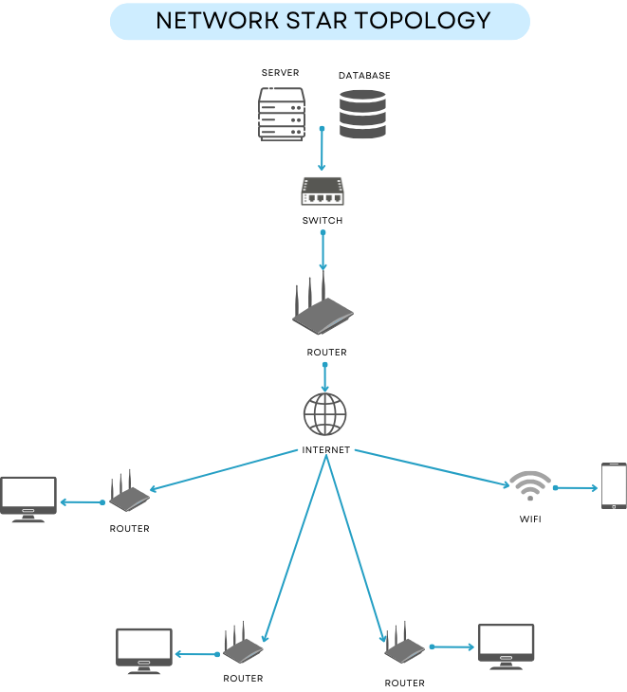

Network Star Topology, where all devices (such as computers, routers, and wireless access points) are connected to a central hub — in this case, the internet. The server and database are also connected to this hub through a switch and router, forming a centralized communication system.

In your Barangay Tanod Patrol Management System, this topology ensures that all system components — such as the incident reporting module, patrol scheduling, performance tracking, and resource management — are accessible in real-time over a reliable and centralized network. Each user (e.g., barangay tanods, admins, or LGU officials) connects via the internet to interact with the central server, which hosts the system and database.

This setup is beneficial for your project because:

* **Centralized Access**: All modules and data are stored on a central server, making it easier to maintain and update.
* **Reliable Communication**: Each device connects independently to the central hub, minimizing the risk of network failure.
* **Scalability**: New users or devices (e.g., new barangay stations or mobile access points) can be easily added.

**Software Technologies**

The Barangay Tanod Patrol Management System uses several software technologies to support its features and performance.

|  |  |  |
| --- | --- | --- |
| Title | Picture | Descriptions |
| MongoDB | IMG_256 | A free, cross-platform NoSQL database that stores data in flexible, JSON-like documents, allowing developers to handle large amounts of unstructured or semi-structured data. It is commonly used for modern web and mobile applications that require fast and scalable database solutions.. |
| Visual Studio | IMG_256 | A powerful integrated development environment (IDE) from Microsoft, supporting multiple programming languages like C#, C++, and Python, and widely used for developing web, desktop, and mobile applications. |
| Indevfinite | IMG_256 | ndefinite web hosting provides long-term, uninterrupted access to the Barangay Tanod Patrol Management System. It ensures the system remains online and usable for tasks like patrol scheduling, incident reporting, and resource tracking, supporting sustainable and continuous service for the community. |
| Bitvise ssh Client | IMG_256 | Bitvise SSH Client is a secure remote access tool used to connect to servers via SSH (Secure Shell). It provides encrypted terminal access, file transfer through SFTP, and remote command execution. For development projects like the Barangay Tanod Patrol Management System, Bitvise SSH can be used to securely manage the web server, upload system files, and perform remote maintenance tasks. |

Table no: 13 4.8.3.Software Technologies

**Scalability and Performance Considerations**

* Traffic Management – Uses NGINX for load balancing and database replication to handle high traffic.
* **Faster Database** – Uses indexing and caching to make database queries faster.
* **Better API Performance** – Uses Redis Queues for background tasks and WebSockets for real-time updates.
* **Faster Frontend** – Minifies CSS/JS and uses Cloudflare CDN to speed up page loading.
* **Cloud Deployment** – Uses cloud hosting Google Cloud instead of local servers for better scaling.
* **Security + Speed** – Uses HTTPS (TLS), hashed passwords, and security settings to keep data safe while staying fast.
  1. **Development Process**

**Agile Scrum Role and Responsibility**

The key duties of each participant in the capstone are indicated in the table below.

|  |  |  |
| --- | --- | --- |
| **Name** | **Role** | **Responsibilities** |
| Reymond Medica | Project Manager/ Scrum Master | The project manager oversees the project's progress, ensures deadlines are met, assigns team members, collaborates, and communicates with stakeholders, planning, tracking progress, and aligning objectives. |
| Kim Rovil Garcia | Lead Programmer | Leads development, writes and reviews code, and ensures technical quality. |
| Tristan Cyrus Mallari and Noeven Omnes | Document Specialist | Manages and maintains project documentation, ensuring clarity and accuracy. |
| Mc. Angelo Abbatuan | System Analyst | Analyzes user requirements, translates them into technical specifications, and designs effective solutions. |
| Reymond Medica | Security Specialist | A Security Specialist designs, implements, and maintains security measures—such as firewalls, intrusion detection, and access controls—to safeguard the system’s infrastructure and data against threats. |

Table no : 14 Agile Scrum Role and Responsibility

**Sprint Planning and Backlog Management**

Sprint planning is a crucial phase in the development of the Barangay Tanod Patrol Management System, ensuring that tasks are clearly defined, prioritized, and assigned to streamline progress and maintain focus on the sprint goal. The objective of this sprint is to enhance system functionality by implementing key modules such as patrol scheduling, incident reporting, and resource management. A team meeting will be conducted to assign roles, clarify user stories, estimate efforts, and track deliverables using Agile methodology. The tasks in this sprint focus on improving existing features and integrating new modules that enhance user experience and system performance.

**Sprint Execution and deliverables**

|  |  |
| --- | --- |
| Step | Activity |
| Define Sprint Goal | Establish the main objective of the sprint |
| Backlog Review | Review the product backlog and prioritize the most important tasks. |
| Sprint Review | Demonstrate the work completed to the stakeholders. |
| User Story Breakdown | Break down backlog items into smaller user stories and tasks |
| Sprint Backlog Creation | Create a sprint backlog with selected tasks for the sprint |

Table no: 15 Sprint Execution and deliverables

**User story Backlog**

|  |  |  |  |  |
| --- | --- | --- | --- | --- |
| **No** | **User Story** | **Priority** | **Estimated Efforts** | **Fully Functional Deliverable** |
| 1 | As a barangay tanod, I want to receive real-time patrol assignments so that I can respond efficiently. | High | 5 days | Patrol scheduling module |
| 2 | As a barangay official, I want to track patrol routes in real-time so that I can monitor patrol coverage. | High | 7 days | GPS-based patrol tracking |
| 3 | As a resident, I want to report incidents easily so that barangay tanods can respond quickly. | High | 6 days | Incident reporting feature |
| 4 | As a barangay tanod, I want to log patrol activities so that I can keep track of my duties | Medium | 4 days | Patrol logging system |
| 5 | As a barangay official, I want to generate reports on patrol performance so that I can analyze effectiveness. | Medium | 6 days | Performance tracking dashboard |
| 6 | As an LGU officer, I want to manage resource allocations for patrols so that barangay security is well-equipped. | Low | 8 days | Resource management system |

Table no: 16 .User story Backlog

**Sprint Execution and Deliverables**

The development process of the Barangay Tanod Patrol Management System was carried out in multiple sprints, each focusing on delivering specific functional components. Each sprint followed an agile methodology, ensuring incremental progress and adaptability to feedback. Key deliverables included patrol scheduling and assignment, patrol route mapping, incident reporting and response, performance tracking, and resource management. Regular sprint reviews and testing ensured that each feature met the requirements before deployment.

**Challenges Faced in the Development Process**

During development, several challenges were encountered, including technical difficulties, data synchronization issues, and integration complexities with emergency response systems. Another significant hurdle was ensuring user-friendliness while maintaining system security and accessibility. Stakeholder feedback and iterative testing helped resolve these challenges, ensuring the system's efficiency and reliability.

* 1. **Implementation**

**Technichal Implementation Details**

|  |  |
| --- | --- |
| COMPONENT | DESCRIPTION |
| Map Interface | Leaflet is utilized to create an interactive map that showcases barangay boundaries and locations for user engagement. |
| User Interface | React.Js is used to build a Web-based user interface |
| Design Patterns | MVC (Model-View-Controller): Divides responsibilities between the user interface, business logic, and data.  Observer Pattern: Manages real-time emergency notifications.  Factory Pattern: Enables dynamic creation of services based on user queries.  Strategy Pattern: Allows flexible selection of algorithms or methods depending on the type of user query. |
| Security | Ensures data is securely managed and protected against unauthorized access and common vulnerabilities.  - Role-based Access Control (RBAC):Controls user permissions based on their roles.  - Encryption: Protects data transfers through TLS/SSL encryption. |

Table no: 17 Technichal Implementation Details

**Tools and Technology Used**

|  |  |
| --- | --- |
| **TITLE** | **DESCRIPTION** |
| **FRONT END** | React: A JavaScript library for building interactive and dynamic user interfaces. |
| **BACK END** | Node.js: A runtime environment that allows JavaScript to run on the server side. |
| **FRAMEWORK** | CSS Tailwind: A utility-first CSS framework for creating responsive and customizable designs. |
| **DATABASE** | MongoDB: A NoSQL database that stores data in flexible, JSON-like documents. |

Table no 18: Tools and Technology Used

**Code Integration and Interoperability**

Integrating various software modules within the Barangay Tanod Patrol Management System was crucial to ensuring seamless communication and functionality. The integration process involved linking key components such as patrol scheduling, incident reporting, emergency response, and resource management into a unified platform. One of the main challenges was maintaining data consistency across different modules, as real-time updates were essential for efficient patrol operations. Additionally, system compatibility had to be addressed to enable smooth communication between different technologies and frameworks used in development. To overcome these challenges, APIs were developed to facilitate data exchange, and middleware was implemented to ensure seamless interaction between modules and external systems, such as emergency response units. Standardized data formats like JSON and XML were used to maintain consistency. The integration process was managed using Git for version control, allowing developers to track changes efficiently, while code reviews ensured quality and minimized errors. Through these strategies, the system achieved interoperability, enabling different components to work together smoothly and improving overall efficiency in patrol and incident response management.

**Integration Testing and Debugging**

Integration testing and debugging are essential to ensure the seamless functionality of the Barangay Tanod Patrol Management System. Various testing strategies were implemented, including unit testing to check individual modules, integration testing to verify data flow between components, and end-to-end testing to simulate real-world scenarios. During the process, issues such as data inconsistencies, communication errors, and system crashes were identified. These were documented and addressed through systematic debugging, using error logs, automated test scripts, and manual verification. By resolving these issues iteratively, the system's reliability and performance were optimized to ensure a smooth and error-free user experience.

* 1. **Testing and Quality**

**Testing Strategies and Methodologies**

To ensure the Barangay Tanod Patrol Management System operates reliably and meets stakeholder expectations, a comprehensive testing strategy has been defined that combines both manual and automated techniques across multiple test levels. The process begins with test planning, where clear objectives, scope, entry and exit criteria, and resource assignments are established. A dedicated test plan document outlines the testing schedule, tools, environments, and responsibilities, ensuring everyone understands what will be tested, when, and by whom.

Unit Testing is the first line of defense, focusing on individual components—such as the user authentication module, patrol scheduler, incident reporter, and resource manager—to verify that each function behaves as intended in isolation. Developers write and execute unit tests using a test framework (e.g., Jest for JavaScript or NUnit for .NET) immediately after coding a feature. This approach, often combined with Test-Driven Development (TDD), catches logic errors early and provides fast feedback on code correctness.

Once individual units are validated, Integration Testing examines how these modules interact. Test scripts simulate real-world data flows—for example, creating a patrol schedule and then triggering the incident reporting workflow—to ensure data passes seamlessly between components and that APIs behave correctly. Any discrepancies or data mismatches are captured in a shared bug-tracking system (e.g., Jira or GitHub Issues), where they are prioritized and assigned for resolution.

To confirm the system’s overall behavior, System Testing exercises end-to-end scenarios in an environment that mirrors production. Testers perform manual exploratory testing to navigate the application as an end user would—scheduling patrols, reporting incidents, and viewing performance dashboards—looking for usability issues, layout inconsistencies, and unexpected workflows. Parallel to this, Automated Regression Tests run nightly against the latest build, quickly identifying regressions introduced by recent changes and ensuring new features do not break existing functionality.

Finally, User Acceptance Testing (UAT) involves barangay tanods and officials in validating that the system satisfies real-world needs. Participants execute predefined test cases and provide feedback on ease of use, performance, and completeness. Their sign-off marks the final confirmation that the system is ready for deployment.

Throughout the process, a continuous integration (CI) pipeline enforces quality gates: builds must pass all automated tests before merging code, and any test failures automatically halt deployment. This rigorous, multi-layered testing methodology—combining manual oversight with automated precision—ensures the Barangay Tanod Patrol Management System is robust, user-friendly, and fit for real-time community safety operations

.**Test Cases and Test Data**

A rigorous set of test cases will be developed to validate each module and feature of the Barangay Tanod Patrol Management System, ensuring that all functional requirements are met. For every user story and use case—such as user authentication, patrol scheduling, incident reporting, and resource management—a corresponding test case will be defined. Each test case includes the following elements:

* Test Case ID & Title: A unique identifier and brief description of the functionality under test.
* Preconditions: Any system state or data setup required before execution (e.g., a valid Tanod account exists).
* Test Steps: A step-by-step procedure to perform actions in the application (e.g., log in as Tanod → navigate to Schedule module → create a new patrol).
* Test Data: Specific input values for each step, such as valid credentials, patrol dates, incident descriptions, and resource quantities. Test data will cover:
* Positive scenarios: Typical, expected inputs that should succeed
* Negative scenarios: Invalid or malformed inputs that should be rejected
* Boundary cases: Data at the edges of allowed ranges
* Error conditions: Conditions that trigger system errors or warnings.
* Expected Result: The precise outcome the system should produce, such as “Patrol schedule is created and visible in the dashboard,” or “An error message appears preventing creation of an overlap in schedules.”
* Actual Result & Status: Fields to record what actually happened when the test ran (Pass/Fail) and any error details.
* Postconditions: The expected state of the system after the test, such as new records in the database or updated status flags.

Test data will be derived from both anonymized real-world scenarios (e.g., typical barangay patrol routes, realistic incident descriptions) and synthetic edge-case datasets to push system limits. All test cases and associated data sets will be managed in a test management tool (e.g., Jira or TestRail), enabling traceability back to requirements and user stories. When a test fails, the defect will be logged with detailed reproduction steps, screenshots, and system logs to facilitate rapid debugging. This disciplined approach to designing test cases and curating comprehensive test data ensures that every aspect of the system is thoroughly validated before release, resulting in a robust, reliable platform for community safety.

**Test Result and Bug Reports**

The outcome of each test cycle will be meticulously documented in detailed test result reports to evaluate the system’s performance and correctness. These reports will include the status of every executed test case—whether passed, failed, or blocked—as well as any deviations from expected behavior. If a test case fails, a bug report will be created immediately, capturing all relevant information such as the steps to reproduce the error, screenshots, logs, the environment where the issue occurred, and the severity or priority level of the bug.

These bug reports will be submitted to the development team for review. Developers will analyze each report to identify the root cause of the issue, implement a fix, and then return the corrected version of the system to the QA team. The affected test cases will then be re-executed to confirm that the problems are resolved and that no new issues have been introduced—a process known as regression testing.

This iterative cycle of testing, reporting, fixing, and re-testing ensures a continuous improvement of system quality. The process continues until all critical bugs are resolved, and the system meets the functional and performance criteria set during the planning phase. By maintaining thorough test documentation and a structured bug tracking system, the project ensures accountability, transparency, and high standards of software reliability.

**Quality Assurance Measures**

To guarantee a robust and user-friendly Barangay Tanod Patrol Management System, the following quality assurance measures will be implemented:

* Security Testing: Conduct vulnerability assessments and penetration tests to protect sensitive user data and enforce strong access controls.
* Performance Testing: Measure system responsiveness and stability under various load conditions to ensure smooth operation during peak usage.
* Usability Testing: Engage end users (tanods and officials) in hands-on trials to validate the system’s ease of use and intuitive design.
* Regression Testing: Re-execute existing test cases after each update to confirm that new changes do not introduce defects.
* Acceptance Testing: Collaborate with stakeholders to verify that all functional requirements are met and that the system fulfills its intended purpose.
  1. **Result and Evaluation**

**Project Outcomes and Deliverables**

The project will create a working patrol management system. It will help in scheduling, tracking and even in reporting patrols. The system will make the barangay operations more organized. It will also replace the manual processes with a digital system. The final result will be a more efficient patrol system.

**Alignment with Project Objectives**

The system will be checked to see if it will meets the project goals. It should help the barangay officials to manage patrols easily. It must also improve the response times to incidents. If the system works, the project will be successful. Any missing features will be noted for the future updates.

**Stakeholder And User Feedback**

Users and the barangay officials will test the system and give their opinions. Their feedback will show what works well and what needs for the improvement. If they have problems in using the system, changes will be made. Their suggestions will help to make the system better. Good feedback means that the project is useful and successful.

**Lessons Learned**

The project will teach the important lessons about creating a patrol system. The developers will learn what worked well and what did not. Any problems faced during the development will be studied. These lessons will help in making a better systems in the future. Understanding these issues will also make a future projects easier to complete.

**Chapter 5**

**SUMMARY, CONCLUSION, AND RECOMMENDATIONS**

1. SUMMARY, CONCLUSION, AND RECOMMENDATIONS

**Key Takeaway and Summary**

The development of the Barangay Tanod Patrol Management System highlights the importance of system integration, efficiency, and real-time response in enhancing community safety. Through features such as patrol scheduling, incident reporting, performance tracking, and resource management, the system streamlines barangay operations, ensuring faster and more organized emergency responses. Key challenges, such as system interoperability, data synchronization, and debugging, were successfully addressed through rigorous testing and structured development processes. Ultimately, the project demonstrates how technology can improve public safety and governance, providing a scalable and reliable solution for barangay officials and responders.

**Project Achievements and Contributions**

The Barangay Tanod Patrol Management System has successfully enhanced the efficiency and coordination of barangay patrol operations. Key achievements include real-time patrol scheduling, automated incident reporting, and data-driven performance tracking, leading to improved emergency response times and resource allocation. The system's integration with logistics and emergency services has strengthened collaboration between barangay tanods and local authorities, ensuring a more proactive approach to community safety. Additionally, the project has contributed to the digitization of barangay security operations, reducing manual processes and enhancing data accuracy.

**Future Work and Enhancements**

To further improve the system, future enhancements will focus on AI-driven predictive analytics for crime trend analysis, GPS-based patrol tracking, and mobile app integration for real-time reporting by residents. Enhancing interoperability with other government systems will enable better coordination between barangays and local government units. Additionally, implementing cloud-based storage and cybersecurity measures will ensure secure and scalable data management. Continuous user feedback will guide future improvements, ensuring the system remains adaptable to the evolving needs of barangay security operations.

**Reference :**

AGILE SCRUM METHODOLOGY OVERVIEW

1. Drumond, (2024) elaborated the principles and roles in Agile Scrum in What is Scrum? [+ How to Start] paving the way for Agile project management.
2. The "Agile vs. Scrum: What's the Difference?" by Joubert, S. (2024) discussed the core values of Agile methodologies, laying the groundwork for Agile methods
3. In "What Is Agile Scrum Methodology?," Peek, S. (2024) gave a thorough view of Agile Scrum Methodology, emphasizing their importance in collaborating nature.
4. Hron, M., & Obwegeser, N., in “”Why and how is Scrum being adapted in practice: A systematic review” (2021) discuss the extensive ways on how Scrum Methodologies and how it contributed on development projects.
5. “Comprehensive Review of Agile Methologies in Project Management” (2024) by Daraojimba et. al. discusses what can be done to succeed the acceptance of Scrum Methodologies in the contemporary world. The paper reviewed extant literature on the acceptance of traditional SDMs and agile methodologies and developed a conceptual framework for agile methodologies.
6. “Agile Methodologies” by Trivedi, D. divulges the introduction of Agile methods to different enterprises and their environments.
7. In the works of Daraojimba and Nwasike in “Comprehensive Review of Agile Methodologies in Project Management," they detailed the impact of Agile methodologies in project management enterprises.
8. “Impact of Agile Methodology Use on Project Success in Organizations - A Systematic Literature Review” by Maloto, M. et al, explains the attestation of Agile method and its great impact on project success.
9. Sandstø, R. and Reme-Ness, C. explained the potential outcomes of project success when its conditions are involved with Agile methodologies in their work named “Agile Practices and Impacts on Project Success” (2021).

Baxter D. & Turner, N. in their work “Why Scrum works in new product development: the role of social capital in managing complexity”

1. (2020) investigated the effectiveness of Agile methodology on complex process, in an example of air traffic management systems.
2. “Framework Study for Agile Software Development Via Scrum and Kanban” (2020) by Zayat and Zenvar provided a detailed review between Scrum and Kanban as an Agile methodology.
3. Jallow, M. et. al examined the effects of team collaboration on Agile projects in their work Examining the Impact of Team Dynamics in Agile Project Management Success in Software Development: A Systematic Literature Review” (2023).
4. “A systematic literature review: how agile is agile project management?” (2021) by Behrens, et al. explains how efficient Agile methodologies are on different enterprises.
5. In the work of Beerbaum in “Applying Agile Methodology to Regulatory Compliance Projects in the Financial Industry: A Case Study Research” (2020), they explored the role of Agile methodologies on projects that involve regulatory compliance.
6. Bhavsar et al. examined how Scrum is used as an SDLC framework through literature review in “Scrum: An Agile Process Reengineering In Software Engineering” (2020).

ENTERPRISE ARCHITECTURE CONCEPTS

1. Kotusev and Kurnia’s “The Theoretical Basis of Enterprise Architecture: A Critical Review and Taxonomy of Relevant Theories” (2021) discusses extensive guidance for enterprise architecture development, giving emphasis on the importance of defining architectural domains.
2. In "What is TOGAF? An enterprise architecture methodology for business," White (2022) defined the importance of enterprise architecture in succeeding enterprise architecture methodologies for businesses.
3. Kemala et al.’s "A TOGAF® ADM Perspective on Integrating Quantum Computing in Enterprises (2024) provides an introduction to enterprise architecture in quantum computing, helping in understanding its relevance to organizations.
4. Jaidan, E., & Holcman, S. "Transforming business practices through augmented intelligence: a new revolution" (2024) discusses the importance of enterprise architecture on business concepts..
5. In “The Enterprise Architecture (EA) Practice – An Analysis of EA Models for Different Organisational Contexts.” by Adikpe et al., (2024) gave an overview of the importance of enterprise architecture models on different organisational context and its uses.
6. “ Enterprise Architecture “As-Is” Analysis for Competitive Advantage” by Nasef & Bakar discusses how enterprise architecture can be a solution and can be a strategic advantage for a telecom company.
7. White S.K.’s (2022) “What is TOGAF? An enterprise architecture methodology for business” tackled the integration of enterprise architecture methodology in commercial setting and how it can be beneficial for its users.
8. In the works of Dumitriu D. and Popescu M., they discussed the insights into key technical considerations related to designing and choosing an architectural framework for an organization in their work “Enterprise Architecture Framework Design in IT Management” (2020).
9. Bree T. and Karger E. discussed the iterative systematic literature review (SLR) to uncover relevant challenges in enterprise architecture management (EAM) across various EAM tasks in “Challenges in enterprise architecture management: Overview and future research” (2022).
10. Hardi K. and Legowo N. divulged in their research on enterprise architecture guidelines for digital transformation during COVID-19 in their work “Enterprise Architecture: Enabling Digital Transformation for Operational Business Process during COVID-19” (2023).

MICROSERVICES ARCHITECTURE

1. Soylemez et al. identified current state of the art in Multiple Sequence Alignment (MSA) has been explored, highlighting the key challenges in its application. Alongside these challenges, potential solution approaches have been identified and discussed to address the difficulties in implementing MSA effectively in their work “Challenges and Solution Directions of Microservice Architectures: A Systematic Literature Review” (2022)
2. Bushong V. in their work “On Microservice Analysis and Architecture Evolution: A Systematic Mapping Study” (2021) focused on analyzing microservice-based systems and how their architectures evolve over time. Microservices, as a popular architectural style, break down applications into small, independently deployable services, offering flexibility and scalability.
3. In Microservices Architecture pattern (2023) they summed up the efficacy of Microservices Pattern among enterprises for its business capability.
4. In the works of Velepucha and Flores “A Survey on Microservices Architecture: Principles, Patterns and Migration Challenges” gathered literature that examines the core principles of the object-oriented approach and explores how these concepts relate to monolithic and microservices architectures (2023).
5. Wang et al. in their study “Promises and challenges of microservices: an exploratory study” (2021) aims to gather and categorize best practices, challenges, and existing solutions used by practitioners in the successful development of microservice-based applications for commercial use. It focuses on identifying key strategies and methods that address common obstacles in microservices development.
6. Waseem et al in their work “A Systematic Mapping Study on Microservices Architecture in DevOps” (2020) presents the current state of research on microservice architecture (MSA) within the context of DevOps, covering key research themes, challenges, and solutions. It also examines MSA description methods, quality attributes (QAs), tools, and various application domains.
7. In the research Coelho et al. (2021) shows that Microservices Architecture (MSA) is closely linked to container-based deployment, as both work together in a symbiotic relationship. Containers don't require embedded operating systems, allowing them to access OS resources through an application programming interface (API), making the deployment of microservices more efficient and scalable.
8. Hannousse et al in their study “Securing microservices and microservice architectures: A systematic mapping study” (2021) aims to offer developers a useful guide on known threats to microservices and how these risks can be detected, mitigated, or prevented. Additionally, it seeks to identify potential research gaps in securing microservice architectures (MSA).
9. In the work of Mukaj J. “Containerization: Revolutionizing Software Development and Deployment Through Microservices Architecture Using Docker and Kubernetes” (2023) demonstrates an effective implementation of Kubernetes and microservices through the deployment of Apache Airflow as a platform for managing data workflows. It highlights how Kubernetes facilitates the orchestration and scalability of microservices in provisioning complex workflow environments.
10. Waseem et al. on “Testing Microservices Architecture-Based Applications: A Systematic Mapping Study” (2020) explained that microservices architecture (MSA) enables the development of applications as small, independent services, and software testing plays a crucial role in supporting this process. This study found that integration and unit testing are the most widely used approaches, while challenges in automated and inter-service testing remain significant areas of interest, alongside a lack of dedicated tools for MSA testing

DEVOPS CI/CD

1. Ashtari H. in his work “Key Differences Between CI/CD and DevOps” (2022) outlines the key differences between Continuous Integration/Continuous Deployment (CI/CD) and DevOps, highlighting how CI/CD focuses specifically on automating the software development pipeline to facilitate frequent code changes and deployments.
2. Bigelow S. J. in his article “CI/CD Pipelines Explained: Everything You Need to Know” (2024) provides a comprehensive overview of CI/CD pipelines, which are essential frameworks for automating the process of software development, testing, and deployment.
3. In the article retrieved from Red Hat (2023) it is explained that CI/CD which stands for Continuous Integration and Continuous Delivery/Deployment, is designed to optimize and expedite the software development lifecycle. Continuous Integration (CI) involves the automated and frequent merging of code changes into a shared repository, while Continuous Delivery/Deployment (CD) encompasses the integration, testing, and delivery of these changes, with Continuous Delivery halting before automatic deployment to production, and Continuous Deployment automatically releasing updates directly into the production environment.
4. Mishra and Otaiwi explained in their work “DevOps and software quality: A systematic mapping” (2020) focuses on examining how the characteristics of DevOps impact software quality.
5. da Giao et al. in “Chronicles of CI/CD: A Deep Dive into its Usage Over Time” (2024) explained that data can provide various insights that aid in technical and academic decision-making.
6. In the works of Rajapakse et al. in “Challenges and solutions when adopting DevSecOps: A systematic review” (2022) seeks to organize knowledge regarding the challenges encountered by practitioners in adopting DevSecOps, along with the solutions suggested in the literature. Additionally, it aims to identify areas that require further research in the future.
7. Shahin M. et al in their work “Continuous Integration, Delivery and Deployment: A Systematic Review on Approaches, Tools, Challenges and Practices” (2021) aims to conduct a systematic review of the current state of continuous practices to classify various approaches and tools, identify associated challenges and practices, and pinpoint gaps for future research.
8. Battina D. explained in his work “Improving La Redoute's CI/CD Pipeline and DevOps Processes by Applying Machine Learning Techniques” (2021) examined how machine learning can be utilized to enhance CI/CD pipelines and DevOps processes.

RELEVANT STUDIES AND RESEARCH

1. Smith and Johnson (2018) conducted a study on "Modernizing University Systems: Challenges and Opportunities" and emphasized the demand for integrated university systems that offer comprehensive solutions for student data management, faculty scheduling, and data-driven decision-making.
2. Brown et al. (2019) addressed the importance of automation in higher education administration in their study "Automation and Efficiency in Higher Education Administration: A Case Study."
3. Smith, A., & Johnson, L. (2018) conducted a study on "Managing Complexity in Higher Education: Using Data-Driven Decision Making," focusing on data-driven decision-making in higher education.
4. Martinez, R., et al. (2018) explored "Faculty Workload Management in Higher Education: Challenges and Opportunities," providing insights into faculty workload management, a critical aspect of our university system.
5. In "Improving Student Enrollment and Records Management: A Case Study of Higher Education Institutions," Johnson and Clark (2019) offered insights into the challenges and opportunities related to student enrollment and records management in higher education.