COMP3021: Java Programming (Fall 2019)

*Programming Assignment 3*: Text-based Pokémon

## Contents

Background 1

Text-Based Pokémon 2

Specifications of the Input File 2

The Expected Output 4

Documentation using JavaDoc Syntax 5

Using OOP concepts 5

Marking Schemes 5

Input and Output file 6

Implementation Notes 7

Submission Details 9

Bonus 9

Deadline 9

# Background

Pokémon Go is a free-to-play, location-based augmented reality game developed by Niantic for iOS, Android, and Apple Watch devices. It was initially released in July 2016 and got extremely popular worldwide. In this game, players can acquire random numbers of Poke Balls at different Supply Stations. When wild Pokémons hidden in the surrounding environment are spotted, the players can use Poke Balls to catch these Pokémons. The following shows some screenshots of this game.



*Figure 1 Screenshots of Pokémon Go*

In this assignment, you are required to implement a text-based Pokémon Go. We will give you a map with a number of Supply Stations and Pokémons. You are going to walk through the map from a point (denoted as starting point) to an end (denoted as destination point) by moving up, down, left and right. There may be several paths from the starting point to the destination, and you are required to output the optimum path under the defined scoring function.

# Text-Based Pokémon

You are required to implement a text-based Pokémon in this assignment. The program will read all configuration from the input file to initialize the player, the Pokémon and the map. A single output file is created to show the path from the starting point to the destination along with the state of the player.

The input file:

|  |
| --- |
| Descriptions of the input file |
| Describes the map  Describes the positions and properties of all Pokémons.  Describes the positions and configurations of all supply stations. |

The output file:

|  |
| --- |
| Descriptions of the output file |
| Display the status of the player when he arrives at the destination. Display the path the player has been visited |

# 

# Specifications of the Input File

The input file describes the map, the properties of Pokémons and Supply Stations. The Player can earn Poke balls from Supply Stations. The number of Poke balls earned can vary with stations. These Poke balls will be consumed when Pokémons are caught. The number of Poke balls consumed may vary with different types of Pokémons. In the following, we explain the game set up.

Column 0

20

10

##################D#



Row 0



Column 19

|  |
| --- |
| #### P #  #### ############# #  #### ############# #  ####P############# P  #### ############# #  #### ############# #  #### ############# #  B S P S #  ####################  <1,14>, Spearow, Flying, 138, 4  <4,19>, Ninetales, Fire, 165, 8  <4,4>, Pidgey, Flying, 65, 3  <8,10>, Kakuna, Bug, 15, 1  <8,4>, 10  <8,14>, 15 |
|

Row 9

The screenshot above shows an example of the input file. The first line contains two numbers M and N, which define the number of rows (i.e. 10 rows) and the number of columns (i.e. 20 columns), respectively. Both M and N are positive integers greater than zero. The following M lines define the map. Each line contains exactly N characters. Each cell <R, C> in the map is indexed by its row R and column C (Both R and C are indexed from 0). There are six different types of characters. “#”, “ ”, “B”, “D”, “S”, “P”. The meaning of these characters are shown as followings:

|  |  |  |
| --- | --- | --- |
| Character | Meaning | Can Pass or Not? |
| “#” | Wall cell, which any player cannot pass. | No |
| “ ” | Empty cell | Yes |
| “B” | The starting point of the player (ONLY one) | Yes |
| “D” | The destination point of the player (ONLY one) | Yes |
| “S” | Supply Station. | Yes |
| “P” | Pokémon | Yes |

You (the Player) have 0 pokes balls at the beginning. You will always obtain all the Poke balls when you pass a supply station, and the Poke balls can only be obtained only once for each station. You will always catch the Pokémon when you pass it by default if you have enough Poke balls, and each Pokémon can only be caught once. If you do not have enough Poke balls when you pass a Pokémon, you cannot catch it at this time. However, you may catch it later when you have enough Poke balls.

This file then describes the properties of all Pokémons. Suppose there are NP Pokémons in the map (NP = 4 in the map shown above), there will be NP lines after the map. Each line describes the position of the Pokémon (marked as <row number, column number>), the name of it, the type of species (Water, Bug, Flying, Ground, Poison, …), the combat power of the Pokémon and the number of Poke Balls needed to catch it (all the names and types of Pokemons are composed of 26 English letters. There won’t be commas, empty spaces in any names). These properties are separated by commas, and there may be extra spaces between them.

< 𝑅𝑜𝑤 𝑁𝑢𝑚𝑏𝑒𝑟, 𝐶𝑜𝑙𝑢𝑚𝑛 𝑁𝑢𝑚𝑏𝑒𝑟 >, 𝑁𝑎𝑚𝑒, *Type*, 𝐶𝑜𝑚𝑏𝑎𝑡 𝑃𝑜𝑤𝑒𝑟, 𝑁𝑢𝑚𝑏𝑒𝑟 𝑜𝑓 𝑅𝑒𝑞𝑢𝑖𝑟𝑒𝑑 𝐵𝑎𝑙𝑙𝑠

Finally, the file describes the information of supply stations. Suppose there are NS supply stations in the map (NS =2 in the map shown above), there will be NS lines after the definition of Pokémons.

Each line describes the position of the supply station and how many Poke Balls you can obtain in this station. They are separated by commas and may contain spaces between them.

< 𝑅𝑜𝑤 𝑁𝑢𝑚𝑏𝑒𝑟, 𝐶𝑜𝑙𝑢𝑚𝑛 𝑁𝑢𝑚𝑏𝑒𝑟 >, 𝑁𝑢𝑚𝑏𝑒𝑟 𝑜𝑓 𝑃𝑟𝑜𝑣𝑖𝑑𝑒𝑑 𝐵𝑎𝑙𝑙𝑠

# The Expected Output

There may be several paths from the starting point to the destination, and the player may pass different number of supply stations and catch different number of Pokémons. In this assignment, you are required to find a path that maximizes the following scoring function:

𝑠𝑐𝑜𝑟𝑖𝑛𝑔 𝑓𝑢𝑛𝑐𝑡𝑖𝑜𝑛 = < 𝑁𝐵 + 5 ∗ 𝑁𝑃 + 10 ∗ 𝑁𝑆 + 𝑀𝐶𝑃 − 𝑆𝑡𝑒𝑝𝑠 >

The table below shows the meanings of these symbols:

|  |  |  |
| --- | --- | --- |
| *NB* | *<Number of Poke balls of the player when he arrives at the destination>* | |
| *NP* | *<Number of Pokémons that the player has caught>* | |
| *NS* | *<Number of distinct* | *types of all Pokémons that the player has caught >* |
| *MCP* | *<The maximum combat power of all Pokémons that the player has caught >* | |
| *Steps* | *<The steps of the move from the starting point to the destination>*  *(A move from a cell to another cell is counted as a step)* | |

The output file first prints out the value of the scoring function (denoted asVF) in the first line, it then prints out the final state of the player in the second line, including the following information:

𝑁𝐵: 𝑁𝑃: 𝑁𝑆: 𝑀𝐶𝑃

It then prints the path that the player has visited from the starting point to the destination with an arrow “->” between each step. All the steps should be outputted in one line. The following shows the output of the previous example:

187

13:3:3:165

<8,0>-><8,1>-><8,2>-><8,3>-><8,4>-><7,4>-><6,4>-><5,4>-><4,4>-><5,4>->

<6,4>-><7,4>-><8,4>-><8,5>-><8,6>-><8,7>-><8,8>-><8,9>-><8,10>-><8,11>

-><8,12>-><8,13>-><8,14>-><8,15>-><8,16>-><8,17>-><8,18>-><7,18>-><6,1

8>-><5,18>-><4,18>-><4,19>-><4,18>-><3,18>-><2,18>-><1,18>-><0,18>

In this example, the scoring function is evaluated to 187. The player obtained all the Poke balls at the two stations, and caught three Pokémons: Ninetales, Pidgey and Kakuna in total. In order to obtain all these things from the starting point to the destination, the player has moved 37 steps.

# Documentation using JavaDoc Syntax

It is important for a software project to provide documentation on your code even though you are the sole programmer. JavaDoc is a standard documentation syntax defined in Java. In this programming assignment, you should write documentation to describe different classes and member functions you have created. Here is an example:

*Figure*

*2*

*Example of Java Doc*

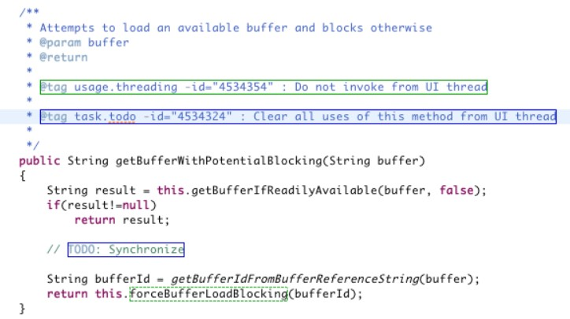

# Using OOP concepts

Object-oriented programming (OOP) involves programming using *encapsulation*, *inheritance*, *dynamic binding* and *polymorphism.* Here is an example shows the data encapsulation.

*Figure*

*3*

*Example of Data Encapsulation*

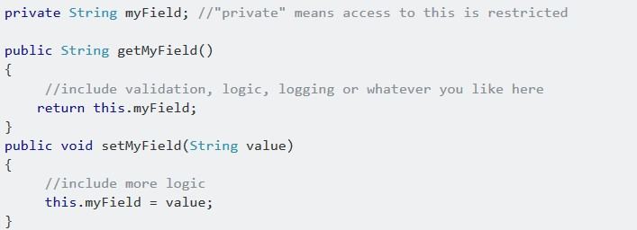

# Marking Schemes

* *Please observe the submission deadline, later submission will not be accepted or evaluated.*
* *This assignment mush be finished individually; plagiarism is not allowed. Please refer to the plagiarism policy on the web page.*

|  |  |  |  |
| --- | --- | --- | --- |
| Description | | | Percentage |
| The correctness of the sample test cases. The input file is given as *sampleInput.txt,* the correct output is given as *sampleOut.txt* (Note: Your output should be exactly matched with the sample output, please use the diff tool in IntelliJ to check them carefully). | | | 25% |
| Documentation using JavaDoc.  You can get full mark if you write Java doc for all the defined classes and methods. | | | 5% |
| Using OOP concepts in your project.  You can get full mark if you have used both the concepts of *Encapsulation* and *Inheritance*. | | | 5% |
| Successfully declaring and defining the necessary classes.  (Game.java, Player.java, Station.java, Pokemon.java, Map.java, 4% for each class) | | | 20% |
| Other test cases  We will provide several other test cases with different maps. | | | 45% |
| For each of the test case, we will first check the output path is valid or not. A valid path satisfies the following criterions:   * Starts at the starting point and ends at the destination point. * No blocking walls in the middle. * Do not excel the border of the map. * The final state of the player you output is in consistent with the path, which means if the player walks along the path you output, the state of the player (i.e. VF, NB, NP, NS, MCP) should be exactly the same as what you output when he arrives at the destination point.   If the path is invalid, 0 credit will be obtained. Otherwise, we check the path is the optimum or not. You can get partial marks even if it is not the optimum. Suppose the credit for this test case is *CT*, the value of the scoring function you output is *VF*, the optimum is *OVF*, the credit you can obtain for this test case is CT ∗ VF/OVF.  It is guaranteed that at least one valid path exists in the map.    The complexity of the other test cases is pretty much the same as the sample test cases which promises the following constraints:  5 ≤ 𝑀 ≤ 10; 10 ≤ 𝑁 ≤ 30; 𝑁𝑝 ≤ 10; 𝑁𝑠 ≤ 5; | | |  |
|  | It’s guaranteed that at least 70% of the cell are walls. |  |

# 

# Input and Output file

The sample input file (e.g. sampleInput.txt) is put in the same location of the src folder of your java project, and you are required to output the file (e.g. sampleOut.txt) file to the same location.

Your project should be capable of configuring the names of the input and output files. Therefore, we pass the names of the input/output files through running arguments. We have already provided the skeleton code of the entry main function in class file Game.java as shown in Figure 5. You are supposed to read the input from the file <inputFile>, and output the result to the file <outputFile>.

*Figure*

*5*

*Main*

*F*

*un*

*c*

*tion*

*of the Whole*

*Program*

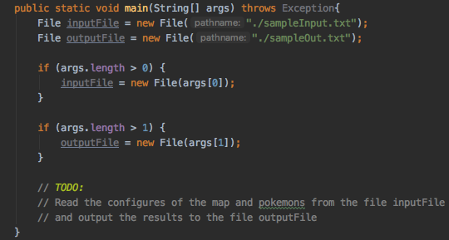

# Implementation Notes

* Your project should be named with “Pokemon_PA3”, and all your defined classes should be put in the default folder. Please DO NOT put your source codes under any *packages* defined by yourselves. The overview of your project should be looked like Figure 6.

*Figure*

*6*

*Project Overview*

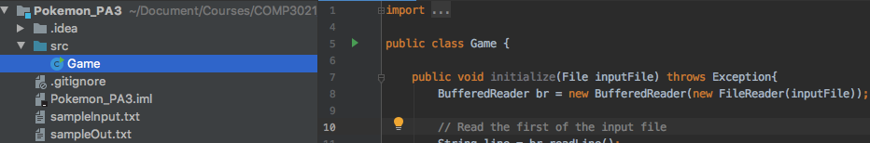

* The entry point of the whole project is the *main* function in the class *Game.java,* which is given by us. You are required to declare and define the following five classes:

|  |  |
| --- | --- |
| Class Name | Class Description |
| Pokemon | Class Pokemon is a special type of cell. Besides recording the location of the cell, it also records the information of the properties of a Pokémon, including the name, type, combat power and required balls to catch it. |
| Station | Class Station is a special type of cell. Besides recording the location of the cell, it also records the information of a supply station, including the number of the provided balls. |
| Map | The class is defined to record the information of all the cells of the map, including walls, Pokemon cells, Station cells and empty cells. |
| Player | The class is used for recording the status of the player, including the current location, the caught Pokémons, the number of Poke balls and the path visited. |
| Game | This the entry class of the whole program, which contains the main function. It’s also responsible for file input and output. It should contain a Map and a Player. |

These classes are the required classes; you *may also need* to define *other* classes in order to finish this assignment.

* Tips on the searching Pokémons and the destination point. First, you need to find the starting point (which is denoted as B) from the map. In order to find a path to the destination, you need to keep trying moving up, down left and right. For example, if you are currently at cell <2,3>, you have four options for your next move as shown in the following picture:

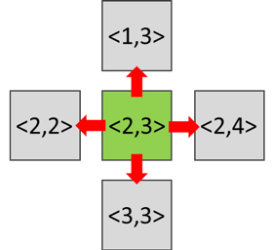

*Figure 7 Moving Options*

You need to try these four options one by one to see if you can make the move or not. You may not move to the next cell if it is a wall. After successfully moving to a new cell, you need to check whether it is the destination or not. If it is, you can print out the solution. You also need to check if the new cell is a Supply Station or contains a Pokémon. If there are, you need to make the action accordingly: acquire the Poke balls or catch the Pokémon. If the cell is not the destination, you need to keep moving by adopting the same strategies.

In order to make your program more efficient and to avoid repeatedly visiting the same cell with the same status, you are suggested to store the status you have searched and avoid repeating the same status on the same cell.

* For all the test cases, we will test your program under the time budget of *1 minutes*, which means we will terminate your program if it runs over than *1 minutes*. In this case, you are suggested to output the results to the <outputFile> once you get a solution. Even if it is not the optimum, you can still get partial credits. If you have no output within *1 minutes*, you may not get any credit for this test case. (We will not test the program using complex maps, the constraints of the map are stated in the marking scheme).
* You can find a runnable Pokemon_PA3.jar with a sample input file (sampleInput.txt) under PA3_Obfuscated folder in the downloaded package. You can run this jar through a terminal. First open your terminal and go to the location where the jar file is located. Then, run the following command java -jar Pokemon_PA3.jar. An output file named sampleOut.txt should be generated at the same location. You can also try to run the jar file with several input arguments. For example, prepare another input file input.txt and run the command java -jar Pokemon_PA3.jar input.txt output.txt. The program will take input.txt as input and output *ouput.txt.*

# Submission Details

You are required to submit all your source codes through a zip file. You should compress the Pokemon_PA3 directory and rename it to <Your_Student_ID>.zip (i.e., 20202795.zip). You should submit the zip file via the CASS system [(https://course.cse.ust.hk/cass/student/#/submit)](https://course.cse.ust.hk/cass/student/#/submit).

# Bonus (To be released)

# Deadline

The assignment will be due on: 22:55, 19 December, 2019.