**Jira Testing with TestComplete**

**Team 4**

Phạm Đức Tài

(Withdraw-Deposit)

Huỳnh Võ Tấn Phước

(DeleteCustomer-DeleteAccount)

Hồ Tấn Thành

(EditAccount-EditCustomer)

Trần Quang Huy

(NewAccount-NewCustomer)

Trí Nhân

(CustomizeStatement-MiniStatement)

**Table of content**

1. **Introduction**
   1. **TestComplete? 3**
   2. **Merits 4**
   3. **TestComplete and Jira 4**
2. **Installation**
   1. **TestComplete 5**
   2. **Jira Extension file 7**
   3. **Zephyr 11**
   4. **Make connection 14**
3. **Testing**
   1. **Test steps ?**
   2. **Test plans ?**
   3. **Test execution ?**
   4. **Test results ?**
4. **Conclusion**
5. **Recommendation**
6. **Reference**
7. **Appendices**
8. **Introduction**
   1. **TestComplete?**

TestComplete is a product of SmartBear Software, a company that provides software quality tools for developers, testers, and operations teams. TestComplete was first released in 1999 and has since evolved into a comprehensive and user-friendly tool that supports many technologies and frameworks, such as .NET, Java, WPF, HTML5, React, Angular, iOS, and Android.

TestComplete allows you to create tests by recording or scripting in different languages, such as Python, JavaScript, VBScript, and C#. You can also use keyword-driven testing or behavior-driven development (BDD) approaches to create tests that are easy to understand and maintain. TestComplete has an intelligent object recognition engine that can identify and interact with dynamic and complex UI elements. You can also use various checkpoints to verify the application state and functionality during the test run.

TestComplete integrates with popular tools in the testing ecosystem, such as Git, Jira, Jenkins, Azure DevOps, and more. You can manage your test cases, track your defects, run your tests in continuous integration or delivery pipelines, and generate detailed reports. TestComplete also enables data-driven testing, distributed testing, and other advanced testing scenarios.

TestComplete can help you with your testing projects in various domains and industries, such as finance, healthcare, education, e-commerce, gaming, and more. You can use TestComplete to test desktop applications that are built with .NET or Java, web applications that are developed with HTML5, React, or Angular, or mobile applications that run on iOS or Android. You can also test hybrid applications that combine different technologies and platforms. I will list some of the benefits of TestComplete below.

* 1. **Merits**
* It supports many technologies and frameworks, such as .NET, Java, WPF, HTML5, React, Angular, iOS, and Android123.
* It allows you to create tests by recording or scripting in different languages, such as Python, JavaScript, VBScript, and C#12.
* It has an intelligent object recognition engine that can identify and interact with dynamic and complex UI elements1.
* It offers various checkpoints to verify the application state and functionality during the test run2.
* It integrates with popular tools in the testing ecosystem, such as Git, Jira, Jenkins, Azure DevOps, and more1.
* It enables data-driven testing, distributed testing, and other advanced testing scenarios2.
  1. **TestComplete and Jira**

With everything being said, we can see that Jira (project management and issue tracking tool that allows you to plan, track, and collaborate on your software development and testing activities) would work wonders with TestComplete. Here are things that Jira and TestComplete can help you:

* You can streamline your testing process by managing your test cases, defects, and automation scripts in one place.
* You can increase your testing efficiency by running your automated tests from Jira and getting instant feedback on the test results.
* You can improve your testing quality by ensuring that your test cases are up-to-date with the application changes and that your defects are resolved promptly.
* You can enhance your testing visibility by generating comprehensive reports on your testing progress and performance.

1. **Installation**
   1. **TestComplete**

Start by creating an account in TestComplete website:

<https://smartbear.com/product/testcomplete/>

Here you will find a “Start my free Trial” button, click on it and it should take you to the create account page

Once you’ve made an account, TestComplete will send you their gratitude and open a folder box to let you choose where to save TestComplete. From there go to the file in your computer and startup the TestComplete installation file.

When this text box shows up click next

After choosing save location, click install.

After installation you will see TestComplete main screen

* 1. **Jira Extension file**

This link will take you to Jira Extension file:

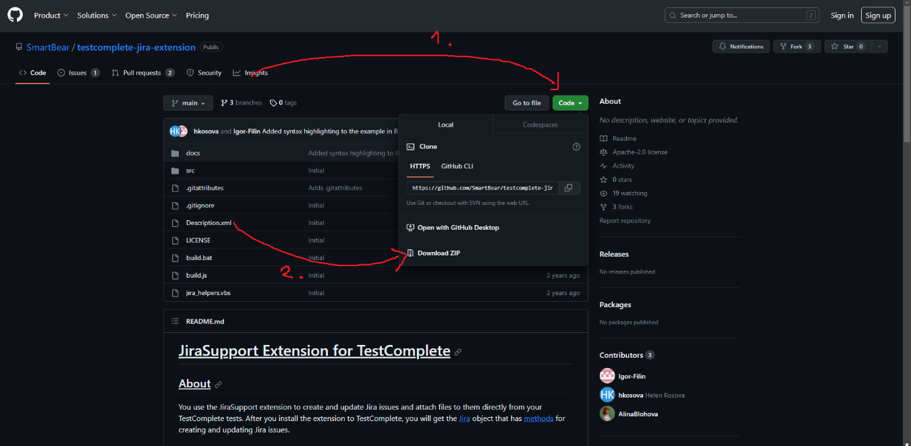<https://github.com/SmartBear/testcomplete-jira-extension>

1st click on “code” button,

2nd click on “download Zip”

A popup will show and again choose where to download Jira Extension file

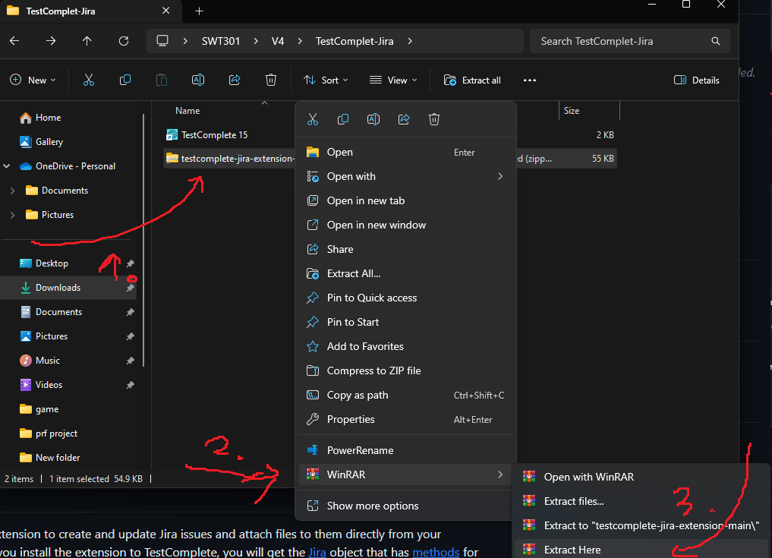Once downloaded, unzip the file

1st right click on the ip file

2nd click on winrar or your preferred unzip tool

3rd extract the file

Once extracted, open the file and you will see a “build.bat” file.

1st proceed to run it

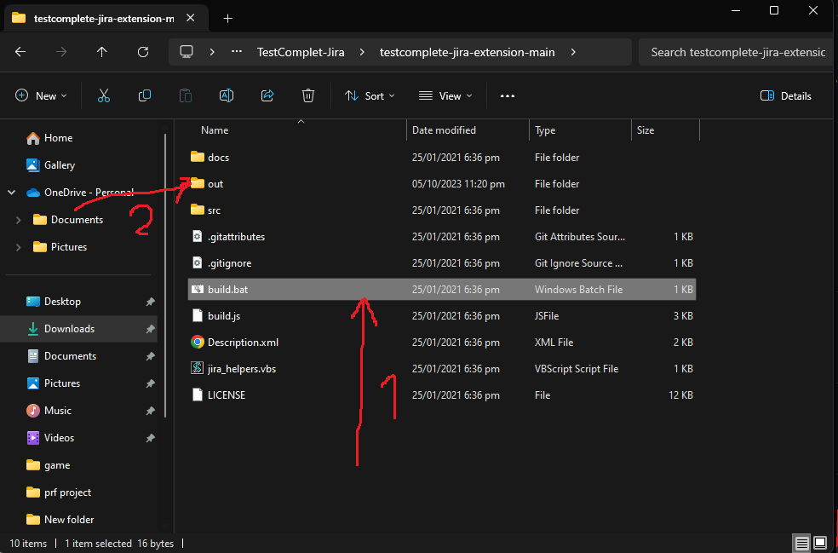

2nd after the file finished running, click on out folder

You will see “JiraSupport.tcx” to open

After open a window appears

After choosing download location click “ok” and the file will automatically download

(optional) you can check if the extension is properly download by:

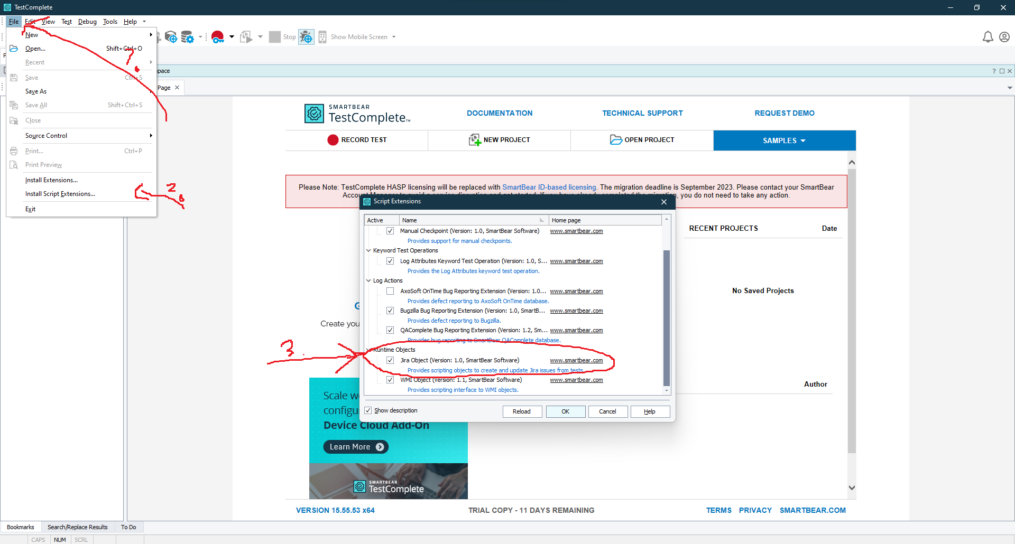1st open TestComplete and open Files

2nd open “Install script extension”

3rd check if “jira object” is checked

* 1. **Zephyr**

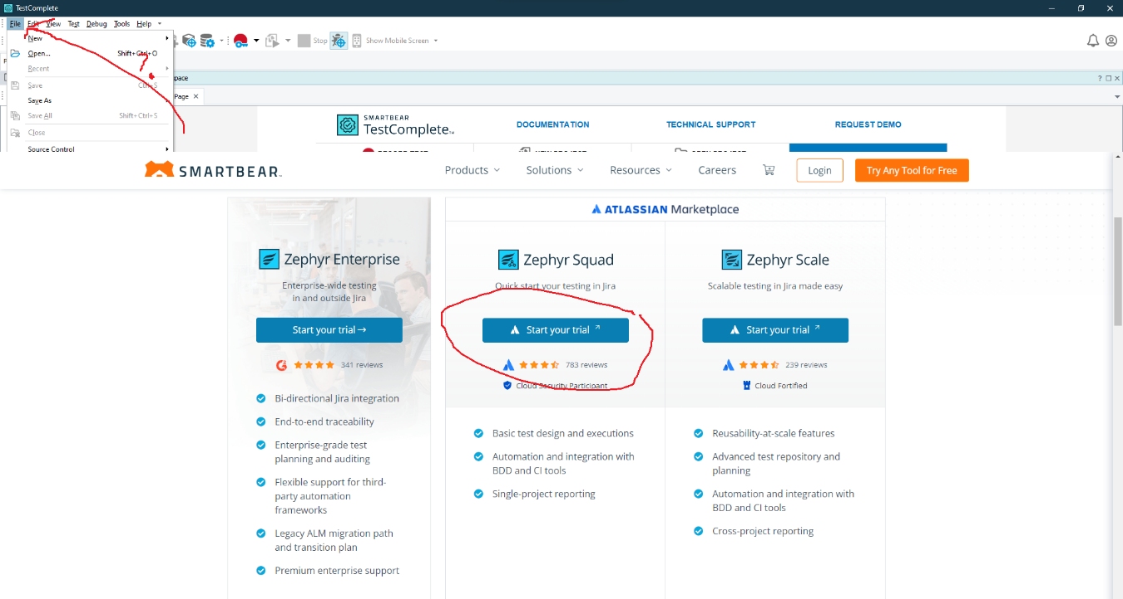This link contains Zephyr installation

Choose “Zephyr Squad”

After that click on “try it free”

This window will show up, click on “login” to continue

Here you will enter the email which linked to your project

Once everything is done you can choose which project to apply Zephyr to test.

* 1. **Make connection**