Individual Differences in Executive-Function Engagement Can Emerge Without Differences in Neurodevelopmental Capacity: A Developing Expected Value of Control Model

Kyuri Park¹ and Yuko Munakata²˒³
¹ Computational Science Lab, Informatics Institute, University of Amsterdam, Amsterdam, the Netherlands
² Department of Psychology, University of California, Davis, CA, USA
³ Center for Mind and Brain, University of California, Davis, CA, USA

Abstract
People vary in their executive functions, the cognitive processes that tap prefrontal cortical and striatal networks to support goal-directed control of thoughts and actions. These variations–from within the first years of life–predict concurrent and longitudinal outcomes in academics, mental and physical health, social relationships, and wealth. Why? According to dominant capacity accounts, people vary in their executive function capacity due to neurobiological constraints; these variations are stable across development, such that high executive function capacity supports adaptive behavior across the lifespan.
However, people can have the relevant executive function capacity but make decisions–from within the first years of life–about whether executive function is worth engaging. These decisions reflect the estimated cost and value of engaging executive function, which are influenced by a variety of internal and external factors. (Is a promised future reward worth resisting an immediate temptation for? Do people around me value controlled behavior? Is there an easier option?) Repeated experiences deciding to engage (or not engage) executive function in turn influence the estimated cost and value of engaging executive function. As a result, patterns of engaging (or not engaging) executive function become stabilized, influencing adaptive behavior across the lifespan.
We used a formal model to test the viability of this alternative account for explaining key phenomena in the developing executive functioning literature. We extend the Expected Value of Control framework (Masis et al., 2021; Shenhav et al., 2013), developed as an integrative theory of anterior cingulate cortex function, to investigate the long-term implications of control processes when repeated over developmental timescales. At each episode, an agent decides whether executive function is worth engaging based on how rewarding it is expected to be, how effortful it currently feels, and temporary contextual demands. Engaging executive function then shapes the next decision in two ways: experienced outcomes update how much payoff is expected from engagement, while practice gradually reduces the effective effort cost of engaging again.
Our Developing Expected Value of Control (DEV-Control) model can explain key developmental phenomena of both stability and change. Specifically: a) individual differences in executive function in the model arise early in development and show stability in the absence of inherent capacity differences, while b) executive function shows protracted increases across development, and c) internal and external factors lead to transient increases and decreases in executive function. Because both engagement and reward are probabilistic, initially identical agents accumulate different experience histories. These histories alter subsequent engagement probabilities, creating a feedback process through which small chance differences become moderately persistent over development. Temporary stressors produce transient drops in executive function engagement. In addition, small reliable environmental differences in how consistently engagement pays off lead to stable individual differences across development.
Our DEV-Control model thus demonstrates how variations in children’s everyday experiences could lead to stable individual differences in developing executive function, with sensitivity to context, in the absence of inherent capacity constraints. We discuss implications for intervention and for understanding the neural bases of developing executive function.

Introduction
Executive functions support the goal-directed control of thought and behavior, including maintaining goals, inhibiting prepotent responses, and flexibly adjusting behavior when circumstances change. Individual differences in executive-function measures are evident early in life and predict a wide range of concurrent and later outcomes, including academic achievement, mental and physical health, social functioning, and economic outcomes [CITATIONS]. Executive-function performance also changes substantially across childhood and adolescence, alongside prolonged development of prefrontal and corticostriatal systems [CITATIONS].
A common interpretation is that children differ in an underlying executive-function capacity. On this view, developmental improvement reflects increasing neurocognitive capacity, while rank-order stability reflects enduring differences in that capacity. A child with greater capacity should therefore be better able to exert control across situations and, over time, show more adaptive patterns of behavior. This interpretation has also shaped intervention efforts that aim to improve executive function by training the capacity to exert control [CITATIONS].
But the ability to exert executive function is not the same as the decision to engage it. A child may be capable of maintaining a goal, resisting a temptation, or switching strategies, but may not always find doing so worthwhile. Engaging executive function can be effortful, and whether control is worth exerting depends on its expected benefits relative to its costs [Shenhav et al., 2013]. These costs and benefits can vary substantially across situations. A promised future reward may or may not seem worth waiting for. Controlled behavior may be valued and rewarded in one social environment but less so in another. A child may also have access to an easier behavioral strategy that makes exerting control unnecessary. Observed differences in executive functioning may therefore reflect not only whether children can engage control, but also whether they have learned that doing so is worth the effort.
This becomes especially important over development because decisions about whether to engage control are made repeatedly. Each time a child engages control, the outcome provides information about whether that effort was worthwhile. Outcomes that are better than expected may increase its learned value, while worse-than-expected outcomes may decrease it. Repeated engagement also provides practice. Behaviors that initially require substantial controlled effort may become easier with experience, reducing the effective cost of engaging again [CITATIONS TO LEVC / AUTOMATICITY]. Not engaging control does not itself make control harder, but it means missing an opportunity to learn from the outcome or benefit from practice.
Repeated across development, these processes create a feedback loop. Current expectations and effort costs influence whether control is engaged; engagement then changes what is learned about its value and, through practice, may change how effortful future engagement becomes. Small differences in experience can therefore feed into later decisions and potentially become more persistent over time.
Existing theories provide components of this account. The Expected Value of Control framework proposes that cognitive control is allocated according to its expected benefits and costs [Shenhav et al., 2013]. Learning-based extensions emphasize that the value of control can itself be learned from experience [Lieder et al., 2018; Masís et al., 2021]. Related work suggests that repeated experience can also change how much control is required for successful performance as behavior becomes more practiced or automatic [CITATIONS]. Experimental findings likewise show that histories of reward and control demand can alter later control allocation, even when the immediate task environment changes [e.g., Bustamante et al., 2021].
These approaches raise a developmental question that has received less attention: What happens when decisions about whether to engage executive function, learning from their consequences, and practice are repeated across development?
One possibility is that stable individual differences need not be present at the outset. Consider two children who begin with the same executive function capacity, the same expectations, and the same environment. Their experiences can still diverge. On a particular occasion, one may happen to engage control while the other does not. Two children who both engage may also experience different outcomes. If those experiences change expected value or future effort cost, small chance differences can influence what happens next. Over repeated interactions, initially identical children could therefore develop different propensities to engage executive function.
This account does not imply that neurobiological capacity differences do not exist or do not matter. Rather, it asks a narrower question: how much of the developmental structure usually attributed to capacity differences can emerge before such differences need to be assumed? A useful test is therefore to deliberately remove inherent capacity differences from a model and examine what can arise from experience-dependent control allocation alone.
Here, we develop a Developing Expected Value of Control (DEV-Control) model to address this question. The model extends expected-value-of-control principles over a developmental timescale. At each episode, an agent decides probabilistically whether executive function is worth engaging based on its learned expected payoff, current effective effort cost, and temporary contextual demands. When executive function is engaged, experienced outcomes update its expected payoff, while repeated practice gradually reduces the effective effort cost of engaging again.
We use the DEV-Control model to test whether this minimal set of processes can generate several characteristic features of developing executive-function engagement without assuming inherent capacity differences. Specifically, we ask whether initially identical agents develop persistent differences in engagement while average engagement increases; whether persistent environmental differences stabilize those emerging differences; whether temporary contextual changes produce transient fluctuations in engagement; and whether experience-dependent feedback alone makes earlier experiences disproportionately influential.

Methods

Developing Expected Value of Control model
The DEV-Control model describes executive-function development as a sequence of repeated opportunities to engage control. Time in the model indexes these opportunities rather than literal days, months, or years. At each episode, an agent decides whether engaging executive function is worthwhile given its current expected payoff, effective effort cost, and temporary contextual demands. Engagement then creates experience that can change the expected payoff and effective cost of engaging again. Development therefore emerges from repeatedly iterating a fast engagement decision together with slower learning and practice processes.
Importantly, agents do not differ in executive-function capacity in the core model. Unless otherwise specified, they begin with the same model states, parameters, and environment. Individual differences can nevertheless arise because both engagement and reward outcomes are probabilistic, such that agents can accumulate different histories of engagement, reward, and practice.
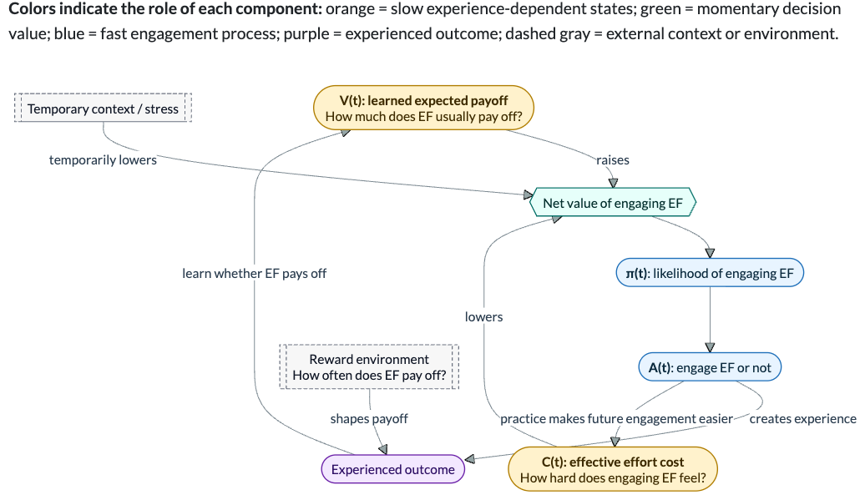
Figure 1. DEV-Control model. Momentary engagement depends on learned expected payoff, effective effort cost, and temporary context. Engagement generates outcome information that updates expected payoff and practice that reduces future effective effort cost.

Executive-function engagement
For agent i at episode t, the net value of engaging executive function is:
D(i,t) = V(i,t) − C(i,t) − X(i,t),
where V(i,t) is the learned expected payoff from engaging executive function, C(i,t) is its current effective effort cost, and X(i,t) captures temporary internal or external demands that make engagement less attractive.
The probability of engaging executive function is:
π(i,t) = 1 / [1 + exp(−D(i,t) / τ)],
where τ controls how strongly differences in net value translate into behavior. Smaller values of τ produce more deterministic choices, whereas larger values produce greater decision variability.
Actual engagement is probabilistic:
A(i,t) ~ Bernoulli[π(i,t)],
where A(i,t) = 1 indicates that executive function is engaged and A(i,t) = 0 indicates that it is not.
This stochasticity is important because it allows individual differences to emerge even when agents start identically. Two agents may have the same probability of engaging executive function, but on a particular episode one may engage while the other does not. Likewise, two agents who both engage may experience different reward outcomes. These initially small differences create different opportunities for learning and practice, which can alter later engagement and accumulate over repeated experiences. Without this stochastic component, identical agents in identical environments would follow identical developmental trajectories.

Learning the expected payoff of engagement
When executive function is engaged, its outcome provides information about whether exerting control was worthwhile. Conditional on engagement, a rewarding outcome occurs with probability p(i,t):
Y(i,t) ~ Bernoulli[p(i,t)],
where Y(i,t) indicates whether engagement produced a rewarding outcome. With reward magnitude r, the experienced payoff is Y(i,t)r.
Expected payoff is updated using a simple delta-learning rule:
V(i,t+1) = V(i,t) + αV A(i,t)[Y(i,t)r − V(i,t)],
where αV is the value-learning rate.
Thus, when an agent engages executive function, outcomes that are better than expected increase its expected payoff, whereas outcomes that are worse than expected decrease it. When the agent does not engage, V does not change because no new information about the consequences of engagement is obtained.
This component captures the idea that whether control is worth exerting can be learned from experience rather than being fixed in advance.

Practice and effective effort cost
Engaging executive function also provides practice. We represent this by allowing repeated engagement to gradually reduce its effective effort cost:
C(i,t+1) = C(i,t) − αC A(i,t)[C(i,t) − Cmin],
where αC determines the rate of practice-related change and Cmin is the minimum effective effort cost.
Each episode of engagement therefore moves C toward Cmin, with progressively smaller changes as the agent becomes more practiced. If executive function is not engaged, its cost does not increase. Rather, the agent simply misses an opportunity for practice.
We use C to represent how effortful engaging executive function is at a given point in time. This effort cost may reflect several processes, such as familiarity with the task, increasing efficiency with practice, or partial automatization of component processes. We do not assume that C corresponds to one specific psychological or neural mechanism.

Experience-dependent feedback
Together, value learning and practice create a simple feedback process:
engagement → learning about payoff + practice → future engagement
An agent that engages control receives an opportunity both to learn whether engagement pays off and to practice. These experiences can change V and C, which in turn change the probability of engaging executive function on subsequent episodes.
Stochastic differences therefore need not remain one-off fluctuations. Suppose two otherwise identical agents initially have the same V, C, and probability of engagement. If one happens to engage executive function more often, or happens to experience different reward outcomes, their internal states can begin to diverge. Once V and C differ, their future engagement probabilities can also differ, allowing small differences in experience to accumulate over development.

Model variants
To determine which components of the model generate developmental change, we compare three nested variants.
M0: Control allocation only. Agents make repeated EVC-like engagement decisions, but neither expected payoff nor effort cost changes with experience.
M1: Control allocation + value learning. Expected payoff V is updated from experienced outcomes, while effort cost remains fixed.
M2: Control allocation + value learning + practice. Both expected payoff and effective effort cost change through experience. This is the full DEV-Control model used for the main analyses.
Comparing these variants allows us to ask what developmental patterns can be generated by value learning alone, and what is added when repeated engagement also changes the future effective cost of control.

Simulation setup

Default simulations
The simulations are qualitative tests of the dynamics implied by DEV-Control rather than fitted estimates of executive-function development. Time indexes repeated opportunities to engage executive function, not literal days, months, or years. Episode counts and parameter values were chosen to allow the relevant dynamics to unfold without immediately reaching floor or ceiling levels.
The default model-comparison simulations included 800 agents followed for 1,500 experience episodes; subsequent illustrative analyses used 1,000 agents unless otherwise noted. Agents began with identical model states and parameters. The initial expected payoff was V0 = .577 and the initial effective effort cost was C0 = .987. The decision temperature was τ = .163. Engagement paid off with probability p = .591, with reward magnitude r = 1.150. The value-learning rate was αV = .0244, the practice-related cost-reduction rate was αC = .00263, and the minimum effective effort cost was Cmin = .459.
These values are provisional model parameters rather than empirically estimated quantities. In the primary analyses, all agents also experienced the same reward probability. Thus, no between-agent differences in starting states, learning rates, reward environments, or executive-function capacity were introduced. The only source of initial differentiation was stochastic variation in realized engagement and reward outcomes.

Developmental periods
We defined three common developmental periods across analyses: an early period spanning 20–30% of the simulation, a middle period spanning 50–60%, and a late period spanning 85–95%.
Population means and between-agent variability were summarized within the early and late periods. Rank-order persistence was assessed by averaging each agent’s engagement propensity within the early, middle, and late periods and calculating Spearman rank correlations between these individual-level averages.

Persistent environmental differences
The primary simulations deliberately assumed an identical reward environment so that emerging individual differences could not be attributed to environmental heterogeneity. We then relaxed this assumption by allowing agents to differ slightly and persistently in the probability that executive-function engagement paid off.
Each agent received a stable reward probability p(i), centered on the same population mean. We varied the imposed between-agent standard deviation in reward probability from 0 to .06 and repeated each setting across independent stochastic populations. All other parameters remained identical across agents. The SD[p(i)] = .02 condition was used as an illustrative long-horizon example.
This analysis asks whether persistent environmental differences are necessary for individual differences to emerge, or instead primarily affect how stable those differences become.

Temporary contextual perturbation
To examine transient contextual variation, we introduced a temporary increase in X, the contextual cost entering the engagement decision. The contextual cost increased gradually, peaked at .20, and then decreased again over a short period around the middle of the simulation.
The perturbation therefore directly changed the momentary attractiveness of engaging executive function but did not directly alter learned expected payoff V or learned effort cost C. The perturbation and reference simulations used otherwise identical parameters and random seeds, allowing differences between conditions to be attributed to the temporary contextual change.

Timing of supportive experience
To test whether experience-dependent feedback itself makes earlier experiences disproportionately influential, we temporarily improved the reward environment by increasing the probability that executive-function engagement was rewarded.
Early and later support used the same smooth reward-probability pulse, with the same duration and a peak increase of .12. The pulse lasted approximately 13% of the experience horizon and began at approximately 20% in the early condition and 60% in the later condition. Thus, the two conditions differed only in timing.
Because a common final-time comparison gives later support less time to decay, we evaluated both the common final-time effect and effects after the same amount of follow-up following each support period.

Parameter sensitivity
Finally, we tested whether the developmental patterns depended on the particular default parameterization. We generated 250 parameter combinations and simulated five independent populations for each combination. These simulations used 150 agents over 900 episodes to make the broader sweep computationally tractable.
Six quantities were varied independently:
Parameter | Range | Sampling
Value-learning rate αV | .006–.070 | log-uniform
Practice-learning rate αC | .0004–.0070 | log-uniform
Decision temperature τ | .10–.30 | uniform
Reward probability p | .45–.72 | uniform
Initial net value V0 − C0 | −.60 to −.20 | uniform
Available practice-related cost reduction C0 − Cmin | .25–.75 | uniform
Within each parameter combination, all agents continued to share the same reward environment. This analysis therefore tests robustness of experience-driven differentiation under different model assumptions rather than introducing environmental heterogeneity between agents.

Results

Practice feedback generates developmental change
We first asked which components of the DEV-Control model were sufficient to generate developmental increases in executive-function engagement and emerging individual differences. We compared the three nested model variants while keeping agents’ initial states and reward environments identical.
With control allocation alone (M0), engagement remained unchanged across the simulation. Mean engagement propensity was .075 in both the early and late periods. Because neither expected payoff nor effort cost changed with experience, agents also remained identical to one another, with no between-agent variation emerging.
Adding value learning (M1) produced modest developmental change. Mean engagement propensity increased from .103 in the early period to .124 in the late period, while between-agent variability increased from SD = .034 to SD = .044. Middle-to-late rank persistence was modest, ρ = .277. Thus, learning from experienced outcomes was sufficient to produce some developmental differentiation among agents who started identically.
The largest change occurred when practice-related reductions in effective effort cost were added (M2). Mean engagement propensity increased from .141 in the early period to .454 in the late period, while between-agent variability increased from SD = .053 to SD = .127. Relative engagement levels also showed greater persistence, with a middle-to-late rank correlation of ρ = .576.
Model | Early mean | Late mean | Early SD | Late SD | Middle-to-late ρ
M0: Control allocation only | .075 | .075 | .000 | .000 | NA
M1: + value learning | .103 | .124 | .034 | .044 | .277
M2: + practice feedback | .141 | .454 | .053 | .127 | .576
Value learning alone therefore produces some developmental change, but the much larger increase in engagement appears after adding the practice pathway. Agents who engage receive practice that lowers the effective cost of later engagement, which in turn makes subsequent engagement more likely. This reinforcing effect is self-limiting: as effort cost approaches its lower bound and learned value approaches the average payoff available in the environment, there is progressively less opportunity for further change.
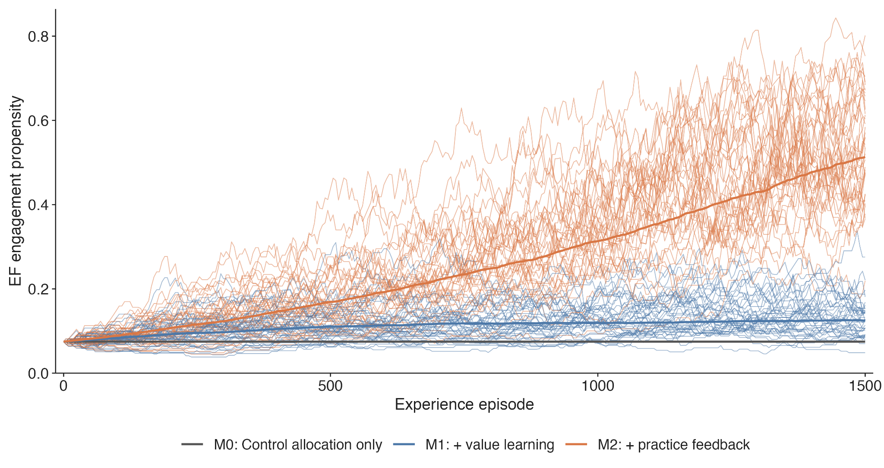
Figure 2. Developmental trajectories across nested model variants. Value learning produces modest change; adding the practice pathway produces a much larger increase in mean engagement and between-agent differentiation.

Individual differences emerge among initially identical agents
We next examined how individual differences arise in the full DEV-Control model. This provides the strictest test of the proposed mechanism because all agents began with the same V, C, engagement probability, learning parameters, and reward environment. Between-agent variation in engagement propensity was therefore zero at baseline.
Despite these identical starting conditions, agents developed different trajectories over repeated experience. Because engagement is probabilistic, some agents happened to engage control on occasions when others did not. Reward outcomes were also probabilistic, so agents who engaged could experience different outcomes. These differences created different opportunities for value learning and practice. Once V and C began to differ, subsequent engagement probabilities also differed, allowing initially small differences in experience to accumulate.
The distribution of engagement propensities widened over development. Figure 3A shows a random subset of individual trajectories, without post-hoc grouping by later engagement. Rank persistence was evaluated separately from these trajectories using individual-level averages within the predefined developmental periods. The Spearman correlation was ρ = .524 between early and middle development, ρ = .618 between middle and late development, and ρ = .495 between early and late development.
Agents who became relatively high or low in engagement therefore tended to retain some of their relative position over subsequent developmental periods, even though no stable differences were imposed at baseline. Because these correlations are moderate rather than close to one, we describe the resulting differences as developmentally persistent or moderately rank-stable, rather than permanently fixed individual types.
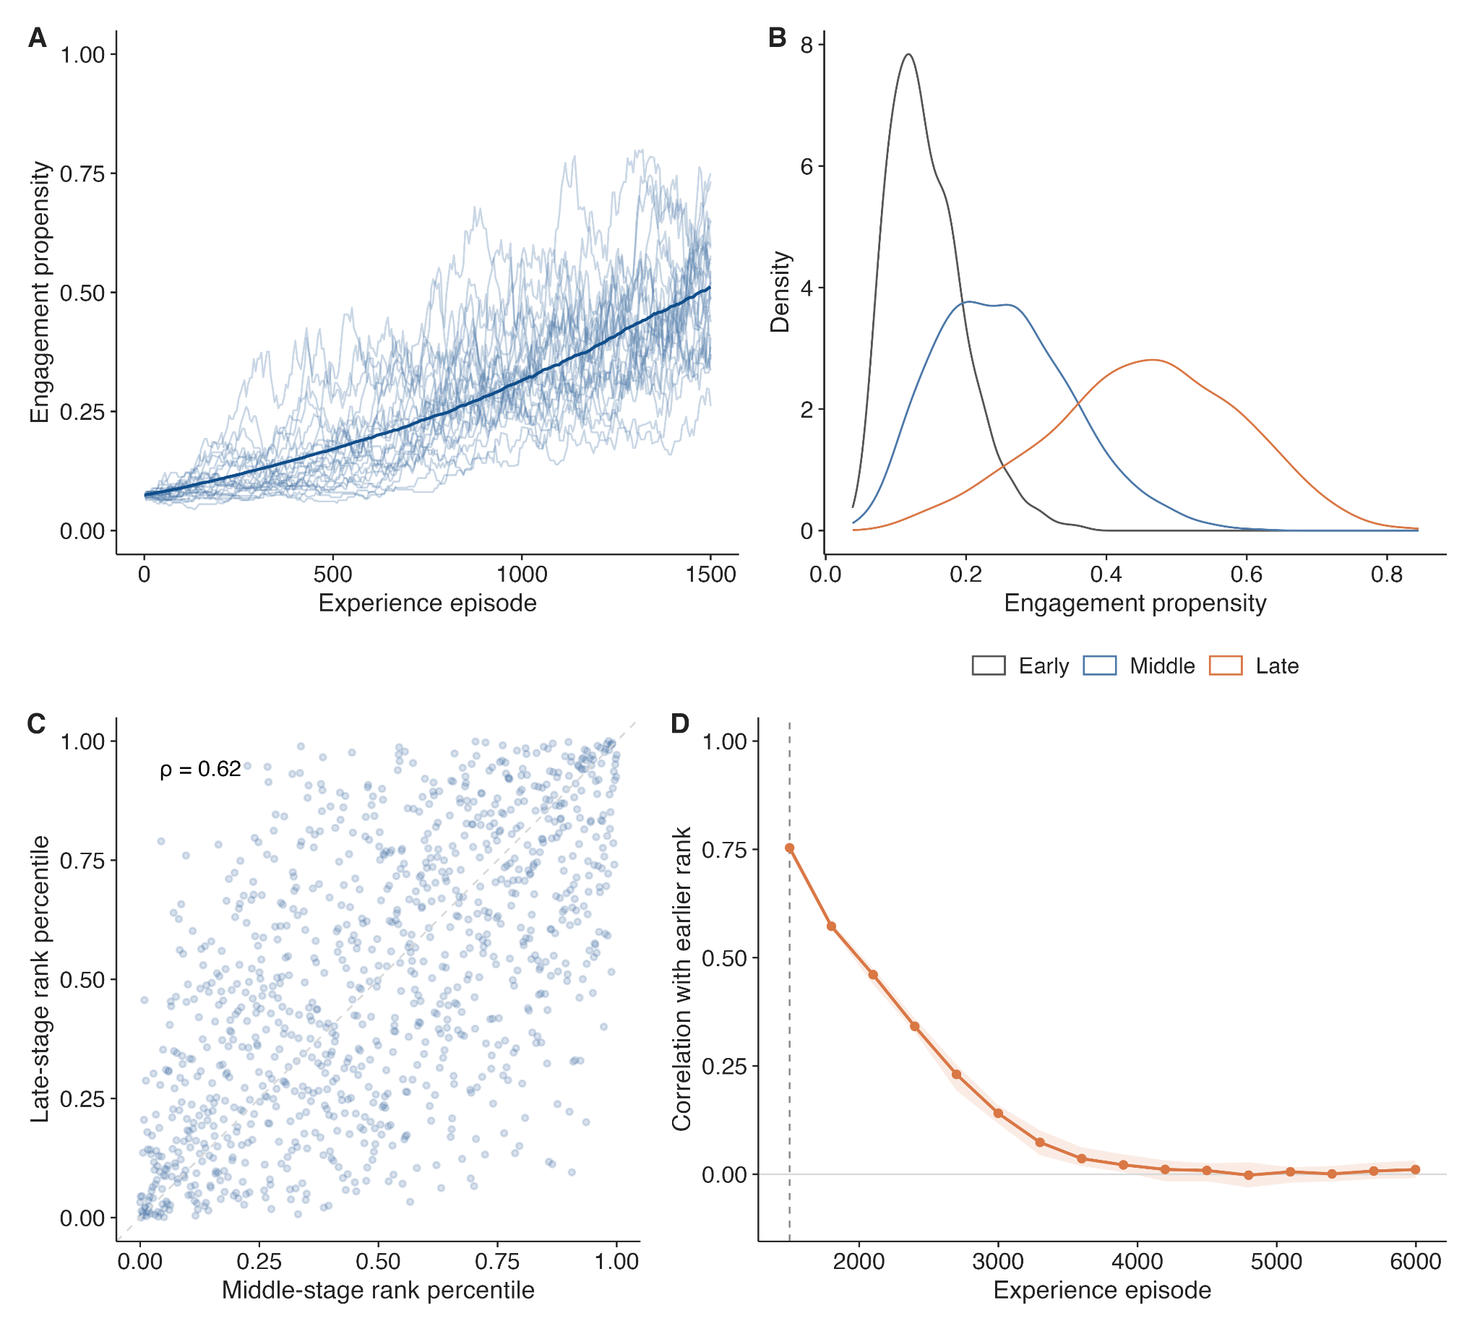
Figure 3. Emergence and persistence of individual differences from identical starts. (A) Randomly sampled individual trajectories. (B) Population distributions across early, middle, and late periods. (C) Middle-to-late rank persistence. (D) Long-horizon rank memory summarized across independent stochastic replications; the line shows the median and the ribbon the interquartile range.

Developmental differences are persistent but not permanent under a shared environment
We next asked whether differences generated under a shared environment remain tied to the same agents indefinitely. We extended the model to approximately four times the original experience horizon and repeated the long-horizon simulation across independent stochastic populations.
Across long-horizon simulations, rank order near the end of the original developmental horizon became progressively less predictive of rank order much later. The median correlation with the earlier ranking declined toward zero, with variation across stochastic replications. Cross-sectional spread did not disappear completely because engagement and reward outcomes remained probabilistic.
Thus, chance differences in experience can generate substantial and moderately persistent differentiation over a developmental horizon, but they do not permanently divide otherwise identical agents into fixed high- and low-engagement groups under a completely shared stable environment. Environmental differences are therefore not needed for differentiation to emerge, but they may help stabilize which individuals remain relatively high or low.

Persistent environmental differences stabilize emerging individual differences
We next introduced small persistent differences in how often executive-function engagement paid off. This manipulation addresses a different question from the previous analysis. Rather than asking whether environmental heterogeneity is necessary for differences to emerge, we asked whether it makes emerging individual differences more stable.
As persistent variation in reward probability increased, agents’ later engagement rankings became progressively more stable. When all agents shared the same reward probability, the median middle-to-late rank correlation was ρ=.601. This increased to .616 when SD[p(i)]=.01, .668 when SD[p(i)]=.02, .779 when SD[p(i)]=.04, and .855 when SD[p(i)]=.06.
Late-stage between-agent variability in engagement propensity also increased, from SD=.129 in the shared-environment condition to .134, .146, .179, and .212 as environmental variability increased.
Greater overall spread is expected once stable environmental differences are introduced. More importantly, rank persistence also increased systematically.
The SD[p(i)] = .02 condition provides a modest illustrative example but is not intended as an empirical estimate of environmental variability among children. The sensitivity analysis instead shows that the stabilization effect increases gradually across the range considered.
Together with the previous result, these simulations separate two processes: chance differences in experience are sufficient for individual differences to emerge, whereas persistent environmental differences make those emerging differences more stable.
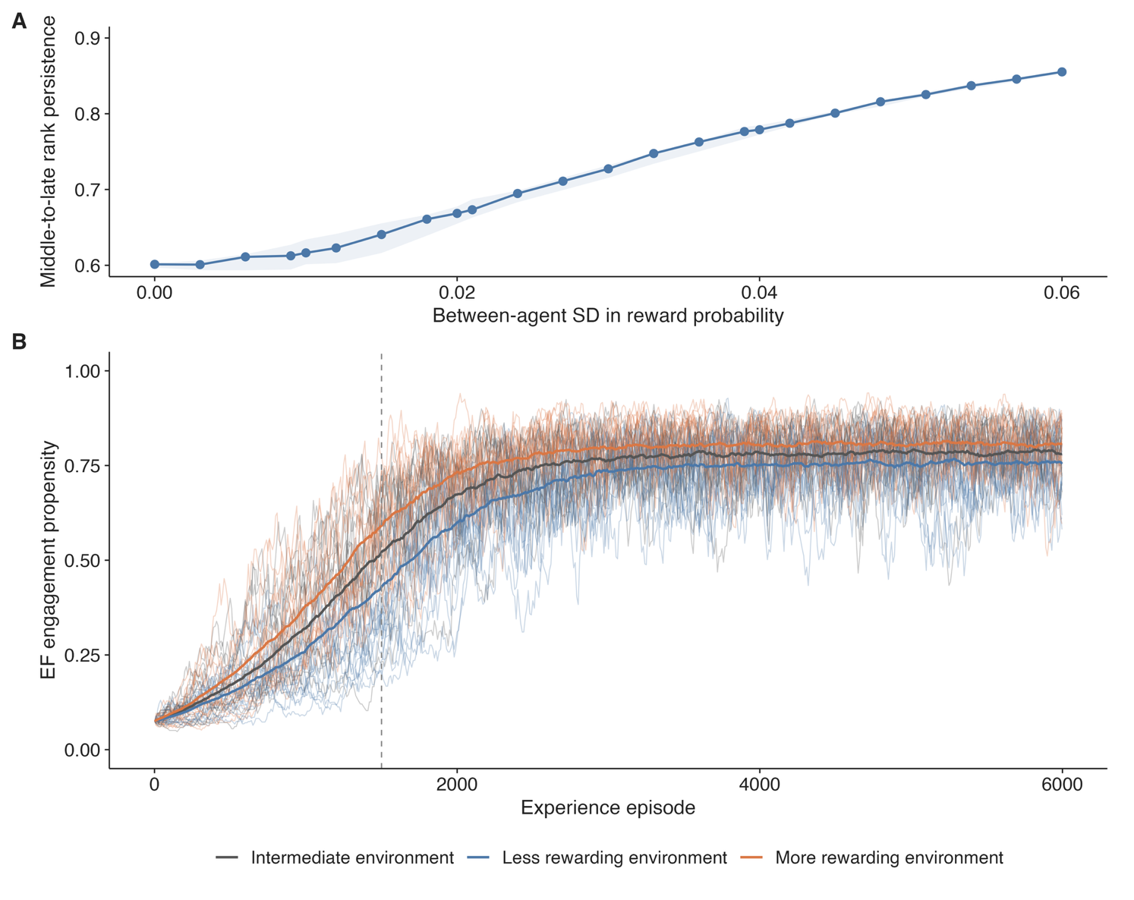
Figure 4. Persistent reward-environment differences stabilize emerging individual differences. (A) Middle-to-late rank persistence across increasing between-agent variation in reward probability. (B) Illustrative long-horizon trajectories for less rewarding, intermediate, and more rewarding environments.

Temporary contextual demands produce largely transient changes in engagement
The previous analyses concerned processes that accumulate over repeated experience. We next asked whether DEV-Control could also reproduce shorter-term fluctuations in executive-function engagement without changing an agent’s underlying capacity or long-term environment.
We introduced a temporary increase in the contextual cost X. This directly reduced the net value of engaging executive function during the perturbation but did not directly change either learned expected payoff V or learned effort cost C.
Engagement declined while the contextual cost was elevated and recovered substantially after the perturbation ended. A small difference remained later in development, with engagement in the temporary-stress condition approximately .010 lower than in the reference condition (Δπ=−.0096). This residual difference arose indirectly. While the contextual demand was present, agents engaged less often and therefore had fewer opportunities for reward learning and practice.
The main pattern was therefore a large temporary reduction followed by substantial recovery. DEV-Control can therefore produce marked contextual variation in executive-function engagement without requiring corresponding changes in underlying capacity.
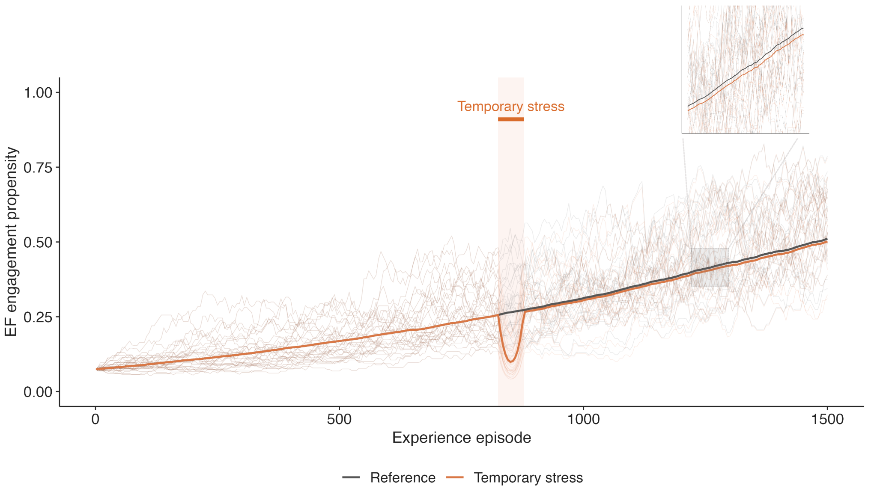
Figure 5. Temporary contextual demands produce largely transient changes in executive-function engagement. A smooth temporary increase in contextual cost, peaking at X=.20, reduces engagement during the perturbation. Engagement subsequently recovers substantially, although a small residual difference remains later in development (Δπ=−.0096). The inset magnifies the post-stress period to make this residual separation visible.

Experience-dependent feedback does not by itself create an early sensitive period
Experience in DEV-Control can influence future engagement, but this does not necessarily imply that earlier experiences are intrinsically more consequential than later ones. We tested this by providing the same temporary increase in reward probability for the same duration either earlier or later in development.
We first evaluated both support periods at the common end of the developmental simulation. Early support increased engagement relative to the reference condition by .026, whereas later support increased it by .031. Because later support had occurred more recently, however, this comparison gives the early effect more time to decay.
We therefore compared the two support conditions after the same amount of follow-up time had elapsed. Under this matched-lag comparison, early support increased engagement by .030 and later support by .035. Thus, matching follow-up time reduced the difference between the two timing conditions, but did not reveal an advantage for earlier support. If anything, the later effect remained slightly larger.
Experience-dependent feedback alone therefore did not make an otherwise identical supportive experience more influential simply because it occurred earlier. If early experiences or interventions are empirically found to have disproportionately large effects after accounting for follow-up time, an additional developmental mechanism, such as age-dependent plasticity or maturation, would be required to reproduce that pattern.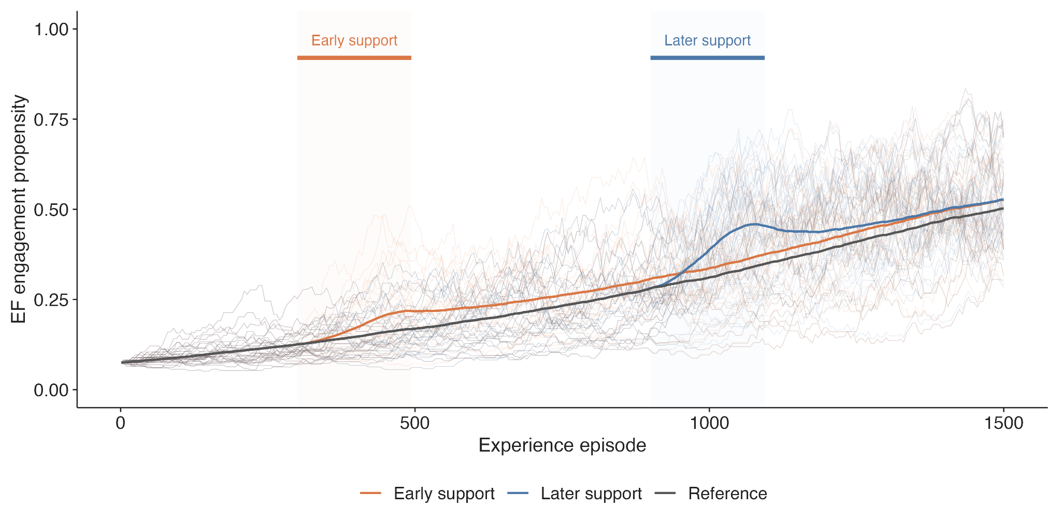
Figure 6. Timing of supportive experience. Early and later support used the same smooth increase in reward probability and differed only in when it occurred. Both support periods temporarily increased executive-function engagement relative to the reference condition, with broadly similar effects despite occurring at different points in the experience horizon.

Developmental improvement and differentiation are robust across parameter settings
The preceding analyses used one provisional default parameterization. We therefore tested whether the main developmental patterns were restricted to those values.
Across 250 parameter combinations, each averaged across five independently simulated populations, 98% produced higher mean engagement late than early in development. Eighty-eight percent produced greater between-agent variability late than early, and 86% produced both increasing mean engagement and increasing heterogeneity. Median middle-to-late rank persistence across parameter combinations was ρ = .48.
Developmental improvement and differentiation are therefore not guaranteed by the model, but they co-occur across a broad region of the parameter space.
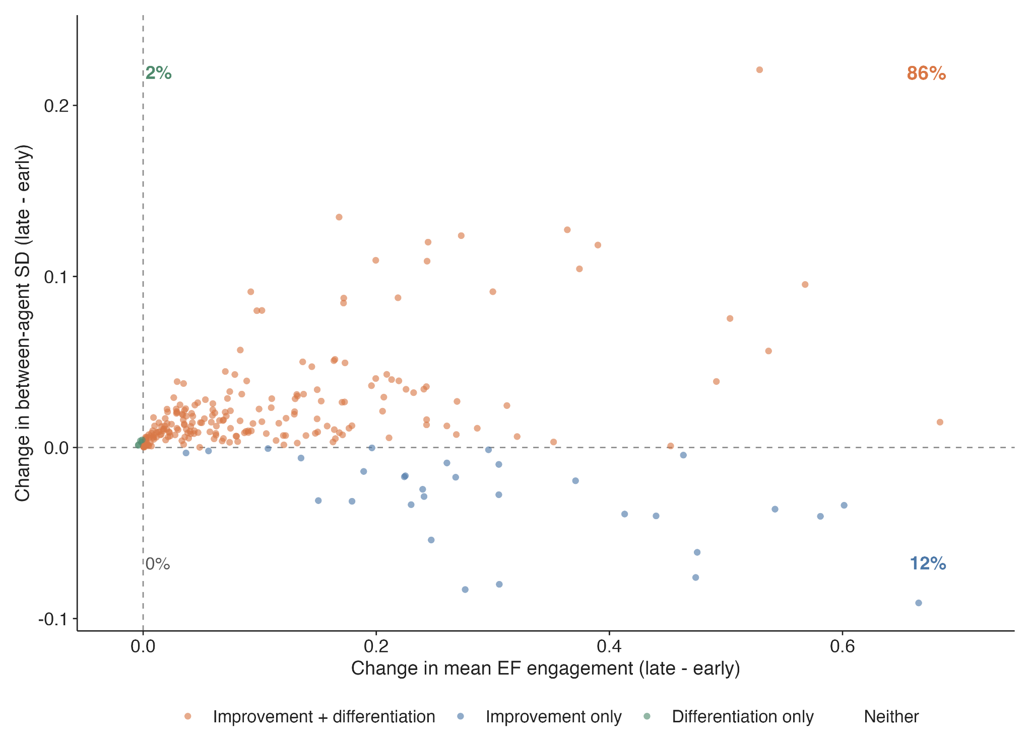
Figure 7. Parameter robustness. Each point summarizes one parameter combination averaged across independent stochastic populations. Most parameter combinations produce both increasing mean engagement and increasing between-agent differentiation.
We also assessed the magnitude of stochastic variation across repeated simulations of the same parameter settings. The median developmental change in mean engagement across parameter sets was .077, compared with a median within-parameter-set Monte Carlo SD of .004. The corresponding values for change in between-agent heterogeneity were .011 and .003. Median middle-to-late rank persistence was .479, with median within-set simulation SD = .055.
Outcome | Median across parameter sets | Median within-set simulation SD
Developmental mean change | .077 | .004
Heterogeneity change | .011 | .003
Middle-to-late rank persistence | .479 | .055
The developmental mean and heterogeneity effects were therefore generally larger than variation introduced by independent stochastic realizations of the same model. Rank persistence was more variable, as expected for a statistic based on the identities and ordering of individual trajectories.
These analyses test the robustness of the mechanism, not whether the parameter values or developmental trajectories are empirically correct.

Discussion
Why do children develop stable individual differences in executive-function engagement? A common explanation for stable differences in executive-function measures is that children differ in an underlying neurocognitive capacity that develops with age and remains relatively stable between individuals. Here, we asked how much of the developmental pattern usually attributed to capacity differences can emerge before those differences are put into the model.
The simulations generate several of these patterns. Initially identical agents develop different engagement trajectories; those differences can remain moderately stable over a developmental horizon while average engagement increases; and temporary contextual changes can shift engagement without changing capacity. Persistent differences in how often control pays off make relative differences more stable, whereas under a completely shared environment the identities of high- and low-engagement agents are not permanently fixed.
None of this implies that capacity differences do not exist or do not matter. Rather, the model shows that these developmental patterns are not, by themselves, evidence that stable capacity differences caused them.

Stable differences in behavior need not imply stable differences in capacity
The main point is not that children do not differ in executive-function capacity. They probably do. The point is that stable differences in observed behavior do not necessarily tell us where those differences came from.
In the model, all agents begin with the same states, parameters, and environment. Differences emerge because they experience different sequences of engagement and reward. One agent may happen to engage when another does not, or two agents who both engage may receive different outcomes. These differences are initially small and stochastic, but once they change expected value or effort cost, they can also change what happens next. Different experience histories can therefore become moderately persistent even when no stable individual difference was present at the start.
This matters for how we interpret longitudinal stability in executive function measures. If the same children remain relatively high or low over time, it is tempting to infer a stable underlying trait or capacity. Our simulations show that some rank-order stability can also emerge from a history-dependent process.
There is also an important limit to this result. Under a completely shared and stable environment, the identities of relatively high- and low-engagement agents eventually become less predictable. Chance differences in experience can generate persistent developmental differences, but they do not permanently sort identical agents into fixed high- and low-engagement types. Persistent environmental differences provide one way for those relative positions to become more stable.

Practice creates a developmental feedback loop
The model comparison also tells us where most of the developmental change is coming from. EVC-like control allocation by itself is flat over development. Learning whether control pays off produces some change, but the much larger developmental increase appears when engaging control also provides practice that makes future engagement easier.
The key feedback is simple: engage control → gain practice → future engagement becomes easier → engagement becomes more likely. This does not mean that engagement keeps increasing indefinitely. Practice-related changes become smaller as effort cost approaches its lower bound, and value learning also slows as expectations come closer to the average payoff available in the environment. The same feedback can therefore generate gradual developmental change without requiring an explicit maturation function in the model.
What exactly this practice pathway represents psychologically is still open. In the current model, C captures how effortful engaging control is at a given point in time. Repeated engagement may reduce this effort through greater familiarity, improved efficiency, or partial automatization of component processes. This is related to learning-based extensions of EVC in which practice changes how much control is needed for successful performance [LEVC CITATIONS], but we do not model automaticity, control intensity, or task performance separately here.
So the result should not be read as showing that automaticity explains EF development. What the model shows more narrowly is that some process through which repeated engagement makes later engagement easier is sufficient to produce much stronger developmental change. Identifying what that process corresponds to in children is an empirical question.

Environments can matter at different timescales
The model also gives two different ways for context to matter. Some influences are temporary. Increasing the contextual cost of control produces an immediate drop in engagement, followed by substantial recovery when that cost is removed. A small difference remains because agents who engaged less during the perturbation also missed some opportunities for learning and practice, but the main effect is short-lived.
Persistent environmental differences do something different. If engaging control consistently pays off somewhat more often for some children than for others, they gradually learn different expected values of engagement. In the simulations, even small persistent differences in reward probability made children's relative engagement rankings more stable over time.
This gives a simple way to think about both within-person variability and between-person stability. A temporary feature of the current situation can move the same child up or down in engagement without producing a lasting individual difference. An environmental feature that is encountered repeatedly can instead become part of the child's learning history and contribute to more persistent differences.
Of course, reward probability is only a very simple representation of an environment. In everyday development, whether engaging control “pays off” could mean many things. Waiting may lead to reliable outcomes in some environments but not others. Controlled behavior may be encouraged or rewarded by parents, teachers, or peers. Exerting control may make success more likely in some settings, while in others it may offer little advantage over an easier strategy. The current model does not distinguish these possibilities. Its more general prediction is that persistent differences in the consequences of engaging control should be more likely to stabilize developmental differences than temporary ones.

Experience dependence does not automatically imply a sensitive period
One result we did not get is an inherent advantage of early experience. It might seem that because experiences feed into later decisions, an experience occurring early should have more opportunity to shape the future and therefore produce a larger effect. But when we gave agents the same temporary improvement in the reward environment either earlier or later, the effects were similar once follow-up time was matched, with no evidence of an early-support advantage.
So experience dependence alone is not enough to generate a sensitive period. Early experience can still matter because it becomes part of a longer developmental history, but the model does not make the same experience intrinsically more powerful simply because it occurs earlier.
If early experiences or interventions really do have disproportionately large effects, something else has to change with age. That could be age-dependent plasticity, changes in learning rates, maturation, or some other developmental mechanism. We see this as a useful constraint on the model: such a mechanism should be added if the empirical phenomenon requires it, rather than assuming an early sensitive period from the outset.

Implications for intervention
Distinguishing capacity from engagement also changes how we might think about intervention. If differences in observed EF partly reflect what children have learned about whether control is worth engaging, improving EF need not only mean increasing a child's maximum control capacity.
An intervention could instead change the experiences surrounding control. It could provide more opportunities to engage successfully, make the consequences of engaging control more reliable, or provide repeated practice that makes later engagement easier. In the model, these experiences can matter beyond the immediate episode because they change later expected value or effective effort cost.
This does not mean that simply giving children more EF practice should improve executive function broadly. One important question is how much the learning represented here generalizes across contexts. LEVC, for example, treats automaticity as task-specific. If practice only makes a particular task easier, then its developmental consequences may be much narrower than the current model assumes. For the account to explain broader developmental differences in EF engagement, at least some of what is learned or practiced would need to transfer across situations.
That gives us a more specific empirical question than whether “EF training works”: what aspects of engaging control are learned across repeated experiences, and how far do those changes generalize?

Engagement is not the same as observed EF performance
A major limitation of the current model is that it models the propensity to engage executive function, not performance on an EF task. These are not the same thing. A child may decide to engage control but still perform poorly because the task exceeds what they can do. Conversely, a highly practiced child may perform well while requiring relatively little active control. Standard EF measures can therefore reflect some combination of capacity, engagement, learned skill, and features of the task itself.
A fuller model could separate these components. Capacity could constrain what level of control is available, engagement could determine whether that control is allocated, and learned efficiency or automaticity could determine how much control is needed for successful performance. Observed task performance would then depend on all three.
We deliberately leave that structure out here. The point of the present model is to ask what can happen before stable capacity differences are introduced. We therefore do not show that individual differences in measured EF performance can be fully explained without capacity differences. We show that substantial developmental structure in the propensity to engage control can emerge without them. Connecting this latent engagement process to the tasks used to measure EF in children is an important next step.

Limitations and empirical predictions
These simulations are theoretical demonstrations, not fitted developmental models. The parameter values were chosen to make the dynamics visible and are not estimates of learning rates, reward environments, or developmental timescales in children. Likewise, the parameter sweep tells us whether the mechanism works across a broader set of assumptions; it does not establish that those assumptions are empirically correct.
The largest open assumption concerns practice. Our developmental results depend strongly on the idea that engaging control can make later engagement easier. We currently represent that process as a gradual reduction in effective effort cost, but the model does not establish what psychological or neural mechanism produces that change or how broadly it generalizes.
This also creates fairly direct empirical predictions. Repeated engagement should predict later engagement above and beyond initial differences if practice genuinely changes the future ease of control. Reward history should separately predict later engagement if children learn whether exerting control tends to pay off. Persistent differences in these experiences should produce more stable individual differences than temporary changes in context.
A particularly informative experiment would manipulate reward history and practice exposure separately. Children could receive comparable opportunities to engage control while differing in how reliably engagement is rewarded, or comparable reward histories while differing in how much practice they receive. Later engagement could then be used to test whether the value-learning and practice pathways make separable contributions.
Longitudinal data with repeated observations of opportunities to engage control, actual engagement, outcomes, and later behavior would provide another way to test the account. Such data would also allow the learning rates and environmental inputs that are currently provisional to be estimated rather than chosen for illustration.

Conclusion
The DEV-Control model asks a deliberately limited question: how much developmental structure in executive-function engagement can emerge before stable differences in capacity need to be assumed?
The simulations show that repeated decisions about whether control is worth engaging, together with learning and practice, can generate increasing engagement and moderately persistent individual differences among agents who begin identically. Temporary context can move engagement up or down, while persistent environmental differences can make emerging individual differences more stable. The same mechanism does not, however, permanently divide identical agents into fixed types or automatically make early experience more influential.
This suggests that developmental differences in executive-function behavior may reflect not only what children are capable of doing, but also the histories through which they learn whether engaging control is worthwhile and how effortful it has become.

References

