**1. Title Page**

* **Game Title**: PHINMA Outbreak: Last Stand
* **Team Name**: Undead Studio
* **Team Members**:
  + Ralph Jan Gallegos
  + Francis Jake Lumactod Roaya
* **Date**: January 17, 2025

**2. Executive Summary**

* **Overview**: "PHINMA Outbreak: Last Stand" is a thrilling RPG adventure game where players assume the role of a brave security guard trapped in PHINMA Cagayan de Oro College during a zombie outbreak. The game combines action-packed combat with strategic planning as the player fights through five increasingly difficult stages filled with zombies. Targeted at casual and hardcore gamers, this game’s unique setting and escalating difficulty offer a memorable challenge.
* **Objective**: The goal is to survive the zombie-infested campus by clearing all five stages, each more challenging than the last, to finally escape the school.

**3. Game Concept**

* **Description**:
  + Genre: RPG Adventure
  + Setting: PHINMA Cagayan de Oro College during a zombie apocalypse. The game’s atmosphere captures the eerie yet familiar feel of an abandoned campus overtaken by the undead.
  + Storyline: Players navigate through five stages, each representing a part of the campus, from classrooms to the rooftop, culminating at the main gate.
* **Gameplay Mechanics**:
  + Players must defeat all zombies in each stage to progress.
  + The zombies’ difficulty increases in terms of damage, health, and numbers with each stage.
  + A stamina system adds a layer of strategy to combat and exploration.
* **Unique Selling Points**:
  + A localized setting that resonates with the Filipino audience.
  + Gradually escalating difficulty that keeps players engaged.
  + Simple yet impactful combat mechanics ideal for Unity-based development.

**4. Target Audience**

* **Demographics**:
  + Age Group: 12-35 years old.
  + Gender: All genders.
  + Location: Inside of PHINMA COC
* **Psychographics**:
  + Interests: Adventure games, zombie themes, survival mechanics.
  + Behaviors: Gamers who enjoy short, challenging sessions with clear progression.
  + Preferences: Players seeking straightforward gameplay with a mix of strategy and action.

**5. Story and Characters**

* **Plot Summary**: A sudden outbreak turns the once-bustling PHINMA Cagayan de Oro College into a battleground. The player, a resourceful security guard, must traverse the school’s five stages to reach freedom, all while battling waves of zombies and uncovering clues about the outbreak.
* **Main Characters**:
  + **The Security Guard**: The protagonist, armed with courage, a baton, and a firearm. He is determined to survive and protect any remaining survivors.
  + **The Zombies**: Former students, faculty, and staff turned into ferocious undead creatures, each stage featuring tougher variations.

**6. Art and Design**

* **Visual Style**:
  + A mix of realistic and cartoonish visuals for an engaging yet approachable aesthetic.
  + Dark, moody lighting with splashes of color for important items and objectives.
* **Concept Art**:
  + A gloomy campus with barricaded hallways and flickering lights.
  + Zombies with varying designs to signify their increasing difficulty.

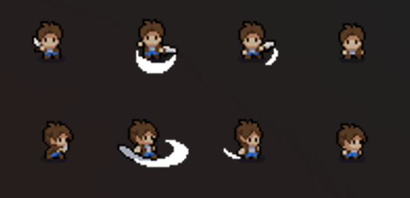

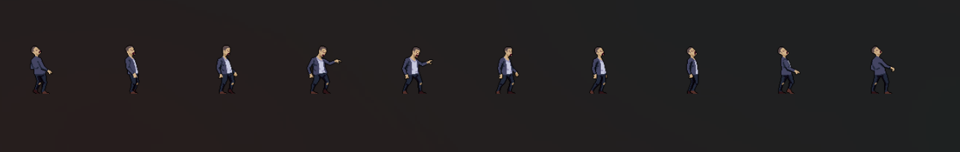

**7. Technical Specifications**

* **Platform**: PC (with potential for mobile expansion).
* **Engine**: Unity.
* **Technical Requirements**:
  + Minimum: Dual-core CPU, 2GB RAM, integrated GPU.
  + Recommended: Quad-core CPU, 4GB RAM, dedicated GPU.

**8. Development Plan**

* **Timeline**:
  + **Week 1**: Pre-production (story, concept art, and design documentation).
  + **Week 2**: Development of core gameplay mechanics and Stage 1.
  + **Week 2**: Development of remaining stages, UI, and assets.
  + **Week 3**: Testing and polishing.
  + **Week 4**: Final release.
* **Budget**:
  + Estimated Total: 4,000
    - Keyboard = 3,500
    - Mouse = 500
* **Resources**:
  + Unity Engine.
  + Visual Studio for coding.
  + Adobe Photoshop/Illustrator for art.
  + Testing devices (PCs and Android phones for cross-platform testing).