08/06/2026
Group 8
Kyle Wayne Darjuan - Database Designer
Shiv Alpeshbhai Patel - Backend Planner
Daiju Saji - Frontend Designer
Hotel Booking Website
Milestone 2 - Project Planning and System Design
https://github.com/Kyweyn/Group-8-Project

Table of Contents
1. Project Description 2
2. Technology 2
Why we chose MySQL 2
3. Database Design 3
Table: users 3
Table: hotels 3
Table: rooms 4
Table: bookings 4
Table: reviews (optional) 5
Relationships summary 5
ERD 6
4. Frontend Wireframes 7
4.1 Home Page 7
4.2 Hotel Listing (data listing) 8
4.3 Room Details 9
4.4 Booking Form (data entry) 10
4.5 My Bookings (data listing) 11
4.6 Edit Booking (edit/update) 12
Navigation 13
Design choices 13
5. Planned API Routes 14
Description of each route 14
JSON example 15
Folder structure 15
How the frontend talks to the backend 15
6. Team Responsibilities 16

1. Project Description
Our project is a hotel booking website. A user can search for hotels in a city for certain dates, see which rooms are available and how much they cost per night, and book a room. After booking, the user can see all their bookings on one page and change the dates or cancel a booking if they need to.
The main users are travelers who want to book hotel rooms online.
Main features:
- Search hotels by city, check-in/check-out dates and number of guests
- See hotel details and room types with prices
- Book a room, the total price is calculated automatically
- See all your bookings on one page
- Change the dates of a booking or cancel it
The biggest problem we have to solve is double booking. The same room should never be booked twice for the same dates. This was important for which database we picked.

2. Technology
Part | Technology
Database | MySQL
Backend | TypeScript + Express.js (mysql2 library)
Frontend | HTML, CSS and JavaScript (no frameworks, API connection comes in Milestone 3)

Why we chose MySQL
- Our data is relational. Users, hotels, rooms and bookings are all connected to each other, so a relational database makes more sense than a document database.
- Foreign keys. With the InnoDB engine a booking always has to point to a real user and a real room. The database checks this for us automatically.
- Transactions. InnoDB supports transactions, so when someone books a room we check the availability and insert the booking inside one transaction. That way two users can't book the same room for the same dates at the same time.
- CHECK constraints. In MySQL 8 rules like check_out_date > check_in_date and star rating between 1 and 5 are checked by the database itself.
- It works well with TypeScript. The mysql2 library for Node is popular and easy to use with Express, and MySQL is free with good tools like MySQL Workbench.
We also looked at MongoDB, but it doesn't enforce relationships between collections. We would have to write all the checking logic ourselves in the application code and it would be easier to make mistakes, especially with the double booking problem.

3. Database Design
This section was done by Kyle. We have 4 main tables and 1 optional table (reviews).

Table: users
Stores the customer accounts.
Field | Data Type | Key | Description
user_id | INT AUTO_INCREMENT | PRIMARY KEY | id of the user
name | VARCHAR(100) | NOT NULL | full name
email | VARCHAR(255) | UNIQUE, NOT NULL | email, used for login
phone | VARCHAR(20) |  | phone number
password | VARCHAR(255) | NOT NULL | password (saved hashed, not plain text)
Relationships: one user can have many bookings and many reviews.

Table: hotels
Stores the hotels.
Field | Data Type | Key | Description
hotel_id | INT AUTO_INCREMENT | PRIMARY KEY | id of the hotel
name | VARCHAR(150) | NOT NULL | hotel name
city | VARCHAR(100) | NOT NULL | city, used for the search
address | TEXT | NOT NULL | address
star_rating | INTEGER | CHECK (1-5) | stars from 1 to 5
description | TEXT |  | description text
Relationships: one hotel has many rooms and can have many reviews.

Table: rooms
Stores the room types of each hotel.
Field | Data Type | Key | Description
room_id | INT AUTO_INCREMENT | PRIMARY KEY | id of the room type
hotel_id | INTEGER | FK -> hotels | which hotel it belongs to
type | VARCHAR(50) | NOT NULL | Single, Double, Suite etc.
price_per_night | NUMERIC(10,2) | NOT NULL | price for one night
max_guests | INTEGER | NOT NULL | how many guests fit
quantity_available | INTEGER | NOT NULL | how many rooms of this type exist
Relationships: belongs to one hotel, one room type can be in many bookings.

Table: bookings
Stores the reservations.
Field | Data Type | Key | Description
booking_id | INT AUTO_INCREMENT | PRIMARY KEY | id of the booking
user_id | INTEGER | FK -> users | who booked
room_id | INTEGER | FK -> rooms | which room
check_in_date | DATE | NOT NULL | arrival
check_out_date | DATE | CHECK (> check_in_date) | departure
total_price | NUMERIC(10,2) | NOT NULL | price per night x number of nights
status | VARCHAR(20) | DEFAULT 'confirmed' | confirmed, cancelled or completed
Relationships: belongs to one user and one room.

Table: reviews (optional)
Stores ratings and comments from guests.
Field | Data Type | Key | Description
review_id | INT AUTO_INCREMENT | PRIMARY KEY | id of the review
user_id | INTEGER | FK -> users | who wrote it
hotel_id | INTEGER | FK -> hotels | which hotel it is about
rating | INTEGER | CHECK (1-5) | score from 1 to 5
comment | TEXT |  | the comment
date | DATE | DEFAULT (CURRENT_DATE) | when it was written
Relationships: belongs to one user and one hotel.

Relationships summary
- One hotel has many rooms, a room belongs to one hotel
- One user can have many bookings
- A booking belongs to one user and one room
- One user can write many reviews, one hotel can have many reviews

ERD
We made the diagram in draw.io, the source file is database/hotel_booking.drawio.
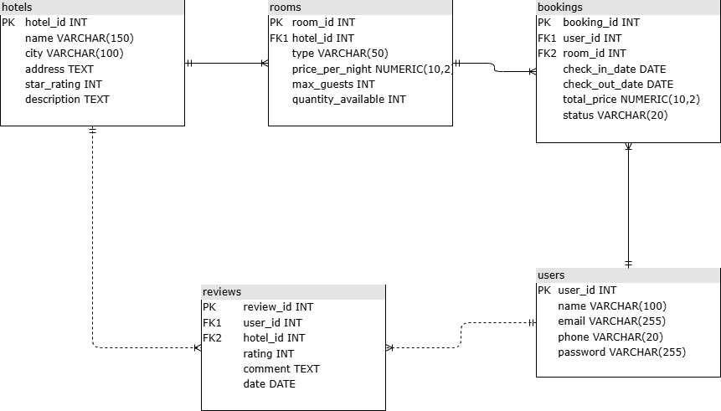

4. Frontend Wireframes
This section was done by Daiju. Our app has 6 pages. This covers the required minimum: Home Page, Data Entry Page (Booking Form), Data Listing Pages (Hotel Listing and My Bookings) and Edit/Update Page (Edit Booking). The wireframes were made in Figma, they show the whole page so they are quite long. The image files are in the wireframes folder of our repository.

4.1 Home Page
The first page. Navigation bar on top, in the middle the search: city field, check-in and check-out date pickers, number of guests and a Search button.


4.2 Hotel Listing (data listing)
Shows the search results. Every hotel is a card with the name, city, star rating, price and a “View Rooms” button.
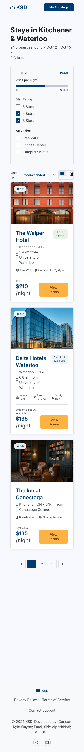

4.3 Room Details
Shows one hotel and its rooms. On top the hotel info, below one row for every room type with the price per night, max guests and a “Book Now” button.
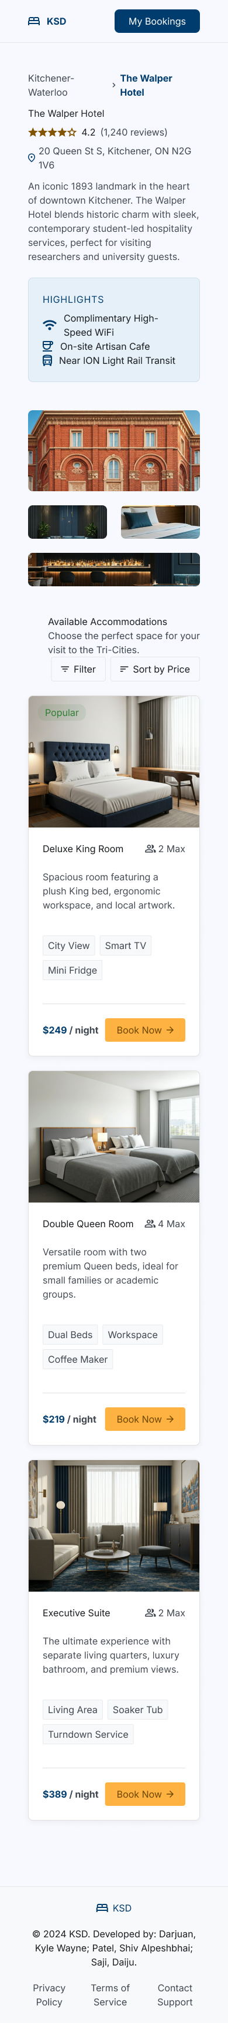

4.4 Booking Form (data entry)
Here the user confirms the booking. The form has name, email, phone and the dates, and a summary with the price per night, number of nights and the total price before confirming.
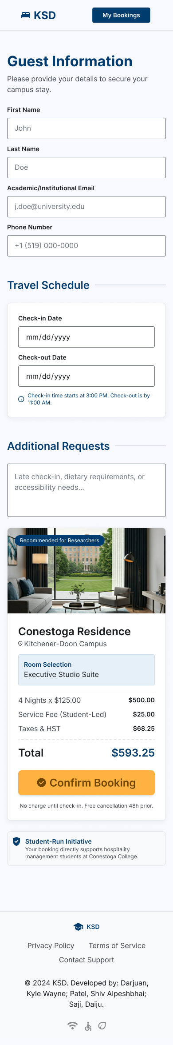

4.5 My Bookings (data listing)
A list of all bookings of the user. Every booking shows the hotel name, dates, total price, status and Edit and Cancel buttons.
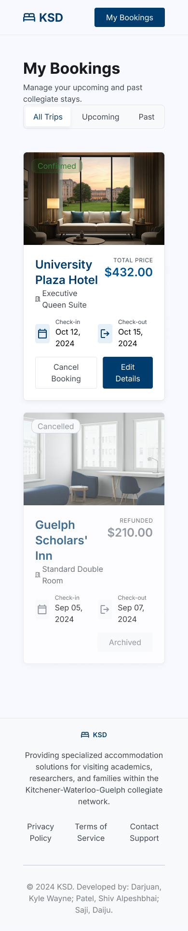

4.6 Edit Booking (edit/update)
Here the user can change a booking. Date pickers for the new dates, the new total price, an “Update Booking” button and a “Cancel Booking” button that asks for confirmation first.
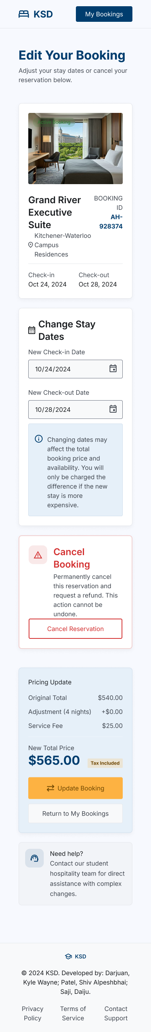

Navigation
Home -> Hotel Listing -> Room Details -> Booking Form -> My Bookings <-> Edit Booking
The navigation bar is the same on every page so the user can always go back to Home or My Bookings.

Design choices
- Every page has one main button (Search, View Rooms, Book Now, Confirm) so it's clear what to do next
- The total price is always shown before the user confirms, so there are no surprises
- The status of a booking has a color so you can see it quickly
- We use cards for lists because they are easier to read than plain tables

5. Planned API Routes
This section was done by Shiv. The backend is a REST API made with TypeScript and Express. The frontend and backend send everything as JSON.
Method | Route | What it does
GET | /hotels | list of all hotels
GET | /hotels/:id | one hotel with its rooms
GET | /search?city=&checkin=&checkout=&guests= | search hotels by city, dates and guests
GET | /rooms/:id | details of one room type
POST | /bookings | create a new booking
GET | /users/:userId/bookings | all bookings of one user
GET | /bookings/:id | one booking
PUT | /bookings/:id | change the dates of a booking
DELETE | /bookings/:id | cancel a booking

Description of each route
- GET /hotels returns all hotels with name, city, stars and starting price. Used by the Hotel Listing page.
- GET /hotels/:id returns one hotel and a list of its room types. Used by the Room Details page.
- GET /search reads city, checkin, checkout and guests from the URL and only returns hotels that still have a free room for those dates. Used by the search on the Home page.
- GET /rooms/:id returns one room type with the price and max guests. The Booking Form uses this to show the price.
- POST /bookings creates a booking. It checks the availability again inside a database transaction and calculates the total price (price per night x number of nights). If the room just got taken it returns an error (409).
- GET /users/:userId/bookings returns all bookings of one user together with the hotel and room names. Used by the My Bookings page.
- GET /bookings/:id returns one booking. Used by the Edit Booking page.
- PUT /bookings/:id changes the dates of a booking, checks the availability for the new dates and recalculates the total price.
- DELETE /bookings/:id cancels a booking. We don't delete the row, we just set the status to 'cancelled' so the user can still see it in their history.
Note: in Milestone 1 we had GET /bookings/:userId and GET /bookings/:bookingId. We changed this because both routes look the same to Express, it can't know if the number is a user id or a booking id. Now the user list is GET /users/:userId/bookings.

JSON example
Creating a booking:
POST /bookings
{
"userId": 12,
"roomId": 4,
"checkInDate": "2026-07-10",
"checkOutDate": "2026-07-13"
}
Answer (201 Created):
{
"bookingId": 87,
"totalPrice": 447.00,
"status": "confirmed"
}
Errors look like { "error": "Room not available for these dates" } with status 400, 404 or 409.

Folder structure
src/
server.ts -> starts Express and loads the routes
db/pool.ts -> connection to MySQL
routes/ -> one file per resource
controllers/ -> the functions that handle the requests
models/ -> the SQL queries
middleware/ -> validation and error handling
Every route calls one controller function. The controller checks the input, calls the model (which runs the SQL) and sends back the JSON.

How the frontend talks to the backend
The HTML pages use fetch() in JavaScript to call these routes. For example the My Bookings page calls GET /users/12/bookings and creates a card for every booking in the answer. Forms send POST or PUT requests with a JSON body. In this milestone we only plan this, the real connection is built in Milestone 3.

6. Team Responsibilities
Member | Role | What they did
Kyle Wayne Darjuan | Database Designer | picked the database, designed the tables, made the ERD in draw.io, wrote the database documentation
Shiv Alpeshbhai Patel | Backend Planner | planned the API routes, planned the Express folder structure, wrote the JSON examples and the technical documentation
Daiju Saji | Frontend Designer | made the wireframes for all 6 pages in Figma, planned the user interface and the navigation

