Chapter II
Presentation, Analysis & Interpretation of Data

Introduction
This section provides background information and the purpose of the study it may include:
- the significance of analyzing the job search platforms.
- previous studies related to job search behaviors or the usage of the platform and;
- the specific research questions and or hypothesis

Methods
Sample Size and Sampling Method
The study was conducted with a total of 10 respondents, all of whom were graduating students. These participants were selected because they present a demographic data that is actively preparing toe enter the job market after they complete the curriculum. The sample size was determined to provide insights into the job search behavior among this specific group. To gather the respondents, the researcher use a random sampling method in selecting the participants, ensuring that every graduating student had an equal chance of being selected for the survey. This approach minimized selection bias and improved the representativeness of the sample.
Data Collection Method
Survey
Data was collected through an online survey created using Google Forms. The survey link was distributed via messenger (facebook messaging app) over a one week span of time and responses were automatically recorded. Google Forms was chosen for its accessibility and ease of use in collecting and organizing data.
Interview
In addition to the survey, a semi-structured interview was conducted with an HR professional from University of Cebu Pardo and Talisay incorporated. The purpose of the interview was to gain deeper qualitative insights into the challenges and strategies used in the recruitment process. The interview covered topics such as job posting frequency, concerns with online recruitment platforms, candidate evaluation methods, and overall satisfaction with recruitment processes.

The interview lasted approximately 40 minutes and was conducted in person. It was recorded with the participant's consent and transcribed for analysis. Thematic analysis was used to extract key themes and insights from the interview, which were then compared and integrated with the survey findings to enrich the overall understanding of recruitment practices from the employer's perspective.
Question Structure
The survey was designed using a single-response multiple-choice question format. This structure was chosen to ensure clarity and ease of response for participants, allowing them to select only one option from a list of predefined answers for each question. The multiple-choice format also facilitated straightforward data analysis, enabling the categorization of preferences and opinions.
Each question was carefully crafted to address key aspects of job-seeking behavior among graduating students. The questions covered a wide range of topics, including:
- Preferred job search platforms (e.g., LinkedIn, JobStreet, Upwork),
- Frequency of job applications (e.g., daily, weekly, monthly),
- Time spent finding relevant job listings,
- Frustrations with the online job application process,
- Accuracy of their online profiles in reflecting their skills and experience, and
- Willingness to pay for premium features on job search platforms.
Respondents were required to select one option that best reflected their experience or opinion. This format ensured that responses were mutually exclusive, providing clear, unambiguous data for analysis.

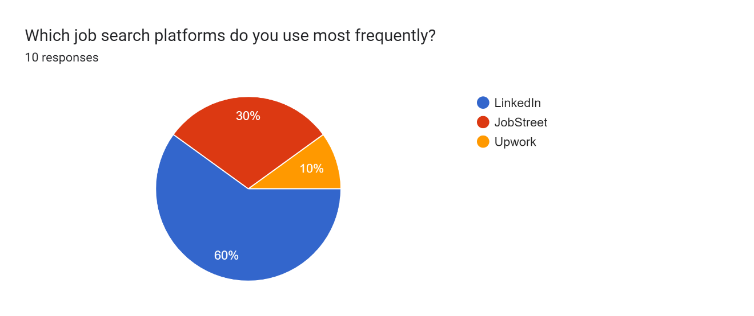
Figure 2.1: Job Search Platform Preference

The responses of the respondents, represented in Figure 2.1, shows that the LinkedIn platform is the most popular job search platform, with 60% of participants selecting it. This could be attributed to LinkedIn's extensive networking capabilities and its reputation as a professional platform that connects job seekers with employers across a wide range of industries. The platform's features, such as its job search filters, company insights, and professional profiles, provide added functionality that appeals to job seekers.
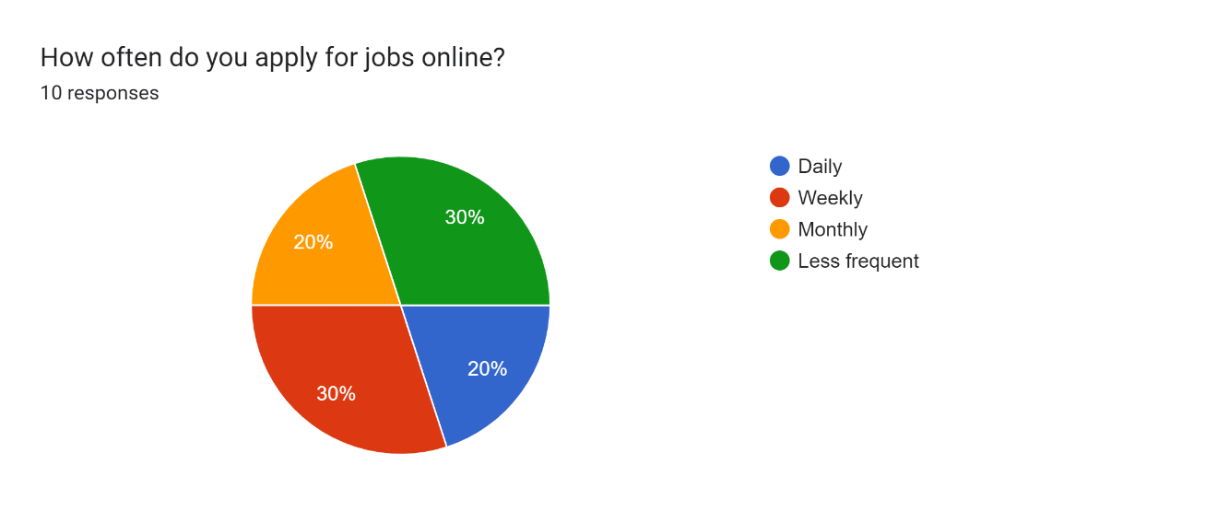
Figure 2.2: Frequency of Job Application
The most common frequency, represented in Figure 2.2, of applying for jobs online among the respondents is weekly, with 30% of them doing so. This suggests that a significant portion of job seekers is actively engaged in their job search, applying for new opportunities regularly.
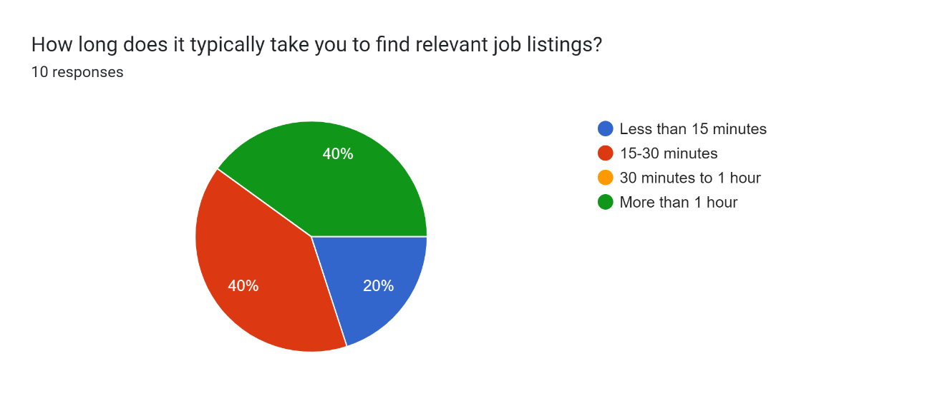
Figure 2.3: Time to Find Relevant Job Listings
The majority of respondents find relevant job listings within 30 minutes, represented in Figure 2.3. However, a significant portion still struggles to find suitable opportunities in a shorter time frame. This indicates that while some users (job seekers) can efficiently navigate the job search process, others may require additional support or tools to streamline their search.
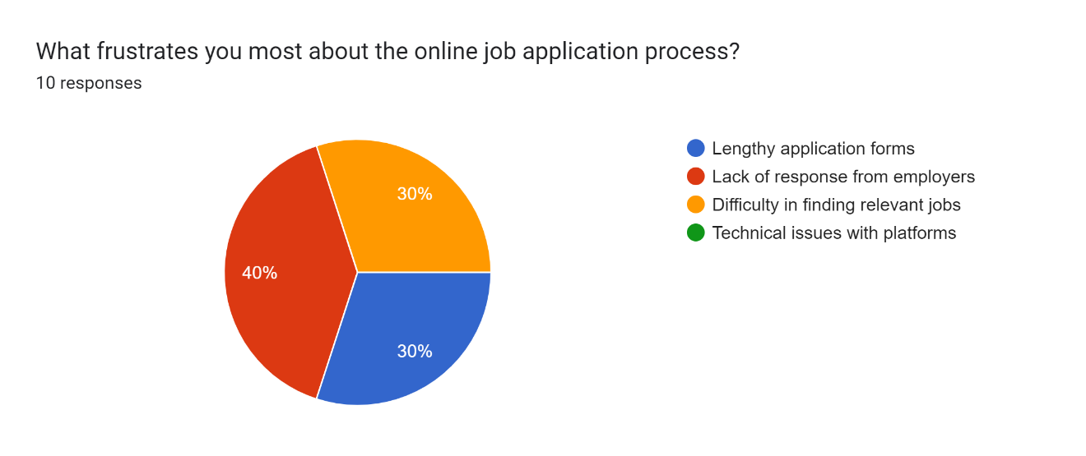
Figure 2.4: Frustrations with the Online Job Application Process
The most common frustration with the online job application process among the respondents is a lack of response from employers, represented in Figure 2.4, with 40% of them citing this as their biggest issue. This lack of communication can lead to feelings of uncertainty and discouragement among job seekers, making them feel undervalued and overlooked in their job search efforts.
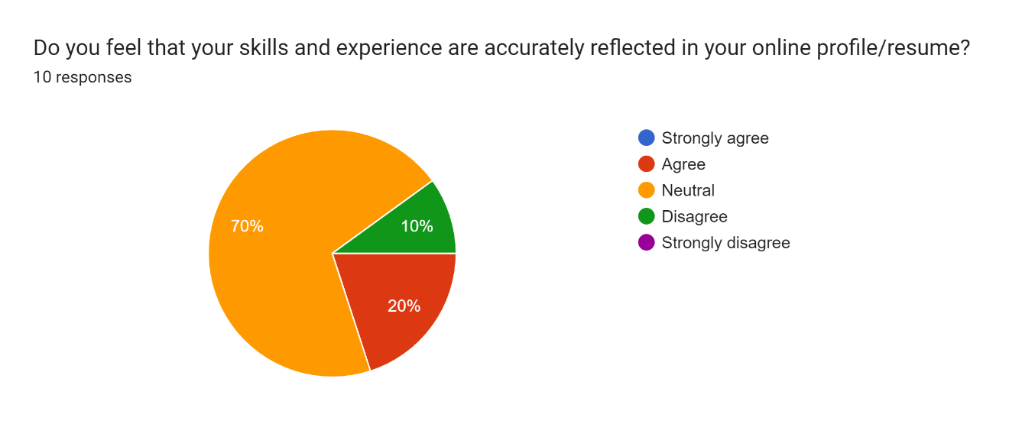

Figure 2.5: Perception of Profile Accuracy

The majority of respondents (70%) agree that their online profile/resume accurately reflects their skills and experience, represented in Figure 2.5. This high level of confidence suggests that many individuals recognize the importance of maintaining an updated and truthful representation of their professional qualifications in a digital format. It indicates a growing awareness among job seekers about the role of online platforms in shaping their career opportunities.
However, despite candidates’ confidence, employers (HR professionals) still face several challenges when using online recruitment platforms. These factors highlight the gap between candidate perception and employer experience:
Factors Affecting Online Recruitment Platforms for Employers (HR)
- Inaccurate Candidate Matching: Employers report that candidates suggested by the system may not always align with the job requirements, despite the candidates' confidence in their resumes. This leads to inefficiencies in finding the right fit for open positions.
- Misalignment with Needed Positions: Even though candidates may feel that their resumes accurately reflect their skills, employers often struggle with finding candidates who are properly aligned with the specific job roles they are looking to fill.
This combination emphasizes that while job seekers may feel confident in their online representation, employers still encounter significant challenges that need to be addressed for better recruitment outcomes.
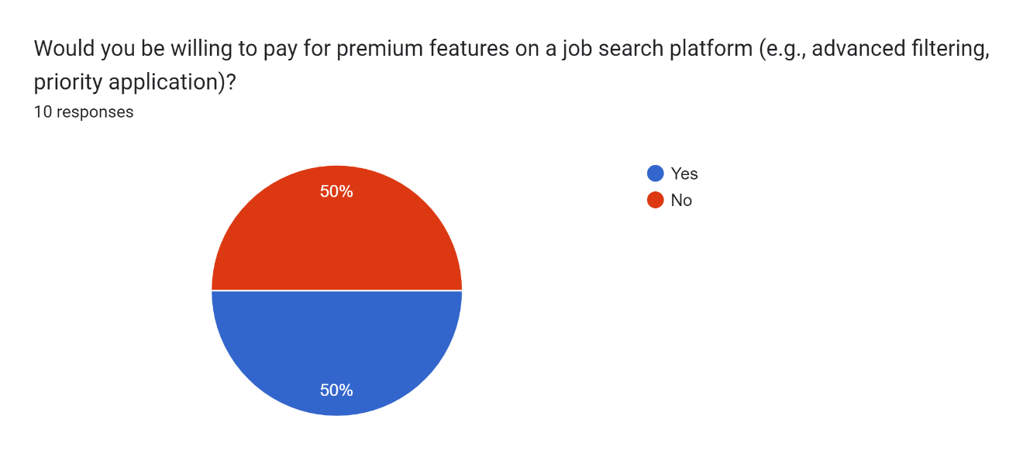
Figure 2.6: Willingness to Pay for Premium Features

Base on Figure 2.6, 50% said yes, while the other 50% said no. This suggests that there is no clear consensus on the value that premium features provide to job seekers. It's possible that some people believe the advanced filtering and priority application features are worth the cost, while others may feel that the basic features are sufficient for their needs.
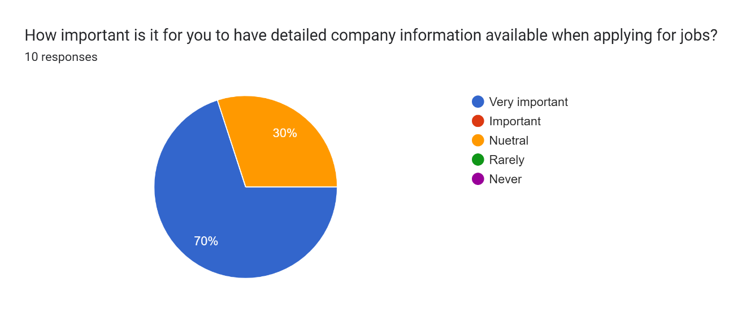
Figure 2.7: Importance of Detailed Company Information
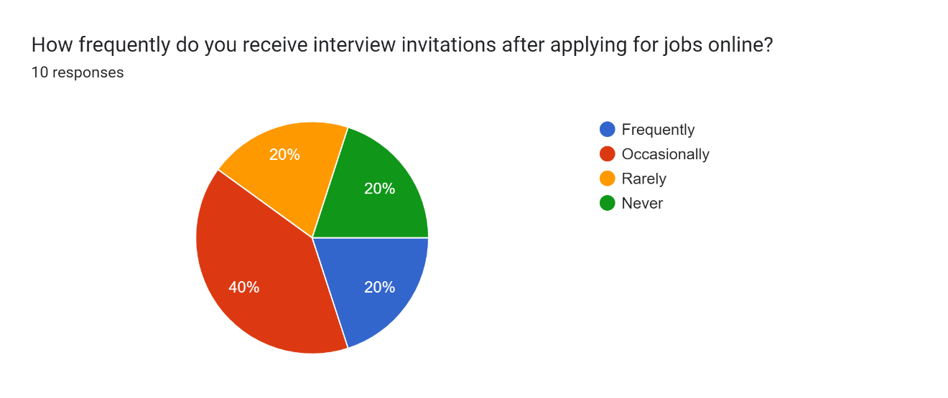
The majority of respondents, represented in Figure 2.7, (70%) consider it "very important" to have detailed company information available when applying for jobs. An additional 30% rated it as "important." Most job seekers value having a thorough understanding of potential employers before submitting their applications. The data indicates that detailed company information is a highly valued resource for job seekers. This information can help them make informed decisions about which companies to apply to and tailor their application to specific employer needs and expectations.
Figure 2.8: Interview Invitation Frequency
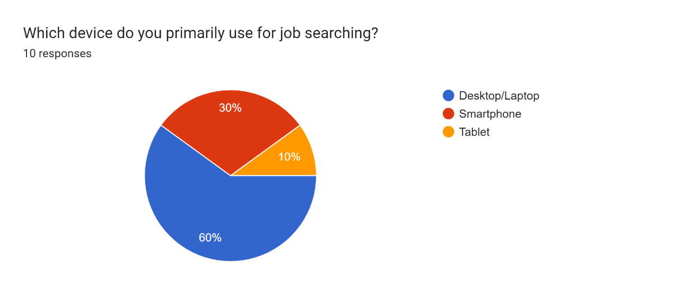
A significant portion of job seekers receive occasional interview invitations, represented in Figure 2.8, a large number also report rarely or never receiving them. This could indicate that the online job application process is not always effective in generating interview opportunities.
Figure 2.9: Devices Used for Job Searching

It shows that desktop and laptop computers are still the most popular devices, represented in Figure 2.9, for job searching, despite the increasing use of smartphones. However, a significant portion of respondents do use smartphones, indicating that mobile job searching is becoming more common. The data also shows that tablets are less frequently used for job searching, possibly due to their smaller screen size and limited functionality compared to desktop and laptop computers.
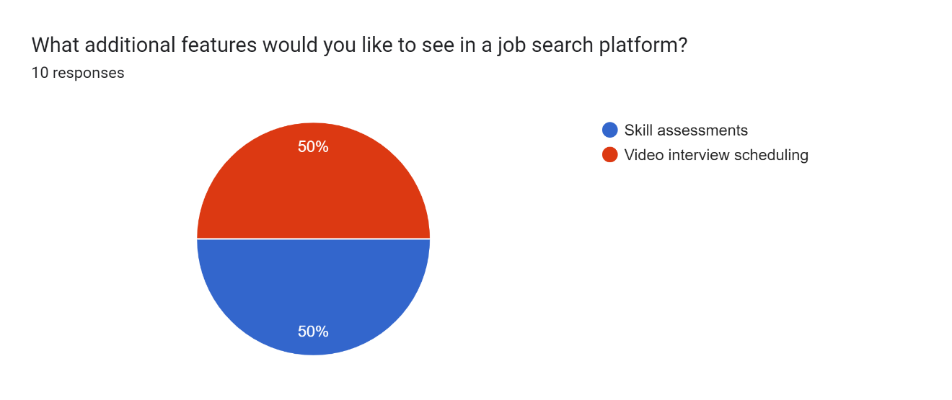
Figure 2.10: Preferred Additional Features for Job Searching Platform

Figure 2.10 presents both features are seen as valuable additions to job search platforms. Skill assessments could provide a way for job seekers to demonstrate their abilities and for employers to identify qualified candidates. Video interview scheduling could streamline the interview process and make it more convenient for both job seekers and employers.

Employer (HR) Data Interpretation

1. Job Posting Frequency
The majority of respondents indicated that they post between 1-5 job openings per month, suggesting that most companies surveyed are small to medium-sized in terms of hiring volume. This reflects moderate recruitment needs for the majority of employers.

2. Biggest Concerns When Using Online Recruitment Platforms
The two primary concerns raised by HR professionals were:
- High Costs: Many HR teams find recruitment platforms to be expensive, posing a challenge to their recruitment budget.
- Limited Candidate Pool: Respondents noted that many platforms fail to provide access to a diverse or sufficient pool of qualified candidates.
Additional concerns, such as inaccurate candidate matching and difficulties in managing applications, were also mentioned, but these issues were highlighted less frequently.

3. Methods of Candidate Evaluation
- Resume Screening: The most common method of candidate evaluation is manual or automated resume screening, which remains a staple of the recruitment process.
- Automated Skill Assessments: Some companies utilize automated skill assessments to evaluate candidates, but this is less common compared to traditional resume reviews.

4. Satisfaction with Candidate Quality
Most respondents expressed a neutral level of satisfaction with the quality of candidates sourced from online platforms, indicating that while the platforms perform adequately, they do not consistently exceed expectations. Only a small number of respondents reported either extreme satisfaction or dissatisfaction, suggesting that the general perception of candidate quality is moderate.

5. Use of Social Media in Recruitment
A significant portion of respondents reported using social media as part of their recruitment process. Platforms like LinkedIn and Facebook are becoming more prominent in job matching and recruitment strategies, reflecting a shift toward social media integration in hiring practices.

6. Importance of Analytics and Reporting Features
The majority of respondents consider analytics and reporting features to be very important in their recruitment processes. This emphasizes the need for platforms to provide comprehensive insights into candidate data and recruitment metrics, enabling HR professionals to make informed decisions.

7. Communication Methods with Candidates
The two most commonly used communication methods are email and phone calls, despite the rise of newer technologies like messaging apps and video calls. This shows that traditional communication channels are still relied upon for candidate interaction.

8. Time to Fill a Job Vacancy
Most respondents reported that they typically fill job vacancies in less than one month, suggesting that recruitment processes are generally fast-paced. A smaller group of respondents indicated that it takes 1-2 months to fill positions, especially for more specialized or higher-level roles.

9. Candidate Progression from Application to Interview
Many respondents reported that less than 10% of candidates progress from the application stage to the interview stage. This low conversion rate suggests potential challenges in aligning candidate qualifications with job requirements, or inefficiencies in the recruitment platforms themselves.

10. Openness to New Recruitment Platforms
Many respondents expressed an openness to trying new recruitment platforms, especially those offering better matching algorithms. This highlights dissatisfaction with current solutions and a desire for more effective tools that better align with their hiring needs.

The survey shows that while jobseekers may feel confident in their online profiles, HR professionals face significant challenges. High costs, a limited candidate pool, and difficulties in managing candidates are the main concerns. There is a clear need for better analytics, reporting features, and matching capabilities in recruitment platforms. Additionally, HR professionals are open to adopting new platforms if they can better align with their hiring needs. Finally, the data gathered from both jobseekers and HR professionals highlight the current strengths and challenges of online recruitment platforms. On the jobseekers' side, LinkedIn is the most popular platform, with 60% of users favoring it due to its professional networking capabilities. Many jobseekers apply for jobs regularly, and most can find relevant job listings within 30 minutes, though frustrations like lack of employer response remain a major concern. Jobseekers also place high value on having detailed company information and are open to features like skill assessments and video interview scheduling. Despite feeling confident in their resumes, jobseekers still report a low rate of receiving interview invitations, suggesting inefficiencies in the online job application process. From the perspective of a HR professional, the main issues with online recruitment platforms are high costs, a limited candidate pool, and inaccurate candidate matching. While most companies use traditional methods like resume screening to evaluate candidates, there is a growing reliance on social media for recruitment and a strong desire for better analytics and reporting features. Additionally, while many HR professionals report filling job vacancies in under a month, the low conversion rate from applications to interviews points to platform inefficiencies and a mismatch between jobseeker profiles and employer needs. Overall, the findings suggest that while online recruitment platforms have made job searching and hiring more accessible, there are still significant gaps in the user experience for both jobseekers and employers. Improvements in candidate matching algorithms, better communication features, and more advanced tools for evaluating candidates could help address these issues and lead to more effective recruitment outcomes.

