**PURBANCHAL UNIVERSITY**



**DEPARTMENT OF COMPUTER ENGINEERING KHWOPA ENGINEERING COLLEGE**

**LIBALI-2, BHAKTAPUR**

**A FINAL PROJECT REPORT ON**

## HOTEL BOOKING AND MANAGEMENT SYSTEM

Project work submitted in partial fulfillment of requirements for the course of Bachelor of Computer Engineering

## SUBMITTED BY

Asmina Koirala (780307) Chandra Prakash Joshi (780309) Kshitiz Rai (780318)

Niharika Sah (780323)

## UNDER THE GUIDANCE OF

DR. MAHAMMAD HUMAYOO

24 November,2023

### ACKNOWLEDGEMENT

We take this opportunity to express sincere gratitude to all the personal who have contributed in this project .Without their active guidance, support and valuable insights, we would not have made headway in this project.

We would also like to extend our heartfelt appreciation to **Er. Bikash Chawal**, the head of the Department of Computer Engineering**, KHWOPA ENGINEERING COLLEGE,** Bhaktapur opportunity to undertake this project. The resources and facilities made available by the organization have played a crucial role in enabling us to carry out this research and develop a comprehensive project.

Finally, we are grateful to the members of our project team and colleagues who have provided their valuable input, suggestions, and feedback during the development of this project.

### ABSTRACT

The Hotel Booking And Management System is a console based application designed to automate and streamline the hotel booking process. It offers a smooth interface for admin to provide available rooms detail, make reservations for customers, and keep the payment accountable. The system provides real-time updates on room availability, the check in and checkout time of the customer which allows hotel staff to efficiently manage bookings and avoid overbooking. We also offer administrative features for hotel management to set room rates and manage discounts for VIP customers. This system also benefits hotel management by facilitating informed decision-making through performance reports and pricing optimization. With its user-friendly interface, real-time updates, and comprehensive management capabilities, the system optimizes the hotel reservation process and boosts revenue generation for hotels.

Keywords: Automate , Bookings, Checkin , Checkout, Updates.

**Table of Content**

|  |  |  |
| --- | --- | --- |
| Chapter | Title | Page no |
|  | Acknowledgement | i |
|  | Abstract  Table Of Content | ii iii |
| 1 | INTRODUCTION | 1 |
|  | 1.1 Background | 1 |
|  | 1.2 Statement of problem | 1 |
|  | 1.3 Objectives | 2 |
|  | 1.4 Application and Scope | 2 |
| 2 | LITERATURE REVIEW | 3 |
| 3 | PROJECT MANAGEMENT | 4 |
|  | 3.1 Feasibility study | 4 |
|  | 3.1.1 Economic Feasibility | 4 |
|  | 3.1.2 Technical Feasibility | 4 |
|  | 3.1.3 Social Feasibility | 4 |
|  | 3.2 Work Breakdown Structure | 5 |
|  | 3.3 Requirements | 5 |
|  | 3.3.1 Hardware Requirements | 5 |
|  | 3.3.2 Software Requirements | 5 |
| 4 | METHODOLOGY | 6 |
|  | 4.1 Background and main features | 6 |
|  | 4.2 Algorithm | 7 |
|  | 4.3 Use case Diagram | 8 |
|  | 4.4 Activity Diagram | 9 |
| 5 | RESULTS AND DISCUSSION | 10 |
|  | 5.1 Work Completed | 10 |

1. CONCLUSION 14
   1. Conculsion 14
   2. Recommendation 14
2. REFERENCES 15
   1. **Background**

# CHAPTER 1

## INTRODUCTION

The Hotel Booking And Management System is a powerful software application designed to simplify and automate the process of hotel reservations. In todays fast-paced and highly competitive hospitality industry, traditional manual methods of managing hotel bookings have become inefficient and time-consuming. The Hotel Booking And Management System addresses these challenges by providing a centralized platform that streamlines and enhances the entire booking process, from availability checking to customer payments.

This system serves as a comprehensive solution for both hotel staff and customers, offering a user-friendly interface and features to improve operational efficiency and elevate the guest experience. For customers, the system provides a convenient option to view available rooms, detailed information about each room, and make reservation. It allows customers to specify their preferred dates, room types, and any special requirements, ensuring a personalized and tailored booking experience.

Hotel staff benefit significantly from the Hotel Booking And Management System as well. The system provides real-time updates on room availability and reservations, enabling staff to efficiently manage bookings, allocate rooms, and avoid overbooking. It also stores and organizes guest information, allowing staff to provide personalized services and ensure effective communication with guests.

Moreover, the Hotel Booking And Management System offers powerful administrative features for hotel management. It allows managers to set room rates, manage discounts and promotions, and generate comprehensive reports on booking trends, revenue, and occupancy rates. These features empower hotel managers to make data-driven decisions, optimize pricing strategies, and identify opportunities for revenue growth.

#### Statement of Problems

With increase number of people accommodation in hospitality services, it is becoming difficult for hotels to manage bookings in effective and efficient manner. It is very hard to go through all paper work and backtracking orders of the customers. If there is any investigation of certain customer’s details then it takes large amount of effort and time to backtrack and fix the problem. This results in loss of resources, increased time, and low output.

Building a booking management system is not an easy task looking at the problems of existing manual system.

#### Objectives

The objective of the Hotel Booking And Management System is to enhance the guest experience and ease the staff .

#### Application and scope

A Hotel Booking And Management System can be used in various settings where there is a need to manage transactions, inventory, reservation, and customer information. Some of the fields where such a system can be used are:

Scope of Hotel Booking And Management System:

* + - Room availability and reservations management.
    - Online booking platforms.
    - Efficient room allocation and inventory management.
    - Front desk operations management, including check-ins, check-outs, and guest requests.
    - Guest information and preferences management.

# CHAPTER 2

## LITERATURE REVIEW

For this project other already existing system were referred so as to take inspirations from the past projects regarding how it has worked so far. Some reviews we have found through the research similar to our projects are listed below:

Fabian Raos developer of multiple projects in source code and projects has published the simple hotel management system in c++ language in May, 2023 that has shown the feature of room booking but lacks the features of admin controls.

Link to the site [4].

Likewise there is the whole project done video captured like a tutorial by a TJ developer who has done

the hotel booking system website project using the language like HTML ,CSS and Bootstrap 5 at front end

and other language like My SQL and Php and backend .He has lot of features at the user-end and admin-end that make up the whole system and some are given below :-

User-end:

1.Book hotel rooms.

2.Check booking availability.

3.Manage bookings -modify or cancel bookings.

4.Give review and ratings of booked rooms and its services.

5.User login and registration system.

6.Profile management .

7.Online payment (Paytm payment gateway).

Admin-end:

1.Room management -add ,modify or delete rooms details( features included ).

2.Manage Users -view,delete, ban or un ban-users.

3.Booking management

Link to the site [5]

* 1. **Feasibility Study**

# CHAPTER 3

## PROJECT MANAGEMENT

For a project to be developed and set to be operational, its feasibility study must be done and determined whether the system is feasible or not. An important outcome of the preliminary investigation is the determination is that system requested is feasible. In our case the system will provide the accuracy among the algorithms for loan eligibility prediction by analyzing the inputs. Further there are three aspects in the feasibility portion of the preliminary investigation.

#### Economic Feasibility

As the economic feasibility covers the economic constrain or economic aspects for the project to be built, the system build must be cost acceptable. The cost of creating the system and making it operational must be acceptable otherwise the project won't be undertaken. The proposed system being built by students and are used as an open source, is hence feasible. So the cost of building and running the system is economically feasible.

#### Technical Feasibility

The project is developed using current equipment, existing software technology and available personnel. The proposed project is developed using c++. There are basic requirements of hardware to run this project .The project will be console based application so the project can be accessed by using devices like personal computer, laptops etc.

#### Social Feasibility

The proposed project is an open source and can be used by anyone of the community so there won't be any discrimination between any caste and culture. Hence the project is socially feasible.

### WORK BREAKDOWN STRUCTURE

|  |  |  |  |  |  |  |  |
| --- | --- | --- | --- | --- | --- | --- | --- |
| Months  Work | May | June | July | August | September | October | November |
| Analysis |  |  |  |  |  |  |  |
| Design |  |  |  |  |  |  |  |
| Implementation |  |  |  |  |  |  |
| Testing |  |  |  |  |  |  |
| Debugging |  |  |  |  |  |  |  |
| Documentation |  |  |  |  |  |  |  |

#### Requirements

* + 1. **Hardware**

Processor: Intel Core i7 RAM:512 MB

Hard Disk: 320 GB

#### Software

OS used: Windows 10 Compiler used: Mingw 9.2

IDE used: Code blocks ,Visual studio code and Dev c++ Browser used: Chrome

# CHAPTER 4

## METHODOLOGY

#### Background and main features

First up all to design any project the depth knowledge is very essential for the developers. So, the information for development of program is collected for the accomplishment of the project. The requirements are gathered by collecting data and discussions with group members. The core functionalities, features, and specific needs of the Hotel Booking And Management System are listed below:

#### Checking in/Checking out room:

**Actors:** Admin and Customer

**Task description:** The User will show display the room type and availability and ask for the ID.

Then enters the name, address, room type and no and age above 18 then the roomcode is given

And key is given. At the same time the program stores the guest info on the guest file with structured guest code.

During the checkout the guest code is entered and receipt is printed and payment is taken in cash.

#### View or edit specific guest info:

**Actors:** User and guest

**Task description:** The User asks for the guest code to display the detail related to the person and asks for the room code to edit guest info.

#### Display room details:

**Actors:** User/Admin

**Tasks Description:** Displays the data of the room in the tabular form. It then shows the type of room and their situation of reserved and availability through the no code.

#### Display guest info:

**Actors:** User/Admin

**Tasks Description:** Display the data of the guest in tabular form. The data will contain name, room code and will be displayed based on the order of the listing of file.

#### Add/Edit/Delete type of room:

**Actors:** Admin

**Task Description:** The Admin has the access to add the type of room and no of room and also change the price of each room.

#### Display the daily report:

**Actors:** Admin

**Task Description:** The admin gets the daily detail report including the info such as total checked in and checkout customer and total revenue generated throughout the day.

#### Direct control over the User panel:

**Actors:** Admin

**Task Description:** The admin can access the User panel directly

#### Algorithm

* + 1. Start the program
    2. Display the Main menu
    3. Choose to enter Admin section or User section
    4. If Entered Admin section
       1. Register ,login and go to admin menu
          1. Edit ,delete or add room
          2. Goto main menu
    5. If Entered the User section
       1. Display the User Section
       2. Enter the choice
       3. If choice=1, goto check in guest section
          1. Enter the information of the guest ,register and go to main menu
       4. If choice=2 goto check out in guest section
          1. Enter the room code of the guest
          2. Display the receipt
          3. Prompt user to enter the paying amount
          4. Display the returning amount and thank you message
    6. Exit the program

#### Use Case Diagram



**check in**

**checkout**

**my detail**

**login**

**customer**

**system**

**register**

**admin**

**add room**

**edit room**

**delete room**

* 1. **Activity Diagram**

choose option

user admin

login register

checkin

my detail

enter

username

set

username

checkout

enter password

set password

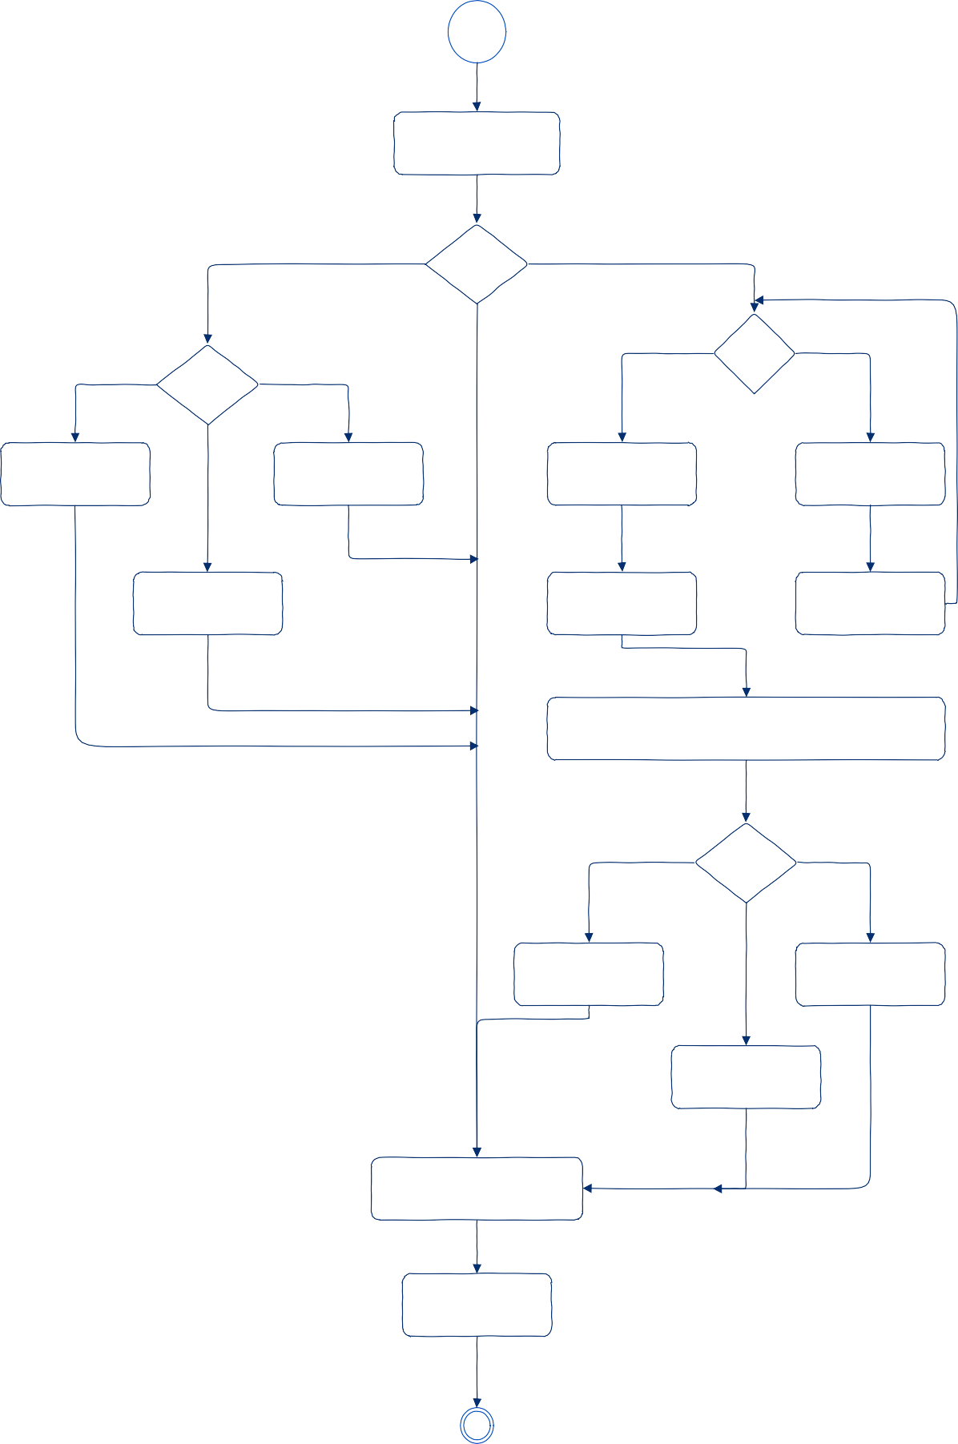

room management

add room delete room

edit room

goto main menu

exit

# CHAPTER 5

## RESULTS AND DISCUSSION

#### Work Completed



**Fig 1: Main menu**

Description: It is the main menu that prompts the user to choose between Admin or customer

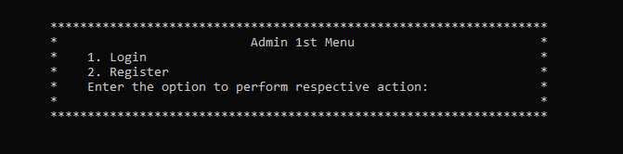

#### Fig 2: Sign-in menu

Description: In this menu a user can register or login into the system

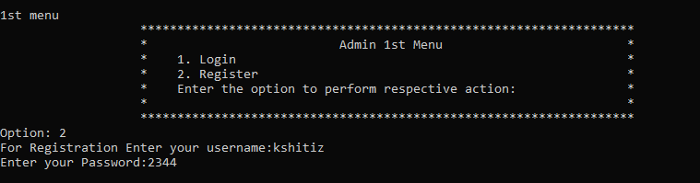

#### Fig 3: Registration

Description: In this page user is prompted to enter name and password and register.

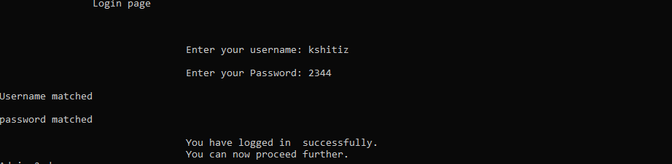

#### Fig 5: Login

Description: User is prompted to enter user name and specific password and system verifies it and give access to the user to next menu in the system.

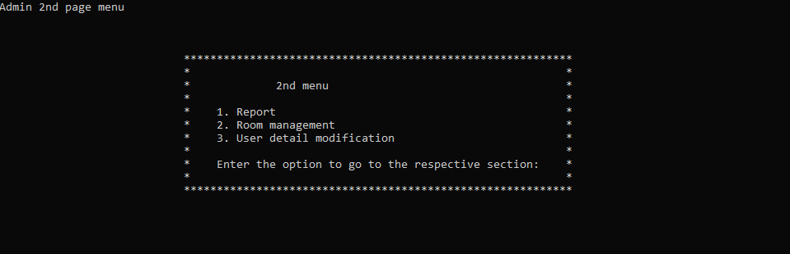

#### Fig 6: Admin menu

Description: In this menu user can choose among report display, room management and user detail modification.

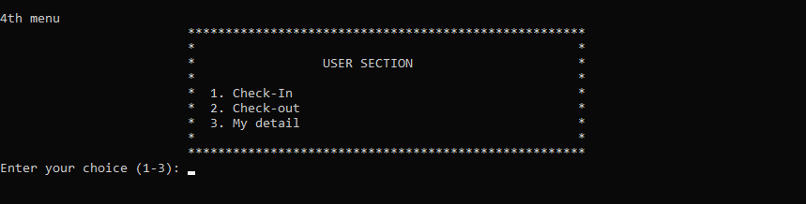

#### Fig 7: User-section

Description: In this menu, a user can check in , check out and check their detail.

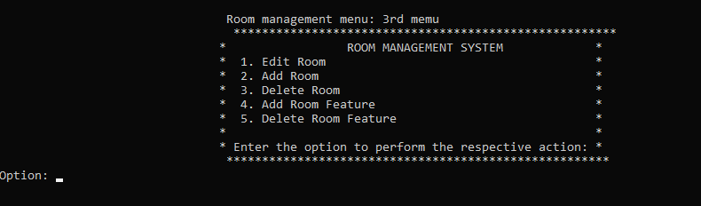

#### Fig 8: Room management menu

Description: In this section, admin can edit, add, delete the room and also add and delete room features.



#### Fig 9:User detail modification menu

Description : In this section, Admin can alter users details.

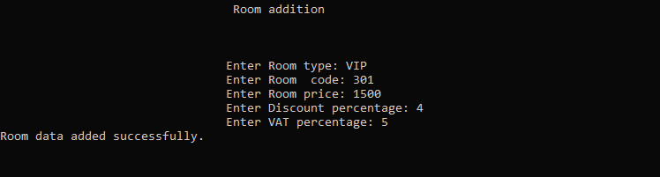

#### Fig 10:Room addition page

Description: In this section, Admin is prompted to enter the room information and add the room successfully.



#### Fig 11:Room display page

Description : In this section admin can display the room details.

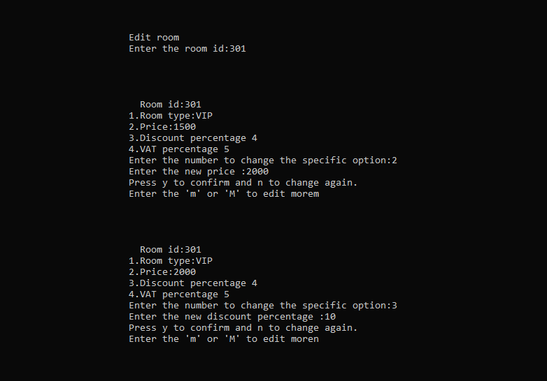

#### Fig 12:Edit room page

Description: In this section, admin edit the room details.

* 1. **Conclusion**

# CHAPTER 6

## CONCLUSION AND RECOMMENDATION

In conclusion, a hotel's success relies heavily on a well-organized booking system. It not only streamlines hotel operations but also elevates the guest experience while ensuring the hotel makes the most money by adjusting prices and making smart decisions using data. As technology keeps advancing, embracing innovations such as artificial intelligence, blockchain, and mobile apps will be essential for hotels to stay competitive and meet the ever-changing needs of guests. A strong commitment to keeping guest information safe, being environmentally responsible, and providing excellent customer service will continue to be at the heart of a hotel's success in the hospitality industry.

#### Recommendation

We recommend incorporating a feature in the Hotel Booking and Management System to capture and store detailed customer information for enhanced convenience. This addition will streamline guest interactions, personalize services, and contribute to a more tailored and satisfying experience.

### REFERENCES:

* + 1. [https://www.freeprojectz.com](https://www.freeprojectz.com/)
    2. [https://www.studocu.com](https://www.studocu.com/)
    3. [https://www.academia.edu](https://www.academia.edu/)
    4. <https://code-projects.org/simple-hotel-management-system-in-c-with-source-code/>
    5. https://www.youtube.com/watch?v=MV8AT9a2oSM&list=PLWxTHN2c_6cbh1C7yIskoXszoTl-okogt