TITLE OF PROJECT

Blood Donation system

END TERM REPORT

By
NAME OF THE CANDIDATES:
Lokeshajaykumar Immandi
(Reg Number: 11909508)
(Section: K19QW)
Rahul singh
(Reg Number: 11909834)
(Section: K19QW)

Synopsis:
Blood donation system

The software system is an online blood Donation system that helps in managing various blood bank operations effectively. The project consists of a central repository containing various blood deposits available along with associated details. These details include blood type, storage area and date of storage. These details help in maintaining and monitoring the blood deposits. The project is an online system that allows to check whether required blood deposits of a particular group are available in the blood bank. Moreover the system also has added features such as patient name and contacts, blood booking and even need for certain blood group is posted on the website to find available donors for a blood emergency. This online system is developed on .net platform and supported by an Sql database to store blood and user specific details.
Features:
- Online Registration/Login: The users that are in need of blood can register online and find their suitable donors online.
- Donor registration: Donors can also register in the system to post their donation information.
- Blood requirement posting: Already registered users can also post their requirements need for blood.
- Donated blood storage data and availability check: The system automatically stores the information as soon as there is any updation made.
- Donor Finder: The system automatically finds the donor information when there arises any requirement.
- Blood Finder: The system also finds blood type required according to user's need.

Software Requirements:
- Windows Xp, Windows 7(ultimate, enterprise),windows 8, windows 10
- Sql 2008
- Visual studio 2010
- Xampp software
Hardware Components:
- Processor – i3 or higher
- Hard Disk – 5 GB
- Memory – 1GB RAM

Advantages:
- Customers can get all blood donation information in this system instead of going and searching around for it.
- The system provides immediate details of blood available in the bank.
- The system is very useful as it immediately provides user about the availability of blood.
- The system also contains donor's details and information so that users don’t have problem in searching for them.
- The system is very effective during emergency conditions.
- It saves their time and efforts.
Disadvantages:
- The system do not check for the user identity hence he must have to first get himself approved from the bank.
- There is no human interaction.
Applications:
- The system can be used for any blood providing organization.
- It can also be used in hospitals to provide doctors about the blood availability details in hospital.

Final Report:

In this project php is used in designing Blood donation system Which includes :
html ,css ,javascript, jQuery and bootstrap.

To run the project the below steps need to be followed
step 1.
xampp software has to be installed in your pc/laptop
step 2.
paste all the files inside xampp folder in htdocs
step 3.
open xampp software start Apache and MySQL
step 4.
open web browser in the url type http://localhost/index.php

Explanation of the files :
Index.php file is the main file of the website.
For header, header.php file is used.
For footer, footer.php file is used.
And about.php, donate.php, donor.php, login.php,
seach.php,signin.php files are linked to navigation.php and usernav.php files which are seen in header codes
Styling of website is done through custom.css and style.css
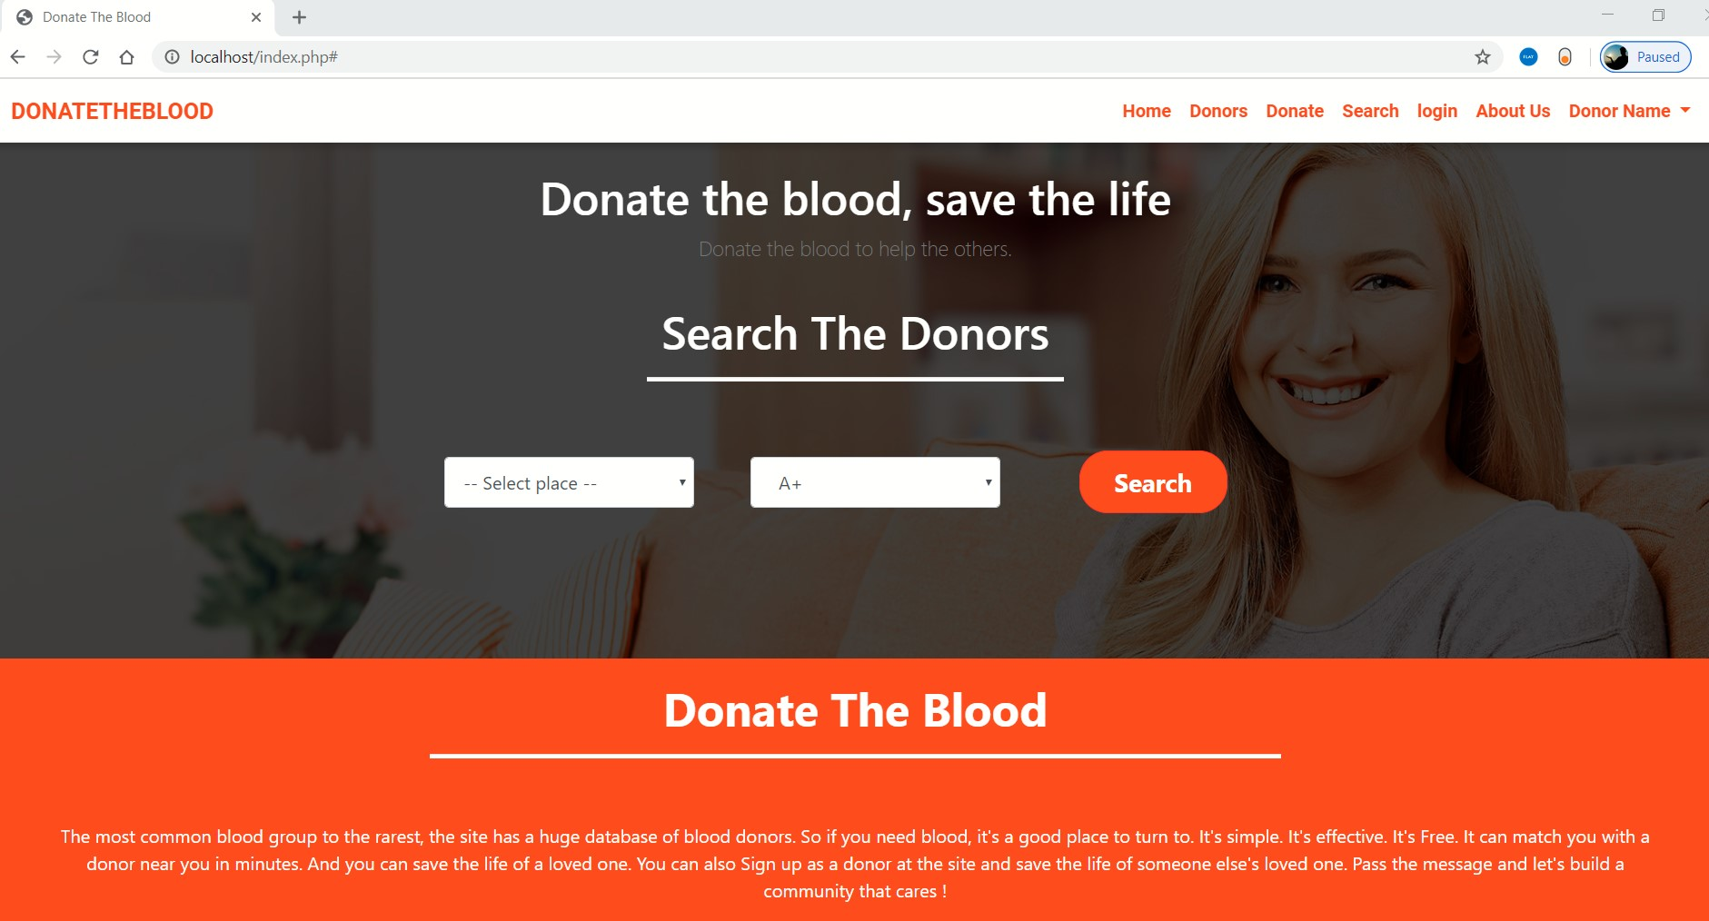

In this page we can see under search the donars
Two dropdowns are present first one is of place in which the donars are available and the second one is of blood group which is needed by the person who is in need.
When the person clicks search after choosing place and blood group this page navingates to donars page(since the data is not exists it shows a message that no record found).
In the navigation bar we can see Home ,
Donars, Donate, search, login ,Aboutus,
Donar name.
If anyone wants to donate the blood he presses donate option in navigation bar and the page takes him to first login to donate which can either be signinpage or signup page.
And in the Aboutus option we can see the mission, vision and goal of the website.

