# Homogeneous coordinates

Translation of 2D pixel from image plane to 3D real world

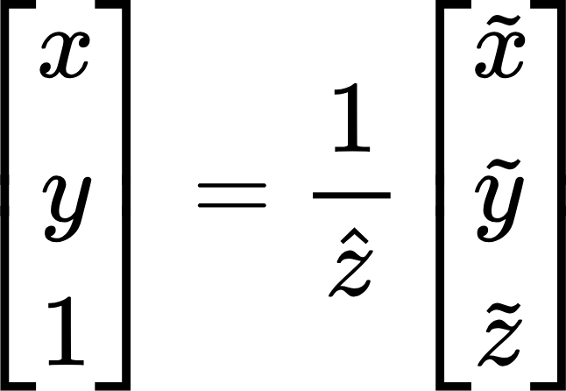

# **3D point to 2D image**

**Cin - camera intrinsic, Cout - camera extrinsic**

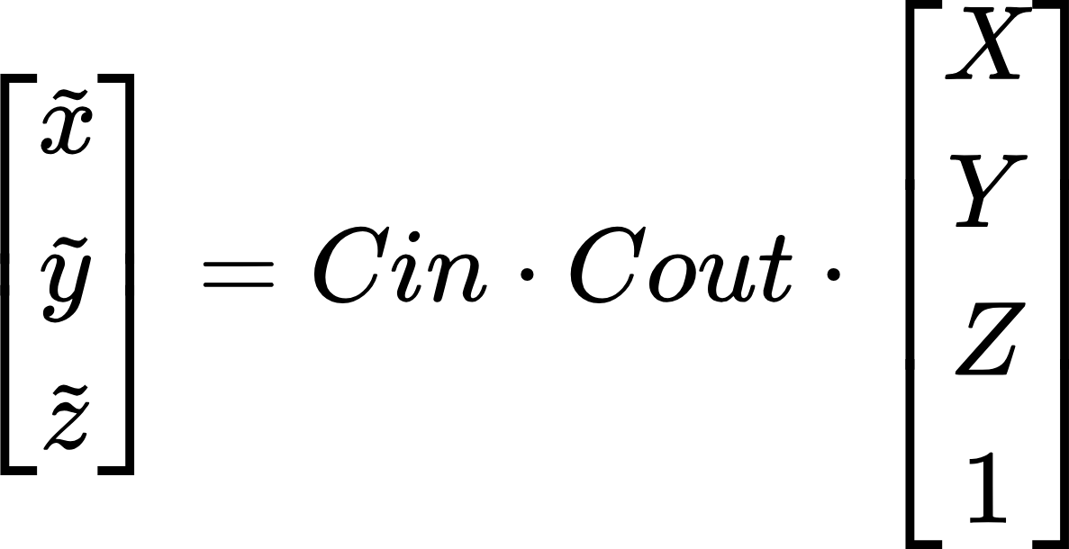

**Intrinsic - translate 3D point to 2D**

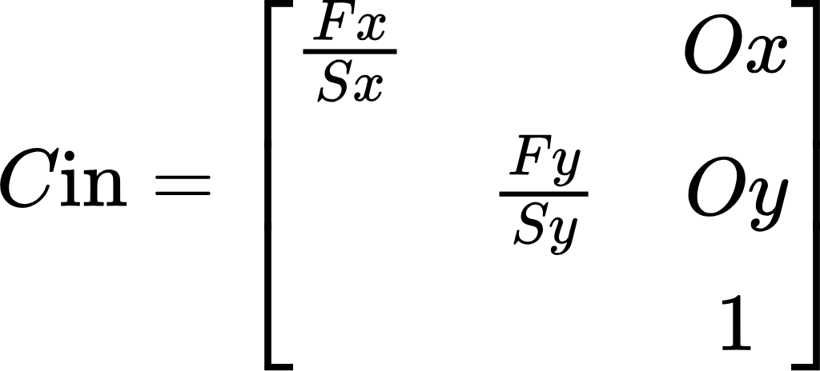, F - focal length, S-sensor size, O - image center

**Extrinsic - translate between coordinate frames**

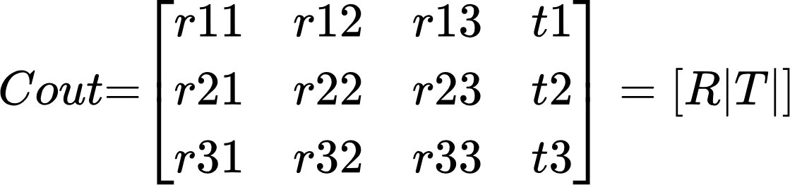, R - rotation matrix, T-translation matrix

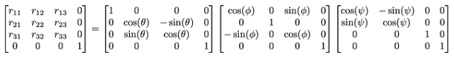

# Homography Matrix

we are looking for a planar surface in the world-view to compute the homography, ***Z***= 0

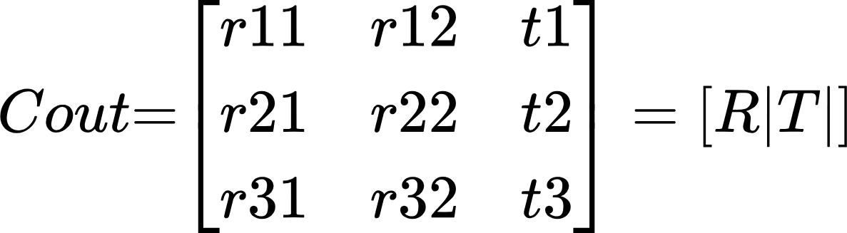

Homography matrix - translation between shots

S -source, d - destination

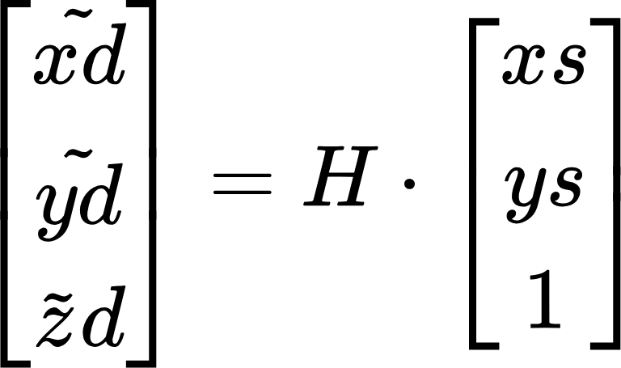, 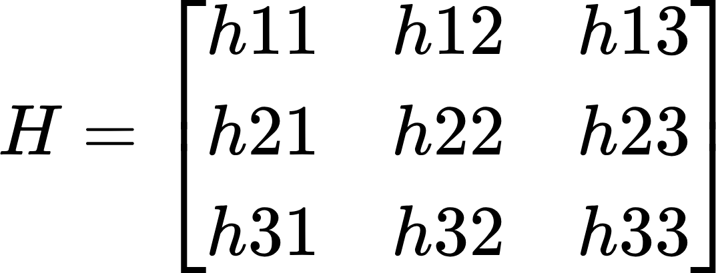, h33 - image scale with pixel position save, so H matrix has 8 degrees of freedom

## Computation

Every point gives 2 features, so H matrix computation needs 4 points

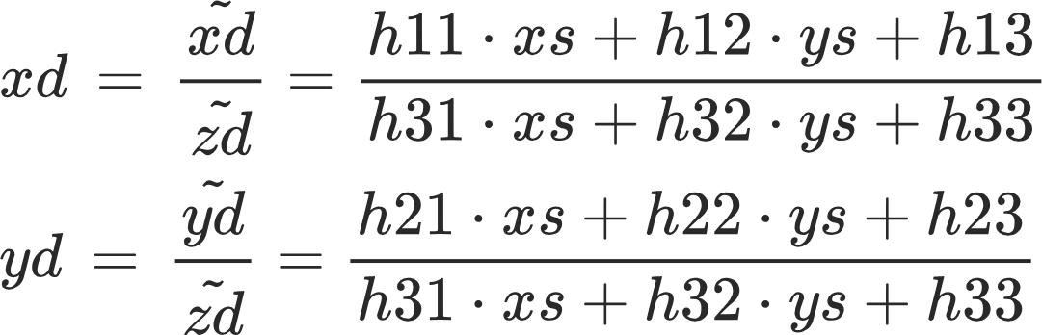

Multiply by denominator and rearrange all to left side

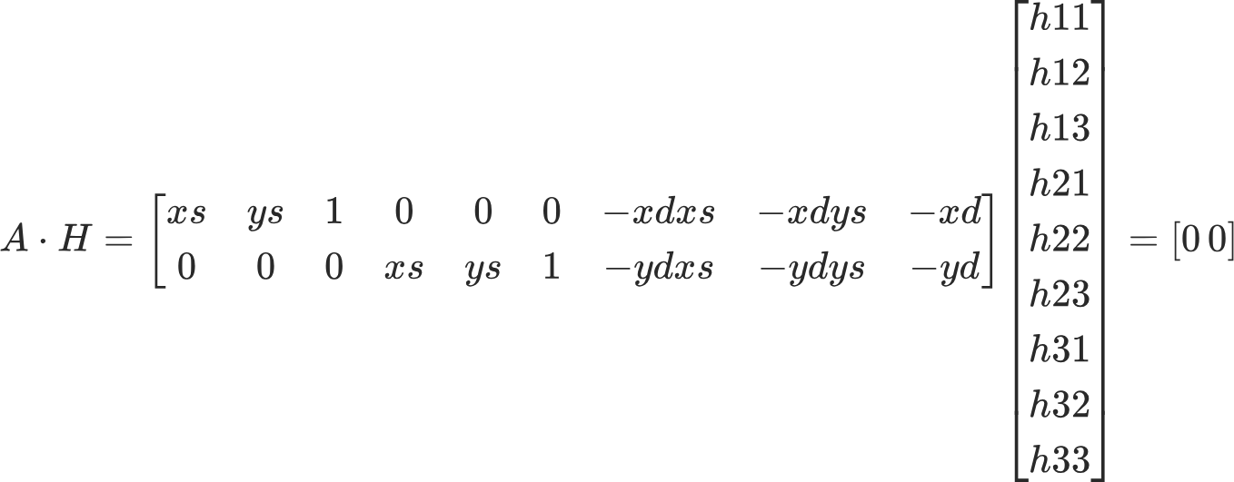

Concatenate 3 more points to the left matrix for H estimation. Find H with known A such that ||H||2=1, which is **Constrained Least Squares problem:**

### **Constrained Least Squares problem**

**min**h||A*H||2 , ||H||2=1

||A*H||2=(A*H)T*(A*H)=HT*AT*A*H, HT*H=1

Define Loss Function:

L(H, l) = HT*AT*A*H - l*(HT*H-1)

Take derivative of loss to find extremum:

AT*A*H - l*H=0

AT*A*H = l*H - **Eigenvalue problem**

**Eigenvector h with smallest eigenvalue l would give minimal Loss value**