**Hello Team!** **Consider the below two tables**:

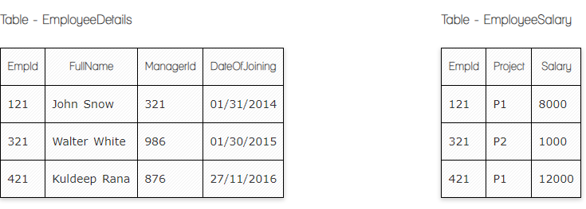

**Ques.1. Write a SQL query to fetch the count of employees working in project 'P1'.**

**Answer:**

**Select** Count (Empld) **From** EmployeeSalary **Where** Project='P1'

**Ques.2. Write a SQL query to fetch employee names having salary greater than or equal to 5000 and less than or equal 10000.**

**Answer:**

**Select** EmployeeDetails.FullName, EmployeeSalary.Salary

**From** EmployeeDetails

**Inner Join** EmployeeSalary

**ON** EmployeeDetails.EmpId=EmployeeSalary.EmpId

**Where** Salary Between 5000 and 10000

**Ques.3. Write a SQL query to fetch count of employees sorted by project's count in descending order.**

**Your Answer:**

**Select** Count (EmpId)

**From** EmployeeSalary

**Group by** EmployeeSalary.Project

**Order by** COUNT (Project) DESC

**Ques.4. Write a query to fetch employee names and salary records. Return employee details even if the salary record is not present for the employee.**

**Answer:**

**Select** EmployeeDetails.FullName, EmployeeDetails.ManagerId, EmployeeDetails.DateOfJoining, EmployeeSalary.Salary

**From** EmployeeDetails

**Left** **Join** EmployeeSalary

**ON** EmployeeDetails.EmpId=EmployeeSalary.EmpId

**Ques.5. Write a SQL query to create an empty table with ‘Test’ name.**

**Answer:**

**Create Table** 'Test';

**Ques.6. Write a SQL query to delete an empty table with ‘Test’ name.**

**Answer:**

**Drop Table** 'Test';

**Ques.7. Write a SQL query to fetch all the Employees details from EmployeeDetails table who joined in Year 2016.**

**Answer:**

**Select** * **From** EmployeeDetails **Where** DateOfJoining like '%2016'

**Ques.8. Write a SQL query to insert new record to the EmployeeDetails table with any data.**

**Answer:**

**Insert** Into EmployeeDetails (EmpId, FullName, ManagerId, DateOfJoining) **Values** ('123', 'Lilya Ghushchyan', '233', '12.12.2022')

**Ques.9. Write a SQL query to update EmployeeSalary table with setting Salary to 2000 for Project P2.**

**Answer:**

**Update** EmployeeSalary **Set** Salary=*'2000'* **Where** Project=*'P2'*

**Ques.10. Write a SQL query to right join both tables and draw the results.**

**Answer:**

**Select \***

**From** EmployeeSalary

**Right Join** EmployeeDetails

**ON** EmployeeDetails.EmpId=EmployeeSalary.EmpId

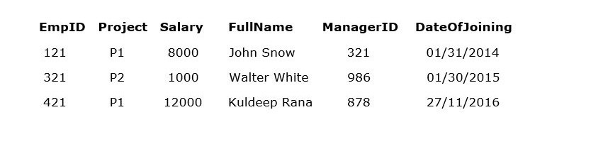

**Now take these two tables:**

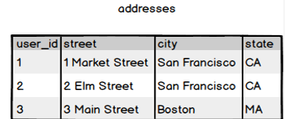

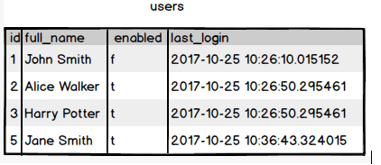

**Ques.11. Write a SQL query to fetch all users full_name from San Francisco.**

**Answer:**

**Select** full_name **From** Users **Where** user_id IN **(Select** from addresses **Where** city= 'San Francisco'

**Ques.12. Write a SQL query to fetch all users full_name, last_login who are enabled**

**Answer:**

**Select** full_name, last_login **From** users **Where** enabled='t'

**Ques.13. Write a SQL query to fetch all users full_name who are not from Main street**

**Answer:**

**Select** full_name **From** users **Where** id IN (**Select** user_id **From** addresses **Where** street **NOT LIKE** 'Main Street')

**Ques.14. Write a SQL query to fetch all users full_name who are from Main street or San Francisco**

**Answer:**

**Select** full_name **From** users **Where** id **IN ( Select** user_id **From** addresses **Where** street= 'Main street' **OR** city='San Franciso'**)**

**Ques.15. Write a SQL query to fetch user full_name who is equal to user_id from Boston (find user_id value in sub_query)**

**Answer:**

**Select** full_name **From** users **Where** id **IN ( Select** user_id **From** addresses **Where** city= *'Boston'*)