**PROJECT TITLE:**

Workforce Administration Solution (Admin)

**NAME OF THE STUDENTS:**

1.Hari Krishna Karlakunta(TL)

2.Orvakanti Naveen Kumar(TM)

3. Lingam Hemanth Kumar(TM)

**NAME OF THE COLLEGE:**

K.S.R.M College of Engineering

**TEAM ID:**

LTVIP2025TMID27583

**SMARTINTERNZ REGISTER NUMBER:**

1.SBAP0027583

2. SBAP0027564

3. SBAP0027622

**PROJECT OVERVIEW:**

# The Workforce Administration Solutions is a Salesforce-based project designed to help organizations help monitor employee data, track project tasks and allocation of assets. It centralizes the information about the workforce, automating the processes such as sending reminder and making reports, and provides dashboards to imagine the use of employee performance and asset. By working on this project, you will gain experience in the creation of Salesforce administration, data modeling and customized applications, while learning to nap the business operation of the real world effectively.

# Objectives

1. **Centralize Employee Data Management**  
   Create a unified platform to store, manage, and access employee information, including roles, departments, project assignments, and asset allocations, ensuring data accuracy and accessibility.
2. **Streamline Project Assignment Processes**  
   Simplify the process of assigning employees to projects by tracking workloads, skills, and availability, ensuring optimal resource allocation and timely project delivery.
3. **Enhance Asset Tracking and Accountability**  
   Implement a system to monitor asset allocation, usage, and return status, reducing asset loss and ensuring compliance with organizational policies.
4. **Automate Routine Workflows**  
   Automate repetitive tasks such as sending notifications for deadlines, overdue assets, or workload thresholds, improving operational efficiency and reducing manual effort.
5. **Monitor and Improve Employee Performance**  
   Track employee performance metrics, project contributions, and productivity to identify high performers, address skill gaps, and support career development.
6. **Provide Real-Time Insights Through Reporting**  
   Develop dynamic reports and dashboards to provide real-time visibility into workforce utilization, project progress, and asset distribution, enabling data-driven decision-making.
7. **Ensure Scalability and Flexibility**  
   Design a solution that can adapt to changing business needs, accommodate additional features, and scale as the organization grows.
8. **Improve Managerial Oversight and Decision-Making**  
   Equip managers with tools to monitor team performance, balance workloads, and allocate resources effectively, ensuring alignment with organizational goals.
9. **Enhance User Experience and Adoption**  
   Build an intuitive, user-friendly interface that encourages widespread adoption and ensures seamless integration into daily workflows.
10. **Support Compliance and Risk Management**  
    Maintain accurate records of employee activities, project timelines, and asset assignments to meet regulatory requirements and mitigate risks associated with non-compliance.

# Salesforce Key Features and Concepts Utilized

**1. Custom Objects**

**Purpose** : To create tailored data structures for managing employees, projects, and assets.

**Implementation** :

**Employee Object** : Stores employee details such as name, role, department, and contact information.

**Project Object** : Tracks project assignments, timelines, and progress.

**Asset Object** : Manages asset allocation, return dates, and status.

**2. Relationships Between Objects**

* **Master-Detail and Lookup Relationships** :
  + Establish connections between objects to reflect real-world relationships (e.g., Employee-to-Project, Employee-to-Asset).
  + Example: A Master-Detail relationship between Employee and Asset ensures that assets are tied to specific employees.

**3. Automation Tools**

* **Process Builder** :
  + Automates workflows such as sending notifications when an asset is overdue or updating project statuses based on deadlines.
* **Flow** :
  + Creates guided processes for tasks like assigning employees to projects or reallocating assets.
* **Approval Processes** :
  + Implements approval workflows for critical actions, such as approving asset requests or project assignments.

**4. Lightning App Builder**

* **Custom Application Development** :
  + Builds a user-friendly interface using Lightning components to create a centralized application for workforce management.
  + Includes custom tabs, pages, and navigation menus tailored to user roles (e.g., managers, HR, employees).

**5. Reports and Dashboards**

* **Custom Reports** :
  + Generate reports to track employee workloads, project progress, asset utilization, and performance metrics.
* **Dynamic Dashboards** :
  + Visualize key metrics such as workforce distribution, project timelines, and asset availability through interactive dashboards.

**6. Role Hierarchy and Permission Sets**

* **Role Hierarchy** :
  + Define organizational structure to control data visibility and access (e.g., managers can view team data, while employees see only their own).
* **Permission Sets** :
  + Assign specific permissions to users based on their roles (e.g., HR can manage employee records, IT can manage assets).

**7. Data Validation Rules**

* **Purpose** : Ensure data integrity by enforcing business rules.
* **Examples** :
  + Prevent duplicate asset assignments.
  + Validate project deadlines to ensure they are realistic.

**8. Workflow Rules**

* **Purpose** : Automate simple tasks and notifications.
* **Examples** :
  + Send email alerts to employees when an asset is due for return.
  + Notify managers if an employee exceeds their workload capacity.

**9. Chatter Collaboration**

* **Purpose** : Facilitate communication and collaboration among teams.
* **Implementation** :
  + Enable employees and managers to discuss project updates, share files, and resolve issues within Salesforce.

**10. Record Types and Page Layouts**

* **Record Types** :
  + Create different record types for employees, projects, and assets to capture unique data requirements.
* **Page Layouts** :
  + Customize page layouts for different user roles to display relevant fields and components.

**11. Formula Fields and Roll-Up Summaries**

* **Formula Fields** :
  + Calculate values dynamically, such as the number of projects assigned to an employee.
* **Roll-Up Summaries** :
  + Aggregate data from related records (e.g., total assets assigned to an employee).

**12. Sharing Rules and Security**

* **Sharing Rules** :
  + Control access to sensitive data by defining sharing rules based on departments or teams.
* **Field-Level Security** :
  + Restrict access to confidential fields (e.g., salary information) for non-HR users.

**13. Integration with External Systems (Optional)**

* **API Integration** :
  + Connect Salesforce with external systems like payroll software or inventory management tools for seamless data exchange.

**14. Mobile Accessibility**

* **Salesforce Mobile App** :
  + Ensure the solution is accessible on mobile devices, enabling managers and employees to stay updated on the go.

# Detailed Steps to Solution Design

**1.Salesforce Platform Setup:** The Salesforce platform is set up by creating a new application called "Workforce Administration Solution" and configuring custom objects, fields, and page layouts to meet project requirements. Role hierarchies, permission sets, and security settings are defined to ensure proper data access and user management.

**2.Object Creation:** In this project, custom objects such as Employee , Project , and Asset are created to manage workforce data, track project assignments, and monitor asset allocation. These objects are interconnected through relationships like Lookup and Master-Detail to ensure seamless data organization and accessibility. 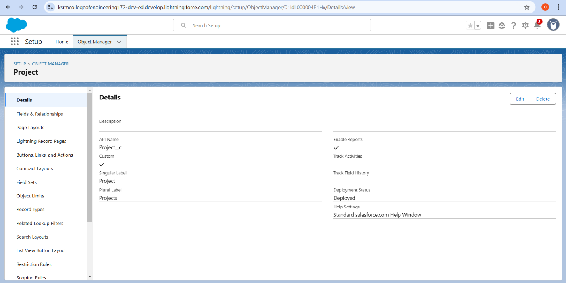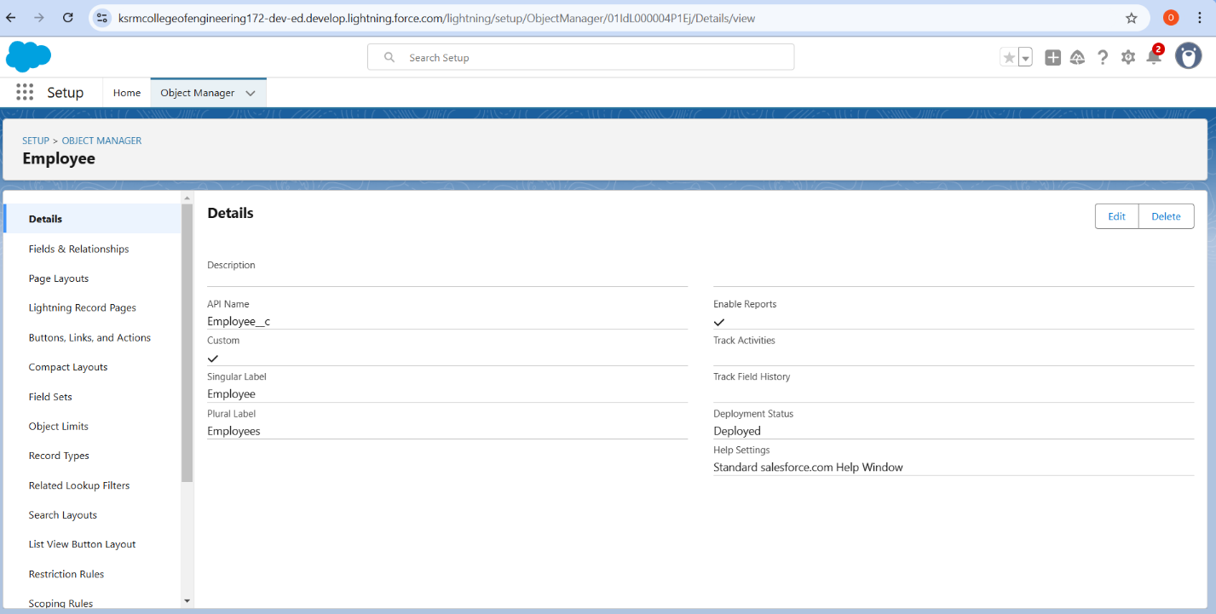

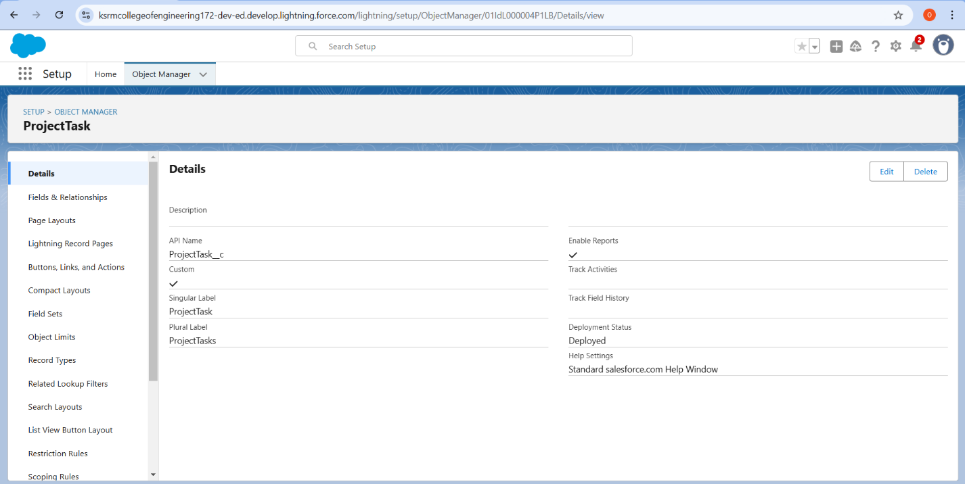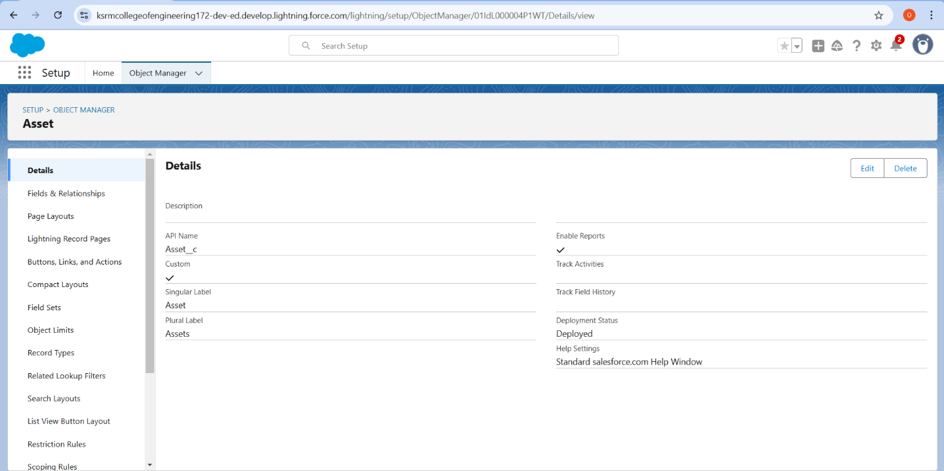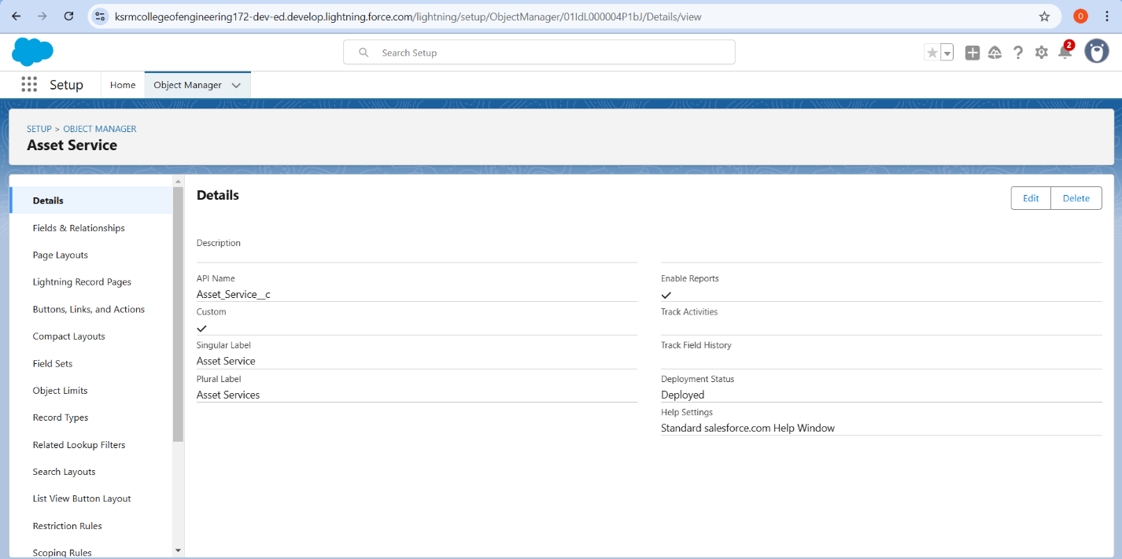

**3.Tabs:** In this project, custom tabs are created for Employee, Project, and Asset objects to provide quick navigation and easy access to key data within the Salesforce application. These tabs are organized in the app’s navigation menu, ensuring a user-friendly experience for different roles like managers and HR personnel.

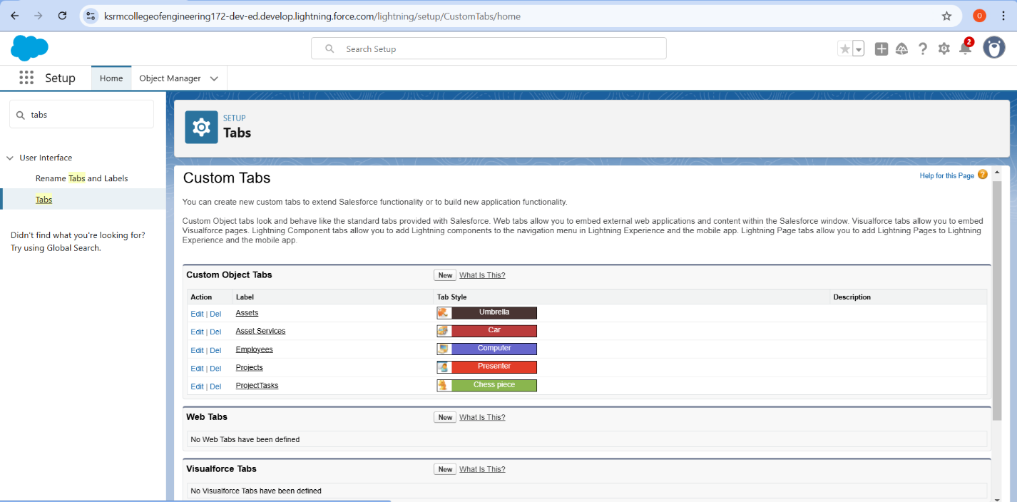

**4.The LightningApp:** The Lightning App is used to design a centralized, user-friendly interface for the Workforce Administration Solution, incorporating custom components like employee lists, project trackers, and asset dashboards. It ensures an intuitive and role-specific experience by leveraging Lightning App Builder to tailor pages for managers, HR, and employees.

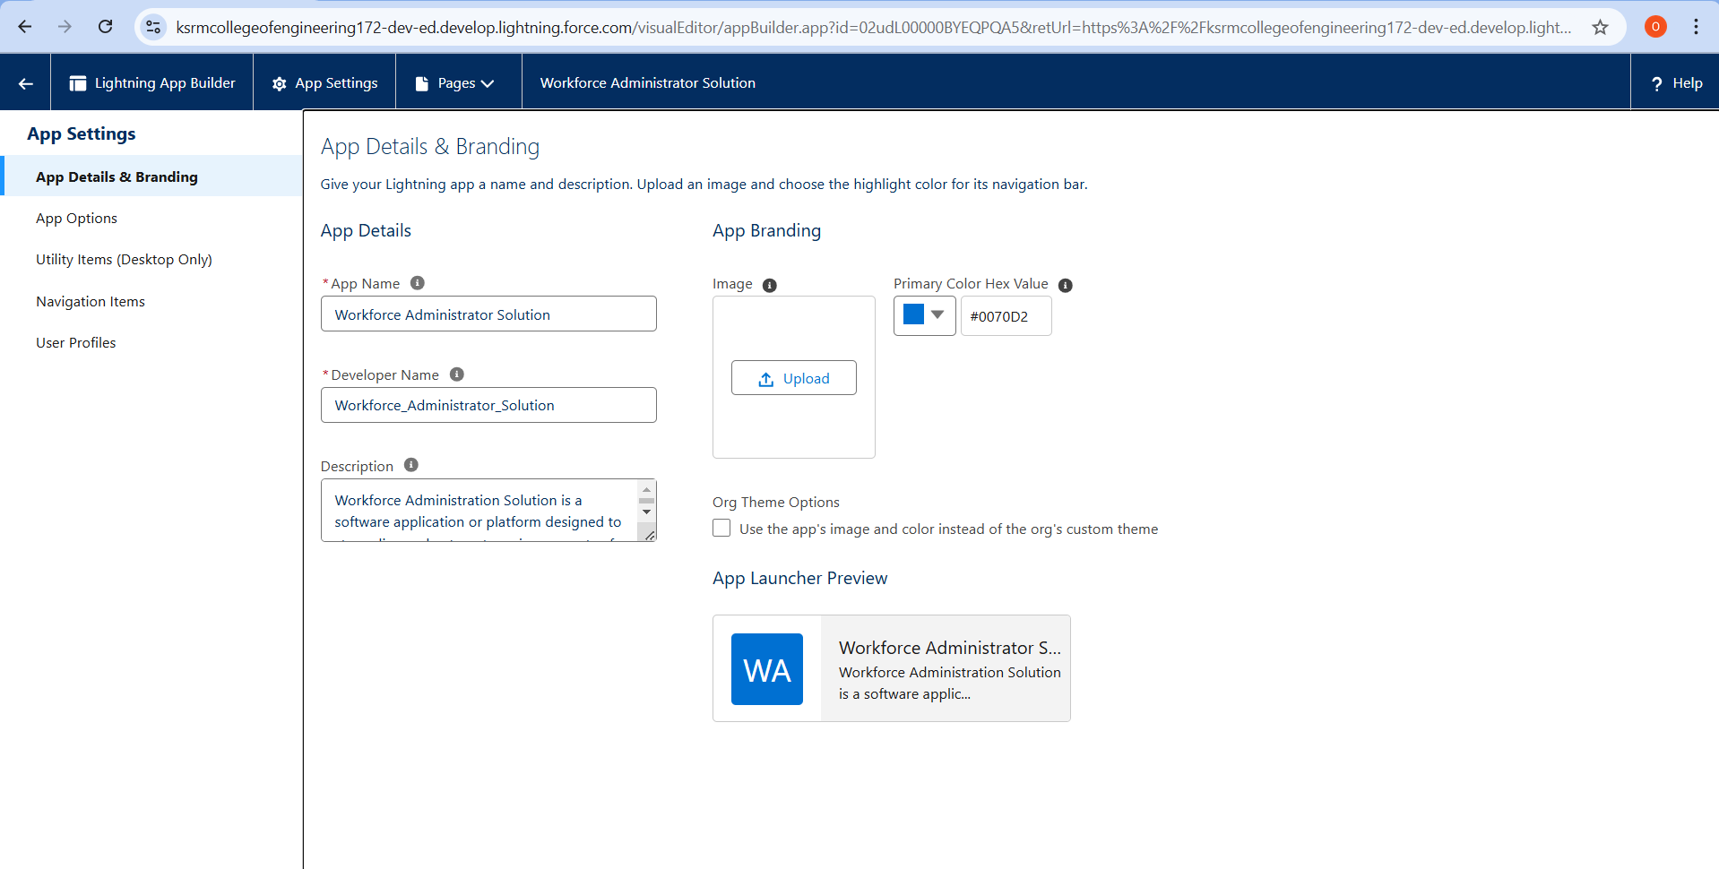

**5.Fields**: Custom fields are created for objects like Employee , Project , and Asset to capture specific data such as employee roles, project deadlines, and asset statuses. These fields are tailored to meet business needs and ensure accurate data tracking throughout the workforce management process.

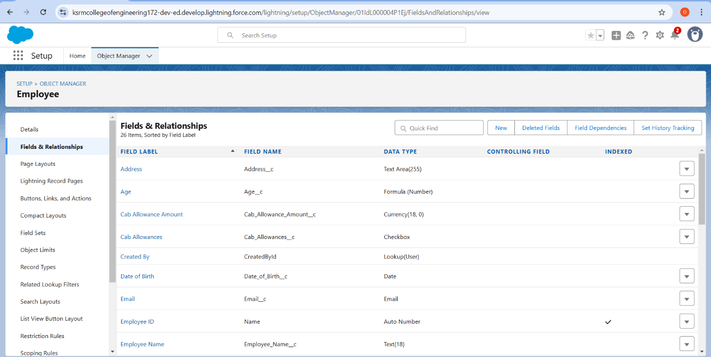

**6.Setting OWD:** In this project, Organization-Wide Defaults (OWD) are configured to set the baseline sharing settings for objects like Employee, Project, and Asset, ensuring data security and appropriate access levels. For example, OWD is set to Private for sensitive employee data, while role hierarchies and sharing rules are used to grant access to managers and HR teams.

**7.User Adoption:** User adoption is ensured by providing role-specific training and resources, such as guides and demos, to help employees and managers effectively use the Workforce Administration Solution. Additionally, an intuitive Lightning interface and ongoing support are implemented to encourage seamless integration into daily workflows.

**8.Import Data:** In this project, data such as employee details, project assignments, and asset records is imported into Salesforce using tools like Data Loader or Import Wizard to ensure accurate initial setup. Proper data mapping and validation rules are applied during the import process to maintain data integrity and alignment with the custom objects.

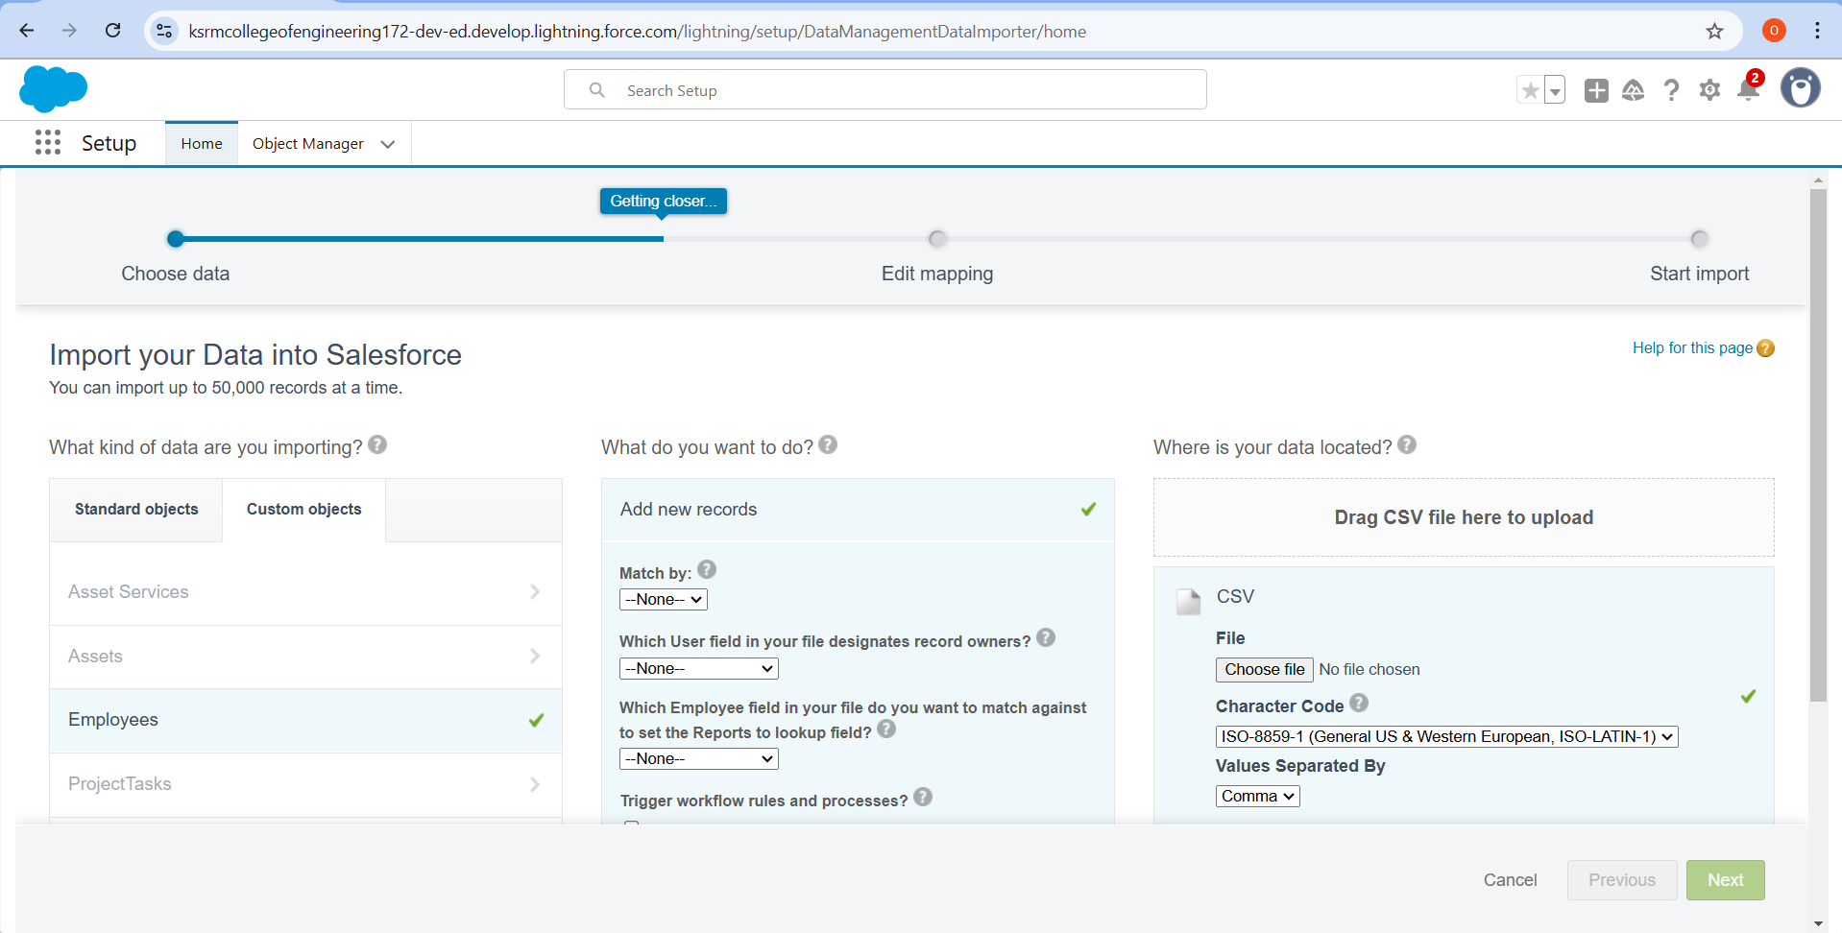

**9. Profiles:** In this project, Profiles are configured to define user access levels, ensuring employees, managers, and HR teams have appropriate permissions to view, edit, or manage records within the Workforce Administration Solution. Custom profiles are tailored to align with specific roles and responsibilities for secure and efficient system usage.

**10.Role**:In this project, Roles are defined within the role hierarchy to control data visibility and access, ensuring managers can view team-related information while employees access only their own records. This structure supports efficient workforce management and maintains data security across different organizational levels.

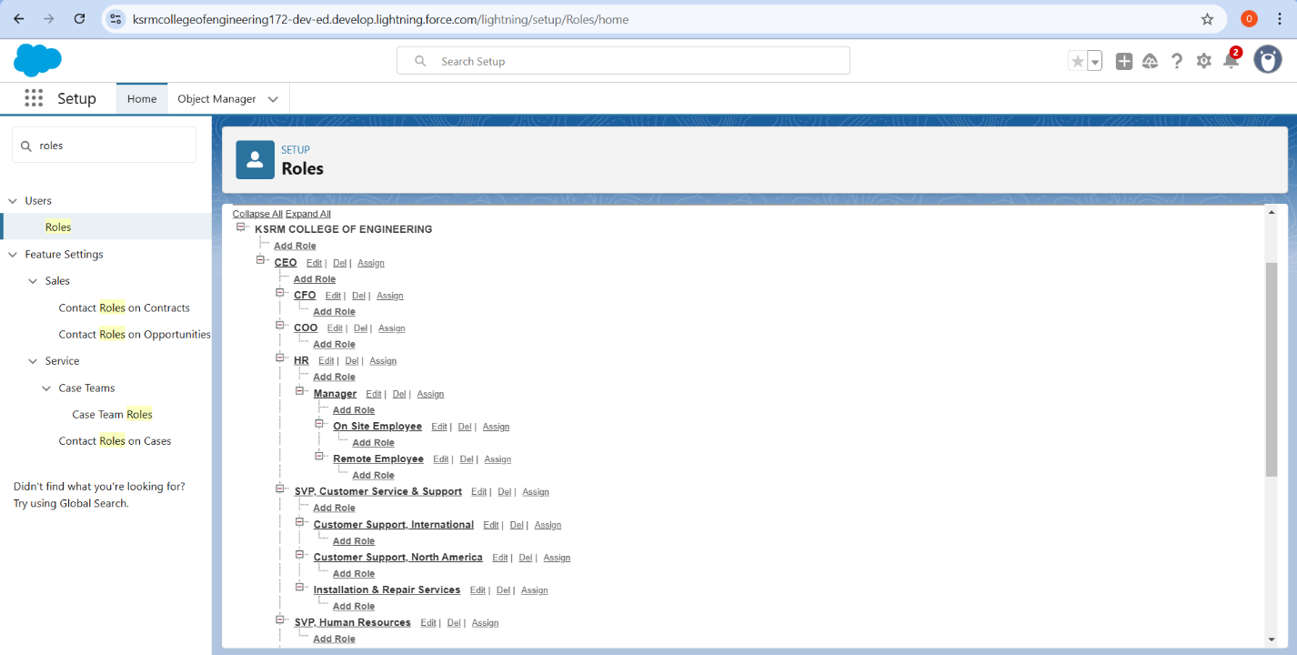

**11.Users:**Users are created and assigned to specific roles and profiles, ensuring they have the appropriate access and permissions to interact with employee, project, and asset data. Proper user setup enables seamless adoption and ensures that workforce management processes align with individual responsibilities.

**12.Page Layout:**Page Layouts are customized for objects like Employee, Project, and Asset to display relevant fields, buttons, and components based on user roles. These layouts ensure a streamlined and role-specific user experience, improving efficiency and data accessibility within the Workforce Administration Solution.

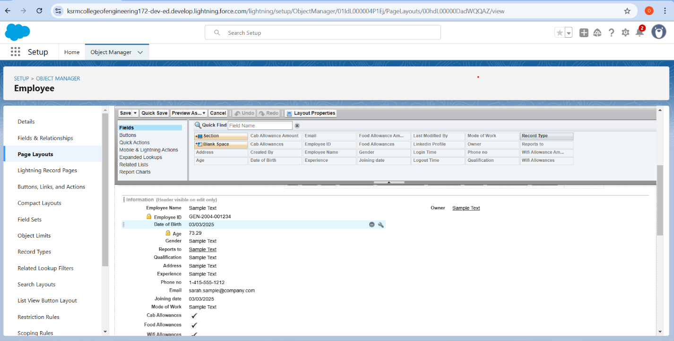

**13.Chatter Group:**Chatter Groups are created to facilitate collaboration among employees and managers, enabling real-time communication about project updates, asset assignments, and performance tracking. These groups enhance teamwork and ensure quick resolution of queries or issues within the workforce management process.

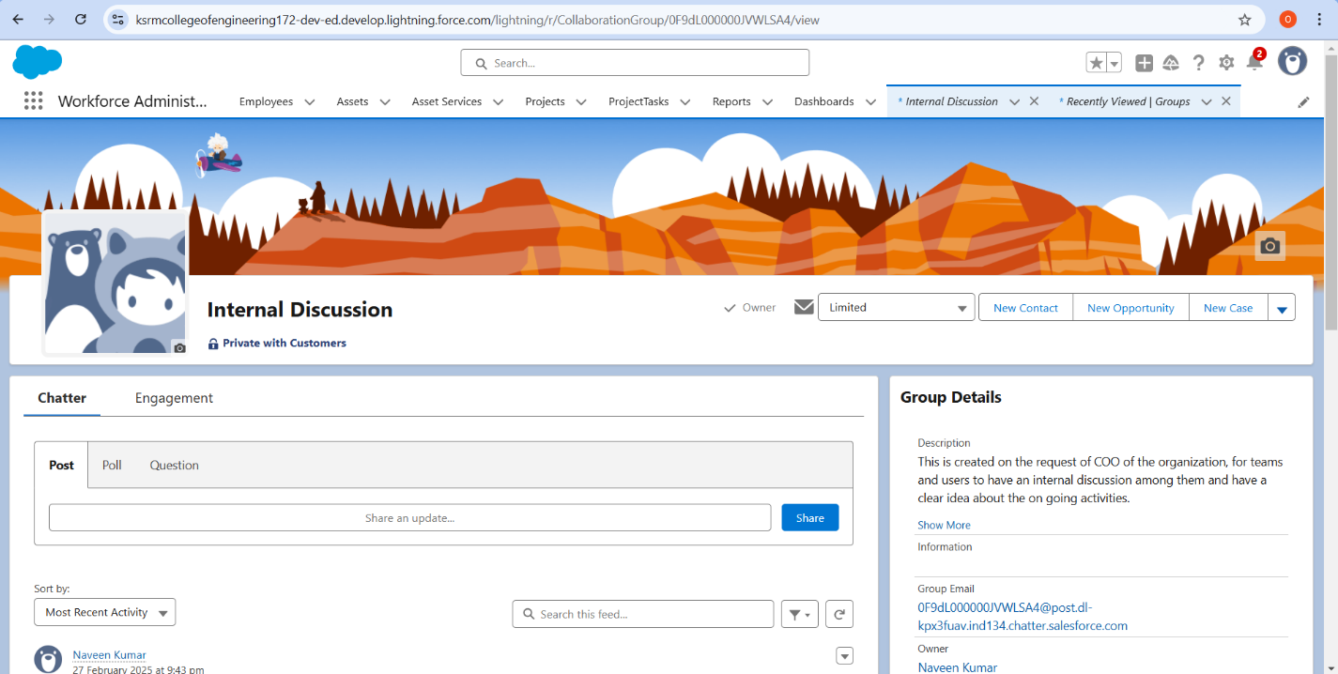

**14.Record Types:**Record Types are used to define different categories of records for objects like Employee, Project, and Asset, ensuring tailored processes and page layouts based on specific use cases. This allows for streamlined data management and ensures users see only the fields and options relevant to their roles or tasks**.**

**15.** **Permission Sets**:Permission Sets are utilized to grant additional access or functionality to specific users without altering their profiles, such as allowing HR to manage employee records or IT to oversee asset assignments. This ensures flexibility and precise control over user permissions while maintaining security and role-based access.

**16**.**Reports:**Reports are created to track key metrics such as employee workloads, project progress, and asset utilization, providing actionable insights for decision-making. Customizable report filters and formats enable stakeholders to analyze data effectively and generate meaningful conclusions tailored to their needs.

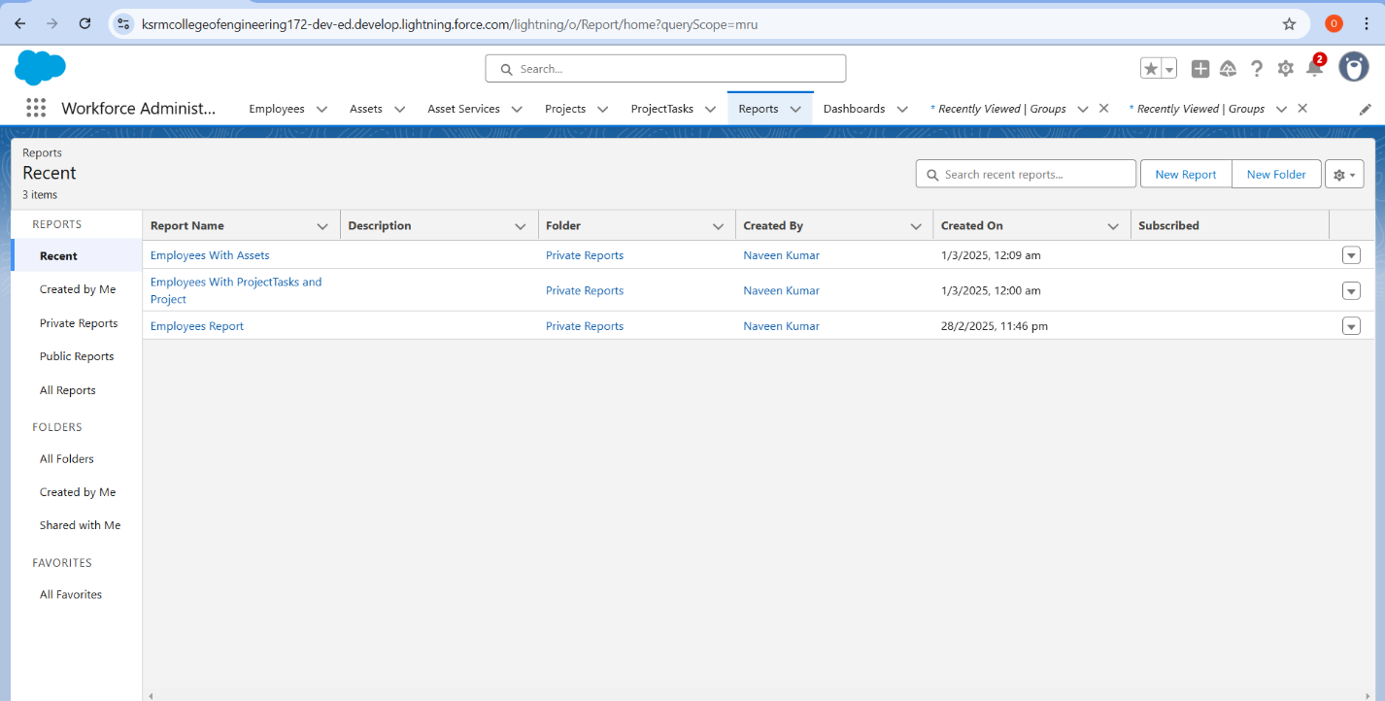

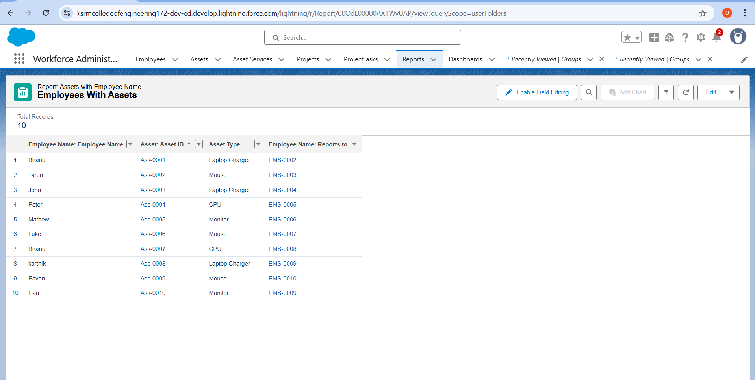

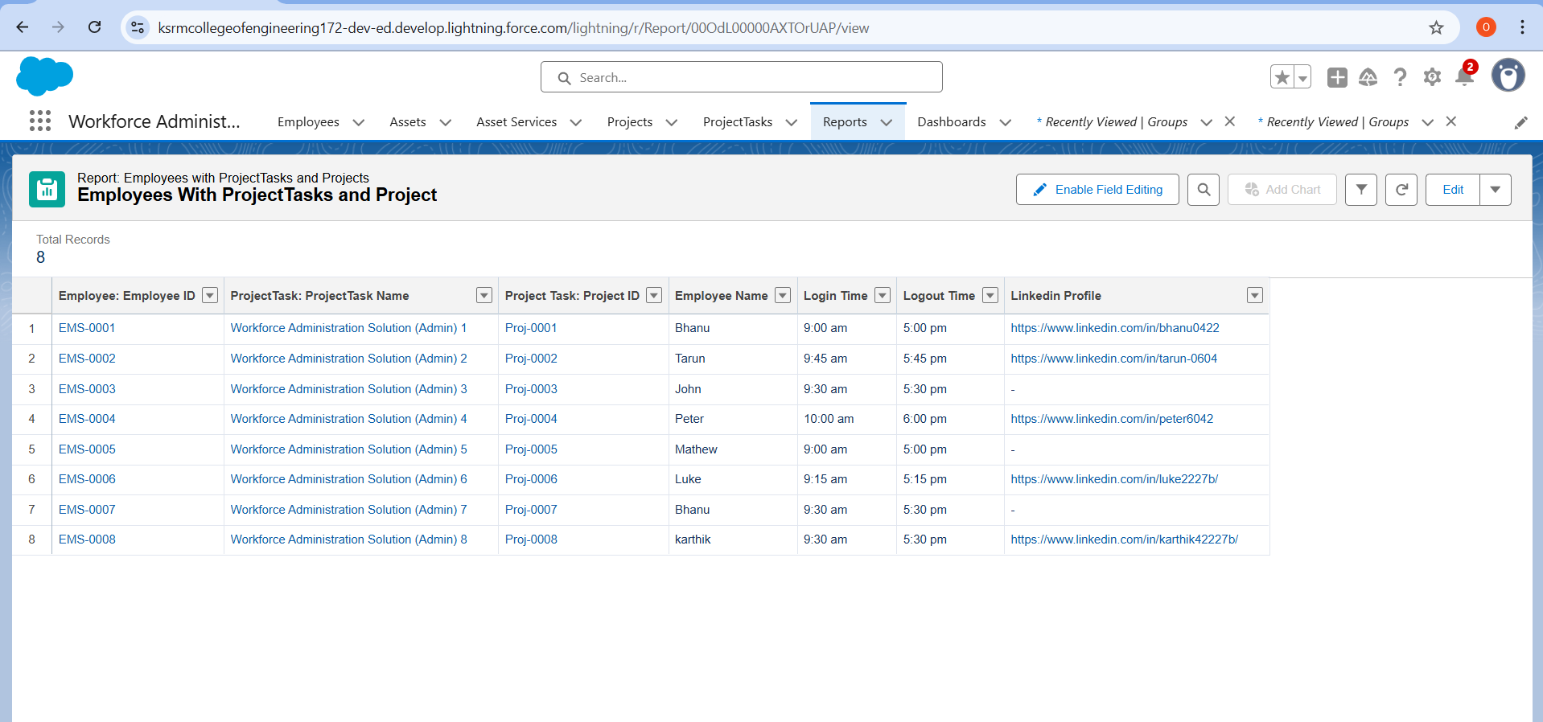

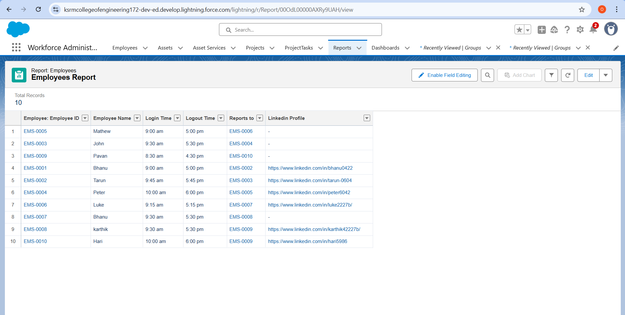

**17.Dashboards:**Dashboards are designed to provide real-time visual insights into workforce metrics, such as employee performance, project timelines, and asset distribution. These dynamic dashboards empower managers and stakeholders to monitor trends, identify bottlenecks, and make data-driven decisions efficiently.

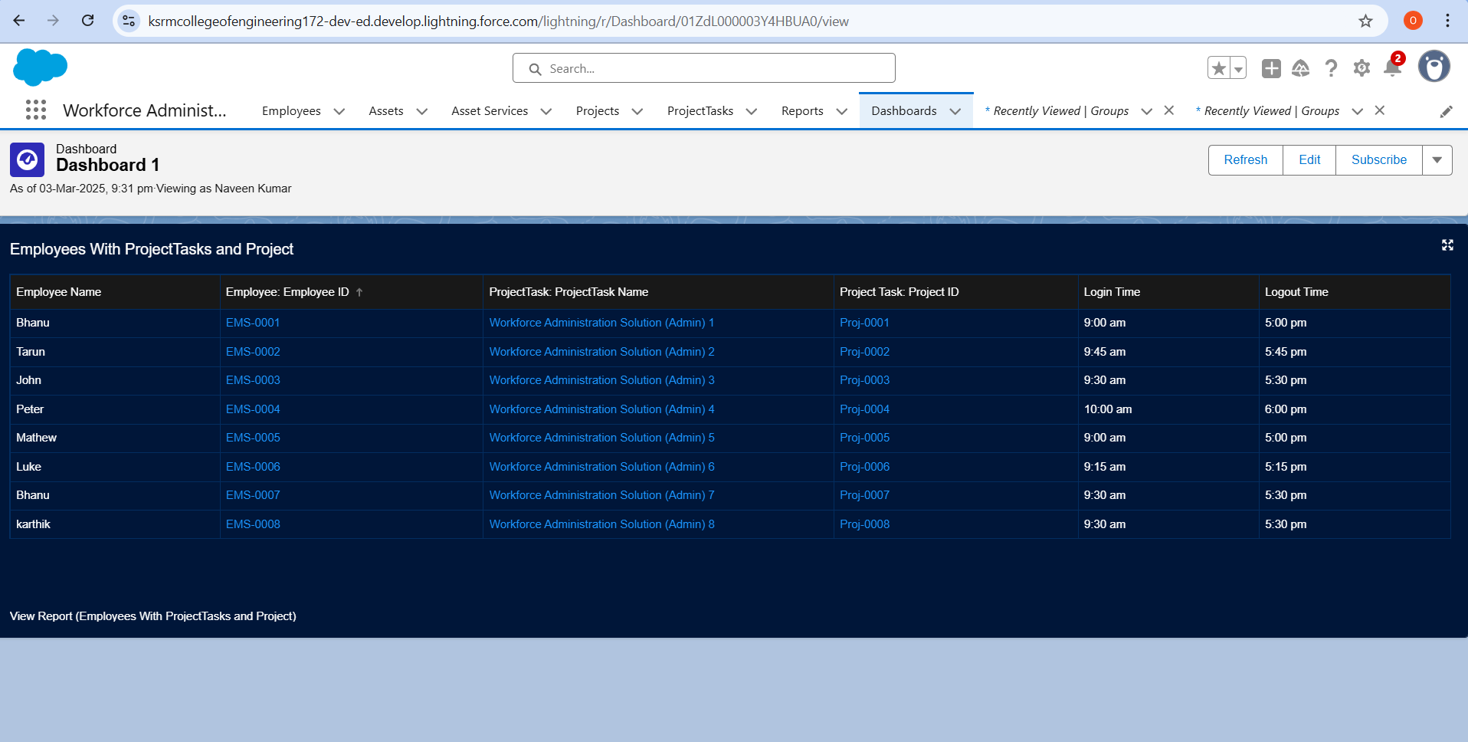

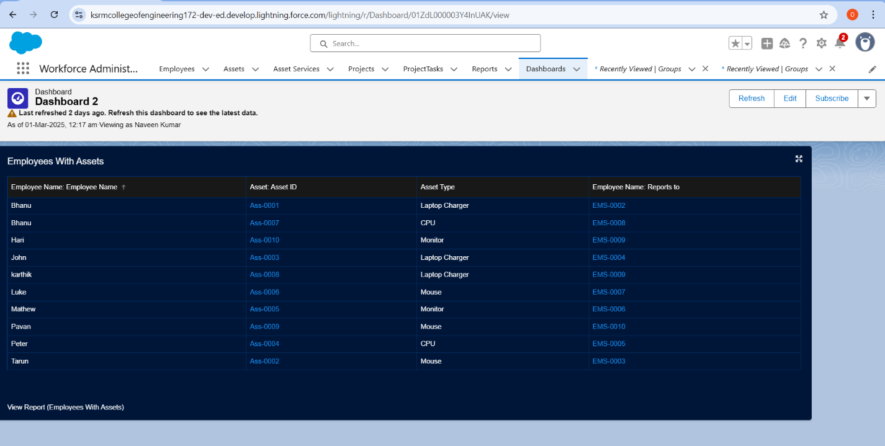





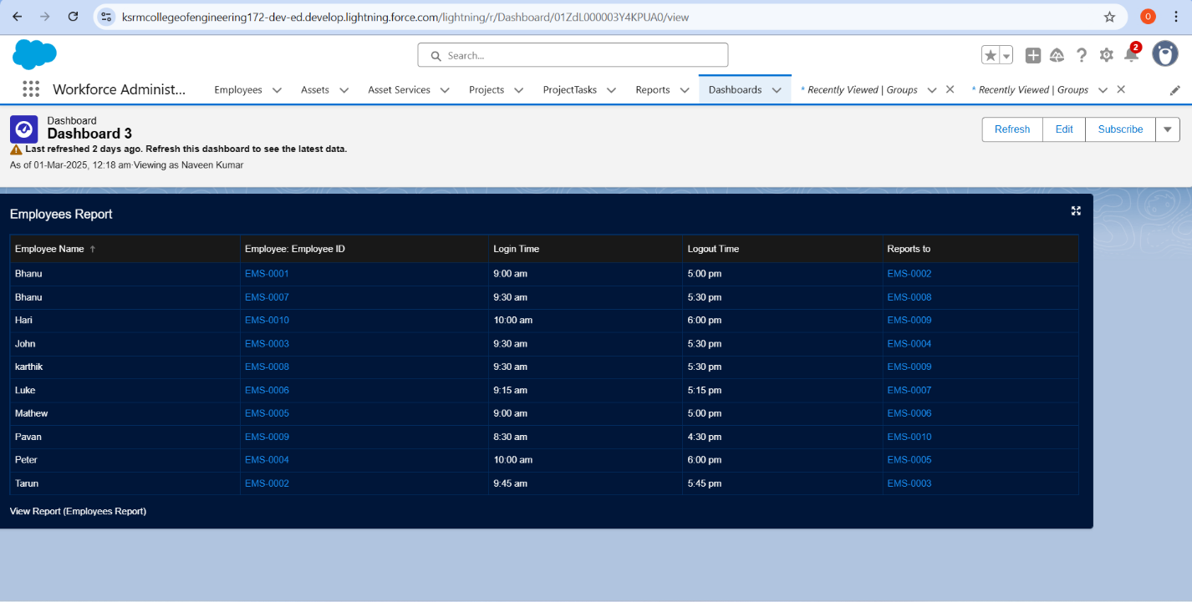

# Testing and Validation

**Approach to Testing and Validation:**

**1.Define Test Scenarios :**Identify key functionalities to test, such as employee data entry, project assignment workflows, asset tracking, and report generation. Include both positive and negative test cases to ensure comprehensive coverage.

**2.Prepare Test Data :**Create realistic test data for objects like Employee, Project, and Asset to simulate real-world scenarios. Ensure data includes edge cases (e.g., overdue assets, overworked employees) to validate system behavior under all conditions.

**3.Unit Testing :**Test individual components, such as validation rules, automation flows, and custom fields, to ensure they function as expected in isolation before integrating them into the overall solution**.**

**4. End-to-End Testing :**Validate complete workflows, such as assigning an employee to a project, allocating assets, and updating statuses, to confirm seamless integration between components and accurate data flow.

**5.User Acceptance Testing (UAT) :**Involve stakeholders (e.g., HR, managers, IT) to test the solution in a sandbox environment. Gather feedback on usability, functionality, and alignment with business requirements.

**6. Bug Fixing and Re-Testing :**Log and address any defects or issues identified during testing. Perform re-testing to ensure fixes are implemented correctly and do not introduce new problems.

**7. Performance and Security Testing :**Verify system performance under high data loads and ensure security settings (e.g., OWD, role hierarchies) protect sensitive information while granting appropriate access.

**8.Final Validation and Sign-Off :**Conduct a final review of the solution against the defined requirements and obtain formal approval from stakeholders before deploying it to production.

# Key Scenarios Addressed by Salesforce in the Implementation Project



1. **Centralized Workforce Management :** Salesforce addresses the challenge of scattered employee data by providing a unified platform to manage employee details, project assignments, and asset allocations, ensuring easy access and real-time updates for all stakeholders.
2. **Automation of Routine Tasks :** Salesforce automates repetitive processes like sending deadline reminders, tracking asset return dates, and updating project statuses, reducing manual effort and minimizing errors while improving operational efficiency.
3. **Enhanced Visibility and Reporting :** Salesforce enables real-time tracking of workforce utilization, project progress, and asset distribution through customizable reports and dashboards, empowering managers to make informed decisions and optimize resource allocation**.**
4. **Scalable and Role-Specific Access :** Salesforce’s role hierarchy, permission sets, and sharing rules ensure secure, scalable, and role-specific access to sensitive data, allowing employees, managers, and HR teams to view only the information relevant to their responsibilities.
5. **Improved Collaboration and Communication :** Salesforce Chatter facilitates seamless communication and collaboration among teams, enabling discussions on project updates, asset management, and performance tracking, which enhances teamwork and issue resolution.
6. **Data Integrity and Compliance :** Salesforce enforces data validation rules, approval processes, and audit trails to maintain accurate records, meet regulatory requirements, and mitigate risks associated with workforce and asset management.
7. **User Adoption and Training Support :** Salesforce ensures smooth user adoption by providing an intuitive Lightning interface, role-specific training, and ongoing support, enabling users to effectively utilize the system in their daily workflows.
8. **Future-Proof Scalability :** Salesforce’s flexible architecture supports future enhancements, such as integrating advanced analytics or external systems, ensuring the solution evolves with the organization’s growing needs.

# Conclusion

In conclusion, the **Workforce Administration Solution** successfully addresses key workforce management challenges by centralizing employee data, automating repetitive tasks, and providing real-time insights into project assignments and asset allocation. Through Salesforce’s robust platform, the project achieved significant milestones, including the creation of a scalable data model with custom objects, streamlined workflows using automation tools like Process Builder and Flow, and enhanced visibility through dynamic reports and dashboards. Role hierarchies and permission sets ensured secure, role-specific access, while Chatter facilitated seamless collaboration among teams. The solution also improved operational efficiency by reducing manual effort, ensuring compliance, and enabling data-driven decision-making. With its intuitive design and focus on user adoption, the project not only met business requirements but also laid a strong foundation for future scalability and enhancements. These achievements collectively empower the organization to optimize resource utilization, boost productivity, and drive long-term success.