Lucas Marcel Silva de Brito

*A fullstack developer who specializes in TypeScript and is a Next.js enthusiast.*

Resume

I'm 20 years old, I live in Brazil (Macau - RN), and I finished the technical high school in informatics at [IFRN - MC](https://portal.ifrn.edu.br/campus/macau) in 2022, even receiving an academic honor. During this period I became a professional in web development with technologies such as [React.js,](https://pt-br.reactjs.org/) [Next.js,](https://nextjs.org/) and [Node.js.](https://nodejs.org/en/) After finishing the [Rocketseat's Ignite](https://www.rocketseat.com.br/ignite) course I got a full scholarship in [Do While 2021.](https://dowhile.io/espera)

At the moment I prefer the Front-end, but I know a little bit of everything I need to complete my projects by myself, with database or not. Mobile application development is na area where I have less experience. My favorite framework is Next.js, with he I can deploy the ecosystem of my projects in an optimized way and without need to separate the Front-end and the Back-end completely.

I started to program in 2018, and today I'm still willing to expand my skills and learn new things as before, continuing my studies.

Some competencies

* I know and have used agile methodologies;
* I’ve experienced a variety of deployment options;
* I understand the database’s entity relations;
* I develop responsively;
* I try to try new things;
* I can find and resolve errors myself.

Soft skills

* Fast reasoning;
* Dedication;
* Constant learning;
* Communication;
* Objectivity;
* Flexibility.

Formations and certificates

* [Informatics](https://drive.google.com/file/d/1fZ-uBi0oNLv1VYnNacIzbgrL1yGOYyQf/view) – IFRN – Feb. 2022;
* [Do While 2021](https://drive.google.com/file/d/1bGLLD-J5xvm3_lJLIp7bnQgWVZYmYkhb/view?usp=sharing) – Rocketseat – Jan. 2022;
* [Ignite: React.js](https://drive.google.com/file/d/1ULHPyXD728rOAql01YTig3Wgwx7M-f_D/view?usp=sharing) – Rocketseat – Dec. 2021;
* [IoT](https://drive.google.com/file/d/1Ub7UsnrhO1-dUwHdg1YcZUb72S-Q4j1Z/view?usp=sharing) – Cisco Network Academy – Dec. 2020;
* [Semana Omnistack 11](https://drive.google.com/file/d/17q3atIdoQvjaIAqXjd0KCCOtbzzyHDuH/view?usp=sharing) – Rocketseat – Mar. 2020.

Technologies proficiency

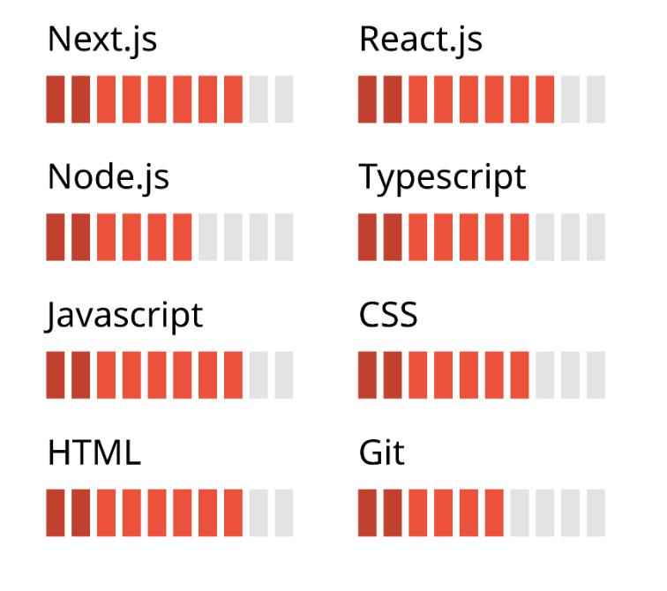

Languages proficiency

* Portuguese – native;
* English – technical.

Contact

* Links: [Homepage](https://l-marcel.vercel.app/) | [Github](https://github.com/l-marcel) | [LinkedIn](https://linkedin.com/in/l-marcel) | [Rocketseat](https://app.rocketseat.com.br/me/l-marcel)
* Email: lmgh1312@gmail.com