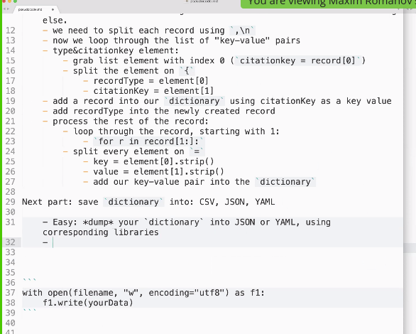
0. look at the file1. create a holder for our data, which will be `dictionary` (dic, list, etc.)
2. read as one big string
3. split into records using `\n@`
- we will get a list of strings
4. loop through all the records:
NB: each records is a string that needs to be converted into something else.
- we need to split each record using `,\n`
- now we loop through the list of “key-value” pairs
- type&citationkey element:
- grab list element with index 0 (`citationkey = record[0]`)
- split the element on `{`
- recordType = element[0]
- citationKey = element[1]
- add a record into our `dictionary` using citationKey as a key value
- add recordType into the newly created record
- process the rest of the record:
- loop through the record, starting with 1:
- `for r in record[1:]:`
- split every element on `=`
- key = element[0].strip()
- value = element[1].strip()
- add our key-value pair into the `dictionary`Next part: save `dictionary` into: CSV, JSON, YAML - Easy: *dump* your `dictionary` into JSON or YAML, using corresponding libraries
- More tricky, but necessary: normalize keys, by replacing rare keys with common keys (for example, year is rare; date is common)```
conversionDic = {
‘year’ : ‘date’,
‘date’ : ‘date’,
...
}

