One D&D:
A Karak Module
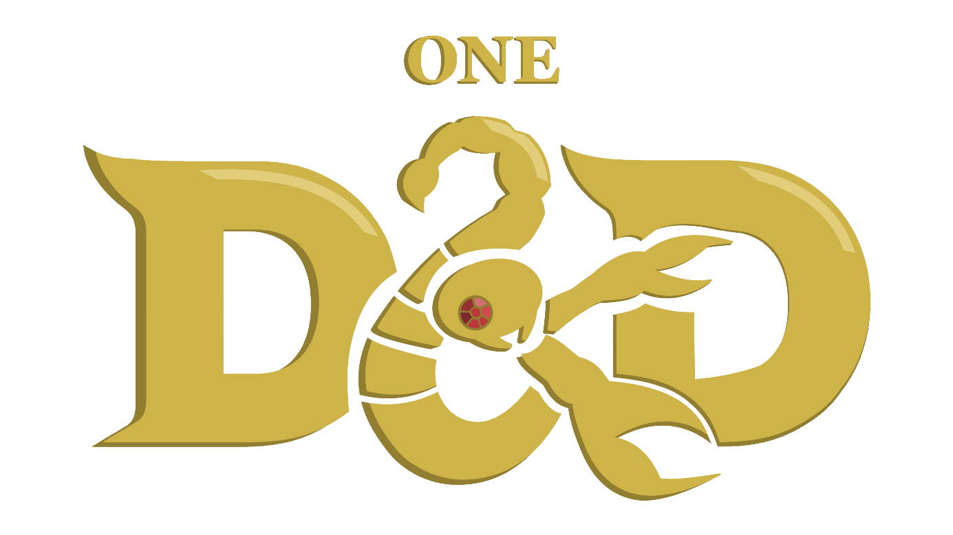
A module by L_PT
Based on Karak by Petr Mikša & Roman Hladík
Table of Contents

Objective of the Game 1
Contents 1
Set-up 1
Turn Order 2
Entering an Undiscovered Tile 2
Entering an Undiscovered Room Tile 2
Battle Companions 5
Bestiary 6
Weapons 6
Rat 6
Skeleton Warrior 6
Skeleton King 7
Daggers, Swords, Axes 7
Magical Scrolls 8
Mummy 8
The Curse of Karak 8
Damage Types 8
Flame Scroll 8
Giant Spider 9
Healing Fountains and Rests 9
Healing Scroll 9
Treasure 10
Skeleton Turnkey 10
The Fallen 10
The Dragon 11
Key & Treasure 11
The Heroes 12
Spellcasting 12
Aderyn, the Assassin 13
Horan, the Ancestral Guardian 14
Victorius, the Champion 15
Argentus, the Wizard 16
Lord Xanrus, the Warlock 17
Taia, the Cleric 18
Elspeth, the Battle Master (SKE) 19
Hannah, the Thief (Regent) 20
Kirima, the Wild Heart (SKE) 21
Valduk, the Bersker (Regent) 22
Baron Markul, the Paladin (Regent) 23
Doctor Sidhar, the Artificer (SKE) 24
Lady Lorraine, the Ranger (Regent) 25

Objective of the Game
The player who has collected the most treasure becomes the victor. The game ends once any player defeats the strongest monster of the game - THE DRAGON - and loots its treasure with a ruby. Each player counts the points from their treasure; treasure collected from chests or by defeating The Fallen are worth 1 Victory Point (VP) each; the dragon ruby is Worth 1,5 VP. The player with the most VPs wins the game.

Contents
In order to play One D&D Karak you will require:
- All of Karak’s (and its extensions) original content
- At least one set of six dice containing a d4, d6, d8, d10, d12 and d20
- Pen and paper to track HP and spell slots
- Easy access to this Rulebook for the complete Hero sheets on pages 13 through 25.

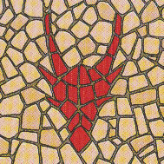
Set-up
- Place the starting dungeon tile (coloured back) in the middle of the playing area.
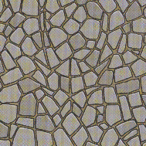
- Shuffle the remaining tiles and place them to the side, face down, so that every player can reach them.
- Each player receives one inventory sheet and five Short Rest tokens (heart/skull), which they place on the inventory sheet.
- Each player picks one hero card, either one of their own choice or randomly (whichever the players agree on), and places it on the inventory sheet.
- Fit the Hero figures into their respective plastic stands and place them on the starting table.
- Roll a d20 to determine which player starts, then go clockwise or anticlockwise from that player.

Turn Order
On their turn, the active player choses what to do. They can move around the dungeon across connected paths or into undiscovered tiles. By default, each Hero has a speed of 4, meaning the player can move up to four tiles in any given turn.

Entering an Undiscovered Tile
In order to move into an undiscovered tile, the player must choose an available path from the tile they are currently in that leads to no tile. When they do so, they will take a tile from the piles and add it to the dungeon. While moving, the player might enter one of four tiles:
- Tunnels, which can be travelled through freely, across connected pathways, for as long as movement allows it.
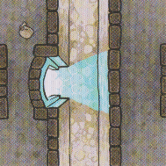
- Rooms, which force the player to draw a token from the bag of monsters and treasures.
- Teleportation Gates – If the new tile contains a Teleportation Gate (TG) and there are more TGs in the dungeon, the player can move between them, spending only one move to teleport from the neighbouring tile into the other side of the gate, or from its own tile to the a neighbouring tile on the other side of the gate.
- Healing Fountains, which prompt the player to choose between passing through as if it were a Tunnel, taking a Short Rest or take a Long Rest.

Entering an Undiscovered Room Tile
When entering a Room tile for the first time, the player that placed the room must take a token from the bag of monsters and treasures and place it on the tile. This token can either be a Treasure or a Monster.
Treasures can be ignored as with tunnels, otherwise the player may choose to open the chest using a key obtained from defeating a Skeleton Turnkey. This uses the key, which must be removed from the game, and ends the player’s turn.
When placing a Monster on the tile, the player automatically initiates combat with the Monster.
Tokens are only added to a Room tile when it is discovered. This means that any player going into that room after it has been emptied mustn’t take a new token to fill it once more.

Initiating Combat
When entering a tile with a Monster, the player initiates combat with it. The following steps happen:
- The player and the Monster each roll a d20 and add their Initiative Modifier. Whoever has the highest total acts first for the remainder of the battle.
- During the first turn of combat, both the player and the monster may only use their starting attack or their items – weapons and scrolls. The player cannot try to flee and neither them nor the monster may use their Combat Features (CF).
- Starting at the second turn, the player may try to flee, triggering an attack of opportunity from the Monster.
- Also, from the second turn onwards, both the player and the Monster can use their CF instead of their attack or items.
The process is the same when engaging with a Monster currently in combat with a different player. The two combats are entirely distinct, if not for the Monster’s Hit Points (HP), which are shared across the two combats. The player that deals the final blow may collect the Monster’s loot.

Combat Actions
During one turn of combat, one of the following things may happen:
- Making a Weapon Attack
The player uses their Base attack. They must roll a d20 and add their Attack Modifier to determine if their attack hits the Monster. If the result is equal to or higher than the target’s Armour Class (AC), then the attack is successful. At this point, they may roll the damage dice according to the attack’s description and add their Damage Modifier.
At this point, up to three Flame Scrolls may also be used by the player.
- Using a Healing Scroll
The player uses a Healing Scroll as described in the Bestiary to teleport themselves out of combat. Combat automatically ends, and the player may continue with their turn.
- Fleeing Combat
Starting at the second turn, the player may try to flee. This allows them to leave combat, but triggers an opportunity attack from the Monster. This means the Monster gets to make one attack for free before the player leaves combat.
- Using the Combat Feature
Starting at the second turn, the player may use their Combat Feature for their action, as described under their character’s subchapter. This includes casting a spell for those that can, assuming they have Spell Slots remaining.

End of Combat
One of four outcomes may happen at the end of any given turn:
- The Monster is defeated
The player moves onto the Monster’s tile; they may collect whatever loot the Monster dropped and finishes their turn.
- The Hero is defeated
The player is knocked unconscious and remains in the tile they are on. They are reduced to 0 Hit Points (HP).
If they still have Short Rests, they will regain one Hit Dice worth of HP on the next turn. They may only start playing again on the turn after that. If they don’t have any Short Rests left, they are teleported to the nearest Healing Fountain (HF). They may only use the HF on their next turn.
The Monster regains all its HP if there are no other players in combat.
- Neither party is defeated
The player ends their turn; the next player gets to play. On the player’s next turn, they are still in combat.
- One of the parties flees combat or is incapacitated
The player may still use their 4 moves after leaving combat. Whether the Monster gets an opportunity attack, and whether the player must return to their original tile is dependent on what ability or action is used to escape. The Monster regains all their HP, but the player does not.

Battle Companions
Battle Companions such as Lady Lorraine’s bear or the conjured beasts from the Find Familiar spell are allies called to aid the Hero in battle.
They are fully controlled by the player on the player’s turn but act independently of the player’s Hero, rolling their own initiative and having their own stats. They don’t have Combat Features or the ability to use or equip items however, meaning they can only take damage and attack.
There are three types of familiars aside from Doctor Sidhar’s Eldritch Cannon. These can be summoned by the Find Familiar spell. The familiar disappears if it reaches 0 HP or when combat ends. Each Hero can only have one familiar at a time.
Remember, Lady Lorraine’s Bear Companion is not a familiar.

Raven
Max HP | 10 | Armour Class | 8 | Peck*
Attack Modifier | +3 | Initiative Modifier | 0 | 1d4 - 1
*This attack targets the enemies’ eye, giving them disadvantage on their next attack roll.

Crab
Max HP | 10 | Armour Class | 12 | Pinch
Attack Modifier | -1 | Initiative Modifier | +4 | 1d6 + 3

Frog
Max HP | 10 | Armour Class | 8 | Acid Spit*
Attack Modifier | +1 | Initiative Modifier | +1 | 1d4
*The target rolls a d20 and adds their Constitution. If the result is lower than 10, they take an additional 1d4 damage.

Eldritch Cannon
Max HP | 15 | Armour Class | 13 | Eldritch Blast
Attack Modifier | +3 | Initiative Modifier | +2 | 1d6 + 2

Bestiary
Each Monster has its own stats, attacks, Combat Features and loot.
- The Rat, Skeleton Warrior and Skeleton King reward the player with a Weapon.
- The Giant Spider and Mummy reward the player with Magical Scrolls.
- The Skeleton Turnkey rewards the player with a Key, The Fallen with a Treasure, and The Dragon with a Treasure and Ruby, worth 1.5 Victory Points.
When defeated, the player turns their token around and choses to take it and add it to their inventory, or to leave it on that tile. The loot may not be discarded.

Weapons

Rat
Wisdom | -3 | Physical | -2 | 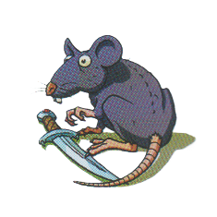
Attack Modifier | -2 | Damage Modifier | -1 | Initiative Modifier | 0
Max HP | 8 | Armour Class | 8 | Bite* | 1d4
*If the target is incapacitated by the attack (brought to 0 HP), they also drop a Weapon on that tile.

Combat Feature – Flee
The Rat flees combat, exiting to a neighbouring tile that doesn’t have a Hero on it. It can flee to an undiscovered tile. If it flees to a tile with a token on it, they will stack, and if it is another Monster they will both be part of the same combat.

Skeleton Warrior
Wisdom | -1 | Physical | +2 | 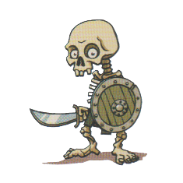
Attack Modifier | 0 | Damage Modifier | +2 | Initiative Modifier | +3
Max HP | 20 | Armour Class | 13 | Sword | 1d6

Combat Feature – Cover
The Skeleton Warrior hides behind its shield. The next attack against it has disadvantage.

Skeleton King
Wisdom | +1 | Physical | +3 | 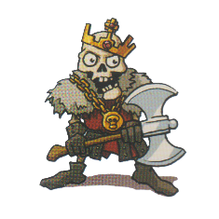
Attack Modifier | +2 | Damage Modifier | +3 | Initiative Modifier | +4
Max HP | 25 | Armour Class | 12 | Axe | 1d10

Combat Feature – Greedy
The Skeleton King steals one of the Hero’s scrolls, if they have any. It is added to the Skeleton King’s tile and may be obtained once more upon the Monster’s defeat.

Daggers, Swords, Axes
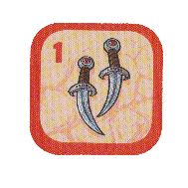
Daggers, Swords and Axes, respectively obtained from defeating a Rat, Skeleton Warrior and Skeleton King are Weapons. They are kept in one of the two Weapon slots of the inventory sheet. If both places are occupied, the player may switch the items out, placing the removed item on that tile.
When placed on the top slot – the main-hand – the Hero gains a boost to their stats:
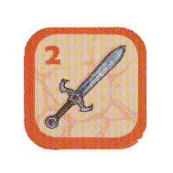
- Daggers – Increases the Hero’s Attack Modifier to 0 if it is negative, or by +1 if it is positive.
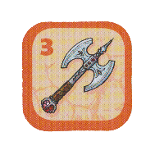
- Sword – Increases the Hero’s Attack Modifier and Damage Modifier by +1 each.
- Axe – Increases the Hero’s Damage Modifier by +2 if it is negative, or by +1 if it is positive.
When placed on the bottom slot – the off-hand – the Hero gains an additional attack. It is performed after the player makes their Base attack and rolls its own Attack Modifier, meaning it risks failing, but allows the player to add their Damage Modifer once more. The Weapons’ additional attack deals 1d4, 1d6 and 1d10 Physical damage respectively.

Magical Scrolls

Mummy
Wisdom | -1 | Physical | +1 | 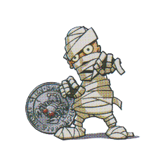
Attack Modifier | 0 | Damage Modifier | +1 | Initiative Modifier | +2
Max HP | 20 | Armour Class | 12 | Smack | 1d6
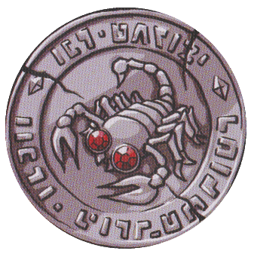
Note: The Mummy takes double damage from Fire.

Combat Feature – Curse
The Mummy inflicts the Curse of Karak upon the player until the end of the combat.

The Curse of Karak
If any player defeats a Mummy, one player becomes cursed. The player who defeated the Mummy chooses another player and places the curse token on their inventory sheet. The player whose Hero was cursed and has the curse token on their Hero’s card cannot use their hero’s Health, Attack and Move Skills but can still use their Combat Feature.
The curse can be lifted by finishing one’s turn on a tile with a Healing Fountain. The curse can also be passed on when another Mummy is defeated, and the player moves the curse token to another player. However, the token does not have to be moved; it can stay on the owner at that time.

Damage Types
There are two damage types from attacks: Physical and Fire. Unless specified otherwise, all attacks deal Physical damage.

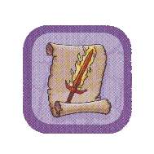
Flame Scroll
The Flame Scroll can be obtained by defeating a Mummy. They are kept in one of the three Scroll slots of the inventory sheet. If all places are occupied, the player may switch the items out, placing the removed item on that tile.
When using it, you add an additional 1d4 + your Wisdom (WIS) as Fire damage to your Base attack. You can choose whether to use the scroll after rolling your damage. In addition, more than one Flame Scroll can be used during one action.
Upon usage, the scroll is consumed and must be removed from the game.

Giant Spider
Wisdom | -2 | Physical | +1 | 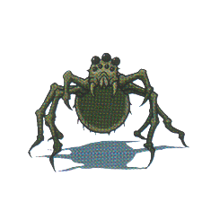
Attack Modifier | -1 | Damage Modifier | +1 | Initiative Modifier | +2
Max HP | 12 | Armour Class | 10 | Bite | 1d4
*If the target is incapacitated by the attack (brought to 0 HP), they also drop a Weapon on that tile.

Combat Feature – Web
The Giant Spider webs the Hero down. They cannot flee combat until either them or the Giant Spider is defeated.

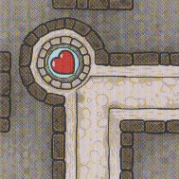
Healing Fountains and Rests
Each Hero has a different maximum Hit Point (HP) count, type of Hit Dice and Constitution modifier (CON), as described in The Heroes but all have 5 Short Rest tokens (heart/skull).
When a player walks through a Healing Fountain (HF) but doesn’t stop there, they may use up to 2 Short Rest tokens, to heal by an amount of one Hit Dice + CON per token expended.
If they instead choose to finish their turn on a HF – therefor taking a Long Rest – they will regain all their HP, restore all expended Short Rest tokens and Spell Slots, and lift the Curse of Karak.

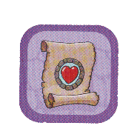
Healing Scroll
The Healing Scroll can be acquired by defeating a Giant Spider. They are kept in one of the three Scroll slots of the inventory sheet. If all places are occupied, the player may switch the items out, placing the removed item on that tile.
It can be used on any Hero, not just the player. The target is then moved to any revealed HF and makes automatically makes a Long Rest. This does not cost any moves, and it does not end the turn. It must however be done before moving.
If used during combat, the player automatically flees, and the Monster cannot take an opportunity attack.
Upon usage, the scroll is consumed and must be removed from the game.

Treasure

Skeleton Turnkey
Wisdom | -1 | Physical | 0 | 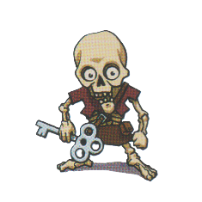
Attack Modifier | 0 | Damage Modifier | 0 | Initiative Modifier | +1
Max HP | 15 | Armour Class | 11 | Smack | 1d6

Combat Feature – Flee
The Skeleton Turnkey flees combat, exiting to a neighbouring tile that doesn’t have a Hero on it. It can flee to an undiscovered tile. If it flees to a tile with a token on it, they will stack, and if it is another Monster they will both be part of the same combat.

The Fallen
Wisdom | +4 | Physical | +2 | 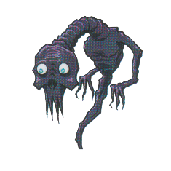
Attack Modifier | +5 | Damage Modifier | +2 | Initiative Modifier | +3
Max HP | 25 | Armour Class | 15 | Whisp | 1d10

Combat Feature – Memories of the Past
The Fallen uses the Combat Feature of the Hero that first fought it.

The Dragon
Wisdom | +3 | Physical | +3 | 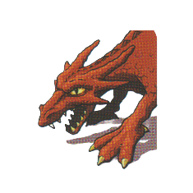
Attack Modifier | +4 | Damage Modifier | +3 | Initiative Modifier | +4
Max HP | 50 | Armour Class | 14 | Bite | 1d12

Combat Feature – Fire Breath
The Dragon deals 1d8 Fire damage to every enemy in combat. This automatically hits.


Key & Treasure
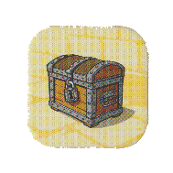
Keys can be obtained by defeating a Skeleton Turnkey. They are kept in the Key slot of the inventory sheet. If the slot is occupied, the player must leave the key on that tile.
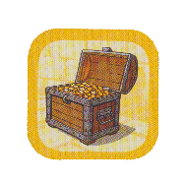
A key can be used to unlock any Treasure chest. To unlock a chest, the player must end their turn on a tile with a locked Treasure. They can flip the Treasure token and keep it on them as 1 Victory Point (VP). The key is removed from the game.
The Fallen reward the player with a Treasure of equal value to those opened with a key.
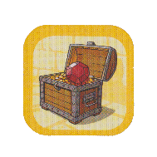
Defeating the Dragon also awards the player with treasure: A regular chest of 1 VP containing a Ruby that is worth ½ VP. This means that defeating the Dragon, rewards the player with 1,5 VP, and not with automatic victory.

The Heroes
Each Hero has various stats all with a lot of importance. Physical (PHY), Wisdom (WIS) and Constitution (CON) are the base stats, that serve to define the rest. PHY represents strength and dexterity, CON affects endurance and healing, WIS defines the character’s wits, which includes their ability to land an attack.
Their Hit Dice is the type of dice rolled when restoring health from a Short Rest.
The Attack Modifier is added to attack rolls to see if the attack lands. On a success, the Damage Modifier is added to the Base attack or Weapon attacks. The Initiative Modifier is added when defining combat turn order.
Each Hero has a Health, Attack and Movement skill that affects those three aspects respectively. These are usually passive and can be temporarily deactivated by the Curse of Karak.
The Combat Feature can be used instead of the Base attack (and any subsequent weapon attacks) starting from the second turn of combat.

Spellcasting
There are two types of heroes, Martial and Spellcasters. Spellcasters all have the same Combat Feature “Spellcasting”, though their list of spells varies. There are two types of spells: Cantrips and Levelled Spells.
Cantrips can be cast indefinitely, while Levelled Spells use one Spell Slot each to be cast. Each Hero has two Spell Slots, which are restored upon taking a Long Rest at a Healing Fountain.
The player may also choose to “Up-cast” their spell, this means using both spell slots on a single spell, for a more powerful effect.
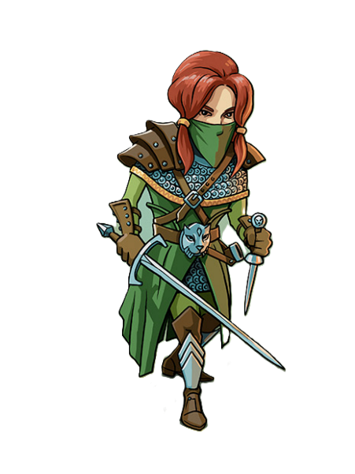

Aderyn, the Assassin
Max HP – 25
Hit Dice – d8
Armour Class – 12
Base attack – Sword and Dagger: Two regular attacks, 1d4 + Damage Mod Physical damage each.

Combat Skill – Cunning Hide
Aderyn can use her turn in combat to Hide. This will use her action but give her advantage on the first attack of her next turn, and trigger her Attack Skill. If she goes before the Monster, it will also have disadvantage on attacks against her while she is hidden.
WIS | +1 | PHY | +1 | CON | -1
Attack Modifier | +2 | Damage Modifer | +1 | Initiative Modifer | +2
Health Skill |  | Evasion | If the Monster’s attack roll hits Aderyn’s AC by a two-point difference (12 or 13), she evades the attack.
Attack Skill |  | Sneak Attack | Aderyn does an additional 1d6 Physical damage on all attacks if she hid last turn.  She also gains 1d6 extra damage on her first attack after initiating combat with a discovered Monster.
Movement Skill |  | Stealth Expertise | Aderyn can ignore monsters, passing by their tile and finishing her turn on it without initiating combat if she so chooses. If she is cursed while on a Monster’s tile, she is forced into combat.

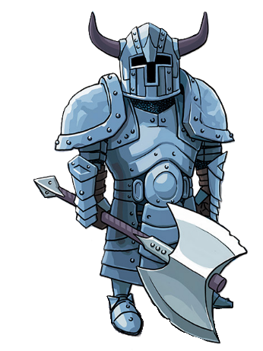
Horan, the Ancestral Guardian
Max HP – 35
Hit Dice – d10
Armour Class – 12
Base attack – Barbarian Battleaxe: Regular attack, 1d8 + Damage Mod Physical damage.

Combat Feature – Ancestral Protector
Horan calls upon his ancestors to create a spirit shield. For the next two turns or until the end of combat, whichever comes first, Horan takes 1d4 less damage from all attacks and deals the same amount of damage back to the attacker.
WIS | -2 | PHY | +1 | CON | +2
Attack Modifier | -1 | Damage Modifer | +1 | Initiative Modifer | +2
Health Skill |  | Relentless | If Horan loses his last HP, he does not fall unconscious like other weaklings, instead he teleports to a Healing Fountain. He can use it on the next turn.
Attack Skill |  | Extra Attack | Horan can make two Base attacks, unless both his Weapon slots are occupied.
Movement Skill |  | Fast Movement | Horan has a speed of 5 instead of 4.

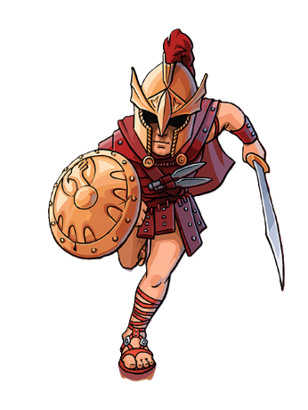
Victorius, the Champion
Max HP – 30
Hit Dice – d10
Armour Class – 13
Base attack – Sword and Shield: Regular attack, 1d6 + Damage Mod Physical damage. Has +2 AC so long as his off-hand Weapon slot isn’t occupied.

Combat Feature – Disengage
Victorius can flee combat without triggering an opportunity attack from the monster. He can also flee past the monster into undiscovered tiles.
WIS | 0 | PHY | +1 | CON | 0
Attack Modifier | +1 | Damage Modifer | +1 | Initiative Modifer | +2
Health Skill |  | Second Wind | When Victorius rolls a 3 on any dice – attack roll or damage roll – he regains 3 HP.
Attack Skill |  | Great Weapon Fighting | When Victorious rolls a 1 on his damage rolls, he can reroll it once.
Movement Skill |  | Action Surge | If Victorius rolls the maximum amount on either any of his dice – attack roll or damage roll – he can continue his turn afterwards.  This means he can continue if he defeats the monster or he can make a singular additional Base attack if the Monster survived.

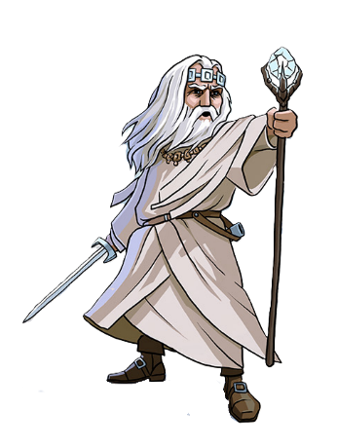
Argentus, the Wizard
Max HP – 30
Hit Dice – d6
Armour Class – 11
Base attack – Sword: Regular attack, 1d6 + Damage Mod Physical damage.

Combat Feature – Spellcasting
Cantrips: Firebolt, Ray of Frost – Levelled Spells: Magic Missiles, Sleep. Argentus has two Spell Slots for levelled spells.
WIS | +2 | PHY | 0 | CON | -1
Attack Modifier | +3 | Damage Modifer | 0 | Initiative Modifer | +1
Health Skill |  | Arcane Recovery | When taking a Short Rest, Argentus regains one Spell Slot.
Attack Skill |  | Spell Mastery | Agrentus does not consume the Flame Scroll when using it.
Movement Skill |  | Astral Walking | Argentus can move through walls into discovered tiles.

Firebolt
Make a regular attack roll. On a success, Argentus deals 1d6 + WIS Fire damage.

Ray of Frost
Make a regular attack roll. On a success, Argentus deals 1d4 + WIS Physical damage, and the target cannot flee combat.

Magic Missiles
Argentus deals 3d4 Physical damage, which can be spread across multiple targets. All damage automatically hits. Up-cast – Add the WIS to each of the 3d4.

Sleep
Make a regular attack roll. On a success, if the target’s WIS is of +1 or lower, it falls asleep. Combat automatically ends as if the target had fled, and the tile acts as if it were empty.
The target wakes back up on the next turn of the player who cast the spell, or if another player initiates combat with it. Up-cast – The spell works on targets with WIS +2 or lower.

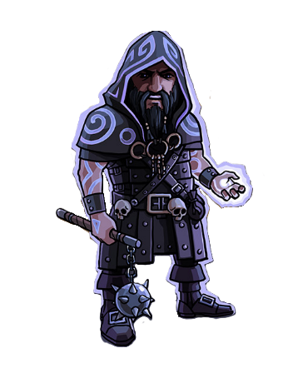
Lord Xanrus, the Warlock
Max HP – 40
Hit Dice – d8
Armour Class – 10
Base attack – Flail: Regular attack, 1d6 + Damage Mod Physical damage.

Combat Feature – Spellcasting
Cantrips: Eldritch Blast, Blade Ward – Levelled Spells: Inflict Wounds, False Life. Lord Xanrus has two Spell Slots for levelled spells.
WIS | +1 | PHY | -2 | CON | +2
Attack Modifier | +2 | Damage Modifer | -2 | Initiative Modifer | -1
Health Skill |  | Sacrifice | Once per combat, Lord Xanrus can sacrifice 6 hp to add 1d12 to the damage of his attack.
Attack Skill |  | Repelling Blast | Lord Xanrus’ Eldritch Blast spell knocks the Monster back on a hit. The Monster skips its next turn.
Movement Skill |  | Magical Swap | At the start of his turn, Lord Xanrus can swap his position with any other hero.  When swapping with a player in combat, he can choose whether to resume combat or not and vice-versa for the swapped player if Lord Xanrus was in combat.

Eldritch Blast
Make a regular attack roll. On a success, Lord Xanrus deals 1d6 + WIS damage.

Blade Ward
Lord Xanrus has resistance against Physical damage until the player’s next turn.

Inflict Wounds
Lord Xanrus deals 2d10 Physical damage to a single target. As he must hold the target to damage him, the attack automatically hits, but the caster cannot flee. Up-cast – The attack deals 3d10 Physical damage instead.

False Life
Lord Xanrus gains 8 Temporary HP, which disappears after the fight and cannot be healed. It does not count as healing, and can therefore be added on top of the Max HP. Up-cast – Lord Xanrus heals for 1d4 + WIS HP and gains 10 Temporary HP instead.

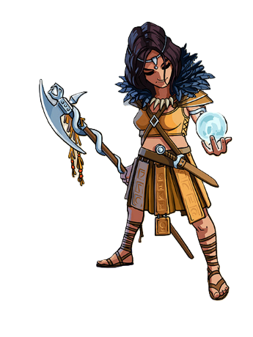
Taia, the Cleric
Max HP – 25
Hit Dice – d6
Armour Class – 14
Base attack – Fate weaver’s Halberd: Regular attack, 1d6 + Damage Mod Physical damage. Gains +1 to Attack Rolls with the Halberd if both Weapon slots are filled.

Combat Feature – Spellcasting
Cantrips: Sacred Flame, Guidance – Levelled Spells: Find Familiar, Guiding Bolt. Taia has two Spell Slots for levelled spells.
WIS | +1 | PHY | +1 | CON | -1
Attack Modifier | +2 | Damage Modifer | +1 | Initiative Modifer | +2
Health Skill |  | Disciple of Life | Taia adds +2 to the results of Hit Dice rolls.
Attack Skill |  | True Sight | Taia has advantage on all her Attack rolls if she triggered combat in her first move.  She also has +1 to all her Attack rolls if she starts her turn in combat.
Movement Skill |  | Arcane Eye | Taia can draw two tokens and choose which she wants to place into the dungeon.

Sacred Flame
The target rolls a d20 and adds their WIS. If the total is lower than 13, it takes 1d10 + Taia’s WIS as Fire damage. This spell ignores advantages and disadvantages.

Guidance
You gain advantage on your next attack if Taia doesn’t take damage until then. If there is a weapon in the off-hand Weapon slot, Taia can still make an attack with it this turn.

Find Familiar
Taia summons a familiar from the list to fight at her side. Up-cast – The Familiar does not disappear once combat ends.

Guiding Bolt
Make a regular attack roll. On a success, Taia deals 2d6 + WIS Fire damage and has advantage on her next attack against the target. Up-cast – The spell gives Taia advantage even on a failed attack roll.

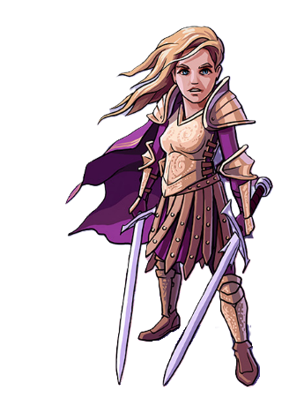
Elspeth, the Battle Master (SKE)
Max HP – 30
Hit Dice – d8
Armour Class – 11
Base attack – Sword: Regular attack, 1d6 + Damage Mod Physical damage.

Combat Feature – Student of War
Elsbeth attacks with her Base attack twice. If both fail, she gains advantage on her next turn. If both succeed, she heals 1d4 HP.
WIS | 0 | PHY | +2 | CON | -1
Attack Modifier | +1 | Damage Modifer | +2 | Initiative Modifer | +3
Health Skill |  | Indomitable | Elspeth can reroll each of her Hit Dice once. She must use the second roll.
Attack Skill |  | Two Weapon Fighting | Weapons in Elspeth’s off-hand Weapon slot also give their main hand Weapon slot bonus.
Movement Skill |  | Know Your Enemy | Elspeth can use one movement and sacrifice 6 HP to move through a tile with a Monster and into a neighbouring tile – including undiscovered tiles – without initiating combat.

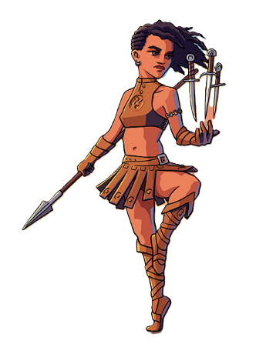
Hannah, the Thief (Regent)
Max HP – 30
Hit Dice – d8
Armour Class – 10
Base attack – Spear: Regular attack, 1d6 + Damage Mod Physical damage.

Combat Feature – Thief’s Reflexes
Hannah prepares a cunning strike. On her next two turns, she can act before and after the Monster. This Combat Feature can only be used once per fight.
WIS | +1 | PHY | 0 | CON | 0
Attack Modifier | +2 | Damage Modifer | 0 | Initiative Modifer | +1
Health Skill |  | Reliable Talent | When rolling Hit Dice, any results under 4 are treated as a 4 by Hannah.
Attack Skill |  | Throwing Daggers | Hannah can store Daggers in the scroll slots. Each adds 1d4 damage to her main attack and isn’t consumed upon use.  If she receives the Curse of Karak while having Daggers in her Scroll Slots, she can’t use or remove them.
Movement Skill |  | Cunning Dash | Hannah can choose to Dash at the start of her turn. If she does, she has 8 speed that turn but can only travel across Discovered Tiles.  When dashing, Hannah can pick up items without ending her turn, but not open chests or initiate combat.

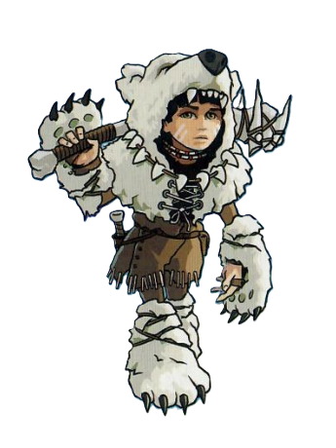
Kirima, the Wild Heart (SKE)
Max HP – 25
Hit Dice – d10
Armour Class – 12
Base attack – Club: Regular attack, 1d8 + Damage Modifier Physical damage. Deals 1d10 Damage instead if there are no weapons in the main hand Weapon slot.

Combat Feature – Aspect of the Beast
Kirima can use the Combat Feature (CF) of the Monster she is fighting. If fighting The Fallen for the first time, she can choose another player’s Hero to copy the CF of. That Fallen will also have that CF.
WIS | +2 | PHY | 0 | CON | -1
Attack Modifier | +3 | Damage Modifer | 0 | Initiative Modifer | +1
Health Skill |  | Danger Sense | Kirima always goes first on Initiative order.
Attack Skill |  | Ambush | Kirima has +1 to her Damage Modifier when fighting against a Monster on a tile that has already been discovered before her turn.
Movement Skill |  | Nature Speaker | Kirima can summon a Familiar, which persists across battles, but disappears after a Short Rest or Long Rest.  After using this skill, Kirima can only use it again after a Short Rest or Long Rest.

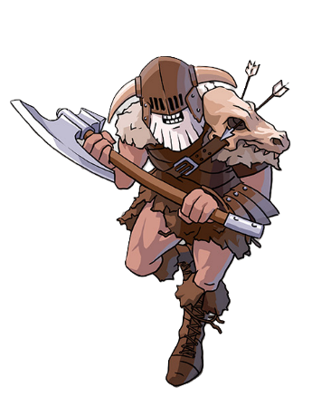
Valduk, the Berserker (Regent)
Max HP – 30
Hit Dice – d10
Armour Class – 13
Base attack – Barbarian Battleaxe: Regular attack, 1d8 + Damage Mod Physical damage.

Combat Feature – Rage
Valduk can use his action on his turn to Rage. For the next two turns or until the end of combat, whichever comes first, Valduk is resistant to Physical damage, and he recieves +1 to his Attack Modifier.
WIS | -2 | PHY | +2 | CON | +1
Attack Modifier | -1 | Damage Modifer | +2 | Initiative Modifer | +3
Health Skill |  | Berserk | If Valduk is below 20 HP, his Damage Modifier is increased by +1.  If he is below 10 HP, it is increased by +2 instead.
Attack Skill |  | Reckless | Valduk can grant himself advantage on his attacks for a turn, but the next attack against him during this combat will also have advantage.
Movement Skill |  | Frenzy | If he doesn’t collect the loot after combat is over, Valduk can continue his turn.

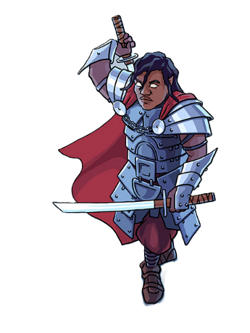
Baron Markul, the Paladin (Regent)
Max HP – 25
Hit Dice – d10
Armour Class – 12
Base attack – Sword: Regular attack, 1d6 + Damage Mod Physical damage.

Combat Feature – Spellcasting
Cantrips: Blade Ward, Sacred Flame – Levelled Spells: Divine Smite, Shield of Faith. Baron Markul has two Spell Slots for levelled spells.
WIS | +1 | PHY | +1 | CON | -1
Attack Modifier | +2 | Damage Modifer | +1 | Initiative Modifer | +2
Health Skill |  | Oath of Devotion | Baron Markul can cast Shield of Faith without expending a spell slot.
Attack Skill |  | Dueling | Baron Markul’s Swords in the main Slot grant an additional +1 to his Damage Modifier.  His Swords in the off-hand Slot deal 1d6 + 1 damage instead.
Movement Skill |  | Blitz Attack | At the start of his turn, Baron Markul can move to any discovered tile next to a Monster not currently in combat.  He immediately initiates combat with the Monster on the neighbouring tile.

Blade Ward
Baron Markul has resistance against Physical damage until the player’s next turn.

Sacred Flame
The target rolls a d20 and adds their WIS. If the total is lower than 13, it takes 1d10 + Baron Markul’s WIS as Fire damage. This spell ignores advantages and disadvantages.

Shield of Faith
Baron Markul gains +2 AC until the end of combat. Up-cast – The increased AC persists until the end of the next combat, and Baron Markul heals for 1d6 + WIS HP.

Divine Smite
This spell can be cast after a successful attack roll. Baron Markul deals an additional 1d8 Fire damage to the target. Up-cast – It deals 2d8 + 2 Fire damage instead.

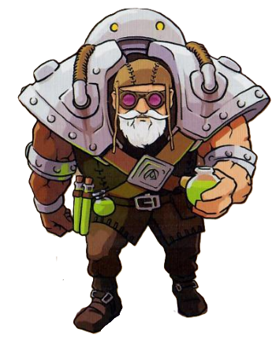
Doctor Sidhar, the Artificer (SKE)
Max HP – 30
Hit Dice – d8
Armour Class – 11
Base attack – Smack: Regular attack, 1d6 + Damage Mod Physical damage.

Combat Feature – Spellcasting
Cantrips: Acid Splash, Firebolt – Levelled Spells: Guiding Bolt, Magic Missile. Doctor Sidhar has two Spell Slots for levelled spells.
WIS | +1 | PHY | -1 | CON | +1
Attack Modifier | +2 | Damage Modifer | -1 | Initiative Modifer | 0
Health Skill |  | Armorer | Doctor Sidhar has 14 AC.
Attack Skill |  | Artillerist | Doctor Sidhar can use a Spell Slot to summon an Eldritch Cannon Familiar.
Movement Skill |  | Alchemist | When taking a token from the bag, Doctor Sidhar can sacrifice 6 HP to take a different one. He can do so as many times as he wants.

Acid Splash
Make a regular attack roll. On a success, Doctor Sidhar deals 1d4 + WIS Physical damage. The target rolls a d20 + CON. If the total is less than 13, they take an additional 1d6 + WIS damage.

Firebolt
Make a regular attack roll. On a success, Doctor Sidhar deals 1d6 + WIS Fire damage.

Guiding Bolt
Make a regular attack roll. On a success, Doctor Sidhar deals 2d6 + WIS damage and has advantage on his next attack against the target. Up-cast – The spell gives Doctor Sidhar advantage even on a failed attack roll.

Magic Missiles
Doctor Sidhar deals 3d4 Physical damage, which can be spread across multiple targets. All damage automatically hits. Up-cast – Add the WIS to each of the 3d4.

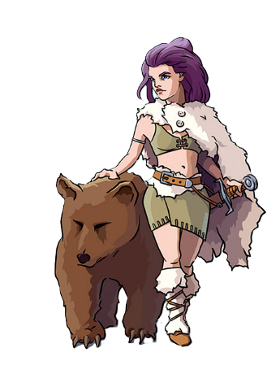
Lady Lorraine, the Ranger (Regent)
Max HP – 25
Hit Dice – d6
Armour Class – 11
Base attack – Sword: Regular attack, 1d6 + Damage Mod Physical damage.

Combat Feature – Spellcasting
Cantrips: Blade Ward, Ray of Frost – Levelled Spells: Find Familiar, Hunter’s Mark. Lady Lorraine has two Spell Slots for levelled spells.
WIS | +1 | PHY | +1 | CON | -1
Attack Modifier | +2 | Damage Modifer | +1 | Initiative Modifer | +2
Health Skill |  | Tireless | If Lady Lorraine uses all her movement on a single turn, she heals for 1d4 HP.
Attack Skill |  | Beastmaster | When Lady Lorrain rolls a 1 on any damage dice, her Bear Companion replaces that with a 1d4 + 1 Physical damage.
Movement Skill |  | Natural Explorer | Lady Lorraine can expend 1 movement to discover a tile without moving onto it or entering combat. She must then expend another movement if she wishes to go to it.

Blade Ward
Lady Lorraine has resistance against Physical damage until the player’s next turn.

Ray of Frost
Make a regular attack roll. On a success, Lady Lorraine deals 1d4 + WIS Physical damage, and the target cannot flee combat.

Find Familiar
Lady Lorraine summons a familiar from to list the fight at her side. Up-cast – The Familiar does not disappear once combat ends.

Hunter’s Mark
Lady Lorraine marks a Monster as her Prey. All damage dealt by her of her allies (Familiars and the Bear Companion) do an additional +2 damage. Only one Monster may be marked as Prey at a time. Up-cast – The Prey takes an additional 1d4 + 1 damage instead.

