One D&D:
A Karak Module
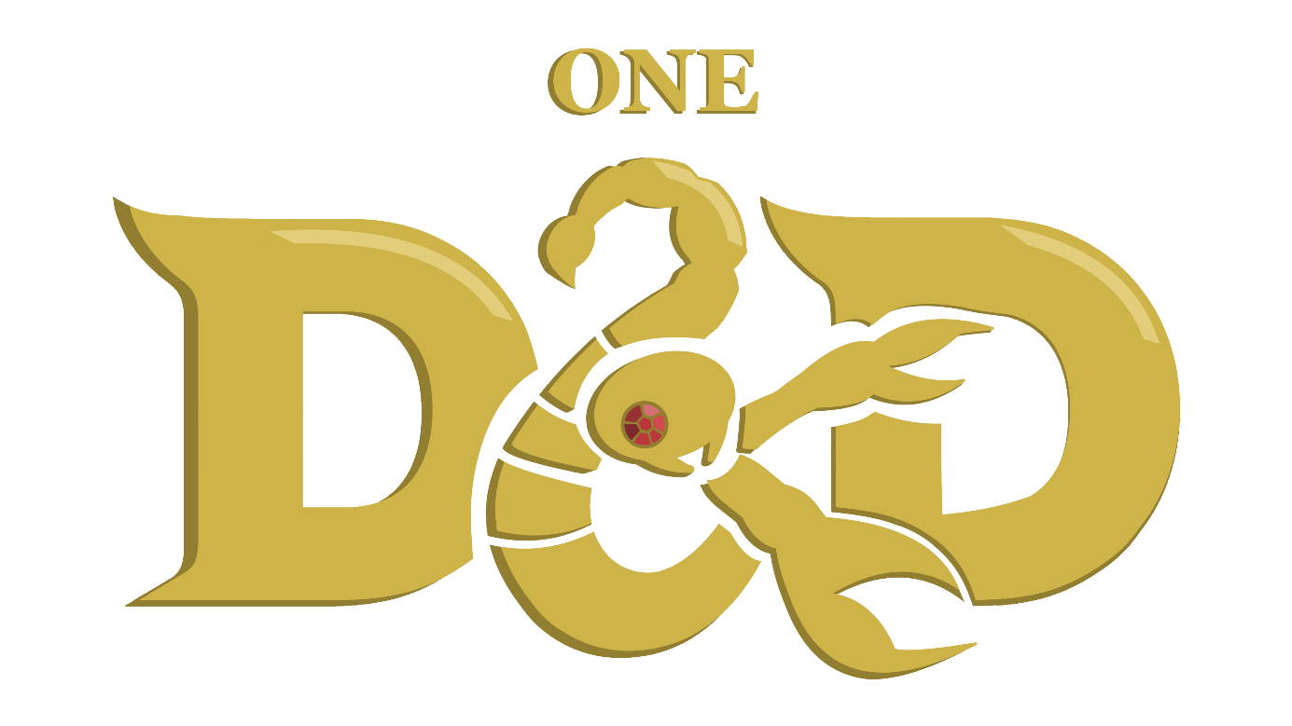
A module by L_P’Tato
Based on Karak by Petr Mikša & Roman Hladík
Table of Contents

Objective of the Game 1
Contents 1
Set-up 1
Turn Order 2
Entering an Undiscovered Tile 2
Hit Points, Healing Fountains and Rests 2
Entering an Undiscovered Room Tile 3
Monsters, Treasures and Items 6
Weapons 7
Rat 7
Skeleton Warrior 7
Skeleton King 8
Daggers, Swords, Axes 8
Magical Scrolls 9
Mummy 9
The Curse of Karak 9
Flame Scroll 9
Giant Spider 10
Healing Scroll 10
Treasure 11
Skeleton Turnkey 11
The Fallen 11
The Dragon 12
Key & Treasure 12
The Heroes 13
Spellcasting 13
Aderyn, the Assassin 14
Horan, the Ancestral Guardian 15
Victorius, the Champion 16
Argentus, the Wizard 17
Lord Xanrus, the Warlock 18
Taia, the Cleric 20
Elspeth, the Battle Master ^{(SKE)} 22
Hannah, the Thief ^{(Regent)} 23
Kirima, the Wild Heart ^{(SKE)} 24
Valduk, the Berserker ^{(Regent)} 25
Baron Markul, the Paladin ^{(Regent)} 26
Doctor Sidhar, the Artificer ^{(SKE)} 28
Lady Lorraine, the Ranger ^{(Regent} 30
List of Familiars 32

Objective of the Game
The game is played between 3 to 6 people. Up to five of them act as players, taking control of a Hero. The last person takes the role of the Dungeon Master: the master of the games who controls all the Monsters. He also acts as a mediator. It is recommended for the DM to check out the One D&D Dungeon Master Guide.
The player who has collected the most treasure at the end of the game becomes the victor. The game ends once any player defeats the strongest monster - THE DRAGON - and loots its treasure with a ruby. Each player counts the points from their treasure; treasure collected from chests or by defeating The Fallen are worth 1 Victory Point (VP) each; the dragon ruby is Worth 1,5 VP. The player with the most VPs wins the game.

Contents
In order to play One D&D Karak you will require:
- All of Karak’s (and its extensions) original content
- At least one set of six dice containing a d4, d6, d8, d10, d12 and d20
- Pen and paper to track HP and spell slots
- Easy access to this Rulebook for the complete Hero sheets.

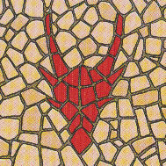
Set-up
- Place the starting dungeon tile (coloured back) in the middle of the playing area.
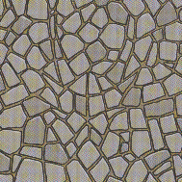
- Shuffle the remaining tiles and place them to the side, face down, so that every player can reach them.
- Each player receives one inventory sheet and five Short Rest tokens (heart/skull), which they place on the inventory sheet.
- Each player picks one hero card – either one of their own choice or randomly (whichever the players agree on) – and places it on the inventory sheet.
- Fit the Hero figures into their respective plastic stands and place them on the starting tile.
- Roll a d20 to determine which player starts, then go clockwise or anticlockwise from that player, depending on the second highest roll.

Turn Order
On their turn, the active player choses what to do. They can move around the dungeon across connected paths or into undiscovered tiles. By default, each Hero has a speed of 4, meaning the player can move up to four tiles in any given turn.

Entering an Undiscovered Tile
In order to move into an undiscovered tile, the player must choose an available path from the tile they are currently in that leads to no tile. When they do so, they will take a tile from the piles and add it to the dungeon. While moving, the player might enter one of four tiles:
- Tunnels, which can be travelled through freely, across connected pathways, for as long as movement allows it.
- Rooms, which force the player to draw a token from the bag of monsters and treasures.
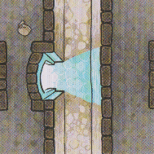
- If the new tile contains a Teleportation Gate (TG) and there are more TGs in the dungeon, the player can move between them, spending only 1 movement to teleport from the neighbouring tile int the other side of the gate, or from its own tile to a neighbouring tile on the other side of the gate.
- Healing Fountains, which prompt the player to choose between passing through as if it were a Tunnel, therefore taking a Short Rest, or ending their turn on that tile to take a Long Rest.

Collecting Abandoned Loot
If a player finds themselves in a tile that contains any number of items on it, they may end their turn to collect any loot they desire from that tile.

Hit Points, Healing Fountains and Rests
Each Hero has three stats relating to their health: Hit Point (HP) maximum, type of Hit Dice and Constitution modifier (CON). Each Hero also starts the game with five Short Rest tokens – small circular token with a heart/skull.
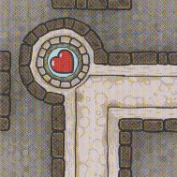
When a player walks through a tile with a Healing Fountain (HF) but doesn’t end their turn on it, they may spend up to 2 Short Rest tokens, to heal by an amount of 2 Hit Dice + CON per token expended.
If they instead end their turn on the tile with a HF – therefor taking a Long Rest – they will regain all their HP, restore all Spell Slots, and lift the Curse of Karak.
Short Rest tokens can never be restored until the end of the game.

Entering an Undiscovered Room Tile
When entering a room tile for the first time, the player that placed the room must take a token from the bag of monsters and treasures and place it on the tile. This token can either be a Treasure or a Monster.
Treasures can be ignored as if they were tunnels, or the player may choose to open the chest using a key obtained from defeating a Skeleton Turnkey. This uses the key, which must be removed from the game, and ends the player’s turn.
When placing a Monster on the tile, the player automatically initiates combat with the Monster.
Tokens are only added to a room tile when it is first discovered. This means that any player going into that room after it has been emptied mustn’t take a new token to fill it once more.

Initiating Combat
When entering a tile with a Monster, the player initiates combat with it.
The player and the Monster each roll a d20 and add their Initiative Modifier. Whoever has the highest total acts before the other for the remainder of the battle. If there are multiple enemies in Combat, they roll individually to go before or after the player in initiative order.
The process is the same when engaging with a Monster currently in combat with a different player. The two combats are entirely distinct, if not for the Monster’s Hit Points (HP), which are shared across the two combats. The player that deals the final blow may collect all the loot on that tile.
No loot may be collected on a tile which has a Monster in it, for as long as the Monster is still on that tile.

Basic Combat Mechanics
There are two ways in which an attack can take place:
- Attack Roll
Any regular attack is made in two parts. First the attacker makes an “attack roll.” To do so, they roll a d20 and add their Attack Modifier.
To determine if the attack “hits” – meaning whether or not it deals damage to the defender – the total result from the d20 + Attack Mod must be equal to or higher than the defender’s Armour Class.
On a success, the attacker rolls damage as described by the attack. At this point, they may also add their Damage Modifier or their Wisdom score to the damage dice, depending on the attack’s description, to define the total amount of the damage delt to the defender.
- Saving Throw
Some attacks, primarily magical spells, will call for a “saving throw” from the defender instead of an attack roll from the attacker. To do so, the defender rolls a d20 and adds the score requested by the attack. For example, a Wisdom saving throw roll equates to a d20 + the defender’s Wisdom score.
Any attack that calls for a saving throw has a predefined Difficulty Class (DC). The attack is successful if the defender’s roll is strictly inferior to the attack’s DC.
On a success, the attacker rolls damage as described by the attack. At this point, they may also add their Damage Modifier or their Wisdom score to the damage dice, depending on the attack’s description, to define the total amount of the damage delt to the defender.
All rolls in the game may be done normally, or occasionally with advantage or disadvantage. These force the player to roll the dice twice and chose the higher or lower result respectively.
There are two types of damage in the game: Physical and Fire. The majority of attacks deal Physical damage – this includes weapon attacks, arcane force, sheer cold or corrosive acid – however any attack which burns, be it through fire or radiant light, deals Fire damage instead.
Some Monsters and Heroes are or can become vulnerable or resistant to a specific damage type. Vulnerability means all damage of that type dealt against the Monster or Hero who is vulnerable is doubled. Resistance is the opposite, where the damage dealt is halved instead.

Combat Actions
During a turn of combat, the player or Monster may perform one of the following actions:
- Attack Action
The player performs a regular attack against the Monster, using their Base attack. This may come with additional special properties, as described in their Hero’s character sheet.
At this point, the Weapon in the off-hand slot and Flame Scrolls can be used.
- Using the Combat Feature
The player may use their Combat Feature (CF) for their action, as described under their character’s subchapter.
A player that uses their CF cannot then also perform the Attack Action, and inversely, they cannot use their CF if they have already attack.
- Fleeing Combat
The player flees. This ends combat, and the player may move back to the tile from which they came.
Unless specified otherwise, fleeing combat allows the Monster to make an “attack of opportunity”. This means the Monster gets to make one free weapon attack before the player leaves combat.
- Using a Healing Scroll
The player uses a Healing Scroll as described in the Bestiary to teleport themselves out of combat.
Combat automatically ends, and the player may continue with their turn. This does not trigger an attack of opportunity from the enemy.

End of Turn during Combat
At the end of the turn, one of four states may have been reached:
- Neither party is defeated
The player ends their turn; the next player gets to play. On the player’s next turn, they are still in combat.
- The Monster is defeated
The player turns the Monster token to its back and moves their Hero to the Monster’s tile. At this point, they may collect any loot in that room.
- The Hero is defeated
The player is knocked unconscious and returns to the tile from which they came. They are reduced to 0 Hit Points (HP). This ends their turn.
On their next turn:
- If they still have any Short Rest tokens remaining, they must expend 1 Short Rest token on their next turn to recover. This ends their turn.
- If they don’t have any Short Rest tokens left, they are teleported to the nearest Healing Fountain and must take a Long Rest.
If the Monster is no longer in combat with any players, it returns to its maximum HP.
- One of the parties flees combat or is incapacitated
The player may still use their 4 tiles of movement after leaving combat.
Whether the Monster or Hero get an opportunity attack, and whether the player must return to the tile from which they came is dependent on what ability or action is used to escape combat.
If the Monster is no longer in combat with any players, it returns to its maximum HP

Monsters, Treasures and Items
Each Monster has its own stats, attacks, Combat Features and loot.
- The Rat, Skeleton Warrior and Skeleton King reward the player with a Weapon.
- The Giant Spider and Mummy reward the player with Magical Scrolls.
- The Skeleton Turnkey rewards the player with a Key, The Fallen with a Treasure, and The Dragon with a Treasure and Ruby.
When the Monster is defeated, its token is turned around and placed on that tile to be collected.

Weapons

Rat
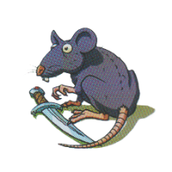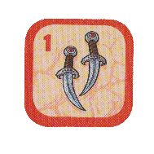 |  |  | Max HP |  | 8 | Armour Class | 8
Wisdom |  | -3 | Physical |  | -2 | Constitution | -2
Attack Modifier |  | -2 | Damage Modifier |  | -2 | Initiative Modifier | -1
Base Attack | Bite |  |  | Attack roll, 1 target – On hit: 1d4 + Damage Mod Physical damage.  If the target is incapacitated, they also drop a Weapon on that tile.
Combat Feature | Swift Flee |  |  | The Rat flees combat, exiting to a neighbouring tile without a Hero.  It can flee to undiscovered tiles, and does not replace another room’s monster. They will stack and both be part of combat.

Skeleton Warrior
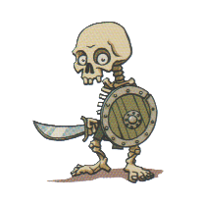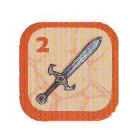 |  |  | Max HP |  | 18 | Armour Class | 12
Wisdom |  | -1 | Physical |  | +2 | Constitution | 0
Attack Modifier |  | 0 | Damage Modifier |  | +2 | Initiative Modifier | +3
Base Attack | Sword |  |  | Attack roll, 1 target – On hit: 1d6 + Damage Mod Physical damage.
Combat Feature | Shield |  |  | The Skeleton Warrior takes cover behind its shield. The next attack against it has disadvantage.

Skeleton King
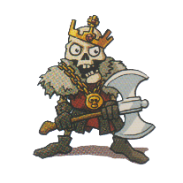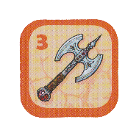 |  |  | Max HP |  | 22 | Armour Class | 11
Wisdom |  | 0 | Physical |  | +2 | Constitution | +1
Attack Modifier |  | +1 | Damage Modifier |  | +2 | Initiative Modifier | +3
Base Attack | Axe |  |  | Attack roll, 1 target – On hit: 1d10 + Damage Mod Physical damage.
Combat Feature | Greedy |  |  | The Skeleton King steals one of the Hero’s scrolls, if they have any.  It is placed on the Skeleton King’s tile.

Daggers, Swords, Axes
Daggers, Swords and Axes, respectively obtained from defeating a Rat, Skeleton Warrior and Skeleton King are Weapons. They are equipped into one of the two Weapon slots of the inventory sheet. If both places are occupied, the player may switch the items out, placing the removed item on that tile.
When placed on the top slot – the main-hand – the Hero gains a boost to their stats:
- Daggers – Increases the Hero’s Attack Modifier to 0 if it is negative, or by +1 if it is positive.
- Sword – Increases the Hero’s Attack Modifier and Damage Modifier by +1 each.
- Axe – Increases the Hero’s Damage Modifier by +2 if it is negative, or by +1 if it is positive.
When placed on the bottom slot – the off-hand – the Hero gains an additional attack.
This additional attack can only be performed if the player took the Attack Action, meaning they made used their Base attack. If they instead used their combat feature, unless specified otherwise, they make an attack with the off-hand weapon.
The Weapons’ additional attack deals 1d4 (Daggers), 1d6 (Sword) and 1d10 (Axe) Physical damage respectively.

Magical Scrolls

Mummy
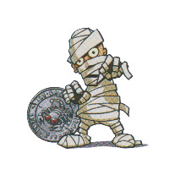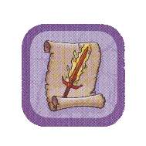 |  |  | Max HP |  | 18* | Armour Class | 10
Wisdom |  | -1 | Physical |  | +1 | Constitution | 0
Attack Modifier |  | 0 | Damage Modifier |  | +1 | Initiative Modifier | +2
Base Attack | Smack |  |  | Attack roll, 1 target – On hit: 1d6 + Damage Mod Physical damage.
Combat Feature | Curse |  |  | The Mummy temporarily inflicts the Curse of Karak upon the Hero. It is lifted once combat with the Mummy ends.
*The Mummy is vulnerable to Fire damage, meaning Fire damage against it is doubled.

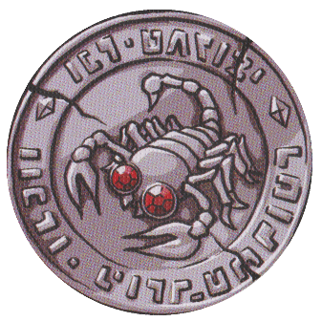
The Curse of Karak
If any player defeats a Mummy, one player becomes cursed. The player who defeated the Mummy chooses another player and places the curse token on their inventory sheet. The player whose Hero was cursed and has the curse token on their Hero’s card cannot use their hero’s Health, Attack and Movement Skills but can still use their Combat Feature.
The curse can be lifted by taking a Long Rest, that is to say finishing one’s turn on a tile with a Healing Fountain. The curse can also be passed on when another Mummy is defeated, and the player moves the curse token to another player. However, the token does not have to be moved if the player that killed the Mummy wishes it to stay on the cursed player.

Flame Scroll
The Flame Scroll can be obtained by defeating a Mummy. It is equipped into one of the three Scroll slots of the inventory sheet. If all places are occupied, the player may switch the items out, placing the removed item on that tile.
After landing a successful attack with the Base attack or an equipped Weapon, the player may choose to consume up to three Flame Scrolls. Each Flame scroll increases that attack’s damage by 1d4 + Wisdom Fire damage.
Upon being consumed, the Flame Scroll must be discarded. It does not return to the token bag.

Giant Spider
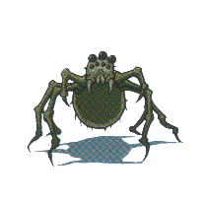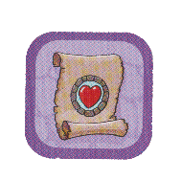 |  |  | Max HP |  | 12 | Armour Class | 9
Wisdom |  | -2 | Physical |  | +1 | Constitution | -1
Attack Modifier |  | -1 | Damage Modifier |  | +1 | Initiative Modifier | +2
Base Attack | Bite |  |  | Attack roll, 1 target – On hit: 1d4 + Damage Mod Physical damage.  If the target is incapacitated, they also drop a Weapon on that tile.
Combat Feature | Web |  |  | The Giant Spider webs the Hero down. They cannot flee combat until either them or the Giant Spider is defeated.

Healing Scroll
The Healing Scroll can be acquired by defeating a Giant Spider. is equipped into one of the three Scroll slots of the inventory sheet. If all places are occupied, the player may switch the items out, placing the removed item on that tile.
At the start of the player’s turn, before moving or taking any actions, they may choose to consume the Healing Scroll. This teleports a Hero of their choice – their own or another player’s – to a Healing Fountain of their choice. The teleported Hero immediately takes a Long Rest.
This, however, does not end the player’s turn. They may continue on with their entire 4 tiles of movement.
If used during combat, the player automatically flees, and the Monster cannot make an attack of opportunity against them.
Upon being consumed, the Healing Scroll must be discarded. It does not return to the token bag.

Treasure

Skeleton Turnkey
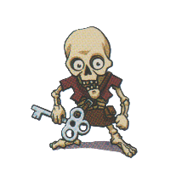 |  |  | Max HP |  | 15 | Armour Class | 10
Wisdom |  | -1 | Physical |  | 0 | Constitution | -1
Attack Modifier |  | 0 | Damage Modifier |  | 0 | Initiative Modifier | +1
Base Attack | Smack |  |  | Attack roll, 1 target – On hit: 1d6 + Damage Mod Physical damage.
Combat Feature | Flee |  |  | The Skeleton Turnkey attempts to flee combat, exiting to a neighbouring tile without a Hero.  It can flee to undiscovered tiles, and does not replace another room’s monster. They will stack and both be part of combat.  This triggers an attack of opportunity from any Hero in combat with it.

The Fallen
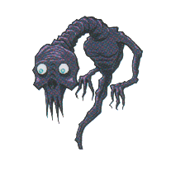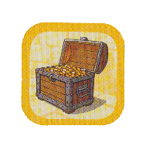 |  |  | Max HP |  | 20 | Armour Class | 12
Wisdom |  | +3 | Physical |  | +2 | Constitution | 0
Attack Modifier |  | +4 | Damage Modifier |  | +2 | Initiative Modifier | +3
Base Attack | Whisp |  |  | Attack roll, 1 target – On hit: 1d10 + Damage Mod Physical damage.
Combat Feature | Memories of the Past |  |  | The Fallen can use the Combat Feature of the Hero that first fights it.

The Dragon
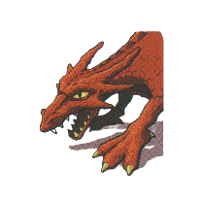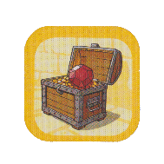 |  |  | Max HP |  | 50 | Armour Class | 13
Wisdom |  | +2 | Physical |  | +3 | Constitution | +2
Attack Modifier |  | +3 | Damage Modifier |  | +3 | Initiative Modifier | +4
Base Attack | Claws |  |  | Attack roll, 1 target – On hit: 1d12 + Damage Mod Physical damage.
Combat Feature | Fire Breath |  |  | DC 10 CON saving throw, all enemies – On failure: 1d8 Fire damage, or half as much on a success.

Key & Treasure
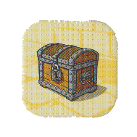
Keys can be obtained by defeating a Skeleton Turnkey. They are equipped in the Key slot of the inventory sheet. If the slot is occupied, the player must leave the key on that tile.
A key can be used to unlock any Treasure chest. To unlock a chest, the player must end their turn on a tile with a locked Treasure. They can flip the Treasure token and keep it on them as 1 Victory Point (VP). The Key must be discarded. It does not return to the token bag.
The Fallen reward the player with a Treasure of equal value to those opened with a Key.
Defeating the Dragon also awards the player with treasure: A regular chest of 1 VP containing a Ruby that is worth ½ VP. This means that defeating the Dragon, rewards the player with 1,5 VP, and not with automatic victory.

The Heroes
Each Hero has various stats all with a lot of importance.
Physical (PHY), Wisdom (WIS) and Constitution (CON) are the base stats, that serve to define the rest. PHY represents strength and dexterity, CON affects endurance and healing, WIS defines the character’s wits, including their ability to land an attack.
Their Hit Dice is the type of dice rolled when restoring health from a Short Rest.
The Attack Modifier is added to attack rolls to see if the attack lands. On a success, the Damage Modifier is added to the Base attack or Weapon attacks. The Initiative Modifier is added when defining combat turn order.
Each Hero has a Health, Attack and Movement Skill that affects those three aspects respectively. These can be passive effects or active powers, and can be temporarily deactivated by the Curse of Karak.
The Combat Feature can be used instead of the Base attack (and any subsequent weapon attacks) during a turn of combat. These may not be used outside combat unless specified otherwise.

Spellcasting
There are two types of Heroes, Martial and Spellcaster. Spellcasters all have the same Combat Feature “Spellcasting”, though their list of spells varies.
There are three levels to spells:
- Cantrips are weak spells that require no resources to be cast. As such they can be freely used by the spellcaster during combat.
- Levelled Spells are stronger spells that require Spell slots to be cast. Every spellcasting Hero has 2 Spell slots that are restored upon taking a Long Rest at a Healing Fountain.
- Up-casting refers to casting a more powerful version of a Levelled Spell by expending more resources. As such, the player may choose to use both their Spell Slots at once to Up-cast their spell. This decision must be made before any dice are rolled.

Aderyn, the Assassin
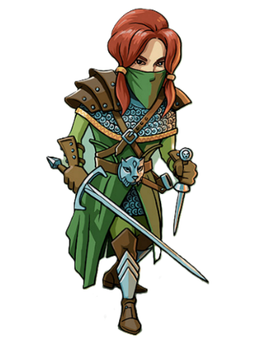 |  |  | Max HP |  |  | 25 | Hit Dice | d8 | Armour Class | 12
 |  |  | Wisdom |  |  | +1 | Physical | +1 | Constitution | -1
 |  |  | Attack Modifier |  |  | +2 | Damage Modifier | +1 | Initiative Modifier | +2
Health Skill |  |  | Evasion |  | Due to her great agility, Aderyn’s AC is effectively increased to 14.
Attack Skill |  |  | Sneak Attack |  | Aderyn does an additional 1d6 Physical damage on all her attacks if she hid on her previous turn.  She also does an additional 1d6 Physical damage on her first attack when initiating combat with an already discovered Monster.
Movement Skill |  |  | Stealth Expertise |  | Aderyn can ignore monsters, passing by their tile and finishing her turn on it without initiating combat if she so chooses.  Using this, she can attempt to collect loot that is on the same tile as a Monster. To do so, she rolls a Physical roll against a Wisdom roll from the Monster.  If the Monster succeeds this roll, or if Aderyn is cursed while on a Monster’s tile, she is forced into combat.
Base Attack |  | Sword and Dagger |  | Two attack rolls, 1-2 target – On hit: 1d6 + Damage Mod | 1d4 + Damage Mod Physical damage.  The second attack can only be performed if Aderyn’s off-hand Weapon slot is empty or has a Dagger, in which case she will make three attacks total.
Combat Feature |  | Hide |  | Aderyn hides from the Monster. Her first attack on her next turn will be made with advantage. This also triggers her Attack Skill.  Additionally, only in the case where she goes before the Monster in Initiative order, it will have disadvantage on its first attack against her.

Horan, the Ancestral Guardian
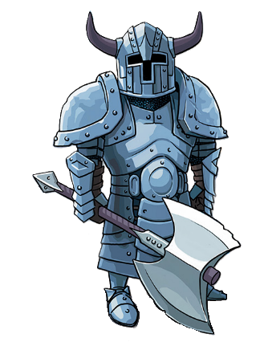 |  |  | Max HP |  |  | 35 | Hit Dice | d10 | Armour Class | 12
 |  |  | Wisdom |  |  | -2 | Physical | +1 | Constitution | +2
 |  |  | Attack Modifier |  |  | -1 | Damage Modifier | +1 | Initiative Modifier | +2
Health Skill |  |  | Relentless |  | If Horan loses his last HP, he does not fall unconscious like other weaklings, instead he teleports to a Healing Fountain. He can use it on the next turn.
Attack Skill |  |  | Extra Attack |  | Horan can make two Base attacks, unless both his Weapon slots are occupied.
Movement Skill |  |  | Fast Movement |  | Horan has a speed of 5 instead of 4.
Base Attack |  | Battelaxe |  | Attack roll, 1 target – On hit: 1d8 + Damage Mod Physical damage.
Combat Feature |  | Ancestral Protector |  | Horan calls upon his ancestors to create a spirit shield.  For the next two turns, Horan takes 1d4 less damage from all attacks made against him and reflects that damage back to the attacker as Fire damage.

Victorius, the Champion
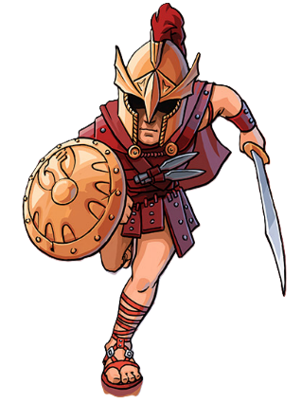 |  |  | Max HP |  |  | 30 | Hit Dice | d10 | Armour Class | 12
 |  |  | Wisdom |  |  | 0 | Physical | +1 | Constitution | 0
 |  |  | Attack Modifier |  |  | +1 | Damage Modifier | +1 | Initiative Modifier | +2
Health Skill |  |  | Second Wind |  | When Victorius rolls a 3 on any dice he regains 3 HP.
Attack Skill |  |  | Great Weapon Fighting |  | When Victorious rolls a 1 on his damage rolls, he can reroll it once.
Movement Skill |  |  | Action Surge |  | If Victorius rolls the maximum amount on any dice, he can continue his turn afterwards.  This means his turn does not if he defeated the Monster and collected its loot.  If he is still in combat, he can make a singular additional attack with his Base attack.
Base Attack |  | Sword and Shield |  | Attack roll, 1 target – On hit: 1d6 + Damage Mod Physical damage.  Victorius has +3 to his AC so long as the off-hand Weapon slot isn’t occupied.
Combat Feature |  | Disengage |  | Victorious flees combat without triggering an attack of opportunity.  This also allows him to move past the Monster into undiscovered tiles.

Argentus, the Wizard
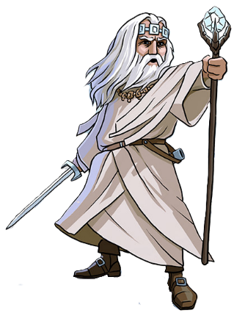 |  |  | Max HP |  |  | 30 | Hit Dice | d6 | Armour Class | 11
 |  |  | Wisdom |  |  | +2 | Physical | 0 | Constitution | -1
 |  |  | Attack Modifier |  |  | +3 | Damage Modifier | 0 | Initiative Modifier | +1
Health Skill |  |  | Arcane Recovery |  | When taking a Short Rest, Argentus regains 1 Spell Slot.
Attack Skill |  |  | Spell Mastery |  | Agrentus does not consume the Flame Scroll when using it.
Movement Skill |  |  | Astral Walking |  | Argentus can move through walls, but only into tiles that have already been discovered.
Base Attack |  | Sword |  | Attack roll, 1 target: 1d6 + Damage Mod Physical damage.
Combat Feature |  | Spellcasting |  | Argentus can cast a single spell in its turn instead of using the Base Attack.  Argentus can cast Cantrips without limit, but only has two Spell Slots for Levelled Spells. He can use both Slots in a single turn to Up-Cast the spell.
Cantrips |  | Firebolt |  | Attack roll, 1 target: 1d8 + WIS Fire damage.
 |  | Ray of Frost |  | Attack roll, 1 target: 1d6 + WIS Physical damage. The target cannot flee combat.
Levelled Spells |  | Magic Missiles |  | Fires three missiles, at up to three targets, that each deal 1d4 Physical damage.
 |  |  |  | Up-cast: Each missile instead deals 1d4 + WIS damage.
 |  | Sleep |  | Attack roll, 1 target – On hit: If the target’s WIS is of +1 or lower, it falls asleep.  Combat automatically ends, and the tile acts as if it were empty. The target wakes up on Argentus’ next turn, or if another player initiates combat with it.
 |  |  |  | Up-cast: The spell can work on any target.

Lord Xanrus, the Warlock
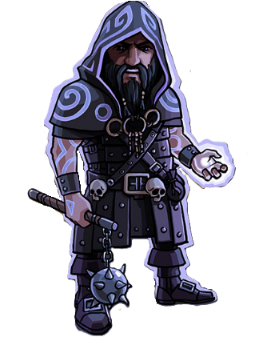 |  |  | Max HP |  |  | 30 | Hit Dice | d6 | Armour Class | 11
 |  |  | Wisdom |  |  | +2 | Physical | 0 | Constitution | -1
 |  |  | Attack Modifier |  |  | +3 | Damage Modifier | 0 | Initiative Modifier | +1
Health Skill |  |  | Sacrifice |  | Once per turn, Lord Xanrus can sacrifice 6 hp to add 1d12 to the damage of any successful attack or spell.
Attack Skill |  |  | Repelling Blast |  | Lord Xanrus’ Eldritch Blast spell knocks the target back on a hit, so it skips its next turn.
Movement Skill |  |  | Magical Swap |  | At the start of his turn, Lord Xanrus can swap his position with any other hero. This does not trigger an attack of opportunity if in combat.  When swapping with a player in combat, he can choose whether to resume that combat or not and vice-versa for the swapped player if Lord Xanrus was in combat.
Base Attack |  | Flail |  | Attack roll, 1 target: 1d6 + Damage Mod Physical damage.
…

Combat Feature | Spellcasting | Lord Xanrus can cast a single spell in its turn instead of using the Base Attack.  Lord Xanrus can cast Cantrips without limit, but only has two Spell Slots for Levelled Spells. He can use both Slots in a single turn to Up-Cast the spell.
Cantrips | Eldritch Blast | Attack roll, 1 target: 1d8 + WIS Physical damage. This trigger’s Lord Xanrus’ Attack Skill.
Cantrips | Blade Ward | Lord Xanrus gains resistance against Physical damage until his next turn.
Levelled Spells | Inflict Wounds | 1 target – 2d8 Physical damage.  The attack automatically hits but Lord Xanrus may not flee until the end of combat. This includes using his Movement Skill.
Levelled Spells | Inflict Wounds | Up-cast: The spell instead deals 3d8 + WIS Physical damage.
Levelled Spells | False Life | Lord Xanrus gains 8 Temporary HP, which and cannot be healed.  It does not count as healing, and can therefore be added on top of the Max HP, but does not stack from multiple sources.  This spell may be cast while out of combat, but it ends Lord Xanrus’ turn.
Levelled Spells | False Life | Up-cast: Lord Xanrus heals for 1d4 + WIS HP in addition to gaining Temporary HP.

Taia, the Cleric
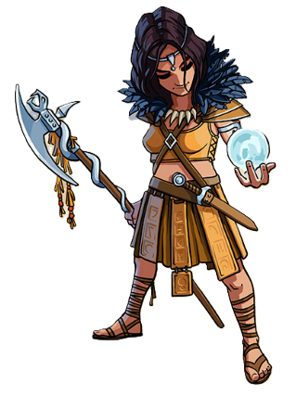 |  |  | Max HP |  |  | 25 | Hit Dice | d6 | Armour Class | 13
 |  |  | Wisdom |  |  | +1 | Physical | +1 | Constitution | -1
 |  |  | Attack Modifier |  |  | +2 | Damage Modifier | +1 | Initiative Modifier | +2
Health Skill |  |  | Disciple of Life |  | Taia adds +2 to the results of Hit Dice rolls.
Attack Skill |  |  | True Sight |  | Taia has advantage on all her attack rolls if she triggered combat in with first movement.  She also has +1 to all her attack rolls if she starts her turn in combat.
Movement Skill |  |  | Arcane Eye |  | Taia draws 2 tokens and chooses which to place into the room upon discovering it.
Base Attack |  | Halberd |  | Attack roll, 1 target – On hit: 1d6 + Damage Mod Physical damage.  If both her Weapon slots are filled, Taia gains +1 to her Attack Modifier.
…

Combat Feature | Spellcasting | Taia can cast a single spell in its turn instead of using the Base Attack.  Taia can cast Cantrips without limit, but only has two Spell Slots for Levelled Spells. She can use both Slots in a single turn to Up-Cast the spell.
Cantrips | Sacred Flame | DC 11 WIS saving throw, 1 target – On failure: 1d10 + WIS Fire damage, or half as much on a success.
Cantrips | Guidance | Taia gains advantage on her next attack. If she has a weapon in her off-hand slot, she can make an attack with it on this turn.
Levelled Spells | Find Familiar | Taia conjures a Familiar from the list at the end of the rulebook.  It fights at her side until the end of combat, or until it dies, whichever one comes first.  She may only have one Familiar at her side at a time.
Levelled Spells | Find Familiar | Up-cast: The Familiar does not disappear once combat ends.  This spell may be cast while out of combat, but it ends Taia’s turn.
Levelled Spells | Guiding Bolt | Attack roll, 1 target – On hit: Taia deals 2d6 + WIS Fire damage, and the next attack against the target made by Taia or her allies has advantage.
Levelled Spells | Guiding Bolt | Up-cast: The spell deals 2d8 + WIS instead and grants advantage even on failure.

Elspeth, the Battle Master ^{(SKE)}
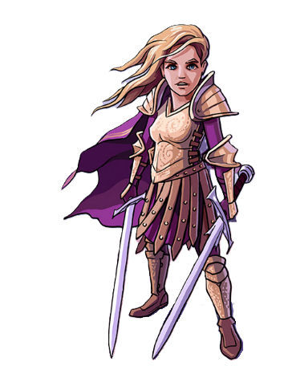 |  |  | Max HP |  |  | 30 | Hit Dice | d8 | Armour Class | 11
 |  |  | Wisdom |  |  | 0 | Physical | +1 | Constitution | 0
 |  |  | Attack Modifier |  |  | +1 | Damage Modifier | +1 | Initiative Modifier | +2
Health Skill |  |  | Indomitable |  | Elspeth can reroll each of her Hit Dice once. She must use the second roll.
Attack Skill |  |  | Two Weapon Fighting |  | Weapons in Elspeth’s off-hand Weapon slot also give their main hand Weapon slot bonus.
Movement Skill |  |  | Know Your Enemy |  | Elspeth can spend 1 movement and sacrifice 6 HP to move through a tile with a Monster, into a neighbouring tile – including undiscovered tiles – without initiating combat.
Base Attack |  | Sword |  | Attack roll, 1 target: 1d6 + Damage Mod Physical damage.
Combat Feature |  | Student of War |  | Elspeth performs her Base attack twice.  If both attack fail, she gains advantage on all her attacks on the next turn.  If both succeed, she heals for 1d4 HP.

Hannah, the Thief ^{(Regent)}
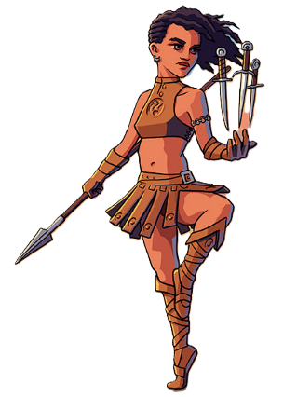 |  |  | Max HP |  |  | 30 | Hit Dice | d8 | Armour Class | 10
 |  |  | Wisdom |  |  | +1 | Physical | 0 | Constitution | 0
 |  |  | Attack Modifier |  |  | +2 | Damage Modifier | 0 | Initiative Modifier | +1
Health Skill |  |  | Reliable Talent |  | When rolling Hit Dice, any results under 4 are treated as a 4 by Hannah.
Attack Skill |  |  | Throwing Daggers |  | Hannah can store Daggers in the scroll slots. Each adds 1d4 damage to her Base attack and isn’t consumed upon use.  If she receives the Curse of Karak while having Daggers in her Scroll Slots, she can’t use or remove them.
Movement Skill |  |  | Cunning Dash |  | Hannah can choose to Dash at the start of her turn. If she does, she has 8 speed for the duration of that turn but can only travel across discovered tiles.  When dashing, Hannah can pick up items without ending her turn. However, opening a Treasure chest and taking a Long Rest, both end her turn.  She cannot initiate combat while dashing.
Base Attack |  | Spear |  | Attack roll, 1 target – On hit: 1d6 + Damage Mod Physical damage.
Combat Feature |  | Thief’s Reflexes |  | Hannah prepares a cunning strike. On her next turn, she can act before and after the Monster.  She cannot use this Combat Feature if she already used it on her previous turn.

Kirima, the Wild Heart ^{(SKE)}
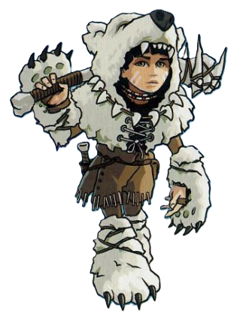 |  |  | Max HP |  |  | 25 | Hit Dice |  | d10 | Armour Class | 12
 |  |  | Wisdom |  |  | +2 | Physical |  | 0 | Constitution | -1
 |  |  | Attack Modifier |  |  | +3 | Damage Modifier |  | 0 | Initiative Modifier | +1
Health Skill |  |  | Danger Sense |  | Kirima always goes first in Initiative order.
Attack Skill |  |  | Ambush |  | Kirima has +1 to her Damage Modifier when fighting against a Monster on a discovered tile.
Movement Skill |  |  | Nature Speaker |  | While out of combat, Kirima can use all her movement to conjure a Familiar from the list at the end of the rulebook.  It fights at her side until it dies or until she takes a Short or Long Rest, whichever one comes first. She may only have one Familiar at her side at a time.
Base Attack |  | Club |  | Attack roll, 1 target – On hit: 1d8 + Damage Mod Physical damage.  If Kirima has no Weapons in her off-hand slot, the Base attack deals 1d10 + Damage Mod Physical damage.
Combat Feature |  | Aspect of the Beast |  | Kirima has a different Combat Feature depending on the kind of Monster she is fighting.
 |  |  |  | Roar  Rat  Giant Spider  The Dragon |  |  |  | DC 13 WIS Saving throw, all enemies – On hit: The target is frightened. It has disadvantage on all attacks against Kirima until her next turn.
 |  |  |  | Banish  Skeletons  Mummy  The Fallen |  |  |  | Kirima performs her Base attack and adds 1d6 + WIS Fire damage to the result.  She may not make additional attacks.

Valduk, the Berserker ^{(Regent)}
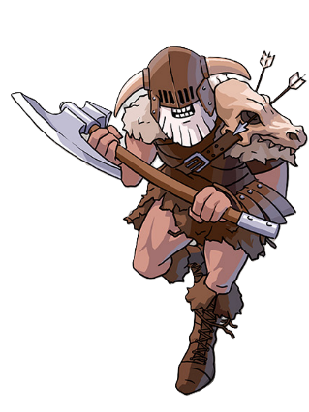 |  |  | Max HP |  |  | 30 | Hit Dice | d10 | Armour Class | 11
 |  |  | Wisdom |  |  | -2 | Physical | +2 | Constitution | +1
 |  |  | Attack Modifier |  |  | -1 | Damage Modifier | +2 | Initiative Modifier | +3
Health Skill |  |  | Berserk |  | Valduk’s Damage Modifier is increased by +1 when he’s below 20 HP and +2 when below 10.
Attack Skill |  |  | Reckless |  | Valduk can grant himself advantage on his attacks for 1 turn, but the next attack against him during this combat will also have advantage.
Movement Skill |  |  | Frenzy |  | If he doesn’t collect the loot after combat is over, Valduk can continue his turn.
Base Attack |  | Battleaxe |  | Attack roll, 1 target – 1d8 + Damage Mod Physical damage.
Combat Feature |  | Rage |  | Valduk enters a rage. For the next two turns Valduk is resistant to Physical damage, and he recieves +1 to his Attack Modifier.

Baron Markul, the Paladin ^{(Regent)}
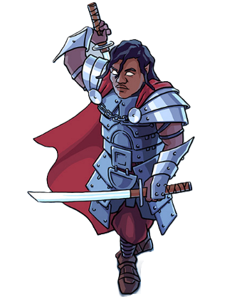 |  |  | Max HP |  |  | 30 | Hit Dice | d10 | Armour Class | 10
 |  |  | Wisdom |  |  | +1 | Physical | +1 | Constitution | -1
 |  |  | Attack Modifier |  |  | +2 | Damage Modifier | +1 | Initiative Modifier | +2
Health Skill |  |  | Oath of Devotion |  | Baron Markul can cast the Shield of Faith spell without expending a Spell slot, and Up-Cast it for the cost only 1 Spell slot.
Attack Skill |  |  | Dueling |  | Baron Markul’s Swords in the main Slot grant an additional +1 to his Damage Modifier.  His Swords in the off-hand Slot gain a +2 bonus to their damage.
Movement Skill |  |  | Blitz Attack |  | At the start of his turn, Baron Markul can move to any discovered tile next to a Monster not currently in combat.  He immediately initiates combat with the Monster on the neighbouring tile, and has advantage on his first attack.
Base Attack |  | Sword |  | Attack roll, 1 target – On hit: 1d6 + Damage Mod Physical damage.
…

Combat Feature | Spellcasting | Baron Markul can cast a single spell in its turn instead of using the Base Attack.  Baron Markul can cast Cantrips without limit, but only has two Spell Slots for Levelled Spells. He can use both Slots in a single turn to Up-Cast the spell.
Cantrips | Blade Ward | Baron Markul gains resistance against Physical damage until his next turn.
Cantrips | Sacred Flame | DC 10 WIS saving throw, 1 target – On failure: 1d10 + WIS Fire damage, or half as much on a success.
Levelled Spells | Shield of Faith | Baron Markul gains +2 AC until the end of combat.
Levelled Spells | Shield of Faith | Up-cast: In addition to the AC bonus, Baron Markul heals for 1d6+ WIS HP.
Levelled Spells | Divine Smite | This spell behaves like a Flame Scroll, so can be cast after a successful attack with the Base attack or a Weapon.  Baron Markul adds 1d8 Fire damage to the result of that attack.
Levelled Spells | Divine Smite | Up-cast: The spell instead adds 2d8 + WIS Fire damage.

Doctor Sidhar, the Artificer ^{(SKE)}
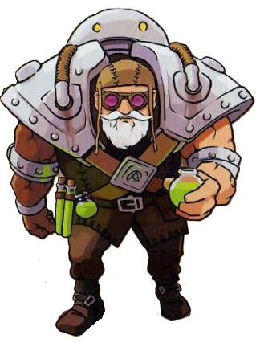 |  |  | Max HP |  |  | 30 | Hit Dice | d8 | Armour Class | 11
 |  |  | Wisdom |  |  | +1 | Physical | -1 | Constitution | +1
 |  |  | Attack Modifier |  |  | +2 | Damage Modifier | +1 | Initiative Modifier | 0
Health Skill |  |  | Armorer |  | Doctor Sidhar takes 1 less damage from all attacks against him.  While over half HP, he also has an AC of 12.
Attack Skill |  |  | Artillerist |  | Doctor Sidhar can expend 1 Spell Slot during combat to conjure an Eldritch Cannon Familiar from the list at the end of the rulebook. It takes one of three forms by the player’s choice.  It fights at his side until the end of combat, or until it dies, whichever one comes first.  Doctor Sidhar may only have one Familiar at her side at a time.  Summoning an Eldritch Cannon does not end Doctor Sidhar’s turn.
Movement Skill |  |  | Alchemist |  | When taking a token from the bag, Doctor Sidhar can sacrifice 6 HP to take a different one. He can do so as many times as he wants.
Base Attack |  | Smack |  | Attack roll, 1 target – On hit: 1d6 + Damage Mod Physical damage.
…

Combat Feature | Spellcasting | Doctor Sidhar can cast a single spell in its turn instead of using the Base Attack.  Doctor Sidhar can cast Cantrips without limit, but only has two Spell slots for Levelled Spells. He can use both Slots in a single turn to Up-Cast the spell.
Cantrips | Firebolt | Attack roll, 1 target: 1d8 + WIS Fire damage.
Cantrips | Acid Splash | DC 10 CON saving throw, all enemies – On failure: the target takes 2d4 + WIS Physical damage, or half as much on a success.
Levelled Spells | Guiding Bolt | Attack roll, 1 target – On hit: Taia deals 2d6 + WIS Fire damage, and the next attack against the target made by Taia or her allies has advantage.
Levelled Spells | Guiding Bolt | Up-cast: The spell deals 2d8 + WIS instead and grants advantage even on failure.
Levelled Spells | Magic Missiles | Fires three missiles, at up to three targets, that each deal 1d4 Physical damage.
Levelled Spells | Magic Missiles | Up-cast: Each missile instead deals 1d4 + WIS damage.

Lady Lorraine, the Ranger ^{(Regent}
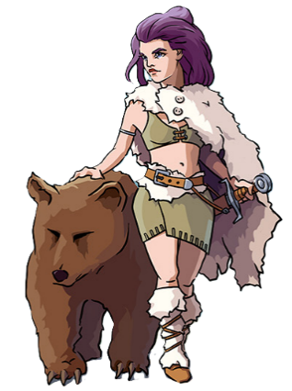 |  |  | Max HP |  |  | 25 | Hit Dice | d6 | Armour Class | 11
 |  |  | Wisdom |  |  | +1 | Physical | +1 | Constitution | -1
 |  |  | Attack Modifier |  |  | +2 | Damage Modifier | +1 | Initiative Modifier | +2
Health Skill |  |  | Tireless |  | If Lady Lorraine uses all her movement on a single turn, she gains 5 Temporary HP, that cannot be healed.  It does not count as healing, and can therefore be added on top of the Max HP, but does not stack from multiple sources.
Attack Skill |  |  | Beast Master |  | When Lady Lorrain or her allies roll a 1 on a damage dice, her Bear Companion replaces that 1 with a 1d4 Physical damage.
Movement Skill |  |  | Natural Explorer |  | Lady Lorraine can expend 1 movement to discover a tile without moving onto it or entering combat.  She must then expend another movement if she wishes to go to it.
Base Attack |  | Sword |  | Attack roll, 1 target – On hit: 1d6 + Damage Mod Physical damage.
…

Combat Feature | Spellcasting | Lady Lorraine can cast a single spell in its turn instead of using the Base Attack.  Lady Lorraine can cast Cantrips without limit, but only has two Spell slots for Levelled Spells. She can use both Slots in a single turn to Up-Cast the spell.
Cantrips | Ray of Frost | Attack roll, 1 target: 1d6 + WIS Physical damage. The target cannot flee combat.
Cantrips | Blade Ward | Baron Markul gains resistance against Physical damage until his next turn.
Levelled Spells | Find Familiar | Lady Lorraine conjures a Familiar from the list at the end of the rulebook.  It fights at her side until the end of combat, or until it dies, whichever one comes first.  She may only have one Familiar at her side at a time.
Levelled Spells | Find Familiar | Up-cast: The Familiar does not disappear once combat ends.  This spell may be cast while out of combat, but it ends Lady Lorraine’ turn.
Levelled Spells | Hunter’s Mark | Lady Lorraine marks a Monster as her Prey. That Monster remains marked until it is killed or until Lady Lorraine casts this spell again.  All damage dealt by Lady Lorraine or her allies, including her Bear Companion, is increased by +2.
Levelled Spells | Hunter’s Mark | Up-cast: The damage is increased by 1d4 + 1 instead.

List of Familiars
Cat
Wisdom |  | +1 | Physical |  |  | 0 | Constitution |  | -1
Max HP |  |  |  | 10 | Armour Class |  |  | 9
Attack Modifier |  |  |  | +2 | Damage Modifier |  |  | 0
Base Attack
Crab
Wisdom |  | -2 | Physical |  |  | +3 | Constitution |  | 0
Max HP |  |  |  | 10 | Armour Class |  |  | 9
Attack Modifier |  |  |  | -1 | Damage Modifier |  |  | +3
Base Attack | Pinch |  |  | Attack roll, 1 target – On hit: 1d6 + Damage Mod Physical damage.
Frog
Wisdom |  | 0 | Physical |  |  | 0 | Constitution |  | 0
Max HP |  |  |  | 12 | Armour Class |  |  | 8
Attack Modifier |  |  |  | +1 | Damage Modifier |  |  | 0
Base Attack | Acid Spit |  |  | DC 10 CON saving throw, all enemies – On failure: 2d4 + WIS Physical damage, or half as much on a success.
Raven
Wisdom |  | +2 | Physical |  |  | -1 | Constitution |  | -1
Max HP |  |  |  | 8 | Armour Class |  |  | 10
Attack Modifier |  |  |  | +3 | Damage Modifier |  |  | -1
Base Attack | Peck |  |  | Attack roll, 1 target – On hit: 1d4 + Damage Mod Physical damage and the target is blinded until their next attack. As such, their next attack is made with disadvantage.
…

Eldritch Cannon*
Wisdom |  | +1 | Physical |  |  | +2 | Constitution |  | +1
Max HP |  |  |  | 15 | Armour Class |  |  | 12
Attack Modifier |  |  |  | +2 | Damage Modifier |  |  | +2
Base Attack | Ballista Form |  |  | Attack roll, 1 target – On hit: 1d6 + Damage Mod Physical damage.
Base Attack | Fire Form |  |  | DC 11 PHY saving throw, all enemies – On failure: 1d6 + WIS Fire damage, or none on a success.
Base Attack | Protective Form |  |  | Gives 5 Temporary HP to an ally. Temporary HP cannot be healed.  It does not count as healing, and can therefore be added on top of the Max HP, but does not stack from multiple sources.
*Doctor Sidhar’s Eldritch Cannon cannot be conjured by the Find Familiar spell.

