One D&D:
A Karak Module
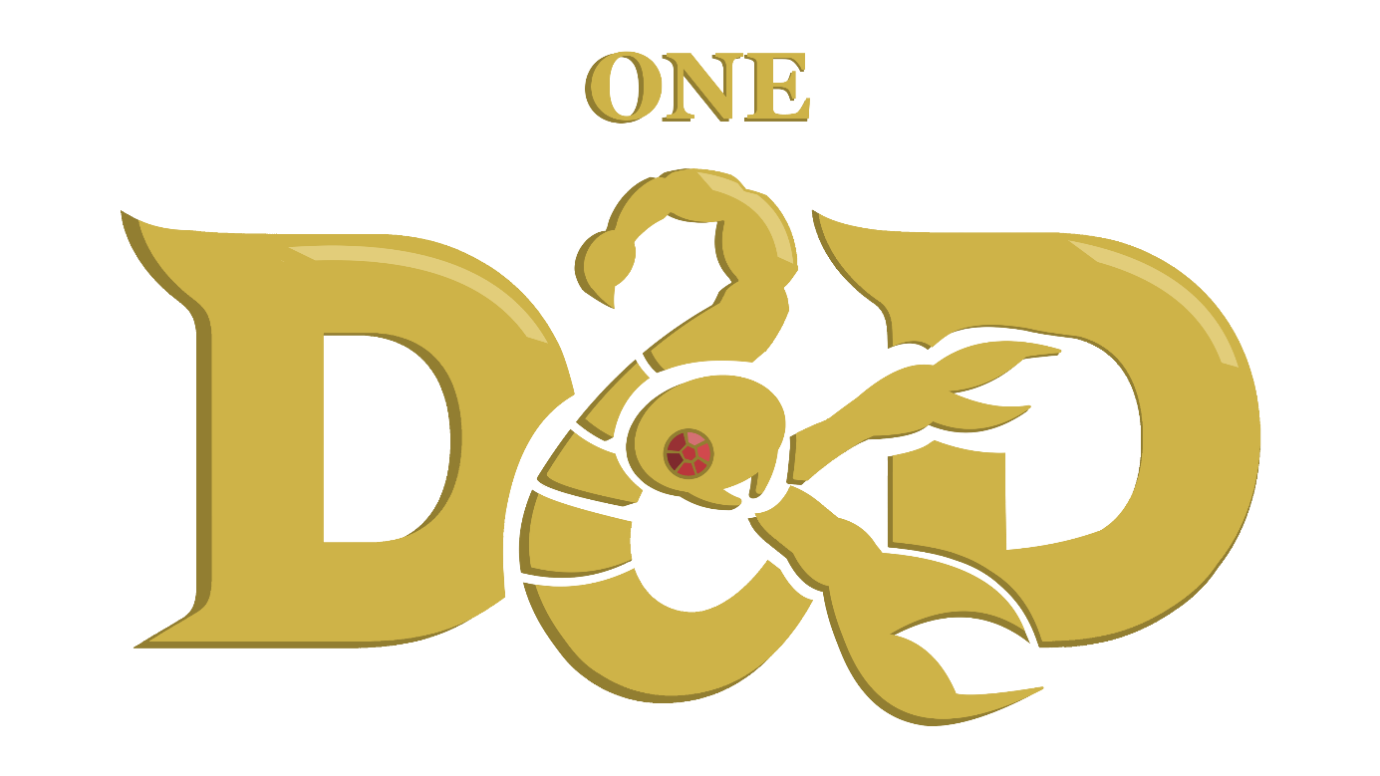
A module by L_PT
Based on Karak by Petr Mikša & Roman Hladík
Table of Contents
Aucune entrée de table des matières n'a été trouvée.

Objective of the Game
The Player who has collected the most treasure becomes the victor. The game ends once any Player defeats the strongest monster of the game - THE DRAGON - and loots its treasure with a ruby. Each Player counts the points from their treasure; treasure collected from chests or by defeating The Fallen are worth 1 Victory Point (VP) each; the dragon ruby is Worth 1,5 VP. The Player with the most VPs wins the game.

Material
In order to play One D&D Karak you will require:
- All of Karak’s original content:

- At least one set of six dice containing a d4, d6, d8, d10, d12 and d20
- Pen and paper to track HP and spell slots
- (Optionally) – The printable Hero sheets found on the GitHub page

Set-up
- Place the starting dungeon tile (coloured back) in the middle of the playing area.
- Shuffle the remaining tiles and place them to the side, face down, so that every player can reach them.
- Each player receives one inventory sheet and five Short Rest tokens (heart/skull), which they place on the inventory sheet.
- Each player picks one hero card, either one of their own choice or randomly (whichever the players agree on), and places it on the inventory sheet.
- Fit the Hero figures into their respective plastic stands and place them on the starting table.
- Roll a d20 to determine which player starts, then go clockwise or anticlockwise from that player.

Turn Order
On their turn, the active player choses what to do. They can move around the dungeon across connected paths or into undiscovered tiles. By default, each Hero has a speed of 4, meaning the player can move up to four tiles in any given turn.

Entering an Undiscovered Tile
In order to move into an undiscovered tile, the player must choose an available path from the tile they are currently in that leads to no tile. When they do so, they will take a tile from the piles and add it to the dungeon. While moving, the player might enter one of four tiles:
- Tunnels, which can be travelled through freely, across connected pathways, for as long as movement allows it.
- Rooms, which force the player to draw a token from the bag of monsters and treasures.
- Teleportation Gates – If the new tile contains a Teleportation Gate (TG) and there are more TGs in the dungeon, the player can move between them, spending only one move to teleport from the neighbouring tile into the other side of the gate, or from its own tile to the a neighbouring tile on the other side of the gate.
- Healing Fountains, which prompt the player to choose between passing through as if it were a Tunnel, taking a Short Rest or take a Long Rest.

Entering an Undiscovered Room Tile
When entering a Room tile for the first time, the player that placed the room must take a token from the bag of monsters and treasures and place it on the tile. This token can either be a Treasure or a Monster.
Treasures can be ignored as with tunnels, otherwise the player may choose to open the chest using a key obtained from defeating a Skeleton Turnkey. This uses the key, which must be removed from the game, and ends the player’s turn.
When placing a Monster on the tile, the player automatically initiates combat with the Monster.
Tokens are only added to a Room tile when it is discovered. This means that any player going into that room after it has been emptied mustn’t take a new token to fill it once more.

Initiating Combat
When entering a tile with a Monster, the player initiates combat with it. The following steps happen:
- The Player and the Monster each roll a d20 and add their Initiative modifier. Whoever has the highest total acts first for the remainder of the battle.
- During the first turn of combat, both the player and the monster may only use their starting attack or their items – weapons and scrolls. The player cannot try to flee and neither them nor the monster may use their Combat Features (CF).
- Starting at the second turn, the player may try to flee, triggering an attack of opportunity from the Monster.
- Also, from the second turn onwards, both the player and the Monster can use their CF instead of their attack or items.
The process is the same when engaging with a Monster currently in combat with a different player. The two combats are entirely distinct, if not for the Monster’s Hit Points (HP), which are shared across the two combats. The player that deals the final blow may collect the Monster’s loot.

Combat Actions
During one turn of combat, one of the following things may happen:
- Making a Weapon Attack
The player uses their starting attack. They must roll a d20 and add their Attack Modifier to determine if their attack hits the Monster. If the result is equal to or higher than the target’s Armour Class (AC), then the attack is successful. At this point, they may roll the damage dice according the to attack’s description and add their Damage Modifier.
At this point, up to three Flame Scrolls may also be used by the player.
- Using a Healing Scroll
The player uses a Healing Scroll as described under Monster Loot to teleport themselves out of combat. Combat automatically ends, and the player may continue with their turn.
- Fleeing Combat
Starting at the second turn, the player may try to flee. This allows them to leave combat, but triggers an opportunity attack from the Monster. This means the Monster gets to make one attack for free before the player leaves combat.
- Using the Combat Feature
Starting at the second turn, the player may use their Combat Feature for their action, as described under their character’s subchapter. This includes casting a spell for those that can, assuming they have Spell Slots remaining.

End of Combat
One of four outcomes may happen at the end of any given turn:
- The Monster is defeated
The Player moves onto the Monster’s tile; they may collect whatever loot the Monster dropped and finishes their turn.
- The Hero is defeated
The Player is knocked unconscious and remains in the tile they are on. They are reduced to 0 Hit Points (HP).
If they still have Short Rests, they will regain one Hit Dice worth of HP on the next turn. They may only start playing again on the turn after that. If they don’t have any Short Rests left, they are teleported to the nearest Healing Fountain (HF). They may only use the HF on their next turn.
The Monster regains all its HP if there are no other players in combat.
- Neither party is defeated
The Player ends their turn; the next player gets to play. On the Player’s next turn, they are still in combat.
- One of the parties flees combat or is incapacitated
The Player may still use their 4 moves after leaving combat. Whether the Monster gets an opportunity attack, and whether the Player must return to their original tile is dependent on what ability or action is used to escape. The Monster regains all their HP, but the Player does not.

Battle Companions
Battle Companions such as Lady Lorraine’s bear or the conjured beasts from the Find Familiar spell are allies called to aid the Hero in battle.
They are fully controlled by the player on the player’s turn but act independently of the player’s Hero, rolling their own initiative and having their own stats. They don’t have Combat Features or the ability to use or equip items however, meaning they can only take damage and attack.
There are three types of familiars that can be summoned by the Find Familiar spell:

Raven
Wisdom |  | Physical
Attack Modifier |  | Damage Modifier |  | Initiative Modifier
Max HP |  | Armour Class |  | Peck* | 1d4
*This attack targets the enemies’ eye, giving them disadvantage on their next attack roll.

Crab
Wisdom |  | Physical
Attack Modifier |  | Damage Modifier |  | Initiative Modifier
Max HP |  | Armour Class |  | Pinch | 1d6

Frog
Wisdom |  | Physical
Attack Modifier |  | Damage Modifier |  | Initiative Modifier
Max HP |  | Armour Class |  | Acid Spit* | 1d4
*The target rolls a d20 and adds then Constitution. If the result is lower than 10, they take an additional 1d4 damage.

Bestiary
Each Monster has its own stats, attacks, Combat Features and loot.
- The Rat, Skeleton Warrior and Skeleton King reward the player with a weapon.
- The Giant Spider and Mummy reward the player with Magical Scrolls.
- The Skeleton Turnkey rewards the player with a Key, The Fallen with a Treasure, and The Dragon with a Treasure and Ruby, worth 1.5 Victory Points.
When defeated, the player turns their token around and choses to take it and add it to their inventory, or to leave it on that tile. The loot may not be discarded.

Weapons

Rat
Wisdom |  | Physical |  | 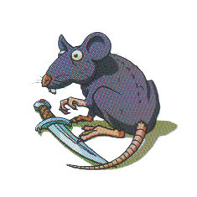
Attack Modifier |  | Damage Modifier |  | Initiative Modifier
Max HP |  | Armour Class |  | Bite* | 1d4
*Bite – If the target is incapacitated by the attack (brought to 0 HP), they also drop a Weapon on that tile.

Combat Feature – Flee
The Rat flees combat, exiting to a neighbouring tile that doesn’t have a Hero on it. It can flee to an undiscovered tile. If it flees to a tile with a token on it, they will stack, and if it is another Monster they will both be part of the same combat.

Skeleton Warrior
Wisdom |  | Physical |  | 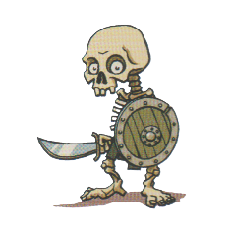
Attack Modifier |  | Damage Modifier |  | Initiative Modifier
Max HP |  | Armour Class |  | Sword | 1d6

Combat Feature – Cover
The Skeleton Warrior hides behind its shield. The next attack against it has disadvantage.

Skeleton King
Wisdom |  | Physical |  | 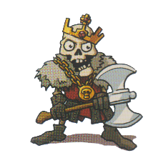
Attack Modifier |  | Damage Modifier |  | Initiative Modifier
Max HP |  | Armour Class |  | Axe | 1d10

Combat Feature – Greedy
The Skeleton King steals one of the Hero’s scrolls, if they have any. It is added to the Skeleton King’s tile and may be obtained once more upon the Monster’s defeat.

Daggers, Swords, Axes
Daggers, Swords and Axes, respectively obtained from defeating a Rat, Skeleton Warrior and Skeleton King are weapons. They are kept in one of the two Weapon slots of the Inventory Sheet. If both places are occupied, the player may switch the items out, placing the removed item on that tile.
When placed on the top slot – the main-hand – the Hero gains a boost to their stats:
- Daggers – Increases the Hero’s Attack Modifier to 0 if it is negative, or by +1 if it is positive.
- Sword – Increases the Hero’s Attack Modifier and Damage Modifier by +1 each.
- Axe – Increases the Hero’s Damage Modifier by +2 if it is negative, or by +1 if it is positive.
When placed on the bottom slot – the off-hand – the Hero gains an additional attack. It is performed after the player makes their base attack and rolls its own Attack Modifier, meaning it risks failing, but allows the player to add their Damage Modifer once more. The weapons additional attack does 1d4, 1d6 and 1d10 respectively.

Magical Scrolls

Mummy
Wisdom |  | Physical |  | 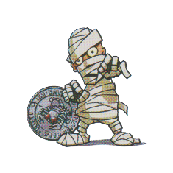
Attack Modifier |  | Damage Modifier |  | Initiative Modifier
Max HP |  | Armour Class |  | Smack | 1d6
Note: The Mummy takes double damage from Fire.

Combat Feature – Curse
The Mummy inflicts the Curse of Karak upon the player until the end of the combat.

The Curse of Karak
If any player defeats a Mummy, one player becomes cursed. The Player who defeated the Mummy chooses another player and places the curse token on their Inventory Sheet. The Player whose Hero was cursed and has the curse token on their Hero’s card cannot use their hero’s Health, Attack and Move Skills but can still use their Combat Feature.
The curse can be lifted by finishing one’s turn on a tile with a Healing Fountain. The curse can also be passed on when another Mummy is defeated, and the Player moves the curse token to another player. However, the token does not have to be moved; it can stay on the owner at that time.

Damage Types
There are two damage types from attacks: Physical and Fire. Unless specified otherwise, all attacks deal Physical damage.

Flame Scroll
The Flame Scroll can be obtained by defeating a Mummy. They are kept in one of the three Scroll slots of the Inventory Sheet. If all places are occupied, the player may switch the items out, placing the removed item on that tile.
When using it, you add an additional 1d4 + your Wisdom (WIS) as Fire damage to your attack. You can choose whether to use the scroll after rolling your damage. In addition, more than one Flame Scroll can be used during one action.
Upon usage, the scroll is consumed and must be removed from the game.

Giant Spider
Wisdom |  | Physical |  | 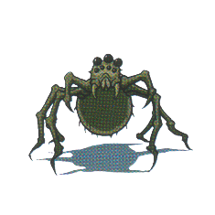
Attack Modifier |  | Damage Modifier |  | Initiative Modifier
Max HP |  | Armour Class |  | Bite | 1d4
*Bite – If the target is incapacitated by the attack (brought to 0 HP), they also drop a Weapon on that tile.

Combat Feature – Web
The Giant Spider webs the Hero down. They cannot flee combat until either them or the Giant Spider is defeated.

Healing Fountains and Rests
Each Hero has a different maximum Hit Point (HP) count, type of Hit Dice and Constitution modifier (CON), as described in The Heroes but all have 5 Short Rest tokens (heart/skull).
When a Player walks through a Healing Fountain (HF) but doesn’t stop there, they may use up to 2 Short Rest tokens, to heal by an amount of one Hit Dice + CON per token expended.
If they instead choose to finish their turn on a HF – therefor taking a Long Rest – they will regain all their HP, restore all expended Short Rest tokens and Spell Slots, and lift the Curse of Karak.

Healing Scroll
The Healing Scroll can be acquired by defeating a Giant Spider. They are kept in one of the three Scroll slots of the Inventory Sheet. If all places are occupied, the player may switch the items out, placing the removed item on that tile.
It can be used on any Hero, not just the player. The target is then moved to any revealed HF and makes automatically makes a Long Rest. This does not cost any moves, and it does not end the turn. It must however be done before moving.
If used during combat, the player automatically flees, and the Monster cannot take an opportunity attack.
Upon usage, the scroll is consumed and must be removed from the game.

Treasure

Skeleton Turnkey
Wisdom |  | Physical |  | 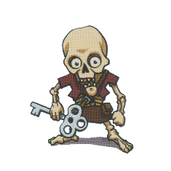
Attack Modifier |  | Damage Modifier |  | Initiative Modifier
Max HP |  | Armour Class |  | Smack | 1d6

Combat Feature – Flee
The Skeleton Turnkey flees combat, exiting to a neighbouring tile that doesn’t have a Hero on it. It can flee to an undiscovered tile. If it flees to a tile with a token on it, they will stack, and if it is another Monster they will both be part of the same combat.

The Fallen
Wisdom |  | Physical |  | 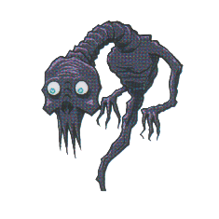
Attack Modifier |  | Damage Modifier |  | Initiative Modifier
Max HP |  | Armour Class |  | Whisp | 1d10

Combat Feature – Memories of the Past
The Fallen uses the Combat Feature of the Hero that first fought it.

The Dragon
Wisdom |  | Physical |  | 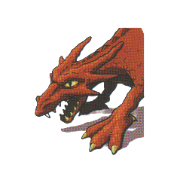
Attack Modifier |  | Damage Modifier |  | Initiative Modifier
Max HP | 50 | Armour Class |  | Bite | 1d12

Combat Feature – Fire Breath
The Dragon deals 1d8 Fire damage to every enemy in combat. This automatically hits.

Key & Treasure
Keys can be obtained by defeating a Skeleton Turnkey. They are kept in the Key slot of the Inventory Sheet. If the slot is occupied, the player must leave the key on that tile.
A key can be used to unlock any Treasure chest. To unlock a chest, the player must end their turn on a tile with a locked Treasure. They can flip the Treasure token and keep it on them as 1 Victory Point (VP). The key is removed from the game.
The Fallen reward the player with a Treasure of equal value to those opened with a key.
Defeating the Dragon also awards the Player with treasure: A regular chest of 1 VP containing a Ruby that is worth ½ VP. This means that defeating the Dragon, rewards the player with 1,5 VP, and not with automatic victory.

The Heroes
Each Hero has various stats all with a lot of importance. Physical (PHY), Wisdom (WIS) and Constitution (CON) are the base stats, that serve to define the rest. PHY represents strength and dexterity, CON affects endurance and healing, WIS defines the character’s wits, which includes their ability to land an attack.
Their Hit Dice is the type of dice rolled when restoring health from a Short Rest.
The Attack Modifier is added to attack rolls to see if the attack lands. On a success, the Damage Modifier is added to the base attack or weapon attacks. The Initiative Modifier is added when defining combat turn order.
Each Hero has a Health, Attack and Movement skill that affects those three aspects respectively. These are usually passive and can be temporarily deactivated by the Curse of Karak.
The Combat Feature can be used instead of the base attack (and any subsequent weapon attacks) starting from the second turn of combat.

Spellcasting
There are two types of heroes, Martial and Spellcasters. Spellcasters all have the same Combat Feature “Spellcasting”, though their list of spells varies. There are two types of spells: Cantrips and Levelled Spells.
Cantrips can be cast indefinitely, while Levelled Spells use one Spell Slot each to be cast. Each Hero has two Spell Slots, which are restored upon taking a Long Rest at a Healing Fountain.
The player may also chose to “Up-cast” their spell, this means using both spell slots on a single spell, for a more powerful effect.

Aderyn
Base attack -
WIS |  | PHY |  | CON
Attack Modifier |  | Damage Modifer |  | Initiative Modifer
Max HP |  | Hit Dice |  | Armour Class
Health Skill | 
Attack Skill | 
Movement Skill | 

Horan
Base attack -
WIS |  | PHY |  | CON
Attack Modifier |  | Damage Modifer |  | Initiative Modifer
Max HP |  | Hit Dice |  | Armour Class
Health Skill | 
Attack Skill | 
Movement Skill | 

Victorius
Base attack -
WIS |  | PHY |  | CON
Attack Modifier |  | Damage Modifer |  | Initiative Modifer
Max HP |  | Hit Dice |  | Armour Class
Health Skill | 
Attack Skill | 
Movement Skill | 

Argentus
Base attack -
WIS |  | PHY |  | CON
Attack Modifier |  | Damage Modifer |  | Initiative Modifer
Max HP |  | Hit Dice |  | Armour Class
Health Skill | 
Attack Skill | 
Movement Skill | 

Lord Xanrus
Base attack -
WIS |  | PHY |  | CON
Attack Modifier |  | Damage Modifer |  | Initiative Modifer
Max HP |  | Hit Dice |  | Armour Class
Health Skill | 
Attack Skill | 
Movement Skill | 

Taia
Base attack -
WIS |  | PHY |  | CON
Attack Modifier |  | Damage Modifer |  | Initiative Modifer
Max HP |  | Hit Dice |  | Armour Class
Health Skill | 
Attack Skill | 
Movement Skill | 

Elspeth (SKE)
Base attack -
WIS |  | PHY |  | CON
Attack Modifier |  | Damage Modifer |  | Initiative Modifer
Max HP |  | Hit Dice |  | Armour Class
Health Skill | 
Attack Skill | 
Movement Skill | 

Hannah (Regent)
Base attack -
WIS |  | PHY |  | CON
Attack Modifier |  | Damage Modifer |  | Initiative Modifer
Max HP |  | Hit Dice |  | Armour Class
Health Skill | 
Attack Skill | 
Movement Skill | 

Kirima (SKE)
Base attack -
WIS |  | PHY |  | CON
Attack Modifier |  | Damage Modifer |  | Initiative Modifer
Max HP |  | Hit Dice |  | Armour Class
Health Skill | 
Attack Skill | 
Movement Skill | 

Valduk (Regent)
Base attack -
WIS |  | PHY |  | CON
Attack Modifier |  | Damage Modifer |  | Initiative Modifer
Max HP |  | Hit Dice |  | Armour Class
Health Skill | 
Attack Skill | 
Movement Skill | 

Baron Markul (Regent)
Base attack -
WIS |  | PHY |  | CON
Attack Modifier |  | Damage Modifer |  | Initiative Modifer
Max HP |  | Hit Dice |  | Armour Class
Health Skill | 
Attack Skill | 
Movement Skill | 

Doctor Sidhar (SKE)
Base attack -
WIS |  | PHY |  | CON
Attack Modifier |  | Damage Modifer |  | Initiative Modifer
Max HP |  | Hit Dice |  | Armour Class
Health Skill | 
Attack Skill | 
Movement Skill | 

Lady Lorraine (Regent)
Base attack -
WIS |  | PHY |  | CON
Attack Modifier |  | Damage Modifer |  | Initiative Modifer
Max HP |  | Hit Dice |  | Armour Class
Health Skill | 
Attack Skill | 
Movement Skill | 

