One D&D:
Dungeon Master Guide
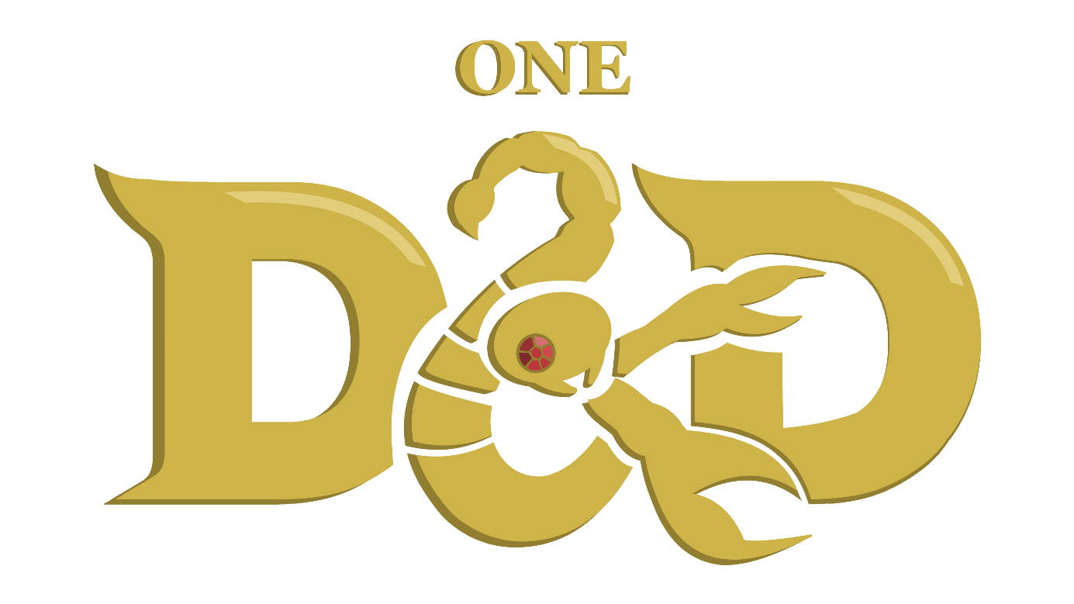
A guide for the One D&D module by L_P’Tato
Based on Karak by Petr Mikša & Roman Hladík
Table of Contents
Who Is The Dungeon Master? 1
The Creation of One D&D 1
Playing the Dungeon Master 1
Dev Tools 1
Embodying the Dungeon 2
Vessel of Creativity 4
Optional Home Rules 4
Critical Successes and Failures 4
Player vs Player Combat 5
Living Dungeon 6
Improvisation 7

Who Is The Dungeon Master?

The Creation of One D&D
The One D&D Karak module was originally created to serve as an introduction to the combat mechanics of Wizards of the Coast’s Dungeons & Dragons (D&D).
Jokingly named after D&D 5.5e, under the logic that Karak possesses only one dungeon and one dragon each game, it attempts to reinterpret the many elements of Karak elements under the lens of Dungeons & Dragons.
The idea behind this new ruleset is to allow people new to tabletop roleplaying games to familiarize themselves with D&D’s complex mechanics before engaging with a full session. The hypothesis being that this would allow the players, made familiar with the system, to more comfortably ease into roleplaying side of the game on which they can focus.
Alternatively, this version of the game can also allow for a play session to hit the TTRPG cravings without engaging with the roleplay, focusing entirely on combat and competition.
Whichever way you want to use this system, it is important to understand how to engage as the Dungeon Master.

Playing the Dungeon Master
The Dungeon Master – or DM for short – is the master of the game. That doesn’t mean he knows every rule by memory and has a mastery of the gameplay; those are helpful skills but certainly not necessary. What the DM does is controls every Monster in the dungeon and makes final calls as mediator.
This means the DM can never win the game, instead he serves to allow the players to fully engage with the world of Karak, which in this case means attempting to incapacitate them as they scavenge the dungeon for treasures.
Remember, while you are embodying the player’s enemies, you are not playing against them. In the end, one player will win the game, and you goal is to ensure that the game is fun until that happens, not to prevent that moment from coming.

Dev Tools
A simple tracker for the Monsters has been put together in a Google Sheets file linked here: One D&D Initiative Tracker
Simply make a copy of the file to use for your own needs.
Alternatively, an incredibly simple initiative tracker with limited features but some automation has also been created, and can be accessed via the “initiative_tracker.html” file found in the GitHub.

Embodying the Dungeon
As the Monsters all have not just their attacks but also combat features, it is important for the DM to truly embody every Monster as they act during combat.
When fighting players, Monsters won’t always necessarily make the objective best choice. The most important is to take the situation into consideration when making decisions for the Monsters.
Here are a few guidelines for each Monster type:

Fleeing Monsters
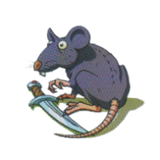
Rats and Skeleton Turnkeys both have the ability to flee combat, but that doesn’t mean they behave the same way.
A Rat might be less inclined to strategically analyse the threat level of the Hero, and just flee right away even on high HP, while a Skeleton Turnkey might instead wait until it reaches half HP to escape.
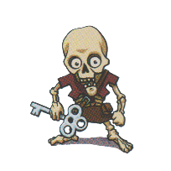
These two are also capable of finding themselves in unusual circumstances due to their ability to move to a different tile. If multiple Rats find themselves on the same tile they might choose fight over flight. A Skeleton Turnkey which finds itself in the same room as a Treasure chest might flee right away to ensure the Key stays away from the Treasure. Or perhaps it would instead refuse to flee, and fight with its life to protect the chest.

Skeleton Warrior
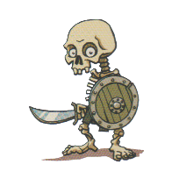
Depending on how you interpret the Monster, Skeleton Warriors might be some of the most tactically intelligent enemies, only second to The Fallen, or completely incapable.
How you choose when to attack or take cover should reflect this. A cowardly Skeleton Warrior might take cover while at full HP if they are threatened by the Hero adversary. On the other hand, a more experienced undead soldier could try to tactically outmanoeuvre the players, making predictions on what their actions will be to determine whether to attack or defend.

Skeleton King
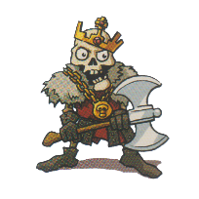
Skeleton Kings are incredibly greedy in nature. Typically, they will choose to steal from the Hero whenever they can, but perhaps this can be interpreted differently
The greed could translate into violence, and a Skeleton King fighting a Hero with an inventory full of Magical Scrolls might instead attack fiercely in hopes of collecting their bounty – of course mechanically they do not steal the Scrolls when they take a Hero out, but lore-wise this could make sense. Additionally, you can always choose to establish this kill-steal as a ruling of your own, so long as you consult the players of course.

Mummy
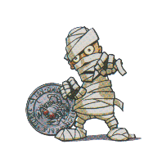
The Mummy is the embodiment of the Curse of Karak, as such it will usually prioritize cursing Heroes over their defeat. A Mummy face to face with a Hero near death, though aware that they could put it down with one fierce Strike, might still choose to flash the red gems of their cursed token at the Hero instead, only to ensure the Curse is spread, if only for a couple of turns.

Giant Spider
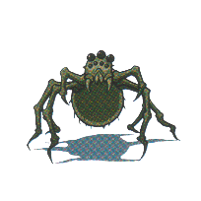
Giant Spiders are instinctive rather than strategic. Though the Hero fleeing might very well work in its favour, what to ensure its own survival, a Giant Spider might still choose to web them down. Their instinct speaks clearly: wrap it then bite it.
Or perhaps the Giant Spider, in its instinct to survive, recognizes a threatening Hero, and fearlessly chooses to bite, expecting the threatened Hero to flee.

The Fallen
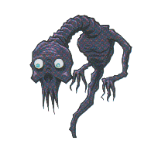
The Fallen are the spirits of deceased heroes, who inflicted by the Curse of Karak while seeking the dungeon’s treasures, were physically consumed and reduced to this ghoul-like form.
They cling on to what little Treasure they found, devoid of all senses but the need to find the treasures hidden within the dungeons and protect them at all costs from the Heroes that come to steal it.
This Monster has the most versatile Combat Feature, varying based on the Hero which fought it. As such, it also displays the most opportunity for interesting and strategic combat, employing the player’s techniques, balancing attacks with spells, or even fleeing combat altogether.

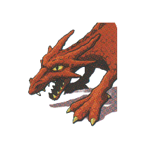
The Dragon
The Dragon is the final boss of the game and should feel threatening, as such the DM should take complete advantage of the wide fire breath attack to hit all Heroes at once and the claw attack’s powerful single-target damage to cripple the most threatening foes to truly present The Dragon as a threatening enemy to even the well-equipped players.

Vessel of Creativity
Though the game has well established ground rules, in its nature as an introduction to Dungeons & Dragons, this Karak module is designed with spontaneous improvisation in mind.
Every player and Dungeon Master has preferences and between different playing parties you might find yourselves wanting to tweak the rules of the games to create an experience more appropriate to your expectations.
Here are some potential guidelines for common, popular or otherwise interesting home rules that could be optionally incorporated into the game for more interest. As the DM it is your job to call for votes and make rulings on decisions for these various elements.

Optional Home Rules

Critical Successes and Failures
Critical Successes and Failures and the common term to refer to rolling the highest or lowest possible result respectively when making a roll with the d20.
There are many elements to consider when implementing this mechanic, so to make it easy, simply answer the following questions:
- Do Critical results affect all roles (such as Initiative and Saving Throw) or only attack rolls?
- How do Critical results affect the result of the roll: Is it an automatic success/failure?
- How is damage affected by a Critical Success on the attack roll? Here are some suggestions:
  - Roll the damage dice twice, and add the modifier: a 1d6 + 2 attack would instead deal 2d6 + 2 damage.
  - Max out the damage, then roll the dice again: a 1d6 + 2 attack would instead deal 6 + 1d6 + 2.
  - Grant a different bonus, such as advantage on the next attack roll.
- What are the consequences of a Critical Failure on an attack? Here are some suggestions:
  - The Hero deals a fixed amount of damage to themselves (1, 1d4, 1d6, …).
  - The Hero attacks themselves, rolling the attack’s full damage.
  - Impose a different negative, such as giving the enemy an attack of opportunity.

Player vs Player Combat
PvP might come up naturally in a competitively driven game such as Karak, but its implementation can be difficult, as there are many aspects to consider. Here are only a few of them.
PvP could be exclusive to when two Heroes are fighting the same Monster, this would allow the players to more directly compete with each other for that tile’s loot. Many existing features would already work with this system: multi-target attacks such as Argentus’ Magic Missiles could allow a player to attack both an enemy and the opposing Hero, Lord Xanrus’ “Repulsive Blast” Attack Skill could disable the opponent, guaranteeing they don’t kill the Monster first.
In some cases, the DM might have to spontaneously intervene for balance reasons. In the case of the last given example, this could come as requesting a Physical saving throw from the hit player to avoid their turn being skipped.
PvP can also be incorporated outside of Monster combat, allowing two players to directly combat each other. Once again, ground rules ought to be established. For example:
- Do both players have to be willing for PvP to be initiated, or can one player force the other into combat?
- Must the players be on the same tile or neighbouring tiles?
- How does initiative order work? Is it rolled once for each player and the complete combat is played on each of their turns, or is it rolled once and the later of the two players’ turn is skipped so that everyone plays the same number of times per round?
- If and when combat ends in one of the Heroes being brought to 0 HP, what impact does this have?
  - Having to recover is already a significant enough hindrance, no other negatives are imposed.
  - The winning player can steal an item of their choice from the other.
  - The losing player must drop an item of their choice on their tile.
Regardless of how these different cases are handled, the most important is to always remember that the primary goal of the game is to have fun, so if the PvP rulings are stopping a player from fully enjoying the play session, then they should be tweaked.

Living Dungeon
As the embodiment of the dungeon, the DM could get a turn of his own at the end of every round. This could be handled in a multitude of ways to make the game more interesting and make the dungeon feel more alive. Here are some suggestions:
- One or more discovered Monsters currently out of combat move around to neighbouring tiles.
Different Monsters would have different behavioural patterns. Perhaps Rats try to cluster together, or look for a room to hide in if they are currently in tunnel, Skeleton Turnkeys and The Fallen seek Treasures to defend, and Skeleton Kings look for abandoned Magical Scrolls to collect.
- One or more abandoned loot item tokens are turned back around. This is a choice that needs to be justified, and it can be done in a multitude of ways.
A Rat might crawl through the holes in the walls into a room where Dagger was left behind, or the dismantled skeletons of Warriors, Kings and Turnkeys could reassemble themselves to wield their weapons (or key) once more.
- A chest left unopened for multiple rounds in a row is turned into a Fallen. The DM looks through the bag of treasures and monsters to get one of the two The Fallen tokens and swaps it out for a locked chest which is thrown back in the bag.
This could be explained by it being the spirit of a fallen hero who was yet to find Treasure and still wandered the dungeon looking for it.
- Driven mad by the increased amount of time in the dungeon, a Hero receives the Curse of Karak. This could be implemented in many different ways; here are only a few possibilities:
  - The Curse of Karak token is switched to a random player or the player with the most treasure.
  - One or all players have the Curse of Karak temporarily for just this round.
  - The player who discovered the most undiscovered tiles on the last round is driven mad by paranoia or fear and is cursed temporarily.
  - The DM rolls a d100, d20 or even d12 and if the result is under the number of rounds played up to that point, a player is cursed.

Improvisation
From attempting to domesticate a Rat to crafting a Mummy’s bandages into a healing bandage, players driven by creativity will suggest all kinds of wacky shenanigans. As the master of the game, it is your job to make the call on whether player’s requests should be accepted or not.
Generally, rewarding player creativity is recommended, though certainly shouldn’t come for free. The simplest way to do this is by asking for a dice roll with the appropriate skill, be it Wisdom, Physical or Constitution. If the request involves a specific request during combat, you could instead call for an attack roll with disadvantage. Regardless of how you go about it, remember that you must define the target Difficulty Classes for all these rolls, so don’t feel ashamed to ask your players for a moment as you consider their request and calculate how to incorporate it.
An important thing to keep in mind is that not to be afraid of refusing a player’s request. Though you might be afraid to take away player agency, it is important not to accept any and all requests. Players should be able to justify why their request makes sense and should be accepted.
Additionally, some requests effectively copy another Hero’s powers, such as preventing the Monster from fleeing or incapacitating them, which can be done by the Ray of Frost and Sleep spells respectively, or fleeing into an undiscovered area, which is part of Victorius’ “Disengage” Combat Feature.
This doesn’t mean they should be automatically denied, but should be considered under stricter rulings, for instance by imposing a particularly difficult role – disadvantage, minimum damage requirement, attack roll complemented by a saving throw from the enemy – and should require a more concrete or developed reasoning, for instance one involving their Hero’s abilities to justify the power to copy a different Hero’s one.

