PvZ: Lawnmageddon
  - Game Design Document
PvZ: Lawnmageddon is an idle tower defence Plant vs Zombies game loosely based on the first issue of the comics. It takes inspiration from various survivor-likes and turret shooter tower defence games like Alpherior’s Genome Guardian but aims to create a cozier idle experience.

Game UI Mock-up
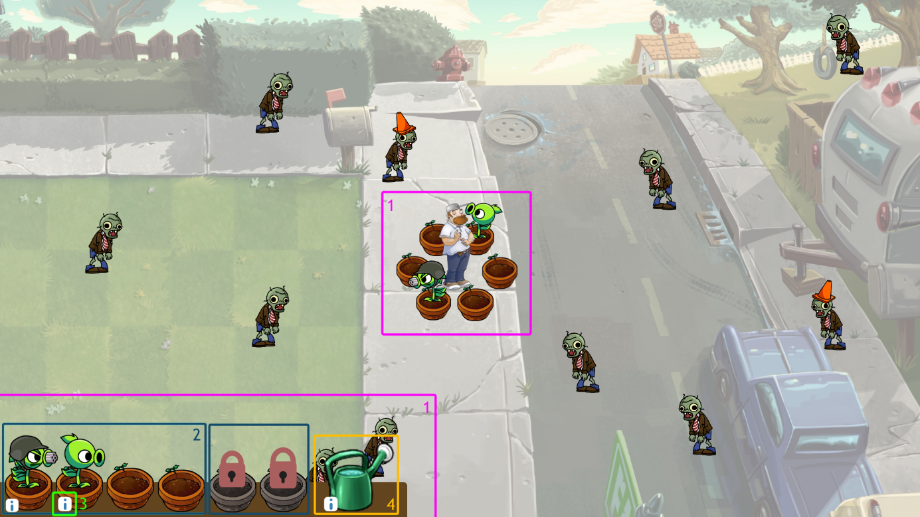

1 – Tower Defence Mechanics
During gameplay, the player character remains at the centre of the screen, surrounded by six Flower Pots. These are the slots in which plants can be planted to defend the player character. Zombies will spawn just outside the edge of the screen and walk towards the player.
The detailed description of these appears on the bottom left of the screen, where the six plants are presented alongside the character’s ability.

2 – Plants
As the game progresses, as well as at the start of the game, the player will be offered to pick from a selection of rewards which notably include plants. These can either be placed on an empty Flower Pot, assuming there is any left, or be placed on an existing compatible plant to upgrade it, such as by placing a Peashooter on another to form a Repeater.
At the start of the game, not every plant pot is available to plant on. These can also be unlocked via random rewards. The bottom shelf and Detailed View mode are accessible while selecting rewards, so that the player can see which plants and buffs they already own or access the Shovel to free up space for a new plant.

3 – Detailed View
By clicking on the information icon next to the plant or ability, the player opens the Detailed View menu which replaces the usual shelf.
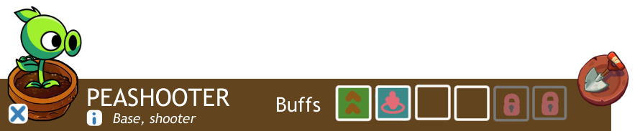
From this menu, the player can see the following information:

Level and type
The level of the plant – Base, Level 2, etc… - defines the level of fusion/evolution. For example, because the peashooter is the base of the Peashooter plant type, it is classed as Base. If evolved into a Repeater or fused into a Snow Pea, then the text will change to say Level 2.
The type of the plant – Shooter, lobber, etc… - defines what buffs the plant can receive.
Clicking on the information icon opens the plant’s evolution tree where all discovered fusions are fully showcased while others are partially obscured, as well as the list of buffs the plant type can get, once again only fully showing those already discovered.

Buffs
The row of icons shows the list of buffs the plant has received. These too are unlocked via random rewards and attributed to the plant of the player’s choice.
The number of buffs that a plant can have is dependent on its level, so lower-level plants can’t be as strengthened. All this information is visible by hovering over the respective icons.

Shovel
The shovel can be used to remove the plant.

4 – Player Character
The game has an array of available player characters based on the human characters from the Plants vs Zombies franchise. Each character has a unique ability that can be evolved and buffed much like the plants, with all information accessible via its own Detailed View.
There are currently three player characters planned for the game: Crazy Dave, as well as Nate Timely and Patrice Blazing from the PvZ comics. The latter two are not available by default, instead unlocked by playing the campaign mode explain in the following chapter.

Crazy Dave
Crazy Dave’s power reflects his caretaker personality, as the creator and keeper of the plants. In the comics especially, Crazy Dave shows he cares a lot for the plants. This is also seen in the PvZ games, with the various entries of the Zen Garden and plant buffs.
As such, Crazy Dave’s power will make him occasionally buff a plant. At the start, this can be a simple temporary attack speed buff by watering one of the plants, but by upgrading the power, it could instead trigger a Plant Food from PvZ 2.

Nate Timely
Despite presenting himself as a wannabe adventurer, Nate Timely often finds himself easily cornered by zombies, and instead relying entirely on plants, notably by cowering behind protectors. This is also seen in his future self, who develops technologies, so he doesn’t need to engage with the zombies directly.
As a reflection of this, Nate Timely will occasionally spawn support plants. At first, these are Wall-nuts that spawn randomly, taking hits from zombies which happen to walk into it. The power could then be upgraded into a stronger Tall-nut or the more efficient Sweet Potato.

Patrice Blazing
Patrice Blazing is the most adventurous of the two protagonists. Despite presenting herself as the more serious and stable-headed one, she often engages the zombies a lot more directly, becoming a martial arts expert in her adulthood.
Furthermore, despite her close relation to Sunflowers, she is notable for her direct combat, and her power reflects this, notably referencing the first issue of the comics’ cover, where she prepares to swing a Cherry Bomb at the zombies.
Patrice Blazing would occasionally throw an instant plant at the zombies, dealing heavy damage. At first, this would be a Cherry Bomb aimed randomly, but it could be upgraded into a variety of different instant plants with varied attack patterns.

Campaign Mode
The Campaign Mode is a non-endless story-driven game mode with scripted waves of zombies and a final boss fight that reference the first issue of the PvZ comics, Lawnmageddon. The tower defence elements will remain but the zombies that spawn as the game goes on will be predefined rather than randomly generated.
Most interestingly, the Campaign Mode will include a handful of dialogues and character interactions, and the player character will change during gameplay as the new characters are introduced.
After completing the Campaign Mode, the player will unlock Nate Timely and Patrice Blazing as playable characters for the regular game mode.

