Plants vs Zombies:
Zombie-Playing Zombie
  - Game Design Document
PvZ ZPG is a rogue-like Plants vs Zombies fan-game inspired by the “I, Zombie” minigame, following a dungeon-crawler style game progression and using a turn-based fighting system for each level. Stray Fawn Studio’s Dungeon Clawler was a great source of inspiration in the creation of this game.

Standard UI
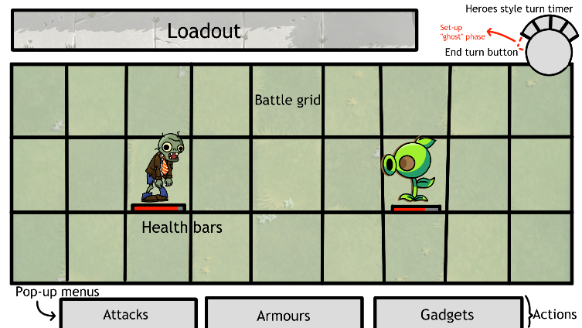
- Battle Grid: The game grid is composed of three horizontal “Lanes” and nine vertical “Columns”.
  - The first three columns (in purple) are the zombie spawn area. At the start of each level, the player choses to spawn in any of these nine tiles.
  - The fourth column (in red) is an empty buffer lane between the zombies and plants.
  - Finally, like in “I, Zombie”, the plant spawn area encompasses the last five columns (in green).
    - Plants are generated from an area-specific and progress-based pool at the start of the level, before the player zombie is placed.
    - Bosses have unique animations at the start of the level before the rest of the plants spawn.
    - Unless specified otherwise, only plants native to the current area, except plants with no area such as Sunflower, can spawn.
    - Certain criteria influence which plants appear in which tiles. For example, while possible, plants with an ability that has an area of effect (AOE) are less likely to spawn in the corners and edges, and Protector-type plants are less likely to spawn in the last columns.
- Turn Order: The turn order and current phase is displayed with an icon similar to PvZ Heroes, including a large “End Turn” button for the player to click once they are done.
  - Before the turn properly starts, a ghost “Set-up Phase” takes place.
    - First, all “Garden Gimmicks”, as in special events unique to the garden, like Freezing Winds for example, take place.
    - Then all plants with an ability at the start of the turn act. This includes, for example, Grow-shroom buffing the lowest health plant.
    - Bosses act first. Then the rest of the plants act one at a time, column by column, top to bottom, right to left, skipping any plants that don’t act of course. (In yellow: A to G…)
  - The first proper phase of the turn is the “Place Spawnlings Phase”.
    - During this phase, the player gets to place Spawnlings, as in zombies that aren’t the player, on available tiles of the zombie spawn area.
    - Every turn, the player is given brains that can be used to place Spawnlings. Other than their cost, there are no limitations to how many Spawnlings may be placed in a single turn.
    - Brains might also be obtained by vanquishing plants or from other miscellaneous sources.
  - Then, the icon flicks to the first phase, the “Player Phase”.
    - The player can perform a given number of actions in its turn, increasing as the game progresses.
    - These actions can be one of three types. The first is using a Weapon, such as Bite, to attack a plant. Please refer to Weapons for more explanation.
    - The next is equipping an Armour. Please refer to Armours for more explanation.
    - Lastly, the player can use a Gadget. These are unique items that have one of two properties: “Passive”, allowing them to be equipped like armour and “Active”, meaning they are instantly activated as part of the action. Please refer to Gadgets for more information.
  - The next phase is the “Plants Phase”.
    - Here, each plant performs their active ability, most often a simple attack. For instance, a Peashooter will attack during this phase, assuming there is a zombie in range.
    - As with the Set-up Phase, bosses attack first, then all other plants act one at a time, column by column, top to bottom, right to left, skipping any plants that don’t act of course. (In yellow: A to G…)
  - Finally, the turn ends with the “Spawnlings Act Phase”
    - Here, the player controls the actions of each Spawnling.
    - Unlike the player, each Spawnling only has one action they can perform, be it using a weapon or a gadget, as Armours and Passive Gadgets are automatically equipped when they are placed. As such, the player needs only to select each Spawnling and the target of their action.

