Rapport de Classification - Modèles ML

Généré le : 01/08/2025 à 12:33:14

Modèles évalués sur le dataset COVID-19 Radiography (4 classes).

# Modèle : Random Forest

## Rapport de classification

precision recall f1-score support  
  
 COVID 0.44 0.60 0.51 20  
 NORMAL 0.82 0.70 0.76 20  
 VIRAL 0.89 0.85 0.87 20  
 LUNG 0.71 0.60 0.65 20  
  
 accuracy 0.69 80  
 macro avg 0.72 0.69 0.70 80  
weighted avg 0.72 0.69 0.70 80

## Matrice de confusion

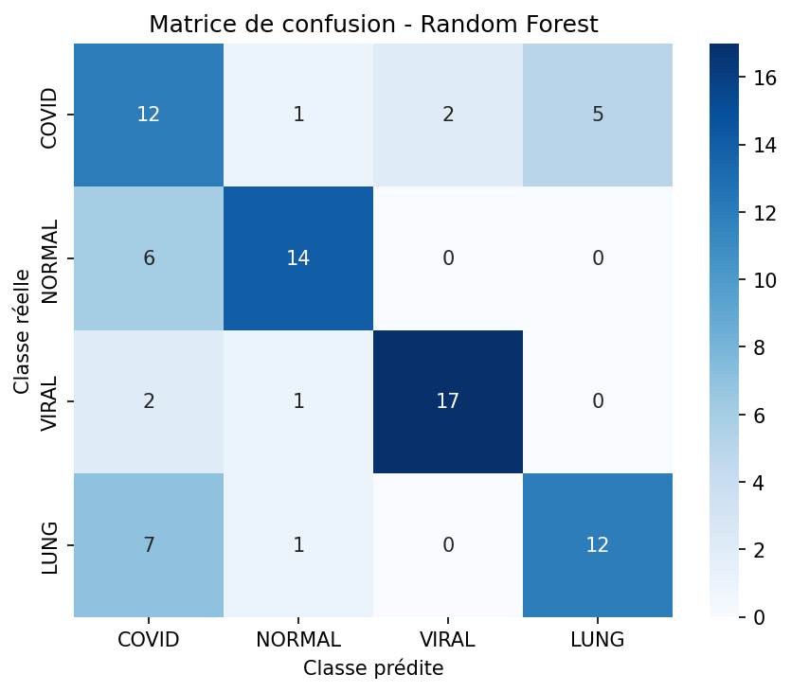

# Modèle : Linear SVM

## Rapport de classification

precision recall f1-score support  
  
 COVID 0.61 0.55 0.58 20  
 NORMAL 0.52 0.70 0.60 20  
 VIRAL 0.85 0.85 0.85 20  
 LUNG 0.53 0.40 0.46 20  
  
 accuracy 0.62 80  
 macro avg 0.63 0.62 0.62 80  
weighted avg 0.63 0.62 0.62 80

## Matrice de confusion

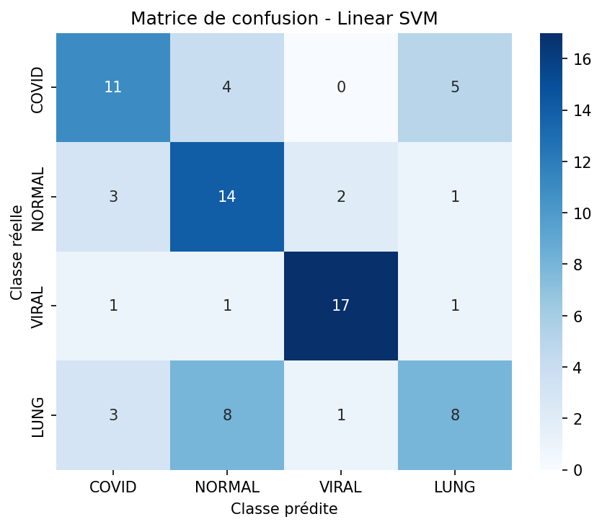

# Modèle : K-Nearest Neighbors

## Rapport de classification

precision recall f1-score support  
  
 COVID 0.41 0.35 0.38 20  
 NORMAL 0.50 0.85 0.63 20  
 VIRAL 0.93 0.70 0.80 20  
 LUNG 0.64 0.45 0.53 20  
  
 accuracy 0.59 80  
 macro avg 0.62 0.59 0.58 80  
weighted avg 0.62 0.59 0.58 80

## Matrice de confusion

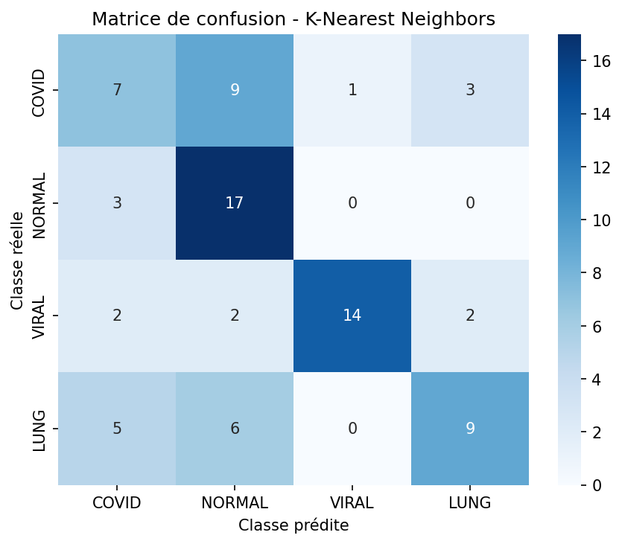

# Modèle : Gradient Boosting

## Rapport de classification

precision recall f1-score support  
  
 COVID 0.43 0.50 0.47 20  
 NORMAL 0.65 0.65 0.65 20  
 VIRAL 0.70 0.80 0.74 20  
 LUNG 0.64 0.45 0.53 20  
  
 accuracy 0.60 80  
 macro avg 0.61 0.60 0.60 80  
weighted avg 0.61 0.60 0.60 80

## Matrice de confusion

