Sliver Care Final Project Report
  - Group6 / 22 September 2026

1 The decision
Group6 has decided to stop advancing the venture after the course. The main reason is the team’s time and future resource commitments: the team cannot commit to ongoing development, maintenance and user support after the course. [C01]
Group member name | Student number
XINYU LAI | 2023362046
ZHENGYUAN QIU | 2023362027
MINXUAN LI | 2023362005
JINGHAO YU | 2023362059
RUI ZHOU | 2023362052
YIYANG FENG | 2023362038
SHENGWEI HUANG | 2023362024
TIANYI LI | 2023362026

Method and scope: the local care workflow and checkout use simulated care data and payments. Outreach now uses the team’s actual consultations and emails, supported by the supplied feedback summary, chat images and email-list image. Four chat screenshots and one email-list screenshot are selected for concise presentation; they are not the complete outreach archive. Previous course outreach simulations are excluded. The team’s decision after the course remains Stop.
The package provides an operating local family-care workflow. Twelve recorded automated functional experiments passed using controlled scenario data, with no external customer participants. [C02]
The report combines feedback from eight individuals consulted on 20–22 September 2026, ten organisational emails sent on 20 September as confirmed by the team, supplied screenshots, and dated local product experiments. Representative evidence is identified for each displayed example. [C03]
The next 90 days concern archiving the product and feedback, completing the team review and keeping the project inactive. The new comments help explain what customers may value, but do not establish sustained use, paid demand or reliable connected delivery.

2 Problem and customer
Our initial problem hypothesis is that family members can lose track of who should follow up after a reminder and what happened after contact. The proposed customer is the adult child coordinating care for an independently living parent who can use a simple response interface. [C04]
The older adult and the family caregiver are intended users. The organising adult child is the proposed buyer. That distinction determines the design: a short response on one side, responsibility and a follow-up record on the other.
Early feedback supports exploring family responsibility and follow-up as a problem. One chat prioritises named responsibility, and another identifies parents living alone, distant children and several relatives sharing care. These qualitative comments do not establish how widespread the need is. [C05]
The two-phone example demonstrates a possible response and follow-up flow. The new feedback gives initial qualitative support to responsibility and record-keeping. The sample is small, recruitment is not documented, and comments after viewing an introduction are different from observed use.
An appropriate future test, only if the project is reopened, would observe a consenting family completing a specific handover without coaching, then ask for an explicit response to the quoted offer. Completion, confusion and the response would need dates and records. This is a proposed method, not a test already run.

3 The product
A user receives a local browser application, sample care profiles, reminder plans, responsibility records and downloadable reports. It runs through a local server; the original two-phone example and the working household have separate histories. [C06]
The working sequence is to choose a recipient and responsible family member, start a reminder, record a self-reported response or help request, record a family outcome or handover, and generate a report from those saved actions. [C07]
The confirmed proposed family prices are Free ¥0, Plus ¥39/month or ¥390/year, Pro 5x ¥79/month or ¥790/year, and Pro 20x ¥99/month or ¥990/year. Annual totals are paid upfront in the proposal; the current offline evaluation costs ¥0. [C08]
Plan | Monthly RMB | Annual RMB | Local capacity | AI templates per cycle
Free | 0 | 0 | 1 recipient / 1 family role | 0
Plus | 39 | 390 | 2 / 4 | 20
Pro 5x | 79 | 790 | 5 / 8 | 100
Pro 20x | 99 | 990 | 5 / 8 | 400

The table capacities are offline product defaults. The Pro options have identical care features; 5x and 20x describe the monthly AI allowance relative to Plus. The assistant generates local templates rather than calling a live model. [C09]
Checkout is simulated and the actual charge is zero. Failure or cancellation does not activate a plan. A successful local activation enables paid-tier features, while quota exhaustion does not block the core care response. [C10]
For the cost model, one unit means one active paying family for one month. Its assumed variable cost is ¥18.19 in the base scenario. Actual development hours, staff costs and supplier quotations have not been recorded, so no measured cost to build the first app or serve a real family is claimed. [C11]
A check-in is a self-report; recording an outcome does not establish clinical safety. This edition has no connected family accounts, real notifications, live payment, medical monitoring or emergency response.
The proposed tiers address different needs. Plus at RMB 39/month supports everyday responsibility, multiple plans and report export. Pro 5x at RMB 79/month adds rota, backups, handovers and adjustable follow-up. Pro 20x at RMB 99/month retains the same Pro care features and adds 300 generations for RMB 20 more per month. One contact conditionally accepts RMB39/month if the service is reliable and used regularly; this does not establish a paid conversion. [C28]
Plus provides 20 successful local generations per monthly cycle, Pro 5x 100 and Pro 20x 400. All roles and recipients in a household share the counter. Each new successful generation, including regeneration, costs one use; failed, cancelled or invalid requests cost zero. Reading or saving an existing draft and exporting a care report cost zero. Unused allowance does not roll over. Plan changes preserve usage, while a new monthly demo cycle resets it and retains past drafts. Annual totals equal ten monthly fees but do not multiply the monthly allowance. [C29]
The current local evaluation is free. Cross-device family accounts, remote notifications and live AI remain proposed capabilities, with no launch date under the Stop decision. Proposed live AI uses would include weekly summaries, handover drafts and follow-up lists based on saved records, subject to family review. Current local templates already produce summaries and handover drafts containing open items. Neither a template nor a future model can verify actual medication intake or establish clinical safety.

4 Show the product
The version comparison below uses the earliest retained screenshot available for this report and the current working household. The earlier picture shows one older-adult and family pair. The current view shows saved care items, named responsibility and distinct open and recorded-outcome states. [C12]
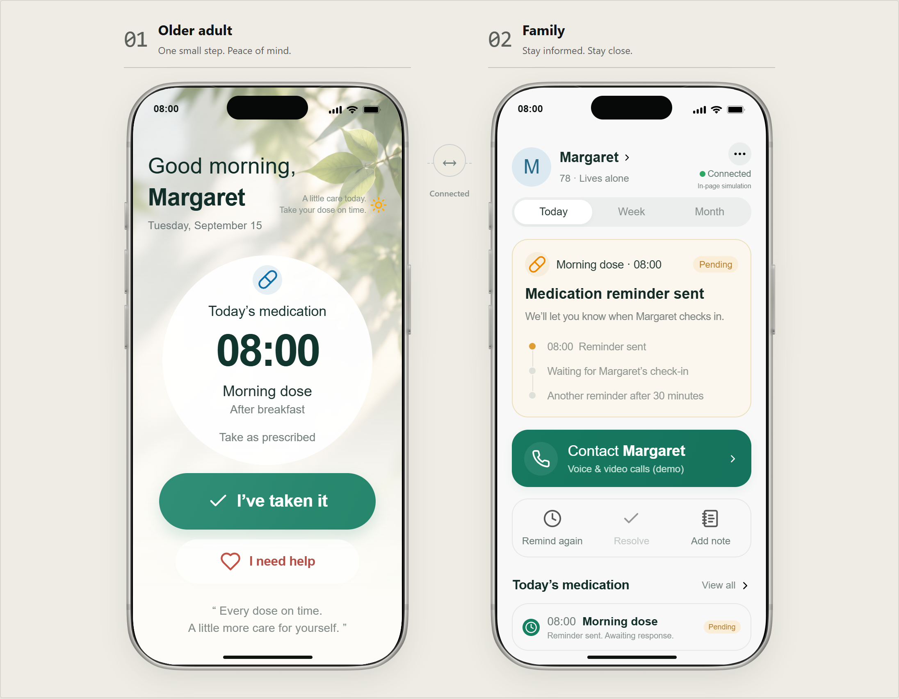  Earlier retained prototype: guided two-phone example. Date of first capture is not established. | 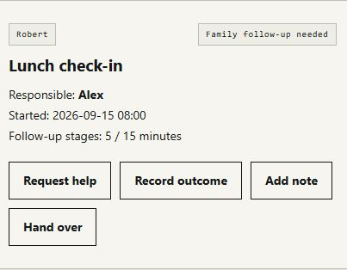  Current local MVP: enlarged detail of an open care item, recaptured 20 September 2026. The complete screenshot is source S14.

Visible change | Earlier retained example | Current workspace
Role of screen | Illustrates a response flow | Operates saved care records
Responsibility | Single illustrated family pair | Recipient and responsible-person fields
Output | On-screen event history | Report containing entered outcomes and handover

The verified report file contains the entered follow-up note and a handover, with 2,322 decoded characters and 2,329 UTF-8 bytes. Its content matches the report preview used in the download check. [C13]
Reproduce the product locally by running Start.cmd, opening Care workspace and following the demonstration script. Appendix B includes a report extract and evidence-file locations. No person outside the team appears using the product; no independent usability test is claimed. We cannot verify that the retained picture was the first-ever design.

5 What you tested
On 20 September 2026, the coding assistant ran twelve automated functional experiments against a saved snapshot of the product rules. The evidence records each belief, procedure and result. These are implementation tests, not observations of market demand. [C14]
Experiments | Belief and action | Observed result
E01–E02 | Complete Free follow-up; activate Plus and inspect the report | Outcome recorded and note included
E03–E04 | Exercise checkout failure, cancellation, duplication and annual totals | State preserved; one receipt; 390 / 790 / 990 quotes
E05–E07 | Exhaust AI quota; use Pro backup and handover; downgrade | Core response works; responsibility changes; history persists
E08–E09 | Age an open reminder eight days, then record an outcome | Open item retained; later outcome counted in its event period
E10 | Reset care with synthetic outreach and request fixtures | Both fixture records retained; not written to real browser log
E11–E12 | Cross midnight with a rota; tamper with a simulated receipt | Due-date owner selected; invalid charged receipt rejected

A reconstructed period-only open-item rule counted zero open reminders after eight days even though one remained unresolved. The current all-date rule counted one and included it in the report. This experiment demonstrates why the reporting window must not hide open work. [C15]
A reconstructed full replacement reset retained zero outreach fixtures. The current care-only reset retained the one fixture and its unsent request. The fixture was synthetic and never entered the real outreach log. [C16]
These results support retaining all open work and preserving outreach during a care reset. They do not show that real families understand the interface. We also have no recorded timed presentation rehearsal or observed outside-user task completion, and do not substitute automated checks for either.
Fifteen additional automated checks recorded on 20 September 2026 cover nine scenario steps and six allowance contracts. All passed. The examples execute the same local product rules in isolated sample households. These checks supplement the original twelve experiments; they are not customer participants or evidence of willingness to pay. [C30]
The team-prepared feedback document contains eight bilingual question-and-answer themes, not a response-by-person dataset. It covers willingness to try, responsibility, ease of use, price, free evaluation, privacy, target households and proposed features. Four chat screenshots support selected themes; individual-level percentages cannot be calculated from this material. [C31]
Belief explored | Action and available result | Implication
Families need clear responsibility | Shared product introduction; one chat prioritises named responsibility (S18) | Show responsibility and saved outcomes in the core demonstration
RMB39/month may be acceptable | One chat accepts conditionally on reliability and frequent use (S19) | Keep pricing proposed; reminders alone may not justify it
Connected coordination matters | One chat requests alerts and shared updates (S20) | Retain as proposed capabilities; delivery remains untested
Organisations will engage | Team sent ten invitations; no replies by 22 September (S23) | This channel has produced no response yet; silence does not establish rejection

6 Model and numbers
The revenue hypothesis is an optional subscription paid per family. The model assumes 70% Plus, 20% Pro 5x and 10% Pro 20x; within each plan, 60% pay monthly and 40% annually. Annual revenue is divided by 12 for monthly comparison. [C17]
Input | Base assumption
Service, support and AI per paid family / month | ¥12.00
Free households funded per paid household | 5 at ¥0.50 each
Processing allowance | 1% of recognised revenue
Equivalent monthly churn and replacement acquisition | 4% and ¥80
Fixed operations per month | ¥30,000
Active paying households | 800

The calculated monthly revenue per paid family is ¥49.47. Variable cost including replacement acquisition is ¥18.19, leaving contribution of ¥31.27. With ¥30,000 fixed monthly operations, break-even is 960 paid families; at 800 families the monthly result is a loss of ¥4,982.40. [C18]
Calculation: variable cost = 12 + (5 × 0.50) + (49.4666667 × 1%) + (4% × 80). Monthly result = paid families × contribution − fixed operations. Rounding occurs only for display.
Allocating fixed costs over 800 assumed paying families gives a total monthly cost of ¥55.69 per family. The model excludes initial development, launch costs, growth acquisition, financing and taxes. It does not establish the cost or time needed to acquire 800 families. [C19]
No supplier quote, measured support load, retention observation or sale validates these inputs. The arithmetic works as a scenario, while the business case remains unproven. We therefore use it to identify evidence we lack, rather than as a forecast that supports continuing.

7 Commitment
The team confirms eight individual consultations on 20–22 September 2026 and product-experience invitations emailed to ten organisations on 20 September. Those emails included an MVP demonstration video and product introduction PDF. No organisational reply had been received as of the team update on 22 September. [C20]
Activity / evidence | Count / period | Outcome and interpretation
Individual consultations | 8; 20–22 Sep 2026 | Four chat screenshots plus a thematic summary; no per-person response-rate estimate
Organisation invitations | 10; sent 20 Sep 2026 | No replies reported as of 22 Sep; six email rows shown
Price feedback | One visible RMB39/month response | Conditional acceptance; reminders alone may feel expensive
Purchase / pilot commitment | No supplied evidence | Stated interest is not a completed sale or trial
Team decision | Stop after the course | Archive feedback; stop due to team time and resource commitments

The supplied chats show interest in trying the product, a preference for named responsibility, conditional acceptance of RMB39/month, and requests for automatic notifications and shared updates. The materials contain no completed purchase, deposit, agreed pilot or observed product trial. No-reply institutional contacts remain pending rather than classified as rejections. [C21]
For the requirement to make at least ten commercial offers, the team reports ten organisational product-experience invitations. The report presents a selected email-list screenshot rather than reproducing all correspondence. The eight individual consultations are recorded separately and are not automatically counted as eight additional commercial offers. [C22]
The practical lesson is to demonstrate named responsibility and saved follow-up before discussing AI. The conditional price response adds a clear requirement: usefulness depends on reliable delivery and regular household use. The notification request identifies a gap in the current local MVP. The absence of replies after the reported email outreach has yielded no institutional commitment so far.
The email-list preview includes greetings to Taikang Home, Xinrong Linbang and Xiaode Zhineng. These examples identify the intended addressee in the message greeting; the screenshot does not independently establish the mailbox’s organisational ownership, delivery or a partnership. All ten institutional contacts remain without a reported reply as of 22 September. [C33]
Earlier ten-record course simulations, including the four-interested, four-declined and two-pending split, are archived separately. They contribute zero contacts, responses or commitments to this updated actual-outreach account. [C32]

8 Limitations
The eight consultations provide initial qualitative reactions. Recruitment, participant characteristics, independently usable task performance, repeat use and paid conversion remain unmeasured. The displayed chats are illustrative excerpts, not a quantitative distribution of opinions. Lack of institutional reply does not distinguish unread mail, low priority or lack of interest.
The functional evidence covers controlled local scenarios and a local browser. It does not establish cross-device delivery, real accounts, reliability in service, clinical effects or live billing. [C23]
The retained prototype screenshot provides a partial development history. We have no measured initial build cost, timed speaking rehearsal, completed customer purchase or agreed pilot. Feedback collection does not resolve live sync, notification reliability, security or service cost. These evidence limits are separate from the team’s main reason for stopping: time and future resource commitments.
Period after the course ends | Stop plan | Condition
Days 1–30 | Archive the product, evidence, outreach register and final report with their method and source notes | No commercial launch or new promises
Days 31–60 | Complete the team review, record unresolved questions and keep the project inactive | No assumed sales, recruitment or development commitment
Days 61–90 | Keep the project stopped; no further development or launch is scheduled | No new development, recruitment or launch promises

The course requires one team submission, a report of no more than 20 pages excluding the appendix, and a seven-minute presentation in four prescribed parts. The supplied final instructions do not state a calendar deadline. [C24]
The 90-day table is a proposed closure and review plan consistent with Stop. It is not evidence that actions have already occurred. Actual Blackboard submission remains a team action.

Appendix A Factual claim register
This register covers the report narrative, tables, captions and identities. Actual outreach is documented through team confirmations, the supplied feedback summary and screenshots. Observed screenshot content is separated from unshown details, estimates, model assumptions and proposed actions. Earlier fictional outreach is archived and excluded. No clinical-effect or representative market claims are made.

C01 Owner decision
Group6 has decided to stop advancing the venture after the course. The main reason is the team’s time and future resource commitments: the team cannot commit to ongoing development, maintenance and user support after the course.
Basis S02. decision and decisionScope

C02 Observed fact
The package provides an operating local family-care workflow. Twelve recorded automated functional experiments passed using controlled scenario data, with no external customer participants.
Basis S04; S05. experimentCount, passed, scope and E01–E12

C03 Observed feedback and team confirmation
The report combines feedback from eight individuals consulted on 20–22 September 2026, ten organisational emails sent on 20 September as confirmed by the team, supplied screenshots, and dated local product experiments. Representative evidence is identified for each displayed example.
Basis S17; S18; S19; S20; S21; S22; S23; S24. Feedback document, four chat images, email list and team confirmation

C04 Problem hypothesis informed by feedback
Our initial problem hypothesis is that family members can lose track of who should follow up after a reminder and what happened after contact. The proposed customer is the adult child coordinating care for an independently living parent who can use a simple response interface.
Basis S17; S18; S21. Problem hypothesis and qualitative comments about responsibility and intended households

C05 Observed feedback and team confirmation
Early feedback supports exploring family responsibility and follow-up as a problem. One chat prioritises named responsibility, and another identifies parents living alone, distant children and several relatives sharing care. These qualitative comments do not establish how widespread the need is.
Basis S18; S21; S23. Two supplied chat screenshots and consultation context

C06 Observed fact
A user receives a local browser application, sample care profiles, reminder plans, responsibility records and downloadable reports. It runs through a local server; the original two-phone example and the working household have separate histories.
Basis S05; S06. newState, saveSchedule, report; browser workspace observation

C07 Observed fact
The working sequence is to choose a recipient and responsible family member, start a reminder, record a self-reported response or help request, record a family outcome or handover, and generate a report from those saved actions.
Basis S04. E01, E02, E06

C08 Observed fact
The confirmed proposed family prices are Free ¥0, Plus ¥39/month or ¥390/year, Pro 5x ¥79/month or ¥790/year, and Pro 20x ¥99/month or ¥990/year. Annual totals are paid upfront in the proposal; the current offline evaluation costs ¥0.
Basis S02; S05; S04. Prior owner pricing carried in PLANS; E04 totals. Prices are proposals for a future service.

C09 Observed fact
The table capacities are offline product defaults. The Pro options have identical care features; 5x and 20x describe the monthly AI allowance relative to Plus. The assistant generates local templates rather than calling a live model.
Basis S05. PLANS and generate

C10 Observed fact
Checkout is simulated and the actual charge is zero. Failure or cancellation does not activate a plan. A successful local activation enables paid-tier features, while quota exhaustion does not block the core care response.
Basis S04. E02–E05

C11 Calculation with unvalidated inputs
For the cost model, one unit means one active paying family for one month. Its assumed variable cost is ¥18.19 in the base scenario. Actual development hours, staff costs and supplier quotations have not been recorded, so no measured cost to build the first app or serve a real family is claimed.
Basis S10. assumptions, calculated.variableCost and excluded

C12 Observed fact
The version comparison below uses the earliest retained screenshot available for this report and the current working household. The earlier picture shows one older-adult and family pair. The current view shows saved care items, named responsibility and distinct open and recorded-outcome states.
Basis S03; S07; S14. Earlier retained prototype, original workspace capture and fresh full-resolution source S14; the report enlarges the open care-item detail.

C13 Observed fact
The verified report file contains the entered follow-up note and a handover, with 2,322 decoded characters and 2,329 UTF-8 bytes. Its content matches the report preview used in the download check.
Basis S06; S09. download observation, character count and SHA-256

C14 Observed fact
On 20 September 2026, the coding assistant ran twelve automated functional experiments against a saved snapshot of the product rules. The evidence records each belief, procedure and result. These are implementation tests, not observations of market demand.
Basis S04; S12. recordedAt, executor, results and reproduction script

C15 Observed fact
A reconstructed period-only open-item rule counted zero open reminders after eight days even though one remained unresolved. The current all-date rule counted one and included it in the report. This experiment demonstrates why the reporting window must not hide open work.
Basis S04. E08. The rejected rule is explicitly a reconstruction.

C16 Observed fact
A reconstructed full replacement reset retained zero outreach fixtures. The current care-only reset retained the one fixture and its unsent request. The fixture was synthetic and never entered the real outreach log.
Basis S04. E10. Reconstructed rejected rule compared with current reset.

C17 Scenario assumption
The revenue hypothesis is an optional subscription paid per family. The model assumes 70% Plus, 20% Pro 5x and 10% Pro 20x; within each plan, 60% pay monthly and 40% annually. Annual revenue is divided by 12 for monthly comparison.
Basis S10. assumptions; formula in S12

C18 Calculation with unvalidated inputs
The calculated monthly revenue per paid family is ¥49.47. Variable cost including replacement acquisition is ¥18.19, leaving contribution of ¥31.27. With ¥30,000 fixed monthly operations, break-even is 960 paid families; at 800 families the monthly result is a loss of ¥4,982.40.
Basis S10. calculated values

C19 Calculation with unvalidated inputs
Allocating fixed costs over 800 assumed paying families gives a total monthly cost of ¥55.69 per family. The model excludes initial development, launch costs, growth acquisition, financing and taxes. It does not establish the cost or time needed to acquire 800 families.
Basis S10. calculated.costIncludingFixedAt800 and excluded

C20 Team-confirmed outreach with selected supporting screenshots
The team confirms eight individual consultations on 20–22 September 2026 and product-experience invitations emailed to ten organisations on 20 September. Those emails included an MVP demonstration video and product introduction PDF. No organisational reply had been received as of the team update on 22 September.
Basis S22; S23; S24. Team count/date/attachment confirmation; six visible email rows

C21 Observed feedback and team confirmation
The supplied chats show interest in trying the product, a preference for named responsibility, conditional acceptance of RMB39/month, and requests for automatic notifications and shared updates. The materials contain no completed purchase, deposit, agreed pilot or observed product trial. No-reply institutional contacts remain pending rather than classified as rejections.
Basis S18; S19; S20; S21; S23. Visible chat responses and owner-reported institutional outcome

C22 Outreach scope and selected evidence
For the requirement to make at least ten commercial offers, the team reports ten organisational product-experience invitations. The report presents a selected email-list screenshot rather than reproducing all correspondence. The eight individual consultations are recorded separately and are not automatically counted as eight additional commercial offers.
Basis S13; S22; S23; S24. Course requirement compared with invitation content and available proof

C23 Evidence limitation
The functional evidence covers controlled local scenarios and a local browser. It does not establish cross-device delivery, real accounts, reliability in service, clinical effects or live billing.
Basis S04; S05; S06. Experiment scope and local implementation boundary

C24 Observed fact
The course requires one team submission, a report of no more than 20 pages excluding the appendix, and a seven-minute presentation in four prescribed parts. The supplied final instructions do not state a calendar deadline.
Basis S01. Report and presentation requirements

C25 Owner-provided identity information
The page-one team roster is Group6 with the eight names and student numbers shown.
Basis S02. members array. Supplied by the project owner; not independently verified against university records.

C26 Scenario assumptions
The model input table uses service/support/AI 12, five free families at 0.50, processing 1%, churn 4%, acquisition 80, fixed operations 30000 and 800 paying families.
Basis S10. assumptions object. These are not measured customer data or supplier quotations.

C27 Evidence limitation
No completed outside-user task observation or timed speaking rehearsal is included in the report evidence. The six-minute-thirty-second presentation schedule is a plan.
Basis S04; S06. Scope of experiment and browser records. The speaker schedule is a future rehearsal aid, not a measured result.

C28 Observed feedback and team confirmation
The proposed tiers address different needs. Plus at RMB 39/month supports everyday responsibility, multiple plans and report export. Pro 5x at RMB 79/month adds rota, backups, handovers and adjustable follow-up. Pro 20x at RMB 99/month retains the same Pro care features and adds 300 generations for RMB 20 more per month. One contact conditionally accepts RMB39/month if the service is reliable and used regularly; this does not establish a paid conversion.
Basis S05; S15; S19. Plan rules and conditional price response

C29 Verified local allowance rules
Plus provides 20 successful local generations per monthly cycle, Pro 5x 100 and Pro 20x 400. All roles and recipients in a household share the counter. Each new successful generation, including regeneration, costs one use; failed, cancelled or invalid requests cost zero. Reading or saving an existing draft and exporting a care report cost zero. Unused allowance does not roll over. Plan changes preserve usage, while a new monthly demo cycle resets it and retains past drafts. Annual totals equal ten monthly fees but do not multiply the monthly allowance.
Basis S05; S15; S16. generate, nextCycle, activate and resetPurchase; Q01-Q06 in value-checks.json

C30 Recorded implementation experiment
Fifteen additional automated checks recorded on 20 September 2026 cover nine scenario steps and six allowance contracts. All passed. The examples execute the same local product rules in isolated sample households. These checks supplement the original twelve experiments; they are not customer participants or evidence of willingness to pay.
Basis S15; S16. 15 results and source hashes in value-checks.json

C31 Thematic summary with limited attribution
The team-prepared feedback document contains eight bilingual question-and-answer themes, not a response-by-person dataset. It covers willingness to try, responsibility, ease of use, price, free evaluation, privacy, target households and proposed features. Four chat screenshots support selected themes; individual-level percentages cannot be calculated from this material.
Basis S17; S18; S19; S20; S21. Eight numbered topics and four screenshots

C32 Method and exclusion rule
Earlier ten-record course simulations, including the four-interested, four-declined and two-pending split, are archived separately. They contribute zero contacts, responses or commitments to this updated actual-outreach account.
Basis S11; S24. Archived content file and current register

C33 Visible email greeting examples
The email-list preview includes greetings to Taikang Home, Xinrong Linbang and Xiaode Zhineng. These examples identify the intended addressee in the message greeting; the screenshot does not independently establish the mailbox’s organisational ownership, delivery or a partnership. All ten institutional contacts remain without a reported reply as of 22 September.
Basis S22; S24. Email-list rows 4–6; named examples in the current register

Appendix B Source inventory and product evidence
Evidence files travel with the offline package. The relative filenames below can be opened from its Evidence library. A source is only used for the claim it can support; a screenshot of the interface does not establish customer adoption.

S01 Producible source
evidence/course-instructions.txt
Owner-supplied course requirements. The text provides no calendar deadline.

S02 Producible source
evidence/owner-instructions.json
Owner-supplied Group6 identities, Stop decision, pricing and confirmation that the teacher permits formal records within the course simulation. Teacher permission is owner-reported.

S03 Producible source
evidence/earlier-prototype.png
Earliest retained screenshot used in this report. Shows the two-phone example; capture date and first-ever version status are not established.

S04 Recorded experiment
evidence/functional-experiments.json
12 automated functional experiments on 20 September 2026. Controlled scenario fixtures, no external participants. E08 and E10 compare reconstructed rejected rules with current rules.

S05 Producible source
evidence/product-core-tested.js
Exact tested product rules and pricing. It establishes implementation, not demand or medical reliability.

S06 Recorded experiment
evidence/browser-observations.json
Local browser observations and report-download comparison. Identifies dates, actions, counts and limitations.

S07 Producible source
evidence/current-workspace.png
Retained screenshot of the working care desk from the 20 September 2026 local demonstration. Course scenario records; no outside user is shown.

S08 Producible source
evidence/report-preview.txt
Text read directly from the actual report preview on 20 September 2026; compare with the downloaded file S09.

S09 Producible source
evidence/downloaded-report-example.txt
Actual downloaded local report from the course demonstration. It is not a medical record.

S10 Recorded calculation
evidence/economics-scenario.json
Reproducible arithmetic from explicit assumptions. Neither cost quotes nor observed customer behaviour.

S11 Producible source
evidence/course-records-archive.js
Archived 20 September course exercise. Synthetic contact identities and responses are excluded from the actual outreach and current commitment counts.

S12 Reproduction procedure
evidence/run-functional-experiments.cjs
Run with Node.js to reproduce experiments against the supplied source snapshot. Results go to evidence-rerun.

S13 Producible source
evidence/earlier-course-notice.jpg
Original owner-supplied course announcement requiring at least ten real offers and an outreach record.

S14 Fresh product screenshot
evidence/current-workspace-hd.jpg
Actual existing local workspace, recaptured on 20 September 2026 at 1180 by 1000 pixels. No record changes. The report and slides crop and enlarge the open care item; the complete capture is retained here.

S15 Value and allowance checks
evidence/value-checks.json
Fifteen recorded automated checks: nine care-scenario steps and six allowance contracts. Local controlled fixtures, no external participants; original experiment records remain unchanged.

S16 Value-check reproduction script
evidence/run-value-checks.cjs
Reproduces the checks against product-core.js and plan-value.js. The default output goes to evidence-rerun; it does not change browser records or send messages.

S17 Team-prepared feedback summary
evidence/outreach-20260922/feedback-questions-answers.docx
Eight bilingual question-and-answer themes supplied by the team. Chinese answers are labelled examples in the document; it is a thematic summary, not eight individually attributed transcripts.

S18 Chat evidence: responsibility
evidence/outreach-20260922/chat-responsibility.png
Product PDF shared; contact prioritises named responsibility. A 20:11 marker is visible, with no calendar date. Consultation range is confirmed separately in S23.

S19 Chat evidence: price
evidence/outreach-20260922/chat-price.png
Product PDF and RMB39/month question visible. Acceptance is conditional on reliability and regular use; simple reminders could feel expensive. A 20:18 marker is visible, no calendar date.

S20 Chat evidence: proposed features
evidence/outreach-20260922/chat-notifications.png
Contact requests automatic notifications and shared current updates. A 20:21 marker is visible, no calendar date. These features remain proposed.

S21 Chat evidence: interest and target users
evidence/outreach-20260922/chat-trial.png
Contact expresses willingness to try and identifies households with parents living alone, distant children or shared caregiving. A 20:29 marker is visible, no calendar date.

S22 Email-list screenshot
evidence/outreach-20260922/email-list.png
Six email-list rows with product-experience invitation subjects are visible. Greeting examples include Taikang Home, Xinrong Linbang and Xiaode Zhineng. This is a representative selection from the ten-organisation campaign, not the full correspondence archive.

S23 Team confirmation on outreach
evidence/outreach-20260922/team-confirmation.json
Owner confirms eight individuals consulted on 20–22 September 2026 and ten organisations emailed on 20 September with MVP video and product PDF; no institutional replies reported by 22 September.

S24 Current outreach register
evidence/outreach-register-2026-09-22.json
18 separate entries: eight consultations and ten organisation emails. The displayed screenshots are representative selections. Individual discussions are not automatically counted as commercial offers.

Report generated from the care scenario
The extract below is the original downloaded output from the course care scenario. S09 and S08 retain the complete file and its preview. Original wording is preserved so the evidence can still be checked against its recorded hash.
SLIVER CARE · LOCAL CARE REPORT
Fictional classroom data · not a medical record
Demo clock: 2026-09-15 08:15
Activity period: last 7 demo days
Open items include all saved dates, including earlier reminders.
Scope: All saved demo profiles
Plan: Pro 5x

Reminders started: 2
Self-reported check-ins: 0
Family follow-ups recorded: 1
Currently open (all saved dates): 1
Help requests recorded: 1

CARE ITEMS STARTED IN THIS PERIOD
Margaret | Morning check-in | Follow-up recorded | Responsible: Alex
Robert | Lunch check-in | Family follow-up needed | Responsible: Alex

FOLLOW-UP NOTES AND EVENTS IN THIS PERIOD
2026-09-15 08:00 | Margaret | Morning check-in | Reminder started: Morning check-in
2026-09-15 08:00 | Margaret | Morning check-in | Help requested in this local demo. No message was sent.
2026-09-15 08:00 | Margaret | Morning check-in | Fictional demo: Alex called Margaret, recorded her request and agreed to follow up after lunch.
2026-09-15 08:00 | Robert | Reminder plan saved: Lunch check-in
2026-09-15 08:00 | Robert | Lunch check-in | Reminder started: Lunch check-in
2026-09-15 08:15 | Robert | Lunch check-in | A follow-up reminder is shown locally.
2026-09-15 08:15 | Robert | Lunch check-in | No response recorded; family follow-up is needed.
2026-09-15 08:15 | Robert | Lunch check-in | Fictional demo: Alex will contact Robert after the planned follow-up.

PRO · RECIPIENT OVERVIEW
Margaret: 1 started, 0 check-ins, 1 follow-up outcomes in this period; 0 currently open across all saved dates.
Robert: 1 started, 0 check-ins, 0 follow-up outcomes in this period; 1 currently open across all saved dates.

PRO · HANDOVERS IN THIS PERIOD
Jamie → Alex: Fictional demo: Alex will contact Robert after the planned follow-up.

PRO · DAILY ACTIVITY IN THIS ROLLING PERIOD
Date | reminders started | check-in events | follow-up outcomes
2026-09-08 | 0 | 0 | 0
Verified exported file: evidence/downloaded-report-example.txt. SHA-256 fe726bafd2bde3646737bd1b0d684e43be9bc1062632005115084f1fb53d0cb3.

Appendix C Recorded experiments
Recorded at 2026-09-20T09:39:18.771Z. Executor: Automated local harness run by the coding assistant. Functional experiments using fictional, in-memory care data. No customer participation, medical validation or market testing.
Twelve experiment cases passed. Counts refer to automated cases, not participants. The two rejected-rule comparisons are reconstructions performed in this run, not claimed historical measurements.

E01 PASS
Belief: The core follow-up works on Free.
Action: Start one reminder, request help, and save a fictional outcome.
Observed: {"careItems": 1, "followUpOutcomes": 1, "actualContacts": 0}

E02 PASS
Belief: A Plus report includes the entered outcome.
Action: Confirm Free report gating, simulate Plus, then generate a report.
Observed: {"reportContainsEnteredNote": true, "aiUsage": 0, "actualCharge": 0}

E03 PASS
Belief: Failure, cancellation and duplicate checkout preserve account state.
Action: Attempt failure and cancel, then complete the same order twice.
Observed: {"savedOrders": 1, "quotedAnnualTotal": 390, "actualCharge": 0}

E04 PASS
Belief: Annual totals match the confirmed catalogue.
Action: Activate each paid annual plan in a fresh fixture.
Observed: [{"plan": "plus", "total": 390, "actualCharge": 0}, {"plan": "pro5", "total": 790, "actualCharge": 0}, {"plan": "pro20", "total": 990, "actualCharge": 0}]

E05 PASS
Belief: AI limits cannot prevent the basic care response.
Action: Consume Plus allowance, reject an extra generation, then record a check-in.
Observed: {"usedGenerations": 20, "excessGenerationRejected": true, "careResponse": "confirmed"}

E06 PASS
Belief: Pro backup and handover update responsibility.
Action: Configure 10/25-minute rules, advance 25 minutes, then hand back with a note.
Observed: {"backupTookOver": true, "recordedHandovers": 1}

E07 PASS
Belief: Downgrade preserves records and current-cycle usage.
Action: Generate one result, downgrade, then record an outcome.
Observed: {"plan": "free", "used": 1, "retainedResults": 1, "outcome": "resolved"}

E08 PASS
Belief: Earlier open work remains visible in a seven-day report.
Action: Leave one reminder open and advance eight demo days.
Observed: {"reconstructedRejectedPeriodOnlyRule": 0, "currentOpenCount": 1, "fixtureDaysAdvanced": 8, "baselineIsReconstruction": true}

E09 PASS
Belief: A new outcome on an old reminder counts in the current period.
Action: Resolve the eight-day-old reminder and inspect one-day activity.
Observed: {"oneDayFollowUpCount": 1, "currentlyOpen": 0}

E10 PASS
Belief: Care reset preserves outreach and unsent request records.
Action: Use one in-memory synthetic outreach fixture and one request, then reset care.
Observed: {"reconstructedFullReplacementRetains": 0, "currentResetRetains": 1, "unsentRequestsRetained": 1, "fixtureNeverWrittenToBrowser": true}

E11 PASS
Belief: Cross-midnight scheduling uses the due-date rota.
Action: Set a dated rota and evening reminder, then advance 24 hours.
Observed: {"dueAt": "2026-09-15T18:00:00.000Z", "ownerMatchesDueDateRota": true}

E12 PASS
Belief: Invalid backup data cannot create a charged demo order.
Action: Tamper with actualCharge on a simulated receipt and validate.
Observed: {"tamperedBackupRejected": true}
Reproduction: node evidence/run-functional-experiments.cjs. The script reads the included product-core-tested.js snapshot and writes results to evidence-rerun. It does not modify browser records or send messages.

Appendix D Presentation and submission checks
Part | Planned time | Evidence or action
1 Where we are | 0:00–0:50 | Group6, intended family users, offline MVP stage
2 Evidence and commitment | 0:50–2:35 | Eight personal consultations; ten organisation emails; recorded experiments and version comparison
3 Product demonstration | 2:35–5:15 | Speaker 3: simulated Plus activated before the talk; save an outcome and export it; proposed price and limits
4 Next steps | 5:15–6:30 | Speaker 4: stop due to team time and resources; archive, review and remain inactive over 90 days
Buffer | 6:30–7:00 | Finish before the hard stop; questions follow

This is a planned schedule, not a completed timed rehearsal. A designated presenter is allowed for an in-class presentation. If exempt from attendance, the course instead requires a seven-minute recording in which everyone appears and speaks.
Only one submission per group. Submit the final report as PDF or Word through Blackboard. Group6 and all eight names and student numbers appear on page one. The main report stays below the 20-page cap; supporting evidence follows in the appendix. No calendar deadline was supplied; verify it on Blackboard. Blackboard submission is the team’s responsibility.

Appendix E Actual outreach evidence
Ten organisational product-experience invitations were reported sent. Four chat records and one email-list image were selected to demonstrate the outreach without reproducing the entire archive. Eight personal consultations are tracked separately and are not automatically counted as eight commercial offers. Visible greeting examples include Taikang Home, Xinrong Linbang and Xiaode Zhineng; these are outreach examples, not responding partners.
The following supplied screenshots support selected feedback themes and six email-list rows. The current register in S24 retains 18 entries with available dates, offers, outcomes, notes and next steps. Earlier fictional cases are excluded.

Willingness to try
A contact expressed willingness to try because families cannot always know how a parent living alone is doing. This is stated interest, not observed trial participation. Sources: S21; S17

Responsibility
A contact prioritised a named responsible person because relatives may each assume somebody else will act. A qualitative account, not a measured reduction in missed care. Sources: S18; S17

Ease of use
The team summary asks for large buttons, few steps and simple completed/help choices. This theme is summarised in S17; it is not an observed older-adult task-performance result. Sources: S17

Price
One contact said RMB39/month could be acceptable with reliable, regular use, but simple reminders alone could feel expensive. Conditional price feedback, not a payment commitment. Sources: S19; S17

Free evaluation
The summary favours trying the tool first to see whether the older person will use it and communication improves. No completed trial or retention observation supplied. Sources: S17

Privacy
The summary identifies privacy and access to family information as concerns. The local demo does not establish production security. Sources: S17

Intended households
A contact highlighted parents living alone, children in other cities and several relatives sharing care. No representative sample or prevalence estimate. Sources: S21; S17

Notifications and shared updates
A contact requested notification of a designated family member after no response and simultaneous updates for relatives. Neither capability is connected in the current local MVP. Sources: S20; S17

S18 Outreach source
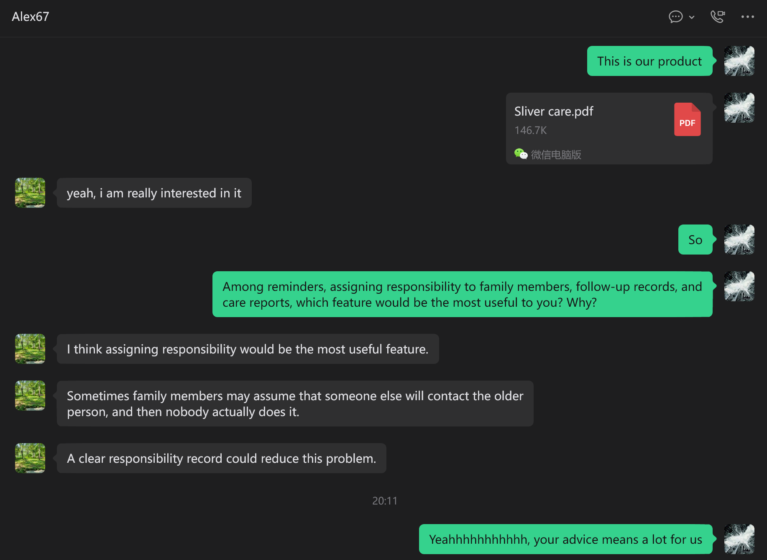
Product PDF shared; contact prioritises named responsibility. A 20:11 marker is visible, with no calendar date. Consultation range is confirmed separately in S23. Source S18

S19 Outreach source
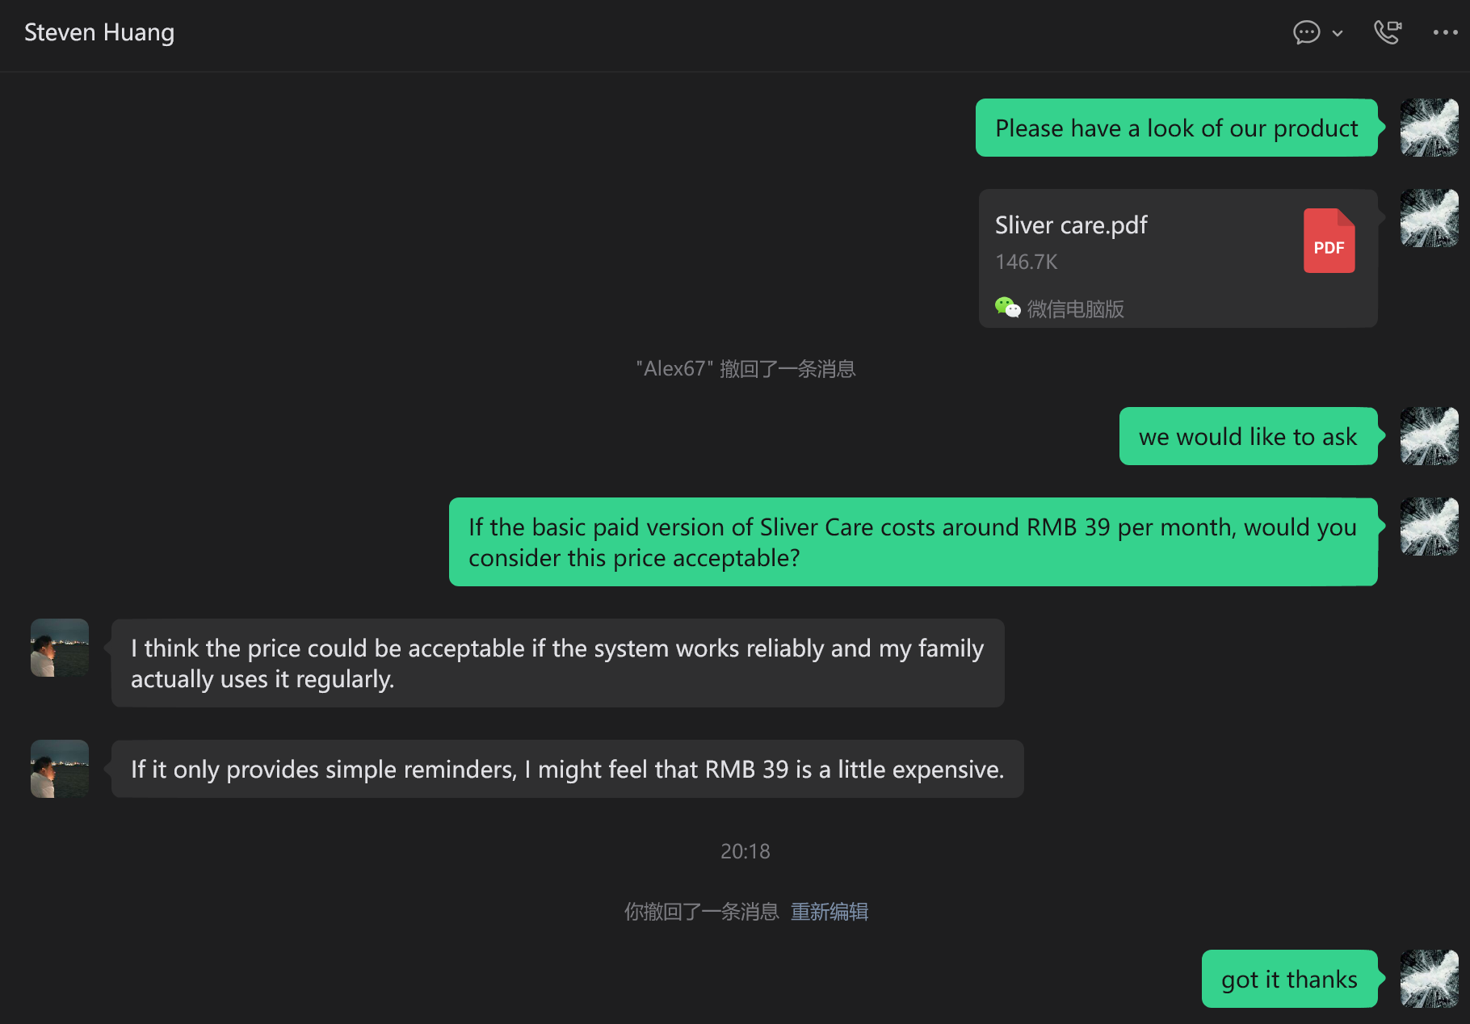
Product PDF and RMB39/month question visible. Acceptance is conditional on reliability and regular use; simple reminders could feel expensive. A 20:18 marker is visible, no calendar date. Source S19

S20 Outreach source
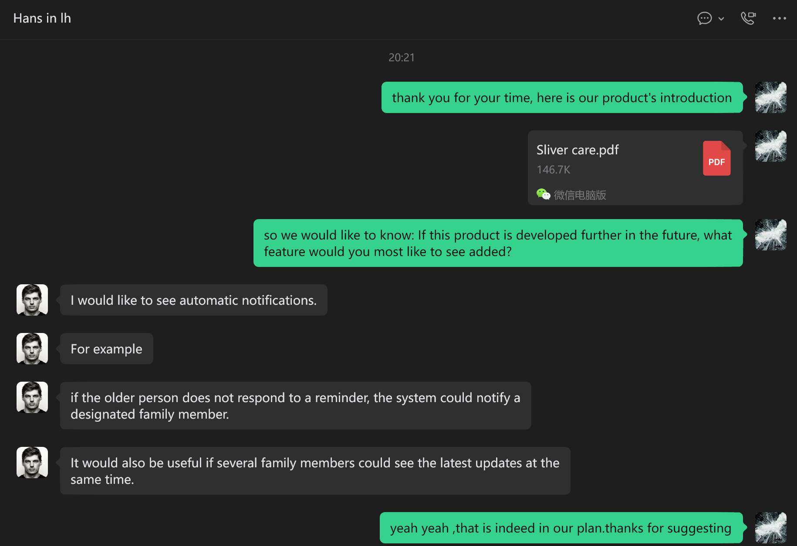
Contact requests automatic notifications and shared current updates. A 20:21 marker is visible, no calendar date. These features remain proposed. Source S20

S21 Outreach source
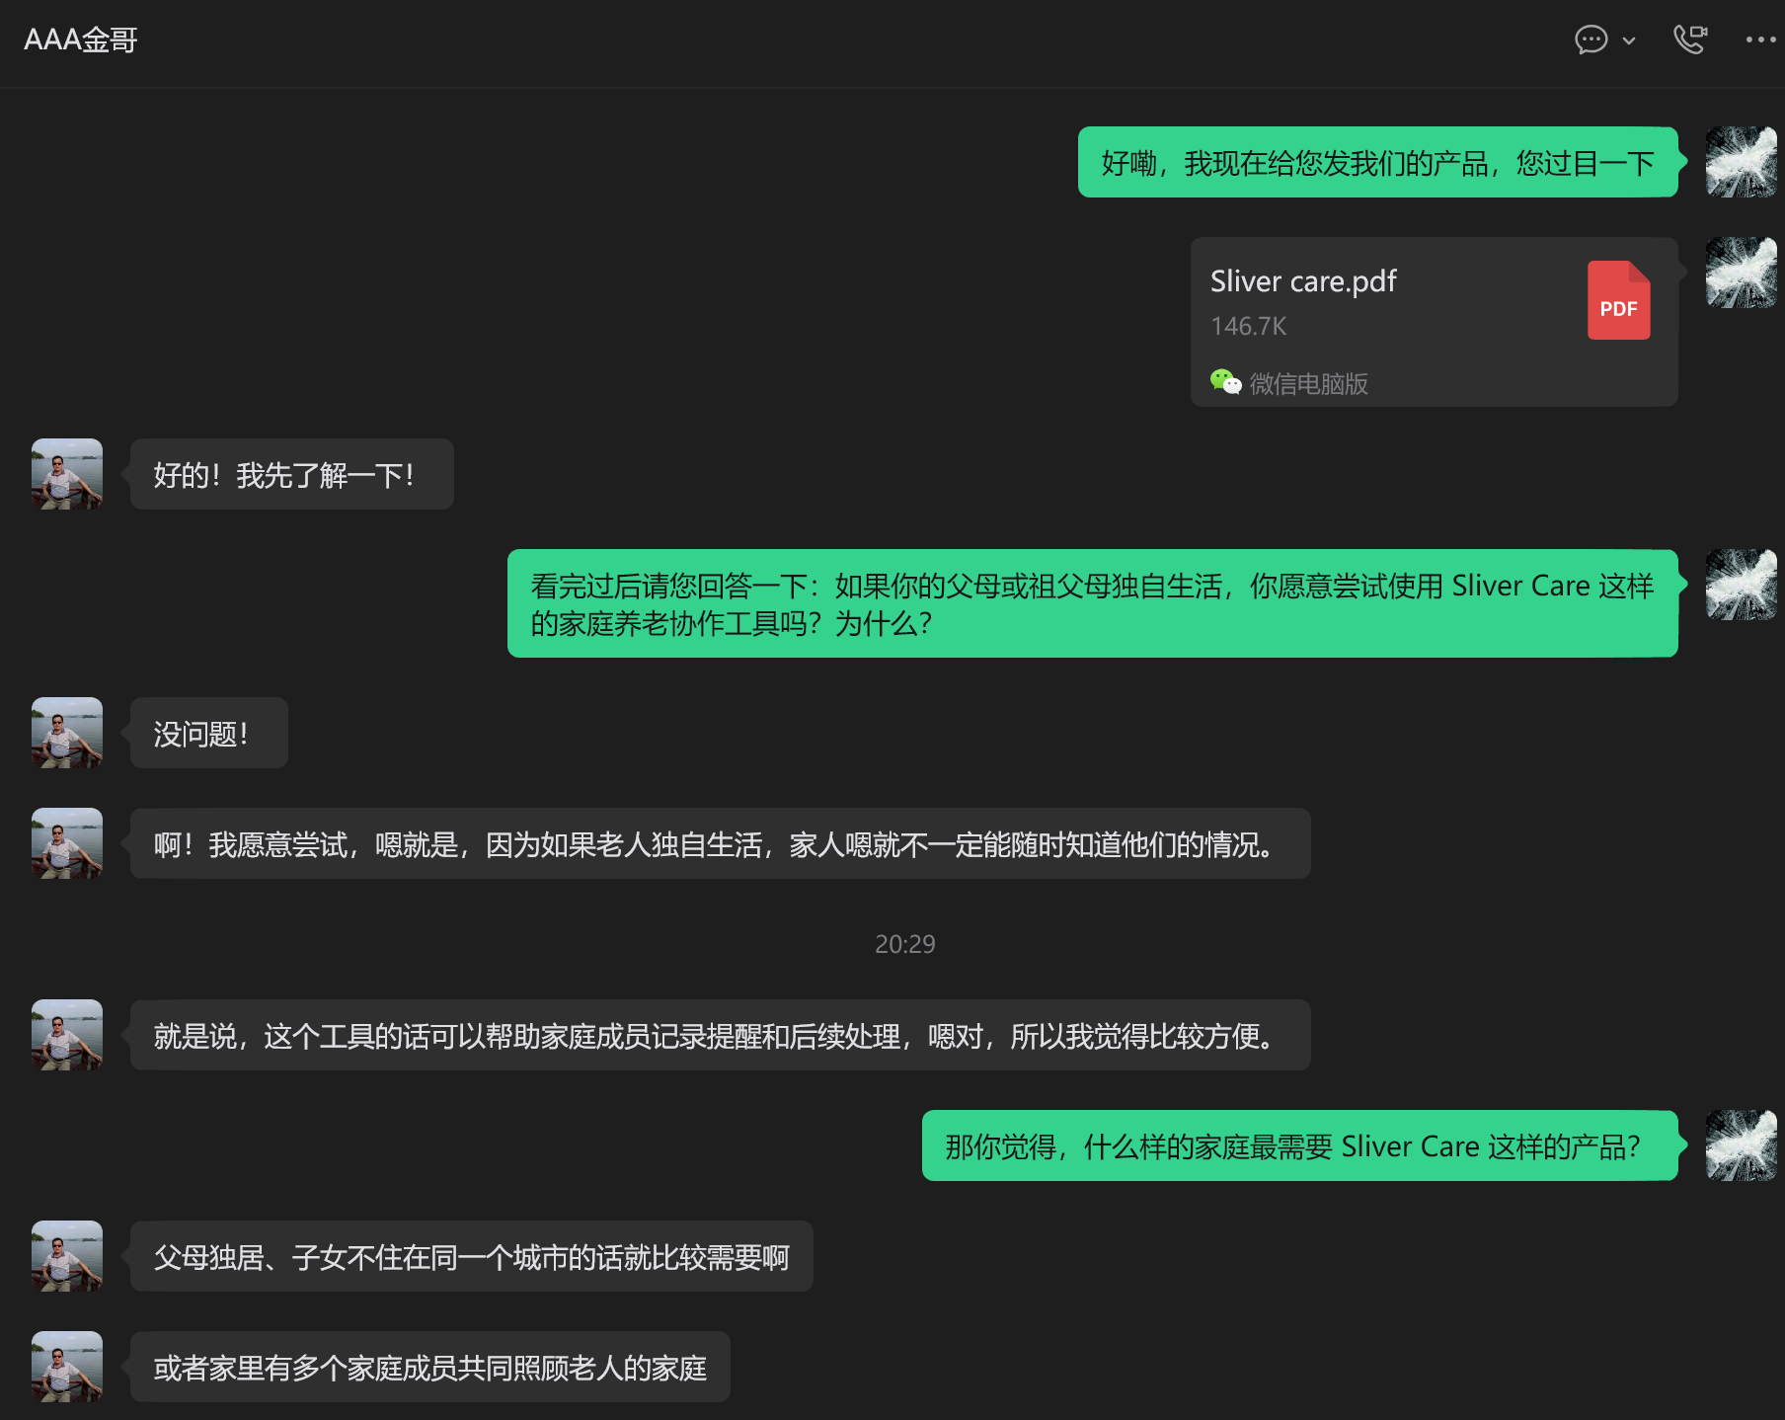
Contact expresses willingness to try and identifies households with parents living alone, distant children or shared caregiving. A 20:29 marker is visible, no calendar date. Source S21

S22 Outreach source

Six email-list rows with product experience invitation subjects are visible. Representative email-list excerpt selected for brevity. Examples include Taikang Home, Xinrong Linbang and Xiaode Zhineng. The campaign covered ten organisations. Source S22

