[**ORACLE 建表**](http://www.cnblogs.com/ouyangtangfeng99/p/5568942.html)

[复制代码](javascript:void(0);)

1 -- Create table

2 create table STUDENT

3 (

4 sno VARCHAR2(**3**) not null,

5 sname VARCHAR2(**8**) not null,

6 ssex VARCHAR2(**3**) not null,

7 sbirthday DATE,

8 class VARCHAR2(**5**)

9 )

10 tablespace TEST.DBF

11 pctfree **10**

12 initrans **1**

13 maxtrans **255**

14 storage

15 (

16 initial 64K

17 next 1M

18 minextents **1**

19 maxextents unlimited

20 );

21 -- Add comments to the table

22 comment on table STUDENT

23 is '学生表';

24 -- Add comments to the columns

25 comment on column STUDENT.sno

26 is '学号（主键）';

27 comment on column STUDENT.sname

28 is '学生姓名';

29 comment on column STUDENT.ssex

30 is '学生性别';

31 comment on column STUDENT.sbirthday

32 is '学生出生年月';

33 comment on column STUDENT.class

34 is '学生所在班级';

[复制代码](javascript:void(0);)

添加数据：

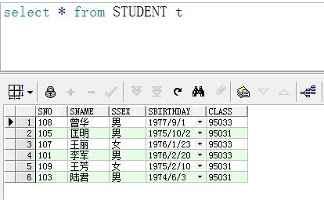

课程表：

[复制代码](javascript:void(0);)

1 -- Create table

2 create table COURSE

3 (

4 cno VARCHAR2(**5**) not null,

5 cname VARCHAR2(**20**) not null,

6 tno VARCHAR2(**3**) not null

7 )

8 tablespace TEST.DBF

9 pctfree **10**

10 initrans **1**

11 maxtrans **255**

12 storage

13 (

14 initial 64K

15 next 1M

16 minextents **1**

17 maxextents unlimited

18 );

19 -- Add comments to the table

20 comment on table COURSE

21 is '课程表';

22 -- Add comments to the columns

23 comment on column COURSE.cno

24 is '课程号（主键）';

25 comment on column COURSE.cname

26 is '课程名称';

27 comment on column COURSE.tno

28 is '教工编号（外键）';

[复制代码](javascript:void(0);)

添加数据：

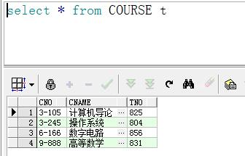

成绩表：

[复制代码](javascript:void(0);)

1 -- Create table

2 create table SCORE

3 (

4 sno VARCHAR2(**3**) not null,

5 cno VARCHAR2(**5**) not null,

6 degree NUMBER(**4**,**1**) not null

7 )

8 tablespace TEST.DBF

9 pctfree **10**

10 initrans **1**

11 maxtrans **255**

12 storage

13 (

14 initial 64K

15 next 1M

16 minextents **1**

17 maxextents unlimited

18 );

19 -- Add comments to the table

20 comment on table SCORE

21 is '成绩表';

22 -- Add comments to the columns

23 comment on column SCORE.sno

24 is '学号（外键）';

25 comment on column SCORE.cno

26 is '课程号（外键）';

27 comment on column SCORE.degree

28 is '成绩';

[复制代码](javascript:void(0);)

添加数据：

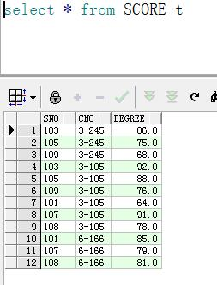

教师表：

[复制代码](javascript:void(0);)

1 -- Create table

2 create table TEACHER

3 (

4 tno VARCHAR2(**3**) not null,

5 tname VARCHAR2(**10**) not null,

6 tsex VARCHAR2(**3**) not null,

7 tbirthday DATE,

8 prof VARCHAR2(**9**),

9 depart VARCHAR2(**20**) not null

10 )

11 tablespace TEST.DBF

12 pctfree **10**

13 initrans **1**

14 maxtrans **255**

15 storage

16 (

17 initial 64K

18 next 1M

19 minextents **1**

20 maxextents unlimited

21 );

22 -- Add comments to the table

23 comment on table TEACHER

24 is '教师表';

25 -- Add comments to the columns

26 comment on column TEACHER.tno

27 is '教工编号（主键）';

28 comment on column TEACHER.tname

29 is '教工姓名';

30 comment on column TEACHER.tsex

31 is '教工性别';

32 comment on column TEACHER.tbirthday

33 is '教工出生年月';

34 comment on column TEACHER.prof

35 is '职称';

36 comment on column TEACHER.depart

37 is '教工所在部门';

[复制代码](javascript:void(0);)

添加数据：

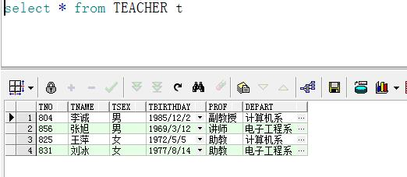

1、 查询Student表中的所有记录的Sname、Ssex和Class列。

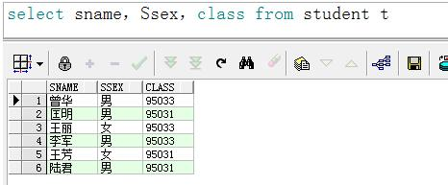

2. 查询Student表的所有记录。

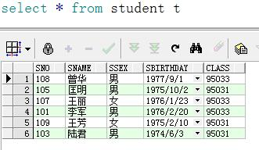

 3.查询Score表中成绩在60到80之间的所有记录

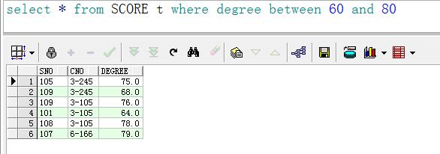

4.查询Score表中成绩为85，86或88的记录。

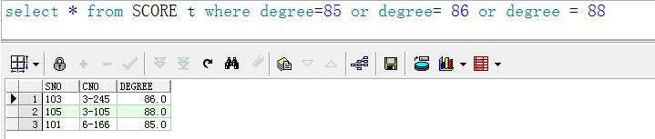

5.查询Student表中“95031”班或性别为“女”的同学记录。

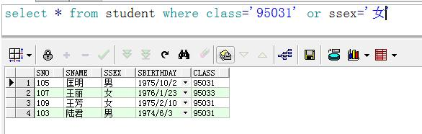

6.查询“95031”班的学生人数。

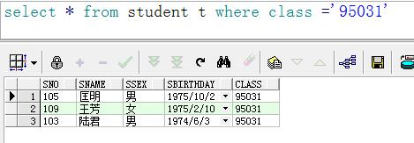

7.查询分数大于70，小于90的Sno列。

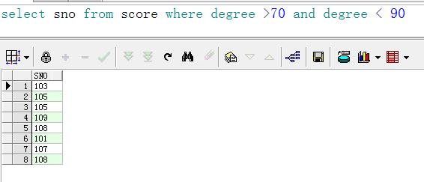

以Class降序查询Student表的所有记录。

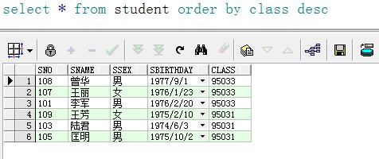

以Cno升序、Degree降序查询Score表的所有记录。

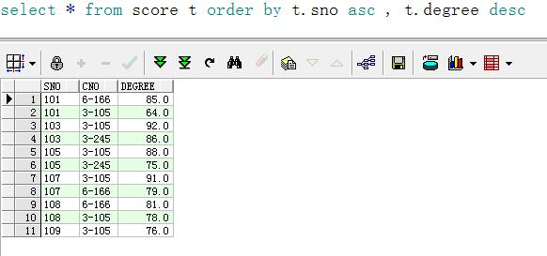

查询教师所有的单位即不重复的Depart列。

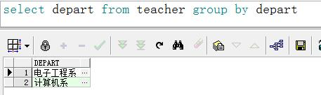

 查询每门课的平均成绩。

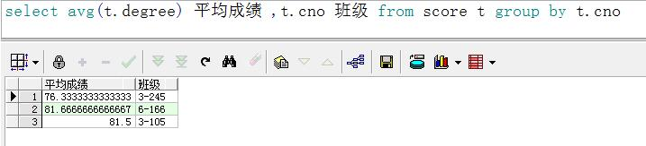

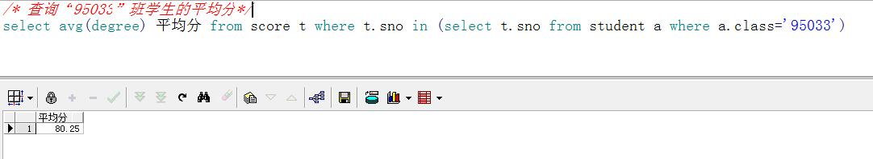

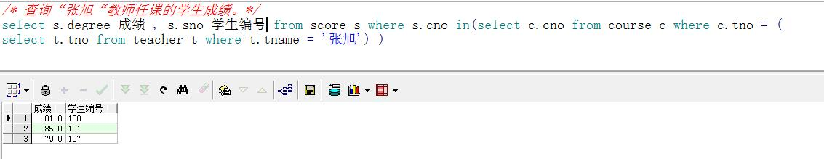

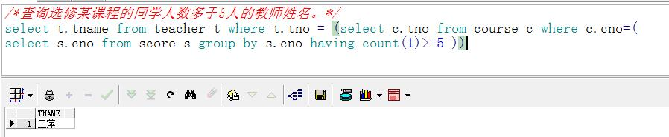

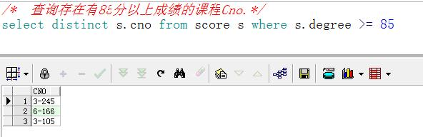

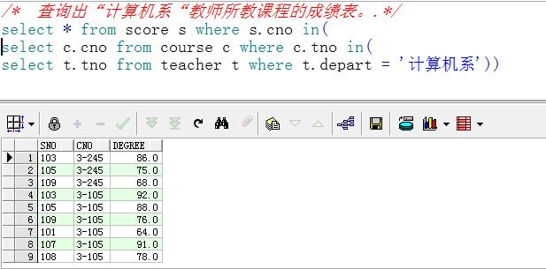

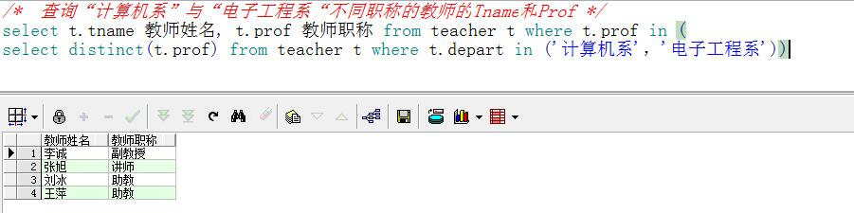

# [据库查询3](http://www.cnblogs.com/ouyangtangfeng99/p/5586163.html)

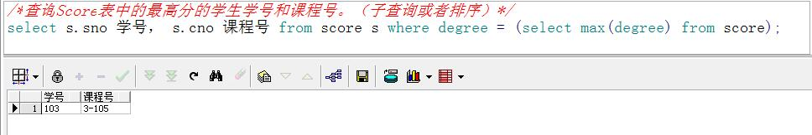

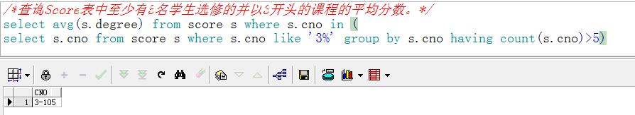

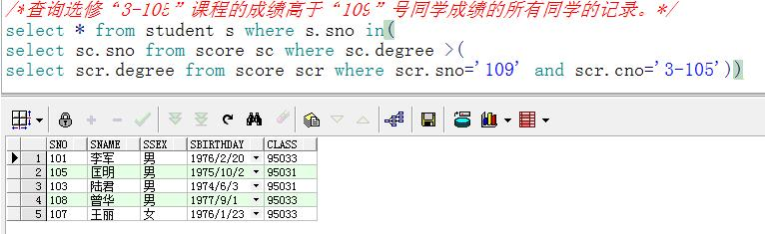

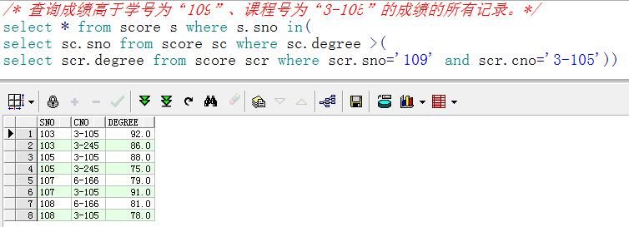

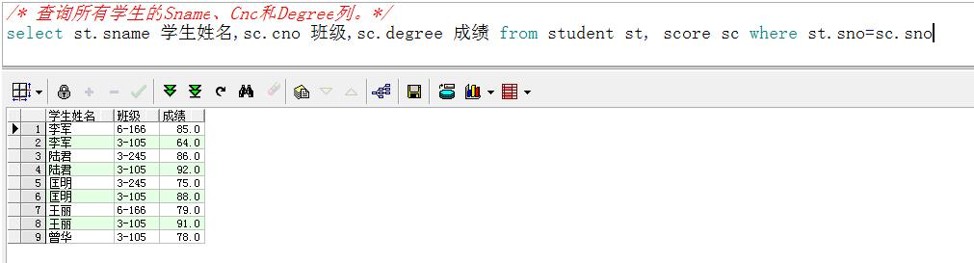

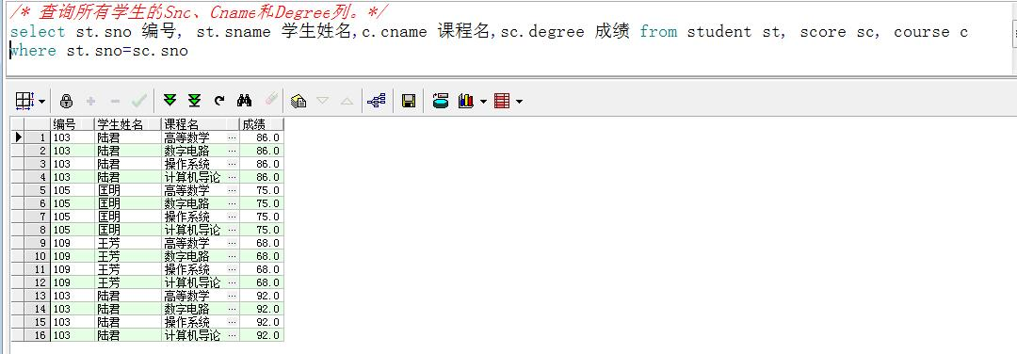

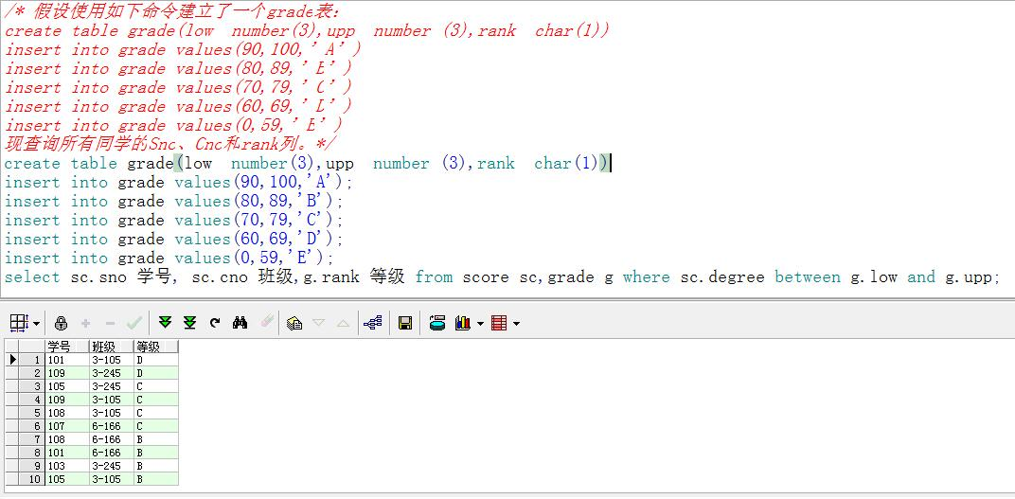

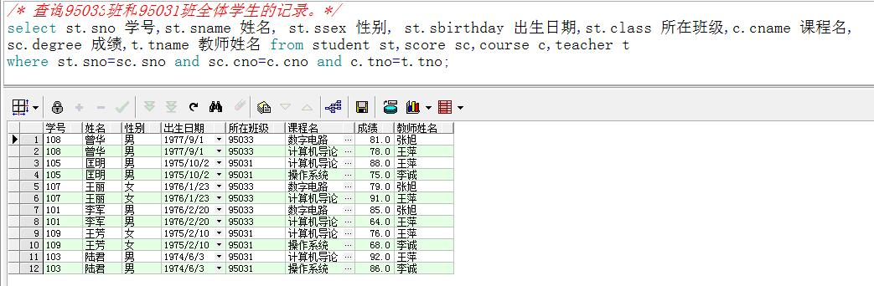

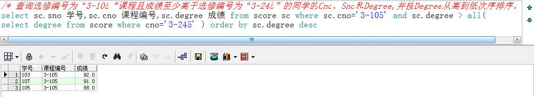

--查询所有任课教师的Tname和Depart.

2 select t.tname 教师,c.cname 课程名 from teacher t,course c where t.tno = c.tno;

3 --查询Student表中不姓“王”的同学记录。

4 select * from student t where t.sname not like '王%';

5 --查询Student表中每个学生的姓名和年龄。

6 select st.sname,extract(year from sysdate)-extract(year from st.sbirthday) as 年龄 from student st;

7 --查询Student表中最大和最小的Sbirthday日期值。

8 select max(extract(day from st.sbirthday)) 最大, min(extract(day from st.sbirthday)) 最小 from student st;

9 --查询“男”教师及其所上的课程。

10 select t.tname 姓名,c.cname 课程 from teacher t,course c where t.tno = c.tno;

11 --查询最高分同学的Sno、Cno和Degree列。

12 select * from score sc where sc.degree = (select max(degree) from score);

13 --查询和“李军”同性别的所有同学的Sname.

14 select st.sname from student st where st.ssex = (select s.ssex from student s where s.sname='李军');

15 --查询和“李军”同性别并同班的同学Sname.

16 select st.sname from student st where st.ssex = (select st1.ssex from student st1 where st1.sname ='李军')

17 and st.class = (select st1.class from student st1 where st1.sname = '李军');

18 --查询所有选修“计算机导论”课程的“男”同学的成绩表。

19 select * from score sc where sc.cno = (select c.cno from course c where c.cname='计算机导论')

20 and sc.sno in (select st.sno from student st where st.ssex = '男');

21 --以班号和年龄从大到小的顺序查询Student表中的全部记录。

22 select * from student st order by st.class desc,extract(year from sysdate)-extract(year from st.sbirthday) desc;

23 -- 查询所有未讲课的教师的Tname和Depart.

24 select t.tname,t.depart from teacher t where t.tno =(

25 select c.tno from course c where c.cno not in(select sc.cno from score sc group by sc.cno));

26 --查询至少有2名男生的班号。

27 select st.class from student st group by st.class having count(st.ssex)>=**2**;

28 --查询和学号为108的同学同年出生的所有学生的Sno、Sname和Sbirthday列。

29 select st.sno,st.sname,st.sbirthday from student st where st.sno<>'108'and extract(year from st.sbirthday)=

30 (select extract(year from st2.sbirthday) from student st2 where st2.sno='108') ;